

Assessment 1 – Reading Task Template

PART 1: Upload your photo of your A3 in-class notes here:
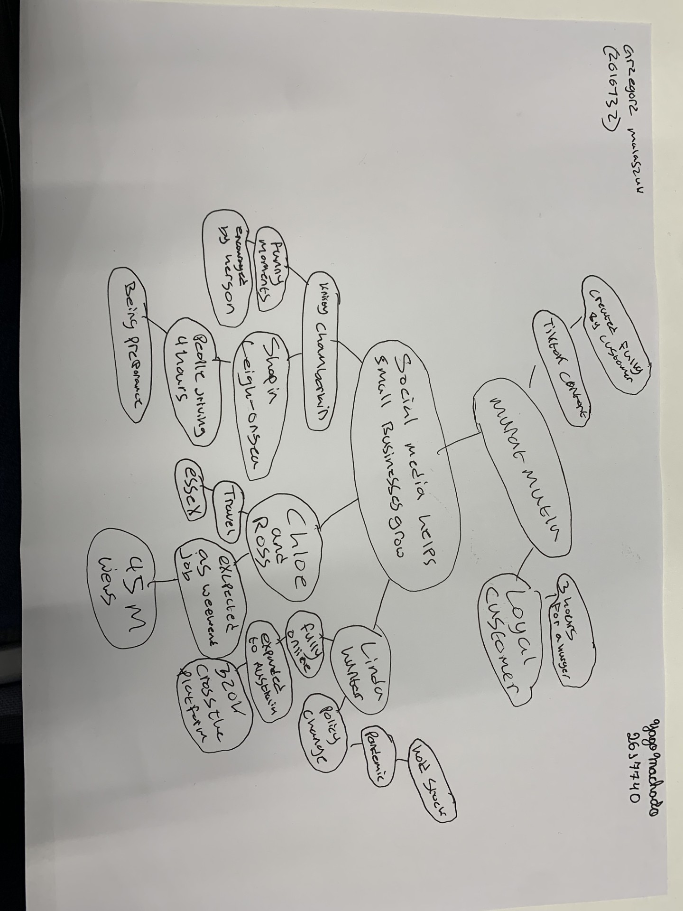

PART 2:
- Answer every question below in 1-3 full sentences.
- Use your own words. Do not use generative AI to answer these questions.
- Include a specific detail from the text when asked.
REMINDER
- The main idea is the overall message of the whole text.
- A key point helps to explain the main idea.
- A specific detail or example from the text shows that the key point is true.

- What is the main idea of the whole text?
The main idea of this articles are that social media, such as Tiktok and Instagram, can help small businesses become more popular and get more customers. The article gives examples of businesses that have become really successful because of there videos going viral.

- What is one key point that supports the main idea, and which specific example from the text shows this?
The key point is to show that social media helps increase business opportunities by attracting more customers. For example, after customers posted videos on social media of honywood sandwich shop, people started travelling three hours just to try there famous chicken burger. This is a great example of how social media can help a business grow and reach more customers.

- What is a different key point that supports the main idea, and which specific example from the text shows this?
Social media also allows business owners to sell their products to people in other countries. For example, lindy loo started posting clothes on Instagram during the pandemic and eventually moved ger business fully online, sending orders across united kingdom and even expanded to Australia.

- Which part of the text do you think is most important, and why?
I think most important part is when the article explains how social media changed the business of little loves pampers bus. Their videos got around 45 millions views in less than a year, and they become much busier than they have expected. I think this is important because shows how social media can change the business for a positive impact.

Reflection:
- What did you find difficult in this task (including in-class components), and why was it difficult?
I found it difficult to make the mind map because my handwriting is quite messy and so was my partners. It was also my first time doing a mind map, so I was learning how to do it while completing the task at the same time.

- What helped you with this difficulty, and how did it help you?
My partner helped me with this difficulty because it was also his first time making a mind map, which made me feel like I wasn’t the only one learning. He was very understanding, and we have took our time to make sure we both understood what we were doing.

