
Student: Armando Forgione (2218650)
Course: Usability Engineering (ACCB6017_LON)
Supervisor: Koushik moduk
Date: 20/12/2025

Table of Contents
- Introduction
- Background and Concept
- Colour and Graphic Design Choices
- Overview of Final Storyboards
  - 4.1 Screen 1 – Home Screen
  - 4.2 Screen 2 – Character Selection
  - 4.3 Screen 3 – Explore / Campus Selection
  - 4.4 Screen 4 – Notes and Clues System
  - 4.5 Screen 5 – New Clue Popup
  - 4.6 Screen 6 – Final Accusation
  - 4.7 Screen 7 – Win/Lose Summary
- Iterations from Wireframe to Full-Colour
- Usability Testing Method
- User Feedback (Positive and Negative)
- Changes Made After Feedback
- Data Collection Strategy for a Real Deployment
- Usability vs User Experience
- Reflective Discussion
- References

1. Introduction
This report presents the final full-colour storyboard prototype for UWTSD: Secrets & Suspects, a mobile adaptation inspired by the traditional board game Cluedo. The design challenge proposed replacing a static mansion with the real environments of the University of Wales Trinity Saint David, turning campuses into investigative spaces where players discover clues, collect notes, and ultimately accuse a suspect.
The report explains the visual and interaction choices, documents the evolution from wireframes to colour screens, summarises usability testing and feedback, and concludes with reflections supported by academic research in interaction design and user experience.

2. Background and Concept
The original board game Cluedo is built around problem-solving, probability, and incremental information. In this version, the murder victim is the Vice-Chancellor, and the suspects represent common university roles (lecturer, librarian, IT technician, student representative, etc.).
The player navigates UWTSD campus locations (such as Swansea, the Science Block, the Library, and the Admin Building), collecting clues and attempting to identify:
- The culprit
- The weapon/item
- The location
This mobile version encourages short investigative sessions, aimed at casual play and social engagement.

3. Colour and Graphic Design Choices
Unlike the monochrome wireframes produced in Assignment 1, the full-colour version introduces:
- high-contrast neon gradients
- vibrant purple, blue, and pink backgrounds
- rounded cards and icons
- large tappable elements
This visual language supports Norman’s view of emotional design, where aesthetics influence satisfaction and engagement. Bright colours were chosen to evoke a playful and rewarding mood rather than a dark crime-scene theme.
Gradients help create hierarchy — important actions such as Play, Join Game, Continue, Accuse use saturated warm-cool gradients to draw attention, following Fitts’s Law recommendations on clear target identification.

4. Overview of Final Storyboards
4.1 Screen 1 – Home Screen
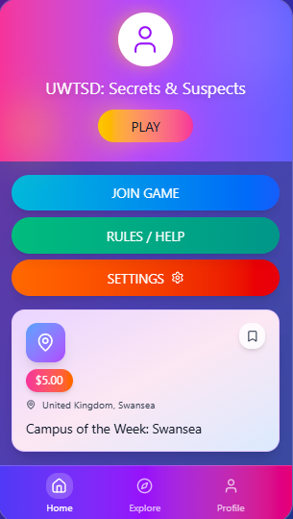
The home interface welcomes the player with a multicolour gradient header and a centred Play button, reinforcing immediate action and reducing cognitive effort. Secondary actions (Join Game, Rules/Help, Settings) are placed beneath, colour-coded to distinguish function. A campus highlight card introduces weekly rotation, encouraging replay.

4.2 Screen 2 – Character Selection
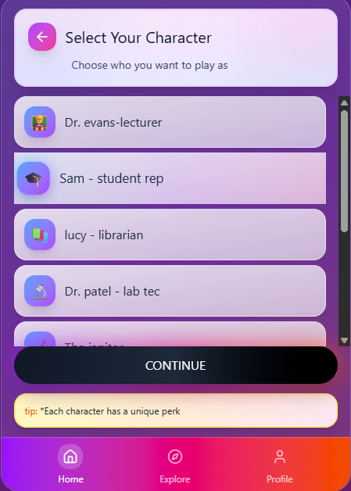
Scrolling cards present suspects with icons and role labels (e.g. Sam – Student Rep, Lucy – Librarian). A short tip below suggests each character has a unique perk, introducing strategic choice. This improves motivation through competence and autonomy principles from self-determination theory.

4.3 Screen 3 – Explore / Campus Selection
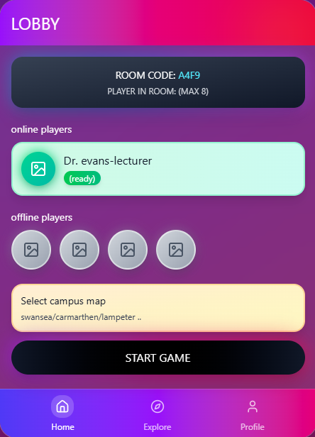
The Explore tab lets users navigate university locations. Campus selection simulates movement on a board, but instead of dice, navigation is contextual. The bottom navigation bar (Home, Explore, Profile) ensures consistency and recognisable affordances, aligning with Shneiderman’s “strive for consistency”.

4.4 Screen 4 – Notes and Clues
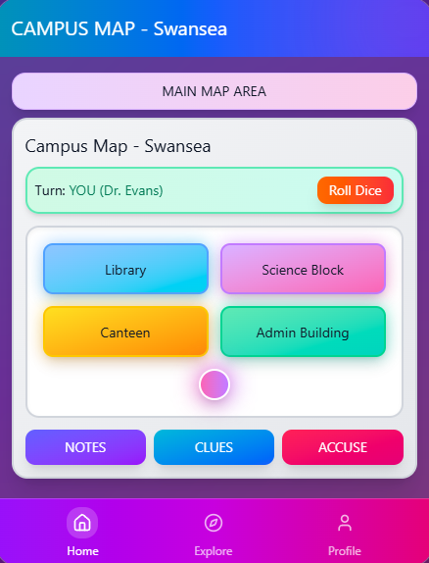
The Notes panel stores suspects, locations, and weapons. Checkboxes allow players to eliminate options — reinforcing deduction logic. This feature directly maps to Cluedo’s notebook mechanic, digitised for clarity.
The visual contrast between categories supports information chunking and wayfinding.

4.5 Screen 5 – New Clue Popup

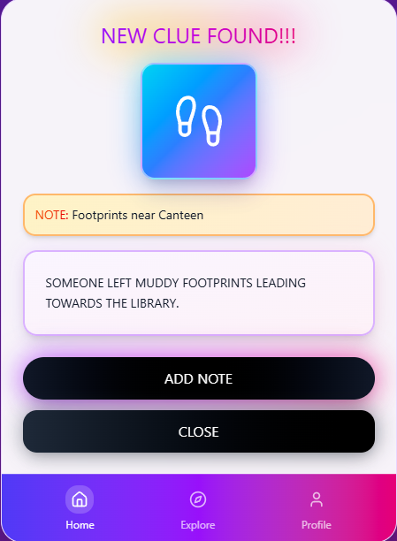
When a discovery occurs, the player receives a modal popup labelled “New Clue Found!”.
An example inserted text reads:
“Someone left muddy footprints leading towards the Library.”
Buttons Add Note or Close support immediate action and task closure — following Nielsen’s heuristic of user control and freedom.

4.6 Screen 6 – Final Accusation
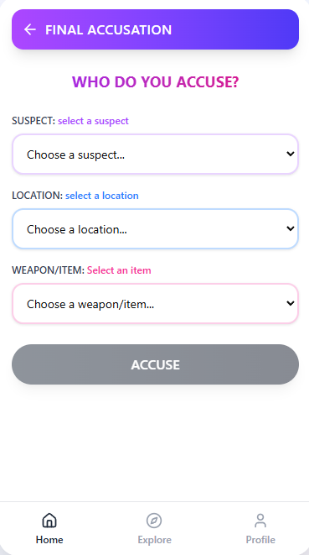

The most decisive screen asks:
- Who do you accuse?
- Where did it happen?
- Which weapon/item?
The interface uses dropdown or selectable cards to minimise typing. Results can be correct or incorrect, and an example solution is displayed to maintain transparency.

4.7 Screen 7 – Win/Lose Summary
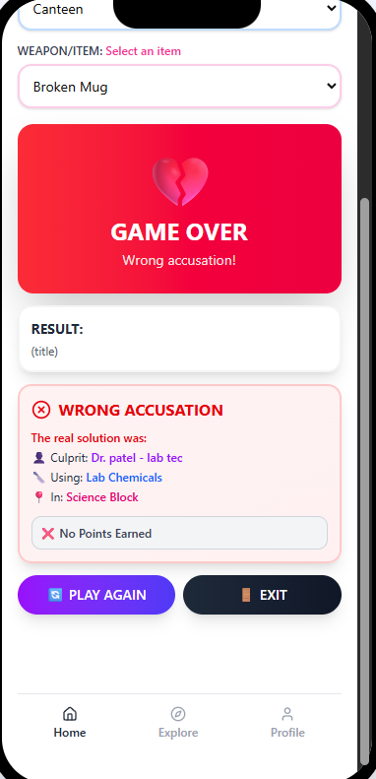

A short summary presents results and offers Play Again or Exit, reducing frustration after a failed attempt. This feedback ecosystem aligns with Norman’s action cycle by closing the loop between intention, execution, and evaluation.

5. Iterations from Wireframe to Full-Colour
Feedback from the initial grey-box wireframes identified:
- The design lacked emotion
- Elements were too small for touch interaction
- Hierarchy was unclear
Therefore, the following improvements were introduced:
- bigger buttons
- vibrant colour hierarchy
- card-based layouts
- emotional tone for narrative text
These enhancements shifted the prototype from functional to enjoyable, matching UX priorities.

6. Usability Testing Method
A lightweight usability evaluation was conducted with five informal participants aged 19–32. Three were university students, one was experienced with mobile games, and one rarely played games.
Testing was remote, using screen-sharing and guided tasks:
- choose a character
- find campus information
- add a clue to notes
- make a final accusation
Participants spoke aloud, and observations were recorded.

7. User Feedback (Positive and Negative)
Positive
- Interface attractiveness: strong emotional reaction to gradients and colours.
- Navigation clarity: bottom menu understood instantly.
- Task satisfaction: clue discovery felt rewarding.
- Character identity: roles were relatable to university life.
Negative
- Some users requested more readable text sizes.
- Two participants found the colours slightly overwhelming.
- One tester wanted more animations or feedback sounds.
- The accusation screen felt “stressful” due to decision-making.
These reactions were mostly expected — especially regarding colour intensity.

8. Changes Made After Feedback
Three revisions were applied:
- Increased body-text size for readability.
- Enlarged primary buttons and improved spacing.
- Adjusted gradients to avoid colour-clashing.
These changes align with Nielsen’s heuristics on visibility of system status, error prevention, and aesthetic minimalism.

9. Data Collection Strategy for a Real Deployment
If the game were released, the following data would be collected:
Automatic analytics
- session duration
- clicks on “Add Note”
- frequency of accusations
- successful vs unsuccessful outcomes
- retention rates
Player profiling
Voluntary demographic data (age, familiarity with Cluedo, gaming frequency) would help refine difficulty.
Emotional feedback
Short UEQ (User Experience Questionnaire) prompts could measure:
- stimulation
- novelty
- clarity
Unlike behavioural analytics, emotional data must be explicitly requested and anonymised.

10. Usability vs User Experience
If usability were the only priority:
- the interface would be monochrome or minimal
- fewer colours and ornamentation
- only functional buttons
- less narrative and drama
However, user experience encourages:
- emotional immersion
- narrative clues
- visual pleasure
The main conflict in this project was legibility vs visual excitement. Gradients can reduce clarity, but contribute to mood. The compromise adopted favoured readability while maintaining vibrancy.

11. Reflective Discussion
The design process demonstrates an iterative, user-centred approach. The journey from wireframe to colour reflects a shift from structural clarity to emotional engagement. Testing showed that even minimal feedback loops guide improvements.
Key lessons:
- UX depends on emotional triggers, not just usability.
- Players appreciate clarity in navigation.
- Visual style must support, not obscure, gameplay logic.
- Involving users early prevents design blindness.
Future development could include multiplayer networking and reward systems.

12. References
Nielsen, J. (1994) Usability Engineering. San Francisco: Morgan Kaufmann.
Preece, J., Rogers, Y. and Sharp, H. (2019) Interaction Design: Beyond Human–Computer Interaction. 6th ed. Hoboken: Wiley.
Norman, D. A. (2013) The Design of Everyday Things. Revised ed. Cambridge, MA: MIT Press.
Tufte, E. (1990) Envisioning Information. Cheshire, CT: Graphics Press

