University of Wales Trinity Saint David



Written Report

Richard’s Castle Soap Box Derby

Integration project (ACHA4008)

Oliver Spears 2004454
Morgan Jessop-Browne 2103898
Sophie Reed 2000492
Ross Burnside 2110614

Acknowledgments:

Team Members: Morgan Browne (team leader and materials), Ross Burnside (design), Sophie Reed (costing), Oliver Spears (design and drivability) for their input into and contribution to the overall project.

Contributions list:

Oliver Spears (Cover Page, introduction, listed research, minutes, conclusion)
Morgan Jessop-Browne (Listed research)
Sophie Reed (Listed Research)
Ross Burnside (Introduction, objectives, Gantt chart, listed research/designs, minutes, conclusion)

Introduction
Upon being given the project of designing a soapbox our team leader, Morgan Jessop-Browne, suggested a delegation of roles best suited to each member’s strengths in order to achieve a detailed and insightful written report. One of our members, Olly Spears, is a keen mechanic and enjoys learning how parts and systems function. It was agreed he should focus predominantly on the dynamics and driveability of the kart alongside Ross Burnside, another team member with mechanical experience. Ross also enjoys designing his own track car projects and was willing to draw our designs. With the delineation of the soapbox sorted, a key role in development was left to Sophie Reed. Having her own modified car, Sophie was experienced in shopping around for materials and parts; finding the cheapest option for greatest quality. This left materials research to Morgan. Having built multiple engines and project cars, we were all confident Morgan would choose the best materials for the right part application. With the delegation of roles discussed and agreed on, we decided the best way to ensure an even share of work was a Gantt chart. We all felt this would also show each team member’s aptitude in specific fields.

Team Objective
As a team we decided from the outset our overall aim would be to build the most competitive soapbox and win the derby. However, more so than winning, each member discussed a personal objective within the field they had chosen. Amongst those expressed were aims we all agreed we should base our team ethic on and abide by with our research. It was found in unanimous agreement that we wanted to:

Build a competitive soapbox for a competitive price.
Although a bigger budget would equate to an overall faster, lighter, and more dynamic kart with further possibilities we recognise that if a budget cap is applied it would make the derby more even; with closer racing between competitors, which is why we all enjoy the sport.

Discover new methods and applications of parts where an advantage could be gained.
An innovative outlook on a classic design. With multiple variations of motorsport widely adored numerous shapes and sizes of cars can be found. With each design, we want to adopt a different style of bodywork and aerodynamics to show the different possibilities and opportunities present within the sport.

Find the best formula/layout and adapt it as far as possible within the parameters set.
With advantages and disadvantages present in each formula of soapbox we design our main aim is to find out the best one for the given circuit and develop its strengths to suit the track and competition.

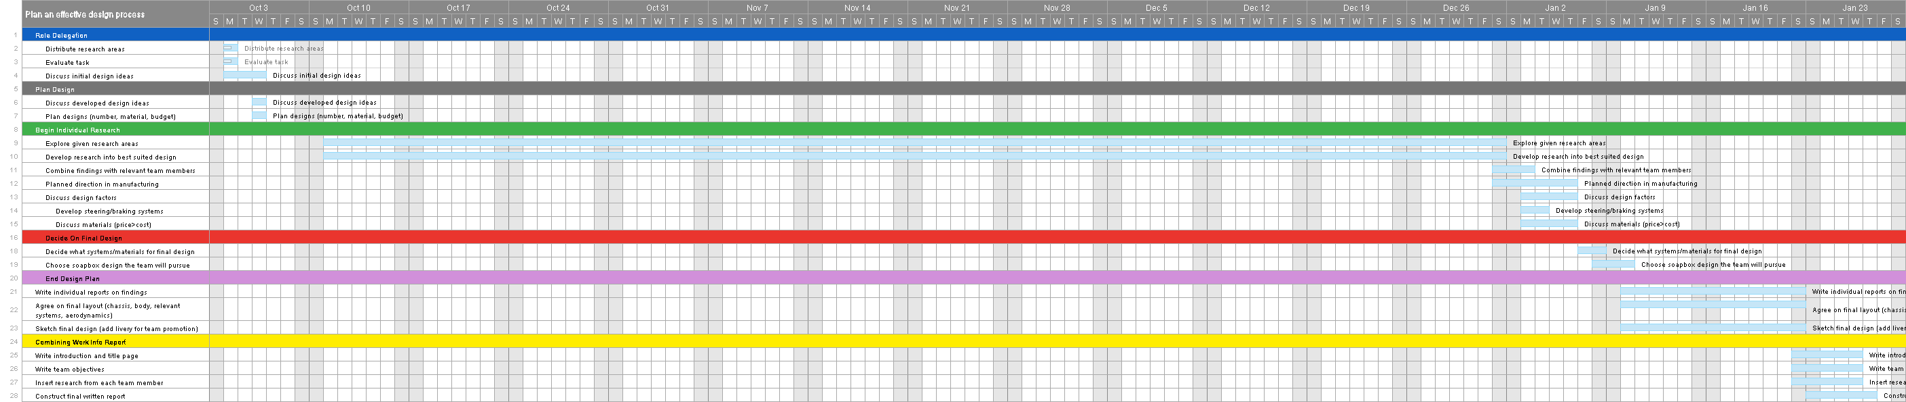

DEVELOPMENT OF THE B1

DEVELOPMENT OF THE B1

Plan Layout and Methods.

Following our set objectives, the group has formulated a plan in which to achieve our goals. Our team member Ross (design) has developed detailed designs of kart layouts in which the other team members have built their research on. Sophie and Morgan were able to research in-depth material costs and manufacturing techniques, alongside Olly, who was able to design steering rack and braking setups to suit each of the soapbox’s layout. With time-estimated goals on our Gantt chart we were able to focus on our design research, allowing us a great opportunity to research our fields heavily. The following research attached is our findings from the time parameters set, alongside our final design and reasoning behind our choices.

Materials and manufacturing, Morgan Jessop-Browne, 2103898

Design No.1 – Wood

For the first design the material of choice was wood, wood is a cheap light and somewhat strong material. The frame will be made up from two 4x2 C16 timber boards and a sheet of ply.
C16 is a softwood timber that comes from fast growing trees. The fast rate of growth means that the timber will have a low density and contain more knots which often leads to holes in the wood where they have fallen out, thus weakening the timber.

The Properties of C16 Timber are:

Ultimate tensile strength – 2.07-3.17 MPa

Youngs Modulus – 8.83 GPa

CO2 Footprint on production – Per kg of timber, 1.8kg of carbon dioxide is taken from the atmosphere, this is a relatively low carbon footprint to other materials.

Plywood is a layered sheet of woof that consist of thin layers of alternating grains preventing the board from breaking. Plywood is also very flexible and can be used to create curved edges around the cockpit of the kart giving it a more aerodynamic design.

The Properties of Plywood are:

Ultimate tensile strength – 27.6-34.5 MPa

Youngs Modulus – 8.2-10.3 GPa

CO2 Footprint on production – Per kg of plywood, 1.65kg to 1.8kg of carbon dioxide is taken from
the atmosphere.

Advantage of using wood is that it’s a very easy material to use whether that’s cutting pieces down to size or fixing them together, no serious power tools are needed such as a welder or mechanical saw, a handsaw and drill will do fine. The kart will be very light if made from wood, (this can be seen as a disadvantage if dependent on gravity to make you go faster). Timber is also a very accessible material it can be purchased from local hardware stores in many shapes and sizes.

Disadvantages of wood include, the strength, upon impact the timber will have no crumple so may injure the driver, it may also be possible for the wood to crack or snap when racing under high stress this could cause it to break completely or a part of the kart fail. The weight of the kart may impact speed if dependent on gravity, it may be good around corners but will be hard to pick up speed in a straight line.

C16 and C24 timber, wood? (armstrongsupplies.co.uk)
Red Pine Wood (matweb.com)
Understanding the different types of plywood and their uses (cbjltd.co.uk)

Design No.2 – Metal

The main materials used in the second design are steel and aluminum.

Steel is commonly used to create chassis and body panels for lots of types of vehicles. Steel is a very hard and strong material with a decent strength to weight ratio. Because steel has a lower boiling point it can be poured into different molds to quickly and easily produce panels and other components.

The Properties of steel are:

Ultimate tensile strength – 400 - 2000 MPa

Youngs Modulus – 150 – 220 GPa

CO2 Footprint on production – Per kg of steel, 2.26-2.61kg of carbon dioxide is taken from the atmosphere.

Aluminum is a very light metal which can be up to 40% lighter than steel. Aluminum provides good rigidity improving control over the kart, aluminum is also relatively malleable so can be shaped in various ways. If a crash was to occur aluminum can absorb a good amount of energy increasing safety without weight.

The Properties of Aluminum are:

Ultimate tensile strength – 90 - 550 MPa

Youngs Modulus – 60 – 75 GPa

CO2 Footprint on production – Per kg of aluminum, 12.4 -13.7kg of carbon dioxide is taken from the atmosphere. This is a very high amount.

Advantages for a metal kart include strength to weight ratio, easy to work with as both materials are malleable, steel is a cheap material and easily accessible, but aluminum is not. Aluminum can absorb a lot of energy which is good upon impact saving the driver from serious injury. It would be wise to use these materials together for different components on the kart maximizing performance.

Disadvantages of these metals include a high energy to produce aluminum with a very big carbon footprint. Steel is also a common material to suffer from corrosion wakening the metal.

Why Is Steel Used for Car Bodies? (itstillruns.com)
Aluminum and the Auto Industry - Metal Supermarkets

Design No.3 – Carbon

Carbon fibre has many benefits. The stiffness of carbon fibre can work as a benefit, stiffening up the chassis creates less body roll so less stress on the suspension and all-around better handling. Carbon fibre has the highest strength and stiffness per density than metal or any other material. The strength makes carbon fibre perfect to use in the cockpit of the car, surrounding the driver in a carbon fibre cocoon provides better safety in a crash for the driver.

Carbon fibre is extremely resistant to oxidisation due to the bond strength between atoms, it takes sufficiently more energy to break the bond in carbon fibre. Mixing this naturally resistant material with others such as epoxy resin increases the resistance to oxidisation, stopping it from rusting and making it perfect for harsh environments.

The Properties of carbon fibre are:

Ultimate tensile strength – 500 - 1050 MPa

Youngs Modulus – 69 -150 GPa

CO2 Footprint on production – Per kg of Carbon fibre, 45.8 -50.5kg of carbon dioxide is taken from the atmosphere. This is the highest amounts of all materials.

In conclusion using carbon fibre has many advantages to using other materials in motorsport, the high tensile stress, stiffness, low density, high chemical resistance, light weight, strength, high temperature tolerance, low thermal expansion and ability to create a mould for all types of parts, makes it the perfect material to use and continue to use in high end competition. As cost is a big factor, carbon fibre may not be the best material to use, it is a labour-intensive material to produce and is expensive, but for motorsport carbon fibre brings the most cutting-edge technology and has many more benefits that its competition (aluminium and steel).

(How Durable Is Carbon Fiber? – Carbon Fiber Gear, https://carbonfibergear.com/blogs/carbonfiber/carbon-fiber-durability)
(Carbon fibre: the fabric of the future? (automotiveworld.com, May 2014)
The Pros and Cons of Carbon Fiber Material vs Aluminum Cars - Dent Goalie)

Design and Development, Ross Burnside, 2110614

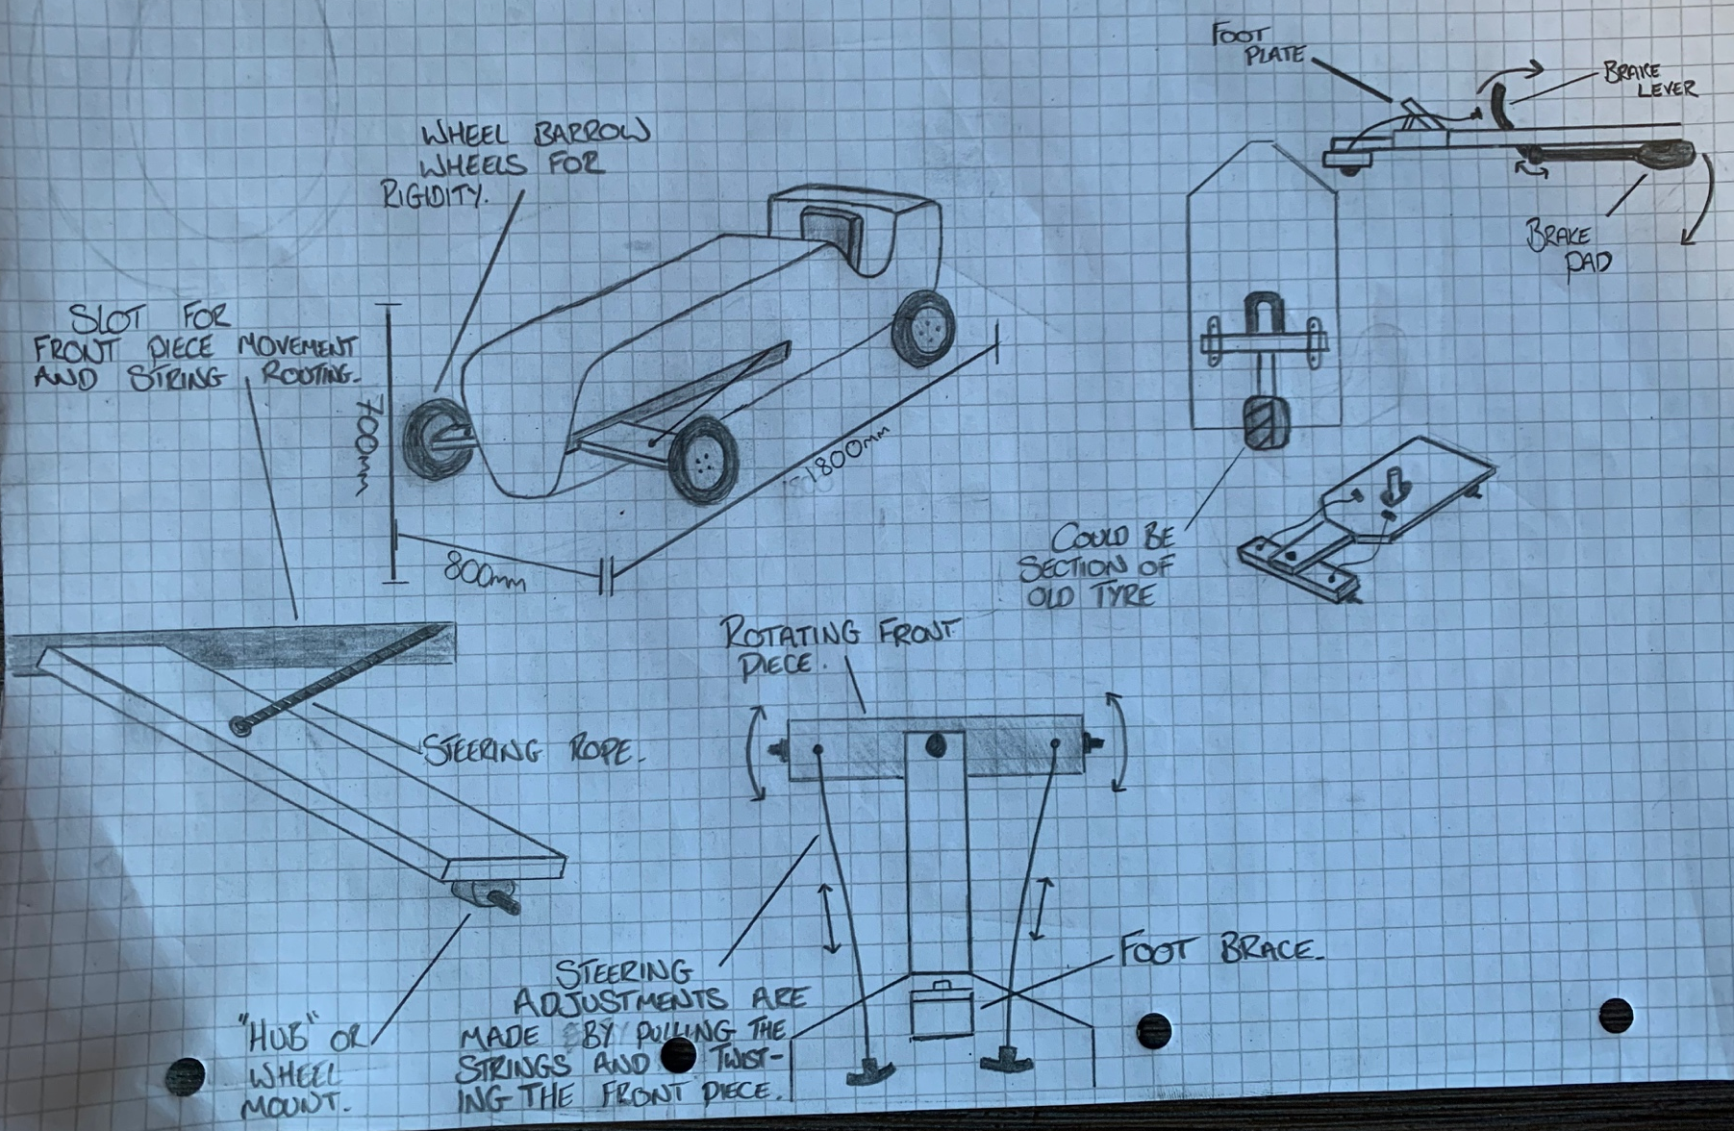

Initial Design, Wooden Soapbox

For our first design, the team discussed a soapbox as low-weight for low-budget as possible. The soapbox was kept short and narrow for benefit of cost and manufacturing. Wood was decided as our initial material venture due to its ease of manufacturing and malleability once steamed and curved. 2 lengths of 4x2 timber were cut to suit a rectangular chassis, with plyboard sheets as body panels. A curved front was still desired, with one brace for a seat to be bolted to along the back of the frame, also positioning the driver’s weight directly over the back axle, and brake set up. Fears were mentioned of a weight-shift under heavy braking, with the brake design physically lifting the rear of the car up, inducing oversteer and raising the possibility of a roll over. Although cheap and easily maintained, the team was not happy from a safety perspective. The issue was also found in a braking and steering combination. All controls are hand operated meaning either effected steering or ineffective braking; because of this the group agreed this would not be the design taken forward.

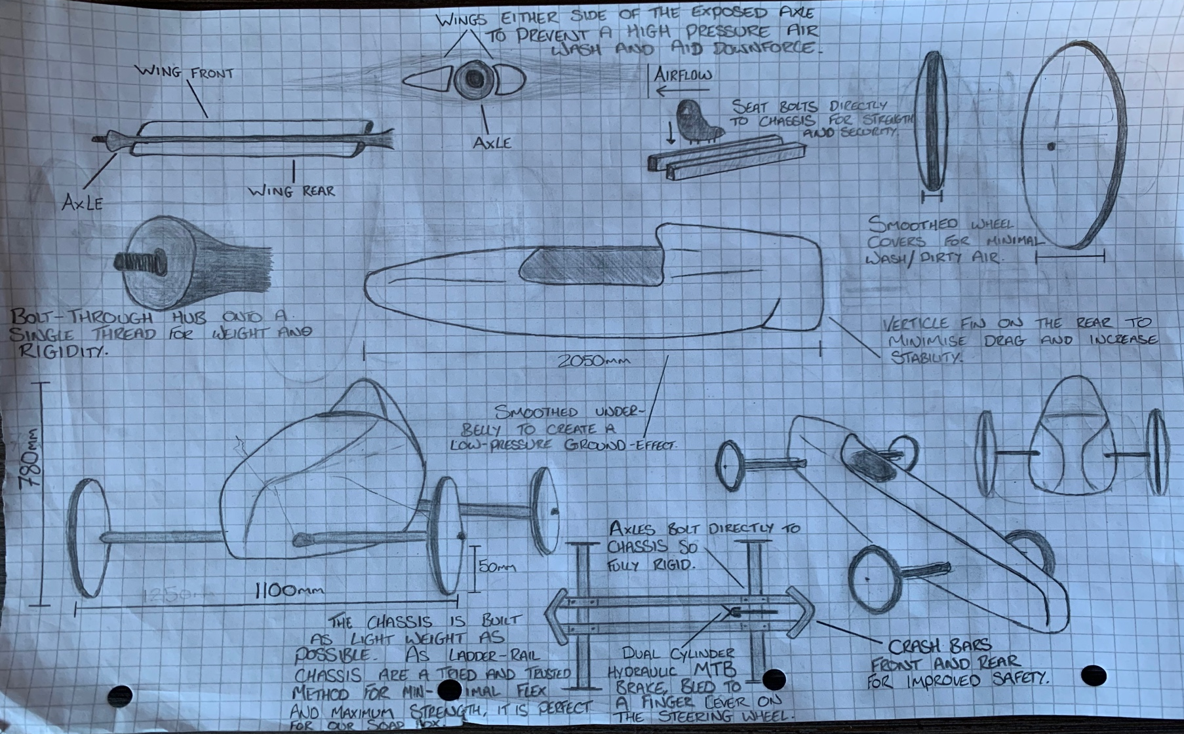

Secondary Design, Metal Soapbox

Experiencing concerns with the original low-budget-design’s aerodynamic efficiency and strength on impact, we were keen to see how an increase in money spent on materials would compare. The next natural leap from wood is metal. In light of aluminium’s malleable nature, I wanted to design a smoothed ‘bullet-shaped’ soapbox. I felt due to the drag caused by downforce a more effective alternative of grip on the track would be ground-effect. A smoothed/enclosed undercarriage and sweeping rear end would enable the kart to have low resistance shape without stalls created or dirty air. One of the things I considered was the aerodynamic inefficiency of a driver’s helmet and shoulders. The rear tail of the soapbox allows air passing around the drivers helmet to be redirected into a low-pressure airflow, whilst also protecting the driver in the event of a rollover. Alongside this, winglets either side of both front and rear axles were developed. Dirty air wash is created by airflow hitting the axle and being dispersed in a sporadic way. These winglets allow minimal airflow to be affected by being a low-resistance wing shape. These have also been angled slightly front-down, as to generate a small amount of downforce over each axle, thus allowing greater friction/grip on the track. The kart is finished in smoothed rims in order to avoid air disturbance further. The chassis’ layout also gave us an opportunity to add in front/rear crash bars and have the axle be rotational, as opposed to just the wheels. With an immediate strength advantage over the initial design, we could focus more on driveability. An attempt to promote stability found a low, wide, and still a relatively short wheelbase.

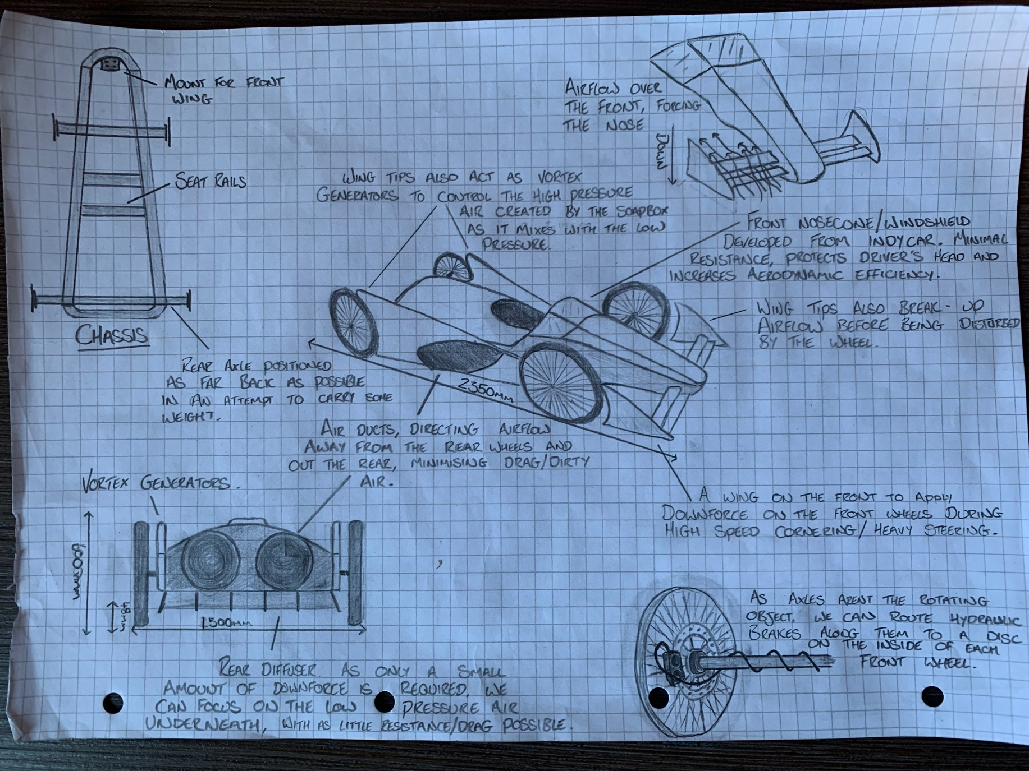

High Budget Design, Carbon Soapbox

The team had discussed a possible high-budget kart. Carbon-fibre construction to save weight (aside from a metal chassis for in-expense/safety) gave us an opportunity to experiment with aerodynamics. Low-pressure air channelling throughout the body was added; diverting air away from the wash of the rear wheels and through the side of the kart before being fed out the rear end, also eliminating drag and stalls by creating forceful airflow. Vortex generators further help control the mixing of high and low-pressure airflow off the top of the body. With the design focus being a reduced weight, we wanted to ensure an excess of traction at lower speeds too. A front wing was placed at the end of an “Indy-Car” style nose-cone. It was felt this would provide sufficient downforce on the front wheels during cornering whilst not creating so much drag that the kart’s overall speed was reduced. Wing-tips were placed at the extended-end of the front wing, splitting the airflow either side of the front wheels, reducing dirty-air wash and drag. The diffuser at the rear also aids in reducing resistance and assisting the desired low-pressure air suction by mediating the exit of the airflow from under the kart. With so much weight saved, the team discussed an already-proven (but heavier) steering system from a conventional car. Swivel hubs could be fitted to the metal axles with an orthodox rack-and-pinion steering rack positioned just behind. From there, the only query was steering shaft angle onto the base of the column, and up to the driver.
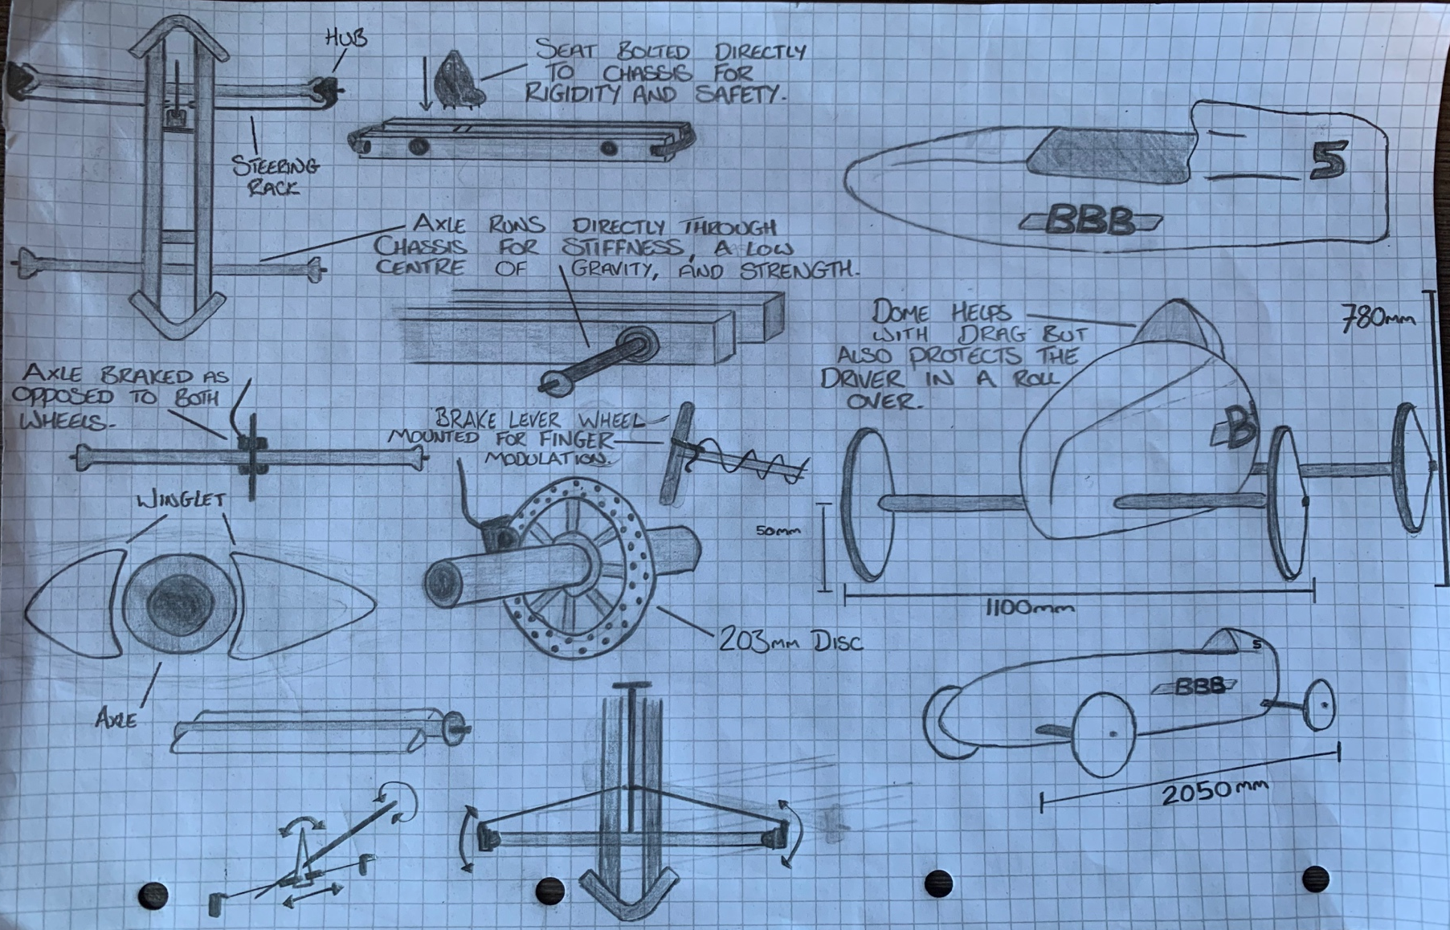

Final Design

After much consideration, we opted for the second, moderately priced soapbox-build as our final design. An advantage was unanimously seen in a low-resistance ‘bullet-shape’ from a fabrication and cost perspective. With a slight change from original chassis design regarding axle mounting routed through the frame as opposed to the original ‘bolt-on’ configuration. I felt that the streamline body would be the most effective whilst still maintaining an attainable budget/timeframe with our project-oriented Gantt chart. Whilst the more expensive carbon Soapbox has more purpose-built aerodynamics in which performance could be gained, the cost of manufacturing a monocoque body with purpose-routed low-pressure air ducts, diffusers, vortex generators, and wings was deemed over-expensive and in-efficient given the time parameters present.

In order to still maintain an edge over the competition, the streamline body was favoured highly, with specific detail taken around the rear fin. Not only does it protect the driver in the event of a roll-over/impact, but also significantly reduces the drag on the soapbox by eliminating any stalls/high-pressure re-entry of airflow. In addition, it was decided that a smoothed under-belly was necessary due to the lack of actual downforce. In order to maintain a traction advantage, the group had discussed ground-effect. The low-pressure air underneath the kart sucking it to the track would aid massively in keeping us level and stable, assisting the tyres in maintaining grip and track-contact alongside the downforce generated by the driveshaft winglets.

Although minimal, dirty air is created by the rotating of the axle. These winglets allow a clean distribution of air both over and under, angled slightly to create a higher-pressure flow over the top, forcing the axles (and in turn the wheels) downward.

In an attempt to shed some weight (being completely metal in frame and bodywork) the lighter of steering racks was chosen. After some research and a discussion with my team partner, Oliver Spears, we decided the chosen system was sturdy enough to take abuse from a corner, whilst sustaining a large weight advantage over the system taken from a conventional car. In conjunction with this reasoning, a single-disc axle brake system was chosen. A 203mm vented disc was deemed sufficient enough to provide a transposable brake feel and operation. Oliver had expressed concerns with a front wheel braking system being over-powered, resulting in lock-ups, understeer under braking, and modulatory control. It was felt that a dual piston, single disc set up would favour a greater weight advantage, be sufficient enough to hold the kart on the start ramp, and have enough modulation to benefit the driver. The soapbox was also kept with a 50mm ride height in order to clear the starting ramp.

In addition to the changes developed by the team we have our livery. The soapbox is the “B1” designed and developed by BBB. Due to one of our team members, Ross, having some racing experience it was decided his number 5 be our soapbox’s running number, further adding to the livery. We had discussed the possibility of the kart being a dark colour with the livery highlights being lighter, giving a clear view of our team name and good promotion at the event.

Driveability and Dynamics: Oliver Spears, 2004454

Contents
- Figure table
- Introduction
- Methodology
- Steering
4.1. Rotating axle rope steering
4.2. triangular hub steering system
4.3. Car part system (rack and pinion steering rack)
4.4. conclusion
- Breaking systems
5.1. friction lever system
5.2. Pushbike brake leaver and front axle-mounted bike brake disc
5.3. Pushbike brake leaver and brake disc to each front wheel
5.4. conclusion
- Aerodynamic systems
6.1. curved nose design
6.2. aero kit system
6.3. Carbon fiber body mould
6.4. conclusion
- Final design
- Recommendation for further study
- Reference list

Fig 2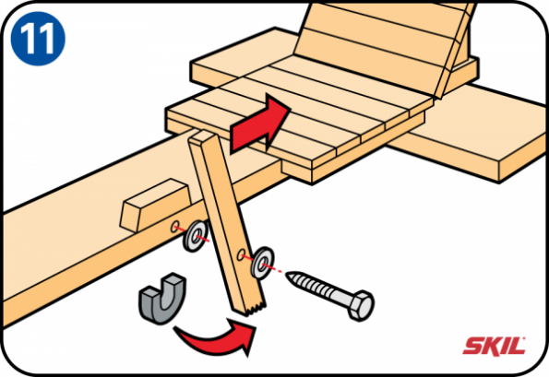
- figures:
Fig 1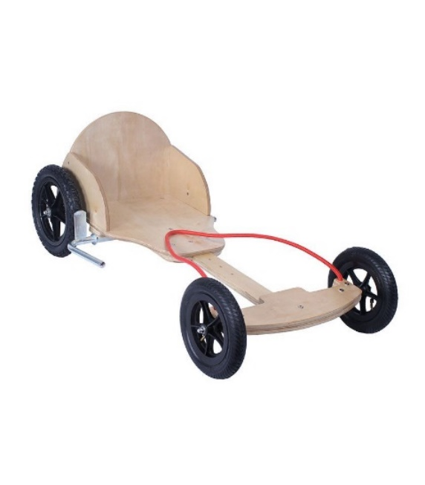

Fig 4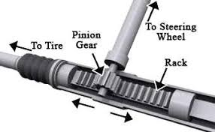
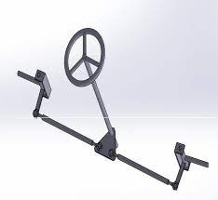
Fig 3

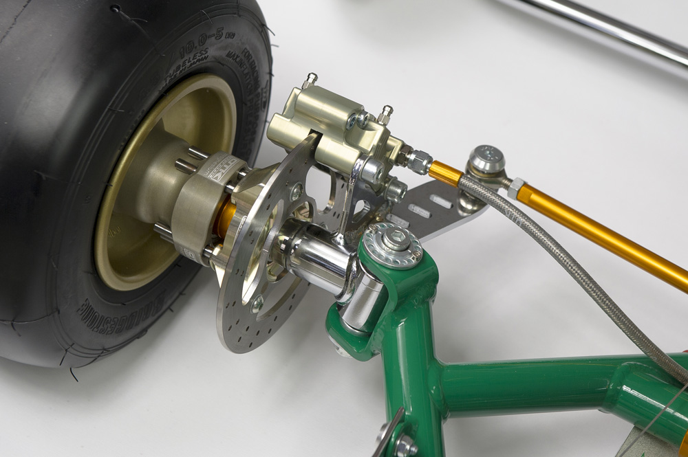
figure 6
Fig 5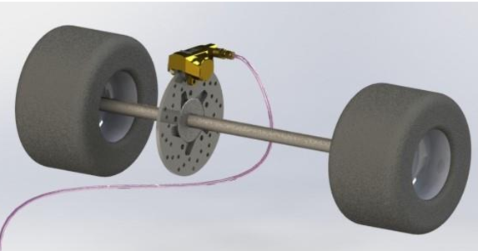

2. Introduction:
In this report, I will be looking into the different steering systems and braking systems of soapbox carts to draw a conclusion in which is the best to use for my cart as well as understand how the different dynamics of each system and how this will affect the drivability and rigidity of the cart on the track. I will also be covering aerodynamics and the different aerodynamic features we can add to the cart. As this is part of the drawings and design aspect of the project, my teammate Ross Burnside and I have worked together on the final cart design for the aero design

My team had agreed to design three different carts all designed from a low-budget cart, a moderate budget cart, and an expensive cart. Therefore, I will be basing my research on each system of this and will have the different systems in different price ranges for each design

3. Methodology: How you are going to undertake the analysis, what are each member of the team’s roles and aims by which methods, using which programs/tools, etc. You can also include the aims of the report here. Need to be lightweight, low cost, easy to control, adheres to the rules, and is safe

To undertake this project of designing a soapbox cart with my team, I will analyze three main types of steering systems and three different braking systems. To achieve a finalized design, I will be researching online sources to find the different possible systems appropriate for use in our cart, each different system will be broken down and I will explain how each one of the dynamics of the system works and how this directly affects the drivability of the cart. From this, I will be able to conclude which systems I think are best to use and why my team members think it’s best to use. For example, Sophie may decide that a braking system that I think is best to use is too expensive then we can compromise on a different system with similar attributes but cheaper, furthermore ross may think a slightly different braking system is better for the design

To further assist the finalized drivability design, I will also be incorporating my team members’ research and reasoning to add to what our final cart will be using. This will be executed by each of the team members communicating their research between their projects towards each other to form the cart.

For the aero that we will be using Ross Burnside has designed 3 models of cars in three different price ranges all with different aero kits on them. To show how each kit affects the drivability I will analyze the different parts of each kit and explain their features and differences

4. Steering

The three main different types of steering I will be using are:

4.1. Rotating axle rope steering

This system is a very simple design and works by having an axle that rotates on a beam of wood extended from the front of the frame, each wheel rotates freely but is otherwise fixed to the axle meaning that the two front wheels are always in parallel, this can be seen in figure 1. Ropes are attached just inward from each wheel and are fed through the body of the cart to the driver. This type of setup allows for a sharper turning circle on the cart, it is also a lot easier to turn as you just have to push and pull on the ropes as opposed to turning a wheel and worrying about overlapping hands. However, the improved appropriate driveability and ease of operation for this vehicle are combatted by the fact the ropes are flimsy and when turning may cause you to become less firmly seated in the cart affecting your ability to control the cart as well.

Following on from this because the ropes are less sturdy than a traditional system there is a risk of accidentally dropping one of the ropes when piloting the cart. This is of course detrimental as you will lose control of the cart. Furthermore, with the whole of the front-end weight of the cart being on the front axle attached to a singular beam of wood, there will be a lot of flex and play in the frame, this will make the cart feel unstable and unbalanced especially in corners forcing the driver to go slower

4.2. triangular hub steering system

this is the most commonly used system seen in carts today this is because of its simple set up allowing it to be adjusted or replaced easily and also because it is a very sensitive setup and will react to acute movements ideal for carts that need to be agile, this is perfect for the cart because the course has several corners, and the cart will need to have the ability to re-correct itself after a jump or sharp corner. An example of this system is shown in the figure table, figure 3.

The steering column is free to rotate but also fixed at the bottom and behind the steering wheel in triangular-shaped support. Because of this strong design, the cart will have a lot of rigidity and will feel very firm and stable, this will allow for faster corners as the vehicle will be firmer to the ground preventing roll. The driver is also able to position his body weight greatly according to the oncoming course because the cart is stable enough it will not sweigh or pull to the side

From a drivability standpoint, there is only really one downside to this setup and that would be the space, having the steering wheel and column having to be supported firmly in the frame this greatly reduces the movement space inside the cart, this may slightly hinder the driver’s ability to turn as well but also n positioning their body appropriately. Further, there is slight play in this steering system as it is not the most secure setup causing a slight delight
in the time it takes for the cart to turn.

4.3. Car part system (rack and pinion steering rack)

Lastly, the final steering system is based on parts used in cars today. Ross Burnside my team member has put together a simplified version, in figure 4 is a very similar design. This is key for how the cart will handle. Firstly, the wheel will turn in a linear motion to the steering wheel allowing for very sharp turns to be made. This also means from the time it takes the driver to react to the cart turning will decrease, adding to this because of the firm design there is no play in this system, this greatly improves the handling of the cart. Another obvious reason for wanting to use this system is the fact that it has been tripled and proven to be very reliable and resilient meaning if the cart was to hit the wheel or axle or even land on the wheel in an ununiformed position it will not damage the steering nearly as easily.

There are very few drawbacks to this system however a couple of aspects of this design do leave it flawed. Firstly, the size is much larger than other systems using bulker parts. This restricts space in the cabin for the driver limiting their disability by restricting their movement to steer and brake

4.4. Conclusion
In conclusion. discussion between the team and my input on the effect on drivability on the cart we agreed that the first pivot axle steering design was too flimsy and impractical to use for a downhill racetrack where there could potentially be lots of sharp movements and bumps causing loss of control of the cart. The car part system from a drivability standpoint I thought personally would be the best option to use however my team members raised concerns over the cost of the system and the manufacturing that was required for the system. Subsequently, we were left with the triangular hub design for the steering which the whole team agreed on using, again from a driveability standpoint this is still a very good system to use, and the advantages of the car part systems are not worth the drawbacks to other aspects of the build.

5. Braking

The three main different types of breaking I will be using are:

5.1. Friction leaver system

This system is a relatively simple design and involves a lever like a hand brake that pivots on the frame of the cart, one end of the leaver under the cart encounters the ground causing friction, an example of this system can be seen in figure 2. because of its few moving parts it is easy to use and is easily accessible being attached to a rotational bar axle this allows for an improvement in drivability as It will reduce the time it takes for the pilot to activate the brakes as they are much closer to him in between the legs there for slowing the cart sooner. As well as this having the brake mounted as a pedal in the middle of the footwell means that the driver can use one foot for stability and one for the break while keeping hands free for steering, as a result of this it gives the driver more stability in the seated position improving the drivability by allowing the driver to turn with more ease as they can position their body weight according to the approaching corner. Furthermore, because the steering and braking system are so close together it is easy for the driver to return the second hand to the wheel almost instantly improving the cart by adding more agility.

Another aspect affecting the drivability of the care would be where the contact patch of the bake leaver hit the track, and this is because of the downward force applied there is an equal opposite reaction pushing the cart up of the track. This is a downside to this system as a loss in directional friction from the brake occurs and directional friction is increased on the brake pad, Coincidently the wheels have the potential of losing grip causing the cart to slip and potentially spin out. To help combat this as much as possible the pad comes into contact with the ground directly under the driver, not only is this the point of most weight of the car but it allows the driver to have a much better fee of the feedback of the brake and the effect it’s having on the stability and balance of the cart giving a maximin improvement for drivability with this system.

The biggest drawbacks to this system would be that this system relies on friction to have braking force however this means in rough and bumpy areas of the track the contact pad will not always be touching the track. This combined with little force having to be put on the braking system to stop the cart from lifting greatly adds to the braking distance Obviously, this affects drivability in a big way as the driver now must try to brake as soon as possible for oncoming obstacles. As the track is short it has a lot of bends and jumps so this will require a lot of attention from the driver. Secondly, you must operate it using your hands meaning that you can only one of your hands for the steering reducing the drivability by reducing the agility

5.2. Pushbike brake leaver and front axle-mounted bike brake disc

For our mid-ranged priced braking system, we will be using a braking system from a pushbike. This presents us with already a lot more advantages for drivability. Firstly, the system is mounted on the steering wheel itself. not only is this a great sleek design it means that there takes no time from brake to steering wheel and wheel to break this allows for much more accurate and precise braking. Not only this the driver can also break while turning with both hands. This combined with the bike leaver and caliper allows for acute modular breaking minimizing over or under breaking improving overall speed and driveability.

Another advantage to this system is that it is a disc brake this caliper design is shown in figure 5. which allows for an extreme amount of pressure to be placed onto the brake pads. As a result of this, the driver can assert a sharper breaking force allowing a much shorter stopping distance, as a result, the driver can brake later into a corner improving the overall drivability and speed. Disc brakes are reliable not only for their simplest up but also for their performance in wet conditions being almost the same, this is important as the course may contain water obstacles and it could also be raining on the day of the event this maintains the consistency of the driving allowing for a better run down the track

5.3. Pushbike brake leaver and brake disc to each front wheel

This system works in a very similar way to the previous system which has naturally and dynamically developed into a duel-braking system in that the braking lever is mounted to the steering wheel which follows a cable splitting into the two calipers on each of the wheels an example of one of he wheels can be seen as figure 6. This system is more expensive as it requires two brake cables, two calipers, and two brake discs. However, because this system has implemented a double caliper design it means that the braking force is greatly improved. Because of this, the modular breaking is easier to control as you must use less pressure to break the same amount, this allows for easy breaking affecting drivability by allowing the driver to focus more on other aspects of the event in progress. The dual caliper system is more reliable, although it does have more parts to break if one of the parts does break then there is a backup there in case of such an event.

The main downside to this system is that it requires two brake cables which are wrapped around the steering column. This presents a few problems. Firstly, having double the cables means your hand could get caught more easily. Dropping the drivability of the cart for the driver. Not only this but the brake cables will have a resistance on the steering wheel which increases as you turn to one side causing an illusion of the cart pulling to one side for the driver. If a cable is to snag on anything like the steering column or the driver’s knee, hand it may cause the brakes to come on briefly as the cables tighten hover the risk of this is low but would dramatically affect the drivability if it was to happen in the race.

Analysis: This is where you look at the graphs/numbers and report back on findings

5.4. Conclusion

As a team, we discussed the different braking systems and what impact they would have on the cost, materials needed, and drivability of the cart. In my conclusion, the cheaper methods of the hand brake system are great in their simplicity, however, are lacking in many other fields. For example, this system has very little modular breaking meaning you can’t adjust the braking force easily leading to more judgment having to be made by the driver causing distractions as a knock-on effect. Overall, it was thought the effect this system would have on the cart would lower the level of driveability too much to be a suitable option for my team to use.

Moving onto our next option of the braking system, the moderately priced pushbike brake leaver. In my opinion, this system is dramatically improving the dynamics of the braking aspects compared to the cheaper system, this is shown in all of the advantages to this system but the main characteristics that made it improve the drivability and set it apart for me was the mounting location being on the steering wheel and also the ability to control the braking force to both the rear wheels with ease and also in a short amount of time consistently and reliably substantially improving driveability. Overall, there is little bad about this system other than the fact it is slightly more expensive leaving it as a high possibility to be used

Finally, we are left with the most expensive braking system being, the dual caliper pushbike brake system. This system provides the best performance for what we need. A perfect example of this would be the stopping power, stopping distance, and more sensitive breaking. Because this system also shares the force required to stop this is also an advantage as the disc brake designed for a bike has the potential of getting very hot and in doing so losing stopping power however, the disadvantages to this system are critical if they happen in the race if the cart were to accidentally break or the driver loses grip of the wheel it causes a large time loss in the race

For the overall braking system design the team and I agreed on using the moderately priced system this seem to make the most sense as it offered the most performance and was the simplest design and it was thought that the dual brake set up had an unnecessary amount of components and the performance gained was not essential

6. Aerodynamics
There are three different aerodynamic systems that we will potentially be using. Each of the different aero kits is designed differently in three different price ranges, this means that each kit will be made from different materials, and will each have different aerodynamic features all of which will affect the drivability of the car. Each will also improve from the last when going up in price Ross Burnside and I will expand on the dynamics progressing in the kits.

6.1. Curved nose design

For our first budget build, we decided that to improve the drivability and speed of the cart a complex aero system would be insignificant to other changes. Because of this as a team, we discussed that at least the main shape of the body should be made as aerodynamic as possible as this is where the most air displacement will occur. To combat this, it was decided that a curved front was decided to guide the displaced air away from the cart from a performance standpoint, as well as it isn’t easy to manufacture as the cart was made from bendable plywood, allowing the cart to move through the air with less resistance increasing speed as a result, this effect increases expediently as speed is increased increasing its improved effect and drivability.

6.2. Aero kit system

For our moderately priced cart, we decided to give a lot more attention to the aero we could achieve on the cart and how it would improve the speed and driveability. Firstly, the biggest noticeable aero design added to the cart would have to be the vertical rear fin. The rear fin twined by the rounded front of the cart allows the displaced air around the vehicle to be re-used at the rear of the vehicle where it can help eliminate a pressure differential created by the drag of the car causing turbulence behind it as it’s in motion. This effect will make the cart glide a lot more seamlessly in straight lines, but it also adds a lot of stability in the corners as the pressure differential at the rear of the vehicle will have less of an effect on the back end of the cart, this improved drivability greatly as you can achieve greater corner speeds be firmer on the track overall.

Another focus point for the aero system would be the wheels and axles and they are the next major aspects affecting the drag from aero on the cart. To achieve this Ross burnside designed a slim wheel with domed covers on each side, this allowed for a uniform disc shape for each of these wheels, this reduced the high pressure that would usually form with thicker wheels. The dome design also prevents air from getting trapped in the dead space of the wheel where the spokes are this prevents any wheel wash air from causing drag. The axle has also been equipped with added aero features. At the front, it has a dome-shaped splitter to cut through the air and direct it to the back of the axle rear wing again reducing the amount of low-pressure air causing turbulence this has a knock-on effect on the rear axle that is fitted with the same features. All the aero features mentioned will greatly improve the cart, especially at high speeds as there is no added aero for downforce as this would cause air resistance. This greatly improves the cart because not only does it help with corning but the top speed and acceleration to this makes the cart feel a lot more race like from a driving perspective

6.3. Carbon fiber Body molding

For the final most expensive design a Carbon-fibre body design was decided on. this presented us the opportunity to completely re-model the cart’s body and its aerodynamics. Ground-effect air channelling was implemented on the sides of the cart this diverted air away from the turbulence of the rear wheels and through the side of the kart before being fed out the rear end, eliminating drag and build-up of low pressure. Vortex generators further help control the mixing of high- and low-pressure airflow off the top of the kart by redirecting air that would split into low pressure after coming off the top of the cart into vortex wind swirls eliminating drag behind the cart. With the design focus being to

A wing was placed at the front end of the cart again with a nose-shaped head of the car. This allowed for sufficient downforce on the front wheels during cornering however when reaching high speeds not create too much drag to slow the car down. This gives the driver the ability to make much sharper turns much faster. Wingtips were also added to the splitter mainly to focus on trying to split and move the air around the wheels again improving the aerodynamics. As a lot of the car’s aerodynamics on the top front and sides have been focused on however don force to the rear of the cart was needed as it was added to the front there was a risk of oversteering in corners, however, the problem was that a spoiler would create too much resistance so a rear diffuser was added. This improves downforce on the car as a whole but has a greater effect on the back of the vehicle. Because a lot of air flows under the cart it creates a high pressure so adding a rear diffuser helps the air to escape from under the cart creating a low pressure pulling the cart to the ground.

This has a massive effect on drivability as the cart would be very firm and planted to the track then in motion along for very fast corner speeds to be achieved.

6.4. Conclusion

The first cart design that was suggested did not involve many aerodynamic features incorporated into it. Because of this, it had little effect on the driveability there leaving it as an unideal option for using on our final design. However, the second design using all the aerodynamic features easily available hugely affects the cart’s drivability as the cart now had a sense of being more planted on the track and faster in corners making it an ideal system to use. Finally, the lase carbon design model, this body model was perfect for aerodynamics and in all its features contributing to reducing wind resistance and downforce this improved the drivability incredibly as it maximized the lateral grip of the cart allowing the speed that has been built up to be carried through the corners with little braking.

7. Final design
for the final design, a depth discussion between all the team members resulted in a decision to go with the moderately priced system for all the systems I presented. From a drivability standpoint, this was a very good option as the braking system is optimal for use as well as the braking systems as discussed in the conclusions to those systems. The carbon body for the aerodynamics would have provided the most performance however from other aspects of the build like cost and design it was decided that we would not use it.

8. Recommendations for further study
For further study and future projects my time management could have been improved as well as communication at the start of the project.

9) References
Figure1 | https://tr.pinterest.com/pin/506373551828084133/ | Published on Pinterest
Figure 2 | https://www.skil.lt/step-by-step/how-to-build-a-soapbox-cart.html | Published by Skil on their webste
Figure 3 | https://www.ijert.org/research/formulation-of-a-standardized-procedure-for-designing-the-steering-system-of-small-vehicles-like-go-karts-IJERTV5IS050329.pdf | International Journal of Engineering Research & Technology (IJERT)  05, May-2016
Figure 5 | https://www.semanticscholar.org/paper/Development-of-adjustable-systems-for-a-Go-Kart-Singh-Singh/0ed51fa7b0a859d09b84118dbde91dfca5b764d2#references | Published on semantic schlor  Published 30 April 2018
Figure 6 | http://www.formula1-dictionary.net/karting.html | Formula 1 Dictionary  No author or date present

Cost, Sophie Reed, 2000492

Design 1 (Wooden Kart)
To work out the cost of the kart I am going for find the cheapest price but ensure that the items are all new and can be collected in the local area. ​

- 2 x 3.6m 4x2 length – £17.64 at SELCO ​
- 2 x Plyboard sheets - £30 at B&Q​
- 4 x steel wheel barrow wheels - £31.48 at Key Stone Castors ​
- Half bucket seat - £155.26 at Sportseats4u​
- 4x 30mm stainless steel bolts – Pack of 10 £4.25 at B&Q​
- 200mm 1” steel tube (hollow) - £7.26 at Metals4u​
- 4x U-clamps (200mm) - £21.38 at B&Q​
- Box of 10mm wood screws

Design 2 (Metal Kart)
To work out the cost of the kart I am going for find the cheapest price but ensure that the items are all new and can be collected in the local area. ​

- 4500mm 3” box section (steel) - £26.25 at The Metal Store​
- 2500mm 1” tube (solid steel) - £8​
- 20mm 2” tube (cylinder steel) - £5.25​
- 8x 50.8mm sealed bearings – £52.48 at Bearing boys​
- 2x 2mm aluminium sheets (2000mm x 1000mm) – £220 at The Metal Store​
- 2mm steel sheet (50mm x 50mm) - £2 at The Metal store​
- 1” steel rod (200mm) - £18 at The Metal store​
- 2x fibreglass 2pac kit - £32.50 at MBFG​
- 1x hydraulic bicycle brake - £250 at Hopetech​
- 203mm brake rotor - £49.39 at Wiggle ​
- 4x domed/encased soapbox wheels - £29.99 at Bankrupt bike parts​
- Half bucket seat - £155.26 at Sportseats4u​
- Metric hardware box (stainless steel) - £19.99 at DMS racing​
- Steering wheel momo – 189.99 at GSM performance

Design 3 (Carbon Kart)
To work out the cost of the kart I am going for find the cheapest price but ensure that the items are all new and can be collected in the local area. ​
- 5000mm 2” tube (hollow, steel) - £30 at The Metal store​
- 4x mtb wheels - £170 at Hopetech​
- Carbon mould - £1500 at XM tech​
- 4x hydraulic mtb brakes - £1000 at Hopetech​
- 2x 180mm brake rotors - £57.98 at Wiggle​
- 1mm aluminium sheet (300mm x 300mm) - £6.88 at The Metal store​
- 1x quick steering rack - £65 at Minispares online​
- Sliding steering shaft - £31.89​
- Perspex sheet (200mm x 200mm) - £3.99​
- Metric hardware box (stainless steel) - £19.99 at DMS racing​
- Steering wheel momo – 189.99 at GSM performance

Cost comparison

- Kart 1 overall cost - £287.47​
- Kart 2 overall cost - £1059.10​
- Kart 3 overall cost – 3075.72​

Kart 1 is the cheapest option, this is due to wood being easier to source and cheaper to manufacture. Kart 3 was the most expensive, this is highly caused by the carbon mould that is needed to manufacture the kart. ​
​
We decided to go with Kart 2 because the framework will be stronger than wood. It isn’t the cheapest option however it will be faster and will be lighter than wood.

Conclusion and Reflections

Team BBB are fortunate to have our own personal ties within motorsport and each feel like that was a key factor in our research and overall design. One thing that has been prominent throughout our work is all team members in unanimous agreement that part of what makes racing enjoyable is doing what you can and being as innovative as possible with what you have.

Despite the carbon build being the most expensive and with purpose built aerodynamic advantages, compared to the competition we would be facing at the track as a team, we felt it was overkill and left everyone else at a disadvantage too great to overcome.

Even though the second soapbox design, still being five times as much as the wooden one, is an expensive opportunity in retrospect we felt it would be the best suited to the task at hand. With a sleek aerodynamic design and light-weight (but effective) steering/braking systems it was seen as the most competitive for a lower cost and build time.

Throughout our report one of the most common factors has been the cost and timeframe we were given. All team members agreed they were happy with the outcome of their research and how it developed our racer. Despite facing the challenges of creating a dynamic chassis with low weight, whilst still featuring an aerodynamic body shell easy to manufacture/safe for our driver, we felt we had achieved our goal to the team’s potential.

With our final soapbox design, we feel we have ticked all boxes and can confidently say we have created a competitive kart for a competitive price and each discovered something new in our fields we have applied to our research and build design.

—BBB—

Team Minutes

—BBB—

Members present for each meeting:

RB: Ross Burnside
OS: Olly Spears
MB: Morgan Browne
SR: Sophie Reed

First meeting: 04/10/2021, 1300

MB: Suggested role delegation playing to team member’s strengths and talents.

OS: Research in vehicle dynamics and drivability.

SR: Research in soapbox/materials pricing/availability.

RB: Design development/drawings.

RB: Create Gantt chart with planned achievable goals.

OS: Suggested sharing of remaining tasks.

ALL: Agreed.

Second Meeting: 06/10/2021, 1500

OS: Suggested sharing of ideas/findings.

SR: Shown materials available at fair price.

RB: Suggested three soapbox variations with different budget levels

MB: Suggested: Wood, Metal, Carbon Fibre.

OS: Suggested different systems for each kart (braking/steering/general dynamics)

ALL: Agreed.

Third Meeting, 11/10/2021, 1400

ALL: Share ideas from findings/initial individual research.

RB: Present initial soapbox design/ideas.

SR//MB: Present opportunities with each material, discuss manufacturing alongside timeframe/budget.

OS: Discuss initial dynamic systems with RB and develop ideas from personal research.

RB: Discuss system strengths/weights with OS and decide in agreement which system for which soapbox present.

ALL: Discuss initial cost queries.

SR: Develop cost ideas/different options from different manufacturers.

MB: Explore manufacturing possibilities within the materials present.

ALL: Leave meeting with new information/ideas in which to develop individual research in set fields.

Fourth Meeting: 25/10/2021, 1100

ALL: Discuss findings.

RB: Present semi-final soapbox designs with team members and explore any ideas/suggestions presented.

OS: Decide on three different steering/braking systems with valid reasoning behind each, including advantages and disadvantages. and explore any ideas/suggestions presented.

MB: Present material information/findings (tensile strengths, malleability, concerns) and explore any ideas/suggestions presented.

SR: Present material information/findings (initial cost, shipping difficulties/availability, concerns) and explore any ideas/suggestions presented.

ALL: Discuss findings/following steps for final build.

Fifth Meeting: 01/01/22, 0900

ALL: Discuss findings.

RB: Present final soapbox design idea with developed points from OS’s findings and dynamic development. Explain reasoning why and how.

MB: Discuss material findings, adaptations of original design criteria, developments of materials used in the individual build, decide final material plan.

SR: Present cost sheet for each idea, take information down of each design innovation and create final cost list/comparison.

OS: Present final/updated system designs and provide knowledge on engineering behind each. Discuss best options moving forward with the project and explain reasoning.

ALL: Agree on end game/final result aims.

Sixth Meeting: 09/01/22, 1600

ALL: Consider developments.

RB: Present final design ideas, ensure team are comfortable and in agreement.

OS: Present final braking system/steering set up, ensure team are comfortable and in agreement.

SR: Present final cost breakdown, ensure team are happy the relevant information has been gathered.

MB: Present material findings/report with given advantages for the build we will be pursuing, ensure team are happy and in agreement.

ALL: Ensure unanimous agreement in project’s final direction. Agree on end goal and research conclusion.

Seventh Meeting: 24/01/22, 1200

ALL: Present final findings and designs.

RB: Structure written report with given spaces for each individual’s research.

OS: Write introduction/conclusion.

RB: Write introduction/conclusion.

OS: Create title/covering page ensuring assessment criteria is met.

MB: Add research into final report.

SR: Add research into final report.

ALL: Ensure report objectives have been met and work load is sufficient for current educational level.

