````````````````````````````````````````````````````````````````````````````````````````````````````````````

Module: Changemakers: Creativity and Value Creation

Module code: BMHP5014_BIRM

Assignment Title: E-Portfolio evidence of learning comprising of 2 separate artefact items

Lecturer: Chloe Harries

Student ID number: 2017032

Student name: Susan Ajmad

Contents
What is Cancer? 3
Causes 4
Treatments in Cancer 4
References: 4
Breast cancer 7
REFERANCING 7

Introduction
I have chosen task 1 (Mind map) and my subject is cancer. My second task is task 5 (Poster) regarding breast cancer.

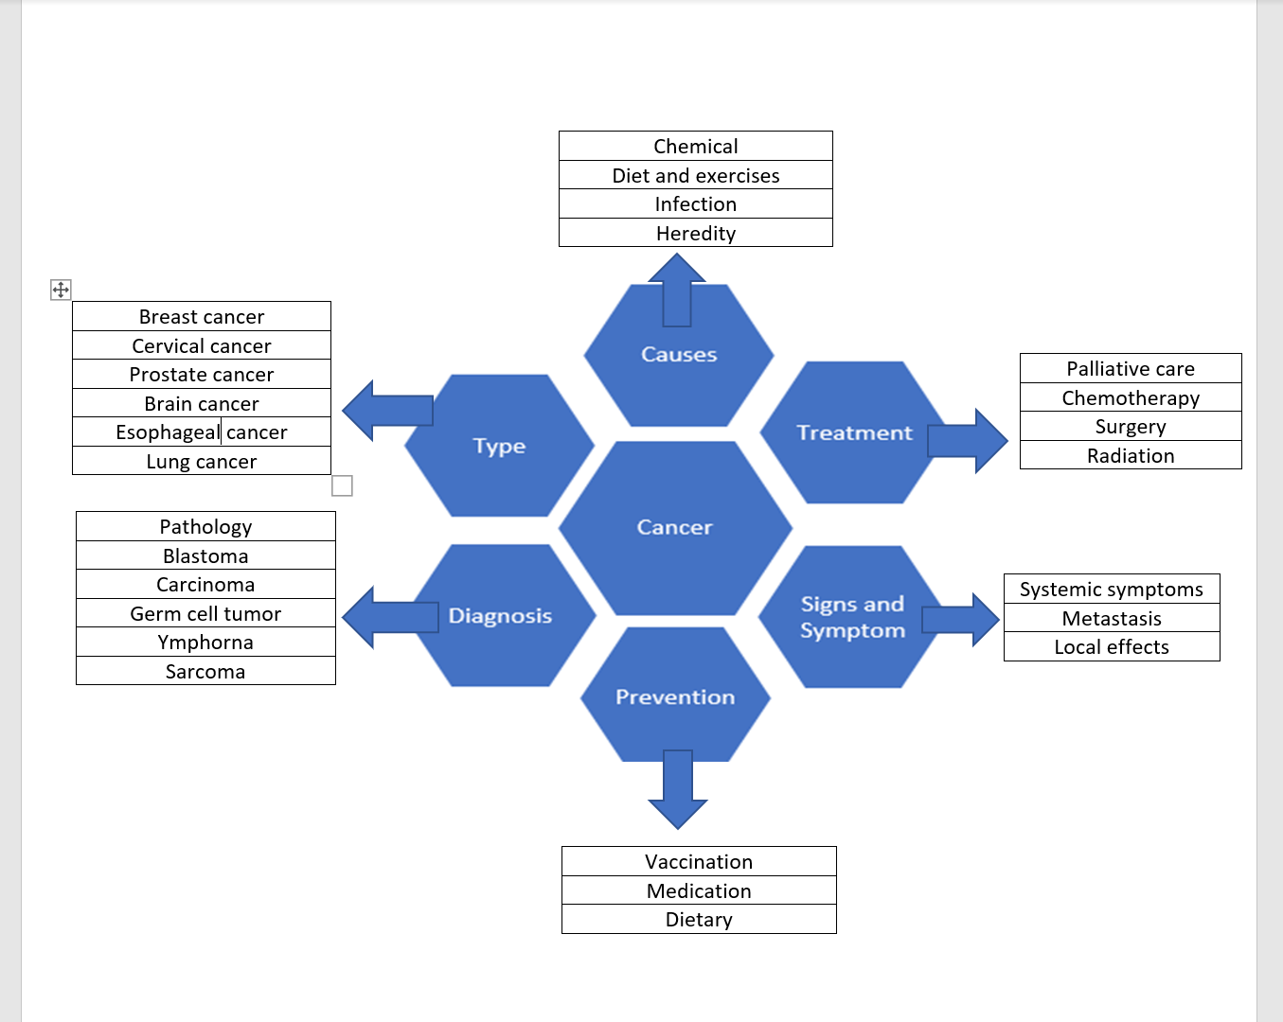

What is Cancer?
The condition where cells in a specific part of the body reproduce and grow without control is called cancer. These cells can infect and invade the healthy tissue surrounding it including organs. Cancer can start in one part of the body and over time spread into other areas this is known as metastasis. (NHS, 2019) With the evidence we have now it implies that many human cancers do not happen by conventional mutagens ( Cairns, 1981).
In the UK 1 in 2 people will develop some form of cancer. There are over 200 forms of cancer and each of them are treated and diagnosed in a specific way. The top four common types of cancer are breast cancer, lung cancer, prostate cancer, and bowel cancer (NHS, 2019).
Changes to your body's normal processes or unusual, unexplained symptoms can sometimes be an early sign of cancer. There are many symptoms of cancer. Every type of cancer has some sort of different symptoms however to speak about them in general the three main symptoms are systemic symptoms, metastasis, and local effects.

Causes
Cancer is originated by mutations to the DNA in the cells. The DNA in the cell is kept in a big number of single genes, each have a set of orders telling the cell what its job is to work, as well as how to spread and divide. Mistakes in the orders can make the cell stop its regular function and might let a cell to become cancerous (Mayo Clinic Staff, 2021)

As there are more studies about which pathways are encouraged by genetic and molecular changed that copy and encourage its cancer progression, targeted therapies are being improved to show these performances. Furthermore plans are particularly looked at interrupting the final (late) stage, but still pre-malignant, processes that end up to SITU cancers, with the target of adverting progression to real invasive cancer (Umar, A. ,K. B and Greenwald, P, 2012).

Treatments in Cancer

The earlier the cancer is spotted the sooner and easier it will be to treat as it hasn’t fully spread nor divided throughout the body. In spite of big advances, the step currently to face cancer treatment is still reductionist. Going for individual molecular abnormalities or cancer paths has gotten great clinical feedback that have affected survival in a couple cancers. Although, going for an individual hallmark or path with a single drug (magic bullet) will probably most likely not lead to a cure for cancer however a treatment. Many think a combination against many molecular alterations or cancer hallmarks, in a way that is close to what we currently have at the moment (Clinical Therapeutics, 2016).

References:

Cairns, J. (1981)The origin of human cancers.
Available at: The origin of human cancers | Nature
(Accessed 16 February 2022).

Clinical Therapeutics, (2016) Current Challenges in Cancer Treatment.
Available at: Current Challenges in Cancer Treatment - ScienceDirect
(Accessed 20 February 2022)

NHS (2019) Signs and symptoms.
Available at: https://www.nhs.uk/conditions/cancer/https://www.nhs.uk/conditions/cancer/
(Accessed 20 February 2022)
Mayo Clinic Staff, (2021) Symptoms.
Available at: Cancer - Symptoms and causes - Mayo Clinic
(Accessed 20 February 2022).

Umar, A. ,K. B and Greenwald, P (2012). Future directions in cancer prevention
Available at: Future directions in cancer prevention | Nature Reviews Cancer
(Accessed 20 February 2022).
Visone, R and Croce, P.(2009) MiRNAs and Cancer
Available at: https://www.sciencedirect.com/science/article/pii/S0002944010609728#
(Accessed 20 February 2022).

Breast Cancer

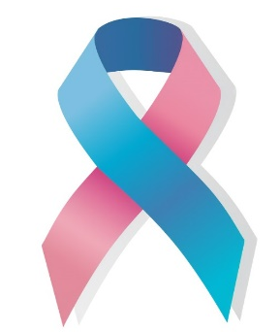
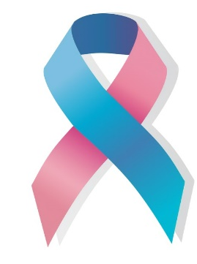
Breast cancer in one of the most common cancer deaths amongst women around the world. This can change depending on place however it is becoming more common many of these risks are established to oestrogen. There is a higher chance of risks by early menarche, late menopause, and obesity in postmenopausal women and prospective studies have reported that the higher concentrations of endogenous oestradiol are linked with a higher chance.

What is breast cancer?

breast cancer symptoms
- Bloody discharge
- Swelling of all or part of breast
- Pain of breast
- The growth of the veins
- Nipple changes inversion
- Dimpled or depressed skin
- A lump in the breast
- Redness hot skin swelling
- The destruction of the skin
- Size difference proportions

Breast cancer is the most common cancer in the UK. Survival for breast cancer is generally good, particularly if you are diagnosed early.

Reduce the risk of breast cancer

- Keeping a healthy weight

- Exercising regularly

- Getting enough sleep

- Limiting alcohol intake

- Breastfeeding your babies




Seeing a GP
Tests at a breast cancer clinic
Mammogram and breast ultrasound
Biopsy
Needle aspiration
Needle biopsy
Vacuum-assisted biopsy


Diagnosed

Causes


Men’s breast Cancer
Age
Family history
Previous breast cancer or lump
Dense breast tissue
Hormones and hormone medicine
Hormone replacement therapy (HRT)
Contraceptive pill
Lifestyle factors
Radiation

1 out of 100 breast cancer cases are in men.
350 men diagnosed with it yearly in the UK.
There are differences between breast cancer in men and women

Breast cancer
Breast cancer is a disease in which cells in the breast grow out of control. There are different kinds of breast cancer. There different type of breast cancer symptoms some do not have any symptoms at all. Some of the common breast cancer symptoms are feeling a lump in the breast area or armpit. Another symptom is nipple discharge other than breast milk, including blood. There are many treatments for breast cancer one of the biggest treatments is have surgery to cut out the tissue. Chemotherapy to kill the cancer cells. Radiation therapy which is by using high-energy which is similar to x-rays This is to kill cancer cells as well. All these treatments depends on the person and doctors. Sometimes getting surgery means you probably won’t need chemotherapy or radiation therapy It depends on how well the surgery goes and what was done during the surgery. Having breast cancer symptoms or worrying about a lump calling your GP straight away is the best option or there are breast screening services around where you may live. Here is a website where you can check places that may available for a breast screening services just type in your postcode or town and it will show up.
There new cases of breast cancer each year between 2016 - 2018 around 55,920 of women was diagnosed with breast cancer and around 11,547 deaths was confirmed.
The chances of breast cancer Survival are 90% which means 90 out of 100 women are alive after 5 years they’ve been Diagnosed with breast cancer. survival of breast cancer all depends on the person and the treatments they get.
Breast cancer is the most common cancer in the UK. Survival for breast cancer is generally good, particularly if you are diagnosed early. However, men can also get breast cancer.

REFERANCING

- Breast cancer now, (2021) What are the symptoms of breast cancer?
Available at: Breast cancer symptoms | Breast Cancer Now
(Accessed 05 March 2022).
- Cancer Research UK. Breast cancer in men.
Available at: Breast cancer in men | Cancer Research UK
(Accessed 06 March 2022).

- Daly, A, A, el al (2021) A Review of Modifiable Risk Factors in Young Women for the Prevention of Breast Cancer.
Avalables at :https://www.ncbi.nlm.nih.gov/pmc/articles/PMC8053601/
(Accessed 06 March 2022).

- Key, J,T (2021) Epidemiology of breast cancer.
Available at: Epidemiology of breast cancer - ScienceDirect
(Accessed 03 March 2022).

- Kotepui , M (2016) Diet and risk of breast cancer.
Available at: Diet and risk of breast cancer (nih.gov)
(Accessed 03 March 2022).

- NHS, (2019) Breast cancer in women
Available at: Breast cancer in women - NHS (www.nhs.uk)
Accessed 03 March 2022).

- NHS, (2017) Diagnosis-Breast cancer in women,
Available at: https://www.nhs.uk/conditions/breast-cancer/diagnosis/
(Accessed 06 March 2022).

- Wang, L (2017)Early Diagnosis of Breast Cancer.
Available at : https://www.mdpi.com/1424-8220/17/7/1572/htm
(Accessed 06 March 2022).

