Title of assignment

Name - Courtney Morgan

CIPD Membership Number - 5343295X

Date – Tuesday 8th January 2019

Word Count: 4,241

I declare that this assignment is my own work and that any information obtained from books and other sources have been appropriately referenced.

Signed : Courtney Morgan Date 8/1/19

Business Issues and the Contexts of Human Resources

“The Evolving Role of HR in the contemporary business World”

Written by Courtney Morgan

Contents Page

- Introduction……………………………………………………………………………………………………………Page 4
- Key Forces Shaping the HR agenda………………………………………………………………………...Page 5
- HR Roles ………………………………………………………………………………………………………………..Page 6
- Strategic HRM ……………………………………………………………………………………………..………. Page 7
- What is Strategy?.………………………………………………………………………………………….….…. Page 8
- So, what is HR Strategy?.………………………………………………………………………………….……Page 10
- Change Management ……………………………………………………………………………………………Page 12
- Business Ethics ……………………………………………………………………………………………………..Page 13
- Tools for analysing the business environment ………………………………………………………Page 15
- Factors which impact on a organisations business and its HR Function ……………..…Page 17
- Business Performance ………………………………………………………………………………………….Page 19
- The use of business and contextual data …………………………………………………..……….. Page 21
- Conclusion ……………………………………………………………………………………………………………Page 22
- References……………………………………………………………………………………………………………Page 23

- - Introduction
Over the years the HR functioning within businesses has evolved, there has been research over the last 20 years showing that the HR function in organisations have undertaken some sort of HR transformation. The Purpose of the HR function is to be there to support the organisations strategy and objectives through the management of people and their performance. The organisations strategy and endeavours should all be linked with the business’s strategy and objectives (Wilkinson and Taylor, 2016).

The role of human resource management has seen a shift from personnel to human resource management in its evolvement for some time. The growth of the HR was to show the value of its employees and to try and resolve some of the talk around personnel departments being associated with being slow and bureaucratic. This was also for HR to become a strategic partner of the panel within organisations and have a seat at the table to be part of the business decisions, advice in critical situations and to develop the value of its employees.

HR is forever evolving, and will continue to evolve in this contemporary business world. This paper will cover and understand the key contemporary business issues and main external factors affecting different organisations and the impact this has on the HR function. This paper will also understand how organisational and HR strategies and practices are shapes and developed and know how to identify and respond to any changes within the business environment.

- Key Forces Shaping the Agenda

There are many contributors as to why the forces shaping human resource management at work has changed through the years which has influenced the shift from personnel to Strategic HRM. These forces come from an array of factors such as external factors as cited in Kew and Stredwick (2016). Please see below table 2.1 demonstrating these :

Table 2.1- Forces Shaping the HR Agenda
Force: | Examples:
Social | How demographics influences the need for change in HR
Technological | how technology advances and provide new advances for working
Economic | - how the economy effects both the internal and external labour market and how HR needs to adapt to these
Environmental | how any environmental issues helps to support the HR role which could lead into areas for example engagement with the community and secondment.
Political | how any political developments have influenced the need for change for example BREXIT and migratory pattern
Legal | HR needs to align with any legal requirements or legal updates for example policies and procedures associated with employment law.
Ecological | For the HR teams to be socially responsible and control in areas such as ethical behaviour within the organisation

Kew and Stredwick (2016)

- - HR Roles

Dave Ulrich developed the “Dave Ulrich Model Of HR Roles” which organises the HR roles with in businesses. Ulrich underlines a clear pathway to the next generation of HR and its evolvement and underpins an approach to the delivery of HR services that adjoins the needs of both its employees and employers and also how these HR positions contribute to the success of the business Ulrich (1997).
Diagram 1.0 below illustrates the Model of HR Roles by Ulrich.

Diagram 1.0 – Dave Ulrich Model of HR Roles
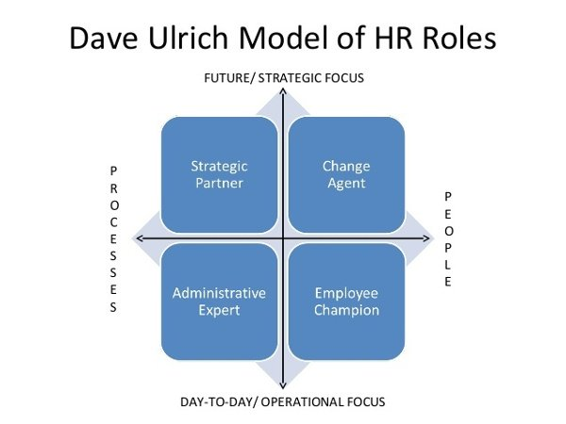

Mettl Blog (2018)

Strategic HRM

With the shift in HR moving from personnel to HRM to SHRM. Storey (1992) as cited on Guardian Initiative (2018) stated that HR has 2 approaches, Hard and Soft HRM. Soft HRM is seen as more people focused and needs a high level of commitment. This is where employees are seen as having high values in the business and have competitive advantage. These employees are treated as individuals and their needs are assessed individually and have employee empowerment. Hard HRM is seen are task-focused and is low commitment. This is where employees are seen to be only resources of the business just like its assets such as machinery. This is also seen as a instrumental way of managing its employees. The Harvard Model was created by Beer et al. (1984) and was designed to inform management of ways to improve on the management of people. The model centres its attention on the out comes of people and their commitment to the organisation, Diagram 1.1 below demonstrates The Havard Model:
Diagram 1.1 - The Havard Model
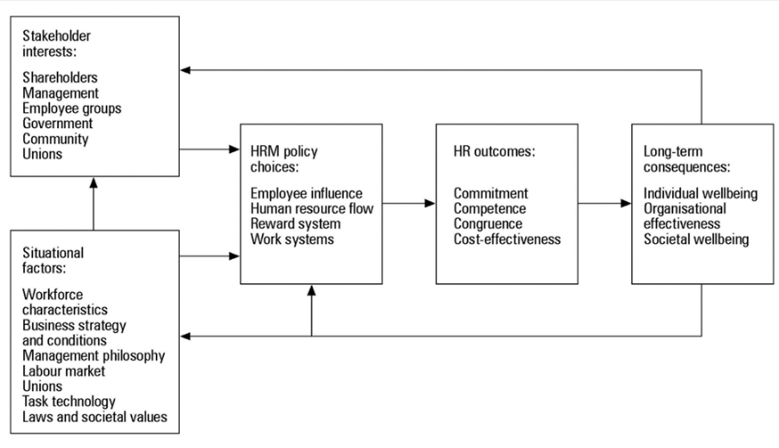

Boselie (2014)
4.0 – Strategic HRM
Strategic HRM as stated by Boselie (2014) can be seen as a key to success in the organisational change for a business. For example this could be seen by recruiting talent, employee development and also the change of culture within the organisation. Strategic HRM focuses on the joining of HRM to the business strategy by adding value to the organisation in an attempt to gain competitor advantage.
Dave Ulrich also created the ‘Three Legged Stool’ Model which underpins strategic HRM and its function which is also seen as best practice. See below model image in Diagram 2.0

Diagram 2.0- Ulrich “Three Legged Stool” Model.
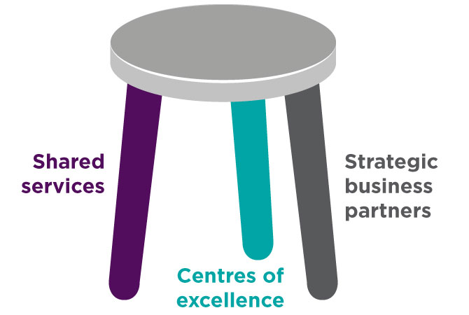

(CIPD 2018)

This model divides the HR function into 3 parts in the areas of its expertise:

- “Shared services – usually a centralised entity that handles the routine ‘transactional’ services across the business such as recruitment administration, payroll, absence monitoring, HR template generation and advice on simpler employee relations.
- Centres of excellence – usually small teams of HR experts with specialist knowledge. Centres of excellence deliver business and people benefits through HR innovations in areas such as reward, learning, recruitment, employee engagement, and talent management.
- Strategic business partners– senior HR professionals who work closely with business leaders or line managers, usually embedded in the business unit, influencing, steering and implementing the strategy.”
CIPD (2018) Accessed: 3.1.18

5.0- What is Strategy?

De Wit and Meyer (1998) define strategy as an organisations desired intention to archive different goals through planned arrangement with the organisations and its environment. This is where the organisation has a strategic plan to implement these changes/goals for their current and any future endeavours. The word goal in this definition is also important as it is the organisations aim to be successful and the achievement of these goals can be defined as aiming for higher sales or satisfying stakeholder value for example organisational goals or individual employee goals.

As cited in Marchinton and Wilkinson (2006) , Quinn(1988) suggested that there are four dimensions to formal strategy below in table 5.1:

Table 5.1 – Four Dimensions to Formal Strategy
- Information, policies and procedures to guide by an action to those to be accomplished
- Effective strategy to develop around key concepts
- The management to deal with unplanned events which they may face
- A supportive hierarchy of mutually supporting strategies

There are also different approaches in which strategy can be formulated as seen in Table 5.2:
Table 5.2 – Approaches to Strategy
Approach: | Description:
Rational/Classical | using a use of tools such as the SWOT – and using the outcome information to create objectives.
Emergent/logical incrementalism | strategy influenced by external factors
Symbolic/radical | is the trying of things before formulation of a strategy

As cited in Boxhall.P and Purcell. J (2011), Henry Mintzberg (1994) has debated that it is not wise to consider strategy without a strategic plan in place. This Strategic plan is a document that outlines the organisation’s goals and initiatives over a period of time. Mintzberg (1994) came up with a contingency model which underpins the circumstances when the types of strategy formulation are appropriate. These can be varies in different organisations and also can be complex with its environment and rate of change within the environment. “Henry Mintzberg suggests that the traditional way of thinking about strategy implementation focuses only on deliberate strategies. Minztberg claims that some organizations begin implementing strategies before they clearly articulate mission, goals, or objectives. In this case strategy implementation actually precedes strategy formulation” Strategic Management: Formulation and Implementation (2018).

Higgins and Vincze (1993) created the five-stage model of strategic management for determining objectives and formulating strategy which are linked closely with HR’s role. By HR playing an important part in each of the following parts below this gives HR a chair at the table and also are well knowledgeable of the organisation’s strategy. This also gives HR an insight into any external/internal factors which would affect its strategy and also the organisations strengths, weaknesses, opportunities and threats. For example, please see table 5.3 below:

Table 5.3- Five Stage Model by Higgins and Vincze
Stage: | The Role of HR
1-Formulation of vision statement, mission statement and goals | HR role in this for example could be to review the current vision and decide if this is needed to be changed by collecting necessary data
2-Determination of strategic objectives | HR role in this could be conducting the PESTLE, upskilling staff due to the aging workforce, ensuring efficient staffing levels are met for objectives to be met, review rates of pay if change of skills are made, review performance levels, review and act upon complaints and also benchmarking against competitors
3- Formulation of strategies | HR would review this about how is it going to be implemented into the organisation, how this is going to affect any human capital and also affect on HRM, review any restructures or if any contracts need to be amended or if there is a change of culture in the organisation.
4-Implementation of strategies | HRM acts as a change agent for modelling and communicating any change within the organisation, engaging staff and providing support to the business.
5-Evaluation and control of strategies | HRM manages any issues that has arisen, review any feedback given and also feed back any information needed. HR will also be able to review if the new strategy put in place has had any effect on things such as sickness, turn over of staff, moral etc. HR role is to also collect the data and also to plan for work force planning/gap analysis.

There are various key ways in which businesses can formulate strategy, this does differentiate depending on the organisation. For example, the size of organisation, the culture, the market they operate in and also the management style of the management within the organisation.

- Top-down approach
- Bottom up approach
- Interactive approach
- Semi-autonomous approach

There can be many restraints towards strategy within organisations as stated in Kew and Stredwick (2016):
- Corporate governance- this could be relation into external constraints such as laws and regulatory bodies
- Stakeholders- any stake holders of the business this could be the power they have or an interest in the business.
- Ethics- corporate social responsibility for the company and also how the strategy effects the behaviour of its employees
- Culture- the values and policies of the business.

6.0 - So, what is HR Strategy?

HR can participate in various parts in the formulation of organisational strategy in many ways and also at different levels weather it’s at an advisory role or a higher member of the panel as a board member. HR plays an important role in the commutation aspect in all members of staff, identifying any obstacles or risks arisen or identified to arise. HR also plays a big part in the formulation of policies and preparing positions if any paper work were needed to be prepared.

According to Boselie (2014) HR strategy is the main structure to the overall business strategy of any business. HR Strategy scan starts with underlying the business strategy and what its goals and intentions are. It’s a collaboration of ideas, policies and practices which are adapted by the management to achieve the overall businesses objective.

There are 3 approaches to the formation of HR Strategy:
- Best Fit/ Contingency
- Best Practice/ High Commitment
- Resource Based Thinking

Best Practice
As cited in Kew and Stredwick (2016) identified by researchers that a high level of commitment comes from the input in the following HR Practices which need to be adapted to enhance the chance of success in Table 6.1 below:
Table 6.1 – HR Practices
- Flexibility/ Team working
- Employee involvement
- Employee voice
- Performance related awards
- Employee ownership
- Sophisticated selection
- Internal promotion
- Employment security
- Commitment to learning
- Harmonisation of terms and conditions

These best practices are also linked with the business performance within the organisation.
According to Boxhall and Purcell (2011) identified the AMO Model .
Diagram 3.0 shows the IMO Model Below

( Boxhall and Purcell ,2011)

The IMO Model underpins that performance equals ability (having skills and knowledge), motivation (if the right things are in place to motivate staff) and opportunity (having opportunity to demonstrate skills) all conjoined together In place leads to better overall performance.

Best Fit
The model developed by Gratton and Truss (2003) as cited in Kew and Stredwick (2013) puts HR in 3 dimensions. It aligns the main characteristics of the HR Strategy and its integration with the organisation’s strategy. The HR Strategy need to externally fit in line with the business strategy and be vertical with them. It also needed to have a horizontal integration with all aspects of HR strategy where all HR practices support each other to be successful. The higher the vertical and horizontal integration within the business, the more successful the overall HR strategy will be.

Diagram 4.0 – The Horizontal – vertical alignment model

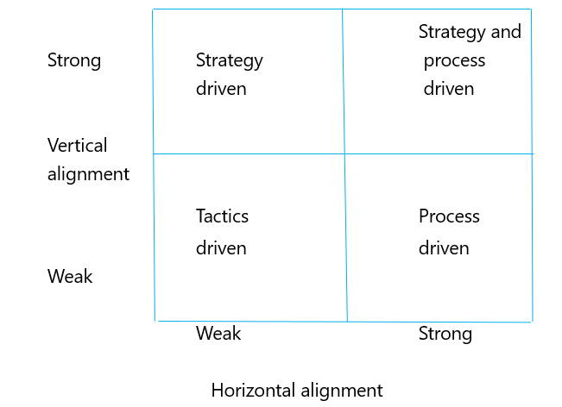 (Kew and Stredwick , 2016)

Resource Based Thinking
Resourced based thinking is looking internally at the organisation. Looking at the skills that are already in the organisation and other strengths it has. Such as its reputation, culture and knowledge. The strategy it has to protect, enhance, reinforce its existing and future strengths in order to build and gain advantage.

7.0 - Change Management
As cited in Boselie (2014) part of the HR role is seen as a “change agent”. The change agent role has the centre of interest in managing change. This role helps its employees adapt to the new changes taken place in the new strategy and helps deliver this change to its full capacity to gain the new culture.

The important tole of HR in change management are highlighted in Beer’s Model as cited in Kew and Stredwick (2016) this also shows how HR intervene in the HR function in the following 7 stages:

Role of HR: | HR Intervention needed:
1-Mobilise commitment to change through joint analysis | Agreeing there is a need for change to me made after such as a PESTLE , SWOT is completed
2-Develop a shared vision | What do they want the change to bed? What are we looking at in the future also from a HR perspective
3-foster consensus and commitments to the shared vision | Communicate this change
4-Spread the word for change | Internal posts, advertise and spread this word for change, communication groups and communication sources
5-Instituationalise the change through formal policies | Culture change and change of procedures
6- Monitor and adjust if needed | Support staff through this change and identify any issues if arisen.

8.0- Business Ethics

As stated on the CIPD (2018) ethical cultures are essential in organisations to shift from short term profits to long term sustainability. This will benefit everyone in the organisation- from its employees to its shareholders. This is not just a role for HR to be involved in but everyone in the organisation and a key part in the organisations strategy and how it manages its workforce.

Ethical practice within businesses includes the ethical values to organisational behaviour. These are for example fairness, honesty, openness and integrity. Organisations need to consider facts around these such as are people such as customers and employees being treated fairly, treated with dignity and also does the business understand its responsibilities to the wider society such as the environment. This applies to all areas for the business and its conduct. Organisations should put in place their ethical practices and support their staff to embrace these in their work place culture and day to day practice. This also involves allowing to recognise when such as a ethical dilemma has arisen if so, and how to deal with this.

Also as stated on the CIPD (2018) organisations are responsible for what they do and their decisions as a business. This includes corporate social responsibility and legal requirements. Businesses should do the right thing simply because it is the right thing to do also the it is supported by The institute of business Ethics. It has been researched there can be such benefits if organisations take their ethical values on board as seen in table 8.1:

Table 8.1 - Benefits of Ethical Views
- A better morale if an open culture is within the organisation
- A good relationship with customers leads too a good reputation for the business
- Good ethical companies have shown to out perform their competitors financially in the long term.

The CIPD (2018) founded the eight ethical lenses- these are to be used in situations which organisations are required to make decisions and decide which is the right decision for them as described in table 8.2 below:
Table 8.2 – CIPD Eight Ethical Views
Fairness | Does everyone agree to the decision?
Merit – | jobs and rewards should track talent and hard work
Markets | jobs and rewards should follow from voluntary market exchanges
Democracy | no one should be subject to a regime in which they have no say
Well-being | work should be good for us
Rights and Duties | everyone has rights to do some things and to be free of some things, and everyone has duties not to violate others’ rights
Character | each of us should work to develop the best ethical character for our roles
Handing down | responsible for conserving and maintaining what we have stewardship over, pass it on undamaged to our descendants

The CIPD also has their code of Conduct and its ethical framework which sets high standards to professionals to abide by as a professional.

What is HR Role in Business Ethics?

HR role in business ethics is to embed the ethical culture into the business and also to uphold these ethical behaviours not to its staff but to all its stake holders for example its customers. This could be taking into consideration employment rights, looking at its community and its purpose. Corporate social responsibility also plays a big part in HR role and the part the business pays on its community or any social factors by communicating their social and environmental responsibilities.

According to HR Magazine (2018) HR’s role can add to the ethical conduct in various ways for example:
- The embedding of an ethical organisational culture
- Recruit staff who will set the proposed ethical responsibility of the organisation and uphold this
- Resolve any issues arisen to do with its ethical conduct
- And also deal and with the aftermath or any ethical conflict if arisen
Ethical factors which HR could face would be legislative such as new GDPR policies and procedures which has new boundaries or organisations and its staff. Another example could be environmental pressures, such as climate change and pollution. This may face many companies in the steel industry for example with the pollution they have on the environment, this also contributes to corporate social responsibility they have for the environment.
HR’s part is also to communicate these ethics into the business environment, by distributing these and making all stakeholders of the business aware of these. Many organisations also such as Fielday Ltd. Have their own code of conduct set out for their staff work in line with to archive its company objectives.

9.0- Tools for analysing the business environment
There are various tools in which businesses can use to strategically analyse the business environment. By using these tools this allows businesses help understand the organisational environment and also think more strategically about the business. Using this strategy analysis also “is an approach to facilitating, researching, analysing, and mapping an organization’s abilities to achieve a future envisioned state based on present reality and often with consideration of the organization's processes, technologies, business development and people capabilities” BA Times (2018).

Here are three of the main tools that are used by businesses which looks at the present and future stares and risks and financial implications and the risks to map out the future in comparison to each of them:
- SWOT Analysis-
The SWOT stands for Strengths, Weaknesses, Opportunities and Threats. This is one of the most popular strategic analysis models uses. This analysis’s the business strengths and weaknesses and also any threats and opportunities to the business. Once these are identified the business can then focus on their strengths, reduce the effects of their weaknesses, embrace any opportunities and minimise any potential treats. NI Business Info (2018)
A SWOT analysis gives you a better insight into your internal and external business environment. However, it does not always prioritise the results, which can lead to an improper strategic action.
Table below highlights the advantages and disadvantages of the SWOT analysis –
Advantages of SWOT | Disadvantages of SWOT
- Allows you to understand your business  - Identifies weaknesses  - Allows to seek opportunities  - Can identify strengths and take advantage of these  - Helps to develop goals and strategies and archive these  - Eliminate threats | - The SWOT only covers strengths, weaknesses, opportunities and threats.  - Difficult to address uncertain or two-sided factors.  - Does not prioritise issues  - This does not provide solutions or alternative decisions  - Produces lots of information of which some is not useful
Queensland Government (2018)
- PESTLE-
“A PESTLE analysis is a framework to analyse the key factors (Political, Economic, Sociological, Technological, Legal and Environmental) influencing an organisation from the outside. It offers HR practitioners insight into the external factors impacting their organisation “ CIPD (2018). The PESTLE is a very flexible analysis and can be used in a number of situations, these results can then be used to guide in strategic decision making by seeing the bigger picture in which the business is in. This is a useful tool which specifically highlights the risks, position, potential and direction for a business or organisation.
Table below highlights the advantages and disadvantages of the PESTLE analysis –
Advantages of PESTLE | Disadvantages of PESTLE
- Its simplistic  - Allows businesses to look at potential future threats and take action to avoid these  - Allows the business to spot opportunities and make the most of these  - Gives a wider understanding of the business environment | - Data found using the PESTLE can be over simplified  - There is a risk of identifying too much data  - The PESTLE needs to be taken on a regular basis  - Speed of change makes it hard to anticipate the affects that make take place in the future  - Data found in the PESTLE maybe based on assumptions and not proven correct
CIPD (2018)
- Porters Five Forces
The Porters 5 forces is a simplistic although powerful tool that allows businesses to understand the competitiveness for their business environment and for evaluating the businesses strategy and potential profitability. Mind Tools (2018).
The frame work highlights five important factors that affect businesses :
1-Threat of entry
2-Threat of substitute products/services
3-The bargaining power of customers
4-The bargaining power of suppliers
5-The competitive rivalry among existing firms
Clear Point Strategy (2018)
Table below highlights the advantages and disadvantages of the Porters 5 forces
Advantages of Porters 5 forces: | Disadvantages of Porters 5 forces:
- Gives more direct information about the businesses strategic competitiveness  - The model can help deepen your evaluation of your position in the market  - Helps think and position where you want to be in the market  - Easy to see what changed are needed to be made to deliver long term profit | - Since the model was developed in the eighties the market dynamics have changed  - In today’s day and age technology has a high influence

10.0 - Factors which impact on a organisations business and its HR Function
- Technology (External Factor)
Technology is rapidly expanding hand having a greater impact on the way business are run. For example, you have seen businesses interpret more and more ways with technology for example the concept of going paperless (HR Magazine ,2018). Business such as Amazon are coming more up to date with technology introducing robots into the organisation such as drones to deliver parcels and driver less vehicles planned for the future. This plan is to up its productivity and generate more income to be spent on public health, this could also have an the HR function within the organisation. As Technology is rapidly evolving more electric data is being reproduced efficiently, this could mean that the work load for the HR admin could be reduced and cutting out paper process such as payroll. This means upskilling its staff to use them to their full potential, but this then could have cost implications. The implantation of more technical workforce makes it harder for HR to reward performance to its employees and a situation with regards to gender and equal pay. Another impact this could affect in the HR function is its recruitment, More organisations are using technology such as Facetime to conduct interviews and questionnaires online to test their future workforce, which could lead to recruitment going all technology based. This also links to training, cutting out trainers and implementing E-Learning. Although it is noted that face to face has been noticed as the most effective way of training staff.
- Legal
There are many Legal aspects which change and get updated which could have an impact on the organisations business and its HR function. Different Laws get changed and come into place for example in 2018 businesses saw the new legislation came in with regards to the General Data Protection Regulation (GDPR). This was new legislation to modernise the Data Protection act and allows individuals to have more control over their information held by others. This meant that businesses had to put provisions in place to meet with these new guidelines to align with the new legislation, such as assigning a data protection officer for the company. Companies such as Fielbday completed an audit on their staff files for example to discard all the information they no longer needed for their staff as there was no legitimate reason as to why they needed it any more. With in the HR department this has put pressure as this means that there must be tighter provisions in place with the confidentiality of paper work etc and make sure it’s kept safe. If this new law is disregarded then businesses can face high penalties. Local Government Association (2018)
- Size of Organisation (Internal Factor)
The size of an organisation can impact the business. Organisations can be seen as Small (less than 10 employees), Small to medium (less than 250 employees) and large with over 250 employees. This could affect the business as the larger the business HR would need to allow HR to manage with HR function, the smaller the business then HR would be able to devote more time to them and manage the change. For example smaller companies such as Lite Ladders and Towers have 1 HR admin assistant managing the HR function and a larger company such as Fieldbay with 500+ staff have 7 members of the HR team. With regards to the HR function businesses need to look at is the HR big enough to manage the work force and work in proportion to the size to support and lead the way for change.

- Culture in Organisation (Internal Factor)
Culture in the organisation is often to be know is now things are done in the business. Culture is the values, behaviours and the attitudes that are adopted by the organisation CIPD (2018) . The culture could impact the business and its HR function for example if the business is doing something that is not inline with its company values this will not have a good image on the business. With regards to the HR function the culture in some business are seen as “this is we do it” with regards to the management. It is the job of the HR to make sure that things are done correctly and meeting the right guidelines and meeting any policies and procedures such as employment law etc. If the culture in the business is good this has a positive affect on the business and will succeed and have a happy workforce.

11.0- Business Performance
All companies evaluate their businesses performance to analyse how well they are doing as a company. As stated in Kramar and Syed (2012) measuring the performance has become important tool to allow excellent organisational performance. This is critical to determine gaps with regards to job expectations and the businesses strategic goals. It is considered that performance management is critical in strategic human resource management and is crucial for an organisation to implement strategy to have a successful performance management system.
Performance management is a term used for many of the HR functions which are liked with managing the performance of its employees as members and individuals of the company by bettering organisational performance to archive the company’s mission and goals. This has let to improved performance management systems as this is now a crucial goal. This also stems from the HR function as the concept of successful recruitment, deployment and also using staff to their full potential will lead to overall better performance.
For a business to know the different areas it’s performing in can help determine weather the business is going strong and also determine the factors where it is weaker to change this for the better and amend the business strategy and also allows to bench mark against its competitors. It is important for businesses to determine non-financial targets as well has considering the financial factors for example:
- Customers- how many, how frequent they visit and how many customers they have lost and gained
- Customer Service- reviewing waiting times, reviewing complaints
- Market Share- if this has increased or decreased
- Staff- staff satisfaction levels, sick/attendance records
Business Gateway (2018).

Please see below 3 examples in which business performance can be evaluated/measured:
- KPI – Key Performance Indicators | KPI is a tool that businesses measure how effective the company is archiving its key business objectives. These key performance indicators need to be defined for example by underlying what is the outcome, how will you measure its progress and how often will you review the outcome to know when you have archived success.  An example relating to sales, a business sets a target to increase their over all sales growth by 20%. The KPI will indicate how they are going to archive it, how this will allow the business to become profitable and who is responsible for doing it and to review it. It is the role of HR to contribute to this to see what is needed from a HR perspective for example are any additional staff needed to carry out this target, is any additional training needs required. Also, once this is reviewed it is also the HR to see if staff sales are meeting their targets and determine if they are completing their jobs correctly, if again any additional training is needed, how the culture is if it has changed within the business how that there is a new strategic plan in place.
- Sickness Statistics | A business can evaluate its performance by reviewing its sickness statistics, This allows companies to review costings to see how much they are spending each year on sickness absence. According to The Centre of Mental Health (2018) in 2017 £10.6 billion was spent on sickness that year. By the business reviewing these statistics this allows the HR department also to see if there are continuous people calling in sick if any disciplinary action is needed, is there is any reason people are calling in sick that is related to their job, and also is there any need for recruitment if any members of staff are on long term sick. Also, being HR role is the communicator, it is HR role to protect the well being of the staff and have a duty of care for them.
- Performance Appraisals | By completing a performance appraisal this allows businesses to review their employee’s performance. As a business this allows HR to keep on top of the employee’s targets if in place, this also allows employees to discuss any issues he/she is having and any feedback on how the business is being operated. This is a benefit for the business to ensure the appropriate culture is being met and if there are any issues that need to be addressed. From a HR perspective if any strategic change has been made this is a good communication tool to have with its employees during their appraisal, a great tool to discuss if any additional training or if any additional needs are required. This can also be used to strategically plan its employee’s future’s with regards to succession planning or simply reward them for their hard work.

12.0 The use of business and contextual data
“ A popular new approach in HRM measurement is called human resource analytics (HR analytics). This is a very specific area within the HR metrics domain focused on advanced and sophisticated analysis of large and longitudinal HRM datasets” (Boselie, 2014, pp98). Organisations are collecting more and more data which allows them to use this effectively in terms of use to predict work force trends, success areas and also failing areas in HRM. This data is both valuable to both the business and HR to be utilized and assessed in terms of planning purposes, and there are many types of data that can be used such as internal and external data.
Please see below examples of these data types:
Data Type | How this data is used:
Competitor Information (External Data) | Companies often collect data on external competitors to weigh up the differences between them. This allows companies to see what advantages others have to gain competitive advantage over them. This data may include things such as competitor pay rates, staffing levels, any charge fees etc, employee benefits that they offer such as sickness, annual leave etc. For example, a care home company is opening a new home in an area and will look at other care homes in the areas and see what they offer to weigh up the differences. This allows businesses and HR to have a strategic plan in place to put these advantages in place and costings to have that advantage over others.
Management Accounts (Internal Data) | Some companies use management accounts to use strategically plan how they are doing as a business. This is often done monthly or yearly to assess their financial situation. These accounts cover financial data to see how the business is doing as a success, is there anything they are failing on and also the turnover per month. This also gives the business a good idea if they are meeting their plans and if anything needs to be changed, HR will also be involved in this process to support the plan and also communicate any change or any amendments needed to be made with staff.
Training Data Base (Internal Data) | Training data bases are used for planning purposes to identify any training needs that are required, HR will also be able to work with this data base and help and support their staff with succession planning. Companies often have probationary periods where these training data bases are used to sign staff up to do QCF’S etc or additional courses. This also links to performance related pay reviews with regards to employees’ qualifications. This is also beneficial to the business as if their staff are more qualified this can gain competitor advantage over others.
Government Data (External Data) | Government data could be used in order to planning purposes. For example, with regards to care homes in the care industry they have to abide by certain regulations and meet these criteria to operate. This data is then used to plan how they will meet these criteria and strategically plan their end goals to meet this. Strategic HRM plans would be in place to support this to communicate these plans to the staff for example making sure the right staffing levels are in place and if the staff have all the relevant training needed to complete the job.

- Conclusion
To conclude this paper its understandable how HR has grown over the decades and how it will continue to evolve.
It is understood there are many factors which affects HR and how factors such as technology and how this continuously grows will see an impact with the likes of more computerised systems replacing employees’ jobs and also how the culture in the organisation affect this and how it is HR role to set the culture.
The future of HR is that the HR function will always have a strategic plan and will continue to have a seat at the table and have an insight into the company’s goals and objectives. HR will always be seen as a change agent within the organisation and they play a vital role in the communication of this change and the approaches to the HR function they have.
HR also plays an important role in the planning of the organisation with the collection and analysing of data, this could be both internal and external data such as annual reviews on how the organisation succeeding or anything, they are failing in.

14.0 References

Boselie. P (2014) Strategic Human Resource Management: A Balanced Approach, 2nd Edn. McGraw-Hill Education:Berkshire
Boxall, P and Purcell,J ( 2011) Strategy and Human Resource Management , 3rd Edn, Palgrave: England
Buisness Gateway (2019) Measuring Business Performance. Available at: https://www.bgateway.com/resources/measuring-performance (Accessed 6th January 2019)
Centre for Mental Health (2019) Mental health at work: The business cost ten years on. Available at:https://www.centreformentalhealth.org.uk/publications/mental-health-work-business-costs-ten-years (Accessed 6th January 2019)
CIPD (2019) Perspectives on ethical workplace decision-making. Available at: https://www.cipd.co.uk/knowledge/culture/ethics/workplace-decisions-report (Accessed 2nd January 2019)
CIPD (2019) Changing HR operating models. Available at: https://www.cipd.co.uk/knowledge/strategy/hr/operating-models (Accessed 1st January 2019)

CIPD (2019) HR Business Partnering. Available at: https://www.cipd.co.uk/knowledge/fundamentals/people/hr/business-partnering-factsheet (Accessed 1st January 2019)

CIPD (2019) International Culture Factsheet. Available at:https://www.cipd.co.uk/knowledge/culture/working-environment/international-culture-factsheet (Accessed 2nd January 2019)
CIPD (2019) PESTLE Analysis Factsheet. Available at :https://www.cipd.co.uk/knowledge/strategy/organisational-development/pestle-analysis-factsheet (Accessed 1st January 2019)
CIPD (2019) Role of HR Factsheet. Available at: https://www.cipd.co.uk/knowledge/culture/ethics/role-hr-factsheet (Accessed 1st January 2019)
Clear Point Strategy (2019) 8 Strategic Planning Models To Consider. Available at: https://www.clearpointstrategy.com/strategic-planning-models/ (Accessed 1st January 2019)
Guardian Initiative (2019) Hard and Soft HR . Available at : https://guardianinitiative.wordpress.com/tag/hard-vs-soft-hr/ (Accessed 1st January 2019)

HR Magazine (2019) Finding a balance when it comes to technology. Available at: https://www.hrmagazine.co.uk/article-details/finding-a-balance-when-it-comes-to-technology (Accessed 3rd January 2019)
HR Magazine (2019) What is HR role in Ethics?. Available at: https://www.hrmagazine.co.uk/article-details/what-is-hrs-role-in-ethics-1 (Accessed 2nd January 2019)
Kew. J and Stredwick.J (2016) Human Resource Management in a Business Context , 3RD Ed. ,CIPD:London

Kramar, R and Syed, J (2012) Human resource management in a global context: a critical approach, Palgrave:London
Local Government Association (2019) General Data Protection Regulation (GDPR). Available at :https://www.local.gov.uk/our-support/general-data-protection-regulation-gdpr (Accessed 2nd January 2019)
Marchington,M and Wilkinson, A (2006) Human Resource Management at Work, 3rd Edn , CIPD:London
Mind Tools (2019) Porters Five Forces. Available at: https://www.mindtools.com/pages/article/newTMC_08.htm (Accessed 1st January 2019)
Mintzberg, H., The fall and rise of strategic planning. Harvard Business Review, (1994, January-February), 107-114.

NI Business Info (2019) Measure performance and set targets. Available at: https://www.nibusinessinfo.co.uk/content/swot-pestle-and-other-models-strategic-analysis (Accessed 2nd January 2019)
Queensland Government (2019) Benefits and Limitations of SWOT analysis. Available at:https://www.business.qld.gov.au/starting-business/planning/market-customer-research/swot-analysis/benefits-limitations (Accessed 1st January 2018)
Society for Industrial and Organisational Psychology (2019) Work in the 21st Century: The Changing Role of Human Resources. Available at: http://www.siop.org/tip/backissues/tipjan98/may.aspx (Accessed 1st January 2019)

Strategic Management Insight (2018) Porters Five Forces. Available at :https://www.strategicmanagementinsight.com/tools/porters-five-forces.html (Accessed 1st January 2019)
Strategic Management: Formulation and Implementation (2018) Mintzberg’s Model. Available at: https://www.strategy-implementation.24xls.com/en104 (Accessed 1st January 2019)

Taylor, S and Woodhams C ( 2016) Human Resource Management: People and Organisations, 2nd Edn, CIPD:London
Taylor, S and Woodhams, C (2016) Studying Human Resource Management , 2nd Edn , CIPD:London
Ulrich, D. (1997). Human resource champions: the next agenda for adding value and delivering results. Boston: Harvard Business School Press.

