Diana Decheva
Student ID: 2129230

Academic and Employability Skills
Lecturer: Sukhpreet Grewal

Table of Contents
Introduction 3
Time management 3
Academic writing 5
Reflection 6
Public speaking and giving presentations 8
Conclusion 9
References 11

Introduction
Self-reflection is essential for achieving progress regardless of whether this is applied in personal, academic or professional context. Reflecting on past experience is mainly important for assessing its positive and negative impact but it also assists in identifying gaps for improvement and planning on specific actions which can be undertaken, so that this is achieved. The current paper aims to evaluate the main skills developed through the module on the basis of using Gibbs’ reflective cycle model, shown below. It is one of the most recognised reflective models – often used to encourage learners to think systematically about the different phases of an activity and its contribution to learning (Wain, 2017).
Figure 1 – Gibbs reflective cycle
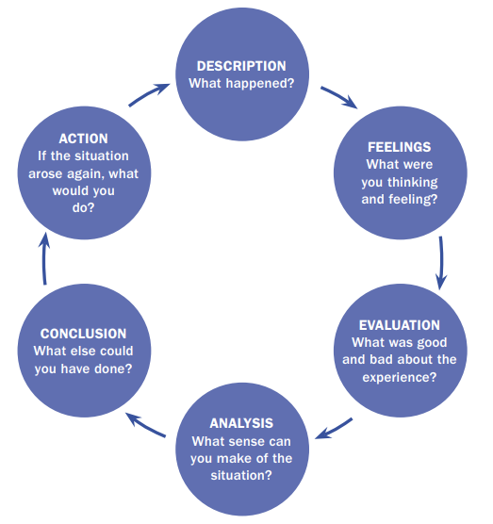
Source: Wain (2017)
Respectively, the propositions of the model are used to address four distinctive skills developed significantly during the course.

Time management
By definition, time management is the process of planning and controlling how much time will be spent on specific tasks and activities, considering their urgency, priority and complexity (CFI, 2022). Good and effective time management is essential for building a career in the professional field, as well as for successfully graduating academic qualifications. It allows individuals to complete more in less time, to lower stress and to increase the potential for future achievements on the basis of better knowledge and skilled obtained (CFI, 2022). Effective time management also results in having more time for other activities, increased pool of opportunities for development and a better ability to realise pre-defined and pre-set goals (CFI, 2022). During the course I realised the importance and value of these benefits and understood that I have to prioritise improving my time management, as it has always been a weakness in my case.
In order to achieve that, I have explored different strategies and tips for actions in practice. As shown below, there are different tactics which one can utilise with the aim of improving time management skills. I decided to use setting goals correctly, prioritising wisely, setting a time limit, organising well, and planning ahead as best options for my personal routine.
Figure 2 – Strategies to improve time management
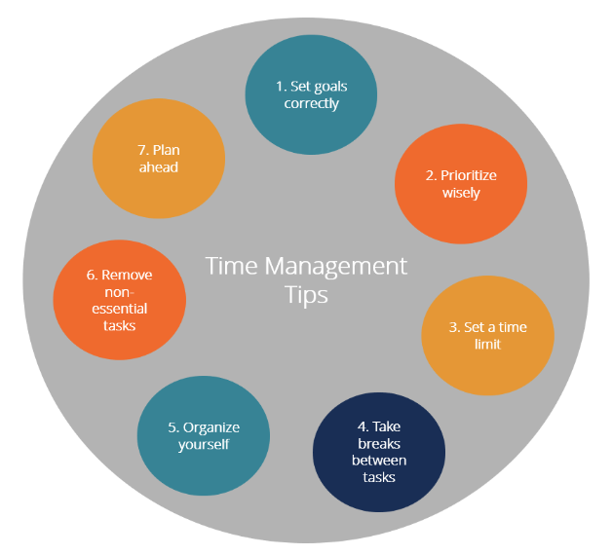
Source: CFI (2022)
During the course I have learnt to set goals correctly and this made me feel more confident. I also learned how to make my targets achievable and measurable, so that I could track progress in an effective manner. This has helped me a lot to also become more organised, plan better, prioritise and set a time limit for each task, so that I can monitor and record progress accordingly. Thus, I eventually became aware about techniques for better productivity.
Some additional things could be also done during the course. For instance, I could start keeping records of tasks and their degree of achievement along with the time spent on each activity during the day. This would help me to better analyse the distractions and factors wasting my valuable time. This, in turn, would further improve my time management skills and would allow me to better organise all work in advance, so that all tasks are completed on time and up to the required standard. For example, while I was preparing the presentation, some disruptions arose and I wasted a lot of time on completing my research. If this situation arises again and I have each stage of presentation development planned in advance, I would track this early and I take appropriate measures to prevent further delays.

Academic writing
Throughout the current course, I also understood the importance of developing academic writing skills. Basically explained, this is the writing which is performed for academic purposes (Jonsson, 2006). Academic writing can be distinguished by other written forms of communication on the basis of several important features, including formality, density, abstraction, objectivity, rigour and being tightly-knit (Routledge, 2021).
In terms of formality, academic writing is based on higher degree of precision and informativity, avoidance of ambiguity, subjectivity and misinterpretation (Routledge, 2021). The main aim of academic writing is to present ideas which are well-supported, establishing high level of authority and credibility (Routledge, 2021). In terms of density, academic writing can be suggested to use long noun phrases with multiple modifiers to present heavy loads of information when necessary (Routledge, 2021). When abstraction is considered, academic writing is claimed to deal mainly with concepts, ideas and theoretical interpretations instead of tangible things and separate individual contexts (Routledge, 2021). Academic writing is also objective and based on rigorous choice of words and arguments (Routledge, 2021). It is also highly structured and following specific format depending on the particular piece intended to be developed.
During the course I realised the importance of academic writing. I understood its essential importance for being successful in passing different academic discipline, as well as in developing skills to create professional documentation. Academic writing improves other related skills, such as communication, organisation and critical thinking. During the course, I also understood that it could be helpful to better contextualise my ideas and opinions; thereby, being better in debating different arguments and positions on a certain matter. This also improved the way I explained concepts and theoretical models, as well as my engagement with opposing views.
For me personally, academic writing is crucial for my future career development and this is one of the main reasons why I consider it a priority to further improve it. What I could do more is to read about various strategies and tactics to further improve academic writing skills, as well as ways to integrate them along with the rest of my capabilities. However, as I am still enrolled in my academic qualification, I believe I will have more opportunities to create and develop different academic pieces with a potential to further improve my skills in this area.

Reflection
As also evidenced by the current assignment, self-reflection is essential for identifying gaps for improvement and for planning on how to fill them on the basis of evaluating past experiences. It is proven that, if applied effectively, self-reflection is likely to result in deeper learning, as well as better ability to regulate own studying and knowledge/skill obtaining process in the future (JISC, 2021). The ability to reflect on own experience is also important in a professional context. It helps individuals to better understand the strong and the weak sides of their performance, as well as identify problems easier and plan accordingly on how to solve them.
Apart from Gibbs’ reflective cycle, which was presented in the introduction and used for the current reflection assignment, there are other models of reflection with a wide use in practice. These theoretical frameworks include Kolb’s experiential learning cycle and John’s model for structured reflection.
Kolb’s experiential learning cycle suggests that individuals learn through discovery and experience, leading to effecting learning taking place throughout all four stages of the process (Wain, 2017). This self-reflection theory proposes that reflection process consists of four different phases – concrete experience, reflective observation, abstract conceptualisation and active experimentation (Wain, 2017).
Figure 3 – Kolb's experiential learning cycle
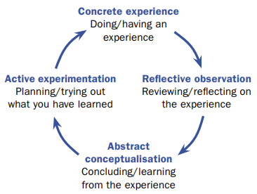
Source: Wain (2017)
John’s model for structured reflection, as illustrated below, suggests that students should use a particular experience and assess the factors that influence it, so that they can control them and their influence better if a similar situation arises again (Wain, 2017). The model consists of five stages, including describing the experience, reflecting on the aim and consequences of the experience, assessing the influencing factors, including internal, external, existing knowledge. It is also important to evaluate choices, which may have been made different, together with effective learning in order to identify the occurring changes as a part of the respective experience (Wain, 2017).

Figure 4 – John's model for structured reflection
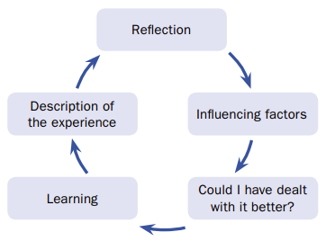
Source: Wain (2017)
During the current course I have understood that every experience has certain contribution to my personal, academic and professional development. I have also realised the importance of regularly reflecting on every event, so that it is properly assessed in order to recognise its value. To me, self-reflection is also the best way to identify gaps for improvement which I may miss otherwise. I also clearly understand the existence of different models of reflection and thus, I have decided to use a combination of them in the future, so that I can have a better result from the reflection process and cover more perspectives of it. This is also something that I could have done during this course, but instead I used only one particular theory.

Public speaking and giving presentations
One of the most important aspects of skill improvement during the current course is the way I enhanced my public speaking and presentation skills. The individual presentation, which is a part of the assignment, helps me realise that this area needs significant improvement and I have to work in this direction in the future. I have not had a lot of issues during the preparation of the presentation itself. Nevertheless, selecting the accurate content for the presentation was challenging. I also delayed my research for it; thereby, resulting in ineffective planning and time management of the whole process. However, my biggest problem is to tackle stress and anxiety to speak in front of a public. I am extremely nervous when I have to do public speaking and I fully realise that this is a significant issue to solve through practice and other tactics.
Presentation skills are essential for both academic and professional success. The way individuals present their views, thoughts, opinion or even own qualities might be a source of competitive advantage, improved communication, better understanding of their viewpoint and greater confidence in their potential (Torok, 2015). Presentation skills are also crucial for being a good team member when working in groups and when one needs to defend their views or positions. In most academic and business organisations, public speaking and presentation skills are prioritised as being among the top employability skills which need to be mastered by successful individuals. In order to both earn good grades in school and be successful in the workplace, people have to be able to present their ideas to others with confidence, trustworthiness and credibility. Good presentation skills also increase confidence and relief stress and anxiety (Torok, 2015). Effective public speaking and presentation skills also contribute to more effective time management as preparation is more organised and no time is wasted (Torok, 2015). The ability to defend own ideas publicly and present them clearly also helps developing other communication skills, as well as negotiation, teamwork and organisation capabilities (Torok, 2015). Presentation skills are also considered essential for perceiving a person as being an effective leader who can encourage others to follow (Torok, 2015).
As I have realised that this is one of my weak areas, I have planned on alternative ways to improve it. There are many different strategies and tactics but one of the main solutions refers to practice speaking in front of others. For this purpose, I will use my peers, friends and family to practice public speaking more, so that I can decrease the level of stress through practice. Moreover, I may also practice welcoming questions and comments, so that I can use this feedback in real time and change the course of my arguments, if necessary. Again, this will be achieved by using others in my informal environment. I will also spend more time in preparing and researching the topics of my presentations more, so that I am well informed and I can easily respond to any additional questions.

Conclusion
To sum up, the current reflection on my course experience helped me identify crucial gaps for improvement and assisted me in exploring alternative ways to achieve that. I have realised the importance of the assessed skills, as well as my current state in their excelling. I truly believe that these four skills are essential for both my academic and professional development, which is why I intend to continue working on them in a consistent manner. I may also apply self-reflection techniques to assess experiences and events, so that I am able to identify potential paths for continuous improvement which would contribute to have better employability skills and status.

References
CFI (2022) Time Management, [online] Available: https://corporatefinanceinstitute.com/resources/careers/soft-skills/time-management-list-tips/ [Accessed: 23 July 2022]
JISK (2021) Student Self-Reflection, [online] Available: https://www.jisc.ac.uk/guides/transforming-assessment-and-feedback/self-reflection#:~:text=Why%20is%20student%20self%20reflection%20important%3F&text=Research%20shows%20that%20a%20combination,time%2Dconsuming%20appeals%20and%20complaints [Accessed: 22 July 2022]
Jonsson, S. (2006) On Academic Writing, European Business Review, Vol. 18(6), pp. 479-490.
Routledge (2021) What is Academic Writing? [online] Available: https://www.routledge.com/blog/article/what-is-academic-writing-and-other-burning-questions-about-it#:~:text=Why%20is%20academic%20writing%20important,and%20critical%20for%20academic%20success [Accessed: 24 July 2022]
Torok, G. (2015) Why Are Presentation Skills Important? [online] Available: https://www.linkedin.com/pulse/why-presentation-skills-important-george-torok/ [Accessed: 22 July 2022]
Wain, A. (2017) Learning through Reflection, British Journal of Midwifery, Vol. 25(10), pp. 662-666.

