
School of Engineering

Application of Computer Aided Engineering processes
12TH November 2023
Module: Structural Design & Fluid Analysis Module Code: ACHA6010
Jonathan Bennett (1807541)
2024

Table of Contents
2 Introduction iii
2.1 Aims iii
3 Literature review iv
3.1 CAE in the industry iv
3.2 Advantages and disadvantages v
3.3 Stress, strain, Youngs modulus and Poisons ratio vi
3.4 Iterative approach vi
4 Methodology vi
4.1 Modelling vii
5 Discussion x
7 Conclusions xi
8 References xiv
9 Appendix xv

Introduction
CAE is a software process that enables companies to carry out cost effective research and design techniques without much overheads and any production tooling including personnel, it is a process that involved computer aided engineering of parts from initial design phases up to the point of ready to produce the parts.
A key aspect is proving the products viability and making updates to the design features and materials used to achieve the strength and durability some manufactured parts require, an iterative approach is often utalised to ensure that when the part isn’t initially meeting target constraints that the next stage works closer to the end goal, making improvements each run through of testing.

Aims
This report is to highlight the strengths, weaknesses and importance of CAE as a process to engineer required parts prior to manufacturing, the process is to be learned at each stage so that an understanding is developed for future employment and viability for working out of the CAD industry.
It is expected to run through thermal conditions for parts subjected to intense heat, to ensure they can withstand the pressures and temperatures impacting them so they can last and continue to perform the required task, that force loading can be maintained without stresses causing the product to yield and break during use, also that objects produced do not deform beyond intended boundaries and cause seizures or contact between two unwanted components, an overall safety measure and a long lasting part demands this refinement and finite testing method to produce a well designed part.
CAE carried out well can lead to reduced development costs and quicker work times, less physical material waste and in some events the avoidance of complete component failure. (Siemens, 2023)

Literature review

CAE in the industry
Computer aided engineering (CAE) involves the use of computer software to improve product design and resolve engineering problems for a wide range of industries (TWI,2022)
The use of CAE has rose dramatically since WHEN and has quickly become the first measure of the design process due to its low implementation costs and usefulness as a validation tool to warrant even taking a design further than its initial stage, this stage involves designing the product which is then able to be tested and validated on its merits, testing for stress and strain, thermal analysis and fluid dynamics, it is also possible to build multibody assemblies that can simulate motion of intricate parts, test for potential stress points that will result in failure of the product it it were to be carried through to the manufacturing process.
Designing a product without CAE can be an expensive process with many pitfalls and lessons to be learned where observing each product iteration in testing will quickly reveal short comings, testing using CAE is an invaluable method to design, giving the product validation to trust it will perform its desired task.
The process requires skilled engineers to draw the design in applications such as Vision 360 or Solidworks, this will have the appropriate dimensions applied and any multibody parts can be laid out individually and then pieced together into a functioning assembly, moving onto a motion simulation should the part require and then moving into applications such as Ansys where the design becomes about validation and testing.
Stress constraints are applied to calculate where the material used for the design will suffer weak spots and likely breakages, the software will give colour gradients based on the weaker areas and if the stress is too high on said area, the same can be given based on thermal properties not only for the part but the environment it will be situated. The quality of the simulation is only as good as the precision of the boundary conditions to which a product will be exposed. (TWI,2022)
According to Grand View Research the CAE industry is worth over 9.1m USD worldwide and is projected to grow by 12.5% by 2030 as demand for higher levels of dependability, less product recall incidents owing to a better brand image and safer product user outcome (Grand View Research, 2022)

Advantages and disadvantages

This process requires strong computing power, which is the major initial cost for CAE as the software is taxing and demands higher computational capacity, the software licences are also a factor, however the introduction of cloud based services has enabled this cost to be lessened somewhat with lower upfront costs by means of lower powered hardware essentially streaming the software from cloud based servers running the process. This isn’t accessible to all but the cloud based system does mitigate this somewhat but is a point to consider.

The skill level needed to input relevant data and accurately define constraints is higher than most roles where accuracy and attention to detail are key, the level of workmanship will dictate how true to form the validation results are so to make the whole CAE process valid at all it is important to maintain a high level of standard start to finish, it can take years to become adept with the processes of CAE and CAD, it is not as simple as open the software and draw out the designs, a technical understanding is required and knowledge on the desire result and implementation is key
Saving time and cost is the key advantage of CAE as the process does not require any tooling or materials to be spent in making prototype models or stress testing (thus breaking) repeated iterations to learn the failures and stress points, besides the cost of the computing hardware and the software licences the key costs are the engineers themselves, which is necessary whether CAE is involved or not.
The testing can result in much less failures both before sale of products and after, if a product fails beyond reaching the consumer the issue can range from mild inconvenience to disastrous where possible harm could be caused depending on the item, the more robust the preprocess testing is the safer a product will resulted.

There are negatives to relying on CAE mostly common to any use of computers such as being on location without power supplies, or in the event of power outages can stop work, or if the computer suffers damage or a virus it can be costly to replace or rectify, the downtime cant always be worked around either such as waiting for replacement computer parts to arrive.
There is an element of training new engineers can take years especially from start to finish, studies at university through to employment and bringing that staff up to speed with not only the various different CAE software but also with regards to the companies specific needs and projects.
The software is subject to live updates where ever year or 2 there are major revisions and this can not only leave the company without a certain feature, but also result in older systems not being able to work with the newer updated software’s files due to backward compatibility.( Arcvertex,2018)

This design is easy to keep and store, move around or even sell on for others to simply begin production as a file is all you need to start up a CAD machine to produce what was designed in CAE, its become so streamlined and simple in this regard that even at a consumer level products are being designed and shared for recreational 3D printing on a small scale, 3D printing has grown to the estimated market value of over $5bn (Ultimaker,2020).

Stress, strain, Youngs modulus and Poisons ratio
Stress and strain is highlighted by gradually applying a load to an object and measuring its deformation, this can be better calculated by knowing all that can be said about the material used this has key information taken from Youngs modulus and Poissons ratio.
Poissons ratio is defined as a given measurement along a X,Y and Z axis and its deformation amount given as a Delta or Dx, Dy and Dz after an applied load where $ϵ=\frac{Δy}{y}$ , there is a ratio between Lateral strain / Longitudinal strain where the lateral load is proportional to the longitudinal stress when we refer to isotropic materials with an elastic property, the ratio is usually around 0.3 for metals (Efficient engineer, 2019).
The Young’s modulus (E) is a property of the material that tells us how easily it can stretch and deform and is defined as the ratio of tensile stress (σ) to tensile strain (ε) (University of Birmingham,2018) $E=\frac{σ}{ε}=\frac{F/A}{dl/l}$ is the given equation.

Iterative approach
The main advantage of an iterative approach is that it is a constant refinement from iteration to iteration, and each gets closer to the expected target goal of what the product is expected to meet, initial designs may fall short of the required tolerance or threshold for safety and this approach allows for the findings to be refined as the meshing, constrains and material choice becomes more appropriate for the final product, maybe applying new boundary conditions, having another engineer perform the calculations or simply validate another’s work ensuring everyone is working to the same end result, the smallest of miscalculation or number input can cause varied results so a critical attention to detail is necessary (Massobrio, 2019)

Methodology
There are many limitations to using Ansys for structural analysis, from the very start of the workflow when entering the specific material properties if at all lacking in finite date on the material proposed, there will be lack of accuracy in the end results, for example entering properties for Isotropic elasticity the given values were in increments of 50 degree, given that any temperature between 100 and 150 degrees for example will have been made on an assumption rather than factual data. Down the line this can lead to inaccuracies and invalid data to some degree due to the guess work involved in the material fundamentals.
Discretising using meshes that are not adequately chosen can have a big influence on the overall out come results and can leave a certain margin of error and this is only routed out by means of trial and error, but running various mesh sizing on each part is time consuming and is not always best use of time, however it is worth noting this as a downfall of using CAE for analysis. Compounding the margin of error is an acceptable method to speed up the computational workflow, however this has a stacking effect and can make a string of components more and more inaccurate by the end result.
The possibility of the program running on more limited hardware being not able to solve a finer mesh that the system will simply crash under the load, it may be found that its needed to work within the constraints of the hardware at hand, which of course has a cost element assigned to it, more capable computers cost more.
Entering values for the materials used, it was assumed that the Poisson’s ratio was a static figure without a temperature dependency due to this being an unknown variable.
At this point it is worth noting that an element of the thermal testing failed to accurately give results as was to be expected by a magnitude of 10, which is an element of how the software is difficult to use and get reliable results due to its complexity, with so many complex calculations it was not possible to rectify the issue due to it being an unknown issue.

Modelling
We begin in a CAD software where the part is first made up from scratch, given definition and form, a Piston was to be used in this test so a extruded boss of the pistons diameter is extruded to the right height for the given properties, the piston needs a crown with 4 valve cutouts, 3 piston rings and a length of piston skirt to flank both sides perpendicular to the gudgeon pin cut outs, this is then saved as a STEP file and moved over to Ansys workbench where testing can be structured.

Initially the engineering data section is implemented to supply the part its material properties for use throughout the Ansys suite, this was specified in class and a temperature dependant range, Poisons ratio and Young’s modulus is applied to a “new” material we called 6061-T6, rather than rely on the engineering databases own version of this aluminium grade, after setting this up it is then fed directly into the Rigid dynamics module that can be loaded up with the premade piston STEP file, where the part is then opened in Ansys Mechanical.
From this module is it to be given constraints and boundary conditions to begin calculating the stress and strains of the given Young’s modulus and Poissons ratio to determine where the piston will suffer deformation, applying a mesh to the entire part making sure that the assigned material is still applied to the piston.
At this stage we are working with not only the piston but the majority of the rotational mass of the engine including the connecting rod and gudgeon pin, and crankshaft, these 4 parts were jointed via selecting the correct sections as a revolute joint, this allows Ansys to allow only revolution movement for each part, the Crankshaft needed to be locked to ground via a bearing face so it did not move in an undesired direction or manner when tested but locked in a Z axis, the piston also needs to be constrained to a Z axis to allow it to move up and down the theoretical engine cylinder.

Running a set mesh of 1.0 solving the simulation gives a graph result with data showing the various stress and strains over the course of half a second at a given 4000rpm, retrieving data for just a maximum force highlight and exporting to a text file for later importing into static structural module in a moment, only one instance of data from the results is needed as it is only 1 point in time considered, ie static result.

Moving onto the static structural module it is needed to link this module to the model stage from the previous stage of rigid dynamics, opening this model and importing the exported text loads file, and suppressing the other bodies in the assembly, it is now only the piston we are concerned with and by supressing the other parts the software only considers the piston that is now left, applying the loadings to the piston from the text file it is shown in the static structural section of the design tree shown as forces and moments which is depicted in the view window.

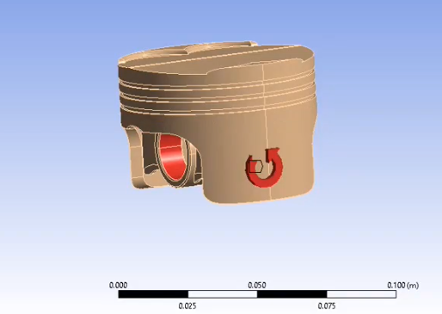
Figure 1 - loading forces acting on piston
At this point its needed that thermal studies come into the mix, so opening a Steady-state thermal linking to the engineering data and geometry data in the workbench and opening it we can now begin to set the thermal study, by first supressing the other parts but leaving the piston, making sure the piston is set with the correct material as before in previous modules.

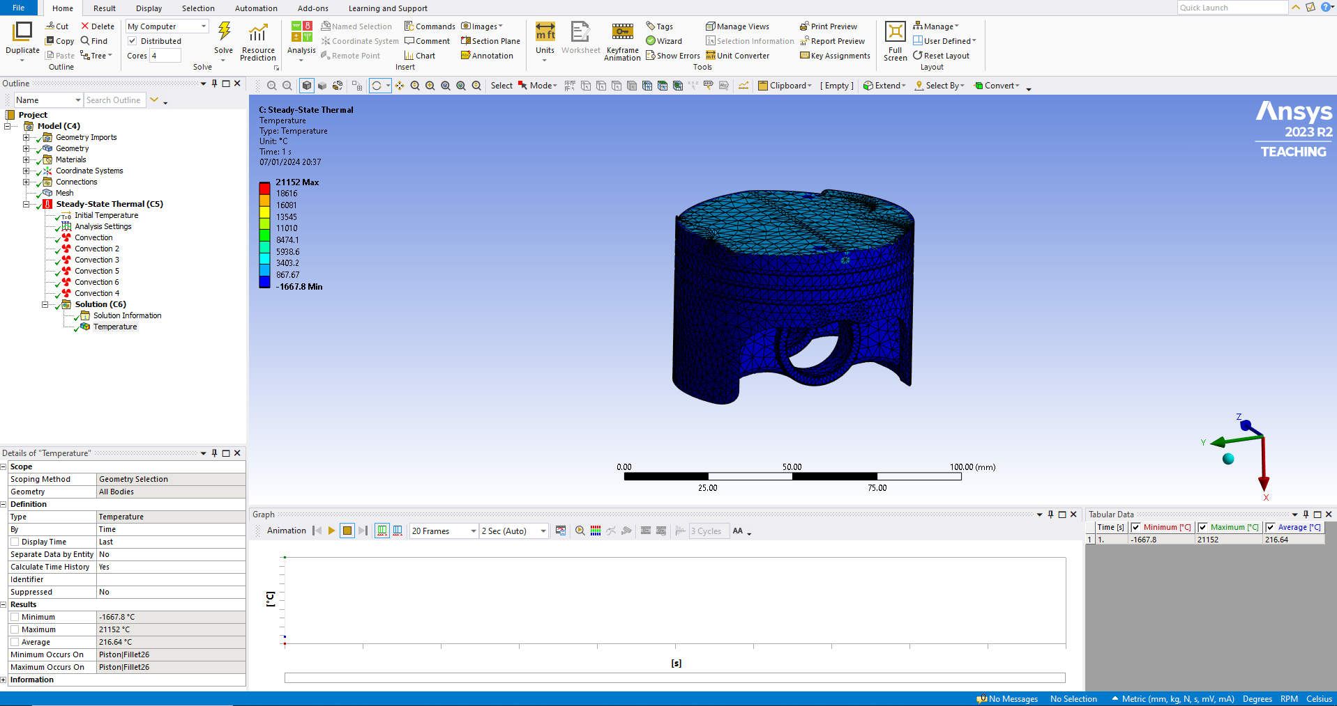
Figure 2 - Thermal study result (inadvertent results)
Next is generating a mesh going for 1.0mm, and following onto selecting convection boundary conditions, one for each region of the piston starting with the crown, then crown edges, down to each ring land and then skirts and finishing with the underside as a whole, setting the thermal conditions and ambient temperature for each, now setting temperature as the solution the final solving stage is ready, allowing the part to be calculated as a whole based on all previous calculations to be included. Finally adjoining the thermal study to the static structural module, opening the final model and making sure again the supressed other parts and that the correct material is selected for the piston, the meshing can then be set, concentrating a finer mesh to the crown being a critically effected area by the pressures and temperatures , applying a stress and total deformation result to the solution section, running solve for the final time.

Discussion
In discussion of validating and performing the constraints, meshing and joints we have many levels of accuracy to determine and how well an overall outlook on the product at the end of testing, with the main setbacks being time constraints and level of computing power available, the engineers skill level also has a determining factor on the end results level of accuracy.
Constraints are what sets the parameters for the information gathering to be output to the result probes, it is key to highlight every working area and set the constraints needed for the desired outcome, choosing an appropriate mesh size is also important as the smaller the mesh size the finer the details in the outcome, areas of lower interest such as the crown of the piston in this case have smaller levels of varying pressure and heat so a larger mesh can be used to aid in simplicity and speed, however nearer the edges of the gudgeon pin mounting points we would want more data as this is a vital area for failure point and somewhere that would best be carefully monitored, so in an area such as this it is possible to increase the mesh quantity by reducing the mesh size in just this localised region of the piston.
Results were proving that reducing mesh sizes across the entire product can yield a difference of magnitude, it Is also possible to change the mesh style between squares triangular etc the right shape to suit the shape of the product has importance. (Baskar, 2022)

Conclusions
The data yielded from the combined calculations performed once the entire set of modules has been compiled will show in the relevant module, Firstly the thermal data behaved adversely going exaggerated numbers for the heat, it is at this point unknown why, however the representative graphic does follow as expected.
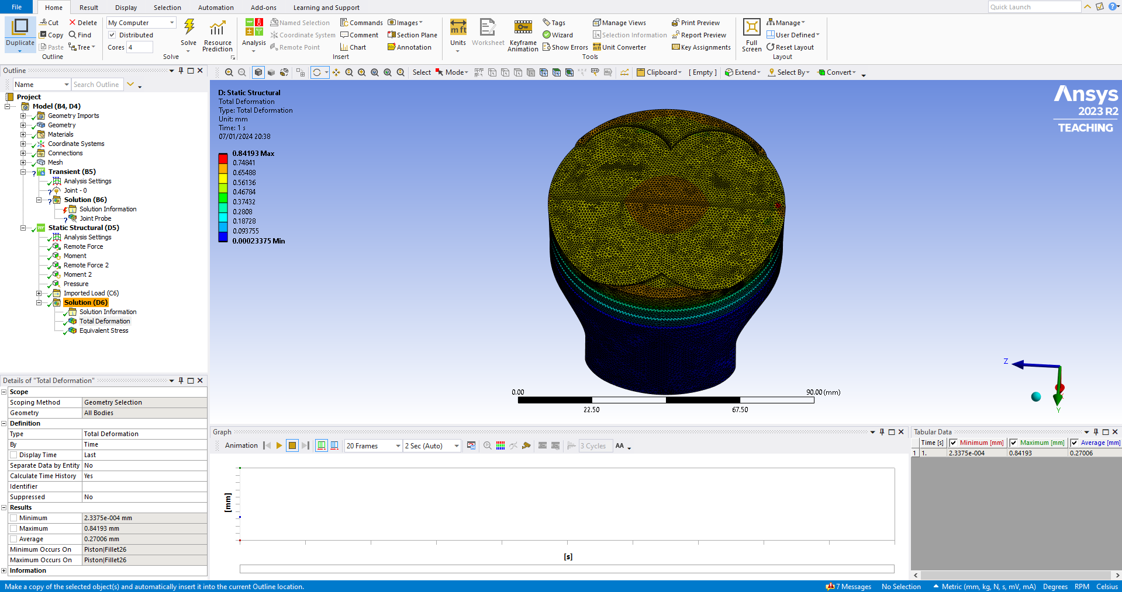
Figure 3 - total deformation result
The crown is showing high concentrations of heat in the very centre of the crown, slightly lowering towards the surrounding area as the flame front has moved away from the starting point and become more stagnated.
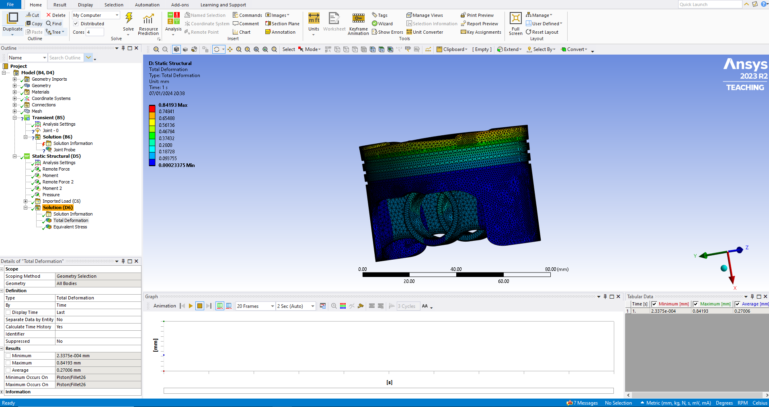
Figure 4 - total deformation side view
Looking now from the side of the piston the heat level drops dramatically at the sides of the piston body and shown here is the deformation from the top radically drops off at the sides of the crown and becomes more normalised by the first and second ring land, with only the very edge of the crown showing noticeable deformation, as to be expected this is the higher heat source and at operating temperature the aluminium is rather close to the melting point and is expected to deform somewhat as the cylinder pressures are applied under loading, the results show an upper limit of deformation in the region of 0.84mm, this coincides with the a visual check of a piston when fitted inside the bore, there is the slightest of gap between the piston and bore when viewed from above, this tolerance is to allow the piston to expand under full load and at operating temperature allowing this gap to close up, the benefit of this is the gap closing only aids in creating a sealed environment for the cylinder to operate at maximum capacity.
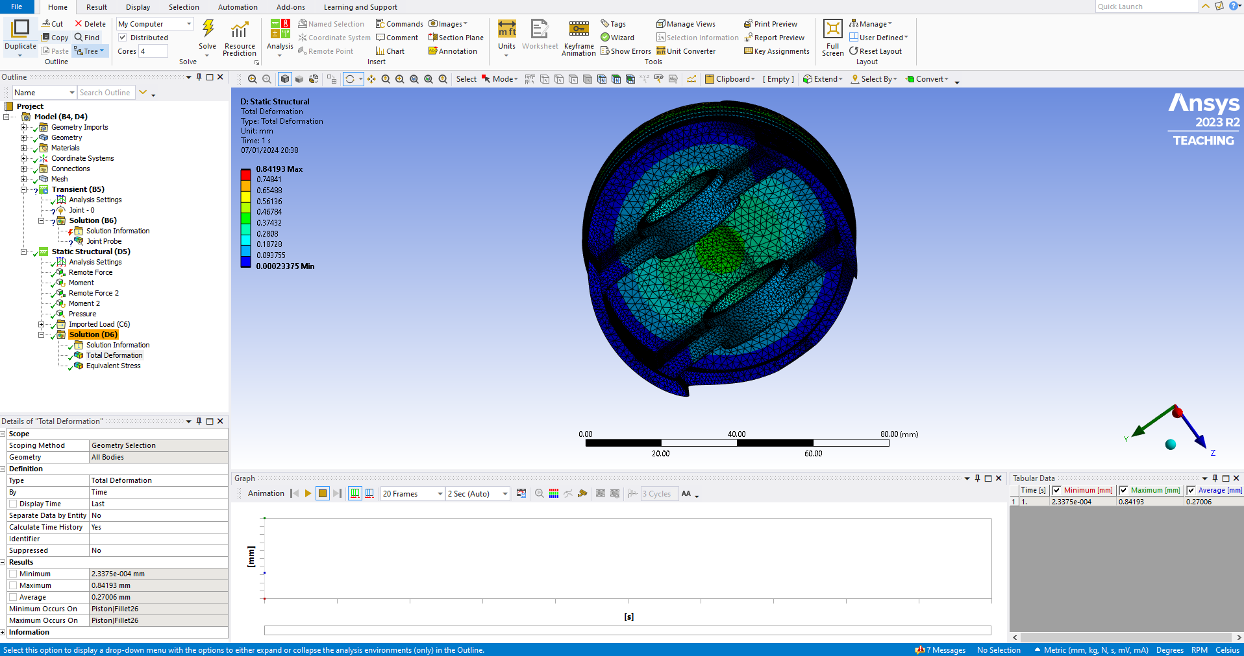
Figure 5 - Total deformation underside
The underside has experienced less deformation, this area is cooler and away from direct excess heat and in some engine cases oil sprayed to aid in cooling, the centre of the area is the thinnest and most effected from the crown heat and shown here the deformation is slightly higher than that of the surrounding area, in this result we see that the gudgeon pin mounts are deforming very minimally with the average of 0.09mm.

A fine attention to detail is key at all times of the process as the intricacies of the software demand each phase to be completed accurately for the best results, the process can take a few hours in some events with many interconnecting aspects that need to be linked.

References
Arcvertex (2018) Advantages And Disadvantages of Using Computer Aided Design (CAD) Available at: https://www.arcvertex.com/article/advantages-and-disadvantages-of-using-computer-aided-design-cad/ (accessed: 3rd January 2024).
Baskar, N. (2022) Mesh Sizing In Ansys Workbench Available at: https://skill-lync.com/blogs/technical-blogs/cfd-the-mesh-sizing-in-ansys-workbench (accessed: 7th January 2024).
Grand view research (2022) Computer Aided Engineering Market Size, Share, and Trend Analysis By Component (Software, Services), By Deployment Model (On-premise, Cloud-base), By End-use (Automotive, Defense & aerospace), By Region, And Segment Forecasts, 2023 - 2030 Available at: https://www.grandviewresearch.com/industry-analysis/computer-aided-engineering-cae-market (accessed: 20th December 2023).
Massobrio, A (2019) Iterative Design Process: A Guide & The Role of Deep Learning Available at: https://www.neuralconcept.com/post/the-iterative-design-process-a-step-by-step-guide-the-role-of-deep-learning#:~:text=One%20of%20the%20main%20advantages,Aided%20Engineering%20(CAE)%20tools. (accessed: 8th January 2024)
Siemens (2023) Computer-Aided Engineering (CAE) Available at: https://www.plm.automation.siemens.com/global/en/our-story/glossary/computer-aided-engineering-cae/13112 (accessed 8th January 2024)
TWI (2022) WHAT IS COMPUTER AIDED ENGINEERING (CAE)? Available at: https://www.twi-global.com/technical-knowledge/faqs/what-is-computer-aided-engineering (accessed: 29th December 2023).
University of Birmingham (2018) Physics A level revision resource: Introduction to Young's Modulus Available at: https://www.birmingham.ac.uk/study/undergraduate/schools-and-colleges/post-16/a-level-stem-resources/youngs-modulus (accessed: 3rd January 2024).

Appendix


