
Population Health and Digital Health Promotion
Module Code: LCHS7009
Assignment Title
Component 1 – Blog 1 and Blog 2
Digital Health Promotion Blogs
Blog 1 Title
The Role of Mobile Health Applications in Addressing Chronic Disease and Public Health Promotion
Blog 2 Title
AI Personalized Preventive Health Companion: A Next Generation Digital Health Promotion Platform
Student Name:
Isha Patel
Student ID:
2503804
Programme:
MSc Public Health and Social Care in Practice
Lecturer:
Dr Besty Jose

TABLE OF CONTENTS
Blog 1 — Existing Digital Health Technology (LO1, LO2) 3
1.0 The Role of Mobile Health Applications in Addressing Chronic Disease and Public Health Promotion 3
1.1 Introduction: Public Health Problem Context 3
1.2 Overview of Existing Digital Health Technology 4
1.3 Evidence of Effectiveness (Literature + Data) 5
1.4 Critical Discussion — Impact, Advantages and Limitations 6
1.5 Improvement / Recommendations 7
Reference List — Blog 1: 8
Image References — Blog 1: 9
Blog 2 — Your Designed Digital Health Technology (LO1, LO2, LO3) 10
2.0 AI Personalised Preventive Health Companion: A Next Generation Digital Health Promotion Platform 10
2.1 Public Health Problem Context (Reintroduce Briefly) 10
2.2 Description of Your Designed Digital Health Technology 11
2.3 How Your Technology Supports Health Promotion 12
2.4 Critical Discussion — Expected Impact + Limitations 13
2.5 Improvement and Future Development 15
Reference List — Blog 2: 16
Image References — Blog 2: 16

Blog 1 — Existing Digital Health Technology (LO1, LO2)

1.0 The Role of Mobile Health Applications in Addressing Chronic Disease and Public Health Promotion

1.1 Introduction: Public Health Problem Context

Figure 1: Public Health Problem
(Source: Mary, 2023)
The problem of chronic diseases like diabetes is a significant global public health issue, as it is associated with high long-term morbidity, quality of life, and health system expenses. Poor dietary habits and sedentary lifestyles have served to hasten the occurrence of these diseases in both the developed and developing world. According to Waalen (2023), preventive digital health instruments are becoming a necessity to aid in the early intervention and long-term management of the disease. Mobile health applications have become a convenient digital health promotion, one that can aid with behaviour monitoring, health education and prompting risk detection. Mobile health technology is, therefore, a viable solution to the burden of chronic diseases by using scalable and preventive healthcare solutions.

1.2 Overview of Existing Digital Health Technology
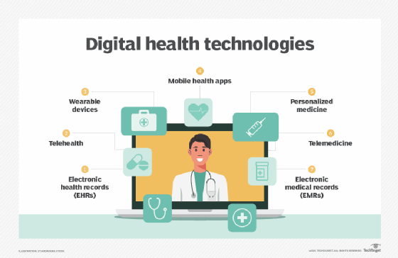
Figure 2: Digital Health Technology
(Source: Bernstein, 2022)
Mobile health applications are software systems that are aimed at monitoring, tracking and enhancing health behaviours using smartphones or wearable integration. Some functions that are normally present in these applications are physical activity trackers, medication reminders, glucose management and personalised health education. According to Grundy (2022), the quality of mobile health applications ranges widely, yet numerous of them exhibit positive shifts in the health engagement behaviour of the user and disease management behaviour. The patients with chronic conditions, at-risk populations, and the general health-conscious users are the wide users of these technologies. Mobile applications play a role in the continuous self-monitoring in the promotion of public health, which is a major principle of behaviour change intervention. As a result, mobile healthcare apps transform the conventional clinical health sector into the everyday life area.

1.3 Evidence of Effectiveness (Literature + Data)
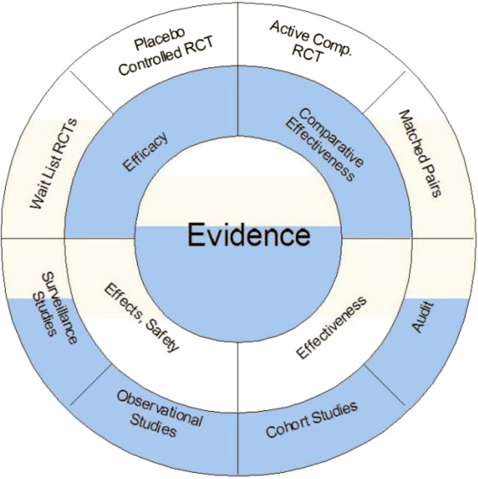
Figure 3: Evidence of Effectiveness
(Source: Peter, 2023)
The body of research proves that digital health technologies can be extremely effective in terms of monitoring the disease and medication adherence. According to Stevens et al. (2022), digital health technologies enhanced compliance in glucose monitoring and favoured improved long-term results of diabetic management. These tools are usually incorporated with behaviour change models that are based on goal setting, feedback, and tracking of progress. These are the methods that correspond to the contemporary principles of the behaviour change theory applied in digital health interventions. It was proposed by Pelly et al. (2023) that the ability to engage and sustainably achieve long-term health outcomes was supported by structured behavioural frameworks within the context of digital health users. The application in real life proves that regular digital monitoring assists in the early identification of health risks and decreases the number of hospital admissions.

1.4 Critical Discussion — Impact, Advantages and Limitations

Figure 4: Critical analysis
(Source: Kathy, 2022)
Mobile health applications offer high benefit in terms of accessibility, cost-effectiveness and scaling in large groups. According to Katz et al. (2024), digital health interventions are able to drive healthcare accessibility in populations with health disparities. Patient empowerment and self-management behaviours are enhanced with the possibility to provide constant supervision and feedback, which is personalised. Nonetheless, there are a number of shortcomings. Adoption permeates the older adults and low-income members of the population with the issue of digital health inequality. User trust and long-term commitment are also affected by privacy issues surrounding the collection of health information. Also, components of the user drop-off rates are also high when the application has not customised or adaptive content. Grundy (2022) claimed that a lack of consistency in the quality of application when using digital health services decreases the quality of the entire system and user trust. Thus, mobile health technologies carry powerful benefits to the overall public health; implementation quality and accessibility issues continue to be the key hurdles.

1.5 Improvement / Recommendations
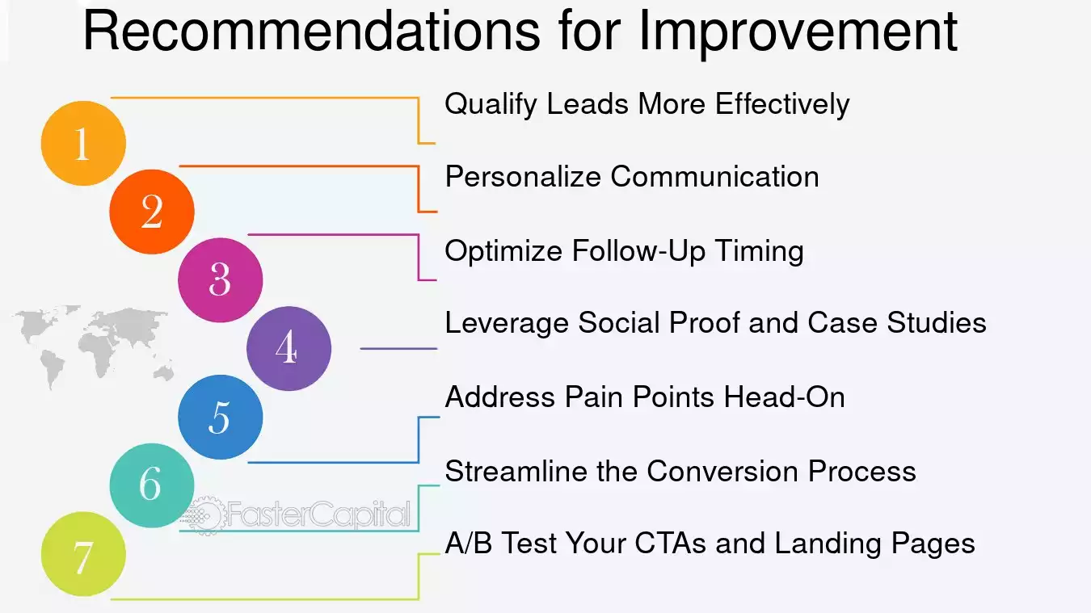
Figure 5: Recommendations for Improvement
(Source: Nirali, 2024)
The next generation advances must concern the inclusion of artificial intelligence-guided personalisation to enhance long-term engagements and behavioural compliance. The boost in data security laws can increase their acceptance and usage. Waalen (2023) proposed accessibility and usability of digital health strategies amongst the different population groups as the priority of preventative strategies. Multi-sector cooperation and policy support can also help to enhance implementation success. Therefore, enhancing the inclusivity and reliability of technology will make the mobile health promotion technologies more powerful in the long run.

Reference List — Blog 1:
Grundy, Q., 2022. A review of the quality and impact of mobile health apps. Annual review of public health, 43(1), pp.117-134. https://www.annualreviews.org/content/journals/10.1146/annurev-publhealth-052020-103738
Katz, M.E., Mszar, R., Grimshaw, A.A., Gunderson, C.G., Onuma, O.K., Lu, Y. and Spatz, E.S., 2024. Digital health interventions for hypertension management in US populations experiencing health disparities: a systematic review and meta-analysis. JAMA Network open, 7(2), pp e2356070-e2356070. https://jamanetwork.com/journals/jamanetworkopen/article-abstract/2815070
Pelly, M., Fatehi, F., Liew, D. and Verdejo-Garcia, A., 2023. Novel behaviour changes frameworks for digital health interventions: A critical review. Journal of Health PsychologyHealth Psychology, 28(10), pp.970-983. https://journals.sagepub.com/doi/abs/10.1177/13591053231164499
Stevens, S., Gallagher, S., Andrews, T., Ashall-Payne, L., Humphreys, L. and Leigh, S., 2022. The effectiveness of digital health technologies for patients with diabetes mellitus: a systematic review. Frontiers in Clinical Diabetes and Healthcare, 3, p.936752. https://www.frontiersin.org/articles/10.3389/fcdhc.2022.936752/full
Waalen, J., 2023. Mobile health and preventive medicine. Medical Clinics, 107(6), pp.1097-1108. https://www.medical.theclinics.com/article/S0025-7125(23)00085-8/abstract

Image References — Blog 1:
Mary (2023). 12 Common Public Health Issues. [online] Maryville Online. Available at: https://online.maryville.edu/blog/12-common-public-health-issues/.
Bernstein (2022). What is digital health (digital healthcare) and why is it important? [online] TechTarget. Available at: https://www.techtarget.com/searchhealthit/definition/digital-health-digital-healthcare.
Peter (2023). Is the ‘Evidence-Pyramid’ now dead?. Journal of Clinical Epidemiology. [online] Available at: https://www.jclinepi.com/article/S0895-4356%2815%2900465-5/fulltext.
Kathy (2022). How to nail your critical analysis. [online] KIS Academics Blog. Available at: https://kisacademics.com/blog/how-to-nail-your-critical-analysis/.
Nirali (2024). Making Recommendations For Improvement - FasterCapital. [online] FasterCapital. Available at: https://fastercapital.com/topics/making-recommendations-for-improvement.html/1.

Blog 2 — Your Designed Digital Health Technology (LO1, LO2, LO3)

2.0 AI Personalised Preventive Health Companion: A Next Generation Digital Health Promotion Platform

2.1 Public Health Problem Context (Reintroduce Briefly)

Figure 1: Public Healthcare
(Source: Howland, 2025)
The noncommunicable diseases, diabetes, obesity or cardiovascular disease are still on the rise in the world because of poor lifestyle behaviours and minimal strategies to intervene in the early stages. The existing digital health tools are commonly behaviour tracking, but not behaviour proactively,as far as sustainable behavioural change is concerned. Mair et al. (2023) expressed that behaviour change strategies are not successfully and actively incorporated when many digital health interventions do not succeed. In addition, a lot of the existing technologies are not adapted personally according to the needs of the users. Thus, demand is on the rise to consider digital health promotion technologies that can be customised to actively steer preventive behaviour and aid in the long term reduction of disease risks by means of applying strategies of adaptive interventions.

2.2 Description of Your Designed Digital Health Technology
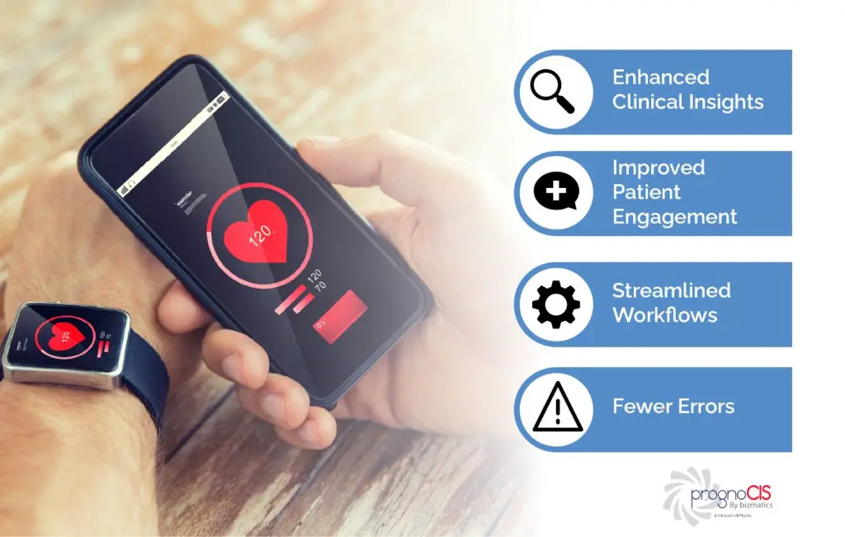
Figure 2: Mobile And Wearable Integrated Health Promotional Platform
(Source: Vikram, 2022)
The planned technology will be referred to as PreventAI Health Companion, which is a mobile and wearable integrated health promotional platform that runs through artificial intelligence. The system is a combination of behavioural and predictive risk analysis and personalised health coaching. According to Farao et al. (2020), user-centered design frameworks are critical in making digital health tools accessible, acceptable, and effective even among different populations. Prevent AI makes personalised health recommendations using continuous data from wearable sensors, living records, and location data. The site has mainly been directed towards young adults and working-age people who are likely to develop chronic diseases. The technology is a smartphone application that acts as tacombination of wearable devices and cloud-based artificial intelligence (AI). Thus, the system provides the real time preventive health advice according to the patterns of behaviour and risk profiles.

2.3 How Your Technology Supports Health Promotion
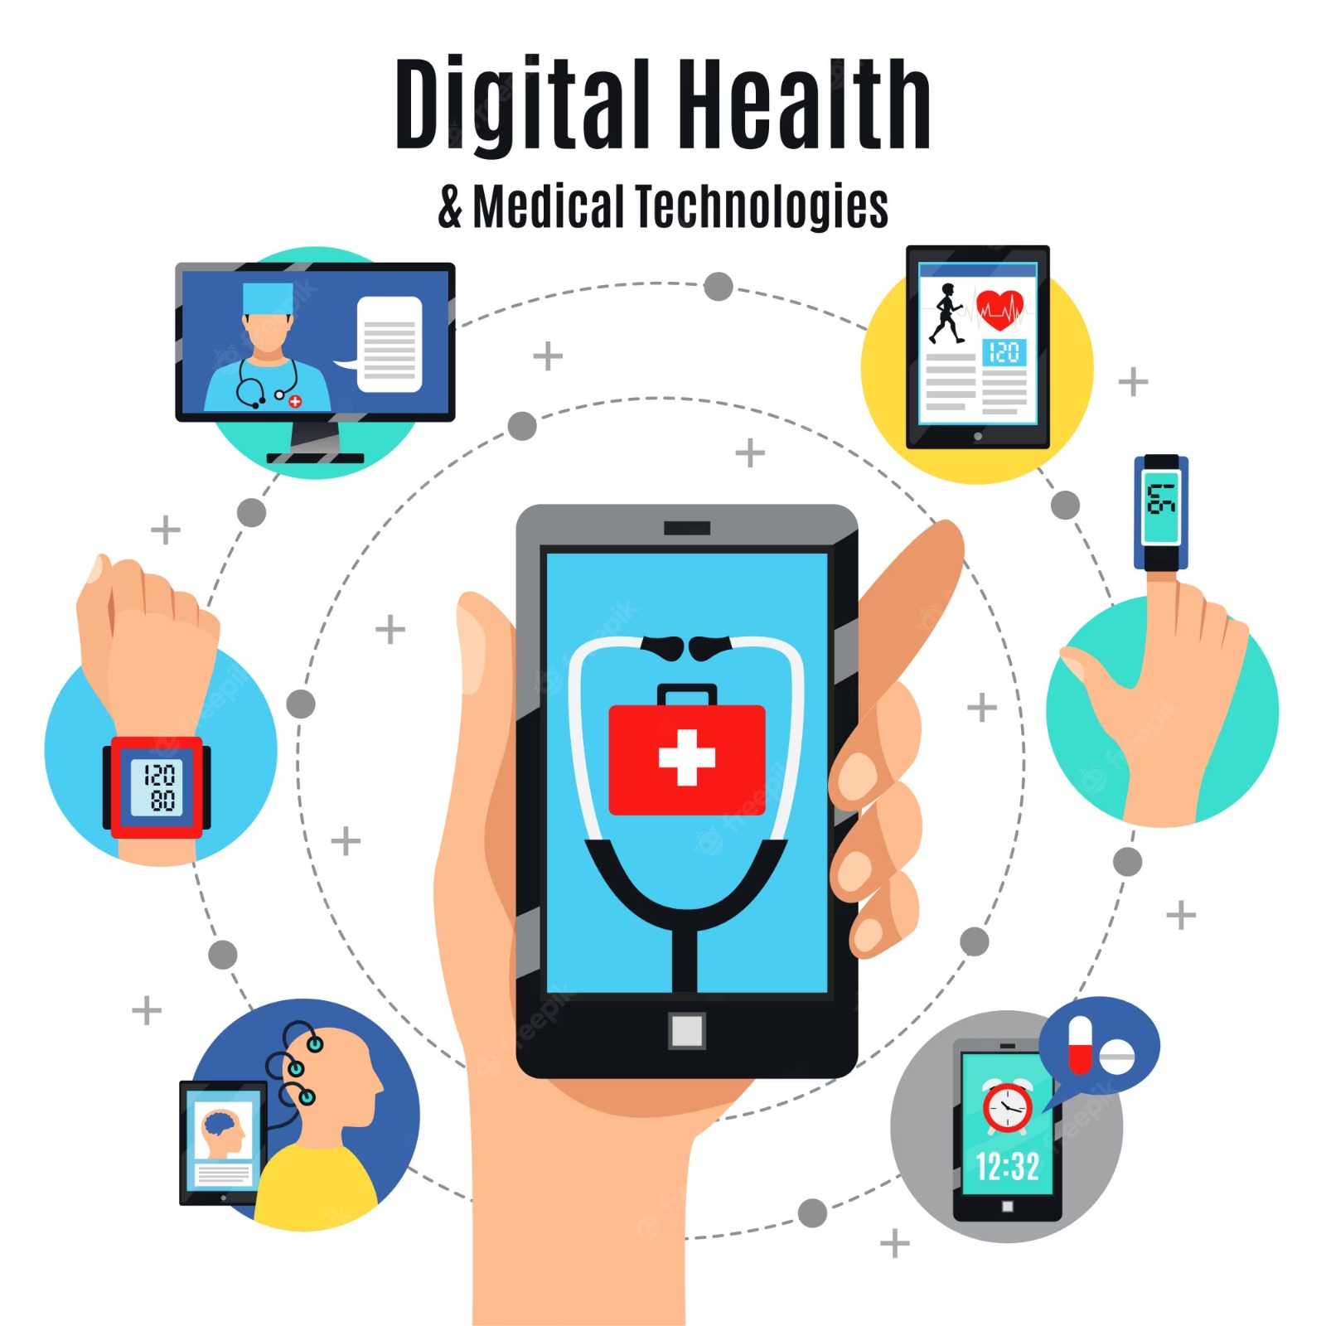
Figure 3: Technology Supports Health Promotion
(Source: Prakhar, 2023)
Prevent AI helps in health promotion by affixing the domain of several strategies known as behaviour change interventions with the principles of a personalised digital coach in real time. The system applies the concepts of goal setting, adaptive feedback and predictive health alerts to promote sustainable behavioural change. According to Mair et al. (2023), personalised feedback and self-monitoring are behaviour change strategies that substantially enhance long term engagement and performance of behaviour change. Among the ways to communicate with the platform are daily activity tracking, risk notifications, and interactive health education modules. The intervention strategies are constantly altered according to the patterns of user behaviour and the prediction of health risk by the application of artificial intelligence. According to Rowe and Lester (2020), preventive healthcare systems based on artificial intelligence can be profoundly beneficial to prevent diseases earlier and provide improved health results in the long term.

2.4 Critical Discussion — Expected Impact + Limitations
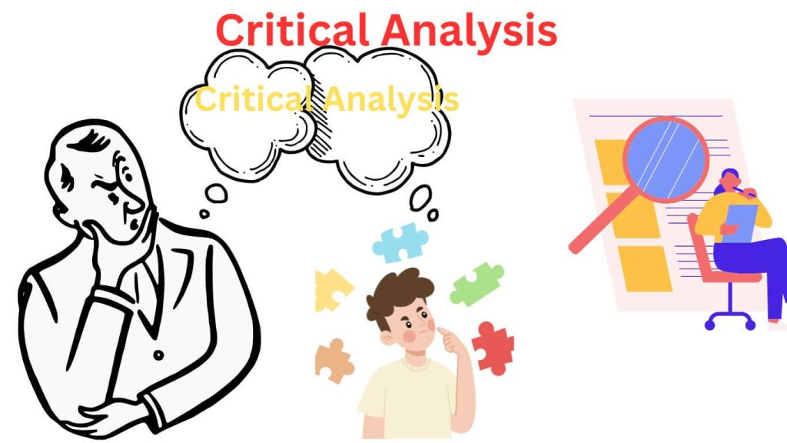
Figure 4: Critical Analysis on Impact& Limitations
(Source: Sonia, 2023)
Prevent AI will enhance user interaction, monitoring precision, and effectiveness of preventive intervention with the help of personalised AI-driven healthcare. According to Malloy et al. (2023), co-design methods in digital health enhance the usability and long-term adoption by target populations. Individualised digital coaching can lead to a rise in long-term behavioural adherence and prevention of health outcomes. There are, however, several limitations which should be taken into consideration. Large-scale implementation costs can limit the high development cost of large-scale deployments in low-resource settings. Algorithms or data privacy and decision-making complexities are ethical issues that are still significant limitations. According to Zarif (2022), one of the factors that continues to hinder expansive digitisation of healthcare is ethical and regulatory factors. Moreover, the barriers to adoption could be due to the technical literacy level, as older people may be less likely to utilise it. Consequently, although Prevent AI has excellent potential in preventive capabilities, ethical, financial, and access issues should be appropriately considered.

2.5 Improvement and Future Development
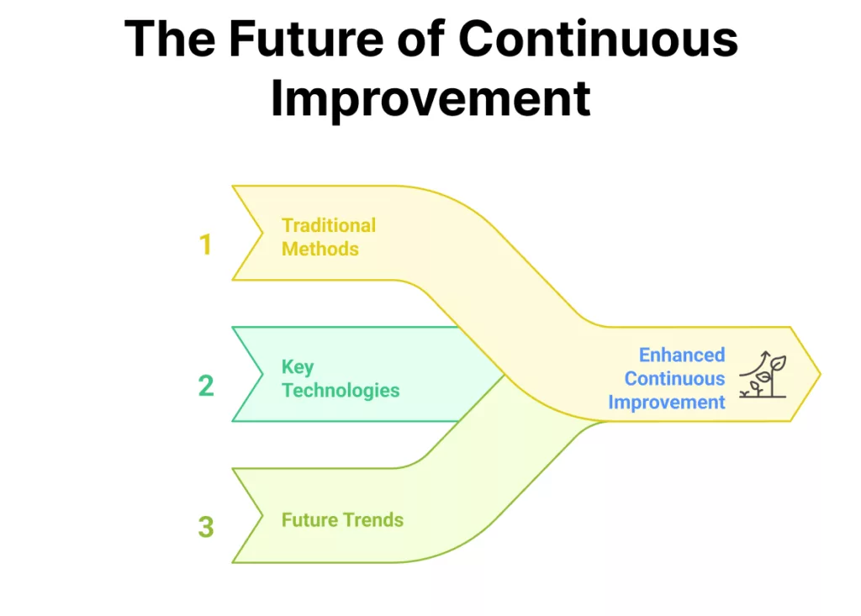
Figure 5: The future of continuous improvement
(Source: Bibisha, 2025)
Further progress could be supported with the goal of enhancing affordability using scalable cloud infrastructure, as well as integration with the public health policy. A larger multilingual access and easier user interface design can enhance world adoption. Farao et al. (2020) proposed that an effective and efficient digital health technology is associated with the continuous incorporation of user feedback. As a result, the incorporation of policy, ethical systems of governance, and sustained user-centred development will enhance the success of long-term implementation of AI-based preventive health technologies.

Reference List — Blog 2:
Farao, J., Malila, B., Conrad, N., Mutsvangwa, T., Rangaka, M.X. and Douglas, T.S., 2020. A user-centred design framework for mHealth. PloS one, 15(8), p.e0237910. https://journals.plos.org/plosone/article?id=10.1371/journal.pone.0237910
Mair, J.L., Salamanca-Sanabria, A., Augsburger, M., Frese, B.F., Abend, S., Jakob, R., Kowatsch, T. and Haug, S., 2023. Effective behaviour change techniques in digital health interventions for the prevention or management of noncommunicable diseases: an umbrella review. Annals of Behavioural Medicine, 57(10), pp.817-835. https://academic.oup.com/abm/article-abstract/57/10/817/7251346
Malloy, J., Partridge, S.R., Kemper, J.A., Braakhuis, A. and Roy, R., 2023. Co-design of digital health interventions with young people: A scoping review. Digital Health, 9, p.20552076231219117. https://journals.sagepub.com/doi/abs/10.1177/20552076231219117
Rowe, J.P. and Lester, J.C., 2020. Artificial intelligence for personalised preventive adolescent healthcare. Journal of Adolescent Health, 67(2), pp.S52-S58. https://www.sciencedirect.com/science/article/pii/S1054139X20300951
Zarif, A., 2022. The ethical challenges facing the widespread adoption of digital healthcare technology. Health and technology, 12(1), pp.175-179. https://link.springer.com/article/10.1007/s12553-021-00596-w

Image References — Blog 2:
Howland (2025). What is Public Health? Definition, Scope & Key Issues. [online] O.P. Jindal Global University. Available at: https://jgu.edu.in/opjgublog/what-is-public-health/.
Vikram (2022). Telemedicine and EHR Integration with Wearable Technology. [online] PrognoCIS EHR. Available at: https://prognocis.com/wearable-integration-with-ehr-promotes-interoperability/.
Prakhar (2023). Digital Health and Telepharmacy: Transforming Healthcare Delivery. [online] IIMT University Official Blog - Explore more! Available at: https://iimtu.edu.in/blog/digital-health-and-telepharmacy-transforming-healthcare-delivery/.
Sonia (2023). Interpretation of ‘Won’t Get Fooled Again’. Critique. [online]
Bibisha (2025). COVID-19 Situation: Six Sigma Ongoing Training Announcements. [online] SixSigma.us. Available at: https://www.6sigma.us/kaizen/continuous-improvement-strategies/.

