
iKonnect2U with Apple
By Nicola Bennett
Student: 1905849
Module: BMSW6102
Date: 25th March 2022
Executive Summary
Innovation drives growth and expands creative minds within an organisation. Recreating products and enhancing their chances to become popular within the world’s trending society leaves an organisation in high demand and high in profit. How an organisation put to use their innovation and creativity for business advantages is down to the leaders and management skill. Enhancing a product to communicate emotionally through artificial intelligence and psychologist expertise is classed as a gift.
Everyone in this world should be able to communicate, learn and better themselves individually and within a workplace, whether it is using tacit or implicit knowledge or many other sources that suit them, by having emotional intelligence within technology, is the way forward of the futuristic world of innovative communication.

Contents Page
1.0 Introduction …………………………………………………………………… ……Page 4
2.0 Apple Inc Background …………………………………………………………..Page 5
2.1 iKonnect2U – Innovation Opportunity………………………………..Page 6
3.0 Main Findings – Innovation Models ……………………………………..Page 8
3.1 Innovation Matrix ……………………………………………………………….Page 8
3.2 The Creativity Thinking Process…………………………………………..Page 9
4.0 Models of innovation …………………………………………………………..Page 10
4.1 Open and closed innovation ……………………………………………….Page 10
4.2 The Innovation Process ………………………………………………………Page 11
4.3 - 4 P’s of Innovation ……………………………………………………………Page 12
5.0 Assessment of the Effectiveness ………………………………………….Page 13
5.1 Forcefield Analysis………………………………………………………………Page 13
5.2 Barriers and Risks ……………………………………………………………….Page 14
5.3 Leadership and Management …………………………………………….Page 15
6.0 Conclusion ……………………………………………………………………………Page 16
7.0 References …………………………………………………………………………..Page 17

- Introduction
This report was requested by Davina Evans on Monday 10th January 2022 and to be submitted on Friday 25th March 2022.
It illustrates a thorough analysis on innovation and creativity within the chosen organisation, Apple Incorporated.
The purpose of this task is to explore and critically differentiate between models such as innovation process, innovation theories, secondary research, tools and techniques, whilst assessing the characteristics of the organisation.
This is to identify an innovative opportunity that can make a difference and capture values to those in need. Understanding technological enhancements, its strengths, weaknesses and limitations will highlight the innovation and creativity concept.
Drucker (1994, P.17) defines innovation as a precise tool that exploit changes to and organisation or service, symptomizing opportunities and achievements. King and Anderson (1995, p.5) believe innovation can be studied and applied at different levels, individually, within a small group or large organisation.
Henry (2001, p.5) explains that creativity is inventive thinking skills, expertise and motivation rolled into one. Creativity can be used compliantly with imaginative skills. Having experience, knowledge and technological intellect creates inner passion for motivation.
The difference between the innovation and creativity according to Taylor (2015) to innovate is to understand a process of an already made creation, refine it and to improve it. Whilst creativity is a measurable and changeable front-end process designed for a purpose and value.
“Appreciating the Curve, is the art of Innovation”
(Kawasaki, 2014)

2.0 Apple Inc Background
The company name Apple Inc represented a tiny seed, growing into something solid and substantial.
Apple is one of the largest information technology companies in the world and number one tech rated organisation, they are best known for innovation in hardware and software. World Atlas (2022) claims it’s estimated value is currently 1 trillion dollars and it all started with Steve Jobs and Steve Wozinak, both expertise in marketing and tech. Both met at UCLA Berkley and formed great friendships along with astonishing inventions, leading to a multinational corporation based in the USA.
According to Podolny and Hensen (2020) Apple produces many devices such as consumer electronics, personal computers including iPhones, iPads and iMac, which are manufactured in China. Apple work within functional structures within the organisation to maintain innovation, employees work alone and unite as a team to recreate and experiment new products and ideas continuously. Apple use motivational strategies along with building great relationships with them too. Management of Apple Inc (2022) state that leaders and management go by Maslow hierarchy of needs to reflect upon, constantly networking to maintain the top of the higher order of need.

2.1 iKonnect2U - Innovation Opportunity
Within our world of technology, communication has never been better, many devices implement efficient ways of communicating to loved ones, work colleagues and as of recent times, working from home. Innovative systems have been modified so that we can talk to anyone from anywhere in the world. However, Allen (2017) claims that technology has limited personal contact and separation between work and social life online, which can get in the way of connecting emotionally with loved ones.
Simons (2016) agreed that those with smart a phone, pick it up at least 85 times a day and use them over 25 hours per week, demonstrating that online activities have taken away a large percentage of quality time. However young children with mental health disorders and disabilities have been uncommunicated for a much longer period, sometimes their only way of activity and social aspects is with technology.
To address personal connection and communication with a family dynamic of those with specialist requirements, demonstrates there is a gap or flaw to communication. Interaction with family and friends is vital for emotional evolvement, although there is sign language, sign boards and even flip charts to help express their basic needs, there is very little technology to help express and understand their emotional and physical needs.
Rudy (2022) reports that autism emotionally effects people differently, they have trouble expressing and understanding emotions and become frustrated and challenging very quickly. This opportunity was identified by many social media trends for the public, Ackingbade (2022) approached the subject and reveals an autistic person can demonstrate frustration, confused emotions, limited focus and they cannot communicate how they feel, however, most people with autism can be visual learners their intelect is suited to the use of technology.

iKonnect2U is a new application which can be downloaded and linked to multiple Apple products. This app will use realistic visionary and sounding pictures, sign language and talk- tech to teach and sign post directly to a parent or carers device, letting them know their loved one is in basic need, emotional, happy or sad. A master device will be built especially and personalised to the family and situated in the heart of the home. The child can use this to communicate what they would like to eat, drink, play, or help explain how they are feeling, by creating a story or picture of what their needs are, as a linked system, a two-way connection for open communication is made clear.
The app reveals hidden psychological meanings of a child’s feelings at the time, once a child has used their device, an alert will signal to the parent’s device with reasons for the child’s behaviour also displaying professional psychological hints and tips on how to deal with the situation, in order to calmly address the child’s vulnerability, rather than frustrate them further.

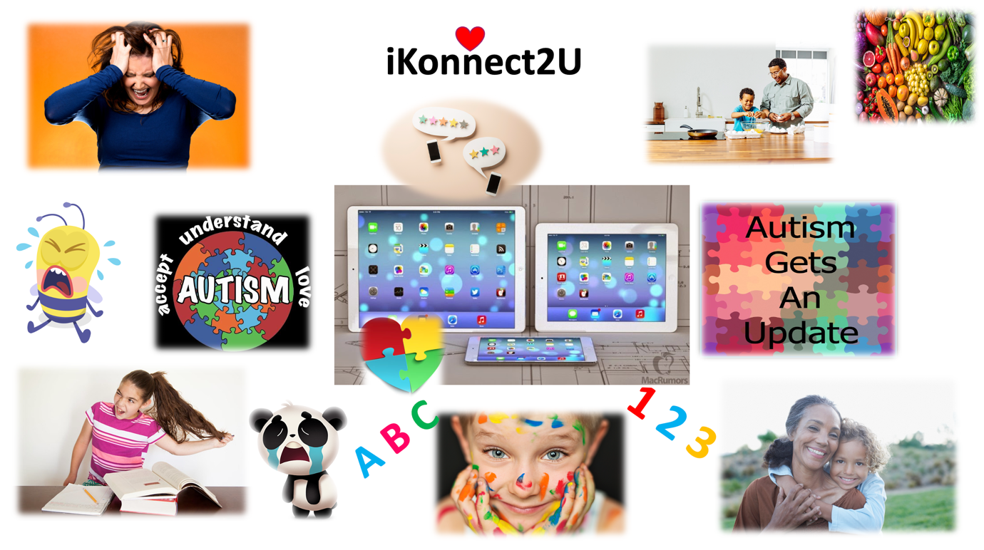
Apple Inc (2022), Stock Images (2022) and clipartkey.com (2019)

3.0 Main Findings – Innovation Models
3.1 Innovation Matrix
Models that are used within this report break down efficient ways of considering knowledge and understanding. A matrix helps explore innovation, understand tools, concepts and changes. According to Fey and Rivin (2005) the matrix can find qualities in technology and can identify problems swiftly.
Hough (2020) says that innovation is looked at in many ways, for revolution or problem solving. Whilst Toolshero (2022) explains that the matrix is a four-category visualisation method and can often be misunderstood due to its diversification tendency.
iKonnect2U is a sustaining and incremental innovation. Strengths of this innovation is that is it an improved device that will enhance communication at a different level and as it is enhanced, problems may be resolved sooner. There are areas that may be considered radical, such as a rebuild of a master device, but the advantages within this hardware is already available with Apple, the software is needed to be created with delicacy and creativity to help progress relationships within family dynamics.
However, the weaknesses of this innovation may be time consuming and only for a selective customer base, as it progresses, adaptations may take longer if external sources are needed.
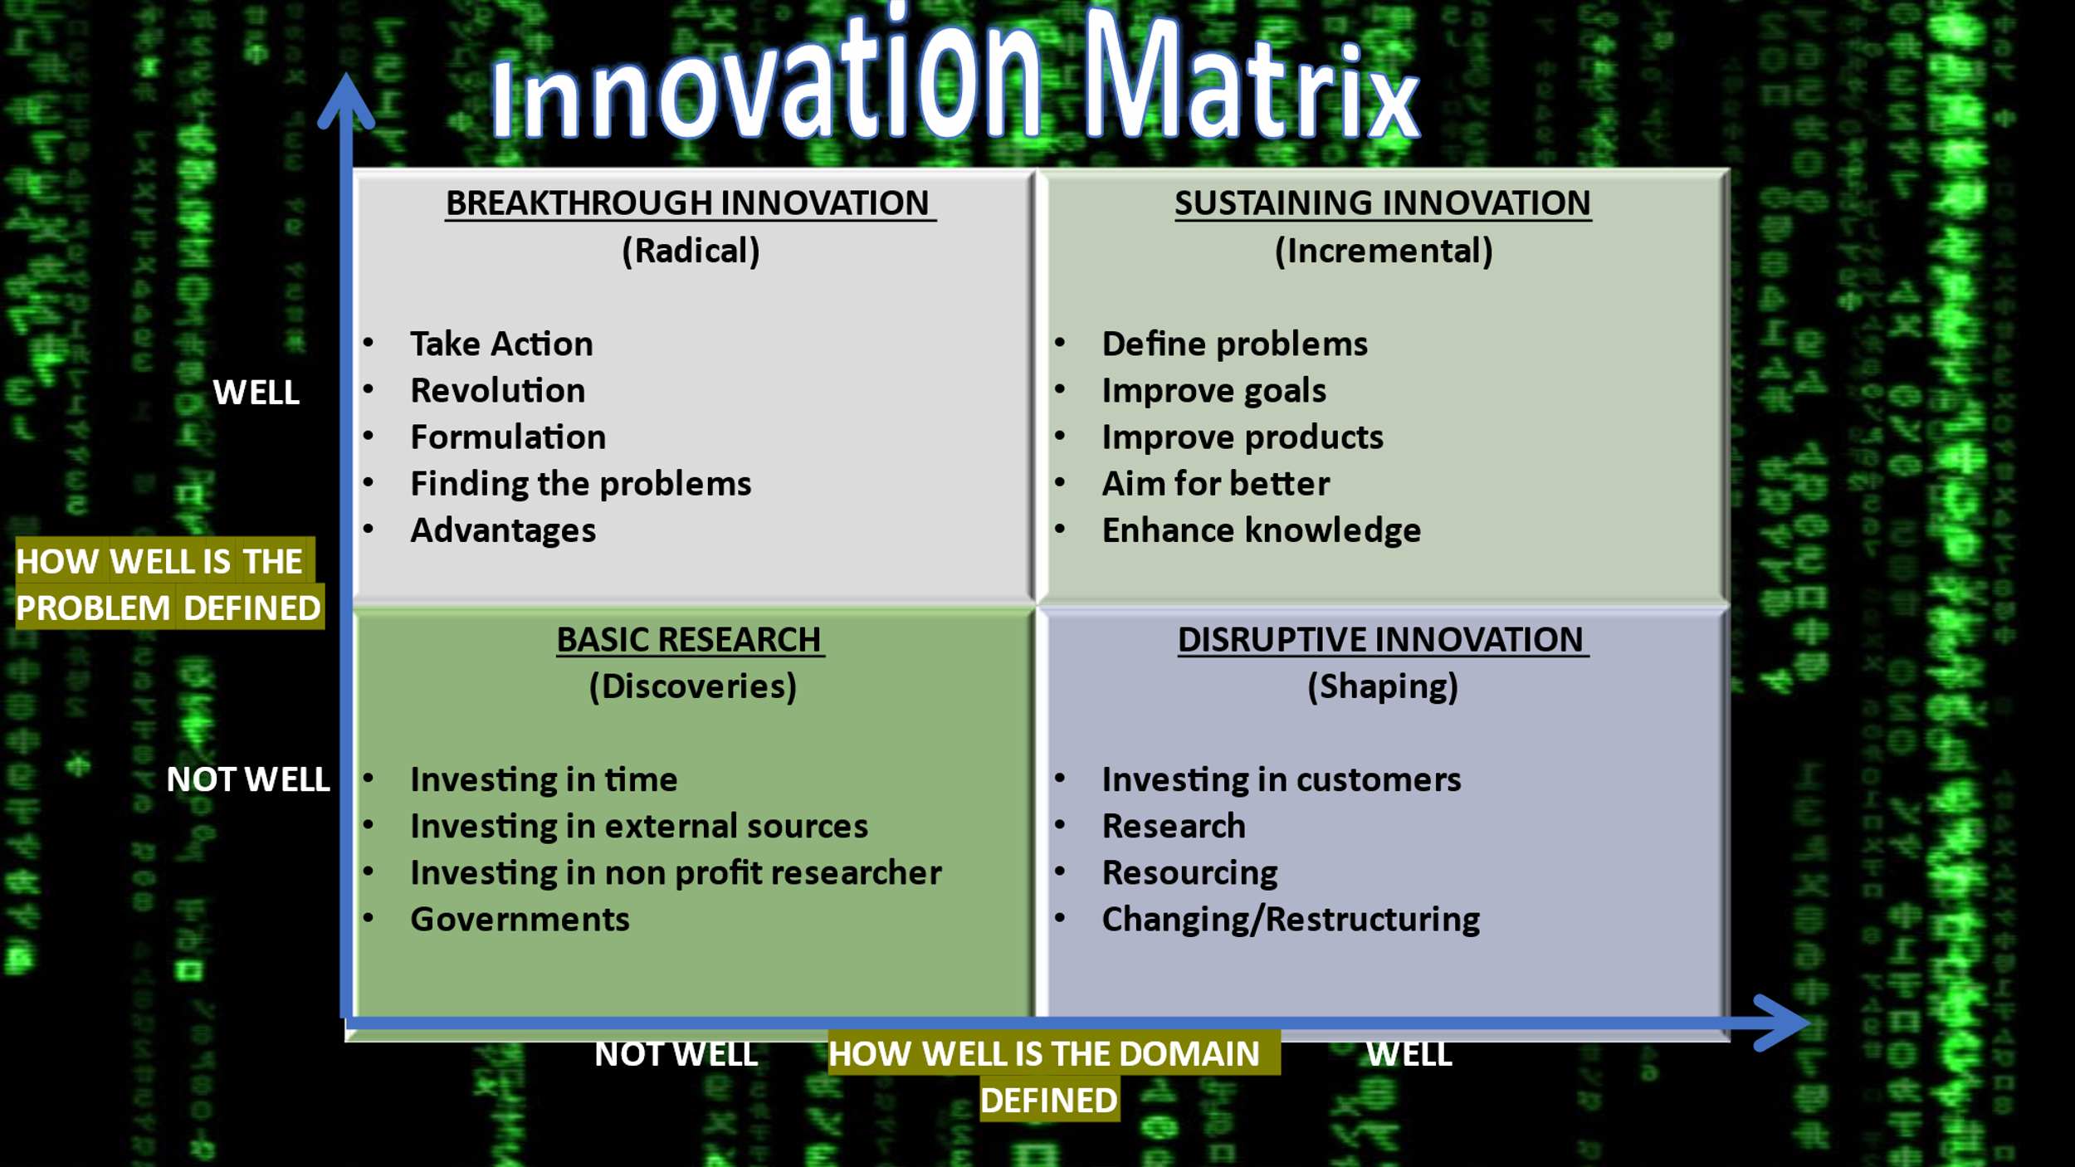
Devila et al. (2012) and Toolshero (2022).
3.2 The Creativity Thinking Process
Tidd (2018, p.89) claims that every individual has a unique capability, but if many unique individuals were creative and placed together, they could harness new ideas and combine motivation to invent and innovate. The Peak Performance Center (2022) says that planning for creativity is the key process that comes in four stages, preparation – defining the problems and acquiring information, incubation – mentally processing the information and cultivate new thoughts, illumination – the idea comes to life and the details are recorded, and verification - rules out strengths, risks, barriers of the creation.
At Apple, creativity and innovation is their specialist domain, Fitzsimons, Tanya and Fitzsimons (2008) write that Apple Inc has cultivated a strong work ethic for creativity and innovation. To help with their ideas, motivation and creative thinking campaigns are set to advertise marketing strategies.

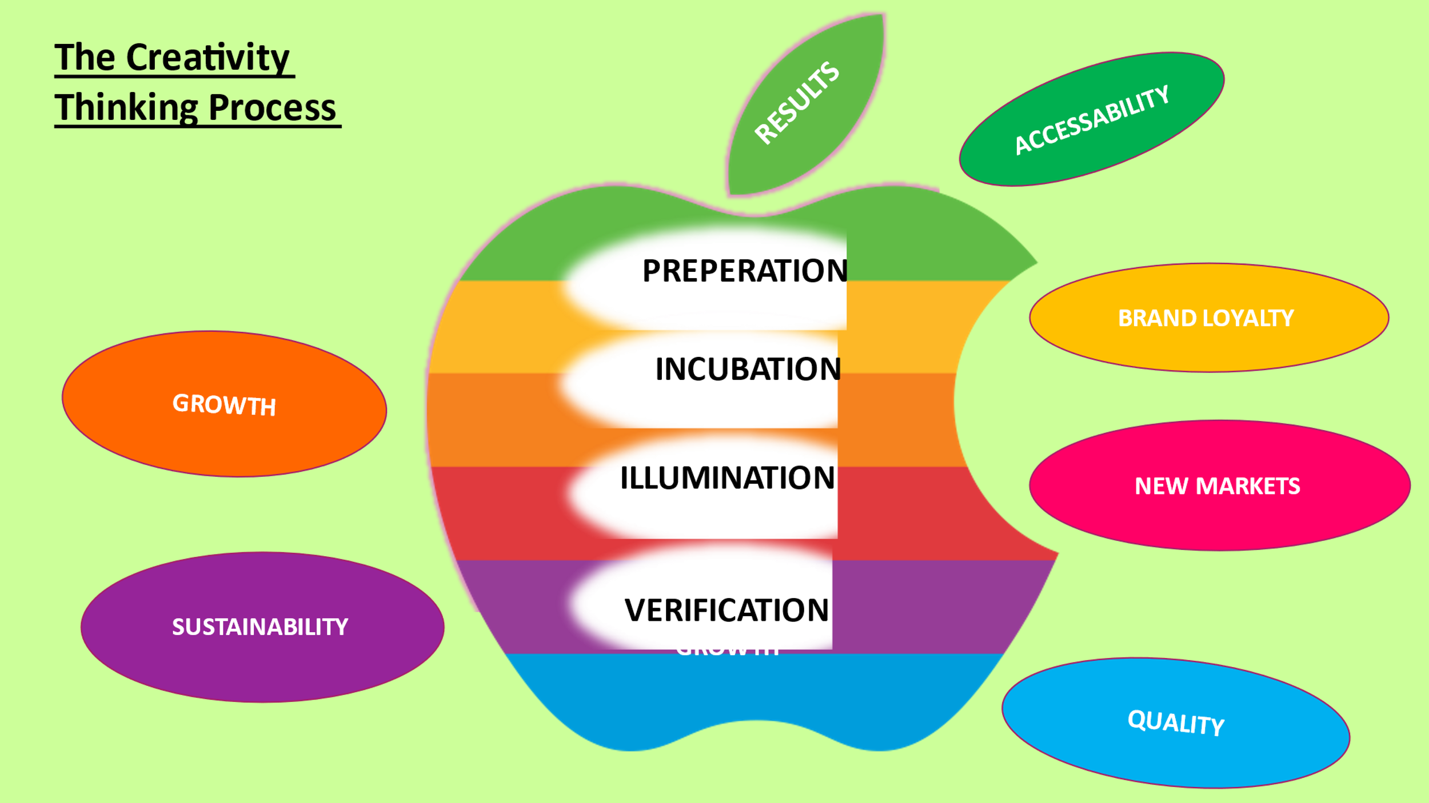
The Peak Performance Centre (2022)

4.0 Models of innovation
4.1 Open and closed innovation
Chesbrough, Vanhaverbeke and West (2014) explain that open innovation is defined as “the use of purposive inflows and outflows of knowledge to accelerate internal innovation and expand the markets for external use of innovation, respectively”, whereas Baranowski (2020, pp. 27-47) explains that closed innovation is where an organisation integrates and controls all of their research, development and design internally.
Casadesus-Masanell (2010, pp.27-47) reports that closed Innovation strategy within Apple had at one point helped them recuperate better products.
Whilst bringing iKonnect2U to life, it is imperative that it would be within a closed innovation strategy, due to its capability to enhance and progress communication preferences to a diversity of customers. Google has an open innovation process that welcomes external specialist knowledge to build its technology and ideas. Spruijt (2012) says that Google has set up many labs for researchers to evolve, create and develop their curiosities so that major inventions and innovations can be created.
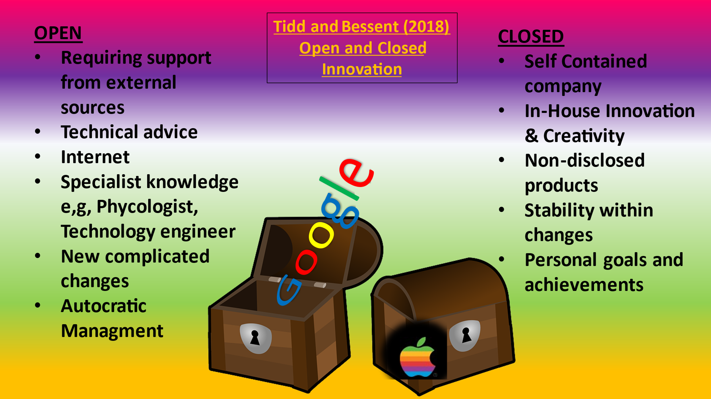
Tidd and Bessent (2018)

4.2 The Innovation Process
According to Satell (2017) the innovation process is about recognising a product, researching its qualities and possible failures and solving its problems, compromising changes that compliments the product.
Landry (2017) claims that taking different approaches and gathering feedback is essential during the process by aiming to have the right employees and targeting the correct customer base. The Schumpeter’s Team (2022) theory of innovation is believed to be the main reason for increased investments.

However, Khurana (2013) criticises that the innovation process can take time and customer needs change frequently, so there may be no end in sight for this product, leading to expensive and delayed evaluation.

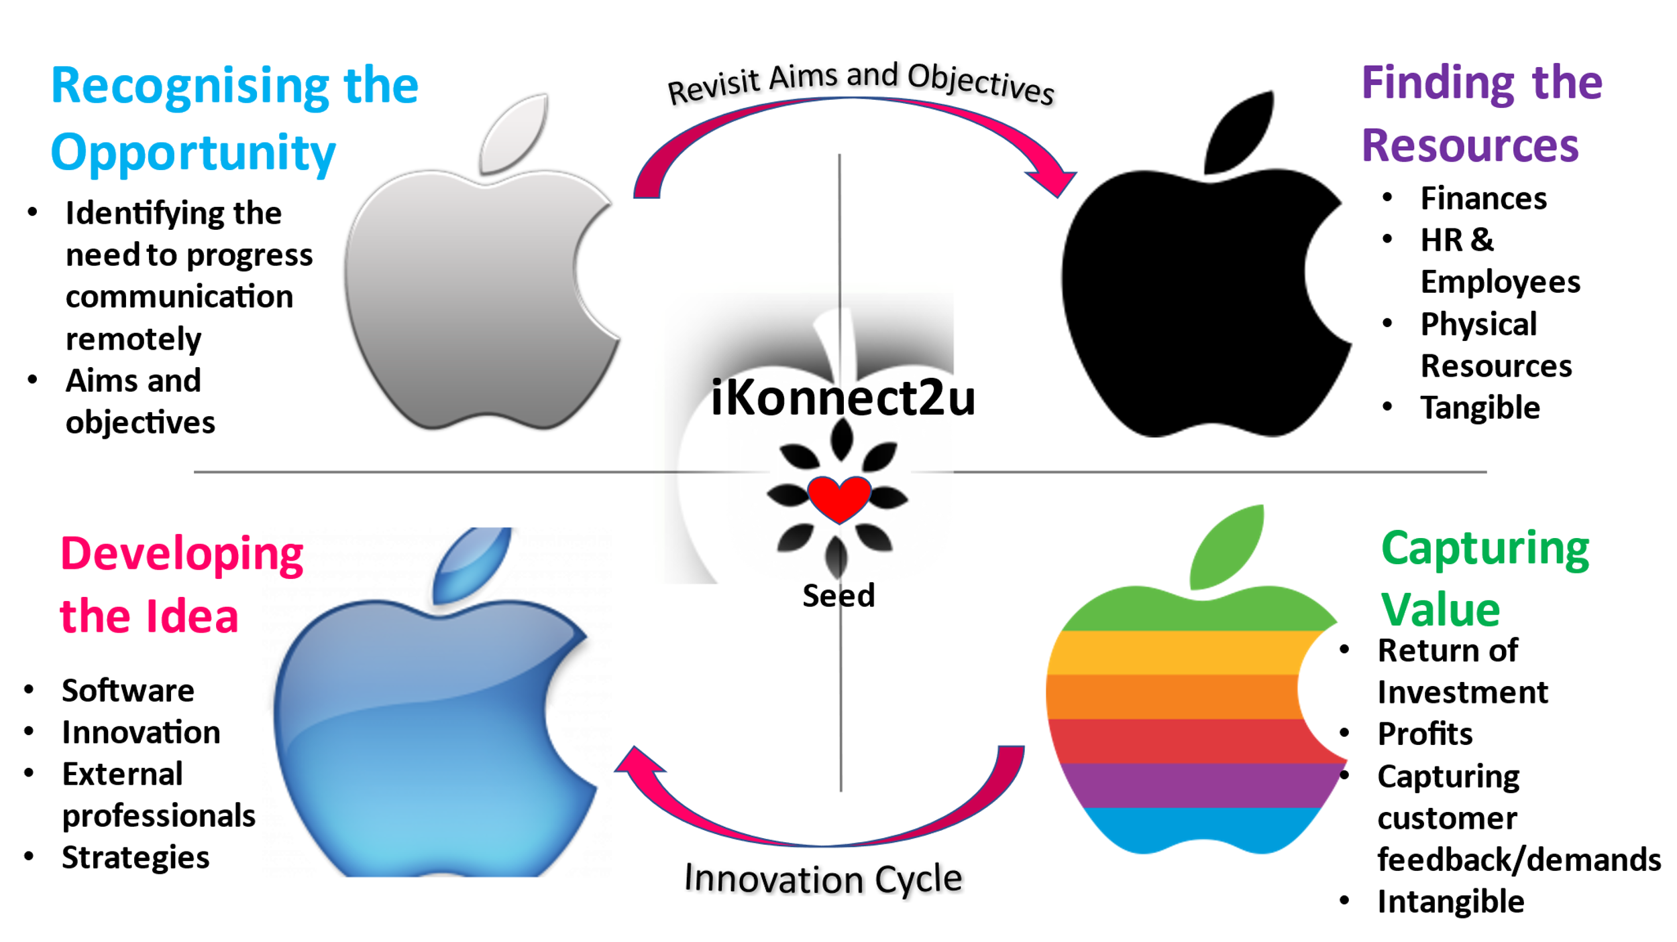
Khurana (2013)

4.3 - 4 P’s of Innovation
IM4 (2014) described the 4P’s from an organisation’s perspective, to create and offer products and services to the right customer base. The Business Teacher (2018) explains that product innovation is an induction to something great and new. Process is how they implement new ways of delivering the product to make it better. Position is how customers may view the organisation and recognise quality or service. Paradigm can mean big changes and possibly radical amendments to have the intangible effect at making a difference.
iKonnect2U is an incremental product if using the hardware, the software gives radical meaning to technology that focuses on psychology and emotional communication. Improving logistics with product familiarity and adding segments throughout the process can attract and educate customers.
The limitation of this model is that it is designed within a simple process to capture the basic, but yet important outcomes, it is very easy to overlook, specific and smaller weaknesses within the model.

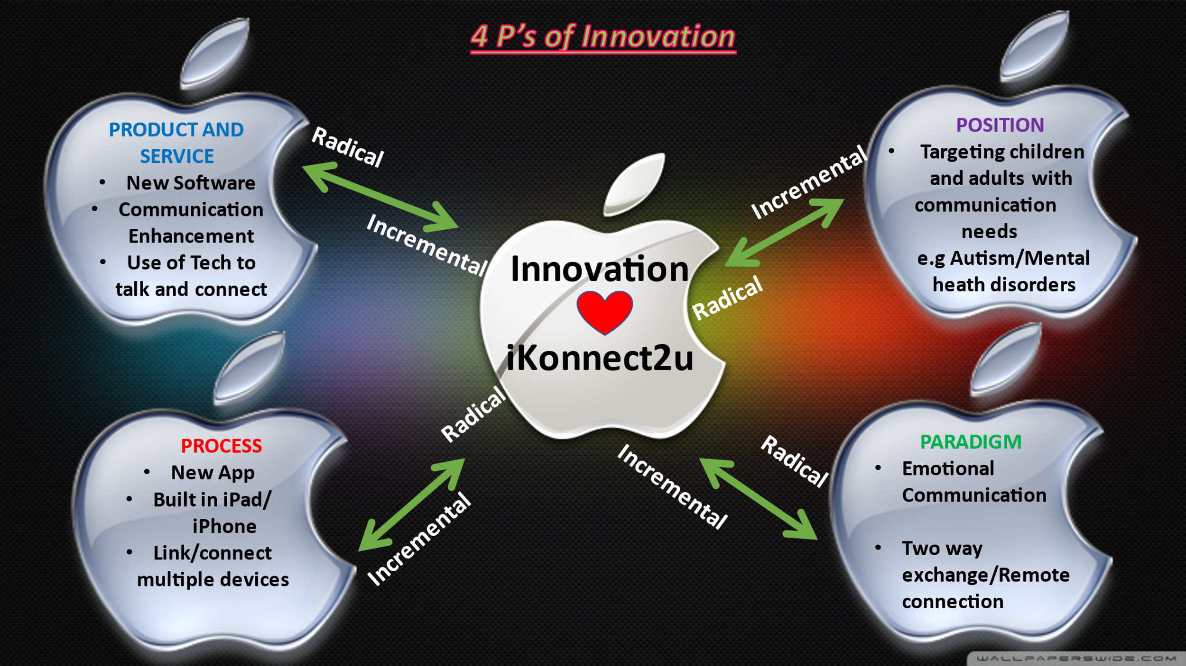
IM4 (2014)

5.0 Assessment of the Effectiveness
5.1 Forcefield Analysis
MindTools (2022) simplify that the Forcefield analysis is a way to separate the pros and cons of an innovation, as decision making can be challenging within new processes. Lewin invented this tool to find the driving factors that forces a definitive decision, either for or against change. A score is calculated to identify the importance of the change.
iKonnect2U was calculated and the good points came out at 22 and 19 for the limitations and risks, meaning that the outcomes for this innovation product is trending towards customers. To maintain effectiveness in the trend and product, a Forcefield analysis can be conducted throughout the innovation process. However, this may waste time and resourcing if covering similar changes, especially if trends are unpredictable with external factors.
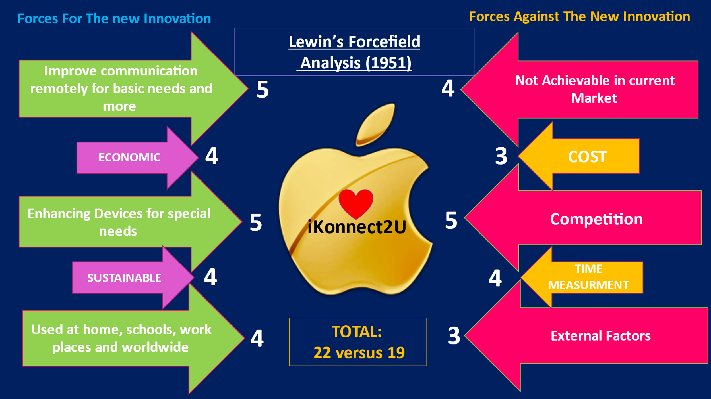
MindTools (2022)

5.2 Barriers and Risks
Within a PESTLE analysis the key areas Apple would look at is the Economical, Social and Technological factors, which can indicate some barriers and risks to be mindful of. Beattie (2022) explains that Apple’s weaknesses could be their In-house (closed) responsibilities regarding their hard and software, with the amount of content, may become too much for the company to handle, especially external suppliers cost and expenses to younger generations.
The Independent (2022) states a current risk to Apple that is circulating the media, one of Apples own employees had fraudulently laundered roughly $10 million dollars, but it’s not the money that is the issue, it is the negative social impacts and the conspiracy theories circulating. Using this risk within a forcefield analysis allows a breakdown of potential harm that may escalate from the fraud committed.
This could negatively impact iKonnect2U, as many investors would demonstrate concern the way fraud has been overlooked and see Apple as vulnerable, leading to jeopardization of contracts and a fear of security breach.
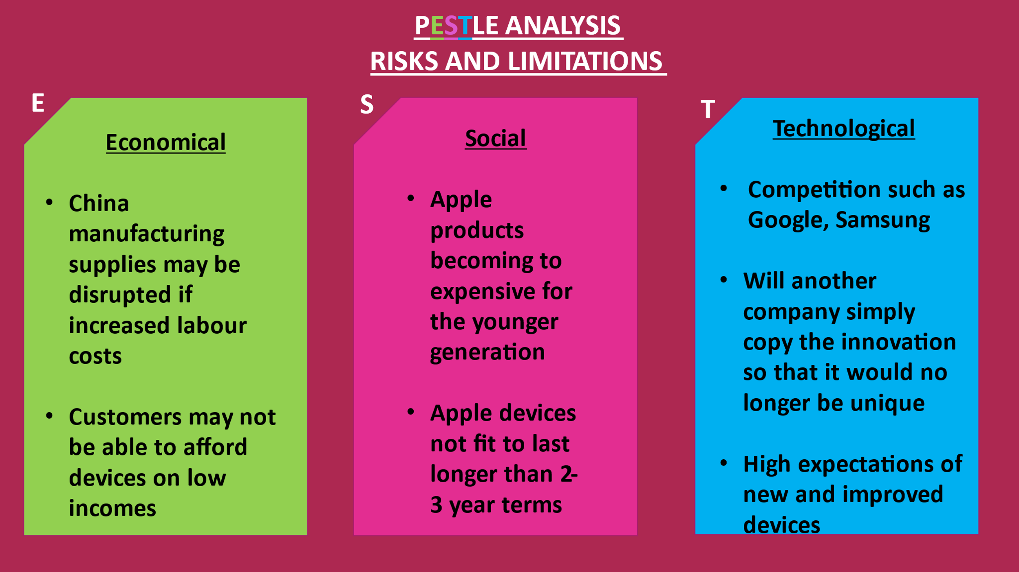
Beattie (2022)

5.3 Leadership and Management
Drucker (2002) once said that innovation is at its best when a leader employs potential staff to do the jobs independently. “Innovation is the work of knowing rather than doing”.
Apple Insider (2022) claims the management system had been changed in 1984 when Steve Jobs knew the company would drastically expand, hiring managers who had great experience, they categorised departments separately and individually. This demonstrated an Autocratic and Top-down trait towards employees, known as a classical or formal way of working for big companies. When Steve Jobs came back to Apple in 1997, he immediately fired the leaders in charge and united the departments, he hired product and engineer specialists and found the right employees that knew what they were doing, this tactic was a functional structure. Nelson (2019) refers to functional structure as a positive for skill development and great working atmospheres, exposes consequences and accountability, whereas Dontigney (2019) supports this theory and explains the disadvantages of hierarchical structure can have poor flexibility and poor communication leading to conflict between departments.
Apple Insider (2022) continues that Jobs had always believed in combining expertise to bounce ideas and innovation which has clearly worked in the organisations favour, it maintained when Cook had taken over Apple’s leadership in 2011. Dudovskiy (2021) echoes that Apple has integrated elements of democratic leadership but in a quiet yet effective way, it is believed the expertise and leaders within the organisation have an inspirational leadership approach, Cook has faith in in his qualified and well-trained employees to do the jobs at high levels, if not they simply will not last.
“Employee creativity can fundamentally contribute to organizational innovation, effectiveness, and survival. The main contribution of this research is to answer and explore a highly ignored link between transactional leadership style and employee creativity”
(Khattak, Batool, Haider, 2017, pp. 698-719)

6.0 Conclusion
Reflecting on this report and drawing all models and theories together, highlights Apple’s innovative and creative features. This report has analysed the true meaning of innovation and how many wonderful things have been created because of it.
The models of innovation help to explore new materials and to understand changes, whilst the thinking process has the drive and motivation combined. These models and theories have a visual concept of finding risks sooner, they also identify potential and evolve creativity. Utilising open innovation processes for iKonnect2U may lose sight of its originality due to the lengthy process and its many ideas but, going forward with the tools provided, it can help to amend its true features, which is emotional communication and family connection. Maintaining a closed approach within Apple is beneficial although, customer feedback overtime will certainly mould the software to become enhanced and specific to customer needs.
Having the right leaders and employees in place to implement motivation is vital for Apple, it shows competitive strength and unity as it can be passed through the organisation for greater outcomes. Enhancing employee abilities and trust in their work will not only build their self-esteem but will continue to produce productivity and effectiveness throughout.
Innovation demonstrates that the paradigm is already facilitating communication with technology, this shifts the paradigm slightly towards emotional communication rather than technical communication.
Using Apple to design iKonnect2U software is an advantage, a product designed for those in need can remotely connect a family to evolve their relationship and understanding, embracing technological communication, all of the time, at any time.

7.0 References
Ackingbade, D. (2022) 18 Things to Remember When You Love a Person With Autism. Available at: https://www.lifehack.org/articles/communication/18-things-remember-you-love-person-with-autism.html (Accessed: 17 March 2022).
Allen, S, (2017) The Effect of Modern Technology on Relationships. Available at: https://oureverydaylife.com/the-effects-of-modern-technology-on-relationships-12521218.html (Accessed: 15 March 2022).
Apple Insider (2022) How Steve Jobs’ Unorthodox Management Continues to Make Apple a Success. Available at: https://appleinsider.com/articles/20/10/26/how-steve-jobss-unorthodox-management-continues-to-make-apple-a-success (Accessed: 21 March 2022).
Baraowski, R. (2020) Open vs. Closed Innovation. Available at: https://www.linkedin.com/pulse/open-vs-closed-innovation-richard-baranowski?articleId=6630272717788590080 (Accessed: 17 March 2022).
Beattie, A. Apples Key Weaknesses. Available at: https://www.investopedia.com/articles/investing/072715/apples-key-weaknesses.asp (Accessed: 20 March 2022).
Casadesus-Masanell, R. (2010) ‘Open Versus Closed Innovation: A Model of Discovery and Divergence’, Academy of Management Review, 35(1), pp.27-47.
Chesbrough, H. Vanhaverbeke, W. and West, J. (2014) New Frontiers in Open Innovation. Oxford: Oxford University Press.
Drucker, P. (1994) Innovation and Entrepreneurship: Practice and Principles. 2nd rev. edn. Oxford: Butterworth-Heinemann.
Drucker, P. (2002) The Discipline of Innovation. Available at: https://hbr.org/2002/08/the-discipline-of-innovation (Accessed: 20 March 2022).
Dontigney, E. (2019) What are the Advantages & Disadvantages of Hierarchical Structure? Available at: https://bizfluent.com/info-8536984-advantages-disadvantages-hierarchical-structure.html (Accessed: 21 March 2022).
Dudovskiy, J. (2021) Apple Leadership: A Brief Overview. Available at: https://research-methodology.net/apple-leadership-and-apple-organizational-structure/ (Accessed: 21 March 2022).
Fey, V. and Rivin, E. I. (2005) Innovation on Demand. Cambridge: Cambridge University Press.
Fitzsimons, G. Chartrand, T. and Fitzsimons, G.L. (2008) ‘Automatic Effects of Brand Exposure on Motivated Behaviour: How Apple Makes You Think Different’ The Journal of Consumer Research, 35(1), pp 21-35. doi: 10.1086527269
IM 4 (2014) What is Innovation Space 4P’s? Available at: https://innovationmanagement4.wordpress.com/innovation-space-4ps/what-is-innovation-space-4ps/ (Accessed: 18 March 2022).
Independent (2022) ‘Former Apple Employee Charged with Defrauding $10 Million’, The Independent, 19 March. Available at: https://www.independent.co.uk/news/ap-apple-san-jose-b2039754.html (Accessed: 20 March 2022).
Kawasaki, G (2013) Lessons of Steve Jobs. Available at: https://www.youtube.com/watch?v=Mtjatz9r-Vc&t=1275s (Accessed: 17 January 2022).
Khattak, S. R. Batool, S. and Haider, M. (2017) ‘Pakistan Journal of Commerce and Social Sciences’, Relationship of Leadership Styles and Employee Creativity: A Mediating Role of Creative Self-efficacy and Moderating Role of Organizational Climate, 11(2), pp. 698-719.
Khurana, V. K. (2013) Innovation Process and Models. Available at: https://www.slideshare.net/VijayKrKhurana/innovation-process-models#:~:text=Linear%20Innovation%20Process%20Models%20Weakness%20%2F%20Limitations%20of,attaining%20target%20%2F%20maturity%2C%20less%20focus%20on%20learning (Accessed: 18 March 2022).
King, N. and Anderson, N. (1995) Innovation and Change in Organizations. London: Routledge.
Landry, L. (2017) The Innovation Process: A Step by Step Guide. Available at: https://www.northeastern.edu/graduate/blog/innovation-process/ (Accessed: 18 March 2022).

Management of Apple Inc (2022) Motivation: What does Apple to do Motivate Their Employees. Available at: https://managementofapple.wordpress.com/motivation/ (Accessed: 21 March 2022).
MindTools (2022) Forcefield Analysis: Analyzing the Pressures Fore and Against Change. Available at: https://www.mindtools.com/pages/article/newTED_06.htm (Accessed: 18 March 2022).
Nelson, L. (2019) The Advantages of Functional Organization Structure. Available at: https://bizfluent.com/list-6544799-advantages-functional-organization-structure.html (Accessed: 21 March 2022).
Podolny, J. and Hansen, M. (2020) ’How Apple is Organised For Innovation: Its About Experts Leading Experts’, Harvard Business Review (November/December), Available at: https://hbr.org/2020/11/how-apple-is-organized-for-innovation (Accessed: 14 March 2022).
Satell, G. (2017) Innovation: The 4 Types of Innovation and the Problems They Solve. Available at: https://hbr.org/2017/06/the-4-types-of-innovation-and-the-problems-they-solve (Accessed: 17 March 2022).
Simons, M. (2016) How Technology Affects Our Relationships. Available at: https://welldoing.org/article/how-technology-affects-our-relationships (Accessed: 15 March 2022).
Spruijt, J. (2014) Brilliant Management Advice From Google’s Eric Schmidt on How Google Works. Available at: https://openinnovation.eu/tag/google/ (Accessed: 17 March 2022).
Taylor, J. (2015) What is the difference between Innovation and Creativity. Available at: https://www.youtube.com/watch?v=TL2d2t2iZkY&t=443s (Accessed: 10 March 2022).
The Business Teacher (2018) What are the 4 P’s of Innovation. Available at: https://www.youtube.com/c/TheBusinessTeacher/search?query=innovation (Accessed: 18 March 2022).
The Peak Performance Centre (2022) The Creative Thinking Process. Available at: https://thepeakperformancecenter.com/educational-learning/thinking/types-of-thinking-2/creative-thinking-process/ (Accessed: 21 March 2022).
The Schumpeter’s Team (2022) Improving Lives through Market -Creating Innovation. Available at: https://www.schumpeter.org/ (Accessed: 21 Marxh 2022).
Tidd, J. (2018) Managing Innovation: Integrating Technological, Market and Organisational Change. 6th edn. NJ: John Wiley and Sons Inc.
Toolshero (2022) Innovation Matrix. Available at https://www.toolshero.com/innovation/innovation-matrix/ (Accessed: 15 March 2022).
Tutor2U (2016) Lewin’s Forcefield Analysis Model. Available at: https://www.youtube.com/watch?v=X9ujAtYAfqU (Accessed:14 March 2022).

Images List
Clipartkey.com (2019) Autism Spectrum Disorder Heart. Available at: https://www.clipartkey.com/view/wRhbiR_autism-awareness-heart-autism-spectrum-disorder-heart/ (Accessed: 15 March 2022).
Clip Art Library (2019) Apple Logos. Available at: https://pngimg.com/image/19689 Accessed: 15 March 2022).

Innovation and Creativity – Task 2
Critically explain how innovation and creativity can support business advantage.
Schumpeter’s theory of innovation was viewed to recognise new changes in a methodological form, as in new markets production and new technology sources that is based upon a continuous cycle of development. Business Jargons (2022) claim that business growth enables a natural evolution in many aspects, intangible qualities, providing low-cost products and generating profitable value to the organisation.
Innovation and creativity can deliver substantial benefits that support business advantages. These benefits can help achieve build a diversity in trends and help to drive out competitors. Researching for lower cost in manufacturing and suppliers can be difficult especially making sure better quality of products than its competitors.
Sokolova (2015) identify that innovation and creativity have become a critical skill in many successful organisations. Gloor (2006) explains that advantages of innovation and creativity apply collaboration and social networking, disseminating knowledge within a business can often positively change strategies which can then progress to further research and great findings. These advantages in a business can have a positive knock-on effect in many areas, Reguia (2014) include sales, profits, new products, services and new market share, whilst InvestNI (2021) believe it will increase brand recognition and value.
However, they continue to say that the risk of not having innovation and creativity within organisations can fail a business, running the risks of losing shares to competition, reducing the cohesion of team efficiency and also tarnishing brand names and profit.
Problem solving is a key to innovation, finding risks associated with a new or enhanced product can eliminate risks and barriers before going onto the market. If innovation had not been introduced to a product many organisations would suffer, many faults and bad customer reviews can lead to public displays of negativity and drive the organisation to have a bad reputation, therefore not surviving economically.
Supporting business advantage starts from leadership and knowledge management, leadership can be viewed as a group rather than a role. Motivation and culture are assets that can be delegated to others, infectious qualities that will radiate through departments, managers need to maintain motivation and best practice culture, to keep momentum with competitive strategies and reputation.
MBA Knowledge Base (2021) convey that inimitable leadership qualities demonstrate visual concepts, these influences are absorbed by employees who will thrive on tacit knowledge, and own innovative perceptions, they continue to say that the right employees are a major advantage in any organisation.
However, Soulsby (2017) reports that a certain leadership quality, innovation and creativity can become very costly, demanding and time consuming. It is a possibility that many products can waste weeks months or even years being created or enhanced, which has been agreed by the leader and for it to end up being wasted or unsellable and have no guarantee on return investments. Technology for example can be copied by another organisation and enhanced further, creating something better and even more competitive.
To conclude, leadership is the top priority for business advantage, it is a pathway for success if the right leader has innovative qualities and can help anyone expand their skill set.
“Your employees are your company’s real competitive advantage. They’re the ones making the magic happen- so long as their needs are met.”
(Richard Branson, date unknown)

References
Business Jargon (2022) Schumpeter’s Theory of Innovation. https://businessjargons.com/schumpeters-theory-of-innovation.html#:~:text=Definition%3A%20Schumpeter%E2%80%99s%20Theory%20of%20Innovation%20is%20in%20line,major%20reason%20for%20increased%20investments%20and%20business%20fluctuations. (Accessed: 23 March 2022).
Gloor, P. A. (2006) ‘Swarm Creativity’, Competitive Advantage Through Collaborative Innovative Networks. Oxford: Oxford Scholarship Online. doi.10.1093970195304121.001.0001.
InvestNI (2021) Use Innovation to Start or Grow Your Business: Advantages of Innovation. Available at: https://www.nibusinessinfo.co.uk/content/advantages-innovation (Accessed: 22 March 2022).
MBA Knowledge Base (2021) The Role of Leadership in Innovation. Available at: https://www.mbaknol.com/modern-management-concepts/the-role-of-leadership-in-innovation/ (Accessed: 22 March 2022).
Reguia, C. (2014) ‘Product Innovation and the Competitive Advantage: Faculty of Economics and Management. https://core.ac.uk/download/pdf/328024363.pdf (Accessed: 22 March 2022).
Sokolova, S. (2015) The Importance of Creativity and Innovation in Business. Available at: https://www.linkedin.com/pulse/importance-creativity-innovation-business-siyana-sokolova (Accessed: 22 March 2022).
Soulsby, T. (2017) Advantages and Disadvantages of Innovation. Available at: https://getrevising.co.uk/grids/advantages-and-disadvantages-of-innovation (Accessed: 22 March 2022).
Quotefancy (2022) Richard Branson Quotes. Available at: https://quotefancy.com/richard-branson-quotes (Accessed: 23 march 2022).

Critically review and evaluate one lecture from the module and reflect on how this has supported your understanding of innovation and creativity.
Reflection
On the 14th February ‘The Innovative organisation’ activity was taught to us on campus, my first lecture after winter break, before this we received online tutorials.
I have always struggled with online lectures and found that I am easily distracted. However, when I am with my peers in an interactive session, I am focused and engaged fully. Serva (2016) describes this engagement as a social/interpersonal learning style, I feel my best work is produced surrounded by others who can relate and can bounce ideas off one another.
Having a visual perception can increase my understanding, Roell (2019) articulates that, visual learners have many strengths, such as, having a great sense of balance and alliance, they notice differences or similarities immediately and they have excellent organisation and imagination. However, according to Psychology Answers (2021) visual learners experience difficulties in education from text or speech, this may waste time due to repetitive reading or finding other ways to translate and can lead to frustration and confusion as sources for a visual learner may not always be available.
Another disadvantage is the distractions whilst at home, Ward (2019) reported that 45% of home workers/learners complained that they were easily distracted by household noises, dogs barking and feeling isolated, even family living at home may have a hard time accepting that we are actually at home and learning.
Within this lecture being on campus, we spoke about identifying opportunities and ways to access effectiveness. A Forcefield analysis had been demonstrated and used for the purpose of helping discover the advantages and disadvantages of an innovation. A spider diagram was implemented as a great visual source alongside audience participation in you tube and video tasks.
I decided to use this in preparation for my own effective innovation called iKonnect2U which is a software intended to help with special needs communication. The analysis had presented to me a visual diagnosis of what is important and what product research was needed to be enhanced or resolved before the next step was taken. Morrison (2007) clarifies that a Forcefield analysis is a graphical and visualisation tool. Once the analysis was carried out, we had a group discussion on our innovative idea. I explained to the lecturer and class, how I feel my product would help others, taking into consideration my own struggles with learning, I empowered those visions into words and came out with many more enhancements and ideas for the app. The vision became a reality when my power points were made, my way of learning and understanding a model is by making a power point and adapting my reports from there. Being in class, socialising, feeling supported and gaining implicit knowledge has been my strengths within this module.
Further reflect on how you could have improved on your understanding of this one lecture.
To understand this module a lot better and be fully engaged, I would have chosen to be on campus to help me maintain my visual and social ways of learning. Online is difficult to socially engage, therefore the only way I can improve is by having the tools, help, support and quiet time at the university class and library.
“Tell me and I forget.
Teach me and I remember.
Involve me and I learn.”
(Benjamin Franklin, date unknown)
(North Coast Education Services quotes, 2018)

References
Morrison, M. (2007) Forcefield Analysis: A Decision Making Tool. Available at: https://www.rapidbi.com/forcefieldanalysis/ (Accessed: 23 March 2022).
North Coasted Education Services (2018) The Power of Visual Communication. Available at: https://northcoasted.com/power-of-visual-communication/ (Accessed: 23 March 2022).
Psychology Answers (2021) What are the Advantages and Disadvantages of Visual Learning? Available at: https://psichologyanswers.com/library/lecture/read/516026-what-are-the-advantages-and-disadvantages-of-visual-learning#0 (Accessed: 23 March 2022).
Roell, K. (2019) The Visual Learning Style. Available at: https://www.thoughtco.com/visual-learning-style-3212062 (Accessed: 23 March 2022).
Serva, C. (2016) Social/Interpersonal Learning Style: Characteristics & Strategies. Available at: https://study.com/academy/lesson/social-interpersonal-learning-style-characteristics-strategies.html (Accessed: 23 March 2022).

