Poor communication can lead to many problems. Communication between police services and the community always needs to be at its best. However, this is not always the case. Communication between police and socially disadvantaged communities are causing problems such as “limiting the success of community policing and crime prevention in this neighbourhood and perpetuated the asymmetrical relations between many residents and the police.” The police not having the support of the public due to lack of communication can cause obstacles that prevent the police from supporting individuals and preventing crime. They also lose faith in the police force and take things into their own hands which can cause more problems to arise.
One case of a member of public taking things into their own hands was the daughter of Harry Harrington. She felt let down by police officers after reporting her father’s car and finding they were “pretty slack” with how they handled the case. The communication between police and Mr Harrington’s daughter was poor, when asked about checking CCTV footage she was met with “If we have the manpower.” The watch dog found in August 2022 that only “6.6% of robbery and 4.2% of thefts in England and Wales resulted in a charge.” On average over 80% more crimes were recorded in more deprived communities with violence crimes being 2.6% more likely. If the police were more involved and had more communication with lower income communities the public would have more trust in the police and crimes could also reduce due to more people coming forward and possible supporting.
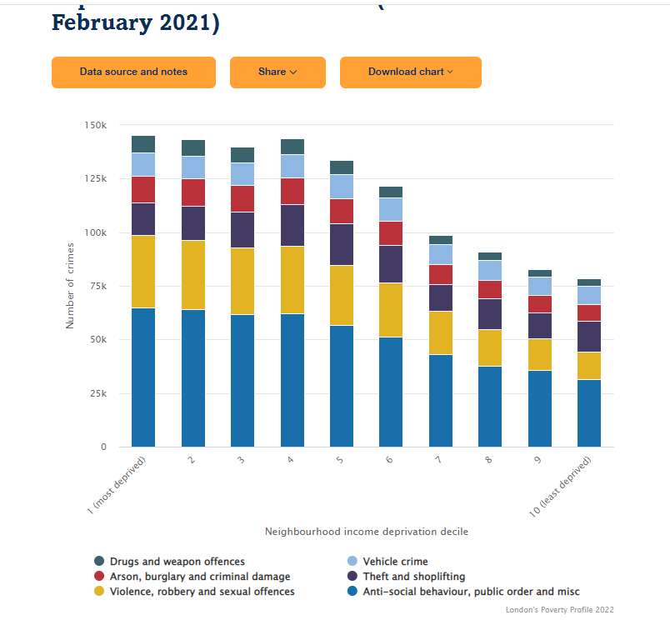

- Crime, Law & Social Change 30: 347–377, 1999. (1999) Kluwer Academic Publishers. Printed in the Netherlands
- Trust for London Crime and income deprivation (2021) https://www.trustforlondon.org.uk/data/crime-and-income-deprivation/ - Accessed on 24/10/22
- The Guardian (2022) Watchdog (2022) https://www.theguardian.com/uk-news/2022/aug/11/england-and-wales-police-failing-burglary-victims-inspectorate-finds - Assessed on 24/10/22
- Wales online, (2022) https://www.walesonline.co.uk/news/uk-news/woman-let-down-police-tracked-24740072 - Accessed on 24/10/22

