TITLE OF THE MODULE- BMSW4001
TITLE OF THE ASSIGNMENT- ACADEMIC AND EMPLOYABILITY SKILLS
STUDENT NAME-CRISTINEL ALEXANDRU BALINT
STUDENT NUMBER-1916886
MODULE LECTURER-JOANNA WALSH

Executive Summary
The academic and employability skills present the scope of learning the coursework and the additional skills which are considered essential in the job market. The Higher Education provides the purpose of seeking employment in the field of studies that the learner has attempted as a course of study. This report presents the aim of learning the essential skills of employment and incorporating them parallel with the coursework successfully. The report furnishes the SWOT analysis, Personal and Professional Development Plan as well as the time management tools implemented for the achievement of the position in a reputed organization after completion of the graduation level or can be utilized for the enhancement of the career by pursuing an advanced course of studies.

Table of Contents
1. Introduction 4
2. Skills 4
3. Different types of skills used with the learning strategies. 4
4. Classification of the skills used in academic and employability development 6
5. SWOT analysis 8
Personal and Professional Development Plan (PDP) 9
Time management tools 12
6. Conclusion 12
References 13
Appendix 15

Introduction
The academic and employability skills report produces effective learning of a student in bringing positive results in the field of higher education as well as in the sector of potential employment. The essential employability skills are evident to stand out in the crowd of the job market where employers seek candidates with both merit and employability skills. The report helps in providing a personal SWOT analysis depicting the areas of strength and the areas for improvement overcoming the weaknesses. The Personal and Professional Development Plan aims to bring the current level of achievement of the skills whereas the time management tools help in providing in-depth knowledge of management skills in the long-term for sustainable development in the personal and professional career growth.

Skills
Skills can be defined as the ability which helps in performance to produce desired results with investment of energy, time and both of them. Skills can be learnt during the academic coursework and to enhance for the employment. Skills can be earned through deliberation and dedication with flexibility in the outlook and having adapting nature.

Different types of skills used with the learning strategies.
The Higher Education learning theories are incorporated in the curriculum for assisting the learners in developing the skills through the theories and models. Every individual displays different styles of learning and acquiring academic and employability skills (Yew et al. 2016).
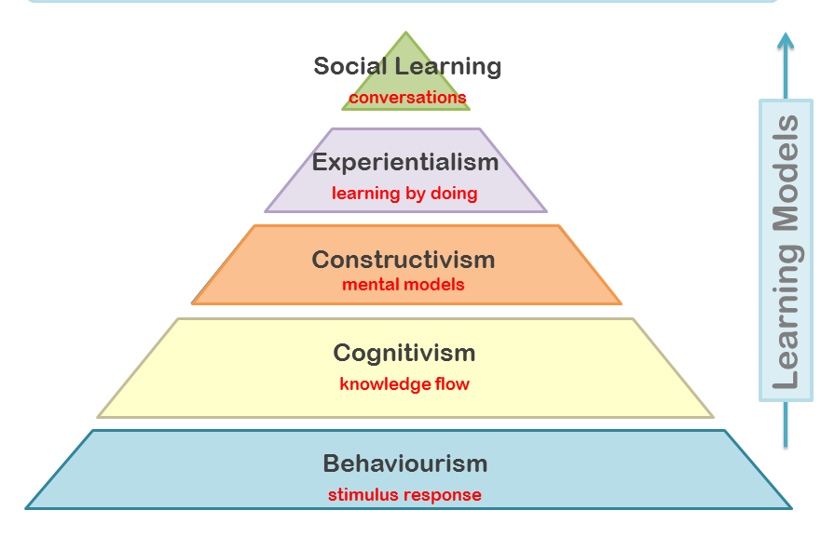
Figure 1: Five Higher Education Learning theories
The students pursuing higher education will pursue the course by imbibing the learning theories which comprise of the five learning theories known as behaviorism, constructivism, cognitivism, humanism, and connectivism (Major et al. 2018).

Behaviorism
This learning model projects the external facets of behavior displayed and the conditional behavior used during the process of learning. The theory defines that the process of learning begins when the learning environment provides a cue or stimulus which is responded by the learner. (Yarbrough, 2018).

Constructivism
This theory of learning provides the idea that the learner is responsible for formulating their comprehension of the context and they have a prior experience where they can relate them with the new ideas gained through the learning of the concepts and theories. This can also be known as interpretation of one’s learning through a previous understanding of the concept and relating the same with new perception and experiences. (Harasim, 2017).

Cognitivism
This theory of learning was proposed by Jean Piaget which provides the information of a child developing cognitive mapping in the comprehension of various contexts and providing physical response when he/she gains similar experiences. This theory of learning mainly focuses on reading and listening to the lectures provided by the tutors. (Barrett et al. 2016).

Social learning
This theory of learning can also be referred to as Connectivism. The social connections formed by the learners through the social media platforms or by socializing through the digital media help in the enhancement of the employability skills as well as develop working on the technology as well as networking with formal education (Siemens, 2017).

Experientialism
The learning theory connects with self-actualization also known as Humanism. This theory is proposed with the contribution of Abraham Maslow, James f. T. Bugental, and Carl Rogers where the theory of experientialism is merged. This theory of learning focuses on the personal growth of the learner, induce a creative approach to learning, and providing choice in learning. (Akhigbe, 2018).
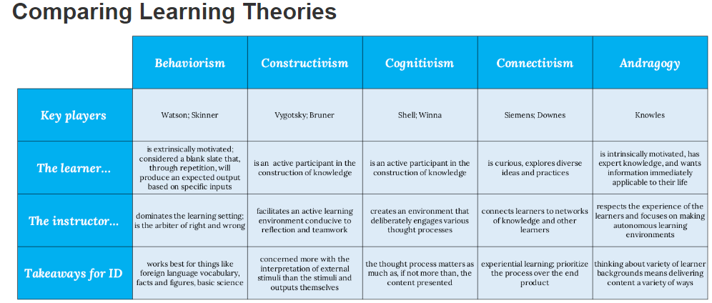
Figure 2 : Comparison of learning theories

Classification of the skills used in academic and employability development
The academic skills and employability skills are the stairs considered for the growth of a professional career. The Higher Education provides the scope of honing skills required to be presented during the time of employment that one may seek through personal contacts or campus interviews. The benefits associated with learning these skills are that a potential employee is better updated with the latest information about the working environments, has professional responsibilities, and can maintain the decorum and ethics of the organization. The skills therefore essential to learn and keep practicing are mentioned in the following points
Academic Skills- The skills displayed by the students during the higher education with the attributes of critical problem solving, decision-making and expressing exceptional analytical skills. The critical thinking and analytical skills prepare a student for the real-life situation that may be faced at workplaces. Examples are like referencing skills, researching skills, managing and interpreting information (Ribner et al. 2017).
Employability skills- The skills eventually developed in the higher education to be presented with qualities at the work place and sustain for a lon-term is known as employability ksills. The employability skills can be enhanced by the students by constantly practicing them. The examples are good communication skill, leadership skills and motivational skills (Suleman, 2016).
Hard Skills- The skills which are acquired by the potential candidates seeking employment through training, formal education, apprenticeship or internship are known as hard skills. It is essential to learn hard skills which are required to be displayed in the competitive job market. For example- computer skills, design skills, technical skills, presentation skills etc (Jones et al. 2016).
Soft Skills- The skills required to be displayed to impress and win trust of the employers are known as the soft skills. It can be learnt anywhere in life even during the academic courses. Application of soft skills involve effective communication with good body gestures, active listening, effective management of time, providing empathetic outlook and motivating the co-workers.
Planning and organizing skills- The coursework prepares a student to take the responsibility of creating assignments and projects which require organizing and planning resources and executing them sequentially. Therefore a potential employee needs to be prepared with the planning and organizing skills that can be timely displayed in the organization and the teamwork. The employee has to understand the priority of essential tasks and which ones can be postponed with extended deadlines (Todd, 2020).
Skills of communication- This is another important skill that has been practiced and incorporated in the academic and professional growth as effective communication can help accomplish an individual as well as teamwork. An effective communicator tends to fill the gaps of communication between the management and the employees. Miscommunication is reduced and conflicts of interest that may arise in teamwork can be mitigated through effective communication (Lynch et al. 2017).
Skills of negotiation- As stated by Khadhraoui et al. (2017), An effective communicator can easily become a negotiator between the clients, employees, and the employer. The terms and conditions can be negotiated by an effective medium of communication where there exists a gap in communication and negotiation (Stevens et al. 2016).

SWOT analysis
The SWOT analysis helps in evaluating the personal areas of competence where I might have weaknesses and strengths that can be transformed with the practice of academic and employability skills. This would also help me in exploring the opportunities and threats existing in the competitive world of employment.
- I have a good commanding and leadership skills.  - I can easily impress through my understanding of the subject and the content while speaking  - I have the ability of multi-tasking activities with precision  - I am confident with my decision-making skills considering all the aspects while making any decision.  - I have the skills of supervisor as I am engaged in Construction company. | - I am not a trained professional.  - I have the weakness of writing fast which may not be legible at times  - I am slow at completing the task as I take tome for completing it with precision.  - I have difficulty in understanding multiple languages which might be a communication barrier.  - I do not have time for my hobbies which is again a weakness for ehnacement of personal skills.
  STRENGTH
  WEAKNESSES
- I have been provided the opportunity to arrange a philately exhibition at my college campus  - I got the opportunity to completion of the advanced online marketing diploma course.  - I got the opportunity of representing my college in inter-college debate and won the second position. | - The potential employees joining the job market are considered as a personal threat for occupying the desired position.  - The constant competition in the job market is the potential threat for me being a candidate seeking employment.  - I have very busy schedule in which I cannot manage the advanced learning techniques.
  OPPORTUNITIES
  THREATS

Personal and Professional Development Plan (PDP)
The personal and professional plan helps in evaluating the current competent level of the employability skills that have included the progress of academic and employability skills with the feedback of the evaluator and provides the scope or improving the skills.
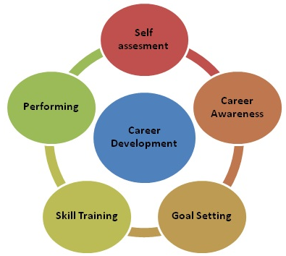
Figure 3: Professional Development Cycle
Professional skills | Current level | Evidence of action | Activities to be improved
Communication skills | Excellent | I have good communication skills which I used during the group assignments and employed during the arrangement of the philatelic exhibition. | I can still improve the formal communication where I can handle arranging events and the officials for a reputed business organization.
Time management Skills | Very Good | I have scheduling my work with planners and calenders which help me managing the time. | I have the scope of improving the time management skills through incorporating the urgent tasks in the scheduled time.
Planning and organization skills | Good | I have good organizing and planning abilities where I research for the resources and employ them sequentially for a given task. | I need to improve the planning and organizing skills by recording the priority to be fulfilled at the first stage and then the rest of the tasks.
Leadership skills | Good | I have good leadership skills as I have been given the opportunity of leading my team in various events of the college. | I need to improve my leadership skills where I can employ the required methods to control the energy of the team and can direct them to achieve desired results.
Technological skills | Average | I perceive that I have average skill in technical aspects as I am not conversant with the application of various technological devices or applications. | I can improvise technological skills by learning advanced skills.
Academic Skills | Current level | Evidence of action | Activities to be improved
Research and note taking skills | Very Good | I have been able to communicate with mu supervisors or tutors in conducting research and taking appropriate notes on the assignments provided in the coursework | I have the sope of searching the authentic sites for collecting evidences as facts and figures which can help me honing the note taking skills in advanced course of education.
Writing Referncing and avoiding plagiarism | Very Good | I have been very cautious from the beginning of the session to use the authentic source for referencing my assignments. Plagiarism is the most crucial aspect which has been strictly followed by me in avoiding them in all circumstances. | I have the scope of learning more authentic sites for using the referencing as well as various styles for my future course of studies.
Paraphrasing and Summarizing skills | Good | I am good at paraphrasing and summarizing skills however I need to quote better words as well as understand the content for precisely summarizing them as per the requirements. | I can still improve in paraphrasing the context and mention the reference as per the requirements.

Time management tools
The time management tools can be used as the Time Priority Matrix which can be utilized for the prioritizing of the tasks, planning for a rapid method of completion of the tasks, and time blocking method where the time can be blocked for specified tasks. The planners and calendars can be used to fix the schedule of priority tasks and buffer time can also be provided in between two or more important tasks to be completed so that the tasks do not grow monotonous. These strategies can be implemented where the matrix can determine between the urgent and non-urgent tasks.

Conclusion
In conclusion, it can be inferred that recommendation on the skills is offered based on the current level of competency which can further be improved with advanced learning and practicing the employability skills. It is essential to acquire sound technological knowledge which can help get employment in the desired position and the reputed organizations.
I have the opportunity of using my academic skills and employability skills in the coursework as well as managing the employment in construction company. The role of supervisor enhanced the graph of my career which has supported me in providing attention to details, hone up my planning and organizational skills and improve my formal communication with the present employer.

References
Akhigbe, T., 2018. Cognitive-behaviorism and experientialism in emergency medicine training: from theory to practice in a teaching hospital. International Journal of Medical Reviews, 5(3), pp.87-89.
Barrett, T.J. and CMP, C., 2016. Principles and theories of adult learning. Alliance Learning Center.
Harasim, L., 2017. Learning theory and online technologies. Taylor & Francis.
Jones, M., Orozco, V. and Rascon-Ramirez, E.G., 2016. Hard Skills or Soft Talk: Unintended consequences of.
Khadhraoui, M., Plaisentm, M., Bernard, P. and Lakhal, L., 2017. The impact of marketing skills and negotiation skills of universities technology transfer office on technology transfer success. Journal of Marketing and Management, 8(2), pp.38-46.
Lynch, C. and Kidd, J., 2017. Early Communication Skills: Early Communication Skills 3e. Routledge.
Major, T. and Thalia, M., 2018. Problem-based learning pedagogies in teacher education: The case of Botswana. Interdisciplinary journal of problem-based learning, 12(1), p.1.
Ribner, A.D., Willoughby, M.T., Blair, C.B. and Family Life Project Key Investigators, 2017. Executive function buffers the association between early math and later academic skills. Frontiers in psychology, 8, p.869.
Siemens, G., 2017. Connectivism. Foundations of Learning and Instructional Design Technology.
Stevens, C., de Weerd, H., Cnossen, F. and Taatgen, N.A., 2016. A metacognitive agent for training negotiation skills. In Proceedings of the 14th International Conference on Cognitive Modeling (ICCM 2016).
Suleman, F., 2016. Employability skills of higher education graduates: Little consensus on a much-discussed subject. Procedia-Social and Behavioral Sciences, 228, pp.169-174.
Todd, F. ed., 2020. Planning continuing professional development. Routledge.
Yarbrough, J.R., 2018. Adapting Adult Learning Theory to Support Innovative, Advanced, Online Learning--WVMD Model. Research in Higher Education Journal, 35.
Yew, E.H. and Goh, K., 2016. Problem-based learning: An overview of its process and impact on learning. Health Professions Education, 2(2), pp.75-79.

Appendix
Professional skills | Current level | Evidence of action | Activities to be improved
Communication skills | Excellent | I have good communication skills which I used during the group assignments and employed during the arrangement of the philatelic exhibition. | I can still improve the formal communication where I can handle arranging events and the officials for a reputed business organization.
Time management Skills | Very Good | I have scheduling my work with planners and calenders which help me managing the time. | I have the scope of improving the time management skills through incorporating the urgent tasks in the scheduled time.
Planning and organization skills | Good | I have good organizing and planning abilities where I research for the resources and employ them sequentially for a given task. | I need to improve the planning and organizing skills by recording the priority to be fulfilled at the first stage and then the rest of the tasks.
Leadership skills | Good | I have good leadership skills as I have been given the opportunity of leading my team in various events of the college. | I need to improve my leadership skills where I can employ the required methods to control the energy of the team and can direct them to achieve desired results.
Technological skills | Average | I perceive that I have average skill in technical aspects as I am not conversant with the application of various technological devices or applications. | I can improvise technological skills by learning advanced skills.
Academic Skills | Current level | Evidence of action | Activities to be improved
Research and note taking skills | Very Good | I have been able to communicate with mu supervisors or tutors in conducting research and taking appropriate notes on the assignments provided in the coursework | I have the sope of searching the authentic sites for collecting evidences as facts and figures which can help me honing the note taking skills in advanced course of education.
Writing Referncing and avoiding plagiarism | Very Good | I have been very cautious from the beginning of the session to use the authentic source for referencing my assignments. Plagiarism is the most crucial aspect which has been strictly followed by me in avoiding them in all circumstances. | I have the scope of learning more authentic sites for using the referencing as well as various styles for my future course of studies.
Paraphrasing and Summarizing skills | Good | I am good at paraphrasing and summarizing skills however I need to quote better words as well as understand the content for precisely summarizing them as per the requirements. | I can still improve in paraphrasing the context and mention the reference as per the requirements.

