Polygon layer files in QGIS

When we create new Polygon files in QGIS we are creating a new database of information. The main aim of this process is to bring in our own data and therefore we can manipulate this data to enhance our presentation of our chosen area of interest. with any database we need to think about the fields that we want to add to our attribute table. Any file that we import into Q GIS we have an attached attribute table and you will notice that this table contains a field name, a record identification and other information attributed to that Polygon or point that you wish to add to the map.
Each time we create files within QGIS we are creating a new layer. So to begin with we need to use the create new layer option:

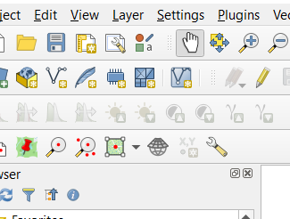

To do this you can use the icon as seen above or click on the layer option from the pull down menu and click on create new shapefile layer.

You will be presented with a new dialogue window and on this window we need to set up our database we do this by giving the file a name. Notice that whatever name you provide will default to a dot S HP file type. You then need to choose your geometry type again notice that you have the option to choose points lines we're going to create polygons. Look at the projection and because we are using data downloaded from Ordnance Survey we can use the British National Grid. A final step Mr add a field list this is our database.
The database is where you create references to your own information, so we need to provide some meaningful names and field types to contain our data. Remember we may wish to query the information contained within the fields at some later stage later in the analysis process so think about the field types.

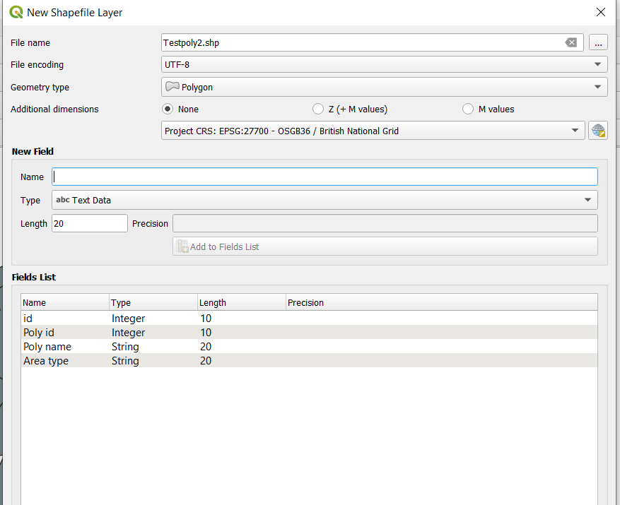

You will now see a reference to you new polygon in the layers section.
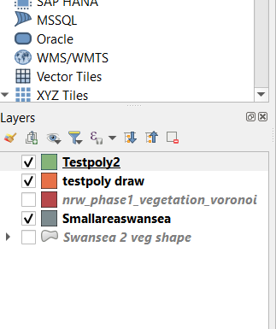

Right click on the newly created Polygon and choose the toggle editing option. Alternatively click on the pencil icon on the top menu bar. Once editing is activated we are able to select the odd feature button this time shown as a green Polygon.
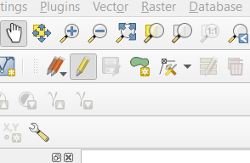

Once you click this feature you can draw in your new attribute and add the relevant data.1



