Joseph Davies (2502677)
[Company name] [Company address]
Industrial Robot Arm

Contents
Introduction JD 2
Group Organisation JD 3
Work Undertaken 4
Research 5
Project Management JD 5
Regulatory and Standard Requirements JD 8
Planning JD 10
Key Performance Indicators JD 11
Design Specification JD 11
Gantt Chart JD 12
Material and Manufacturing methods – HC 13
Introduction 14
Material comparison and research 14
Material selection 22
Base Frame – High Strength Structural Steel (S355) 22
Joints and Shafts – Hardened Alloy Steel (4140) 23
Extended sections – Carbon Fibre Reinforced Polymer (CFRP) 24
Bearing and Bushings – Bronze and Polymer Composites 24
Covers and housing – ABS and Nylon 25
Manufacturing Process selection 25
Base Frame S355 – Welded steel fabrication 28
Joints and shafts – CNC Machining 29
Arm Link manufacturing – Aluminium Extrusion and CNC machining 29
Extended section manufacturing – CFRP Resin transfer moulding 29
Bearings and Bushing manufacture 30
Covers and housing manufacture – Injection moulding 30
Design (OT) 31
Introduction to CAD Design 32
Concepts/Real Life Models 33
Sketch and Techniques 34
Components and Drawings 38
Assembly and Joints 44
Evaluation of CAD Design 46
Conclusion of CAD Design 47
Programming and Electronic LB 47
Analysis and Testing TE 48
Introduction TE 48
Robotic Arm Load, Weight and Length Analysis TE 49
Collective Mass/ Weight Table 54
Length of each Joint 54
Torque Analysis TE 55
Payload Force Calculation (25 kg Payload) 55
Joint Torque Calculations 56
Torque at Maximum Reach TE 58
Simulation Setup TE 59
Worst-Case Stress Analysis at Full Extension 59
Optimised Stress Analysis at 1500 mm Reach 60
Displacement Analysis 61
Conclusion TE 62
Procurement CG 62
Introduction to Procurement 63
Procurement Requirements 63
Market Research & Benchmarking 64
Supplier Risk Management 65
Commodity Risk 65
Geographic Risk 66
Political & Economic Risk 66
Supplier Dependency Risk 67
Lead Times and Supply Chain Considerations 67
Cost Analysis & Budget Control 67
Total Cost of Ownership 67
Cost vs Performance Trade-Off 68
Standardisation Strategy 69
Make vs Buy Analysis 69
Economies of Scale 70
Sustainability Considerations 70
Procurement Selection and Conclusion 70
Control Systems (LB) 74
Personal Contribution 74
Control Research 74
Frames of Reference 74
Kinematics 76
Trajectories 76
Jacobian 76
Position Sensing 76
Reduction Drives 77
Motors 77
Control Model Design 78
Matlab Simscape Physical Model 78
Control Methodologies 79
Sinewave 79
Signal Editor - Joint Rotation Profiles 80
Matlab Robotics Systems ToolBox Design 81
Trajectory Control 82
Jacobian Calculation 83
Future Work 83
Control Conclusion 84
Project Review JD 86
Successes 87
Failures 87
Bibliography 88
References JD 89
References OT 89
References CG 90
References HC 93
‌References TE 97
Laurence Browne References 98
Appendix 99
Time Sheet 100

Introduction JD
This report is to present the design and development process of an automated industrial robotic arm. The report will also present the planning, research and designs of the robotic arm as well as testing and evaluation of the robotic arm.
The goal of the project was to design and develop an automatic robotic arm that can be used across various industries at a price point that the robot arm can be purchased and used by smaller scale operations. The robot arm will be able to carry out hazardous and repetitive manual handling tasks that can reduce the risk to human operators.
The report will present the work carried out to research, plan, design and evaluate the robotic arm. Research was carried out by each member of the group based on their roles. Planning was carried out using a Gantt chart to determine the best possible rout to carry out the task. The design process included Drive systems and material selection alongside CAD models and simulations. Torque, stress, safety and payload analysis was carried out to ensure that the robot arm functions effectively and safely in real world environments.
There will also be an evaluation of the final design to determine if the group met the goal of designing an affordable automated robotic arm that can carry out various types of tasks at an affordable price that small scale operations can afford. As well as a project review, there will also be personal evaluations to determine our own performances.
Project Scope
- Must Have
  - Control Method of arm
  - CAD Model that displays motion of Robotic Arm
  - Simulation of Control system correlating to the robotic arms range of motion
  - Basic Safety controls such as limited access and interlocks
- Nice to Have
  - Ability to program robotic arm for repetitive tasks
  - Combined simulation of CAD model and control system using Simscape
  - FEA Analysis to show tolerances and Deflections
  - Situational Awareness to detect people or objects

Group Organisation JD

Member | Role | Course | Background
Joseph Davies | Project Manager | BEng Mechanical & Manufacturing Engineering | Manufacturing Engineer, BAE Systems
Thomas Evans | Analysis | BEng Mechanical Engineering | Mechanical Degree Apprentice, Safran Seats GB
Hywel Cleaves | Materials & Manufacturing Methods | BEng Material Science | Technical Manager, Zodiac Llanwern
Laurence Browne | Programming & Electronics | BEng Mechanical Engineering | Systems Engineer, Electro Optical & Infra Red, Leonardo
Charlie Gallagher | Procurement | BEng Manufacturing Systems Engineering | Aston Martin
Oliver Thomas | Design | BEng Mechanical Engineering | Injection Moulding Technician/ Maintenance

Work Undertaken

Research

Project Management JD
Project management is the discipline of planning, organising and controlling the work that is needed to achieve a specific goal within defined constraints such as time and cost. Project Management is an internationally standardised discipline, ISO 21502:2020 (Institute of Project Management,2022)
Project Management has 5 phases during any project, (Institute of Project Management, 2022)
- Initiation
- Planning
- Execution
- Monitoring & Control
- Closure
The role of a project manager can be split across the phases. During the Initiation and planning phase, the project manager is responsible for developing the business case, defining the scope, building a schedule and identifying risks. During the execution phase, they are responsible for managing communications and leading the team and keeping the project on track and within the time scale. During monitoring and control, they track performance, analyse variances and take corrective actions. And finally, during the closure phase, a project manager will ensure that the deliverables are accepted, capture lessons and formally close the project. A good project manager should be good at planning, budgeting, risk assessment and have the ability to communicate and manage a team of people (Institute of Project Management 2022)

Project Management Techniques JD
There are many project management techniques that are utilised by project managers during a project. Those Techniques are (Oxford College, 2023)
- The Traditional Approach
The traditional approach involves identifying the required tasks and creating a monitoring schedule that allows them to ensure that the tasks are completed on time to a high standard.
The approach means that the project manager will closely monitor team members to ensure that the tasks are complete, while offering support and resources where needed. The benefit of the traditional approach is that the project manager has clear control of the defined objectives
- Agile Method
An agile approach is similar to that of the traditional approach. Rather than focusing the larger objectives of the project, this method breaks those down into smaller short-term objectives that are easier to achieve.
The agile method is more appropriate for projects with many smaller goals that need to be achieved quickly, this allows the project manager to focus more on the individual tasks rather than the whole project. The method does require flexibility from all members of the project team, as the method does not follow a fixed plan, this does allow for quick response to change.
- Scrum
Based on the agile method, the Scrum technique is designed for smaller teams working on a project. The project manager is seen as the Scrum master; it is the project managers responsibility to deal any problems and obstacles that can prevent work from being completed on time. The method is typically used for projects that require testing and development, with smaller teams, ensuring focus on high-priority tasks, to ensure each is completed before the project progresses.
- Critical Path Management
The technique involves identifying the tasks that are vital to the project’s completion and planning the project that allows for those tasks to be completed. Critical Path management allows project managers to calculate how long tasks will take and identify tasks as critical or non-critical. This allows for an efficient project as teams can priorities tasks that require more time and effort and prevent bottlenecks as a manager can identify which tasks can be carried out alongside one another and which tasks rely on another being completed before it can start.
- Waterfall
The Waterfall technique ensures team members complete each task in turn, ensuring that current tasks are complete before moving on. The tasks need to be carried out in a chronological order for this method to be effective. The method relies on good communication to ensure tasks are completed in time and a high level of accuracy.
- Adaptive

An adaptive project management style allows for decisions and tasks to be gradually improved throughout the project lifespan. Project managers will take learned lessons from the outcomes of previous stages and apply them in the later stages to avoid the same mistakes. The method adapts to the need of the project and varies throughout. Instead of sticking to a rigid criterion the method enables the project manager to make decisions as you go. The method is driven by stakeholder feedback which allows them to dictate the project more for their requirements
These project management techniques use various tools to aid in project management such as (Oxford College, 2023)
- Project Evaluation and Review Technique (PERT) Chart
The PERT Chart is used to calculate the exact amount of time the project will take to complete. The chart displays the task dependencies and sequence and can be used along side the critical path management technique. It allows for project managers to evaluate task time frames and resource allocation within a project.
- Kanban Board
A Kanban Board provides a visual standard on the projects required tasks with each tasks current progress and priority level. Team members will have access to their own and the rest of the teams’ board to provide a status report to all members. A Kanban board identifies where there are delays or problems within a project and allows for tasks to be allocated. The method can be used within the agile project management methodology as it focuses on efficient and presents the current workload.
- Rational Unified Process (RUP)

RUP is a project management tool that enables companies to identify protypes and drafts which allows for adjustments to be made to the final product close to the targeted completion date to improve the final product from user experience. The RUP tool also allows for risks to be identified quickly and controlled.

- Gantt Chart

A visual project management tool that displays tasks, task duration and milestones on a shared timeline. The chart allows for all project team members with a clear understanding of how the project should unfold. (Bello, 2016) Gantt charts allow project managers to compare plans with the actual status and identify any delays which lets corrective actions to be taken quickly. (Malsam, 2025)

Regulatory and Standard Requirements JD
When designing and manufacturing any product to be used in industry it is important to ensure that that product meets all safety regulation and standards that are implemented by various governing bodies. Failure to meet these requirements can lead to action from these governing bodies, in the case of this project these actions can prevent the robotic arm from being manufactured, sold or put the at market disadvantage due to not being awarded specific markings. There could also be more sever actions that include fines and possible criminal charges.

Safety JD
There is key safety regulation that the design must comply to for sale and use of the robotic arm within the UK
PUWER 1998
Provision and Use of Work Equipment Regulation 1998 (PUWER) places duties on people and companies who own and operate work equipment. The regulation places responsibilities on companies whose employees use work equipment. PUWER require that any work equipment is suitable for the intended use, safe for use, maintained in a safe condition and inspected to ensure it is correctly installed and does not subsequently deteriorate, only used by those who have received adequate training, is accompanied by suitable health and safety controls such as guarding, emergency stop devices and adequate isolation from power sources and that the work equipment is used in line with specific requirements. (HSE, 2024)
This applied to the project as we must ensure that the robotic arm is designed to carry out tasks safely and that there are adequate safety controls in place
Supply of Machinery Safety Requirements 2008
This regulation requires us the designers and manufacturers of the robotic arm to ensure that machinery supplied is safe for use. As the designer and manufacturer, as a group we are obligated to ensure that essential health and safety requirements are met, there is a technical file is compiled and made available on request, provide information necessary to operate the robotic arm safely and ensure that the relevant conformity assessment procedure is caried out. (Office for Product Safety and Standards , n.d.)

ISO 10218-1
ISO 10218-1 guidelines the safety requirements specific for industrial robots. The standard is vital to ensure a safe design, the inclusion of risk reduction measures, and sharing of information for industrial robots. (ISO - International Organization for Standardization, 2025)
ISO/TS 15066
ISO/TS 15066 guidelines the safety requirements for collaborative industrial robot systems and the work equipment. The standard supplements the requirements and guidance on automated industrial robot operation that is defined in ISO 10218. (ISO - International Organization for Standardization, 2016)

Other Standards JD
ISO 8373
This states the standard terminology to be used for documentation and communication for robotics. This ensures that everything is produced and supplied with a universal language preventing mis communication and ensure that important requirements and factors are meet. (ISO - International Organization for Standardization, 2021)
ISO 9283
These standard details the methods of testing performance characteristics of industrial robots such as accuracy, positioning, path accuracy and repeatability and static compliance. The standard recommends methods of testing to ensure that there is an accurate measure of the robotic arm and covers all types of robotics to be used within industry. (ISO - International Organization for Standardization, 1998)
To support the analysis of the robot arm, research has been undertaken on robots with similar payload and reach requirements. The aim is to understand what level of performance is realistic for a robot arm intended to lift 25kg while operating at a reach of around 1500 to 2000mm.
A key benchmark robot was the FANUC M-20iD/25 as it closely matched the payload target. This is a 6-axis industrial robot with a 25kg payload, 1831mm reach and ±0.02 mm repeatability. The makes it a good comparison as it shows that a 25kg payload robot needs a large and rigid structure. The design is worth following in terms of the 6-axis layout, strong base and dedicated use for handling and manufacturing tasks. However, it would not be suitable to fully replicate as it is a highly engineered commercial robot with advanced motors, precision gearboxes and safety integration. For this project, this robot arm should be used as a performance benchmark rather than a design to be replicated.
The KUKA KR 30 has also been researched due to its similarity in manual handling capabilities. The robot arm has a 30kg payload, 2033mm maximum reach, 6-axis steup and ±0.15 mm repeatability. This shows the scale required to safely lift 30kg over a long reach and shows the importance of a heavy stable base and strong joints. However, it would not be suitable as its overall mass is 665kg which would massively conflict with our project aim of producing a low cost and accessible robotic arm.
The ABB IRB 2600 has also been reviewed as a relevant industrial robot. The arm has a 12kg payload, 1650mm reach, ±0.06 mm repeatability and a robot mass of 280kg. Although this robot arm has a lower payload than our projected target, its still useful as it shows how commercial robots achieve reach and repeatability through rigid structure and carefully designed joints.
Collaborative robot was also considered as the project aims to make automation more accessible and easier to use. The Universal Robots UR20 offers a good comparison because it has a 1750mm reach, 6 rotating joints and a maximum payload of 20kg with 25kg being possible under certain conditions. This makes the arm useful as it demonstrates a more user-friendly approach to automation compared to a more traditional robot arm. The simpler programming and collaborative focus is worth following for a lower-cost concept.
From this research, several important lessons were identified. Firstly, robots that are designed to lift 25kg normally require a reach of around 1750-2033mm and normally use 6 axes to provide flexible positioning. Second, repeatability of a commercial robot is typically much tighter than that of a low- cost prototype. Third, a higher payload and longer reach usually requires a heavier and rigid structure which all supports the need for torque and stability in the project analysis.

Planning JD

Key Performance Indicators JD
The Key Performance Indicators (KPIs) for the design of the robotic arm are:
- High Positional accuracy and Repeatability
- Max payload of 25+kg
- Reach of 530mm
- Successful Operation Rate of 99%
- Manufacture (including material sourcing, machining and assembly) costs below £20k per unit
- 50% or more off the shelf parts
- Use of sustainable materials with long life spans
- Simulations must show that the robotic arm can function in standard conditions with low chance of failure.
Project KPIs
- Design and Development of an automated robotic arm by the 20th of March
- Presentation detailing the plan and completed work by the 20th of March
- Full report with Self and Peer assessment by the 26th of May
- Presentation of Report by the 26th of May

Design Specification JD
Function | - The Robotic Arm should transport object from a defined position (point A) to another defined position (point B) without operator intervention during normal operation  - The robotic arm should carry out the required task at an accuracy of ± 1.0mm when placing the object at point B  - The robotic arm should operate continuously over a standard 8-hour shift without need for operator assistance and minimal faults, excluding planned maintenance
Payload & Reach | - The robotic arm should be capable of handling a max payload of 25kg  - The robotic arm should have a minimum horizontal reach of 2.0m at an accuracy of ± 1.0mm  - Handling of the pay load should not cause structural damage, increased safety risk from instability or loss of accuracy beyond the specified tolerance (± 1.0mm)
Setup | - Initial set should be achievable by one trained engineer and take no more than 1 hour to do so  - The control system should only require the setting of a Home Position (Point A) and Target Position (Point B) as well as safest possible path
Maintenance | - Planned Preventative Maintenance (PPM) activities should not require system downtime greater than the standard 8-hour shift  - The robotic arm should have a calibration procedure to ensure positional accuracy, the procedure should not need to be conducted more than once per 6 months
Production Rate | - The robotic arm should achieve a successful operation rate of ≥99%. A success operation is defined as no damage to other work equipment of the payload  - The robotic arm should complete a full cycle in ≤30 seconds
Safety | - The robotic arm should only take the predefined safest path to avoid known hazards  - The system should include an emergency stop function the stops any motion of the robotic arm without releasing the payload within 1 second of activation  - Supplier risk assessment and operation manual should be provided to demonstrate safe use
Compliance | - The robotic arm should be designed and assessed in accordance with:  PUWER (1998)  Health and Safety at Work Act (1974)  Supply of Machinery (Safety Regulations) 2008  EN ISO 10218-1/2  ISO/TS 15066
Cost | - The total cost of the robotic arm and system (includes mechanical components, actuators, control hardware, safety features, materials and manufacture) shall be within a budget range of £25,000 - £50,000
Sustainability | - 80% of materials used to produce robotic arm should be recyclable  - Use of hazardous materials should be minimised with documented appropriate handling and disposal procedures  - The design must prioritise off the shelf components and materials readily available within the UK

Gantt Chart JD

 |  |  |  | Week
Team Member | Task | Start Date | Due Date | 1 | 2 | 3 | 4 | 5 | 6 | 7 | 8 | 9 | 10 | 11 | 12 | 13 | 14 | 15 | 16 | 17 | 18
All | Research | 30-Jan | 27-Mar
JD | Planning | 06-Feb | 20-Feb
OT, HC, LB, CG | Design | 13-Feb | 27-Mar
O T | CAD Design | 13-Feb | 27-Mar
LB | Program Design | 20-Feb | 27-Mar
All | Design Evaluation | 27-Mar | 03-Apr
T E | Testing | 27-Mar | 17-Apr
TE | Test Evaluation | 17-Apr | 24-Apr
JD | Risk Assessing | 24-Apr | 08-May
All | Product Evaluation | 08-May | 29-May

Material and Manufacturing methods – HC

Introduction

The purpose of this report is to evaluate and select suitable materials and components, for the design and manufacture of a 6 axis industrial robot that is capable of transporting loads up to 25kg over a reach of 1500-2000mm. The robot arm is aimed at automating industrial handling processes, this should ensure efficiency and repeatability. The robot arm must operate accurately, safely and reliably with minimal operator intervention.
In terms of material selection it is critical that the main factors contributing to selected the right materials are understood. It is an engineer’s role to consider and compare material properties, asses advantages and disadvantages prior to production. Material selection will have a significant effect on the product and its overall performance. (www.sciencedirect.com. (2009)
Alongside the choice in materials the manufacturing methods must also be considered as this has a direct effect on cost and lead time which will play a huge part in the financial viability of the product.
Factors that must be considered are, Mechanical properties, thermal properties, associated costs , the objects lifespan, manufacturing processes and environmental considerations for sustainability. The research that has been completed will show comparisons to other materials which will aid selection. (Investacast. (2023)

Material comparison and research

Base Frame
Component | Material | Mechanical Properties | Thermal Properties | Associated Costs (UK £) | Expected Lifespan
Base Frame | S355 Structural Steel (Selected) | σy ~355 MPa, E ~210 GPa, high stiffness, excellent vibration resistance | Melting point ~1425–1540°C, moderate thermal conductivity | £1.20–£2.50/kg | 20–40+ years
Base Frame | Cast Iron | High compressive strength, excellent vibration damping, brittle under tensile loads | Melting point ~1150–1200°C, good heat retention | £2–£4/kg | 20–40 years
Base Frame | Stainless Steel (304) | σy ~215 MPa, excellent corrosion resistance, durable | Melting point ~1400–1450°C | £4–£10/kg | 25–50 years

Table 1 – Potential materials for Base frame
‌Tatasteeluk.com. (2025)
Furley Engineering (2016)
matweb.com. (n.d.). MatWeb

Joints and Shafts
Component | Material | Mechanical Properties | Thermal Properties | Associated Costs (UK £) | Expected Lifespan
Joints & Shafts | 4140 Hardened Alloy Steel (Selected) | σy ~650–950 MPa, excellent fatigue and wear resistance | Melting point ~1416–1460°C | £3–£8/kg | 10–25 years
Joints & Shafts | 4340 Alloy Steel | Very high toughness and fatigue strength | Melting point ~1425°C | £5–£12/kg | 15–30 years
Joints & Shafts | Titanium Alloy (Ti-6Al-4V) | Extremely high strength-to-weight ratio, corrosion resistant | Melting point ~1660°C, low thermal conductivity | £25–£60/kg | 20–40 years

Table 2 – Potential materials for Joint and Shafts
www.matweb.com. (n.d.). MatWeb
‌ West Yorkshire Steel. (n.d.).
‌M-machine-metals.co.uk. (2026)
Arm Links
Component | Material | Mechanical Properties | Thermal Properties | Associated Costs (UK £) | Expected Lifespan
Arm Links | 6061-T6 Aluminium (Selected) | σy ~270 MPa, lightweight, good machinability | Melting point ~582–652°C, high thermal conductivity | £3–£6/kg | 10–20 years
Arm Links | 7075-T6 Aluminium (Selected) | σy ~500–570 MPa, very high strength | Melting point ~477–635°C | £6–£12/kg | 8–15 years
Arm Links | Mild Steel | Strong and easy to fabricate | Melting point ~1370–1510°C | £0.80–£2/kg | 15–30 years
Arm Links | Magnesium Alloy | Very lightweight, moderate strength | Melting point ~650°C | £6–£15/kg | 5–15 years

Table 3 – Potential materials for Arm Links
‌AZO materials (2005)
www.matweb.com. (n.d.). MatWeb
www.smithmetal.com. (n.d.). Aluminium Alloys
‌ AZoM.com. (2003). Magnesium Alloys

Extended Sections
Component | Material | Mechanical Properties | Thermal Properties | Associated Costs (UK £) | Expected Lifespan
Extended Sections | CFRP (Selected) | Tensile strength ~600–1500 MPa, extremely high stiffness-to-weight ratio | Degrades ~200–400°C, low thermal expansion | £20–£80/kg | 15–30 years
Extended Sections | GFRP | Moderate strength and stiffness, corrosion resistant | Service temperature ~150–250°C | £5–£15/kg | 10–25 years
Extended Sections | Aluminium Honeycomb | Lightweight with moderate stiffness | Melting point ~660°C | £10–£30/kg | 10–20 years

Table 4 – Potential materials for Extended sections
‌AZO materials (2005)
www.matweb.com. (n.d.). MatWeb
British Plastics Federation. (2023)

Bearings and Bushings

Component | Material | Mechanical Properties | Thermal Properties | Associated Costs (UK £) | Expected Lifespan
Bearings & Bushings | Bronze (SAE 660) (Selected) | Excellent wear resistance, good compressive strength | Melting point ~950–1050°C | £6–£15/kg | 10–30 years
Bearings & Bushings | PTFE/Nylon Composite (Selected) | Low friction, self-lubricating, moderate load capacity | Operating temperature ~80–200°C | £5–£25/kg | 5–15 years
Bearings & Bushings | Brass | Moderate wear resistance, easy to machine | Melting point ~900–940°C | £4–£10/kg | 5–15 years
Bearings & Bushings | Hardened Steel Roller Bearings | Extremely low friction and precise motion | High temperature resistance | £10–£100+ per bearing | 10–20 years

Table 5 – Potential materials for bearings and bushings
‌ Matweb.com. (2025). MatWeb
Bearings, Automotive Products, and Precision Machinery and Parts. (2026)

Cover and housings

Component | Material | Mechanical Properties | Thermal Properties | Associated Costs (UK £) | Expected Lifespan
Covers & Housing | ABS (Selected) | Tensile strength ~40 MPa, impact resistant | Glass transition temperature ~105°C | £2–£4/kg | 5–10 years
Covers & Housing | Nylon (PA6/PA66) (Selected) | Tensile strength ~50–80 MPa, tough and fatigue resistant | Melting point ~220–265°C | £3–£8/kg | 8–15 years
Covers & Housing | Polycarbonate (PC) | Excellent impact resistance | Glass transition temperature ~147°C | £4–£10/kg | 10–15 years
Covers & Housing | Sheet Aluminium | Strong, corrosion resistant, lightweight for a metal | Melting point ~660°C | £5–£12/kg | 15–25 years

Table 6 – Potential materials for covers and housings
‌MatWeb (n.d.). Aluminum
‌ Matweb.com. (2025). MatWeb
‌www.sciencedirect.com. (n.d.). Polymer Degradation

Figure 1 shows an Ashby chart used to compare material stiffness and density for selection purposes.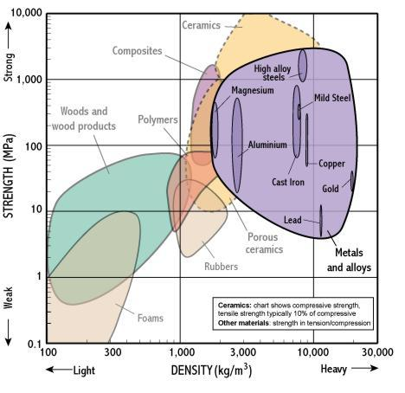

Component | Material | Mechanical Properties | Thermal Properties | Expected Lifespan | Cost (UK £)
Base Frame | S355 Structural Steel | σy ~355 MPa, E ~210 GPa, high stiffness, good fatigue | Melting ~1425–1540°C, moderate conductivity | 20–40+ years | £1.20–£2.50/kg (fabricated frame: ~£50–£300 depending size)
Joints & Shafts | 4140 Alloy Steel (hardened) | σy ~650–950 MPa, very high fatigue strength | Melting ~1416–1460°C | 10–25 years | £3–£8/kg raw, machined shafts: £10–£80 per part
Arm Links | 6061-T6 Aluminium | σy ~270 MPa, good stiffness/weight balance | Melting ~582–652°C, high thermal conductivity | 10–20 years | £3–£6/kg, machined parts: £15–£120 each
Arm Links | 7075-T6 Aluminium | σy ~500–570 MPa, high strength aluminium | Melting ~477–635°C | 8–15 years | £6–£12/kg, machined parts: £25–£200 each
Extended Sections | CFRP (Carbon Fiber Composite) | Tensile 600–1500 MPa, extremely high stiffness/weight | Degrades ~200–400°C, low conductivity | 15–30 years | £20–£80/kg equivalent, structural tubes: £50–£500+ per section
Bearings / Bushings | Bronze (SAE 660) | Compressive strength ~200–300 MPa, excellent wear | Melting ~950–1050°C | 10–30 years | £6–£15/kg, bushings: £2–£20 each
Bearings / Bushings | Polymer Composites (PTFE/Nylon) | Low friction, moderate load capacity | ~80–200°C max operating temp | 5–15 years | £5–£25/kg, bushings: £1–£10 each
Covers / Housing | ABS | Tensile ~40 MPa, impact resistant | Tg ~105°C | 5–10 years | £2–£4/kg, housings: £5–£40 each
Covers / Housing | Nylon (PA6/PA66) | Tensile ~50–80 MPa, tough, fatigue resistant | Melting 220–265°C | 8–15 years | £3–£8/kg, housings: £10–£80 each

Material selection
The material selection for this project has been broken down into smaller main component parts, this is to allow each component in the system to achieve the necessary balance between strength, stiffness, weight, durability safety and cost effectiveness.
As previously mentioned the robot arm spec dictates that the payload will be approximately 25kg across a max reach of 2000mm. Repeatability will be between 0.1 and 1mm and must operate continuously with minimal maintenance. Different materials have then been selected based on the functional requirements of each component.

Base Frame – High Strength Structural Steel (S355)
The base frame of the robot arm should be made from S355, the base frame will provide a solid foundation connecting the robot to the desired placement. It must be able to resist vibration, movement and any deformation as the robot carries out its movements. As the robot arm accelerates and decelerates, holding a payload. Due to the degree of accuracy required and the speed of operation, significant reaction forces will be transferred to the base. Therefore the material required will need high rigidity to ensure stability. This will be essential for maintaining positional accuracy and safe operations.
S355 steel has been selected due to its high yield strength and superior stiffness, it is also low cost comparatively alternate materials, the material has a high degree of weldability and is widely available across the UK. This allows it to be cost effective in terms of fabrication and maintenance. The high density will also provide a benefit to vibration dampening which in turn will reduce the oscillation generated by movement improving repeatability, reducing stress on the motors and joints. The material will be heavier than alternate materials however this increase in mass will aid in keeping the base stable. One drawback on manufacture is that once the part is fabricated it will require a protective coating to prevent corrosion within industrial use.
(Bsigroup.com. (2019). BS EN 10025-2:2019 - TC | 31 Aug 2019)
(Steel Construction (2017)
In terms of sustainability S355 is highly recyclable with a supported infrastructure within the UK. The low cost will support the overall project budget of £25-£30K.

Joints and Shafts – Hardened Alloy Steel (4140)
The joints and shafts especially the rotational ones, will have to take the highest mechanical stresses withing the robot arm, these components will be subjected to the cyclic fatigue, friction and wear upon the continuous movement during the lifetime of the machine. (20,000 hours). For this reason Hardened alloy steel has been selected.
4140 will offer a high tensile strength excellent toughness with strong fatigue resistance, when it is heat treated it will achieve high surface hardness which will make it highly resistant to wear and deformation when operating under repeated loading and unloading conditions. This will be important for the robot to achieve position accuracy and repeatability over its extended lifetime.
(AZoM (2012)
‌ (www.makeitfrom.com. (n.d.)
In terms of machinability and compatibility with the precise manufacturing process required, the material is excellent and will allow high accuracy tolerance to be achieved in bearings, shafts and gear interfaces, this in turn will allow the smooth operation of the robot arm minimising backlash within the joints.
Some downsides of using alloy steel are the overall component weight however this is balanced between the joint areas requiring structural strength and reliability. The durability of the steel will also reduce the additional need for frequent maintenance thus supporting the need for minimal disruption to customer operations.
‌(www.onlinemetals.com. (n.d.)
(2020). Material Pages)
Arm Links – Aluminium Alloy (6061-T6 / 7075-T6)
The Primary arm links should be made from 6061-T6 and 7075-T6, these components will form the main moving sections of the robot arm and require the balance between low weight and the required structural stiffness.
Aluminium alloys provide an excellent strength to weight ratio when comparing to steels, this will reduce the overall all moving mass of the arm. The lower mass will decrease inertia during the acceleration and deceleration which will allow the robot to achieve operating speeds of 1m/s whilst maintaining the high positional accuracy spec. In reducing the weight, the torque needed from the gearbox and motor is decreased improving energy efficiency and reducing wear on the components.
(Makeitfrom.com. (2019)
6061 aluminium will offer good corrosion resistance, machinability and weldability which makes it ideal for the general structure sections. 7075 aluminium provides significantly higher stiffness and strength making it ideal for the areas that will be subjected to the higher loading.
(Makeitfrom.com. (2019)
The corrosion performance will reduce maintenance requirements and expand the overall lifetime of the robot. Its also a highly recyclable material which is readily available within the UK, this will align with our sustainability objectives.
One limitation of aluminium its lower stiffness comparatively to steel, this may result in some deflection under load, to counteract this arm link geometries may be required to provide some re-enforcement.
Overall, aluminium alloys provide the best compromise between performance, sustainability manufacturability and cost.

Extended sections – Carbon Fibre Reinforced Polymer (CFRP)
CFRP should be used in the extended sections, and minimising weight and inertia is critical. CFRP offers an exceptionally high stiffness to weight ration which means its incredibly suitable for long reach robotic applications.
If we reduce the mass in the outer sections CFRP will minimise the bending and inertia forces that are generated during movement, this will improve dynamic response, provide superior handling with the payload over longer distances whilst reducing motor loading. The low mass of the CFRP will contribute to the safer operation by reducing the forces in the event of a system failure or emergency stop.
CFRP also offers excellent fatigue and corrosion resistance which will support long term operation and minimal maintenance, the material will not corrode like metals when exposed to moisture or chemicals
CFRP Is however, significantly more expensive than its metallic counterparts, in both raw material and manufacturing costs, but this is why its been selected only for areas that the performance benefits justify the additional costs.
(Davidson et al., 2026)
(Alam et al., 2019)

Bearing and Bushings – Bronze and Polymer Composites
The Bearings and bushings with the robot should be manufactured from bronze and polymer composites, these materials have been selected for their low friction, wear resistance and the ability to support a smooth rotational movement.
Bronze bushings will provide and excellent load bearing capability and will be durable under repeated motion. The polymer composite will offer the additional self lubricating characteristic which will reduce the need for frequent lubrication. The lower friction within the moving components will improve the efficiency and factor into maintaining accurate movement.
By using self lubricating material we will aid our sustainability objectives by reducing the amount of oil and lubricants required during the robot arm operation. In turn reducing the environmental impact of the system. It will also reduce the risk of any leaks and contamination within the customers workplace.
(Igus.com. (2026)
(Shen, J. (2015)

Covers and housing – ABS and Nylon
The external cover and protective housings should be manufactured from ABS plastic and nylon materials, these components are non load bearing but serve a purpose in protecting the wiring, sensors and any additional internal mechanical systems.
ABS/Nylon is extremely lightweight, cost effective and has good impact resistance, extremely easy to manufacture through the injection moulding process. The low weight will also contribute to the overall effectiveness of the arm whilst keeping within the budgetary constraints.
The materials will help to improve safety by enclosing any exposed cables, hoses and moving parts allowing the machine to be PUWER and ISO 10218 compliant.
Both materials can be recycled at end of life, support our sustainability targets.
(MatWeb (n.d.)
(British Plastics Federation (2019)

Manufacturing Process selection
Component | Material | Method | Reason | Pros | Cons | Estimated Cost (£) | Off-the-Shelf Availability
Base Frame | High-Strength Steel (S355) | Welded fabrication | Provides structural stiffness and is cost-effective for load-bearing applications. | High strength and rigidity; relatively low material cost; widely available; good weldability. | Heavy compared to aluminium or composites; susceptible to corrosion if untreated; welding may introduce residual stresses. | £150–£400 | No – typically custom fabricated to match system dimensions and load requirements.
Joints & Shafts | Alloy Steel (4140, hardened) | CNC machining | Enables high precision, durability, and repeatable manufacturing. | Excellent strength and wear resistance; high fatigue performance; precise and repeatable machining. | Higher machining cost; heat treatment increases production time and expense; heavier than aluminium alternatives. | £80–£250 per set | Partially – standard shafts may be available, but precision joints are usually custom machined.
Arm Links | Aluminium (6061-T6 / 7075-T6) | CNC machining | Offers high dimensional accuracy, good strength-to-weight ratio, and excellent surface finish. | Lightweight; corrosion resistant; high dimensional accuracy; good surface finish; 7075 provides very high strength. | More expensive than mild steel; lower fatigue resistance than steel; 7075 has poorer weldability and corrosion resistance than 6061. | £120–£350 per pair | No – generally custom machined for geometry and mounting requirements.
Extended Sections | Carbon Fiber Reinforced Polymer (CFRP) | Resin transfer moulding (RTM) | Suitable for lightweight structures and repeatable medium-scale production. | Extremely high strength-to-weight ratio; lightweight; corrosion resistant; good stiffness. | High material and tooling cost; difficult to repair; complex manufacturing process; anisotropic properties require careful design. | £300–£900 | Limited – standard CFRP tubes/profiles exist, but custom moulded sections are usually required.
Bearings / Bushings | Bronze / Polymer Composites | CNC machining | Delivers precise tolerances, wear resistance, and repeatable quality. | Good wear resistance; low friction; reliable performance; polymer composites can reduce lubrication requirements. | Bronze components can be heavy and costly; polymer composites may have lower load capacity and temperature resistance. | £20–£80 each | Yes – many standard sizes and specifications are commercially available.
Covers & Housing | ABS / Nylon | Injection moulding (preferred) | Supports high production rates, consistent precision, and good surface quality, though tooling costs must be considered. | Excellent for mass production; good dimensional consistency; lightweight; relatively low per-unit cost at scale. | High initial tooling/setup cost; design changes after tooling are expensive; some plastics may deform under high temperatures or UV exposure. | £5–£30 per unit (+ £1,000–£5,000 tooling) | Yes – generic housings are available, though custom mouldings may be preferred for integration and aesthetics.

Harris (Steels) Limited. (2023)
www.matweb.com. (n.d.).
steelbars.co.uk. (2017)
Protolabs.com. (2019)
‌ Xometry Europe. (n.d.)

Base Frame S355 – Welded steel fabrication
The base frame will be made from S355 and should use a conventional fabrication process, this would initially require laser or plasma cutting to achieve the required dimensions, then during assembly MIG welding is suitable due to the excellent weldability of the material. A welding fixture should be used during the process to achieve and maintain dimensional accuracy. If necessary the frame could undergo stress relief treatment. At the critical mounting points the face should be machined to ensure flatness and positional accuracy for the robot to sit.
Finally the base should receive a powder coat or painted surface dependant on customer requirements, this will improve corrosion resistance within the customers environment.
This method is cost effective and widely available within the UK, and is suited to the medium volume industrial production.
‌(www.steelconstruction.info. (n.d.)
‌(www.twi-global.com. (n.d.)

Joints and shafts – CNC Machining
The joints and shaft which will be manufactured from 4140 alloy steel, require a high dimensional accuracy and excellent surface finish in order to minimise backlash and wear whilst in operation. These components should be manufactured using CNC turning and then machining.
After the machining process the components should undergo heat treatment such as quenching and tempering. This will increase the hardness, fatigue resistance and wear performance. Precision grinding could also be used on bearing surfaces and shaft diameters which require a tighter tolerance.
CNC machining will provide repeatability and allow more complex geometries to be produced accurately whilst also maintaining the compatibility needed to link into bearings, gears and encoders.
Machining alloy steel will increase the manufacturing cost comparatively to mild steel, however this is need in order to ensure durability and lifespan, for this reason the additional expense is justified.
‌ (Haro (2025).
‌ (Goodwin University (2018).

Arm Link manufacturing – Aluminium Extrusion and CNC machining
The Aluminium arm links should be manufactured using a combination of extrusion and CNC machining, the extrusion process will allow the lightweight hollow profiles that need high stiffness to weight ratios, to be manufactured effectively.
Following the extrusion process, CNC machining operations would be used to create the mounting holes, joint interfaces and precision surfaces needed for the assembly process. In the higher strength areas, 7075 would be used to increase its strength.
Aluminium is easy to machine as well as being corrosion resistant and recyclable. The lightweight of the links will reduce the torque on the motors improving overall efficiency.
‌ Goodwin University (2018)
‌ (piranha (2023)
‌Admin (2025)

Extended section manufacturing – CFRP Resin transfer moulding
The CFRP extending sections should be manufactured using RTM process. RTM is a closed mould composite method that will allow the high strength lightweight components to be manufactured will good dimensional accuracy and surface quality.
RTM is suited to robotic applications as it allows a high fibre to resin ratio which results in excellent mechanical performance and minimises weight,.
Comparatively to hand lay up methods RTM will provide excellent repeatability, reducing waste and better overall consistency, this will be critical for industrial production. The closed mould system also improves operator safety as the exposure to airborne fibres is reduced.
RTM tooling costs are relatively high compared with metal manufacturing processes the performance benefits will justify its use in the critical extended sections where stiffness to weight is essential.
(www.sciencedirect.com. (n.d.)
(compositematerialshub.com (2024)
(PatSnap Eureka. (2026)

Bearings and Bushing manufacture
Bronze bushing should be mass manufactured using CNC machining for high dimensional accuracy and tight tolerances, however it should be noted that these type of parts should be purchased off the shelve where appropriate.
‌ (Goodwin University (2018).

Covers and housing manufacture – Injection moulding
ABS and Nylon covers should be produced using the injection moulding process, this process is highly suited for medium to high volume plastic components as it provides excellent repeatability and a per unit low cost, the surface finish is also superior. Injection moulding will also allow for complex geometries and cable routing and safety covers can be integrated directly into the design.
The process supports rapid production and will minimise material wastage, therefore improving manufacturing efficiency and sustainability.
‌ (Protolabs Network (n.d.).
(www.protolabs.com. (n.d.).

Conclusion
In conclusion, the selected materials and manufacturing methods provide a balanced solution that meets the performance, cost, and operational requirements of a 6-axis industrial robot designed to handle a 25 kg payload over a 1500–2000 mm reach. High-strength structural steel (S355) has been chosen for the base frame to ensure rigidity and stability, while hardened alloy steel (4140) is used for joints and shafts to withstand high cyclic loading and wear. Lightweight aluminium alloys (6061-T6 and 7075-T6) are used for the arm links to reduce inertia and improve energy efficiency, with CFRP reserved for the extended sections where stiffness-to-weight ratio is critical. Bronze and polymer composites provide reliable, low-friction performance in bearings and bushings, while ABS and nylon offer a cost-effective and durable solution for protective housings.
Appropriate manufacturing processes such as welding, CNC machining, extrusion, and injection moulding have been selected to match the functional requirements of each component, ensuring precision, repeatability, and efficient production. Overall, the design achieves a strong compromise between mechanical performance, manufacturability, cost-effectiveness, and sustainability, making it suitable for reliable long-term industrial operation.

Design (OT)

Introduction to CAD Design
This section of the project focuses on the development of the CAD model for the robot arm. The purpose of the CAD model serves as the digital blueprint for the project, allowing us to conceptualize, simulate, and refine our ideas before physical production Within the scope of the project, the key component is the CAD model. The CAD model is to support the design, visualisation, and validation of the proposed engineering idea for the project. This shows the component fitment, assembly feasibility, dimensional accuracy, and manufacturability. The CAD modelling process also supported the wider project objectives by enabling engineering calculations, motion analysis, simulation preparation, and production planning. The model was developed using Fusion 360, which allowed parametric modelling and detailed assembly creation.
The key objectives of the CAD design were:
- To produce an accurate digital representation of the design
- To ensure all components assembled correctly
- To optimise the design for manufacture and assembly
- To identify design issues before prototype manufacture
- To support analysis and testing activities
As mentioned in the project specifications, the CAD design was developed in accordance with the project requirements. These being but not limited to a payload capacity of roughly 25kg and a target reach between 1500 and 2000mm. These figures provided a structured framework which guided the analysis and design decisions throughout the project.

Concepts/Real Life Models

As mentioned in the Analysis, examples of real-life robots such as the FANUC M-20iD/25 (Fanuc.eu, 2025), the KUKA KR 30 (KUKA, 2026) and the ABB IRB 2600 (IRB, 2025) were used as a benchmark for the robot design. These are all 6-Axis robot arms that offer similar specifications to our desired amounts. The images below were early concept drawings of what we wanted the robot to look like.

As shown in Figure 1 - Concept 1 of the robot arm, this shows a sleeker design using simpler movements but are usually for smaller items like part sorting more than heavy lifting. Where as shown in Figure 2 - Concept 2 of the robot arm is what we went forward with as it shows a more robust design and more space for stronger gear ratio and motor drives. The final design more resembles that of the ABB IRB 2600 as the design appealed more to us.
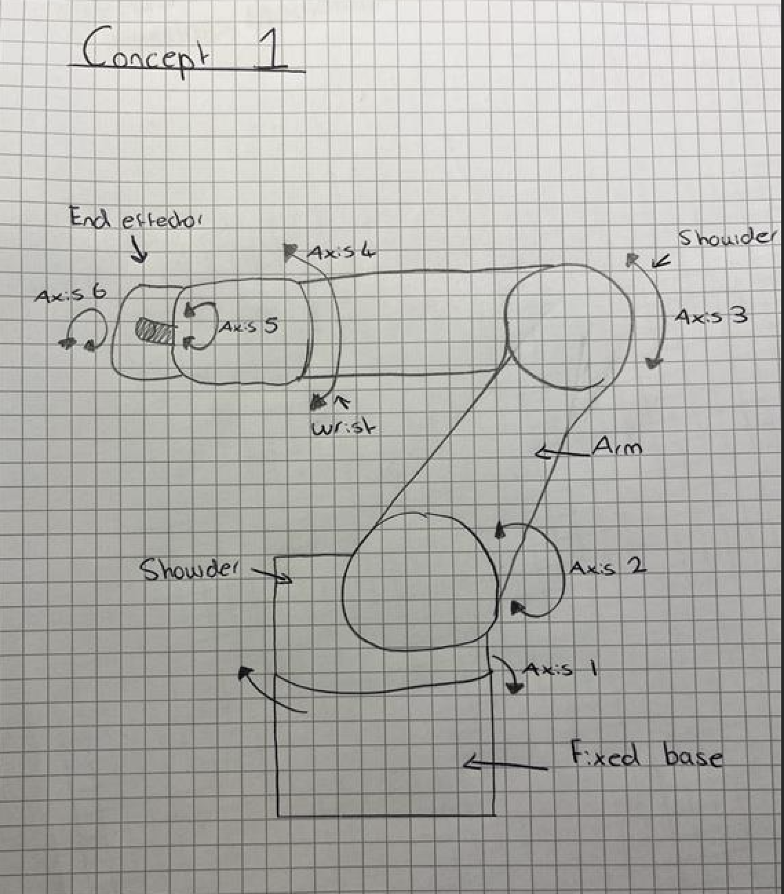
Figure 1 - Concept 1 of the robot arm
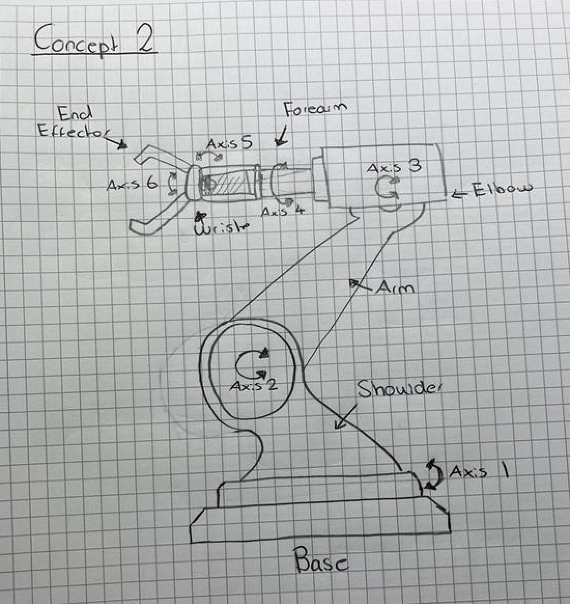
Figure 2 - Concept 2 of the robot arm

Sketch and Techniques
Designing a 3D model in Fusion 360 involves using a range of modelling tools and techniques to transform a 2D sketch into a detailed three-dimensional object. The modelling process usually begins with creating sketches and then applying different features such as extrude, fillet, chamfer, and shell to build the final model.
The first stage is creating a 2D sketch. Sketches are drawn on a plane using tools such as lines, circles, rectangles, arcs, and splines. Constraints and dimensions are then added to control the size and position of the geometry accurately. Fully constrained sketches are important because they ensure the model behaves predictably if changes are made later. As seen in Figure 3 - Sketch of End Effector Gripper Arm and Figure 4 - Sketch of Wrist Assembly, these methods are used to keep measurements consistent.
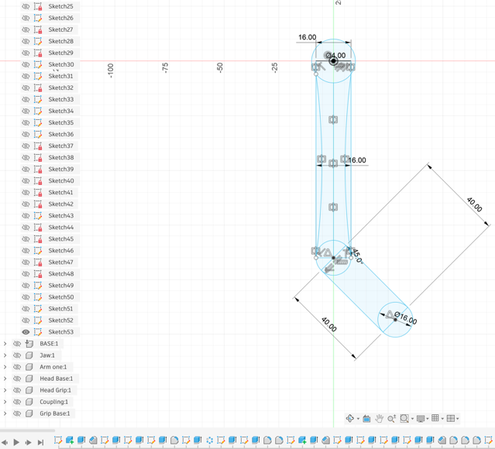
Figure 3 - Sketch of End Effector Gripper Arm
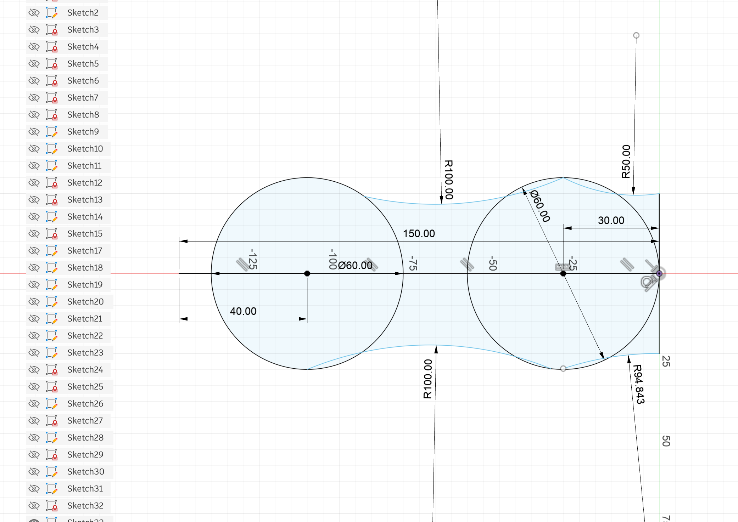
Figure 4 - Sketch of Wrist Assembly

One of the most used methods is the Extrude tool. Extrude takes a 2D sketch and extends it into the third dimension to create a solid body. For example, a rectangle can be extruded to form a box, or a circle can be extruded into a cylinder. Shown in Figure 5 - Extrude on the Arm Joint, I can specify the extrusion distance and choose whether to add material, remove material, or create a new body. Extrude is essential because it quickly converts simple sketches into basic 3D forms.
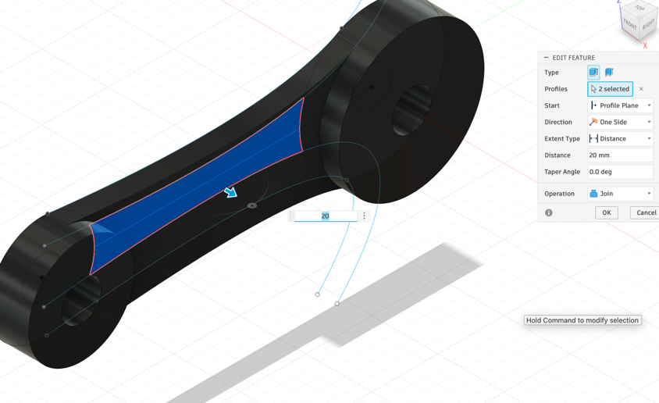
Figure 5 - Extrude on the Arm Joint

The Fillet tool is used to round off sharp edges or corners on a model. Fillets improve the appearance of a design and can also increase safety and strength by reducing stress concentrations. By selecting the edges it specifies a radius value to create the rounded transition as seen in Figure 6 - Fillet command on the base
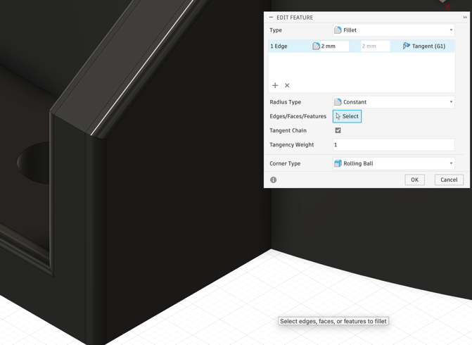
Figure 6 - Fillet command on the base
A related tool is Chamfer, which creates an angled edge instead of a curved one. Chamfers are often used for mechanical parts to remove sharp edges or assist assembly as seen in Figure 7 - Chamfer command on Arm Joint.
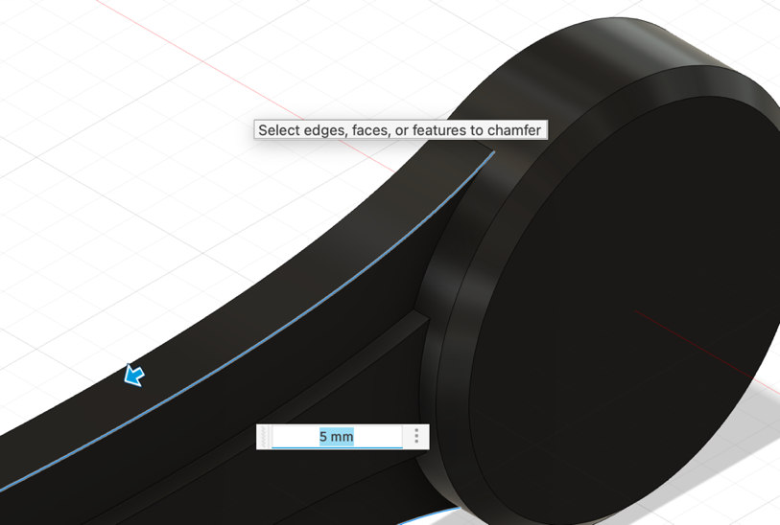
Figure 7 - Chamfer command on Arm Joint

Additional methods include Shell, which hollows out a solid object while leaving walls of a specified thickness, and Pattern, which duplicates features in a linear or circular arrangement. These tools save time and ensure consistency in repetitive designs. As shown in Figure 8 - Shell command used on base, the shell function is used to reduce the total mass of the design. As in a real life build there will be the motors and drives enclosed in the outer housing.
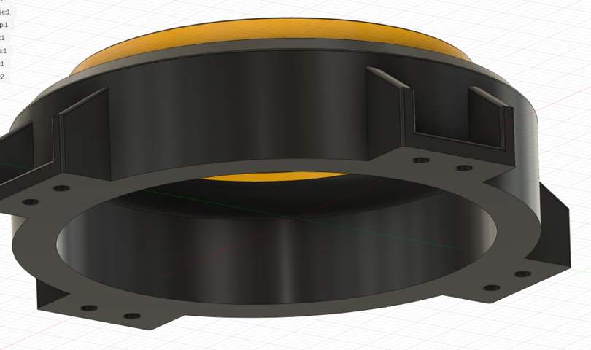
Figure 8 - Shell command used on base

Finally, Fusion 360 uses parametric modelling, meaning dimensions and features can be edited at any stage in the timeline. This allows designers to make changes efficiently without rebuilding the model from scratch. Together, these methods provide flexibility, precision, and efficiency when creating complex 3D models.

Components and Drawings
As a disclaimer, the Drawings below only show the basic dimensions as including all dimensions would clutter the page. Also, the stubs featured on the parts are placeholders for where the actual gear/motors will connect and join.
BASE
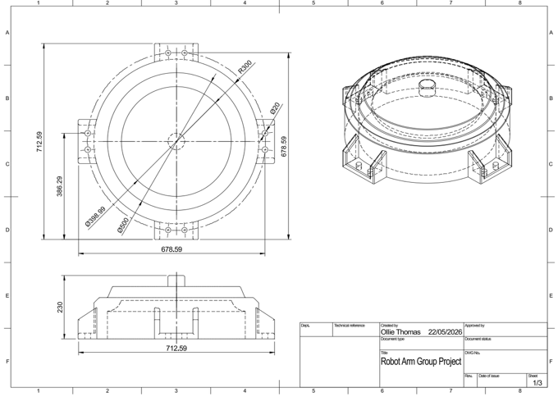
Figure 9 - Drawing of Base
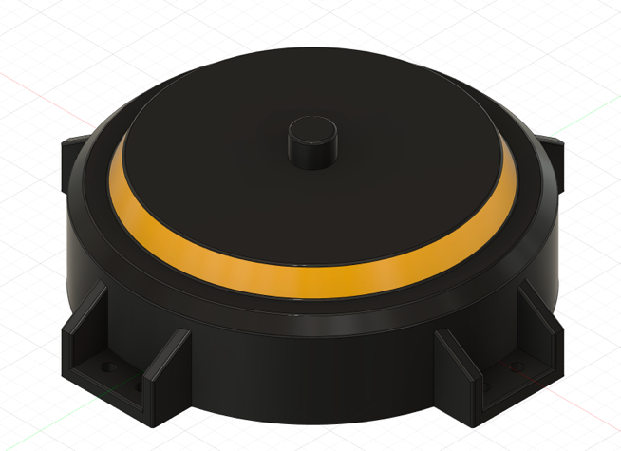
Figure 10 - Model of Base

The first joint being the base rotates the entire robot left and right around the vertical axis. The reason for the base, without this, the robot could only work in one direction. This axis gives the robot a wide working envelope so it can reach different stations or objects around it. The base features four mounting brackets to provide a secure fixture to the ground.
JAW
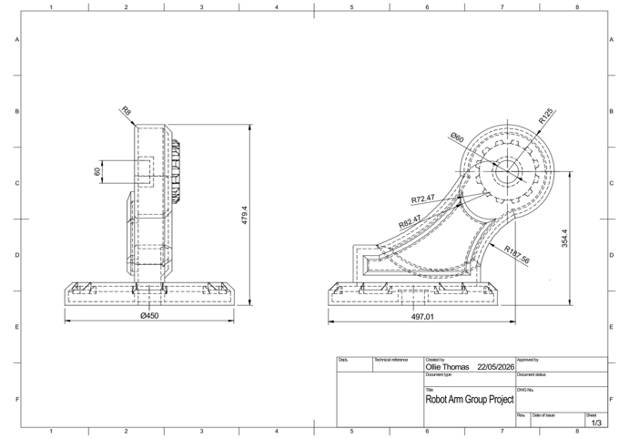
Figure 11 - Drawing of Jaw
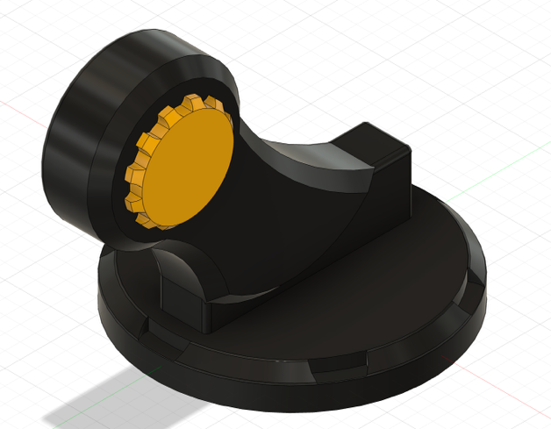
Figure 12 - Model of Jaw

The Jaw Moves the arm forward and backward, lifting the main arm section. It exists to reach and provide height movement. It allows the robot to extend outward toward objects or retract inward. The design of the jaw is as such because it allows room for the arm motor in the top section as well as providing extra distance if the arm were fully extended.

ARM
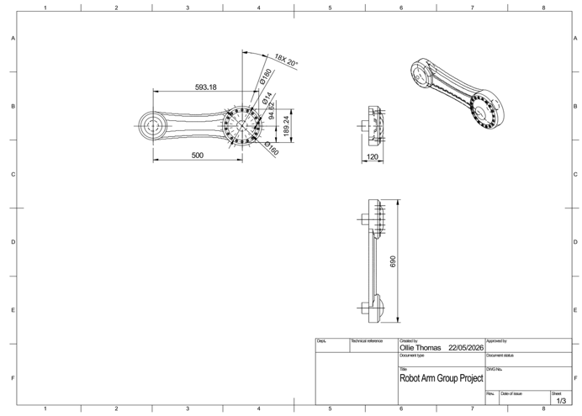
Figure 13 - Drawing of Arm
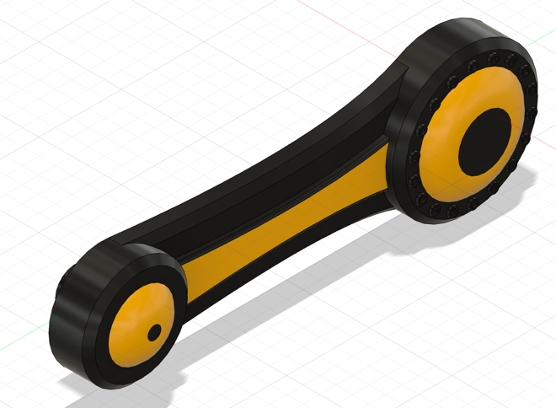
Figure 14 - Model of Arm
The arm pivots and extends the head. The arm increases reach flexibility and allow the robot to fold into tight spaces.
HEAD BASE
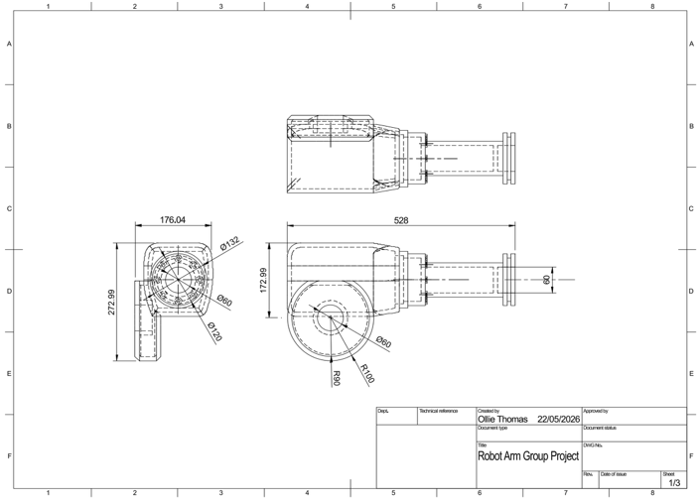
Figure 15 - Drawing of Head Base
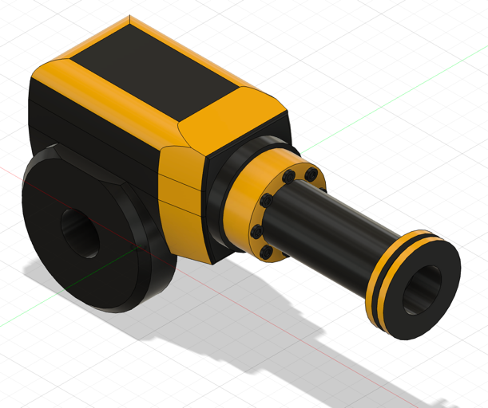
Figure 16 - Model of Head Base

The head base rotates the wrist around the arm’s length. It exists to allow the tool to twist into the correct orientation for tasks like welding or screwing.
HEAD GRIP/WRIST
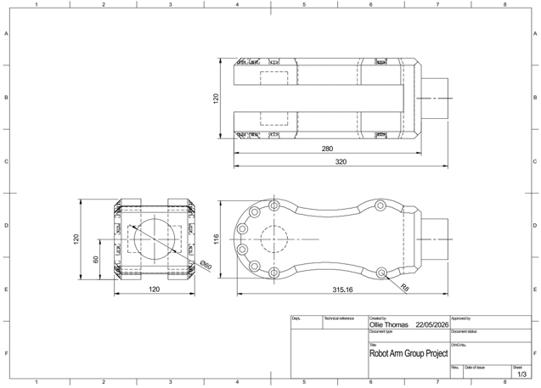
Figure 17 - Drawing of Wrist
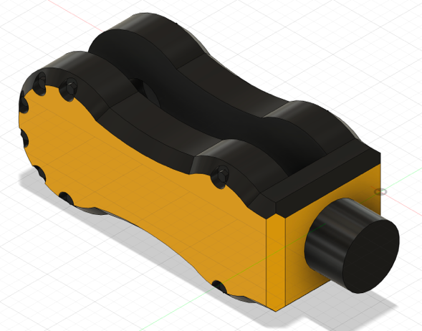
Figure 18 - Model of Wrist

The head grip rotates the wrist in a 360-degree rotation. It exists Lets the robot angle tools toward surfaces.
COUPLING
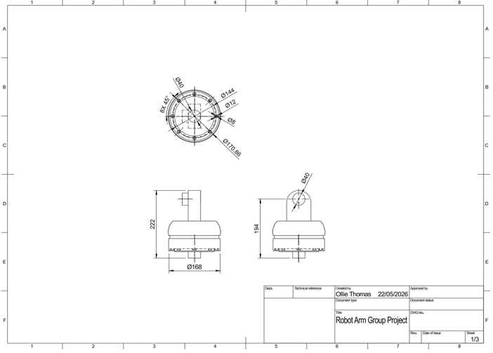
Figure 19 - Drawing of coupling
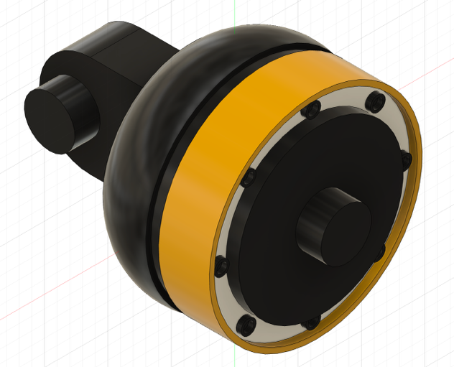
Figure 20 - Model of Coupling
The coupling rotates the end tool itself. It exists to provides final precision alignment. This is where you are able to interchange different end effectors.

GRIP BASE/END EFFECTOR
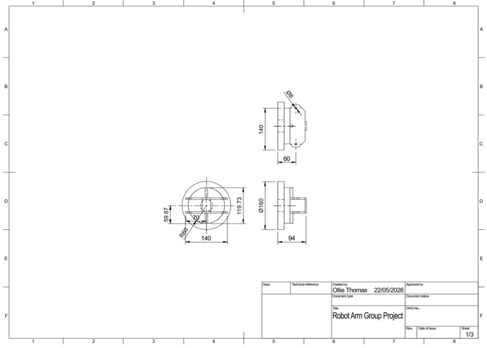
Figure 21 - Drawing of End Effector Base
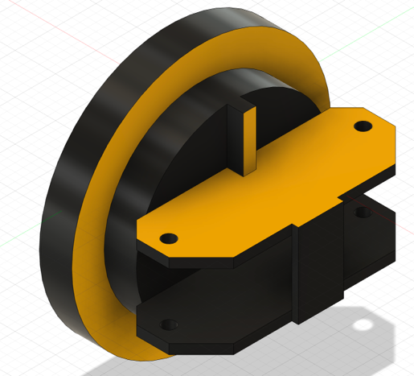
Figure 22 - Model of End Effector Base
This part combines with the grip arm to assemble the end effector. This provides a secure base for the arms to attach.

GRIP ARM
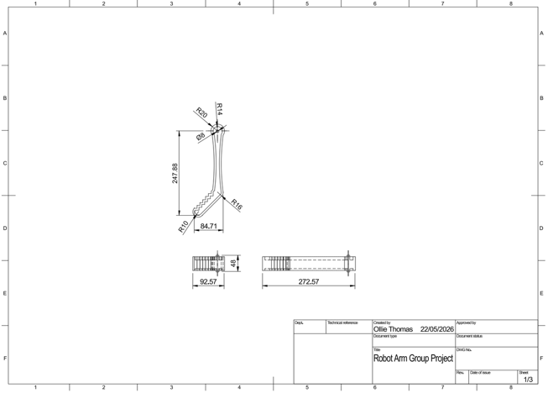
Figure 23 - Drawing of End Effector arm
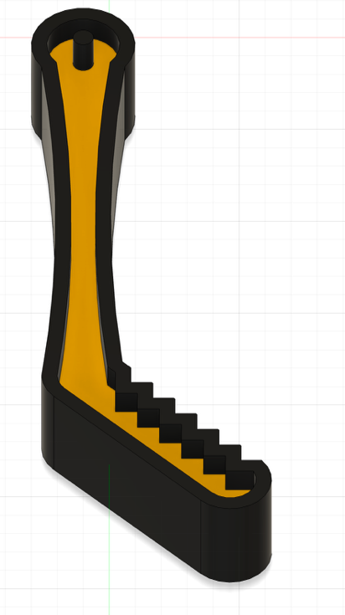
Figure 24 - Model of End Effector arm

The end effector combines two of these arms with the grip base to assemble the full end effector. The purpose of the end effector is the grab the part or depending on the end effector can weld or do other engineering purposes.
The end effector is universal to robot arms. Within the scope of the project where we want to move boxes, a more appropriate end effector would be one with vacuum cups but for the purpose of showing the end effector, a simple gripper suffices.

Assembly and Joints
The exploded view of the assembly of the robot arm is as shown in Figure 9 - Exploded view of Assembly. As mentioned before. The joints would feature the gear ratios but as a concept and simplicity for the assembly they feature 60mm by 40mm stubs to join the components.
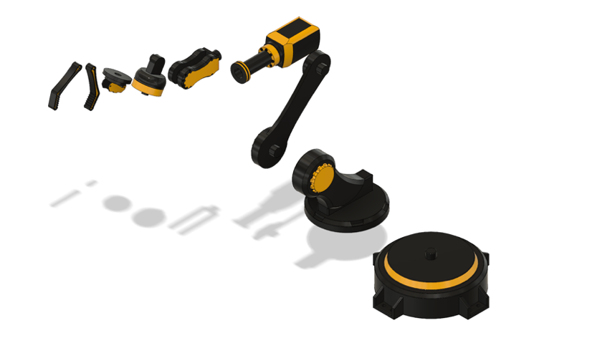
Figure 25 - Exploded view of Assembly

Figure 10 - Complete Assembly shows the complete assembly. Using the joint function in Fusion 360, I was able to apply rigid and rotational functions to the assembly to mimic how the arm would operate in a real-life scenario.
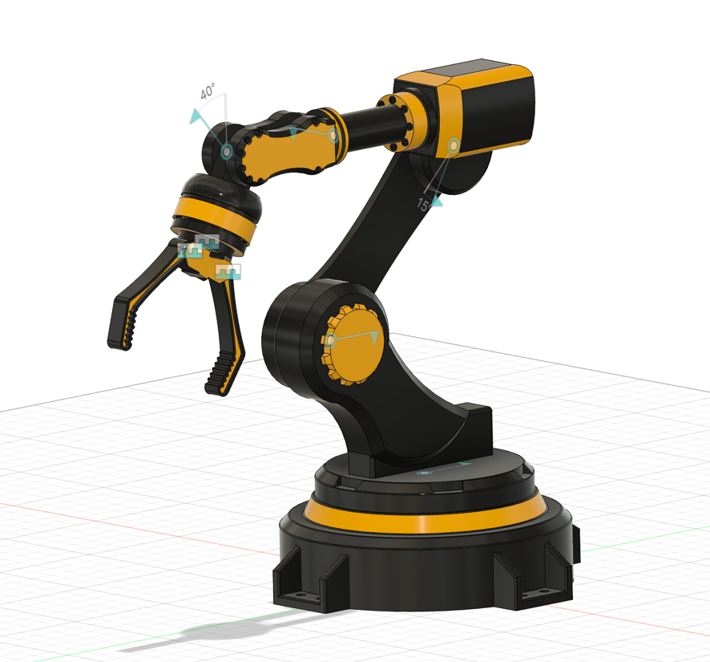
Figure 26 - Complete Assembly

Using the section analysis tool on Fusion 360, the components are shown hollow as seen in Figure 11 - Section analysis on Base and Jaw. The base features a thicker wall section as it still needs to support the total weight of the arm as well as housing the gearboxes.
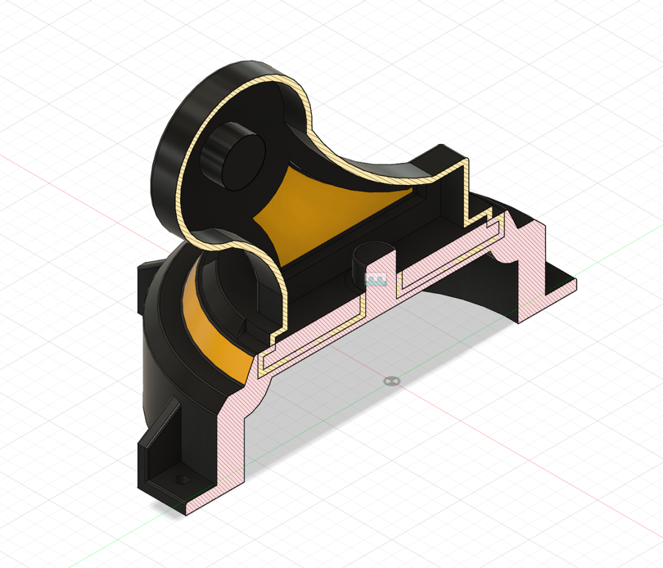
Figure 27 - Section analysis on Base and Jaw

Evaluation of CAD Design
The CAD design and development of the robot arm project successfully met the primary objectives outlined at the beginning of the assignment. The use of Fusion 360 as the chosen CAD software allowed for the creation of a detailed and accurate digital model which supported the design, analysis, and assembly of the robotic arm. Throughout the project, the CAD model acted as a foundation for visualising the final product before any physical manufacturing would take place. This significantly reduced the risk of design flaws, dimensional inconsistencies, and assembly issues. By using a parametric modelling approach, the design could be modified efficiently when changes were required, making the development process more flexible and practical.

One of the strongest aspects of the project was the overall structure and organisation of the robot arm assembly. The design clearly demonstrates an understanding of industrial robotic systems and how each component contributes to the overall movement and functionality of the arm. The decision to use existing industrial robots such as the FANUC M-20iD/25, KUKA KR 30, and ABB IRB 2600 as benchmarks was beneficial because it provided realistic guidance on proportions, movement ranges, and overall construction methods. These examples helped ensure that the final design reflected real engineering principles rather than being purely conceptual. The final robot design particularly resembled the ABB IRB 2600 due to its robust structure and suitability for heavier payloads.

Conclusion of CAD Design
In conclusion, the robot arm CAD project successfully achieved its main objective of designing and developing a functional industrial-style robotic arm using Fusion 360. The project demonstrated the importance of CAD modelling within engineering design by showing how digital modelling can be used to visualise concepts, refine ideas, and prepare for manufacturing before physical production begins. Using parametric modelling, assembly tools, and detailed component creation, the project produced a realistic and well-structured robotic arm design.
The use of CAD modelling tools such as sketches, extrusions, fillets, chamfers, shell features, and assembly joints highlighted a strong understanding of Fusion 360 and modern design techniques. These methods improved the accuracy, flexibility, and efficiency of the modelling process while also supporting manufacturability and assembly. The completed assembly successfully demonstrated how the robot arm would operate in a real-world environment.
Given I had more time and knowledge of Fusion 360, I could have made detailed gear ratios and a full functioning robot arm that moves in unison but unfortunalty with the time restraints I was unable to do so. I would have also wanted to create a BoM of the necessary fixtures needed to fix the assembly together but that would have required an extensive amount of research of which I did not have the time and resources to achieve.

Programming and Electronic LB

Analysis and Testing TE

Introduction TE
This section of the Project focuses primarily on the analysis of the robot arm system. The purpose of the work is to assess whether the robot arm design can automate repetitive manual handling tasks efficiently, safely and at a lower cost than many other existing robotic systems. The analysis forms a significant part of the decision-making process as it allows the design to be evaluated before any physical testing or manufacturing takes place.
The project is to develop a low-investment robotic arm capable of performing repetitive manual handling tasks while also remaining accessible for small/medium-sized manufacturing environments. To establish realistic engineering objectives, design specifications were produced during the early sections of the project. The specifications identified the expected performance targets for the robot arm, which included a payload capacity of roughly 25kg and a target reach between 1500 and 2000mm. These figures provided a structured framework which guided the analysis and design decisions throughout the project.
This section concentrates on analysing the physical and mechanical performance of the robot arm through various engineering calculations and evaluation methods. This includes investigating the arm reach, mass of the component, payload, torque requirement, joint loading, stability and structural considerations. The purpose of completing these calculations is to identify whether the robot arm is mechanically feasible and whether it can operate safely.
The findings from this analysis will intend to support the group decisions regarding motor selection, arm geometry, material selection, structural design and the overall system feasibility. The analysis process provides a structured basis for evaluating the robot arm and identifying the areas for development which plays an important role in the technical side of this project.
To support the analysis of the robot arm, research has been undertaken on robots with similar payload and reach requirements. The aim is to understand what level of performance is realistic for a robot arm intended to lift 25kg while operating at a reach of around 1500 to 2000mm.
A key benchmark robot was the FANUC M-20iD/25 as it closely matched the payload target. This is a 6-axis industrial robot with a 25kg payload, 1831mm reach and ±0.02 mm repeatability. The makes it a good comparison as it shows that a 25kg payload robot needs a large and rigid structure. The design is worth following in terms of the 6-axis layout, strong base and dedicated use for handling and manufacturing tasks. However, it would not be suitable to fully replicate as it is a highly engineered commercial robot with advanced motors, precision gearboxes and safety integration. For this project, this robot arm should be used as a performance benchmark rather than a design to be replicated. (FANUC, 2022)
The KUKA KR 30 has also been researched due to its similarity in manual handling capabilities. The robot arm has a 30kg payload, 2033mm maximum reach, 6-axis steup and ±0.15 mm repeatability. This shows the scale required to safely lift 30kg over a long reach and shows the importance of a heavy stable base and strong joints. However, it would not be suitable as its overall mass is 665kg which would massively conflict with our project aim of producing a low cost and accessible robotic arm. (My.KUKA, 2023)
The ABB IRB 2600 has also been reviewed as a relevant industrial robot. The arm has a 12kg payload, 1650mm reach, ±0.06 mm repeatability and a robot mass of 280kg. Although this robot arm has a lower payload than our projected target, its still useful as it shows how commercial robots achieve reach and repeatability through rigid structure and carefully designed joints. (IRB 2600 | ABB, 2025)
Collaborative robot was also considered as the project aims to make automation more accessible and easier to use. The Universal Robots UR20 offers a good comparison because it has a 1750mm reach, 6 rotating joints and a maximum payload of 20kg with 25kg being possible under certain conditions. This makes the arm useful as it demonstrates a more user-friendly approach to automation compared to a more traditional robot arm. The simpler programming and collaborative focus is worth following for a lower-cost concept. (UR20, 2025)
From this research, several important lessons were identified. Firstly, robots that are designed to lift 25kg normally require a reach of around 1750-2033mm and normally use 6 axes to provide flexible positioning. Second, repeatability of a commercial robot is typically much tighter than that of a low- cost prototype. Third, a higher payload and longer reach usually requires a heavier and rigid structure which all supports the need for torque and stability in the project analysis.

Robotic Arm Load, Weight and Length Analysis TE
Using Autodesk Fusion with the CAD Design, length analysis and weight analysis can be found after correcting the scale and respective materials to the design
Base
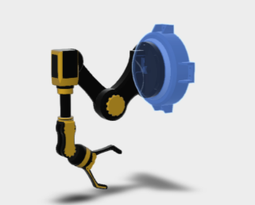
Item | Value
Material | Mild Steel
Weight (Kg) | 200Kg
Weight calculation | 200 x 9.81
Weight | 1962 N
The base is the main support of the robot arm. It provides stability and acts as the fixed support for the entire system. The large mass of the base helps prevent tripping and improves the overall stability during operation. Although the base contributes little to the overall movement, it is structurally integral as it supports the full load of the robot arm.

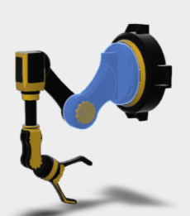
Link 1 (Upper arm / shoulder link)

Item | Value
Material | 4140 Alloy Steel (Hardened)
Mass (Kg) | 52.347Kg
Weight calculation | 52.347 × 9.81
Weight | 513.52 N
This is one of the main structural links of the robot arm. It transfers load between the base and the next joint. It is important because it carries part of the arm weight and contributes to the torque at Joint 1.
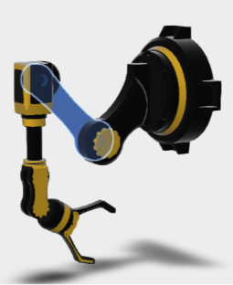
Upper Arm Link (Arm One)

Item | Value
Material | 7075-T6 Aluminium
Mass (Kg) | 15.542Kg
Weight calculation | 15.542 × 9.81
Weight | 152.467 N
The upper arm link is the first major extension arm of the robot. It increases horizontal reach and transfers forces from the payload toward the base. This component experiences significant bending stress during maximum extension.
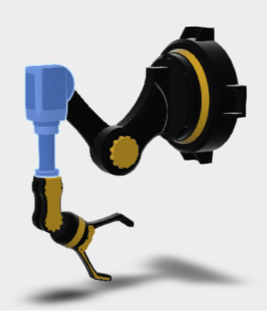
Forearm / Head Support (Head Base)

Item | Value
Material | 6061-T6 Aluminium
Mass | 8.720 kg
Weight calculation | 8.720 × 9.81
Weight | 85.54 N
The forearm section connects the upper arm to the wrist assembly. It allows additional positioning flexibility and supports the wrist and gripper mechanisms.

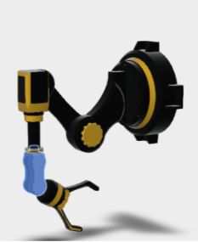
Wrist / Gripper Support (Head Grip)

Item | Value
Material | Aluminium 6061-T6
Mass | 6.287kg
Weight calculation | 6.287 × 9.81
Weight | 61.67 N
This section supports the assembly and allows finer control of the gripper. It is responsible for accurate positioning during pick-and-place operations.

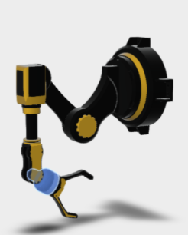
Wrist Coupling

Item | Value
Material | Steel
Mass | 19.267 kg
Weight calculation | 19.267 × 9.81
Weight | 189.01 N
The coupling acts as a connector between the wrist and gripping mechanism. It transfers rotational movement and stabilises the end-effector.

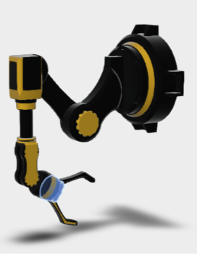
Gripper Base

Item | Value
Material | Nylon 6
Mass | 0.774 kg
Weight calculation | 0.774kg × 9.81
Weight | 7.59 N
The gripper base forms the main body of the gripping mechanism. It supports the moving fingers and houses the gripping pivot system.

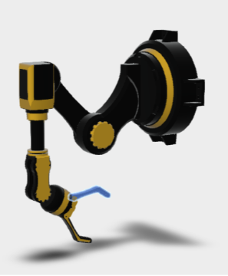
Gripper Finger 1 & 2

Item | Value
Material | Nylon 6
Mass | 0.286 kg
Weight calculation | 0.286 × 9.81
Weight | 2.805 N
These are the end-effectors responsible for physically gripping objects. The fingers apply clamping force to securely hold payloads during lifting and movement operations.

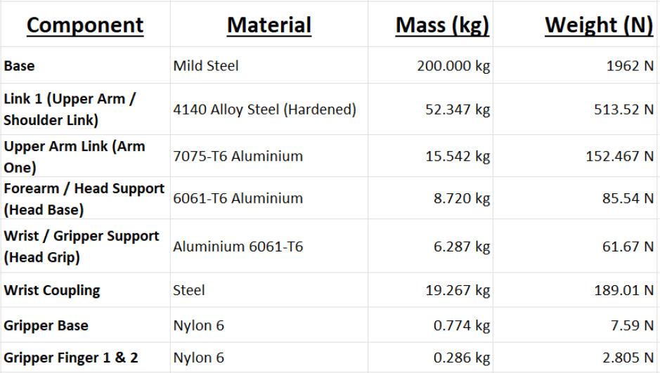
Collective Mass/ Weight Table

Total weight of Robot Arm
Category | Total Sum
Mass (Kg) | 303.23 kg
Weight (N) | 2974.602 N

Length of each Joint
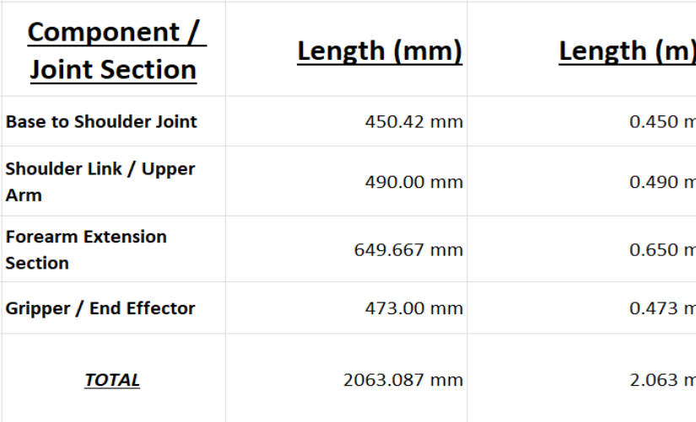

Engineering discussion
The mass and length data shows that the robot arm is a relatively large and heavy loaded structure. The total arm mass has been calculated as 303.223 kg with a maximum reach of 2063.087 mm. The long reach is useful for the workspace coverage but can increase the bending moment as it stretches out to its maximum point. The heaviest components are close to the base which is beneficial as placing the heavier parts toward the base reduces the effect on bending moments.

Torque Analysis TE

Payload Force Calculation (25 kg Payload)
Target payload:
$$m=25\text{ kg}$$
Using gravitational force:
$$F=m×g$$
Where:
- $g=9.81{\text{ m/s}}^{2}$
$$F=25×9.81=245.25 N$$
Payload Force Result
The robotic arm must support:
245.25 N
of downward force at full payload capacity.

Purpose of Torque Calculations
The torque calculations are used to determine the force required at each joint of the arm when lifting the required payload. These calculations can be critical for the project as the help determine:

- Whether the selected motors will be powerful enough
- Which joint experiences the highest stress
- The structural loading throughout the arm
- The required gearbox specifications

Torque Equation
The torque acting on a joint is calculated using:
$$T=F×d$$
Where:
- $T$
= Torque (Nm)
- $F$
= Force (N)
- $d$
= Distance from pivot (m)

Joint Torque Calculations
The torque is not the same at every joint meaning each joint only needs to support the payload and the arm sections beyond that joint. This means the base and shoulder experience the highest torque, while the wrist and gripper experience much lower torque.
Using the payload force:
$$F=245.25N$$
and the measured link lengths:
Section | Length
Base to shoulder | 0.450 m
Shoulder to upper arm | 0.490 m
Forearm extension | 0.650 m
Gripper/end-effector | 0.473 m

Payload Torque at Each Joint TE

Joint | Distance from Joint to Payload | Calculation | Torque
Base joint | 2.063 m | $$245.25×2.063$$ | 505.90 Nm
Shoulder joint | 1.613 m | $$245.25×1.613$$ | 395.61 Nm
Elbow joint | 1.123 m | $$245.25×1.123$$ | 275.44 Nm
Wrist joint | 0.473 m | $$245.25×0.473$$ | 116.02 Nm

Engineering Discussion
The joint torque analysis shows that the torque demand reduces toughout the arm as it gets closer to the payload. The base joint experiences the highest torque at 505.90 Nm as it must resist the full payload throughout the full reach of the arm (2.063m). The should joint is also highly loaded at 395.61Nm making it a crucial area for geaerbox selection and reinforcement.
The elbow and wrist experience lower torque values as the payload is closer to these joints. But these values still matter because the calculations do not include the arms acceleration, friction or gearbox losses. In practise the gear box torque should be higher than these values with a safety factor applied. This supports the need for stronger gearboxes at the base, with smaller systems being suitable for the wrist/gripper.

Torque at Maximum Reach TE
Maximum reach:
$$T=245.25×2.063 \\ T=505.90\text{ Nm}$$
Torque at 1500 mm Working Reach
Working reach:
$$T=245.25×1.500 \\ T=367.88\text{ Nm}$$
Torque Comparison

Condition | Reach | Payload Force | Torque
Maximum extension | 2.063 m | 245.25 N | 505.90 Nm
Reduced working reach | 1.500 m | 245.25 N | 367.88 Nm

Engineering Discussion
The torque analysis shows that reach clearly has a major factor on the load. At full extension, the payload creates 505.90 Nm of torque, compared to the 1500mm working reach which creates 367.88Nm. This is a reduction of:
505.90 – 367.88 = 138.02Nm
This explains why the full-extension simulation produced a much weaker result (see Section 3.5.1) while the 1500mm configuration showed a much higher safety factor (see Section 3.5.2). The shoulder and base joints are most critical as they must resist the largest bending moment from the payload and the arms mass. This means that any gearbox selected for these joints need to safely exceed the calculated torque.

Simulation Setup TE
Static stress analysis was carried out during the project in Autodesk Fusion to evaluate whether the robot arm can safely support the 25kg projected payload. The payload was converted into a downward force of 245.25N and applied at the gripper. The base of the robot arm was fixed to represent the arm being mounted to a rigid floor/work area.
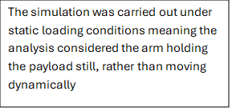
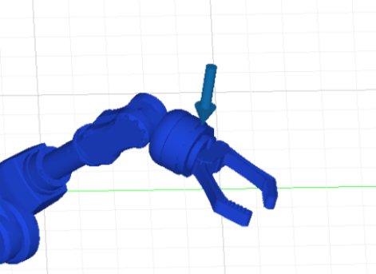

Worst-Case Stress Analysis at Full Extension
The first simulation was carried out with the joints at their maximum reach of 2.063m. This was treated as worst-case scenario because the payload was at its furthest point from the base.
The bending moment created by the payload at full extension was calculated as:
T=F×d
T=245.25×2.063
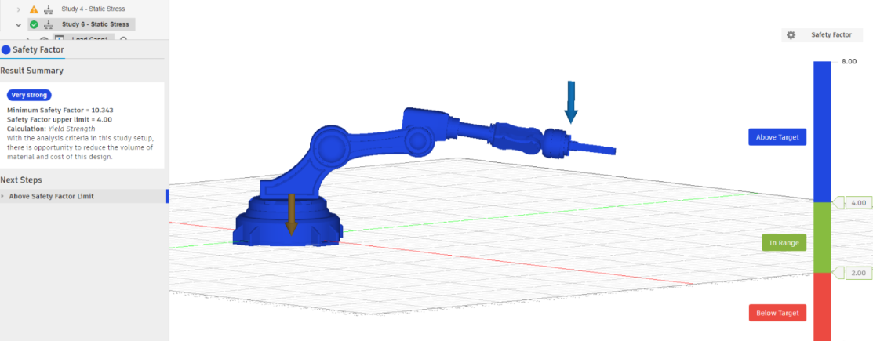
T=505.90Nm
This explains why the full-extension position produced the highest stress in the structure.

The simulation showed a minimum safety factor of 10.343, which indicates that the robot arm is capable of safely supporting the applied 25kg payload at the maximum reach without any deformation taking place.
The highest stress were found around the wrist section where the payload is transferred through to the end effector. However, the robot arm still remained within the safe operating range, as you can see from the blue stress distribution across the structure. This suggest that the chosen materials and geometry provide good stiffness and strength for the maximum reach. This shows us that the robot arm is mechanically sound at its maximum working reach and withstand the expected loading conditions.

Optimised Stress Analysis at 1500 mm Reach
A second simulation was completed with the robot arm positioned at a reach of 1.5m. This represents a more realistic working range when lifting the 25kg payload.
The bending moment at this reach was calculated as:
T = 245.25 x 1.5
T = 367.88Nm
This is lower than the full-extension by:
505.90−367.88=138.02Nm
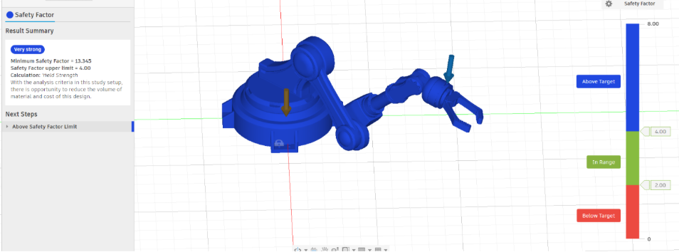Reducing the reach significantly reduced the bending moment acting on the arm.
At the reduced working reach, the minimum safety factor increase to 13.345, which is well above the target safety factor and shows that the arm is structurally safe under static loading conditions in this range. The result also shows that reach has a major influence on the performance of the robotic arm.

Displacement Analysis
Displacement analysis was also carried out at the expected working range (1500mm) to assess how much the arm bends under the 25kg payload. This is important as a ppart may be strong enough to avoid failure but might still bend too much for accurate operations.
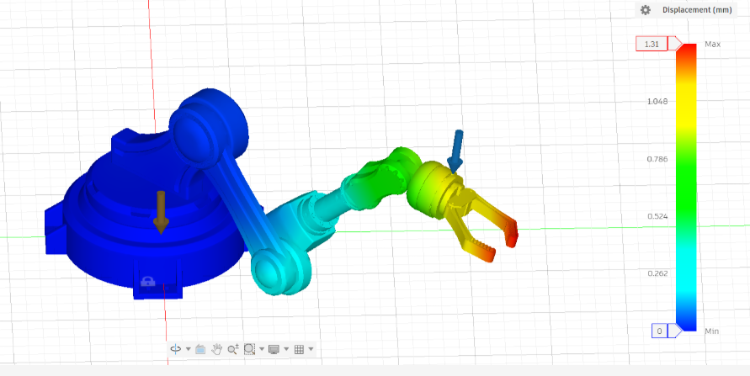
The maximum displacement recorded was 1.31mm occurring at the grippers. This is expected as the gripper is furthest away from the fixed base so it will experience the greatest bending deformation.
A displacement of 1.31 mm is relatively small for a robotic arm that carries a 25kg load, which suggest that this working position provides acceptable stiffness and will provide accuracy during static lifting.

Conclusion TE
The analysis carried out throughout this report shows that the robot arm design is structurally and mechanically feasible within the intended operating conditions. Mass, payload force and torque calculations showed that the highest loading conditions occur at the base and shoulder joints due to the large bending moments created by the reach of the arm itself.
Static stress simulations were carried out in Autodesk fusion, using a 25kg force of 245.25 N which further validate the analysis. The maximum working reach simulation produced a minimum safety factor of 10.343, which remained above our target safety factor. This indicated that the selected materials and geometry are capable of resisting deformation under the applied loading conditions. When the arm was analysed at a reduced range of 1500mm, the minimum safety factor increased to a further 13.345 due to the reduction of bending moments acting on the structure. The shows the strong relationship between operating reach and efficiency.
Displacement analysis also showed that the arm maintained low deformation levels of 1.31 acting at the grippers. This indicates that the structure maintains sufficient stiffness during the operation and can prove accurate handling performance during the practical use.
Overall, the combination of calculations and simulation-based analysis shows that the robot arm design is mechanically feasible for the intended application. The results show that the structure can safely withstand the 25kg payload whilst maintaining acceptable stress levels, safety factors and deformation across the working range of the robot arm.

Procurement CG

Introduction to Procurement
Procurement plays a critical role in the successful delivery of engineering projects, particularly where complex systems such as industrial robot arms require the integration of mechanical, electrical and control components within defined cost and performance constraints. Within this project, the primary objective of procurement was to source suitable components and materials required for the development of a low-cost robotic arm, while ensuring the final product remains within the target budget range of £25,000–£35,000.
The procurement function extended beyond simply purchasing components, instead adopting a strategic approach aligned with recognised procurement principles such as those defined by the Chartered Institute of Procurement and Supply (CIPS). This included consideration of supplier risk, cost optimisation, supply chain resilience and long-term operational performance. The project specifically required the sourcing of predominantly off-the-shelf components to reduce complexity, minimise cost and improve maintainability.
Furthermore, procurement decisions were closely integrated with design and engineering considerations, ensuring that selected components met functional requirements such as payload capacity, reach and precision, whilst also remaining commercially viable. This section outlines the procurement strategy employed, including supplier selection, cost analysis, risk management and opportunities for cost reduction.

Procurement Requirements
Table 1:Procurement Aims and Targets
Aims and Targets
Affordable for SMEs | ~£30k
Payload mirrored of human | ~25kg
Easily programmable | Lead through or joystick controlled
Off the shelf parts | Easily obtainable by customer for maintenance
Reach | ~1.5m-2m
Conforms to standards | ISO10218 and ISO9409

The procurement requirements for the robotic arm were derived directly from the product design specification and performance targets established by the project team. The robotic arm is required to handle payloads of approximately 25kg, achieve a working reach between 1.5m to 2m, and operate with six degrees of freedom to provide flexibility and accuracy. These functional requirements significantly influence the type and specification of components required, particularly in relation to motors, gearboxes and structural elements.
In addition to technical specifications, procurement constraints were also identified, including budget limitations, availability of components, lead times and supplier reliability. The project objective to develop a cost-effective robotic solution for small to medium enterprises required prioritisation of commercially available components that offer acceptable performance at reduced cost compared to high-end industrial robots.

Market Research & Benchmarking
To inform procurement decisions, benchmarking was carried out against existing industrial robotic systems, including the ABB IRB 2600 and FANUC M-20iD. According to Yanchi and Yijie, (2021) benchmarking is a suitable method of understanding the markets products and customer needs to ensure your product in development meets the standard. These robots offer similar payload capacities and reach characteristics to the proposed design but are significantly higher in cost due to their advanced capabilities and proprietary technologies.
The ABB IRB 2600 according to Robot Store (2026) costs approximately £90k and the Fanuc M-20iA costs £60k. These prices demonstrate the more premium pricing and the fact that these robots are used for more heavy industry applications such as welding.
In contrast, this project adopts a modular procurement approach, using off-the-shelf components to replicate similar functionality at a reduced cost. Whilst this may result in some compromise in performance, it enables the development of a more accessible robotic solution suitable for smaller businesses.
This benchmarking exercise supports the chosen procurement strategy, demonstrating that cost reductions can be achieved through component standardisation and strategic sourcing.

Supplier Risk Management
Today, businesses face threats of extreme weather, cyberattacks, stakeholder scrutiny of environmental and social practices, and political, military, and financial crises (Choi et al, 2022). Therefore, a structured procurement strategy was adopted to ensure that component sourcing aligned with both technical and commercial objectives. Central to this approach was the identification and management of potential risks associated with suppliers and supply chains.

Commodity Risk
Key components such as servo motors and precision gearboxes represent high-value and specialised commodities with limited global suppliers. These components are critical to system performance, particularly in terms of accuracy, repeatability and torque delivery. As a result, there is an increased risk associated with supply disruption, long lead times and price volatility.
To mitigate this, preference was given to widely available, standardised components where possible. This reduces dependency on niche suppliers and improves flexibility in sourcing.
Another factor to consider is supplier reliance on globally traded commodities such as oil and gas. Teresko (2007) discusses how manufacturers are having to find alternative ways to create efficient energy consumption to limit the effect of the costs on their profits. And, recent events in years 25/26, such as President Donald Trump's introduction of global tariffs, operation Epic Fury in Iran and subsequent closing of the Strait of Hormuz, have had a dramatic effect on the global price of commodities and, therefore, rising costs for heavy industry and their supply chains (Bahgat, 2026; Todorova, 2025).
Targeting sustainable companies which are less reliant on oil and gas and utilising local manufacturers to limit transport time and geo-political issues having as much of an effect on the supply chain can support mitigating the effects of commodities on manufacturing and, therefore, your supply chain.

Geographic Risk
The procurement of robotics components is heavily influenced by global supply chains. Many electrical and electronic components are manufactured in Asia, particularly China, whilst high-precision mechanical components are often produced in Europe or Japan. This introduces risks associated with transportation delays, geopolitical factors and logistics disruption.
The project, therefore, considered supplier location as a key selection criterion, aiming to balance cost efficiency with supply reliability. Local or European suppliers may offer improved lead times and reduced logistical risk compared to overseas suppliers (Deresky, 2017). According to Balaguer‐Mercado, Kirshner and Tseng (2024) supplier diversification can mitigate effects of global disruptions ensuring your entire supply chain isn’t tied up in one disruption.

Political & Economic Risk
Economic factors such as exchange rate fluctuations can significantly impact component costs, particularly where purchases are made in foreign currencies such as USD or EUR, Msomi and Muzindutsi (2025) states that a fluctuating currency can lead to fluctuations in imports and exports and prompt government action due to inflation caused by this, leading to instability in the supply chain. Political factors including trade policies and import tariffs can further influence pricing and availability, such as the United States tariff landscape between 1997 and 2017 (Chae et al., 2019).
Brexit is also an important lesson for the effects of political decisions on supply chains. Douch and Edward (2021) discusses the effect of Brexit on supply chains and how imports to the UK dipped during the period following the referendum, likely due to rising costs.
To address this, cost estimates were treated as variable and subject to change, highlighting the need for contingency within the project budget.

Supplier Dependency Risk
Reliance on a single supplier for critical components presents a significant risk to project delivery. Delays or quality issues from one supplier could impact the entire system and delay the project.
To mitigate this, a multi-sourcing approach is recommended, such as Javed, Gunasekaran and Mahmoudi (2022) DGRA classification, where alternative suppliers are identified for key components, ensuring continuity of supply. In the case of gearboxes, supply is restricted, costs are high, and lead times are long. Therefore, utilising a multi-sourcing strategy mitigates risk of an unstable supply-chain later down the line and ensures on time production and launch.

Lead Times and Supply Chain Considerations
Lead time is a critical factor in project delivery, particularly for components with long manufacturing or shipping durations (Tatsiopoulos and Kingsman, 1983). High-value items such as motors and gearboxes typically have longer lead times, which must be accounted for in project planning. Suppliers located in further away or in regions with strict customs and tariff laws should have a longer lead time.
Effective management of lead times is essential to ensure alignment with the overall project timeline. Failing this the entire project could be delayed, causing increased costs and dissatisfied customers.

Cost Analysis & Budget Control

Total Cost of Ownership
According to Visani et al., (2016) and Choi et al., (2021) Total Cost of Ownership (TCO) is a widely used tool to determine the costs of a product from supplier over its lifetime. TCO does not just support calculation for the actual cost of the product, it can only be used to calculate late delivery fees, supplier quality, sustainability, transportation and more (Tate, Ellram and Bals, 2022). A TCO analysis for this project will support consumers in making the right decision regarding purchasing our product based on ongoing costs following the upfront purchase. With a main selling point being the low costs to maintain and replace parts, it’s vital we can prove this with a TCO analysis. Factors to consider protecting TCO are the quality of parts used to ensure reliability and minimal downtime to prolong the lifecycle; this will be further discussed in the Cost vs Performance section (1.6.2).
Table 2:TCO Analysis
Category | Cost
Lifetime Use | 20,000 hours (5 Years)
Upfront Capital Cost | £30,000
Annual Depreciation | £6,000
Annual Maintenance Cost | £3,000
Annual Energy Consumption | £3,320 at 3.4kWh and 23p a kWh
Lifetime Cost | £61,600
Data gathered from ABB, (2025), Global Robots, (2020), RCC, (2026)
The TCO analysis determines the possible cost savings for business. According to (Herring, 2025) it will cost business £25,852 to employ a minimum wage worker from April 2026. Using these statistics the business will be able to pay back its initial investment in just over a year when utilising the robot in place of one worker.

Cost vs Performance Trade-Off
Cost vs performance is the understanding of part quality and reliability and whether is it more cost effective to forfeit quality for cost or vice-versa (Farooq et al., 2017). Where cost is such an important factor in this project, ensuring money isn’t wasted on overpriced higher quality parts where they are not needed is necessary. Targeting easily changeable components or components typically included in planned maintenance activities such as lights and sensors are ideal areas to make cost savings. Gearboxes are a component which is integral to achieving a prolonged lifecycle for the product and ensuring satisfied customers, and therefore, an area where extra cost for quality is justified.

Standardisation Strategy
In this project including off the shelf standard parts was critical to ensuring our product met the brief and the customer’s needs. Complicated and unique parts not only will incur higher production costs but also forward high second-hand costs onto customers later in the products life. Small business should utilise this robot as a replacement for human workers but without the need for an onsite engineer, as it would diminish the cost saving made by the robot in the first place. This is why the programme, and components should be as universal as possible ensuring business can change and configure the robot without specialist help or equipment.

Make vs Buy Analysis
A make vs buy analysis is used to determine whether its financially beneficial for a business to manufacture or procure components for their products (Ulrich and Ellison, 2009). A make vs buy analysis is usually split into three pillars: business strategy, risks, and economic factors (CIPS, 2019b). In the context of this project, many components are highly complicated and require precision manufacturing, therefore, production costs are likely to be very high. However, components such as parts of the structure of the robot could be manufactured using simple manufacturing methods. Referencing the materials analysis for the project, the structure will mostly be made of steel or aluminium via machining or fabrication.
According to Craig (2020), UK CNC machining shop rates range from £50 - £65 per hour. Ewing (2021) also discusses raw material cost for CNC machining and labels steel and aluminium as some of the lowest raw material costing metals. In house machining would give the project greater control over production sequence, quality and short-term changes. It would also mitigate the possibility of outsourced manufacturing not being able to keep up with product demand. However, Kingsbury (n.d.) estimates a mid-range CNC machine at between £200,000 and £300,000. Given it would take roughly 4347 hours (£250,000/£57.5) of standard machining to make up the initial investment and the unknown market ahead of the launch of the robot, a capital investment this size into tooling poses too great a risk.

Economies of Scale
Economies of scale was also considered for estimating an accurate budget. As production volume increases, bulk orders from suppliers increase proportionally which decreases the per unit price (CIPS, 2019a). Through ordering more from supplier, the relationship between supplier becomes stronger and you gain a greater ability to negotiate (Porter, 1979). Looking to group different components to one supplier is also a method of achieving cost efficiency and increases negotiation power. These techniques were integrated into the overall procurement strategy.

Sustainability Considerations
Sustainability in procurement goes further than just reducing cost, it should consider environmental, social and economic impact. CIPS, 2019c and Tamas, Banyai and Kaczmar, 2021 states companies should consider carbon emission, unethical labour, waste practices, and living wage. In this project, these factors were considered where possible, utilising local suppliers and reducing transport for components. In the later stages of implementation, thorough vetting of suppliers would be completed to ensure all suppliers not only comply but transcend safety and living standards to ensure the project does not support unfair practices.

Procurement Selection and Conclusion
Table 3:Original Procurement Component Research
Item | Purpose | Specification | Price
Servo Motor | Drive the joints | Brushless AC | £3-£4k
Gearbox | Decrease rpm and increase torque | Cycloidal or strain | £4-£6k
Motor Drive | Control motor speed | AC drive | £1.5-£2.5k
Encoder | Measure motor position | Rotary encoder | £0.5k-1.5k
Bearings | Ensure smooth join motion | Cross-roller bearings | £1-£2k
Robot Structure | Safe and secure mounting and build | Mounting base, arms, links | £2.5k-£3.5k
Controller system | Control of the movement | Easily programmable | £2k-£4k
Safety System | Ensure safe operation of robot | ISO 10218 compliant | £0.5-1.5k
End Effector | Changeable for different applications | ISO 9409 compliant | £1-£2k

The component list above was originally drafted in the early stages of the project. Following the procurement research into analysis methods, risk considerations and planning components were selected to meet our aims and targets and ensure product quality for relative cost.
Table 4:Final Component List for Product
Area | Component | Detail | Cost
Joint 1 | Trinamic QSH8618 Stepper | 7Nm | £250.42
Joint 1 | Nabtesco RDS-100C Cycloidal | 980Nm;101:1 | £3,000
Joint 1 | CRBH15025A Bearings | 210mm | £1,132.16
Joint 2 | RS PRO Hybrid Stepper | 4.6Nm | £199.29
Joint 2 | Nabtesco RDR-80E Cycloidal | 784Nm;101:1 | £3,000
Joint 2 | CRBH6013A Bearings | 90mm | £270.93
Joint 3 | Sanyo Denki 103H7 Stepper | 3.1Nm | £114.45
Joint 3 | Nabtesco RDS-40E Cycloidal | 412Nm;105:1 | £3,000
Joint 3 | CRBH4510A Bearings | 70mm | £238.05
Joint 4 | Skysmotor 80ASM750-5 DC | 2.39Nm | £119.65
Joint 4 | Nabtesco OU-081-HHN Harmonic | 178Nm;100:1 | £3,000
Joint 4 | CRBH4510A Bearings | 36mm | £205.64
Lateral | GLA-Q40 Piston | 250N | £80.54
Joint 5 | Skysmotor 60ASM400 DC | 1.27Nm | £230.85
Joint 5 | HHT Series Harmonic Drive | 40Nm;100:1 | £109.96
Joint 5 | CRBH4510A Bearings | 70mm | £238.05
System | WireTank Joystick |  | £1,200
System | RB-Dfr-527 Emergency Stop |  | £5.56
System | Input Connector | 415V | £19.30
System | MW PSU | 550V AC;48V DC | £103.83
System | RS Pro Motor Controller | 48V DC | £231.97
System | RS Pro Stepper Motor Controller | 24V DC | £120.13
System | 2x UST-05LX LiDAR sensor | 5m;270° | £1,985.46
Structure | Welded Base Frame Steel | £1.85/kg;200kg | £370.00
Structure | CNC Shoulder 4140 | £5.5/kg;53kg | £286.00
Structure | CNC Elbow 7075 | £9.0/kg;16kg | £144.00
Structure | CNC Head 6061 | £4.5/kg;9kg | £300.00
Structure | CNC Wrist 6061 | £4.5/kg;6kg | £27.00
Structure | Wrist Coupling Steel | 1.85/kg;19kg | £35.15
Total |  |  | £20,018.39
All prices confirmed on supplier websites, except for:
*Gearbox costs estimated from second hand prices as suppliers have yet to supply quotes for costing.
*Manufactured components estimates are raw material only supplied by material specialist
Other components were considered, such as Lynxmotion gearboxes, and although it has suitable technical requirements for our product, the supplier reputation is not as strong for quality assurance. They are also located in China which not only increases the transport time, but it also has a dramatic impact on carbon emissions, lead times and stability in delivery. Similar situation occurred with servo motors. Originally research was completed into Rexroth servomotors, however, being a premium product, prices were significantly higher. And while utilising the cost vs performance analysis it was determined that the increased cost would cause too much risk regarding budget constraints and wouldn’t have added proportionate value to the product.
The complete list of components above were carefully selected to ensure they met all necessary requirements, for example all joints have a motor and gearbox capable of delivering the required torque plus a safety factor to ensure safe operating for customers. As well as this, suppliers have been chosen utilising the supplier selection and risk management strategies to ensure a consistent and reliable supply chain will be available for the project. These factors including choosing a lot of UK based suppliers to mitigate geographical, geopolitical and commodity issues and ensuring all parts were widely available for purchase later in products lifecycle as planned. System components were also procured and are included in the list.
A suitable power management system includes a standard UK 400V 3-phase mains input connector followed by a step-down PSU to power the DC circuit of the robot which powers the drivers and motors. There is also inclusion of an emergency stop switch and two LiDAR sensors to comply with ISO10218 safety standards. LiDAR was chosen over standard proximity sensors for their flexibility with positioning and higher levels of detection for both humans and objects. A joystick will also be provided to ensure easy operation of the robot which will be paired with the robot controller PC and control software for programming.
Utilising the material and manufacturing method selection for the project and estimated costs, after raw material and production, it should cost roughly
£1580 per robot to manufacture the structure such as base, shoulder and arm. This concludes that the estimated cost per robot will be roughly £21,600, leaving over £8000 for direct labour costs per robot and machinery cost per robot. However, these costs are all estimates and are likely to change throughout the build process. As previously mentioned, the global supply chain faces many challenges and those costs are likely to fluctuate, meaning a contingency is necessary. Also profit and business costs have not been considered in this analysis as this is a direct per robot manufacturing cost estimation.

Control Systems (LB)

Personal Contribution
I am completing the Mechanical Engineering BEng to support my interest in robotics and automation. My background is biased towards electronics and data science/ AI so the control aspect is something I research and prototype as a hobby.
The original project concept was mine as I knew the UK is lagging in the adoption of automation with small businesses unlikely to consider it a viable option. I performed the original research on the market and technologies and briefed this to the team. I created a confluence area as a tool to aid the sharing of relevant information. I suggested we make a human scale robot- that it has a comparative lifting capacity and accuracy of placement to a human which uses Commercial Off the Shelf (COTS) parts for rapid development and low set-up costs. This would allow it to automate repetitive jobs rather than very heavy or high precision tasks robots are commonly used for.
We agreed to pursue this target market and USP and I drove the development of the problem statement and clarification of core deliverables along with stretch goals.
The research I conducted into the similar products and drive types has been duplicated by the other team members so I will not go into detail here, the content on drives and control in the Interim Viva was entirely mine.
I attempted to drive a structured approach to the development by being active in the teams chat, documenting the early meeting with minutes and proposing the development pathway and documents we should be producing. I tried to encourage team members to contribute to the wider project rather than deliver only within the scope of their assigned role as these were not well balanced.

Control Research
Robotics control is highly complex subject, thankfully there are tools such as Matlab Robotics Toolbox or the Robotics Operating System (ROS) which provide a high level abstraction of the calculations.
In order to use these tools an understanding of the underlying concepts is required.

Frames of Reference
The cartesian coordinates system ( common X,Y,Z location of a point in space) is used in robotics, the complexity arises as the usual understanding of this is only used for the World Frame .
Convention is Z axis pointing up for fixed frames and Z along the axis of rotation/ movement for joints. The right hand rule is used to define axes with Z as thumb and X as forefinger, sometimes this is given as reverse (X as thumb) but is interchangeable.
Positive rotation is given by the direction the fingers wrap in when using right hand grip with thumb being the axis.
The World Frame is given from a fixed reference point, chosen at logical location- the centre of a room or the charging point for a mobile robot.
The Inertial Frame is the fixed reference point of the robot, this is likely to be where the base meets the floor and perpendicular to the base joint. The relationship between the fixed frame and inertial frame is a linear transform here as the robot arm is not mobile.

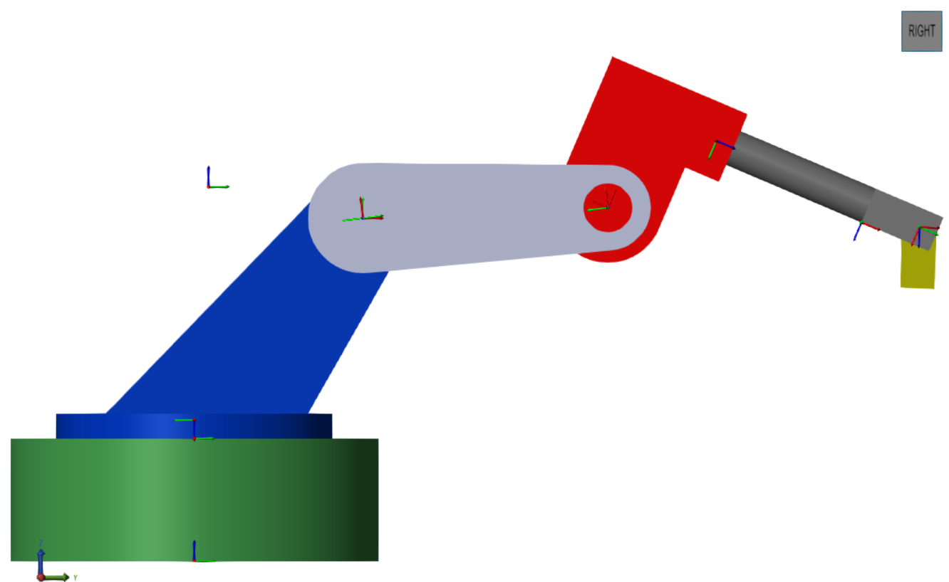
Figure 1: Arm with Frames Visible
The Moving Frames are those associated with a joint as these frames displace or rotate in relation to the inertial and world frames.
There is one moving frame for each joint and are defines using the Denavit-Hartenberg (DH) Convention:
- Z₀ through joints axis of rotation
- X₁ is perpendicular to Z₀
- X₁ intersects to Z₀
The axes are chosen to make the diagram as simple as possible, so X is usually the arm (link) path between the two joints. Y found using right hand rule.
The relationship from the centre of one joint to the centre of the next is fixed and can be found using a linear transformation matrix. The relationship between the frames passing through the joints changes as the joint rotates. This requires a rotational transformation.
The product of the linear and rotational transformation allows the calculation of the next frames relative position. These two transformations when multiplied give a single Homogeneous Transformation.

Kinematics
Kinematics the study of movement without considering the cause of it’s motion (libretexts.org, 2026). In this context it is the process of relating joint positions to that of the end effector which is interacting with the target object.
Forward Kinematics is calculating the end effector positions from the known rotation angle of the joints and arm lengths. There is only one possible solution.
Inverse Kinematics is when given an end effector position, all the possible joint angle combinations which could achieve this are found. Many solutions are possible this is therefore processing heavy.

Trajectories
Trajectories are the paths the effector and joints follow to reach the goal position. In simulation these are calculated at low resolution which is are faster but produces less accurate and jerky motion.
Trapezoidal trajectories have the joints linearly accelerate up to the defined maximum velocity which they hold until linearly decelerating to the desired position.

Jacobian
The Jacobian matrix in robotics provides the relationship between joint velocities and the velocity of the end effector (https://www.rosroboticslearning.com/, 2026). This is accomplished by calculating angular and linear velocity of the end effector via the influence the joints in the current pose have on it’s movement.

Position Sensing
“Robotic arms use position sensors and control to keep a running log of the arms location in three-dimensional space.” (https://control.com/, 2020)
Three types are commonly used:
- Linear- Find a position (such as distance to object) or a change in position in a straight path (CNC bed)
- Angular- Such as throttle or valve position sensor
- Rotary- as angular but allow 360 degree rotation
The Simulink joint blocks are configurable to output position ( or a number of other metrics such as velocity).

Reduction Drives
Robots use reduction drives to decrease the RPM of the motor and so increase the torque. Design parameters relate to the repeatability of the movement, the backlash before motion begins and resolution of the movements ( step size) (Bennett, 2026).
These drives are located between sections of the arm allowing it to rotate and so giving 2 degrees of freedom. Three drives give the common 6 degrees of freedom.
Three types of drive seem to be common, a fourth solution (belt drives) are used for some simple designs.
Planetary Gearbox: These have a central (sun) gear which is driven by the motor, the gears around this transfer drive to large outer (ring) gear. The ratio between sun and ring gives the reduction ration.
Cycloidal Drive: An eccentric bearing attached to the drive shaft from the motor causes the cycloidal disc to wander around the outer ring. The cycloidal disk has one less tooth than the outer (9:10). The drive moves one tooth in a full rotation giving a reduction of 10:1.
Strain Wave or Harmonic Drive: Strain wave drives work by rotating a central oval section (Wave generator) against a cup (Flex Spline) which is thin enough to deform. The splines on the outer of this cup engage with the outer ring (circular spline).
This is a difficult drive to manufacture but offers zero backlash as the splines are always engaged.

Motors
Two types of motors seem common:
Stepper Motors: These are driven by a stepped input which results in a fixed rotation of the motor (RS Online, 2023). A fixed number of steps make a full rotation. Depending on the design partial steps can be used to give very find resolution.
Brushless DC Motors: These use a motor driver circuit to control the waveform in the motor armatures. This is a complex H bridge type controller design and incorporates Hall effect sensors for position monitoring (Arshon Inc, 2025). These motors offer high precision and power.

Control Model Design
I produced a SolidWorks CAD model using approximate dimensions from the Fusion model- simplifying the design by removing decorative features to reduce computation load. I removed the end effector rotation joint so the model had 5 Degrees of Freedom (DoF).
Fusion is not supported by Matlab and there was no appetite on the team to port the model over so I made my own design.
Z up world and inertial frames are the convention so this was set in the SolidWorks view manager. The planes were renamed to reflect the changed orientation (Front -Top, Top – Front as this is not automatic in Solidworks) and saved as a part template for re-use.
I added appropriate joints and exported using Matlab Plug-In.

Matlab Simscape Physical Model
Simscape is a Matlab add in that allows physical models to be created or imported from certain CAD tools (but not Autodesk Fusion). These models include the dimensions, materials and reference geometry. Simscape allows the physical model to be tested with control systems.
The .xml file created by the SolidWorks- Simscape plug-in was imported. This include subsystems for each component, including the reference frame where it joins the preceding part and the transforms to give the next joint location.
The joints and rigid bodies were renamed to be more meaningful.
Position control of the joint is used for this project, this has Simulink calculate the torque required to achieve the position.
The joints are configured to have an input for position control signal (in radians). An output for joint position is added so that actual position can be compared to the desired one. The difference between these is the error signal for use in feedback controllers such as PID.
A quirk of position control is that it assumes an ideal actuator so hard stops set in the joints are overridden. Using torque control this wouldn’t be the case.
Physical Signal (PS) to Simulink blocks were added to convert position to a Simulink signal. This is analogous to an analogue to digital conversion of a real world signal into a digital representation.
Simulink to PS blocks are used for position control input. These are configured to provide Radian inputs with the derivatives calculated. Second order filtering on the input smooths the control signal and so joint movement.
A subsystem block was made for the physical model with only control input and position outputs visible. This simplifies the diagrams and facilitates model re-use.
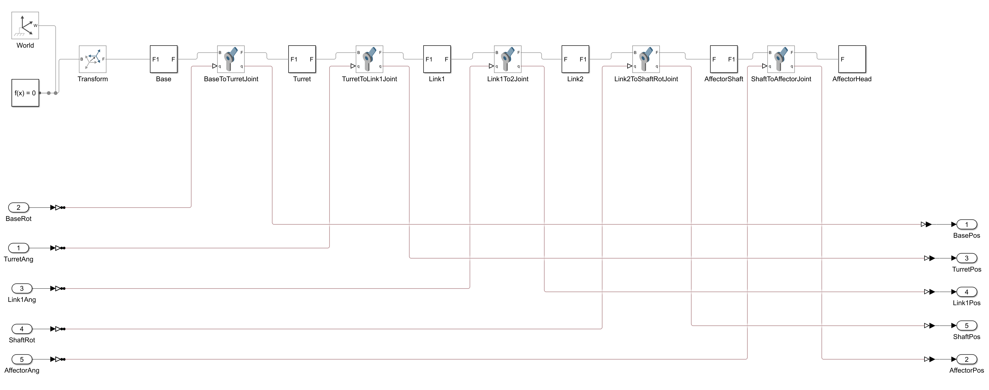
Figure 2: 5DoF Physical Model

Control Methodologies

Sinewave
The model was tested using Sinewave inputs to each joint, amplitude ( giving radians of rotation) and bias (starting point) were adjusted to give a representative range of movement.
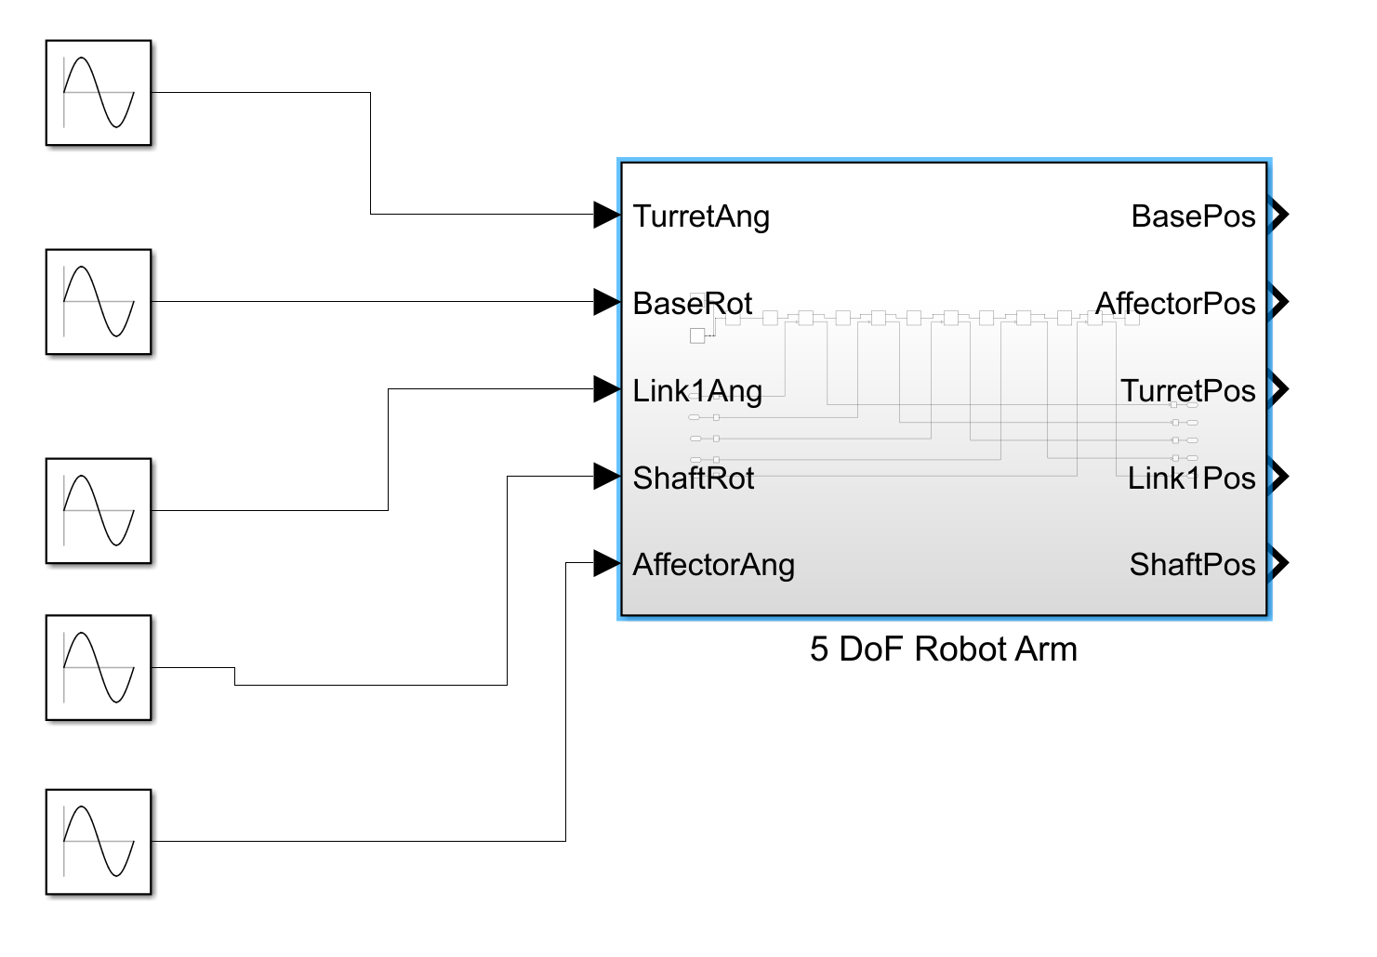
Figure 3:Sine Wave Test Inputs

Signal Editor - Joint Rotation Profiles
Simulink offers a signal builder interface which allows custom waveforms to be defined (Learning Orbis, 2022). The x axis represent time steps and the y axis the rotation ( chosen to be degrees here). A waveform for each joint is created, either via a table or dragging the wave form.
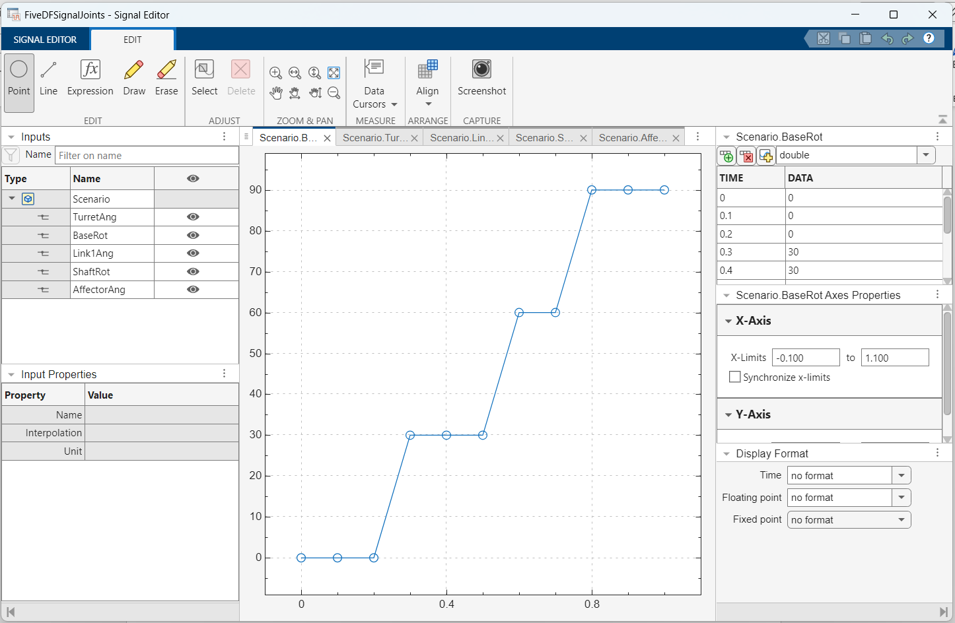
Figure 4: Base Rotation Waveform
The waveform for the base is shown, this rotates the arm from 0 to 90 degrees with two holds in the 1 second simulation.
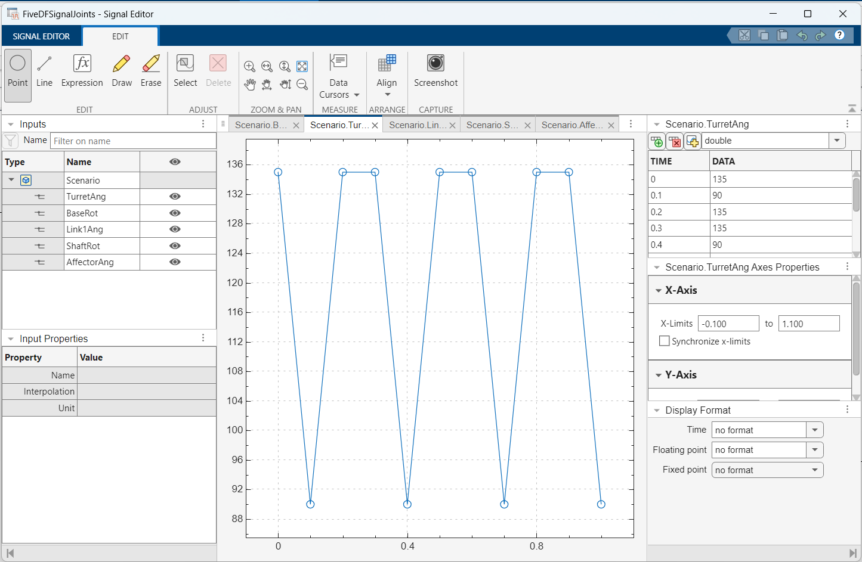
Figure 5: Arm Link 1 Rotation
The profile for Joint 1which connects the rotating turret to the first actuated link lowers the arm at the from 135 to 90 degrees at the points the base is static.
Similar profiles were created for the other 3 joints and used to show the programming of the arm. This is the simulation shown in the group presentation, created using the Matlab Image Processing add in. The original simulation was too fast so a script was used to slow the frame rate of the output video file.
Though the waveform is in degrees this is converted to radians by the Simulink to Physical Signal block in the Robot Arm Sub-System.

Matlab Robotics Systems ToolBox Design
Robotics System ToolBox is a Matlab add-in which incorporates commonly used robotics functions such as forward & reverse kinematics (Anon., 2026). This means that the complex coding of functions is not required.
Rather than joint angles, the waypoints the effector is required to visit were encoded. The X & Y waveform describes a square, the Z profile lowers the effector at each corner.
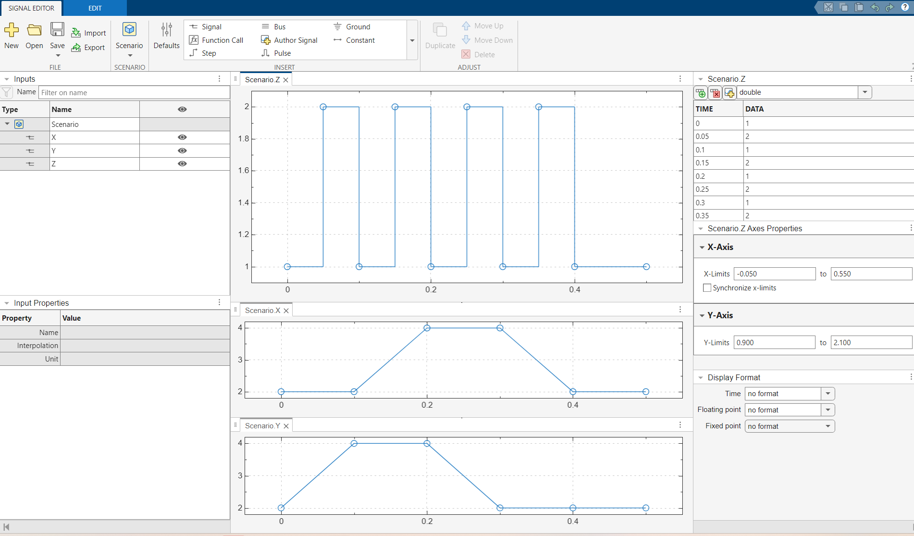
Figure 6: Waypoint Control
These waypoints are transformed into a Homogeneous Matrix by a coordinate conversion block.
The Simscape arm model is converted to a Rigid Body Tree (RBT), this is a robotics orientated version of the model where solid bodies are assumed to be perfectly rigid. This simplifies the calculations in the function blocks.
This RBT is passed to the Inverse Kinematics Block, this calculates the joint rotations which could result in the waypoints passed to it. This is out put as a matrix which is de-multiplexed into angle commands for each joint in the arm subsystem. A Forward Kinematic Block calculates the current effector position from each joint position. A selector block extracts the X, Y, Z positions from the matrix output by the forward kinematics.
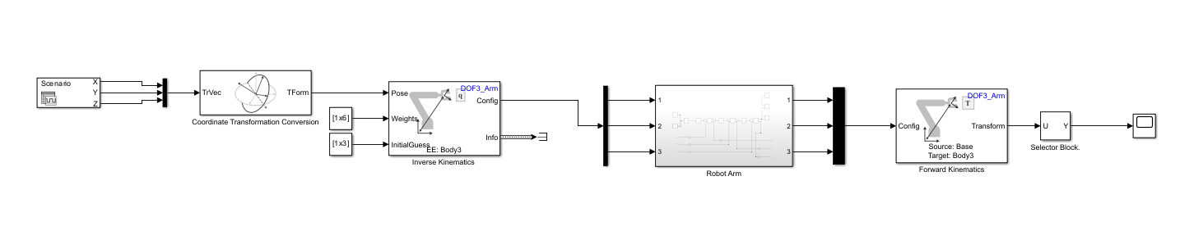
Figure 7:Waypoint and Inverse Kinematics Control

Trajectory Control
To enable trajectory control the waypoints are saved as matrix variable in the Matlab base workspace. This and a clock signal are input to the Trapezoidal control block so that it can accelerate the arm on the long sections between the corners of the square.
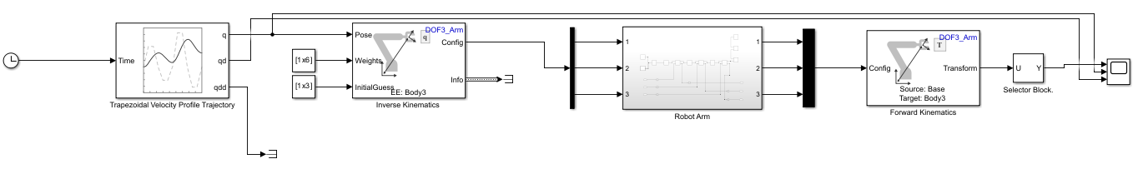
Figure 8: Trajectory Profile Control

Jacobian Calculation
Calculating the velocity of the end effector lets us validate the design specification of maximum 1m/s velocity.
The velocity of the joint is required so the Arm subsystem is modified to output this.
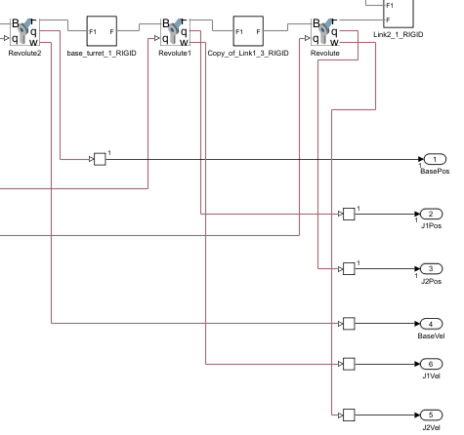
Figure 9: Joint Velocity Sensing
The joint velocities are multiplexed into a matrix then multiplied with the Jacobian. The output is demultiplexed to recover the end effector velocity.
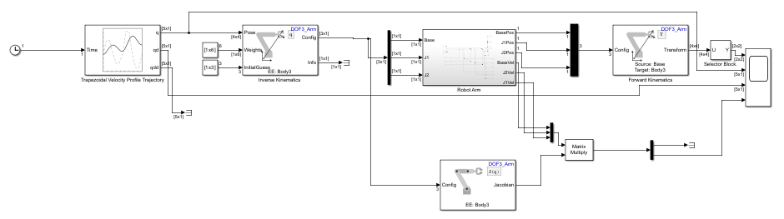
Figure 10: Effector Velocity Calculation

Future Work
End effector control represents the remaining 3 degrees of freedom not covered in the design here. The current design locates the effector in the correct position- follow up work would rotate and angle the effector to orientate it to the work piece.
This can be achieved with programmatic control for object held in jigs with fixed orientations. In a commercial example, image processing and reinforcement learning would be used to allow the robot to self-orientate to account for real world variations. This would also include force feedback to control effector grip strength.
Using torque control related to identified motor options would allow the evaluation of velocity, power consumption and how hard the motor is working. This would require a full CAD model of the arm and example tasks. This modelling would also allow the mechanical design to be optimised so that minimal material can be used, reducing cost and increasing efficiency
This is true Model Based Design as it allows refinement of the whole design prior to prototyping.
The model requires the manual input of each coordinate along with the time. This is effectively as involved as using G Code programming. A graphical User interface which allowed the arm to be moved to the desired positions and effector actions chosen could sit above the current interface and make it more user friendly.
The inverse kinematics assumes a clear operating area, more advanced trajectory planning would allow fixed obstacles to be considered without explicitly defining a move around them for each task.
Feed back control using a PID controller or similar would replace the trajectory block and provide the ability to fine tune the arm behaviour.

Control Conclusion
All the core concepts of arm control have been addressed, the outcome is a working design which can take a sequence of coordinates and timings as input and move the end effector through this path.
Coordinate conversion and inverse kinematics take a user friendly XYZ/ time input and translate it to a complex sequence of joint rotations. The solution is functional and incorporates the basics of feedback control and trajectory planning. This are rudimentary but correct.
The work to accomplish the control was significant, beyond the mechanical and control research there was a requirement to expand my mathematics knowledge and re-learn Solidworks in order to create a new and compatible CAD design. Learning to use Matlab, Simulink, Simscape and Robotics Toolkit was a challenging task at which I am now reasonably comfortable. With the knowledge gained during the project I could replicate a similar design in a matter of hours but the learning curve to get this knowledge has been significant.
The design solution is a solid basis for a robotic arm controller which I will develop to a more production.

Project Review JD
Based on the Gantt chart and Design specification we can say that important aspects of the robot design are met and have been delivered on time. Payload and reach along with safety have been met as the simulations and analysis show that the robot arm is able to function safely with the stated 25kg payload at full reach. The use of off the shelf parts allows for the robotic arm to be easy to maintain and keeps costs down, the use of off the shelf parts means that the customers will be able to set up the robot to their requirements and the control system will allow for coordinate plotting for points A & B and a safest possible path. However, with more time we could have produced prototypes or simulations that will allow for us to test accuracy and production and cycle rates, this could have been planned in and added to the project to ensure that this was done prior to completion.
Overall, this project was completed to on time with major milestones such as the interim viva and final report deadline met on target. However, certain aspects where not completed on target to the Gantt chart which would of delayed other tasks, such as design and simulation.

Successes
Successes of this project include the use of Off shelf parts procured for all non-structural components, such as motors, bearings and fixings. The use of off the shelf parts will allow for us to manufacture the robots at a cheaper price as there will not need to be investment into high skill or new manufacturing techniques, it also allows for the small scale operations to maintain the robotic arm, as they will be able to procure them from the suppliers directly at market price. The estimated price of these components is within the original budget for the design and development of this project.
The control system will also allow for the operator to set point A and point B for the required task; the control system will also allow for the operator to set the safest possible path. The design of the structural components comes with 3D models and engineering drawings which ensures that as a group we are providing key engineering documentation, and we can produce a full specifications list of components which can be provided to the customer. The tests and simulations show that the robot is safe to use when carrying the max payload of 25kg, the tests even showed that there was a safety factor of 10 when the robotic arm was at full reach.

Failures
Due to the time constraint, the cost analysis is based on estimate prices as procurment could not gain quotes for the stated components. In future projects the team would have to gain quotes so to ensure that there is an accurate cost analysis, and that we could make adjustments to bring down cost to below budget.
As a group we could have had better communication to ensure that all task was completed to the Gantt chart. Although weekly meetings where held on campus throughout the project, there was not enough communication with those not on campus via teams to ensure that all members of the group where up to date and on target.

Bibliography

References JD
Bello, I. (2026). Gantt Chart: The Complete Guide. [online] Institute of Project Management. Available at: https://instituteprojectmanagement.com/blog/gantt-chart-the-complete-guide/ [Accessed 14 Mar. 2026].
HSE (2024). Provision and Use of Work Equipment Regulations 1998 (PUWER) - Work equipment and machinery. [online] Hse.gov.uk. Available at: https://www.hse.gov.uk/work-equipment-machinery/puwer.htm [Accessed 8 Mar. 2025].
Institute of Project Management (2022). What is Project Management? [online] Institute of Project Management. Available at: https://instituteprojectmanagement.com/blog/what-is-project-management/ [Accessed 14 Mar. 2026].
ISO - International Organization for Standardization (1998). ISO 9283:1998. [online] ISO. Available at: https://www.iso.org/standard/22244.html [Accessed 8 Mar. 2026].
ISO - International Organization for Standardization (2016). ISO/TS 15066:2016. [online] ISO. Available at: https://www.iso.org/standard/62996.html [Accessed 8 Mar. 2025].
ISO - International Organization for Standardization (2021). ISO 8373:2021. [online] ISO. Available at: https://www.iso.org/standard/75539.html [Accessed 8 Mar. 2026].
ISO - International Organization for Standardization (2025). ISO 10218-1:2025. [online] ISO. Available at: https://www.iso.org/standard/73933.html [Accessed 8 Mar. 2026].
Malsam, W. (2025). Benefits of a Gantt Chart for Project Management: 8 Key Advantages. [online] ProjectManager. Available at: https://www.projectmanager.com/blog/benefits-of-a-gantt-chart [Accessed 14 Mar. 2026].
Office for Product Safety and Standards (n.d.). Supply of Machinery (Safety) Regulations 2008: Great Britain. [online] GOV.UK. Available at: https://www.gov.uk/government/publications/supply-of-machinery-safety-regulations-2008/supply-of-machinery-safety-regulations-2008-great-britain [Accessed 8 Mar. 2025].
Oxford College (2023). 10 Project Management Techniques for Success | Oxford College. [online] Oxford Learning College. Available at: https://www.oxfordcollege.ac/news/10-project-management-techniques-for-success/ [Accessed 8 Mar. 2026].

References OT
Fanuc.eu. (2025). M-20𝑖D/25. [online] Available at: https://www.fanuc.eu/eu-en/product/robot/m-20id25 [Accessed 22 Mar 2026]..
IRB (2025). IRB 2600 | ABB. [online] ABB Group. Available at: https://www.abb.com/global/en/areas/robotics/products/robots/articulated-robots/medium-robots/irb-2600 [Accessed 22 Mar 2026]..
KUKA (2026). my.KUKA. [online] Kuka.com. Available at: https://my.kuka.com/s/product/kr-30-r2100/01t1i000000AQpfAAG?language=en_US&tab=Details [Accessed 22 Mar 2026].

References CG
ABB (2025). IRB 2600 | ABB. [online] ABB Group. Available at: https://www.abb.com/global/en/areas/robotics/products/robots/articulated-robots/medium-robots/irb-2600 [Accessed 12 May 2026].
Bahgat, G. (2026). Changing Security Dynamics in the Persian Gulf after Epic Fury: a Preliminary Assessment. The Middle East Journal, 79(2). doi:https://doi.org/10.3751/79.2.13.
Balaguer‐Mercado, A., Kirshner, S.N. and Tseng, C. (2024). Temporal distance in dual sourcing: A behavioural investigation. Managerial and Decision Economics, 45(8), pp.5757–5766. doi:https://doi.org/10.1002/mde.4353.
Chae, S., Mena, C., Polyviou, M., Rogers, Z.S. and Wiedmer, R. (2019). The effects of tariff increases on supply base complexity: A conceptual framework. Journal of Purchasing and Supply Management, 25(4), p.100556. doi:https://doi.org/10.1016/j.pursup.2019.100556.
Choi, T., Juan Li, J., Rogers, D., Schoenherr, T. and Wagner, S. (2021). The Oxford Handbook of Supply Chain Management. Oxford University Press.
CIPS (2019a). Category Management Benefits | CIPS. [online] cips.org. Available at: https://www.cips.org/intelligence-hub/category-management/benefits#item-block-1 [Accessed 21 May 2026].
CIPS (2019b). Make Or Buy | CIPS. [online] cips.org. Available at: https://www.cips.org/intelligence-hub/procurement/make-or-buy#item-block-1 [Accessed 21 May 2026].
CIPS (2019c). Sustainable Procurement | CIPS. [online] cips.org. Available at: https://www.cips.org/intelligence-hub/sustainability/sustainable-procurement#item-block-1.
Craig (2020). How Much Does CNC Machining Cost? [online] Parallel Precision. Available at: https://www.parallelprecision.co.uk/blog/how_much_does_cnc_machining_cost [Accessed 18 May 2026].
Deresky, H. (2017). International Management : Managing across Borders and cultures; Text and Cases. 9th ed. Boston, Mass. U.A.: Pearson.
Douch, M. and Edwards, T.H. (2021). The bilateral trade effects of announcement shocks: Brexit as a natural field experiment. Journal of Applied Econometrics, 37(2). doi:https://doi.org/10.1002/jae.2878.
Ewing, D. (2021). Understanding CNC manufacturing costs. [online] Protolabs.com. Available at: https://www.protolabs.com/en-gb/resources/blog/understanding-cnc-manufacturing-costs/ [Accessed 18 May 2026].
Farooq, M.A., Kirchain, R., Novoa, H. and Araujo, A. (2017). Cost of quality: Evaluating cost-quality trade-offs for inspection strategies of manufacturing processes. International Journal of Production Economics, [online] 188(2), pp.156–166. doi:https://doi.org/10.1016/j.ijpe.2017.03.019.
G Boothroyd (2005). Assembly automation and product design. Boca Raton, Fl: Taylor & Francis.
Global Robots (2020). ABB IRB 2400L IRC5 Controller | Industrial Automation Solutions | Global Robots. [online] Global Robots . Available at: https://globalrobots.com/product/abb-irb-2400l/ [Accessed 12 May 2026].
Herring, D. (2025). The Cost of Labour - The Centre for Policy Studies. [online] The Centre for Policy Studies. Available at: https://cps.org.uk/research/the-cost-of-labour/.
Javed, S.A., Gunasekaran, A. and Mahmoudi, A. (2022). DGRA: Multi-sourcing and supplier classification through Dynamic Grey Relational Analysis method. Computers & Industrial Engineering, 173(2), p.108674. doi:https://doi.org/10.1016/j.cie.2022.108674.
Kingsbury (n.d.). 5-axis CNC Machine Price Guide. [online] Kingsbury. Available at: https://kingsburyuk.com/guide/5-axis-cnc-machine-price-guide/ [Accessed 18 May 2026].
Msomi, S. and Muzindutsi, P.-F. (2025). Exchange Rates, Supply Chain Activity/Disruption Effects, and Exports. Forecasting, [online] 7(1), pp.10–10. doi:https://doi.org/10.3390/forecast7010010.
Porter, M. (1979). How Competitive Forces Shape Strategy. [online] Harvard Business School. Available at: https://www.hbs.edu/faculty/Pages/item.aspx?num=10692 [Accessed 21 May 2026].
RCC (2026). Robot maintenance cost: full breakdown and savings. [online] RCC - Robotic Cover Concept. Available at: https://www.rcc.fr/en/robot-maintenance-cost/ [Accessed 12 May 2026].
Robot Store (2026). Robotic Cost. [online] Robot Store Ltd. Available at: https://www.robot-store.co.uk/robotic-costs [Accessed 12 May 2026].
Tamás Bányai and Kaczmar, I. (2021). Green supply chain : competitiveness and sustainability. London, United Kingdom: Intechopen.
Tate, W.L., Ellram, L.M. and Bals, L. (2022). Handbook of Theories for Purchasing, Supply Chain and Management Research. Edward Elgar Publishing.
Tatsiopoulos, I.P. and Kingsman, B.G. (1983). Lead time management. European Journal of Operational Research, 14(4), pp.351–358. doi:https://doi.org/10.1016/0377-2217(83)90235-7.
Teresko, J. (2007). COMPETING WITH BOUNDLESS ENERGY EFFICIENCY. Industry week, [online] 256(5), May. Available at: https://research-ebsco-com.uwtsd.idm.oclc.org/c/onvpsy/viewer/pdf/4bhwnj7xtj?route=details [Accessed 10 May 2026].
Todorova, T. (2025). The Welfare Effects of Trump’s Tariff Policy. Theoretical and Practical Research in Economic Fields, 16(4), p.972. doi:https://doi.org/10.14505/tpref.v16.4(36).13.
Ulrich, K.T. and Ellison, D.J. (2009). Beyond Make-Buy: Internalization and Integration of Design and Production. Production and Operations Management, 14(3), pp.315–330. doi:https://doi.org/10.1111/j.1937-5956.2005.tb00027.x.
Visani, F., Barbieri, P., Di Lascio, F.M.L., Raffoni, A. and Vigo, D. (2016). Supplier’s total cost of ownership evaluation: a data envelopment analysis approach. Omega, 61(2), pp.141–154. doi:https://doi.org/10.1016/j.omega.2015.08.001.
Yanchi, L. and Yijie, B. (2021). Enterprise Competitors and Technology Opportunity Identification Based on Technology Proximity and Benchmarking Analysis. Zhishi guanli luntan, [online] 61(3), pp.143–157. doi:https://doi.org/10.13266/j.issn.2095-5472.2021.015.

References HC
www.sciencedirect.com. (2009). Material Selection Chart - an overview | ScienceDirect Topics. [online] Available at: https://www.sciencedirect.com/topics/materials-science/material-selection-chart.
‌
Investacast. (2023). Choosing the right production method for your manufactured parts - Investacast. [online] Available at: https://investacast.com/news/choosing-the-right-production-method-for-your-manufactured-parts/.
‌Tatasteeluk.com. (2025). Available at: https://www.tatasteeluk.com/products/hot-rolled/structural-steel.
‌
Furley Engineering (2016). Furley Engineering - Structural Steel to Eurocode EN1993-1-1. [online] Furleyengineering.co.uk. Available at: https://www.furleyengineering.co.uk/toolkit/materials/Materials-Structural-Steel-Eurocode.html? [Accessed 26 May 2026].
‌ matweb.com. (n.d.). MatWeb - The Online Materials Information Resource. [online] Available at: https://matweb.com/search/DataSheet.aspx?MatGUID=6291a24572754cae94ff365ed99b96f9&ckck=1.
‌
www.matweb.com. (n.d.). MatWeb - The Online Materials Information Resource. [online] Available at: https://www.matweb.com/search/DataSheet.aspx?MatGUID=4644996007054e12b78d49666b8253c3.
‌ West Yorkshire Steel. (n.d.). AISI 4140 In Stock. On Time Delivery. UK ISO 9001 Supplier. [online] Available at: https://www.westyorkssteel.com/alloy-steel/oil-and-gas/aisi-4140/.
‌M-machine-metals.co.uk. (2026). M-Machine Metals, Engineering and Fabrication. [online] Available at: https://www.m-machine-metals.co.uk/ [Accessed 18 May 2026].
‌AZO materials (2005). Aluminium - Specifications, Properties, Classifications and Classes. [online] azom.com. Available at: https://www.azom.com/article.aspx?ArticleID=2863.
‌
www.matweb.com. (n.d.). MatWeb - The Online Materials Information Resource. [online] Available at: https://www.matweb.com/search/datasheet.aspx?matguid=1b8c06d0ca7c456694c7777d9e10be5b.
‌
www.smithmetal.com. (n.d.). Aluminium Alloys | Aluminium Stockholders. [online] Available at: https://www.smithmetal.com/aluminium-alloys.htm.
‌ AZoM.com. (2003). Magnesium Alloys - World Trends, Markets and Supplies of Magnesium. [online] Available at: https://www.azom.com/article.aspx?ArticleID=1801.
‌
British Plastics Federation. (2023). Thermoplastic Composites 2023. [online] Available at: https://www.bpf.co.uk/events/archive/thermoplastic-composites-2023.aspx [Accessed 26 May 2026].
‌ Matweb.com. (2025). MatWeb - The Online Materials Information Resource. [online] Available at: https://www.matweb.com/search/QuickText.aspx?SearchText=brass.
‌
Welcome to NSK Europe Website - Bearings, Automotive Products, and Precision Machinery and Parts. (2026). Self-Lube ISO Standard. [online] Available at: https://www.nsk.com/eu-en/products/bearings/bearing-units/self-lube/ [Accessed 18 May 2026].
‌
www.matweb.com. (n.d.). MatWeb - The Online Materials Information Resource. [online] Available at: https://www.matweb.com/search/QuickText.aspx?SearchText=ABS.
‌
Matweb.com. (2025). MatWeb - The Online Materials Information Resource. [online] Available at: https://www.matweb.com/search/DataSheet.aspx?MatGUID=619cf1604987455588348a473a158043&ckck=1.
‌
www.matweb.com. (n.d.). MatWeb - The Online Materials Information Resource. [online] Available at: https://www.matweb.com/search/DataSheet.aspx?MatGUID=d16a64a389df424f8e53ed481e77477b.
‌MatWeb (n.d.). Aluminum, Al. [online] www.matweb.com. Available at: https://www.matweb.com/search/DataSheet.aspx?MatGUID=0cd1edf33ac145ee93a0aa6fc666c0e0.
‌www.sciencedirect.com. (n.d.). Polymer Degradation - an overview | ScienceDirect Topics. [online] Available at: https://www.sciencedirect.com/topics/materials-science/polymer-degradation.
‌
Bsigroup.com. (2019). BS EN 10025-2:2019 - TC | 31 Aug 2019 | BSI Knowledge. [online] Available at: https://knowledge.bsigroup.com/products/hot-rolled-products-of-structural-steels-technical-delivery-conditions-for-non-alloy-structural-steels-1.
‌ Steel Construction (2017). Steel material properties. [online] www.steelconstruction.info. Available at: https://www.steelconstruction.info/Steel_material_properties.
‌
AZoM (2012). AZoM. [online] AZoM. Available at: https://www.azom.com/article.aspx?ArticleID=6765 [Accessed 26 May 2026].
‌ www.makeitfrom.com. (n.d.). SAE-AISI 4140 (SCM440, G41400) Cr-Mo Steel :: MakeItFrom.com. [online] Available at: https://www.makeitfrom.com/material-properties/SAE-AISI-4140-SCM440-G41400-Cr-Mo-Steel.
‌www.onlinemetals.com. (n.d.). alloy-steel 4140 Product Guide from Online Metals. [online] Available at: https://www.onlinemetals.com/en/product-guide/alloy/4140.
(2020). Material Pages - How to use them. [online] Machining Doctor. Available at: https://www.machiningdoctor.com/mds/?matId=420.
‌
Makeitfrom.com. (2019). 6061-T6 Aluminum :: MakeItFrom.com. [online] Available at: https://www.makeitfrom.com/material-properties/6061-T6-Aluminum.
‌ Davidson, M., Graunke, R., Green, A., Haelsig, H., Heinemann, L., Antony Jose, S. and Menezes, P.L. (2026). Carbon Fiber-Reinforced Polymer Matrix Composites: Processing, Properties, and Applications. Fibers, [online] 14(3), p.29. doi:https://doi.org/10.3390/fib14030029.
‌
‌ Alam, P., Mamalis, D., Robert, C., Floreani, C. and Ó Brádaigh, C.M. (2019). The fatigue of carbon fibre reinforced plastics - A review. Composites Part B: Engineering, [online] 166, pp.555–579. doi:https://doi.org/10.1016/j.compositesb.2019.02.016.
‌
Igus.com. (2026). Plastic Bushings vs. Bronze Bearings | igus®. [online] Available at: https://www.igus.com/company/plastic-vs-bronze-bearings [Accessed 26 May 2026].
‌
Shen, J. (2015). Self-lubricating polymer composites: tribology and interface. [Thesis fully internal (DIV), University of Groningen]. University of Groningen.

‌ British Plastics Federation (2019). Injection Moulding. [online] Bpf.co.uk. Available at: https://www.bpf.co.uk/plastipedia/processes/injection_moulding.aspx.
‌
Harris (Steels) Limited. (2023). Harris (Steels) Limited. [online] Available at: https://www.harrissteels.co.uk/s355-standards-specification/.
‌
www.matweb.com. (n.d.). MatWeb - The Online Materials Information Resource. [online] Available at: https://www.matweb.com/search/DataSheet.aspx?MatGUID=d2b3cde1c1094fb8aaa11bdfb888c0d3.
‌ steelbars.co.uk. (2017). 4140 Steel | steelbars.co.uk. [online] Available at: https://www.steelbars.co.uk/4140 [Accessed 18 May 2026].

Protolabs.com. (2019). Design Tips | Protolabs. [online] Available at: https://www.protolabs.com/en-gb/resources/design-tips/ [Accessed 20 May 2026].
‌ Xometry Europe. (n.d.). Xometry Europe – Manufacturing Services: CNC, Sheet Metal, 3D Printing, Injection Moulding. [online] Available at: https://xometry.eu/en/.
‌ Goodwin University (2018). What Is CNC Machining? [online] Goodwin University. Available at: https://www.goodwin.edu/enews/what-is-cnc/.
‌www.steelconstruction.info. (n.d.). Welding. [online] Available at: https://www.steelconstruction.info/Welding.
‌www.twi-global.com. (n.d.). Technical Knowledge - Engineering and Materials Joining Library. [online] Available at: https://www.twi-global.com/technical-knowledge.
‌ Haro (2025). Comprehensive Analysis of Alloy Steel 4140: Characteristics, Applications and Processing Guidelines. [online] ProtoTi. Available at: https://www.prototi.com/knowledge-base/comprehensive-analysis-of-alloy-steel-4140-characteristics-applications-and-processing-guidelines/.
‌ piranha (2023). Aluminium Extrusion: Combining Strength, Flexibility, and Efficiency. [online] Simmal. Available at: https://simmal.com/aluminium-extrusion-combining-strength-flexibility-and-efficiency/ [Accessed 26 May 2026].
‌Admin (2025). How Aluminium Extrusions Are Driving Innovation for Automotive Manufacturers - BCW. [online] BCW. Available at: https://www.bcwgroup.co.uk/insights/automotive/how-aluminium-extrusions-are-driving-innovation-for-automotive-manufacturers/ [Accessed 20 May 2026].
‌
www.sciencedirect.com. (n.d.). Resin Transfer Molding Process - an overview | ScienceDirect Topics. [online] Available at: https://www.sciencedirect.com/topics/engineering/resin-transfer-molding-process.
‌
compositematerialshub.com (2024). Resin Transfer moulding (RTM) - Composite Materials Hub. [online] Composite Materials Hub. Available at: https://compositematerialshub.com/resin-transfer-moulding/.
‌
PatSnap Eureka. (2026). Resin Transfer Molding vs Hand Lay-Up: Material Waste. [online] Available at: https://eureka.patsnap.com/report-resin-transfer-molding-vs-hand-lay-up-material-waste [Accessed 21 May 2026].
‌ Protolabs Network (n.d.). Injection molding: The manufacturing & design guide. [online] Hubs. Available at: https://www.hubs.com/guides/injection-molding/.
www.protolabs.com. (n.d.). Improve Injection Molding Design With Uniform Wall Thickness. [online] Available at: https://www.protolabs.com/resources/design-tips/improving-part-design-with-uniform-wall-thickness/.

‌References TE
KUKA (2026). my.KUKA. [online] Kuka.com. Available at: https://my.kuka.com/s/product/kr-30-r2100/01t1i000000AQpfAAG?language=en_US&tab=Details [Accessed 23 May 2026].
Fanuc.eu. (2025). M-20𝑖D/25. [online] Available at: https://www.fanuc.eu/eu-en/product/robot/m-20id25 [Accessed 10 May 2026]..
IRB (2025). IRB 2600 | ABB. [online] ABB Group. Available at: https://www.abb.com/global/en/areas/robotics/products/robots/articulated-robots/medium-robots/irb-2600 [Accessed 12 May 2026]..
“UR20 (2025) - Fastest, Heavy Payload Cobot - Universal Robots.” Universal-Robots.com, 2025, www.universal-robots.com/products/ur20/ [Accessed 12 May 2026].

Laurence Browne References
Anon., 2026. Robotics System Toolbox. [Online]
Available at: https://uk.mathworks.com/products/robotics.html?requestedDomain=
[Accessed 1 March 2026].
Arshon Inc, 2025. Complete Guide to BLDC Motor Controller Circuit Diagrams and Design. [Online]
Available at: https://arshon.com/blog/complete-guide-to-bldc-motor-controller-circuit-diagrams-and-design/
[Accessed 10 Feb 2026].
Bennett, L., 2026. Specification of Gear Train Backlash & Repeatability. [Online]
Available at: https://microservomotor.com/common-specifications-and-parameters/gear-train-backlash-repeatability.htm
[Accessed 1 Feb 2026].
https://control.com/, 2020. Position Sensors in Robotics. [Online]
Available at: https://control.com/technical-articles/Position-sensors-in-Robotics/
[Accessed 1 Feb 2026].
https://www.rosroboticslearning.com/, 2026. Jacobian. [Online]
Available at: https://www.rosroboticslearning.com/jacobian
[Accessed 1 March 2026].
Learning Orbis, 2022. Drive Robot Using Inverse Kinematics. [Online]
Available at: https://www.youtube.com/watch?v=20ENJ7jOJzE&t=689s
[Accessed 12 Feb 2026].
libretexts.org, 2026. Basics of Kinematics. [Online]
Available at: https://phys.libretexts.org/Bookshelves/University_Physics/Physics_(Boundless)/2%3A_Kinematics/2.1%3A_Basics_of_Kinematics
[Accessed 21 Feb 2026].
RS Online, 2023. The Complete Guide to Stepper Motors. [Online]
Available at: https://uk.rs-online.com/web/content/discovery/ideas-and-advice/stepper-motors-guide
[Accessed 11 Feb 2026].

Appendix
Table 1:Procurement Aims and Targets 67
Table 2:TCO Analysis 72
Table 3:Original Procurement Component Research 74
Table 4:Final Component List for Product 75
Figure 1 - Concept 1 of the robot arm 34
Figure 2 - Concept 2 of the robot arm 35
Figure 3 - Sketch of End Effector Gripper Arm 36
Figure 4 - Sketch of Wrist Assembly 36
Figure 5 - Extrude on the Arm Joint 37
Figure 6 - Fillet command on the base 37
Figure 7 - Chamfer command on Arm Joint 38
Figure 8 - Shell command used on base 38
Figure 9 - Drawing of Base 39
Figure 10 - Model of Base 39
Figure 11 - Drawing of Jaw 40
Figure 12 - Model of Jaw 40
Figure 13 - Drawing of Arm 41
Figure 14 - Model of Arm 41
Figure 15 - Drawing of Head Base 41
Figure 16 - Model of Head Base 42
Figure 17 - Drawing of Wrist 42
Figure 18 - Model of Wrist 42
Figure 19 - Drawing of coupling 43
Figure 20 - Model of Coupling 43
Figure 21 - Drawing of End Effector Base 44
Figure 22 - Model of End Effector Base 44
Figure 23 - Drawing of End Effector arm 44
Figure 24 - Model of End Effector arm 45
Figure 25 - Exploded view of Assembly 45
Figure 26 - Complete Assembly 46
Figure 27 - Section analysis on Base and Jaw 47

Time Sheet
W-S | Attendance on Campus | Actions
30/01 | OT,HC,CG,LB,TE | First meeting, group meet and greet
06/02 | JD,OT,HC,CG,LB,TE | Robotic arm decided, group roles decided
13/02 | JD,OT,CG,TE | All began research into roles and for the project
20/02 | JDOT,CG,TE | JD to begin planning of Project  OT begin design  CG to begin looking into components  HC begin researching materials  TE to research Simulation methods  LB look into control systems
27/02 | JD,OT,CG,TE | JD Gantt chart complete, begin research into safety  All, continue with current work load
06/03 | JD,OT,CG,TE | All begin to create interim viva
13/03 | JD,OT,CG,TE | To work on interim viva
20/03 | JD,OT,HC,CG,LB,TE | Interim viva
27/03 | JD,OT,CG,TE | OT to work on design
03/04 | JD,OT,CG,TE | OT complete design  TE to begin Testing and Analyses
10/04 | JD,OT,CG,TE | CG and HC to work on cost estimate
17/04 | JD,OT,CG,TE | TE complete simulation
24/04 | JD,OT,CG,TE | All to begin final report
01/05 | JD,OT,CG,TE | All to work on final report
08/05 | JD,OT,CG,TE | All work on final Viva and report
15/05 | JD,OT,CG,TE | Begin to compile final report
22/05 | JD,OT,HC,CG,LB,TE | All complete final Report and presentation, discuss final report and presentation
29/05 | JD,OT,HC,CG,LB,TE | All to look other final presentation

