

University of Wales Trinity Saint David
Certificate of Higher Education in Skills for the Workplace

Academic and Employability Skills

Assessment / Rework
Shenses Maksud (1605761)

Table of Contents
Introduction 3
Discussion 4
Analysis of the employability skills that are possessed by an individual 4
Perspective of a graduate looking for an employment opportunity/ Examining my role 5
Reflective Cycles for Improving the Skills 6
Application of Gibb’s Reflective Model for Improvement 7
Personal Development Plan and Target Job role and process to achieve the role 8
Conclusion 10
Reference List 11

Introduction
The term employability skill brings into question of the different skills that are searched by the employer of an organization in a candidate during the process of recruitment. From the perspective of an employer, employees’ needs to possess efficient problem solving skill, communication strategies and most importantly the skill to carry out the tasks aligned with the organizational objective. Employment skills judges the personality of an individual as it decided whether the person will be able to accomplish the tasks or not. The report will make a personal reflection on the various skills that are possessed individually and the skills that are lacking. Along with it, the report will also shed light on the various efforts that are taken by the employees to improve the lacking skills.

Discussion

Analysis of the employability skills that are possessed by an individual
Perspective of an employer:
In future, I have the desire to become one of the efficient human resource managers in Tesco Plc in UK. Aiming to become HR manager, there are some skills that are required to perform the tasks in an organized manner. An employer always seeks these skills to be possessed by an individual while appearing for the interview as they are to select the best candidate for the company (Rao, 2014). A company is dependent on the skills of an employee, as they are the supporting hand behind the production process. Often chaos and confusion can result in creating violence, which can cause damage to the reputation of the organization. Employees needs to work together to accomplish the task faster and meet the customer demands on a huge scale. As a student, it is necessary to have a brief view of the employability skills so that they can perform better and in an organized way in the company. During the process of the recruitment and selection, it is obvious that the employer will not be able to oversee the potential skills that are present in the candidate due to short time. However, there are some important areas which are identified by the employers like the communication skills, interpersonal skills, problem solving skill and team working spirit in an individual. The skills will not only benefit the organization but also will profit the employee in having personal development and career development.
Some skills that are not found within an individual but having other skills are selected since they can be nurtured through provision of training. In business oriented schools, education is given mainly on the employability skills that the students should implement in their roles. Currently, the employers are looking for candidates having creativity and soft skills as their education. Soft skills are required to maintain IT department of the organization. Some of the employability skills are discussed below from the perspective of employer looking for a candidate in the post of human resource manager.
Positive attitude: Candidates or new trainees having positive attitude as one of the skills, contributes much in changing the environment inside the organization (Abas et al.,2016). An employer looks for this skill in an individual as the candidates are the future of the organization and contributes to the growth. Positive attitude towards the decisions of the management and attitude towards other fellow members changes the organizational behaviour (Martin and Omrani, 2015). The HR manager needs to carry a positive attitude while performing the tasks as this will help to build a relation with the employees. Positive attitude towards the employees will foster better bonding in the organization and enable the manager to collect feedbacks from the employees.
Attitude is the behaviour of one member towards other and also encourages in uplifting the growth of the organization. Chaos and confusion can be avoided when an employee is positive in nature.
Teamwork: The ability to work under a team highlights the fact that the candidate or the employee has the charisma to take pressure and work in coordination. Operations in organization desire teamwork as the work is accomplished at much faster pace (Galegher, et al., 2014).Teamwork will inbuilt the capability to be flexible in nature. Adhering to owns decision may lead to negative impacts or outcome. However, it is recommendable to listen to each other’s decisions and opinions. This develops the opportunity to exchange ideas and interact with each other on respective matter. An employer always seeks to look for this skill as creative ideas will generate when there will be exchange of ideas and views.
Self –management: The ability to handle situation in critical moment reflects on the potentiality of an employee and the suitability of the position (Whette and Cameron, 2014). In a critical situation, the HR manager needs to take decision on own. This skill is required as the employees selected will overtake the position of the current employer in future.
Problem-solving skills in the employees tend to create an impression that the individual is suitable for the position. Selecting candidates, employers often tend to ask the question such as “what would the candidate do in critical situation” (Mishra, 2014). This question is asked to test the ability of self-management in the new employees. It is not always the responsibility of the employers and the management to take decisions, sometimes the employees are too involved as they are the manufacturer of the products (Asiri et al., 2017).

Perspective of a graduate looking for an employment opportunity/ Examining my role
Graduates like me pursuing the career of becoming HR manager in a reputable organization believe that there are some skills which are expected by the employer:
Learning skills: Learning nature in individuals does not end up with the job offer. In the organization, employees have lot to learn and intake as part of career development. Learning develops a feeling that the employee does not restrict their career after getting the job. Even within the organization, the employees should cultivate the skill of learning. Learning from the senior managers or the training imparted to them (Jackson and Oliver, 2018). An individual with the skill to learn never gives up and gradually develops confidence in certain areas. Learning widens the mind set and eventually creates the urge to have something new. I can gain experience from the learning session. Though I have observed that I am a little weak in catching up with things
Planning and organizing: It is a general expectation as a graduate that the employer will certainly look for the planning skills present in an individual. With planning, the employee can manage the operations in an effective way and accomplish the tasks in a given timeframe. This helps to gain positive outcome in a constructive manner. Businesses demands for employees, who can help to plan the structure of the model and organize accordingly. Organizing in business refers to settling down the budget, transporting the raw materials, taking feedbacks from customers and making necessary amendments. I have identified that I have strength in this field of planning and organizing the work activities.
I have learnt through observation, that taking initiatives in the business can change the entire environment of the business. Initiatives enable the employees to participate in different curriculum and gain knowledge. Employers seek imitativeness in nature as employees showing willingness have great ability and positivity in their nature. These skills are boon to the organization and helps in productivity. Employability skills are the criteria that are now judged by almost all industries before selecting any candidates for the organization ((Jackson et al., 2018). Employers or recruiters are given the responsibility oversee that the skills lacking are given training accordingly

Reflective Cycles for Improving the Skills
In my personal experience while trying to evaluate on the skills that are lacking, Kolb’s Learning Cycle can be applied. This model will be helping in analysing the lacking skill as well as implementing ways to improve the skills apparently. With the help of Gibbs Reflective Cycle, I can stress upon the lacking skill and develop action plan that will give the correct structure to proceed in the tasks of improving the tasks one after the other.
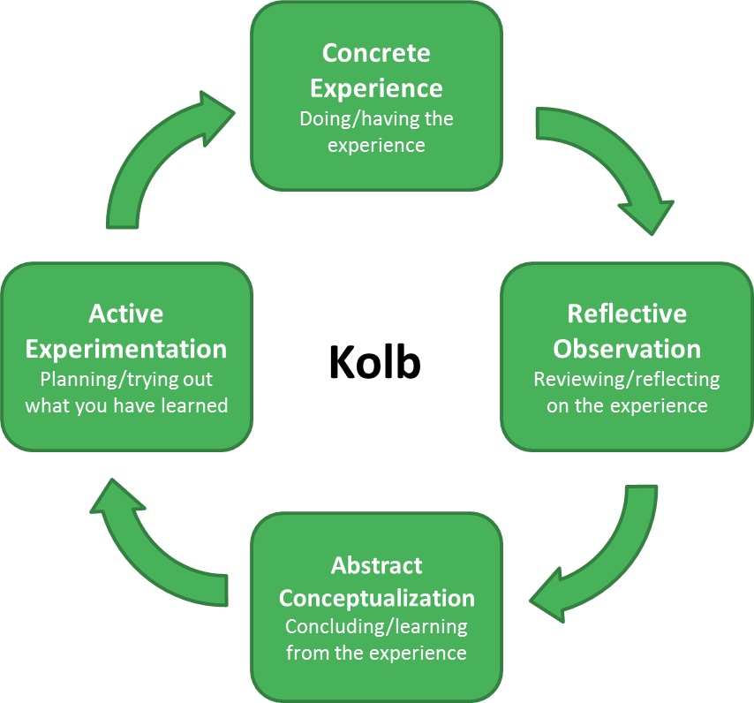
Figure 1: Kolb’ Learning Cycle
(Source: Dixon, 2017)
Some of the skills that are lacking in me are:
Communication skills: I have been lacking in the skill of interacting with individuals fluently. I feel shy while starting a conversation or taking the initiative to start a discussion and this has adversely impacted my career. I can develop this skill by attending the seminars and the debates taking part in the university.
Problem solving skills: At the moment when I am assigned the tasks of solving a problem, I fail in giving solution to the problems immediately. I can give solution but it will take time and this is a negative factor in terms of employment sector.
Management skills: I need to work on the role of leadership as I am more comfortable in working with the peers. However, this has been a lagging factor in my skill stopping me from achieving better position. I can develop the skill by managing the peers in the university and acting as the leader of group works.

Application of Gibb’s Reflective Model for Improvement
In my view, the employability skills that are required are positive attitude, initiative in nature and learning opportunity, self-management capability and the biggest is the problem solving nature. However, when analysed using the Gibbs reflective cycle, it is clear that we have to analyse as to what the recruiters want and develop skills accordingly. While analysing the roles, certain steps from the Gibbs Reflective cycle has been followed:
- Description
- Evaluating
- Feelings
- Analysing
- Conclusions
- Developing Action Plans
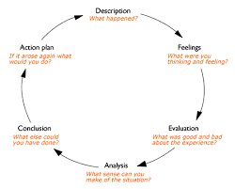
Figure 2: Gibb’s Reflective Cycle
(Source: Husebø et al., 2015).

Personal Development Plan and Target Job role and process to achieve the role
I have the target job role of acquiring the position of Human Resource manager in one of the reputed industries in UK. However, I have identified that there are some skills which are needed to fit into the position like the problem solving skills, software skills, communication skills and strong bond with the employees. I have undertaken the model of personal development plan that will help me to reach the career goal within a given timeframe.
This Personal Development Plan will help me to identify the lacking skills and help to overcome them within a set timeframe.

Weaknesses identified | Short term | Long term | Time period
Learning capability | On the basis of short terms, negotiation can be done with senior managers or people involved in discussion. This will be a lesson for me to learn | For long term purpose, negotiation can be utilized in important business decisions and negotiate with the management | 15 days
Verbal means of communication | I can definitely try to interact with my friends and neighbours | I can attend seminars and take parts in group meetings. Here I will get the opportunity to learn and communicate as well | 15 days
Decision-making ability | I can take decisions regarding small matters on own | For long term, I can take decisions on major points of business or education perspective | 1 month

For decision making skill, particularly I have to emphasize on my confidence level that will give me the courage to take decisions on own. In an organization, the HR manager needs to take immediate decision based on the situations. I have to practice analysing the situation and understand the root cause behind the issue and then take decision with confidence. Speaking with confidence will also inspire the peers about the decision and perform the tasks smoothly.

Conclusion
The report illustrates the fact than en individual needs to possess certain employability skills that will generate the opportunity to become successful entrepreneur or employee. Employability skills are not born rather are grasped and developed over time. Business management schools are responsible for teaching the students about the necessity of various employability skills. Bearing those attitudes and skills helps the employee to occupy a definite position in the company. An individual with an aim to pursue in the career of business needs to have a clear knowledge of the skills that are demanded by the recruiter or an employer for particular organization. Through this report, one can identify the skills that are expected by the employer of an organization to be present in an individual. The employment skills help an individual not only to achieve good position in the firm but also to achieve a prosperous career. Personal and professional development is required by all as all individuals are prepared for the required skills in the organization.

Reference List
Abas, M.C. and Imam, O.A., 2016. Graduates’ competence on employability skills and job performance. International Journal of Evaluation and Research in Education (IJERE), 5(2), pp.119-125.
Brooks, R., 2017. " Who wants a job anyway?": Student approaches to graduate employability.
Collet, C., Hine, D. and du Plessis, K., 2015. Employability skills: perspectives from a knowledge-intensive industry. Education+ Training, 57(5), pp.532-559.
Galegher, J., Kraut, R.E. and Egido, C. eds., 2014. Intellectual teamwork: Social and technological foundations of cooperative work. Psychology Press.
Jackson, T.P. and Oliver, S., 2018. Adaptive learning program for developing employability skills. Journal of pedagogic development.
Kent.ac.uk. (2018). Reflective learning - Learning - University of Kent. [online] Available at: https://www.kent.ac.uk/learning/PDP-and-employability/pdp/reflective.html [Accessed 14 Aug. 2018].
Kerzner, H. and Kerzner, H.R., 2017. Project management: a systems approach to planning, scheduling, and controlling. John Wiley & Sons.
Martin, L. and Omrani, N., 2015. An assessment of trends in technology use, innovative work practices and employees’ attitudes in Europe. Applied Economics, 47(6), pp.623-638.
Mishra, K., 2014. Employability skills that recruiters demand. IUP Journal of Soft Skills, 8(3), p.50.
Rao, M.S., 2014. Enhancing employability in engineering and management students through soft skills. Industrial and Commercial Training, 46(1), pp.42-48.
Whetten, D. and Cameron, K., 2014. Developing Management Skills: Global Edition. Pearson Higher Ed.
Dixon, N.M., 2017. The organizational learning cycle: How we can learn collectively. Routledge.
Husebø, S.E., O'Regan, S. and Nestel, D., 2015. Reflective practice and its role in simulation. Clinical Simulation in Nursing, 11(8), pp.368-375.
Asiri, A., Greasley, A. and Bocij, P., 2017, July. A review of the use of business simulation to enhance students' employability (wip). In Proceedings of the Summer Simulation Multi-Conference (p. 39). Society for Computer Simulation International.

