University of Wales Trinity Saint David
Wales Institute of Science & Art


Sustainability Challenges in Industry
Automotive Materials & Sustainability

Elliot Woodhouse

Student ID: 1908452
Date: 03/2024

Contents
1. Introduction 1
2. Environmental Impact of MotoGP 2
3. Sustainable Practices and Legislations 4
3.1 – Reducing Dependency on Fossil Fuels 4
3.1.1 – Race Fuels 4
3.1.2 – Transport Vehicle Fuels 4
3.2 – Transportation 5
3.3 – Recycled Tyre Material 5
3.4 – Remote Production 5
3.5 – Waste Reduction 6
4. Sustainability and Technological Challenges 7
4.1 – Technological and Economical Challenges 7
4.2 – Social Considerations 7
4.3 – Ethical and Political Considerations 8
5. Future Outlook 9
5.1 – Kinetic Energy Recovery Systems 9
5.2 – Reduce Travel 9
5.3 – Further Investment in MotoE 10
5.4 – Recycling Materials 11
5.5 – Public Knowledge 11
5.6 – Improved Infrastructure and Resource Utilisation 11
5.7 – Bio-Fuel Development 12
6. Conclusion 13
7. Reference List 14

List of Figures
Figure 1 - Formula One 2018 Season CO2 Emissions (F1, 2022) 3
Figure 2 - Effect of HVO Blends on HC Emissions (Bortel et al., 2019) 4
Figure 3 - Travel Between MotoGP Circuits over the Race Season 10

List of Tables
Table 1 - CO2 emissions contribution from each source for a single race event (Dorna, 2021) 2
Table 2 - Potential for Solar Farms to be used for agriculture (Hart et al., 2020) 12

Introduction
MotoGP, considered by many the peak of motorcycle racing, is confronting an evolving landscape marked by the need for sustainable practices. Amidst the thrill and adrenaline, the environmental footprint of this global sport has come under ever increasing pressure, prompting stakeholders to re-evaluate and innovate towards more sustainable operations. This report aims to look into the multifaceted aspects of sustainability within MotoGP, analysing the environmental impact of the sport, current sustainable practices, challenges to the implementation of these practices, and the future outlook of the sport in terms of development and innovation.
The environmental impact of MotoGP extends beyond the racetrack, encompassing carbon emissions from travel, resource utilisation, waste generation, and the consequent effects on the environment. Recognising these impacts, the sport has begun to implement a variety of sustainable practices aimed at minimising its ecological footprint. These initiatives range from employing sustainable transportation and logistics to integrating more eco-friendly technologies, such as electric powertrain systems in MotoE, and promoting waste management and recycling efforts. Despite these advancements, the path to sustainability is fraught with challenges, including economic considerations, social barriers, performance concerns, and regulatory hurdles.

Environmental Impact of MotoGP
This section of the report analyses MotoGP’s governing bodies (Dorna and the FIM) reports on the sport's carbon emissions, covering everything from environmental impacts of racing to global transport costs of race teams and CO2 production annually. Dorna (2022), state that they have been certified with the ISO 20121 certification, which “offers guidance and best practice to help you manage your event and control its social, economic and environmental impact” (ISO, 2024).
Dorna's 2021 environmental report revealed their Italian and Spanish operations emitted 424 tonnes of CO2 that year. This "organisation carbon footprint" encompasses emissions from Dorna Group's permanent workplaces, primarily from electricity (242.5 tonnes, 57.2%) and business travel (133.3 tonnes, 31.4%).
Dorna's (2021) report also included emissions estimates for a single event, covering setup, racing, dismantling, and all associated greenhouse gas (GHG) emissions from entities like teams, providers, circuit managers, spectators, and media, mainly due to electricity and fossil fuels. The event's GHG emissions totalled 2,061 metric tonnes of CO2 equivalent, with an estimated 35 kg of CO2 per spectator.
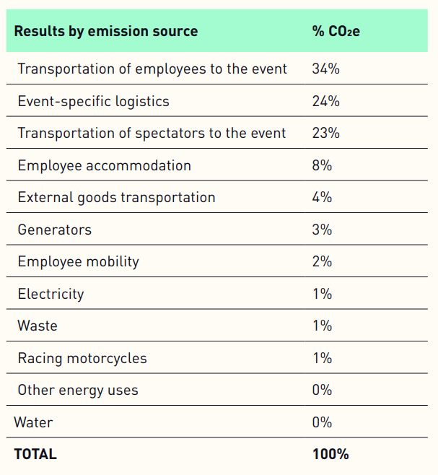
Table 1 below shows how much each source contributes to the total CO2 emissions:
Table 1 - CO2 emissions contribution from each source for a single race event (Dorna, 2021)
Interestingly, only 1% of the entire CO2 emissions is from the actual race, whilst the major contributors to the total emissions are the transportation of employees at 34%, the logistics of the event at 24% and the transportation of the spectators to the event at 23%. This suggests that, if Dorna were to try and significantly reduce their CO2 emissions, these areas could be a main focal point to maximise CO2 reductions.
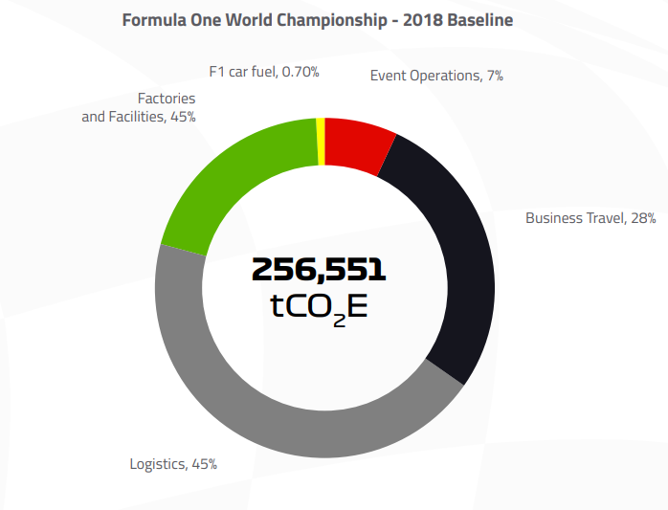
In their 2022 ESG annual report, Dorna (2022) reported that the total CO2 emissions for the entire season (including all racing classes) totalled at 101,079 tonnes, with the largest contributor once again being transportation totalling 32,163 tonnes, 31.82% of the total. Comparing these values with Formula One’s (similarly to MotoGP, regarded by many as the pinnacle of automotive racing) emissions from the 2018 season of 256,551 tonnes (F1, 2022), the output from MotoGP seems relatively small, with a CO2 output of only 39.4% of F1’s. There is a general trend between MotoGP and F1, with the actual racing only producing a small amount (1% or below) of the emissions, with most CO2 being generated from travel.
Figure 1 - Formula One 2018 Season CO2 Emissions (F1, 2022)

Sustainable Practices and Legislations
This section of the report will discuss the current practices and legislation that are currently implemented in MotoGP to improve the sustainability of the sport.

3.1 – Reducing Dependency on Fossil Fuels

3.1.1 – Race Fuels
By 2024, Dorna have committed to to using at least 40% non-fossil fuels in all MotoGP classes, aiming for 100% by 2027, favouring biofuels from municipal waste or non-food biomass (Dorna, 2021). Rockstroh et al. (2016) found synthetic gasoline matches regular gasoline in power and fuel efficiency. This finding is supported by Wouters et al. (2022), who found that methanol-to-gasoline and Porsche Synthetic Fuel (POSYN) perform similarly to RON95 E10 gasoline in power and emissions. Synthetic crude oil, unlike conventional crude, doesn't require energy-intensive refining due to their inherent lack of heteroatoms, making it more sustainable (De Klerk, 2007; 2011; Maitlis & De Klerk, 2013).

3.1.2 – Transport Vehicle Fuels
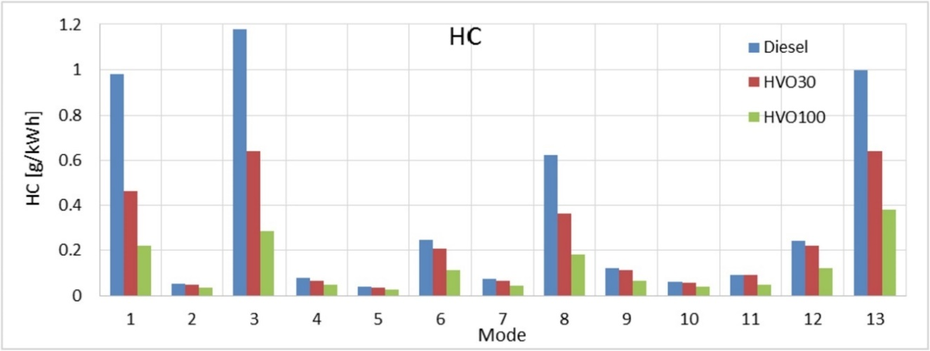
Dorna's 2022 Sustainable Event Management Report reveals that from 2023, their European logistics fleet will use thirteen IVECO S-Way trucks running on Hydrogenated Vegetable Oil (HVO), featuring fuel-saving technologies like anti-idling functions. Bortel et al. (2019)'s study on HVO vs. diesel in the World Harmonized Stationary Cycle test showed HVO reduces emissions of particulate matter, carbon monoxide, and hydrocarbons (HC), with lesser impact on nitrous oxide and particulate number. However, this study was performed without altering the engine control unit map, suggesting that with a refined fuel map, these results could be improved even further. Their results for comparing HC emissions can be seen below in Figure 2 (the number next to HVO representing the percentage of HVO in the fuel blend), and the mode representing the idling mode of the engine as defined in the WHSC.
Figure 2 - Effect of HVO Blends on HC Emissions (Bortel et al., 2019)

– Transportation
As previously mentioned, transportation of materials and personnel between events is the greatest contributor to MotoGP’s carbon footprint. In the same annual ESG report previously mentioned, Dorna (2022) claim that adapting their cargo transport pallets to the available space in the new 2 engine Boeing 777-F will maximise the used volume to 98%, which will “enable the championship to make a gradual year-after-year transition from the 4 engine Boeing 747 configuration, considerably reducing the carbon footprint”. The quantity of GHG savings has not been stated, however. Formula One (2022) also made the change to use more 777-F cargo planes over the 747s, claiming that the 777-Fs emit 19% less carbon that the 747s chartered in the past.

– Recycled Tyre Material
From the 2023 season and onwards, the number of tyres available to riders will be decreased, with MotoGP (2022) stating that this will prevent 1,500 tyres going unused, resulting in 1,500 fewer tyres to manufacture and transport, creating a significant contribution towards MotoGP’s “mission to promote a circular economy and reduce waste”.
In the same article, it’s stated that Michelin, MotoGP’s official tyre sponsor, has set a goal to have tyres comprised of 100% recycled materials across their entire range, with an average target of 40% by 2030. However, this target was exceeded in 2022 in the MotoE class, with all tyres in this class being comprised of 46% sustainable recycled materials, increasing again to 52% in 2023.

– Remote Production
Over the past few years, MotoGP has increased their remote production with Tata Communications so that there’s “less people and equipment to traverse the world” (MotoGP, 2024), which “assists to increase efficiencies and save money at every turn” (Tata Communications, 2018).
In Dorna’s 2022 sustainability report, it was stated that these increases in remote production reduced the number of employees needing to travel by 86 and avoiding 3,146 tonnes of CO2 emissions, a significant portion (3.11%) of the total CO2 emissions of the year of 101,079 tonnes considering this is just a single change.
Before the 2022 season, BT announced that for the Qatar GP the number of crew members attending the GP was reduced to 15 from 30 in 2019 (the last season that wasn’t affected by covid restrictions). It was predicted that this reduction would decrease the CO2 emissions from 53.9 tonnes to 26 tonnes, a reduction of 51.76%. This significant reduction would be primarily due to a decrease in travel, accommodation and catering (Miller, 2022).

3.5 – Waste Reduction
In the same annual report previously mentioned, Dorna (2022) stated they increased their efforts to improve waste collection and recycling in order to promote a circular economy, stating that “separate waste collection benefits the environment, society and economy”. It was reported that with these efforts, 747,665kg of CO2 emissions across the year were avoided due to the recycling of materials, with 70% of circuits having separate waste collection processes in place.

Sustainability and Technological Challenges
Whilst there have been significant advances in recent years to improve the sustainability of MotoGP, especially since 2021, improvements can still be made. However, further improvements to sustainability will inevitably face challenges.

4.1 – Technological and Economical Challenges
To increase MotoGP's sustainability, introducing hybrid systems with Energy Recovery Systems (ERS) could significantly improve fuel efficiency, reduce emissions, and boost performance (Boretti, 2018), akin to F1's adoption of these systems in 2009. Despite the potential benefits, the substantial costs associated with designing and developing these systems pose considerable challenges, particularly for smaller racing series. Kapoor & Parveen (2013) examine various kinetic energy recovery systems (KERS), highlighting cost as the primary limitation. They identify flywheels as a cost-effective option for energy storage, offering a favourable balance of temperature range and efficiency. With all of the elements that go into an effective KERS, manufacturers are faced with a difficult challenge of fitting these complex, and often large systems consisting of motors, controllers and energy storage devices into the frame of a racing motorcycle, which are already tightly packed with their engine and electronics. It is possible however, with companies such as Kawasaki front-lining the development of hybrid motorcycles.
The implementation of these systems also brings other issues, such as the ethics and sustainability of extracting lithium and cobalt for batteries. Vera et al. (2023) state that extremely large volumes of water, between 100-800m³, are lost through evaporation per tonne of lithium carbonate extracted from brines.

4.2 – Social Considerations
Whilst racing series such as MotoE, or the development and implementation of KERS into motorsport is a possible way to reduce the environmental impact of MotoGP, the impact this has on the fans must be considered. Traditional fans may resist changes that alter the nature of the sport, with one example being the change in F1 engine regulations from the naturally-aspirated V8 engine to the turbocharged V6 engine. Many fans, still to this day, miss the “screaming” sound of the older generation V8 and V10 engines. If changes were to be made to MotoGP, such as the implementation of hybrid systems to the regulations, the effect this has to the fans must be considered, as this may have a knock-on effect to viewership and engagement with the sport, leading to a decrease in revenue.

4.3 – Ethical and Political Considerations
MotoGP's goal to shift entirely to bio/synthetic fuels by 2027 necessitates considering ethical concerns. Pimentel et al. (2009) highlight that with nearly 60% of the global population facing malnutrition at the time of publication, prioritizing crops for biofuel could misuse essential resources needed for food production. This shift also risks elevating food prices, including beef, chicken, bread, and milk by 10-30% due to the increased demand for corn in biofuel production. These issues are explored in section 5 of the report.
Current regulations allow manufacturers to source their own non-fossil fuel alternatives, posing risks of choosing cheap, unethical sources. One such debated fuel source is woodchips. Neupane et al. (2011) explored the use of woodchips for liquid biofuels, with there being potential benefits, but found the processing and transport of them emits significant pollutants, largely because the machinery involved uses diesel and gasoline. Suggestions for improvement include increasing machinery fuel efficiency, matching machinery size to tree size (using smaller machinery for smaller trees), and situating bio-refineries near wood sources.

Future Outlook
As the governing bodies of MotoGP aim to make the sport even more sustainable, it’s clear that there are multiple paths that the sport can go down to achieve this goal. This section will look at some of the potential areas for development to further improve the sports sustainability.

5.1 – Kinetic Energy Recovery Systems
In their paper, Boretti (2018) discusses the prospect of allowing F1 teams greater freedom to design the ERS of the cars after analysing lap simulations and telemetry data of an F1 car. This is with a goal to improve the fuel efficiency of the cars, as they state that the 100kg fuel limit for the cars is excessive. This in turn results in the ERS being used more strategically to increase performance, rather than to save fuel, as the 2MJ of recoverable energy allowed per lap are almost never fully collected. They propose that the rules should decrease the allowable amount of fuel, with the teams being allowed greater creativity over their car design in order to keep the sport interesting for spectators whilst also improving fuel efficiency, and making the technology developed more relevant to road cars.
This methodology could be implemented into MotoGP more easily, as this technology isn’t already applied, meaning rules could be easier to set without any backlash. A major benefit of this methodology is the consideration to keep the racing interesting to fans.
Morandin et al. (2015) designed a hybrid motorcycle prototype with the goal of observing how these systems affect performance. The study focused on keeping the system to a low volume, weight and cost with the energy storage system (ESS) being a focal point of this, whilst producing high power for performance and a high energy density for increased driving range. They concluded that their newer hybrid motorcycle had significant improvements over the original design, with both acceleration time and maximum velocity being improved without affecting the mass of the motorcycle significantly.

– Reduce Travel
As discussed previously, travel is the greatest contributor to the GHG emissions in MotoGP. Observing the season calendar (ignoring winter tests), MotoGP travels across the globe multiple times in one season, crossing over racetracks that are used later on in the season whilst travelling to remote countries before returning again. Using Google Earth, the order of circuits in the MotoGP calendar in order have been plotted, starting in Qatar, shown below in Figure 2.
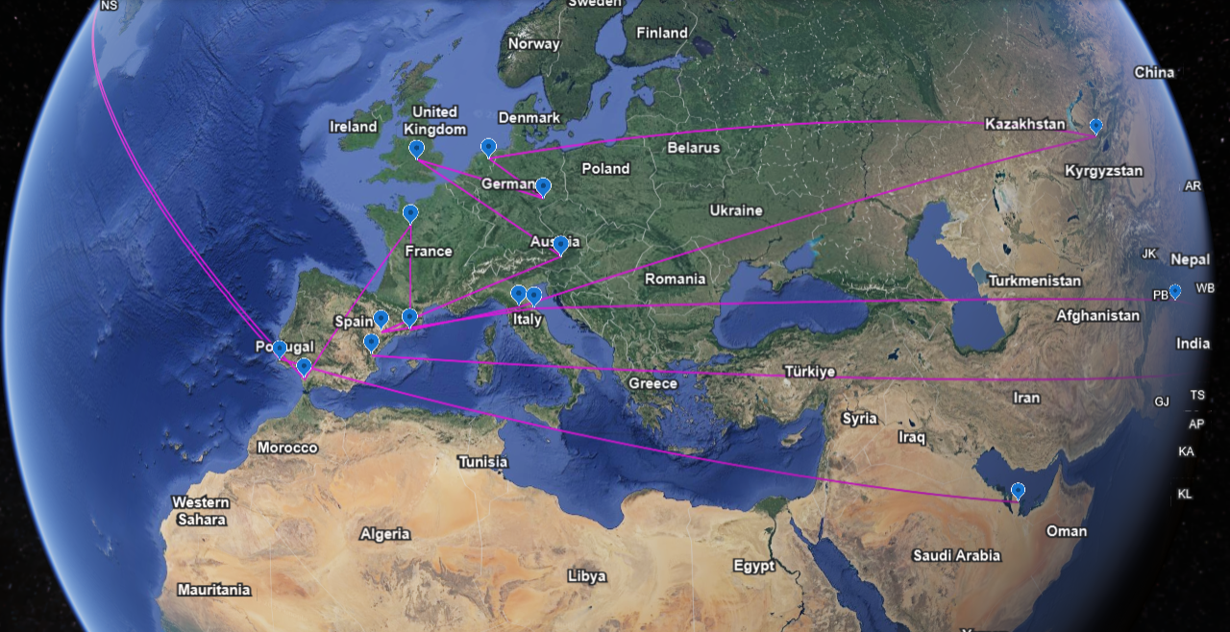
Figure 2 reveals MotoGP's season involves traveling approximately 85,573km, assuming direct travel from circuit to circuit, showing potential for emission reductions through strategic circuit scheduling. An example of inefficient travel is between races 2 to 4, moving from Portugal's Autodromo Internacional do Algarve to Texas' Circuit of the Americas, and then to Spain's Circuito de Jerez, only 240km from the Portuguese GP. This results in 16,193km travelled for these races, significantly impacting emissions.
3
16-20
21
15
14
13
12
11
10
9
8
7
6
5
4
2
1
Figure 3 - Travel Between MotoGP Circuits over the Race Season
Certain races must occur at certain times of year to avoid inevitable weather conditions, such as tropical storms in Asia, but with proper planning regarding the order of circuits in the calendar, the total carbon footprint of MotoGP could be significantly decreased. However, the impact this has on fans must also be considered, as they may want to see the European racetracks spread throughout the year, rather than all of them occurring within a few weeks of each other.
A large proportion of CO2 emissions was due to the travel of fans to race events (23%), as previously discussed. The implementation of park and ride systems to reduce the number of private vehicles travelling to the events has the potential to reduce the GHG emissions of each race weekend, leading to a significant overall reduction across the season.

– Further Investment in MotoE
MotoE first debuted in 2019 and is being used as the tyre testing ground for renewable MotoGP tyres as discussed previously, with major advancements being made in the last 5 years. MotoE, partnered with Enel X Way state that they are driving innovation in solar power and charging capabilities (Dorna, 2021). With further investment, this development could be accelerated, helping to reduce the emissions across all racing series within MotoGP, alongside developing new potential technology for road users.
Whilst it has also been discussed that the CO2 outputs of the actual racing contributes very little to the overall seasons CO2 emissions, the development and promotion of racing series such as MotoE, or the implementation of hybrid technology in MotoGP may change public perception of the sport, encouraging new, potentially “greener” sponsors to join.

– Recycling Materials
As previously discussed, the recycling of materials is a major part of reducing the emissions in MotoGP. One of these areas is in the recycling of tyres. Gigli et al. (2019) studied the benefits of a recycling system for end-of-life tyres (ELT) into a useful secondary raw material. They state that end-of-life tyres are a significant portion of end-of-life vehicle waste and conclude that the recycling of ELTs into bituminous conglomerates (which could then potentially be used for the racetracks’ surface) is economically viable in the medium and long term due to the high economic profitability of the process, whilst a risk assessment shows it isn’t a risky process. This shows potential in the recycling of waste materials from the bikes, rather than them going to landfill or being incinerated.

– Public Knowledge
At each race event, events could take place to inform spectators about sustainability and what can be done to help continue improving the sustainability of the sport. Activities such as tree planting around each circuit, which is already being performed at MotorLand Aragon with local schools (Dorna, 2022), could be performed across further racetracks, further encouraging fans to be actively involved in helping the environment.

– Improved Infrastructure and Resource Utilisation
There are many possible improvements that could be made to each track, such as the installation of more electric vehicle charging points, or the implementation of carbon capture devices around each racetrack to try and capture some of the CO2 emitted from each event. The captured carbon could then potentially be used to create synthetic fuels, or other useful materials. Gadikota (2021) researched the process of carbon mineralization for capturing, storing, and utilizing CO2 to synthesize products with enhanced properties. While this research is not directly related to racetracks, it demonstrates the potential for applying such systems to capture and repurpose emissions from MotoGP events, suggesting a sustainable approach to managing the environmental footprint of the sport.
As discussed previously, a significant proportion of CO2 emitted at the Dorna permanent workplaces and at each race event is the use of electricity. Finding a more environmentally friendly, sustainable source of energy (such as solar or wind power) could help significantly reduce the CO2 emissions in this sector. Each venue could also have more sustainable infrastructure fitted, such as lower energy usage floodlights.

– Bio-Fuel Development
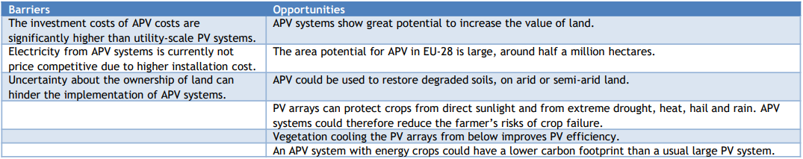
As Dorna have stated, their aim is to have all MotoGP bikes running on fuel that is 100% produced from other sources that aren’t fossil fuels. Hart et al. (2020) studied the prospect of using land not suitable for food agriculture, but to use this land for biomass production. It was concluded that land, such as used by solar-power farms, could be an excellent place for biomass agriculture as there is a large amount of land available, whilst the solar panels can protect the crops from direct sunlight. These areas of land are often called agrophotovoltaics (APV). It was also discussed that, to reduce the use of water, waste water could be used to irrigate crops. A more detailed analysis can be seen below in Table 2.
Table 2 - Potential for Solar Farms to be used for agriculture (Hart et al., 2020)

Conclusion
In conclusion, MotoGP is actively working towards becoming more sustainable, balancing the excitement of the sport with environmental responsibility. By adopting non-fossil fuels, improving transportation efficiency, and focusing on recycling and waste management, the sport has already made notable progress in reducing its environmental impact. This report has shown the various steps MotoGP has taken, including using HVO fuels and synthetic fuel and promoting remote production to reduce its carbon footprint. Despite facing challenges in technology, public perception, and ethical issues, MotoGP's dedication to a more sustainable future is evident. Moving forward, focusing on alternative fuels, improving travel efficiency, and increasing public involvement will be crucial for MotoGP to meet its environmental objectives.
It's apparent that racing contributes minimally to MotoGP's overall CO2 emissions, highlighting the importance of prioritizing efforts and resources towards improving transportation efficiency, reducing travel distances, and optimizing the transportation of personnel and equipment. This strategic approach would help to ensure minimal disruption to racing while effectively reducing emissions, thereby maintaining fan satisfaction.

Reference List
Bortel, I. et al. (2019) ‘Effect of HVO Fuel Mixtures on Emissions and Performance of a Passenger Car Size Diesel Engine’, Renewable Energy, Volume 140, pp.680-691
Boretti, A. (2018) ‘Changes of E-KERS Rules to Make F1 More Relevant to Road Cars’, Advances in Technology Innovation, Volume 3, pp.26-35
De Klerk, A. (2007) ‘Environmentally Friendly Refining: Fischer-Tropsch versus Crude Oil’, Green Chemistry, Volume 9, Issue 6, pp.556-560.
De Klerk, A. (2011) ‘Fischer-Tropsch Refining’, Wiley-VCH Verlag GmbH & Co. KGaA, Weinheim, Germany.
Dorna (2021) ‘ESG Annual Report 2021’, Available at: https://www.dorna.com/wp-content/uploads/2022/07/ESG_Annual_Report_2021.pdf [Accessed: 25/02/2024]
Dorna (2022) ‘ESG Annual Report 2022’, Available at: https://publications.dorna.com/.esg_annualreport2022/?_ga=2.76999708.806036197.1695907643-730965176.1695394320#page=69 [Accessed: 28/02/2024]
Dorna (2022) ‘ISO 20121 Sustainability Report’, Available at: https://www.dorna.com/wp-content/uploads/2023/10/Rend_Dorna2022_NEW23_1.pdf [Accessed: 25/02/2024]
Formula 1 (2022) ‘ESG Briefing Report’, Available at: https://corp.formula1.com/wp-content/uploads/2022/02/F1-ESG-Briefing-Note-February-2022-vF.pdf [Accessed: 25/02/2024]
Formula 1 (2022) ‘Formula 1 2022 Sustainability and Diversity Inclusion Progress’, Available at: https://corp.formula1.com/wp-content/uploads/2022/12/2022-Sustainabilty-and-DI-1.pdf [Accessed: 25/02/2024]
Gadikota, G. (2021) ‘Carbon Mineralization Pathways for Carbon Capture, Storage and Utilization’, Communications Chemistry 4, Volume 23
Gigli, S. et al. (2019) ‘Cost-benefit Analysis of a Circular Economy Project: a Study on a Recycling System for End-of-Life Tyres’, Journal of Cleaner Production, Volume 229, pp.680-694
Kapoor, R. & Parveen, C. (2013) ‘Comparative Study on Various KERS’, Proceedings of the World Congress on Engineering, Volume 3
Hart, K. (2020) ‘Land Availability for Biomass, Energy, and Other Non-Food Services in the EU: Event Summary’, Institute for European Environmental Policy, Available at: https://ieep.eu/news/land-availability-for-biomass-energy-and-other-non-food-services-in-the-eu-event-summary/ [Accessed: 10/03/2024]
ISO (2024) ‘ISO 20121, Sustainable Events’, Available at: https://www.iso.org/iso-20121-sustainable-events.html [Accessed: 23/02/24]
Maitlis P. & De Klerk, A. (2013) ‘Greener Fischer-Tropsch Processes for Fuels and Feedstocks’, Wiley.
Miller, M. (2022) ‘BT Sport and North One take MotoGP Remote’, Broadcast.
Morandin, M. et al. (2015) ‘Power-Train Design and Performance of a Hybrid Motorcycle Prototype’, IEEE Transactions on Industry Applications, Volume 51, Number 3, pp.2216-2226
MotoGP (2022) ‘#RacingTogether on World Environment Day’, Available at: https://www.motogp.com/en/news/2022/06/05/racingtogether-on-world-environment-day/180917 [Accessed: 04/03/2024]
MotoGP (2024) ‘The Paddock: Sustainable & Social’, Available at: https://www.motogp.com/en/racing-together/paddock [Accessed: 02/03/2024]
Neupane, B. et al. (2011) ‘Attributional Life Cycle Assessment of Woodchips for Bioethanol Production’, Journal of Cleaner Production, Volume 19, Elsevier Limited, pp.733-741
Pimentel, D. (2009) ‘Food Versus Biofuels: Environmental and Economic Costs’, Human Ecology, Volume 37, Springer Science, pp.1-12
Rockstroh T. et al. (2016) ‘Optimisation of Synthetic Gasoline Blend Recipes for Use in Modern Charge Boosted GDI Engines’, Fuel, Volume 186, pp.800-820
Tata Communications (2018) ‘Case Study: Go Behind The Scenes at MotoGP With Tata Communications’, Available at: https://www.tatacommunications.com/resource/products-solutions/network/motogp-improves-efficiency-and-reduced-cost-with-tata-communications-network/
Vera, M. et al. (2023) ‘Environmental Impact of Direct Lithium Extraction from Brines’, Nature Reviews Earth & Environment 4, pp.149-165
Wouters, C. et al. (2022) ‘Evaluation of Synthetic Gasoline Fuels and Alcohol Blends in a Spark-Ignition Engine’, SAE International Journal of Fuels and Lubricants, pp.333-347

