BA Business Management

Module: Data Handling & Business Inteligence

Module code: LCBB5000
Student Name: Peter Gottschling
Student ID:2030897
Lecturer: Gasso Wilson Mwaluseke

Table of Contents
Part 1 3
Determination of the decline in sales or profits over the years 3
Evaluation on using Excel for pre-processing the data, analyzation of the data and visualization 4
Analyzing the decline in Sales and profits by using Pivot Table and function “IF” 6
Part 2 9
2.1 Estimation of students who like the flavor of vanilla ice cream 10
2.2 Estimation of male and female students 11
2.3 Median and Mean of participants 11
2.4 Example of K-means clustering 12
2.5 Common data mining and text mining methods 13
2.6 Disadvantages and advantages of SPSS and Excel 14
Reference List 16

Part 1

Determination of the decline in sales or profits over the years
In order to determine the decline in either sales or profits of Superstore it has foreseen the entire data and information that has been given into the spreadsheet. Within the spreadsheet, the upward and downward of sales and profits has been for 4 years respectively, starting from 2009 to 2012. Along with that the spreadsheet has also mentioned the order id, order date, order priority, ship mode, unit prince, customer name, region and others. According to the report of Michalkova (2021), it has been demonstrated that investigating the either increase or decrease of a company’s sales and profits provides a basic overview of a company's financial performance over the years. Therefore, the determination on decline in sales or profits of Superstore have identified and analysed properly.
As this specific section has critically focused on two major aspects of the company which is sales and profits rather than overlooking other factors. Therefore, the analysis has also focused into the decline of only two of these factors. For example, during the years of 2009, in August the overall sale that the company has retained was 261.54. While, the profit that it earned at the same time was -213.54. It shows that the firm has retained a loss more than earning a profitable return. Usually, if the cost of sale price or manufacturing price is more than value of sale, it often brings loss in a company (Ye et al. 2018). Henceforth it can be stated that the company has retained a loss in the month of august in 2009 and there is possibility that the cost of sale has overlapped the value of actual sale.
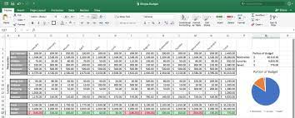
Figure 1 : Excel Sheet
(Source: Ye et al. 2018 )
In addition to this, it has been observed that after two months which means in October in 2009, the overall sale volume was 124.56 and the profit was -14.33. From the result, it is further acknowledged the financial performance has been not good of this company during the particular years. As the sale has become lower and the company has retained loss, it clearly shows that the company still has not progressed to improve its sales level or the level of profitability. In addition to this, it has been found that the profitability level or the sale level has been lowered by this company as order priority or the order volume in most cases has not been specified or low.
During the second year or in 2010, at the month of April it has been reviewed that the overall sales volume was 511.83. Meanwhile, the profit level in the same month has been determined at -172.88 and the order priority has been similarly low. As per the statement of Anwar and Abdullah (2021), it has been stated that the demand of a product or the factor of order priority plays a bigger role for organization’s success and retain positive number of sales, raise both productivity and profitability level. As evidence that order priority impacts on company’s sales volume and level of profitability, at 23rd May in 2011, the order priority was high. However, the total sale was 394.27 and the profit that Superstore has been able to gain was 30.94.
In addition to this, it has been seen that during the last year which means in 2012, the order priority has fluctuated for the company. Moreover, in some case for different order id’s the productivity and profitability has resulted different from one with other. For example, on the 26th of November in 2012 for order id 643, the level of sales was extremely high, which was 2781.82. Although the profit declined and valued at -695.25, means the cost of sales has been higher. It has been stated that in some cases often sales and profit have an inverse relationship if the cost of production is higher (Linh and Mohanlingam, 2018). In this case, similar situations have been confronted. Meanwhile, on the same day for order id 678, the sale was 228.41 and the total profit was -226.36.

Evaluation on using Excel for pre-processing the data, analyzation of the data and visualization
Excel or MS-Excel has been considered as one of the effective and excellent data analysing software that specifically helps in preparing, analysing and formatting a huge pile of quantitative data. According to the report of Vuong et al. (2022), excel spreadsheet can organize raw data into a readable format that helps one to extract all the actionable insights into an easier format. In addition to this, it has been stated that organizing the spreadsheet in excel is the first and foremost stage is to craft the data visualization. Excel is not only able for data analyzation; it is also able for pre-processing and data visualization.
“Data visualization”, “data analysis”, and “data pre-treatment” are all made easier with the help of MS-Excel. “RIGHT”, “COUNTIF”, “IF”, “MID”, “LEFT”, “IFERROR”, “ISTEXT”, and “FIND” are some of the MS-Excel operations that can help with information pre-processing. Among non-programmers, Microsoft Excel is the most efficient application for handling and preparing structured datasets. A good worksheet in Excel helps assist a user in arranging unstructured information in a legible manner, making it easier to extract some meaningful insights (Sharma et al. 2022). Furthermore, while dealing with challenging data sets, Excel provides a greater opportunity to personalize the variables and algorithms that aid in computation.
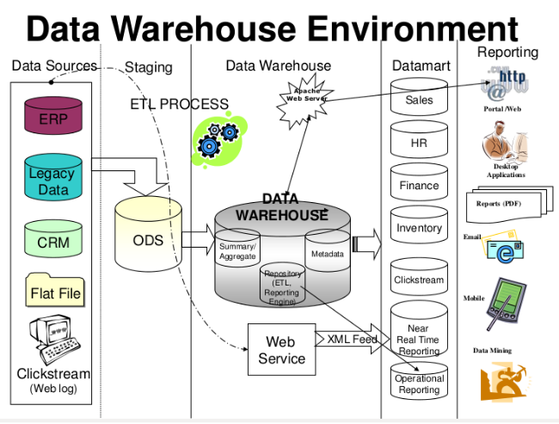
Figure 2: Data Warehouse Environment
(Source: Sharma et al. 2022)
It has been stated that data warehousing has become a more relevant and attractive trend in current periods compared to previous times. Additionally, the new trends of data warehousing have also increased and added several new things. As per the report of Quintero and Lee (2019), the current trends in data warehousing includes ability to seamlessly integrate, integrating of data with existing infrastructure, offloading the data, use of cloud-native, excel to high-performance, computation and storing of tiers. Although, the main reason the demand of using data warehousing has been increased as it provides such facilities like fast-going market at lower risk and constant migration of cloud.
Researchers have further demonstrated that not only has the demand of data warehousing increased, the current trends in business intelligence have become a new and innovative approach for the current business entities and industries. The recent or most innovative trends in today’s business intelligence includes “SaaS”, “cloud analytics”, “data democratization”, “increment of personalization with automated machine learning”, “increased NPL or NGL applications” and “embedded BI application” (Rikhardsson and Yigitbasioglu, 2018). The main purpose of business intelligence is to efficiently help the corporate executives, managers and other operational workers to make informed decisions. As well as it provides a business the opportunity to make clear, concise and informed decisions (Lee and Yoon, 2021). Whereas, most of the researchers also demonstrate that the concept of data mining has also been increased. The current trend of data mining involves application of exploration, multimedia data mining, ubiquitous data mining, increased use of exploring various applications and others.

Figure 3: Business Intelligence
(Source: Rikhardsson and Yigitbasioglu, 2018)
However, it has been seen that this particular study module has emphasis on different graphs that has helped for data visualization. The utilization of the “IF” function is mainly used to pre-processing the data and the purpose of the pivot table for data analysis. Visualization of data or quantitative information’s are essential, as it helps to interprets those data into a simple form of graphs and bars to analyse the outcome at an easy form.

Analyzing the decline in Sales and profits by using Pivot Table and function “IF”
In the above section it has been highlighted that, in order to analyze data, visualize the data and preprocess data, MS-Excel can be utilized. In order to visualize the data and analyze the data effectively, charts along with graphs have been formulated in this section through the Pivot table and side by side, IF functions have also been shown (Selwyn, 2022). In the excel of Superstore Sales, the decline in profits or sales between the year of 2009 to 2012 have been highlighted by the function of Pivot Table.
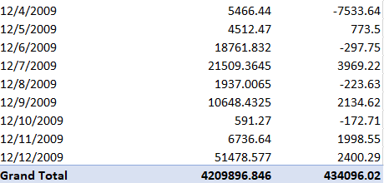
Figure 4: Total profit and sales in 2009
(Source: Excel)
In the month of December, 2009, it has been highlighted that, the sales rate was 964.58 and the decline in profits was nearly -1192.85. In October, 2019, the total sales rate was 23347. 67 and the decline within profit was -13261.64. It can also be stated that, in 2019 the total sales rate was 4209896.846 and the decline within profits was 434096.02 and considering this it can be illustrated that the loss of profit had occurred more than getting profits in sales.
In January 2010, the sales of sum were nearly 9507.24 and the decline within profits also happened nearly -1050.52. In the entire year, the overall sum of total sales was 3560087.045 including that the decline in sales rate was approximately 364917.33 (Domino et al. 2021). It can be stated that, in 2010 also the sales rate was higher than the profits and the rate of profits had declined much more than sales. Therefore, it can be illustrated that, both in 2009 and 2010 had faced the decline in sales issue.
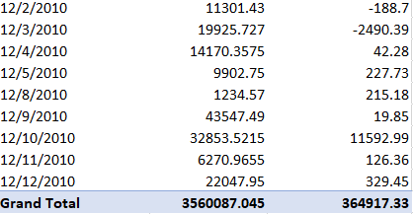
Figure 5: Total profit and sales in 2010
(Source: Excel)

A pivot table and different graphs has been generated to analyse the decline in sales and profits of Superstore. Three different graphs have been produced from the Pivot tables of each year including 2011 and 2021. As per the report of Rahman et al. (2021), in excel a pivot table shows querying large amounts of data in many simple ways, aggregating numeric data and summarizing data based on categories. Here, the pivot table the total sales and total profit has been also estimated at each year. For example, in 2011 the total sales volume was 34,29,994.42 and the total profit was estimated at 3,80,310.50. It shows that this particular store has earned a huge number of sales, although they are not capable of retaining good profits from the sales of the product they have produced. In such instances, several researchers and scholars have demonstrated that if the cost of production is higher than the profit can be lower or very marginal even though the sales is extremely higher (Basu, 2019). Meanwhile, throughout the year 2012, the total sales relating amount was 3715671.953, whereas the entire profitability was around 342444.13, indicating that the profitability spectrum remained significantly lesser than the selling rate. Furthermore, it has been found that during 2011, according to the "IF" function, the profits margin was 30.94, coupled with a selling level of 394.27, and the profit has decreased. In 2012, the profitability margin was 1198.97 while the volume of selling was 4965.76, and the profitability has dropped even more.
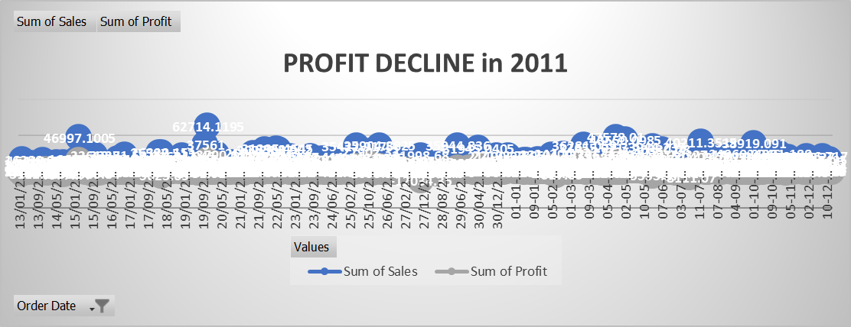
Figure 6: Profit Decline in 2011
(Source: Self-Developed)

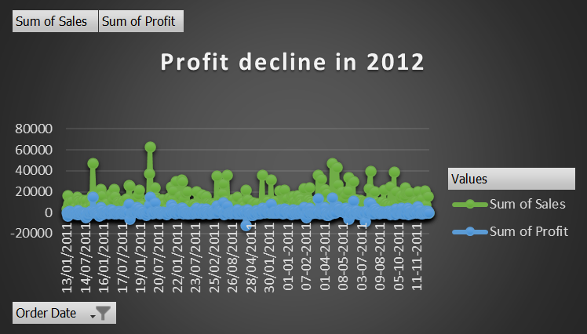
Figure 7: Profit Decline in 2012
(Source: Self-Developed)

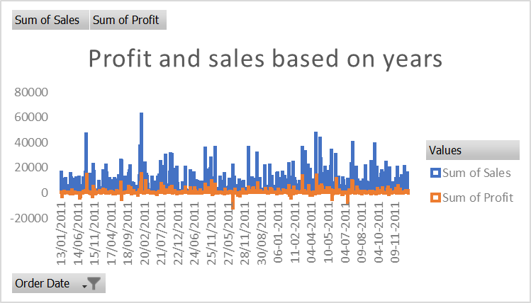
Figure 8: Profit and Sales in 2011
(Source: Self-Developed)

Part 2

Being a data analyst, the main role is to assist a local organization for analyzing a survey containing data gathered on 200 students of high schools. Through conducting the survey, the scores of these students on several tests such as a puzzle and video games. From this survey, the favorite flavor of students and rate of female and male students among the 200 participants will be highlighted (Aziz and Aftab, 2021). The result of this survey has been shown through creating a Bar, Pie chart and Histogram based on the data of Ice cream_csv and Ice cream.xls. In terms of understanding the favorite flavor of ice cream, median and mode of participants and male including female rate among the participants have been shown by using SPSS software.

2.1 Estimation of students who like the flavor of vanilla ice cream
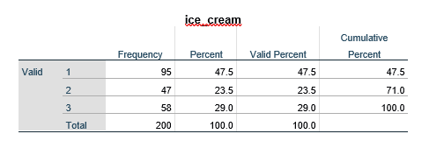
Figure 9: Favorite flavor of participants
(Source: SPSS)
In the dataset it has been shown that, 1 represents the favor of vanilla and the valid percentage of vanilla is 47.5. However, 2 means chocolate flavor and the valid percentage of this flavor is 23.5 and 3 refers to Strawberry flavor and the valid percentage of this flavor is 29.0 and considering this it can be illustrated that most of the students are liking vanilla flavor (Hosseini and Sardo, 2021). In order to get a clear understanding, the below histogram has been created and this also shows that most students are preferring vanilla than other two flavors.
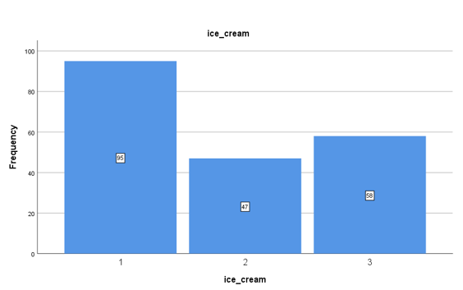
Figure 10: Highest liking of vanilla flavor ice cream
(Source: SPSS)

2.2 Estimation of male and female students
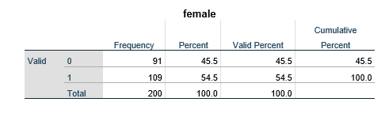
Figure 11: Estimation of male and female
(Source: SPSS)
It can be illustrated that, both female as well as male have participated in the survey and for knowing the estimation of male along with female the SPSS software has been utilized. In the dataset it has been highlighted that, 0 means male and 1 means female and the figure shows that the valid percentage of 0 is 45.5, conversely, the valid percentage of 1 is 54.5 (Kumar, 2019). Considering this it can be illustrated that; the estimation of females is higher than the males and this has been shown clearly in the pie chart. In order to show the female estimation red color has been used and for showing the estimation of males’ blue has been used.
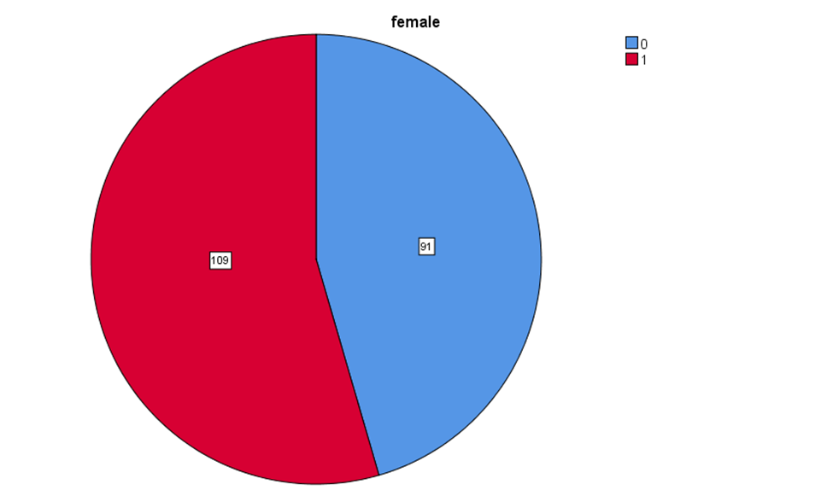
Figure 12: Pie chart on estimation of male and female
(Source: SPSS)

2.3 Median and Mean of participants
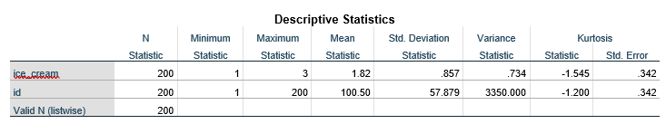
Figure 13: Descriptive statistics
(Source: SPSS)
In terms of showing the Median and Mean of participants of those students who are liking strawberry and chocolate ice cream, SPSS software has been utilized in an effective manner. The entire survey has been conducted by taking 200 students and the Mean value of participants who like chocolate along with strawberry ice cream is 1.82. The Mean value is positive as this value is greater than 1 (Cleff, 2019). In addition, in this figure, it has been shown that the Minimum statistics is 1 including Maximum value is 3 and these values are above 1 therefore, it shows that these are positive values. Considering the Mean along with Median values, it can be illustrated that most of the students are interested in strawberry and chocolate flavors.

2.4 Example of K-means clustering
Utilizing the dataset Ice cream_csv given in the conjunction with SPSS, some instances of “clustering K-means” have been shown in this section in an effective manner. “K-means clustering” can be recognized as an effective method that is utilized for clustering analysis, mainly in data mining along with statistics (Jahwar. and Abdulazeez, 2020). This is aiming to partition some set of proper observations into an estimation of clusters, outcoming within the partitioning of the data. Clustering supports understanding the data in a different way through grouping or else dividing data into some group’s things all together into clusters. In addition, K-means clustering reduces within cluster variances including that it intends to search clusters of “comparable spatial extent”.
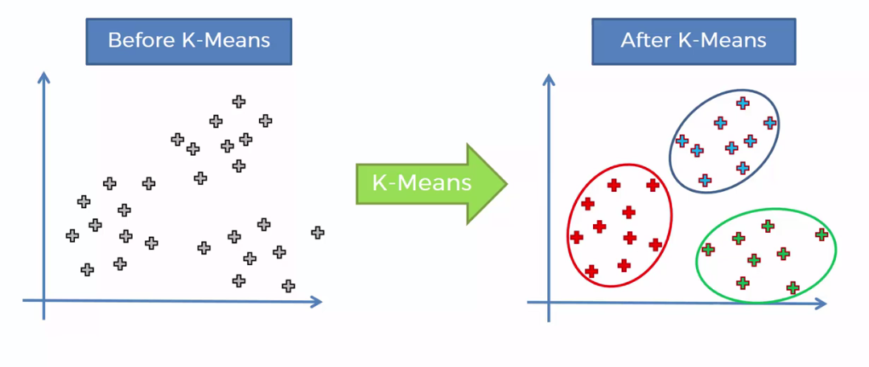
Figure 14: “K-means clustering”
(Source: Jahwar. and Abdulazeez, 2020)

2.5 Common data mining and text mining methods
Machine learning is known as the most common method of data mining and in the present times most of the business firms are using this machine learning (Yuan and Yang, 2019). In terms of giving real business world examples, it can be stated that start applications such as Siri and Google Assistant are known as the digital assistants that are relying on machine learning and artificial intelligence for responding to complete the tasks and responding to user data. In addition, digital assistants such as Google Nest utilize smart speakers in terms of gathering for AI capabilities. In addition, the company which is mostly utilizing machine learning to work is Amazon (Bisong, 2019). “Amazon Web Services (AWS)” is known as the subsidiary of this company and delivers “on demand cloud computing platforms” along with APIs.
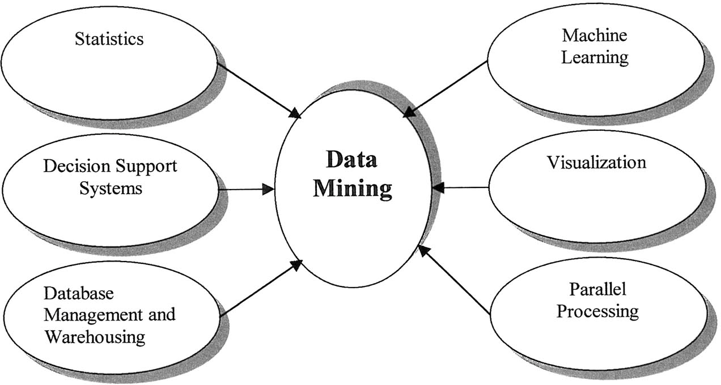
Figure 15: Methods of data mining
(Source: Yuan and Yang, 2019)
On the other hand, clustering is known as the most common method of text mining. Clustering can be considered as the most critical technique of this text mining. This seeks to analyze intrinsic structures within textual information along with effectively organizing them into effective subgroups or clusters to get further analysis. In terms of giving real life examples, it can be illustrated that most of the retail business firms are utilizing clustering for analyzing teams of households which are known to each other (Abualigah, 2019). As an example, any retail business firm might be able to gather some following data on household income, as well as size of the household.
In addition, data mining is effectively utilized for exploring applications within other areas mainly as financial analysis, biomedicine, telecommunications, science and wireless security. Moreover, this is known as the most recent method that is catching up due to the increasing capability to capture the effective data accurately. In the present times various trends can be seen in data mining and among those some main data mining trends are “multimedia data mining”, “ubiquitous data mining”, application exploration, “time series and sequence data mining”, “embedded data mining” and “geographic and spatial data mining”.

2.6 Disadvantages and advantages of SPSS and Excel
Advantages of utilizing SPSS | Disadvantages of utilizing SPSS
- SPSS helps in reducing the chance of creating any kind of errors within the calculations. | - The main limitation of using SPSS data mining software is that this might not be utilized for analyzing a vast large set of data.
- It is better to utilize SPSS when an individual is wanting a customizable and flexible way of getting super granular on even the major difficult data sets (Mustika et al. 2022). For instance, in education purposes SPSS is utilized for identifying trends, drawing some informed conclusions and establishing predictive models. | 2. SPSS can be costly for some students.
Table 1: Advantages including disadvantages of using SPSS
(Source: Self-developed)
Advantages of utilizing MS-Excel | Disadvantages of utilizing MS-Excel
- The major advantage of using MS-Excel is that it makes it simple to visualize the data through charts. | 1. There are some disadvantages of using Excel such as it has a lack of security and control.
- Excel provides cleaner and transformed data. | 2. Data loss issues can happen anytime in case anyone is using Excel. For instance, the badly thought-out usage of Excel was the major reason for 16,000 COVID cases that have gone unreported within England (Kelion, 2020).
Table 2: Advantages including disadvantages of utilizing MS-Excel
(Source: Self-developed)

Reference List

Abualigah, L.M.Q., 2019. Feature selection and enhanced krill herd algorithm for text document clustering (pp. 1-165). Berlin: Springer.

Anwar, G. and Abdullah, N.N., 2021. The impact of Human resource management practice on Organizational performance. International journal of Engineering, Business and Management (IJEBM), 5. https://aipublications.com/uploads/issue_files/4IJEBM-FEB202141.pdf

Aziz, N. and Aftab, S., 2021. Data Mining Framework for Nutrition Ranking: Methodology: SPSS Modeller. International Journal of Technology, Innovation and Management (IJTIM), 1(1), pp.85-95.

Basu, S., 2019. Are price-cost markups rising in the United States? A discussion of the evidence. Journal of Economic Perspectives, 33(3), pp.3-22. https://pubs.aeaweb.org/doi/pdf/10.1257/jep.33.3.3

Bisong, E., 2019. Building machine learning and deep learning models on Google cloud platform: A comprehensive guide for beginners. Apress.

Cleff, T., 2019. Applied statistics and multivariate data analysis for business and economics: A modern approach using SPSS, Stata, and Excel. Springer.

Domino, M.A., Schrag, D., Webinger, M. and Troy, C., 2021. Linking data analytics to real-world business issues: The power of the pivot table. Journal of Accounting Education, 57, p.100744.

Hosseini, S. and Sardo, S.R., 2021. Data mining tools-a case study for network intrusion detection. Multimedia Tools and Applications, 80(4), pp.4999-5019.

Jahwar, A.F. and Abdulazeez, A.M., 2020. Meta-heuristic algorithms for K-means clustering: A review. PalArch's Journal of Archaeology of Egypt/Egyptology, 17(7), pp.12002-12020.
Kelion, L., 2020. Excel: Why using Microsoft's tool caused Covid-19 results to be lost. [Online]. Available at: https://www.bbc.com/news/technology-54423988 [Accessed on: 28 December, 2022].

Kumar, R., 2019. Introduction to Statistical Tool: SPSS. Hands-on Training on “Statistical Tools and Database Management In Agriculture”, p.15.

Lee, D. and Yoon, S.N., 2021. Application of artificial intelligence-based technologies in the healthcare industry: Opportunities and challenges. International Journal of Environmental Research and Public Health, 18(1), p.271. https://www.mdpi.com/1660-4601/18/1/271/pdf

Linh, N.T.P. and Mohanlingam, S., 2018. The effects of cash conversion cycle on profitability: An insight into the agriculture and food industries in Thailand. Asian Journal of Business and Accounting, 11(1), pp.97-119. https://borneojournal.um.edu.my/index.php/AJBA/article/download/12148/7927

Michalkova, L., 2021. Earnings quality and accruals over company´ s life cycle. In SHS Web of Conferences (Vol. 92, p. 02043). EDP Sciences. https://www.shs-conferences.org/articles/shsconf/pdf/2021/03/shsconf_glob20_02043.pdf

Mustika, I., Nabella, S.D. and Mulyadi, M., 2022. DATA-PROCESSING TRAINING USES A SPSS APPLICATION FOR IBNU SINA UNIVERSITY MANAGEMENT STUDENTS. International Journal of Engagement and Empowerment, 2(2), pp.179-183
.
Quintero, D. and Lee, F.N., 2019. IBM reference architecture for high performance data and AI in healthcare and life sciences. IBM Redbooks. https://books.google.com/books?hl=en&lr=&id=vDWuDwAAQBAJ&oi=fnd&pg=PR7&dq=the+current+trends+in+data+warehousing+includes+ability+to+seamlessly+integrate,+integration+of+data+with+existing+infrastructure,+offloading+the+data,+use+of+cloud-native,+excel+to+high-performance,+computation+and+storing+of+tiers&ots=YbQCD88be3&sig=jxlA0WQYCwQ_IFDG8ElYUFQjqJc

Rahman, S., Bendre, M., Liu, Y., Zhu, S., Su, Z., Karahalios, K. and Parameswaran, A.G., 2021. NOAH: interactive spreadsheet exploration with dynamic hierarchical overviews. Proceedings of the VLDB Endowment, 14(6), pp.970-983. https://par.nsf.gov/servlets/purl/10216116

Rikhardsson, P. and Yigitbasioglu, O., 2018. Business intelligence & analytics in management accounting research: Status and future focus. International Journal of Accounting Information Systems, 29, pp.37-58.

Selwyn, N., 2022. ‘Just playing around with Excel and pivot tables’-the realities of data-driven schooling. Research Papers in Education, 37(1), pp.95-114.

Sharma, R., Agarwal, P. and Arya, A., 2022. Natural Language Processing and Big Data: A Strapping Combination. In New Trends and Applications in Internet of Things (IoT) and Big Data Analytics (pp. 255-271). Springer, Cham. https://www.researchgate.net/profile/Wasana-Boonsong-2/publication/360936853_Real-Time_Data-Based_Smart_Hitech_Classroom_Using_Internet_of_Things/links/629440c48d19206823e7101d/Real-Time-Data-Based-Smart-Hitech-Classroom-Using-Internet-of-Things.pdf#page=262

Vuong, P., Wise, M.J., Whiteley, A.S. and Kaur, P., 2022. Ten simple rules for investigating (meta) genomic data from environmental ecosystems. PLOS Computational Biology, 18(12), p.e1010675. https://journals.plos.org/ploscompbiol/article?id=10.1371/journal.pcbi.1010675

Ye, Y., Lau, K.H. and Teo, L.K.Y., 2018. Drivers and barriers of omni-channel retailing in China: A case study of the fashion and apparel industry. International Journal of Retail & Distribution Management. https://www.researchgate.net/profile/Ying-Ye-6/publication/326060521_Drivers_and_barriers_of_omni-channel_retailing_in_China_A_case_study_of_the_fashion_and_apparel_industry/links/6009debd299bf14088b18d0e/Drivers-and-barriers-of-omni-channel-retailing-in-China-A-case-study-of-the-fashion-and-apparel-industry.pdf

Yuan, C. and Yang, H., 2019. Research on K-value selection method of K-means clustering algorithm. J, 2(2), pp.226-235.

