THE INFLUENCE OF NATIONAL AND INTERNATIONAL LABOUR MARKETS ON HRM AND IHRM STRATEGIES
Assignment Title:

Student Name: | Keshu Jivabhai Karavadra | Student ID Number: | 2439531
Programme: | Master of Business Administration – International Business
Module: | Human Capital Management | Module Code: | LCMB7023
Lecturer: | Ejike Udeogu (Birmingham) | Submission Date: | 17/10/2025

Table of Contents
1. Technological Advancements and Implications for HRM and IHRM 3
2. Demographic and Geopolitical Factors: Challenges for HR 4
3. Addressing Skills Gaps and Talent Shortages through Strategic HRM (Tech, Hospitality, Healthcare) 6
4. Personal Preparedness to Enter the Labour Market: A Reflective Action Plan 8
5. References 13

1. Technological Advancements and Implications for HRM and IHRM
Technology is altering labour demand, work processes and employment relationships at a structural level. AI systems now augment cognitive work from sourcing candidates to composing learning paths and forecasting attrition risk. Automation and robotics reconfigure task bundles, shifting roles from routine execution to exception handling, oversight and human-machine collaboration (Budhwar et al., 2022). Digital labour platforms expand access to on-demand, cross-border talent, normalising portfolio careers and project marketplaces that operate beyond traditional organisational boundaries.
For HRM, these shifts demand a decisive pivot from role-based to skills-based operating models. Job architectures anchored in fixed titles struggle to keep pace with emergent tasks and hybrid human-AI workflows. A skills taxonomy, regularly refreshed by labour-market analytics, enables workforce planning that asks not “how many heads” but “which skills, at what proficiency, available when and where.” Recruitment then becomes a dynamic exercise in building skills liquidity through a mix of hiring, contracting, automation and reskilling. Performance management must recognise outcomes produced in conjunction with AI tools, measuring both individual contribution and system-level performance (Farndale et al., 2025). Learning evolves into a continuous, personalised stack: micro-credentials, on-the-job projects, mentoring, and just-in-time content recommended by AI but validated by human experts.
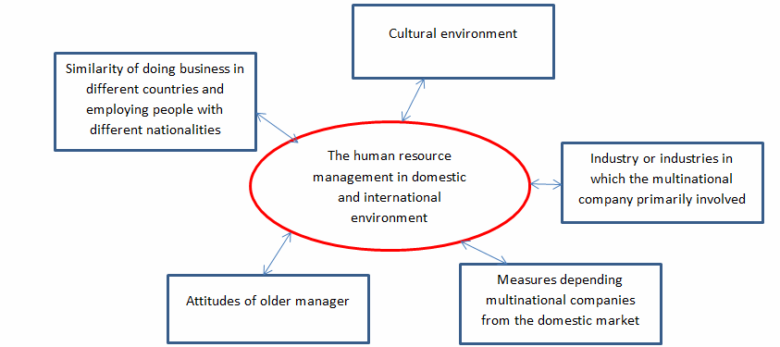
Figure 1: Factors affecting the differences between the human resources management in the domestic
(Source: researchgate.net, 2025)
IHRM magnifies these considerations. Cross-border data flows for people analytics trigger compliance and sovereignty questions. Standardised, global skills frameworks improve mobility, yet require localisation to respect professional licensure, language and cultural norms. Platform work and remote-first hiring widen access to global talent pools, but tax, social security, and right-to-work regulations complicate employment models. International teams using AI tools need harmonised governance on data minimisation, bias testing, explainability and worker consultation (Prasad et al., 2024). Assignments and mobility programmes should adapt; short-term virtual deployments, hub-and-spoke models, and capability academies distributed across regions can replace some long-term expatriate packages while preserving knowledge transfer.
Ethical considerations sit at the centre. Algorithmic tools can amplify bias if trained on skewed histories, undermining equal opportunity. Responsible AI in HR requires documented objectives, auditable pipelines, human-in-the-loop decision rights and channels for employee redress. Transparency about data use, model limitations and the non-deterministic nature of predictions protect trust. HR’s professional duty is to ensure technology augments human potential rather than narrowing it (Malik, Pereira and Budhwar, 2021). This involves promoting digital inclusion, upskilling employees to work effectively alongside AI, maintaining transparency in algorithmic decisions, and safeguarding employee well-being. By championing fairness and accountability, HR can create a culture were innovation and humanity progress together harmoniously.
Practically, organisations should build a people-data product function that partners HR, Legal, IT and Compliance; deploy a unified skills graph integrated with core HR systems; institute AI governance with policy, controls and monitoring; and invest in change-ready leaders who model digital fluency. They should also encourage cross-functional learning labs to experiment with AI-assisted HR tools, promote transparent communication about technological changes, and embed digital ethics into leadership training. The payoff is a workforce strategy capable of meeting volatile skills demand while protecting fairness, dignity and global compliance.

2. Demographic and Geopolitical Factors: Challenges for HR
Demography and geopolitics shape the supply, distribution and movement of talent. In many advanced economies, ageing populations shrink working-age cohorts and elevate dependency ratios, tightening labour supply and increasing competition for experienced professionals. Conversely, regions with large youth populations face high entry-level demand but uneven access to quality education and decent work, creating mismatches between credentials and job-ready skills (Koišová, Masárová and Ivanová, 2021). Migration flows, whether voluntary or forced, add complexity: they refresh talent pools, diversify skills and perspectives, and simultaneously trigger policy debates on integration, recognition of qualifications, and community cohesion.
From an HR perspective, these demographics compound existing shortages in specialised domains such as software engineering, cybersecurity, advanced manufacturing, green energy, clinical care and social care. Pay inflation and bidding wars become symptoms rather than solutions; without investment in training capacity and redesigned career pathways, shortages persist (Lami et al., 2022). Moreover, intergenerational expectations differ: early-career employees often value growth velocity, flexibility and purpose; mid-career professionals seek lateral development and balanced total rewards; late-career workers may prefer phased retirement and mentoring roles. Total rewards and EVP, therefore, require segmentation by life stage and local norms.
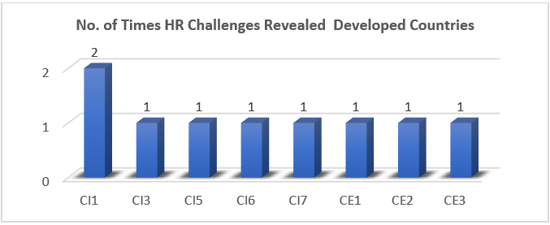
Figure 2: Human-Resources-Challenges-for-Developed-Countries
(Source: researchgate.net, 2025)
Geopolitical volatility further challenges workforce continuity. Trade disputes, sanctions, currency swings, and supply chain disruptions can precipitate rapid hiring freezes or surges. Immigration regimes evolve, impacting visa availability and processing times. Data sovereignty laws restrict cross-border HR data access, complicating centralised analytics. Security risks—from cyber threats to physical safety—require duty-of-care protocols for travellers, assignees and remote workers in high-risk locations (Ogedengbe et al., 2024).
HR must therefore operate with scenario-based workforce planning. Instead of a single headcount plan, teams should maintain option-rich strategies: multiple talent pipelines per critical skill, near-shore and offshore contingencies, and partnerships with education providers to build local capacity (Gerasimova, Oblova and Golovina, 2021). Skills forecasting should incorporate external labour-market signals, credential issuance trends, and regulatory watchlists. Inclusion and integration policies are essential to tap migrant talent: language support, recognition of prior learning, bridging programmes and mentorship accelerate productivity and belonging.
At the organisational level, governance should clarify decision rights between global and local teams. Some policies—ethics, data privacy, anti-discrimination—must be global minimums. Others—benefits design, holidays, learning delivery modes—should be locally optimised. HR business partners require geopolitical literacy: understanding how sanctions affect payroll vendors; how political unrest informs travel approvals; how climate risks alter site location and commuting policies (Kozielec et al., 2024). Communication must be frequent, factual and empathetic, recognising that geopolitics is experienced by employees not as abstract news but as personal stressors.
In short, demographic and geopolitical realities reward HR functions that are externally aware, evidence-led and locally grounded. Those able to align inclusive practices with resilient talent pipelines will outperform in tight and turbulent markets. Practically, this means building adaptive scenario plans, nurturing multilingual, multicultural leadership benches, and codifying portable skills pathways with local accreditation. Partnering with community educators and ethical recruiters expands supply, while worker voice mechanisms surface risks early.

3. Addressing Skills Gaps and Talent Shortages through Strategic HRM (Tech, Hospitality, Healthcare)
Technology
In technology, shortages often centre on cloud engineering, data platforms, AI/ML, cybersecurity and product management. A strategic answer begins with a granular skills inventory mapped to business capabilities. Instead of chasing titles, organisations define the micro-skills underlying critical work—e.g., threat modelling, MLOps, data governance—and assess current proficiency (Onah et al., 2022). Skills-based hiring widens the funnel by evaluating demonstrable competence via work samples, challenge projects and portfolios, not solely formal degrees. Internally, capability academies provide structured pathways combining theory, labs and production-grade projects supervised by senior practitioners. Pairing reskilling with rotational assignments creates the experience gradient needed for confidence and retention. Total rewards should emphasise growth currency—time for learning, recognition for contributions to internal open-source libraries, and pathways into technical leadership without forcing people management.
Hospitality
Hospitality faces high turnover, seasonality and scarcity of experienced supervisors and culinary specialists. The strategic response prioritises job quality, predictable scheduling and accelerated development for front-line roles (Adias and Raimi, 2025). Multi-skilling expands options for hours and advancement while improving resilience when demand spikes or staff call in sick. Apprenticeships and partnerships with vocational schools ensure a stable pipeline and signal credible career paths beyond entry-level. Technology assists by simplifying scheduling, enabling mobile micro-learning and translating SOPs into bite-sized content. Recognition programmes that celebrate service excellence and customer feedback reinforce purpose and pride. Housing, transport assistance and flexible benefits can be decisive in high-cost or tourist-heavy locations.
Healthcare
Healthcare shortages encompass nurses, allied health professionals, care workers and specialised clinicians. Here, workforce planning must integrate licensure rules and patient safety. International recruitment remains part of the mix but must be ethical, ensuring no depletion of critical capacity in origin countries and providing robust pastoral care, credential recognition and family integration (Hassanein and Özgit, 2022). Retention hinges on manageable staffing ratios, career ladders into advanced practice and leadership, and protected time for continuing professional development. Digital tools—e.g., clinical documentation support, ambient scribing and smart rostering—reduce administrative burden and burnout. Flexible contracts, return-to-practice programmes and phased retirement help retain experienced staff. Collaboration with universities to expand placements and simulate clinical scenarios increases training throughput without compromising standards.
Cross-cutting Enablers
Across sectors, three enablers stand out. First, an internal talent marketplace that matches tasks, gigs and roles to skills unlocks hidden capacity and accelerates development. Second, rigorous workforce analytics—covering supply, demand, cost and quality—supports prioritisation; dashboards should track vacancy ageing, time-to-skill, internal mobility rates and learning impact (Abdulkareem and Adekunle, 2025). Third, an inclusive EVP underscores belonging: fair pay practices, transparent progression, accommodations for disability and caregiving, and psychologically safe team climates. The organisation shifts from reactive hiring to portfolio-wide capacity management: forecasting critical capabilities, sequencing reskilling sprints, reserving contingent talent for peak loads, and codifying make-versus-buy decisions. Clear guardrails, ROI tracking and feedback loops align leaders, vendors and learners, ensuring scarce expertise is developed, redeployed and retained where it creates the greatest value.

4. Personal Preparedness to Enter the Labour Market: A Reflective Action Plan
- Current Position and Employability Assets
I approach the labour market with a portfolio that blends analytical capability, digital fluency and research-informed judgement. My academic work has strengthened my ability to interrogate evidence, synthesise competing viewpoints and communicate concisely to professional audiences. I have practical experience designing data-driven solutions, collaborating in multidisciplinary teams, and using productivity and analytics tools to structure complex tasks (Mitosis, Lamnisos and Talias, 2021). These assets are complemented by soft skills that employers consistently value: curiosity, resilience, and the habit of transferring feedback into improvement. Together, they form a credible proposition for roles that require structured problem solving, stakeholder engagement and continuous learning.
However, candid assessment reveals gaps. First, I must deepen sector-specific context for the domains I intend to enter, translating generic skills into domain-ready capabilities. Second, I need more tangible proof points—artefacts that demonstrate outcomes rather than potential. Third, my network is narrower than it could be; many opportunities travel through relationships as much as through formal postings. Recognising these gaps allows me to plan targeted interventions rather than diffuse effort.
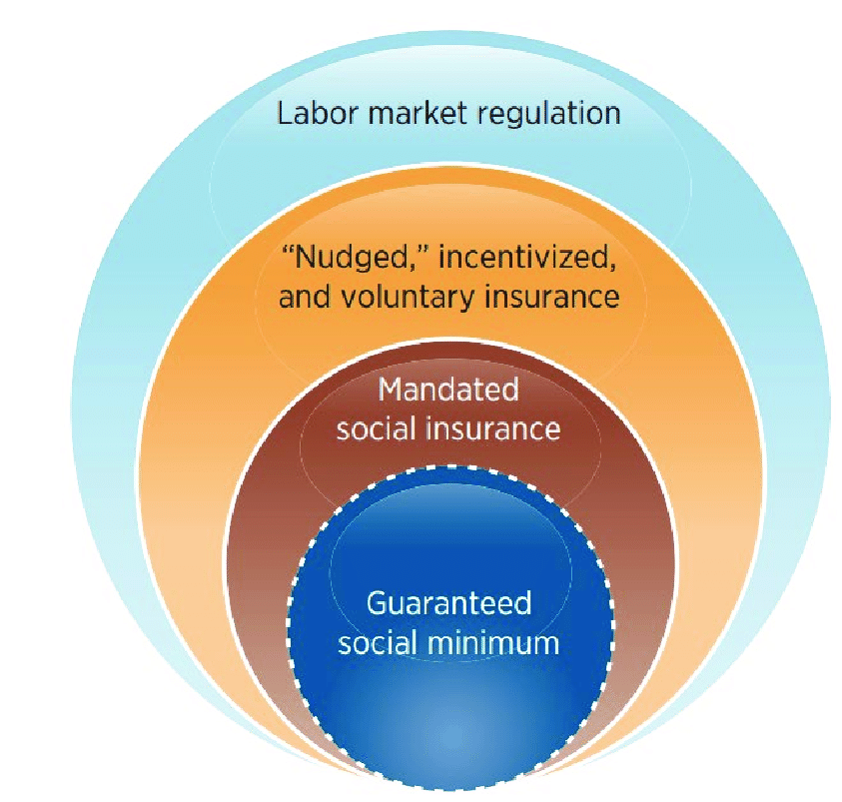
Figure 3: Social-protection-and-labour-regulation-for-labour-market-challenges
(Source: researchgate.net, 2025)
4.2 Target Roles and Value Proposition
My near-term targets are roles at the intersection of people, process and analytics—for example, People Analytics Analyst, HR Technology Associate, Workforce Planning Analyst, or Operations Analyst in talent-intensive sectors. The value I offer is an evidence-based approach to workforce questions (Janjua, Qureshi and Shah, 2025). I can translate business goals into measurable people problems, assemble and clean relevant data, and present insights that change decisions. I pair that with sensitivity to ethics and fairness in people data. Over time, I aim to grow into roles that integrate strategy and enablement, such as HR Product Manager or Analytics Lead, where I can shape platforms, governance and adoption.
4.3 Skills Gap Analysis and Learning Plan
I have completed a baseline inventory using a simple skills matrix with four columns: skill, current proficiency, evidence, and next milestone. For example:
- SQL and data modelling: intermediate; evidenced by course projects; next milestone is implementing a workforce dataset with dimensions for employees, jobs, skills and time, and producing retention and mobility analyses.
- HR domain knowledge: foundational; evidence from literature synthesis; next milestone is producing two short research briefs on skills-based talent practices and people analytics ethics (Mousa, Arslan and Szczepańska-Woszczyna, 2023).
- Visual analytics: intermediate; evidenced by dashboards; next milestone is designing an executive-ready workforce planning dashboard that blends descriptive and diagnostic elements.
- Communication: strong written skills; next milestone is improving executive storytelling with before/after decision narratives.
To close the gaps, I will follow a spiral learning approach: short cycles of study, application and reflection (Janjua, Qureshi and Shah, 2025). Each quarter, I will prioritise two skills. Learning assets will include targeted micro-courses, practitioner blogs, and standards documentation. Application will occur through mini-projects tied to realistic scenarios, such as modelling internal mobility flows or evaluating a recruitment funnel.
4.4 Portfolio and Evidence Development
Employers respond to artefacts that make capability visible. I will build a compact portfolio comprising three items:
Workforce Planning Notebook: a reproducible analysis that forecasts demand and supply for a chosen organisation scenario, highlights skills bottlenecks and proposes interventions (Adias and Raimi, 2025). It will show thoughtful data assumptions, sensitivity testing and decision implications.
People Data Product Concept: a one-page product canvas for a skills graph or internal talent marketplace feature, including problem statement, users, key events, data model sketch, metrics and risk considerations. This demonstrates product thinking beyond analysis.
4.5 Experience and Exposure: Gigs, Volunteering and Simulations
While searching for full-time roles, I will seek experience through small gigs, volunteering and simulations. Short engagements with student societies, local charities or startups—such as optimising a volunteer scheduling process or analysing applicant data—create real outcomes and references (Hassanein and Özgit, 2022). Participating in case challenges or hackathons provides time-boxed problems and feedback from practitioners.
4.6 Networking and Market Intelligence
I will implement a routine for professional outreach that favours consistency over intensity. Each week, I will contact three practitioners whose work intersects with my interests, referencing a specific article, talk or product of theirs to start a thoughtful conversation. My goal is to learn, not to pitch (Abdulkareem and Adekunle, 2025). I will also join relevant communities and attend occasional meetups or webinars, using them to understand hiring signals and vocabulary. A lightweight Customer Relationship Management habit—notes of conversations, follow-ups and thank-you—will make networking cumulative rather than sporadic.
4.7 Application Strategy and Interview Readiness
My application strategy is to customise deeply for fewer roles rather than scatter widely. For each application, I will produce a tailored CV and a brief, employer-specific cover note that links my artefacts to their context (Mitosis, Lamnisos and Talias, 2021).
Interview preparation will follow a repeatable structure: clarify the problem, propose a framework, discuss trade-offs and risks, and end with a test-and-learn approach. I will maintain a bank of concise case stories using a situation-task-action-result format, emphasising decision impact and stakeholder management. For technical screens, I will practise basic SQL tasks, data cleaning steps and a walk-through of my portfolio project decisions, including limitations. For behavioural screens, I will prepare to discuss setbacks candidly and what I changed as a result.
4.8 Professional Identity and Wellbeing
Sustained job search and early career growth are marathons. I will protect energy by setting clear work windows, defining what “enough for today” looks like, and celebrating small wins. I will cultivate a professional identity anchored in curiosity and service: the commitment to help teams make better, fairer decisions with people data (Hassanein and Özgit, 2022). This identity reduces anxiety by focusing me on contribution rather than comparison.
4.9 Milestones and Metrics
To sustain momentum, I’ll track: two portfolio artefacts next term, weekly practitioner conversations, a monthly mini-project, selective applications with clear value hypotheses, and post-interview reflection notes. Brief, regular reviews against these metrics will inform adjustments and keep progress disciplined forward.

5. References
Journals
Abdulkareem, F.O. and Adekunle, O.B., 2025. Effect of Strategic Human Resource Management Practices on Human Capital Flight in Selected Hospitals in the Federal Capital Territory, Abuja. African Journal of Management and Business Research, 19(1), pp.334-356.
Adias, L.T. and Raimi, A.A.G., 2025. Addressing Skills Gaps and Talent Shortages in Nigeria: HRM Strategies for the Future. JMIR Preprints, 11(04), p.2025.
Budhwar, P., Malik, A., De Silva, M.T. and Thevisuthan, P., 2022. Artificial intelligence–challenges and opportunities for international HRM: a review and research agenda. The International Journal of Human Resource Management, 33(6), pp.1065-1097.
Farndale, E., Horak, S., Piyanontalee, R., Puffer, S.M. and Vidović, M., 2025. Looking back to look forward: Disruption, innovation and future trends in international human resource management. International Business Review, 34(1), p.102362.
Gerasimova, I.G., Oblova, I.S. and Golovina, E.I., 2021. The demographic factor's impact on the economics of the Arctic region. Resources, 10(11), p.117.
Hassanein, F. and Özgit, H., 2022. Sustaining human resources through talent management strategies and employee engagement in the Middle East hotel industry. Sustainability, 14(22), p.15365.
Janjua, Z.A., Qureshi, S.S. and Shah, S.M.A., 2025. Human Resource Strategies for Improving Leadership Skills Among Hospitality Graduates. Annual Methodological Archive Research Review, 3(1), pp.13-29.
Koišová, E., Masárová, J. and Ivanová, E., 2021. Socio-demographic potential of human resources in the Visegrad regions. Journal of Business Economics and Management, 22(4), pp.1026-1046.
Kozielec, A., Piecuch, J., Daniek, K. and Luty, L., 2024. Challenges to food security in the Middle East and North Africa in the context of the Russia–Ukraine Conflict. Agriculture, 14(1), p.155.
Lami, B., Tarasenko, I., Shyshova, O., Voropayeva, T. and Verhun, A., 2022. International Migration of Human Resources in the Context of Social Transformations. Economies, 10(9), p.216.
Malik, A., Pereira, V. and Budhwar, P., 2021. HRM in the global information technology (IT) industry: Towards multivergent configurations in strategic business partnerships. Human Resource Management Review, 31(3), p.100743.
Mitosis, K.D., Lamnisos, D. and Talias, M.A., 2021. Talent management in healthcare: A systematic qualitative review. Sustainability, 13(8), p.4469.
Mousa, M., Arslan, A. and Szczepańska-Woszczyna, K., 2023. Talent management practices in the extreme context of the hospitality sector: an exploratory study. International Journal of Organisational Analysis, 31(7), pp.3502-3518.
Ogedengbe, D.E., Oladapo, J.O., Elufioye, O.A., Ejairu, E. and Ezeafulukwe, C., 2024. Strategic HRM in the logistics and shipping sector: Challenges and opportunities. International Journal of Science and Research Archive, 11(1), pp.2000-2011.
Onah, C.K., Azuogu, B.N., Ochie, C.N., Akpa, C.O., Okeke, K.C., Okpunwa, A.O., Bello, H.M. and Ugwu, G.O., 2022. Physician emigration from Nigeria and the associated factors: implications for safeguarding Nigeria's health system. Human Resources for Health, 20(1), p.85.
Prasad, D.B., Hamraaia, M.H.Y., Sharma, A., Sahana, B.C. and Pereira, M.C.S., 2024. The impact of technology on human resource management: Trends and challenges. Educational Administration: Theory and Practice, 30(5), pp.9746-9752.
Websites
researchgate.net, 2025. Factors-affecting-the-differences-between-the-human resources-management-in-the-domestic. (Online).
Available at: https://www.researchgate.net/figure/Factors-affecting-the-differences-between-the-human-resources-management-in-the-domestic_fig1_305860491 [Accessed on: 10.10.2025].
researchgate.net, 2025. Human-Resources-Challenges-for-Developed-Countries. (Online). Available at: https://www.researchgate.net/figure/Human-Resources-Challenges-for-Developed-Countries_fig1_335442653 [Accessed on: 10.10.2025].
researchgate.net, 2025. Social-protection-and-labour-regulation-for-labour-market-challenges. (Online). Available at: https://www.researchgate.net/figure/Social-protection-and-labour-regulation-for-labour-market-challenges_fig1_337195912 [Accessed on: 10.10.2025].

