Let Me Share My Experience

What a way to start a trip!
1st February 2019
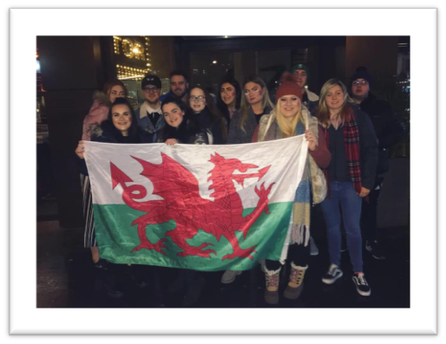
Starting the first night in Paris, there was the opportunity to go and watch the Wales vs France Six Nations rugby game. I was very excited, enthusiastic and very thrilled to be supporting my home country, Wales! I believed that this was a great opportunity, as this was an experience to witness the atmosphere during a sport events, as sports tourism is a niche market that is significantly important to the tourism and hospitality industry.
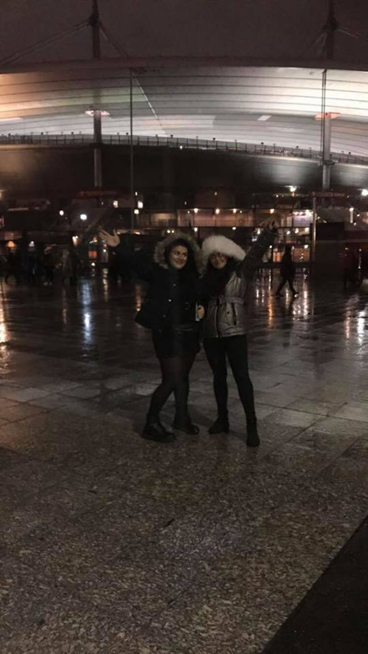
After a long day travelling to Paris, I felt that it was important to stay enthusiastic and get ready for the game when we had free time. By staying positive, myself and a few of my friends thought that it would be a great idea to face paint a red dragon on one-side of our cheeks (all thanks to Alicia for buying the paint and a temple of a dragon). The rest of the students and lecturers also wanted to join in with the face paint, which created a fantastic vibe before he headed to the match. The idea for this was to show our support for Wales, as well as our excitement to go to the stadium and experience the atmosphere. Here is a photograph of us all before we were off to the stadium.
We were ready for the game. The whole group was excited, carrying the welsh flag, everyone was chatting and laughing. The vibe amongst the group was awesome.
We used the metro to get to the match, which was easily accessible, as it was close to our accommodation and only a 10- minute walk to the stadium.
Once we arrived at the stadium, we were all required to go through security and get ourselves and our bags checked. There were minimum ques, and the whole experience went smoothly.
With my excitement being at the event, I really wanted to purchase an alcoholic beverage, which I could drink whilst watching the rugby. But personally, this led to disappointment for me when the food and beverage stalls were only selling one alcoholic beverage to choose from (Heineken to be precise). Truly disappointing! Not all guests like to drink Heineken, so I strongly believe that there could have been more effort in providing more a variety of alcoholic beverages. On the other hand, food wise, they were selling the standard hot dogs or burgers. I bought a hot dog before the game began, as the weather conditions were abysmal!
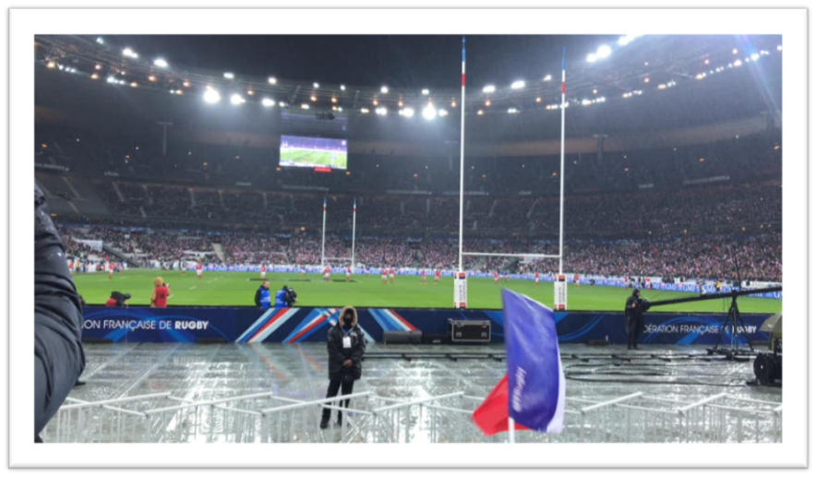
The seats that we had to watch the game were excellent, as we were not far from the front, meaning that we could see all the action happening from a great angle. And for the best part, the tickets were only just under £20! Result! For the view and the seats that we had, you cannot beat the price!
The game had started, the crowd was electric and everything I expected it to be. All the French fans surrounding us were singing and chanting for France, as they were dominating the first half of the game. Not only was France winning the first half of the game, I personally was not enjoying the experience, as the weather was horrific. We were all on the outskirts of the stadium, meaning that we were right outside in the rain. The rain was torrential and was not stopping at any point. Let’s just say that the first 40 minutes, standing in the rain, trying to get involved with atmosphere proved to be very difficult and not enjoyable whatsoever.
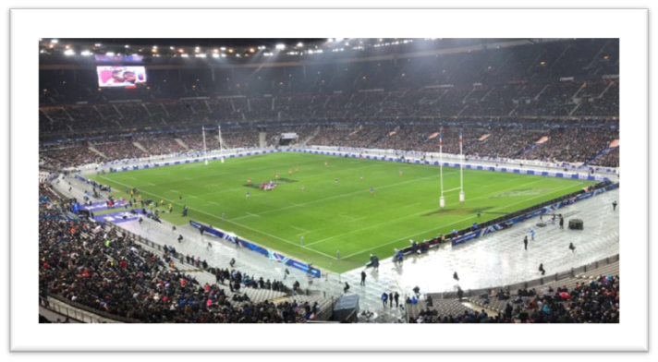
During half time, I and few of my friends went indoors, as we did not want to stand by our seats any longer, because we were soaked thoroughly. I most definitely did not want to return to the same spot for the second half. Luckily, one of the girls noticed that there was an empty block near the upper tier, so we all decided to go watch the second half of the game. We were no longer standing in the rain, that was still not stopping anytime soon.
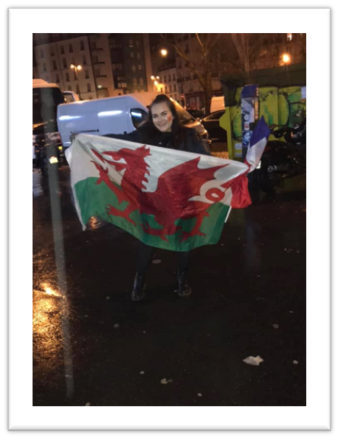
The second half had begun, and it came to my attention that we were surrounded by Welsh fans, as they were all singing and chanting songs that Welsh fans would normally sing during a sports match. This made the mood and atmosphere more alive for me, as we were all involved with the singing and chanting, getting into the spirit. I felt much more enthusiastic and was having the best experience witnessing the live action. Wales was not so great in the first half; however, they came back fighting in the second half of the game. It was an amazing moment when Wales scored the last try, resulting in them winning the game.
What an atmosphere, all of us were on such a high and nothing could beat how we felt about the result. I felt very lucky that I was able to experience Wales winning in a different country. For me, this was the best way to start our European Field Study Trip.
On the way back to the accommodation, I carried the Welsh flag with me, full of enthusiasm and energy. Back at the hostel, we all decided to head to the bar for a couple of drinks, in celebration of Wales winning the game.
What a way to start the trip! However, I would recommend for all individuals to check up on the weather before any sport events. This is so that anyone can dress suitably according to the weather conditions and is fully able to enjoy the full experience.
For now, keep an eye out for any more future blogs.

