Changemaker: Building your Personal Brand for Sustainable Employment
Changemaker: Building your Pe
Changemaker: Building your Personal Brand for Sustainable Employment

Changemaker: Building your Personal Brand for Sustainable Employment
BMHP5015_BIRM

E-Portfolio

Lecturer: Dr Tayo Korede

Student: Elena Vasinc
2016813

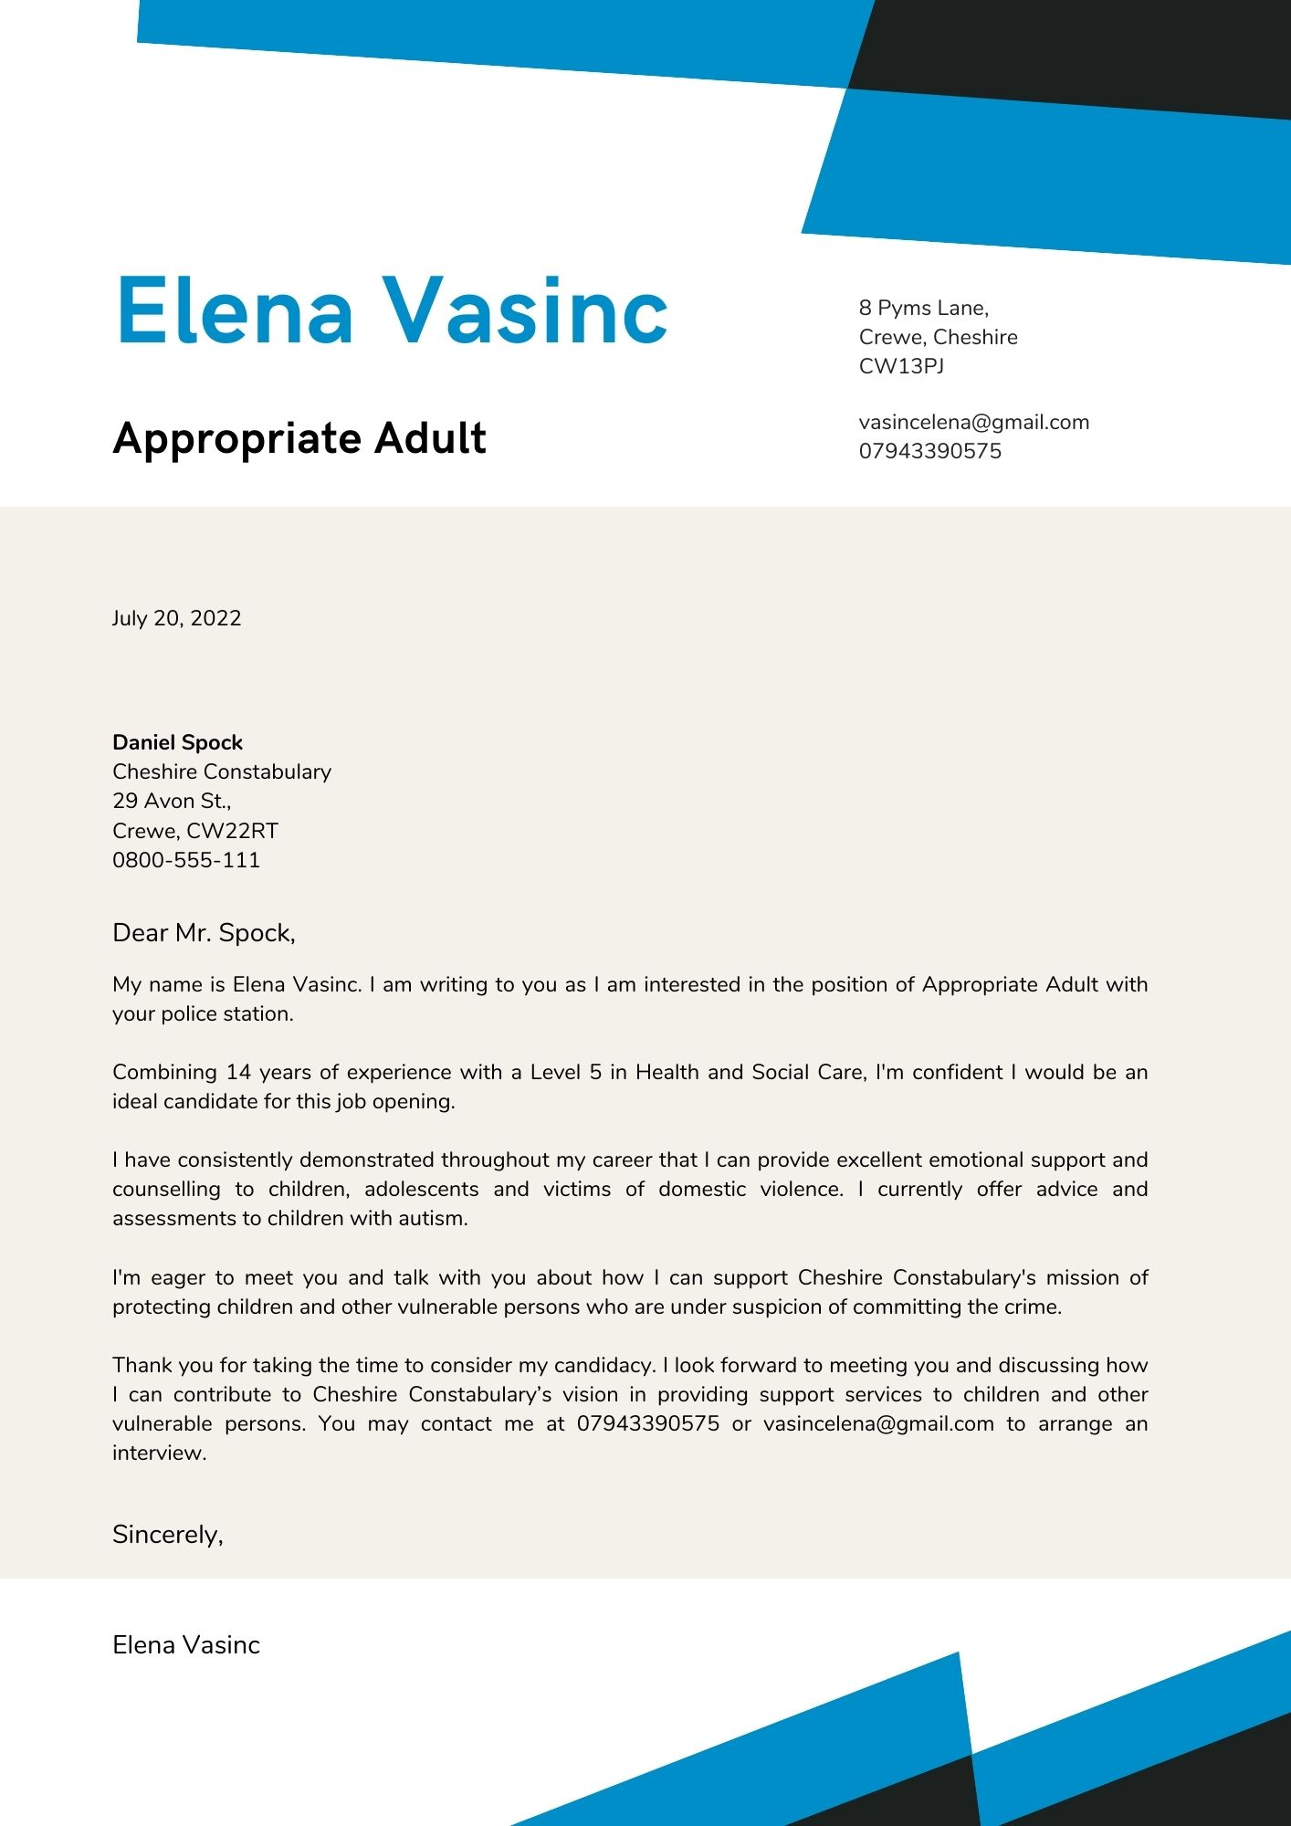

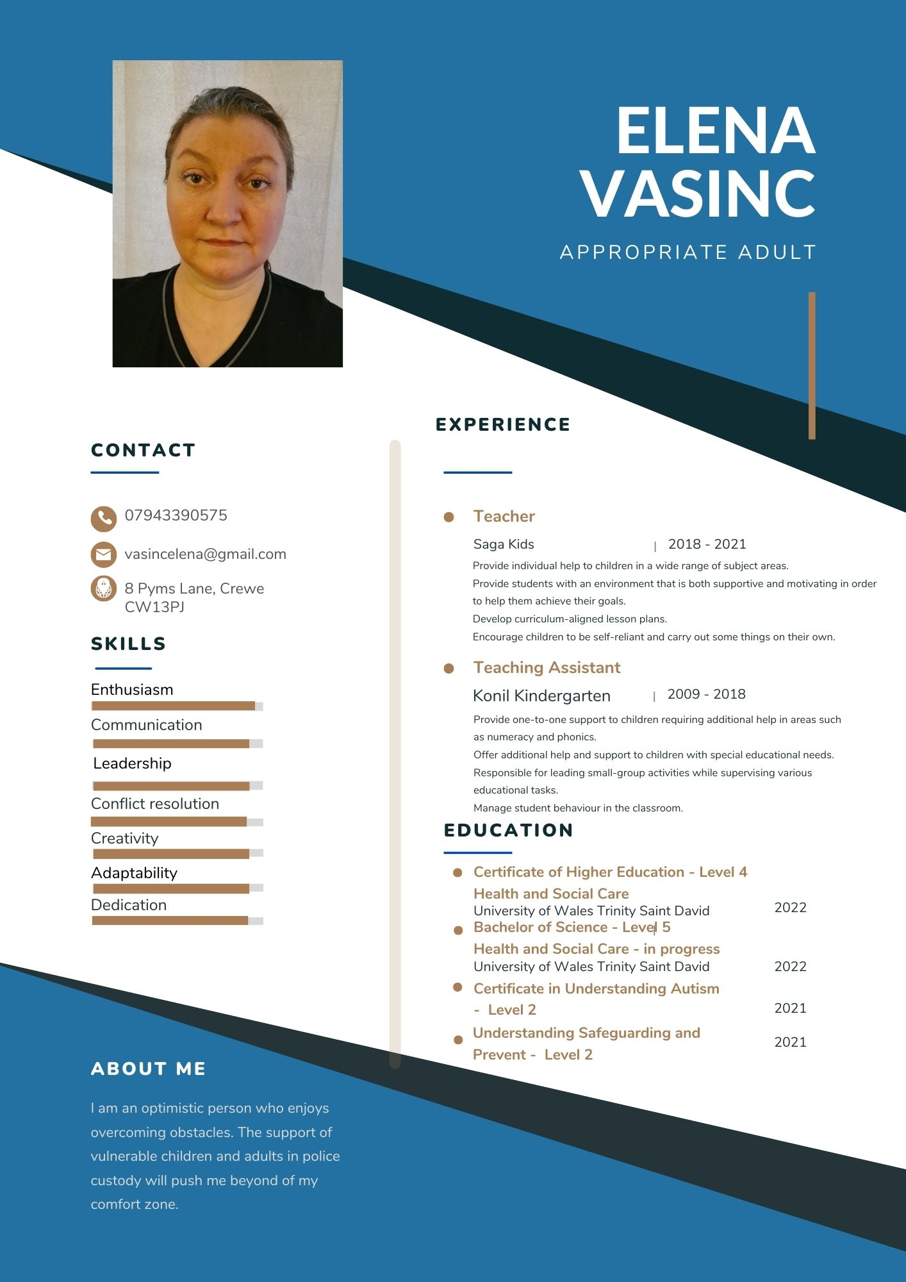



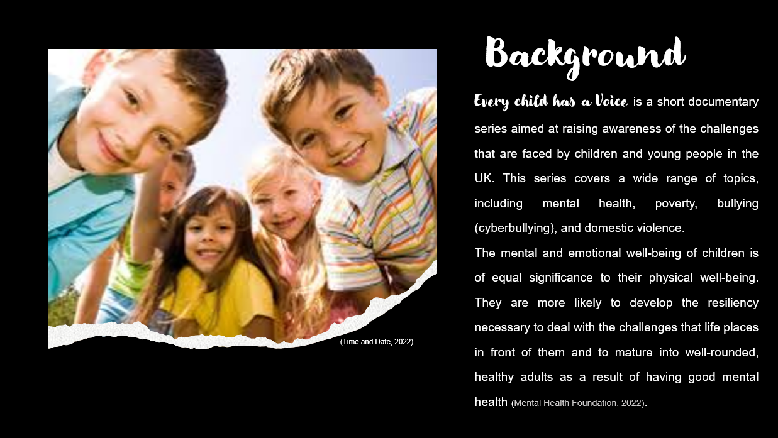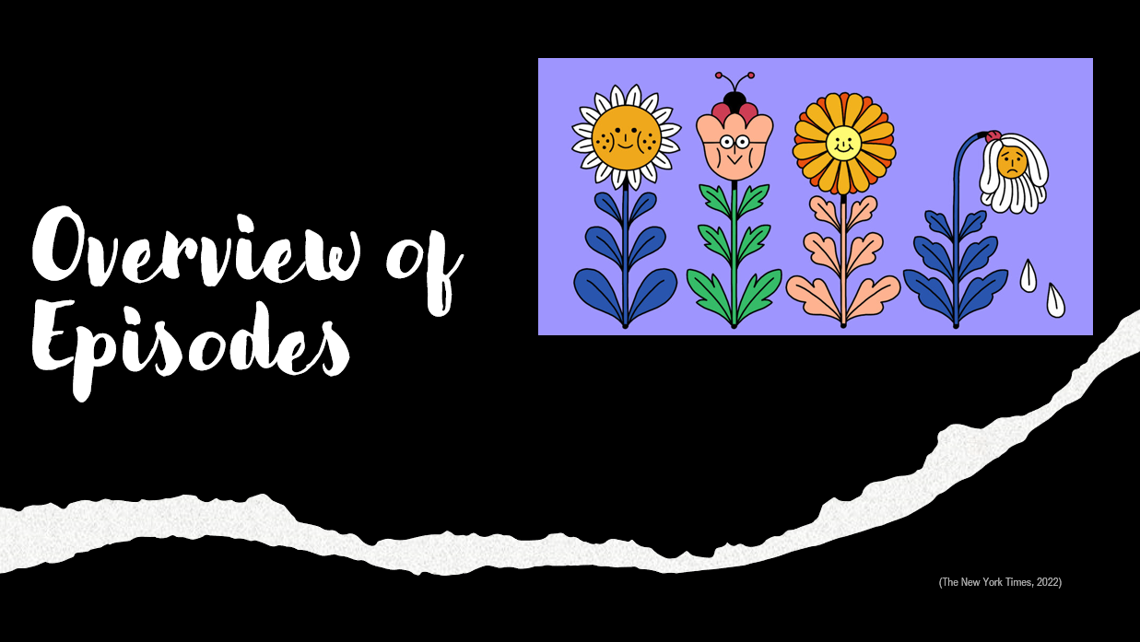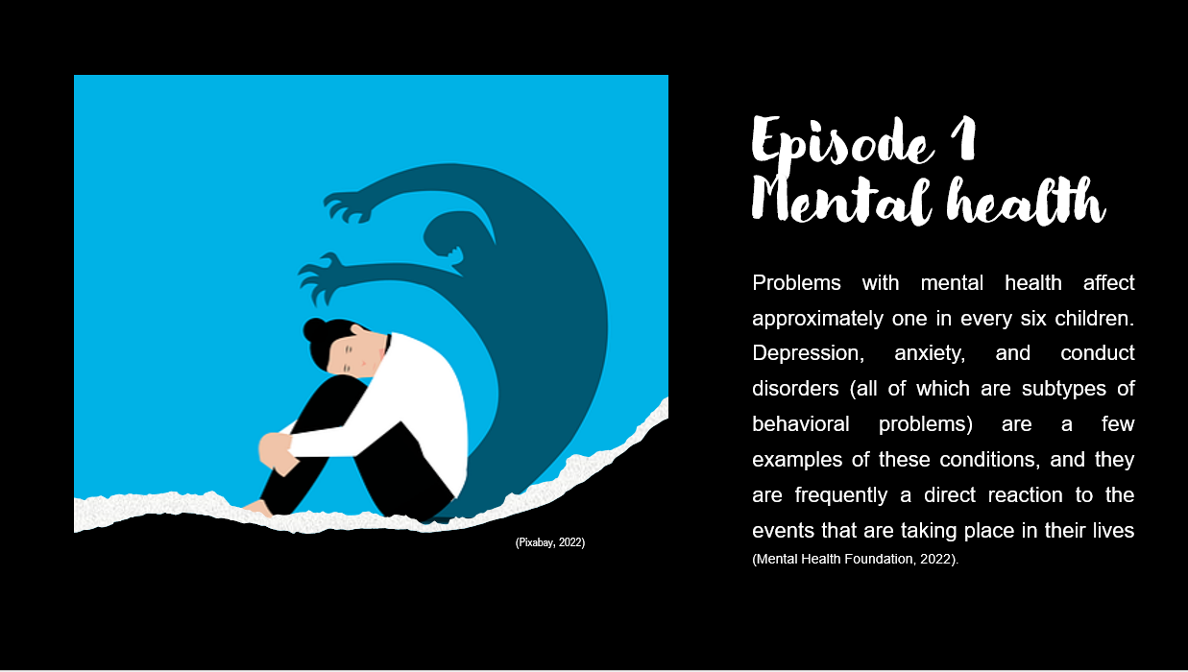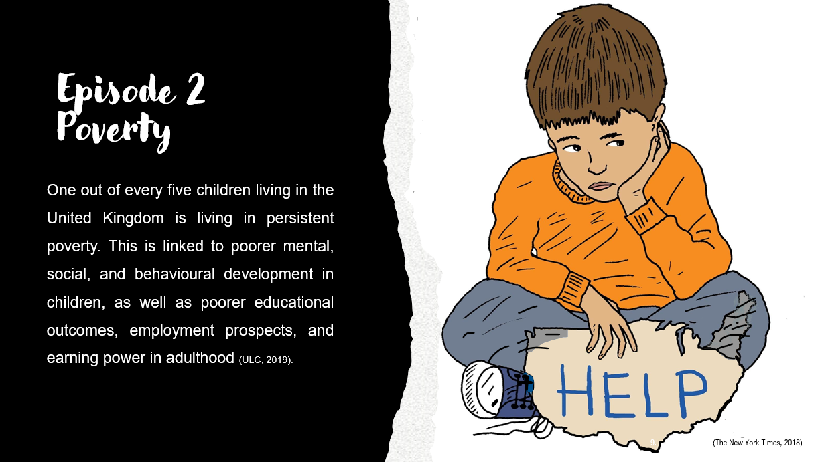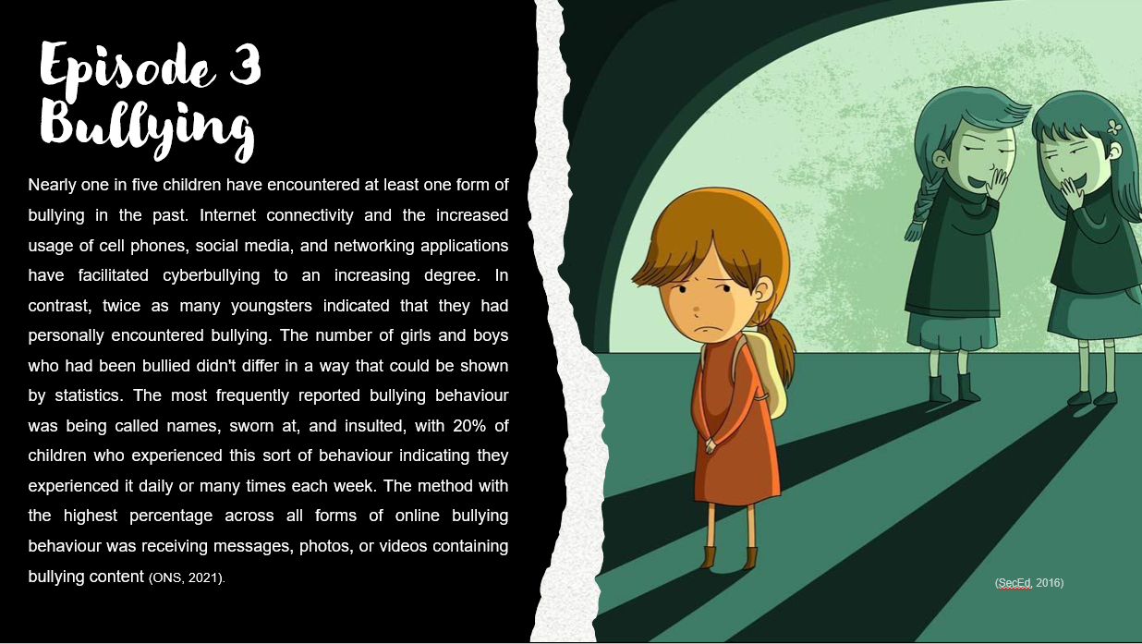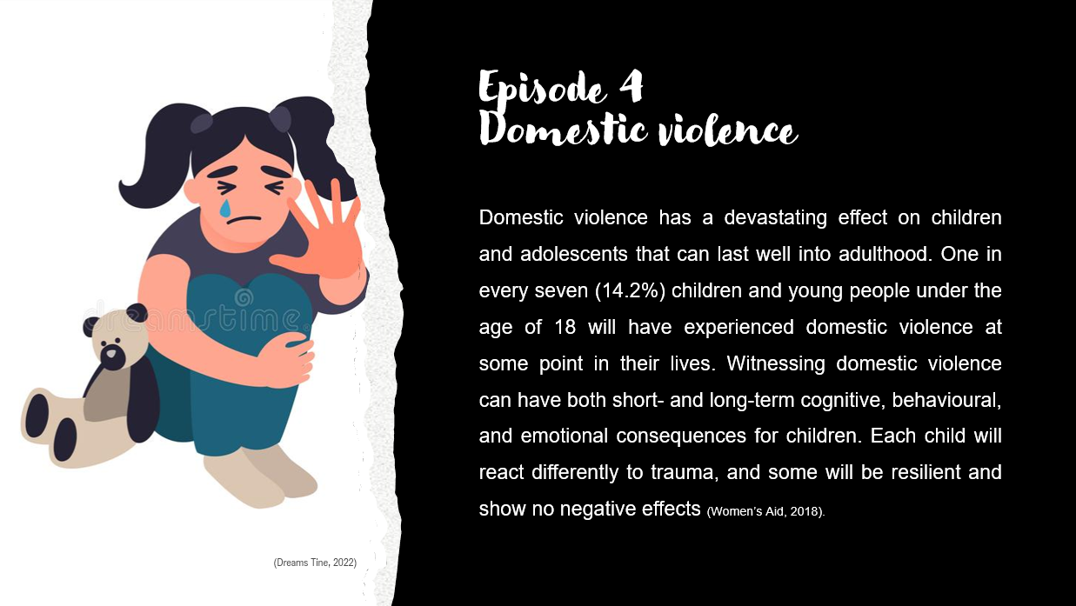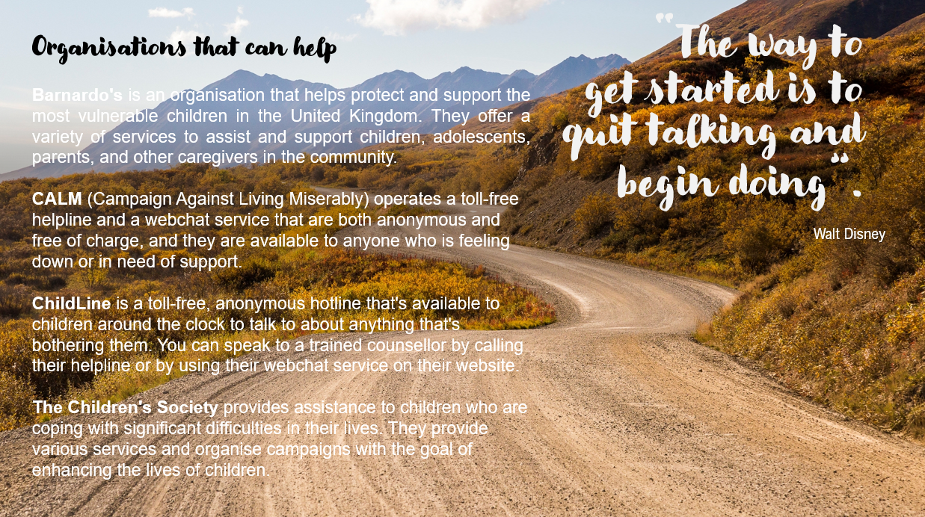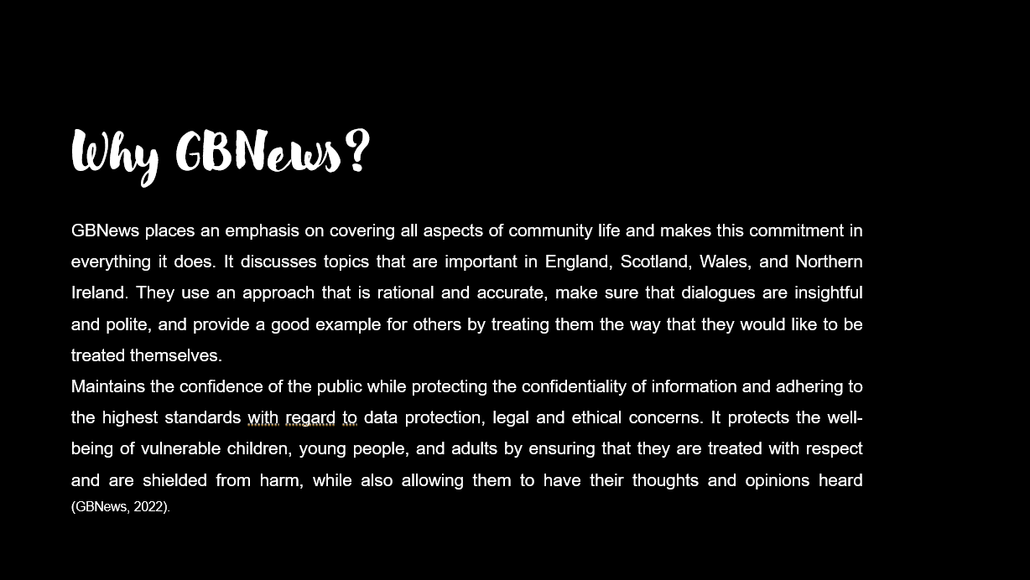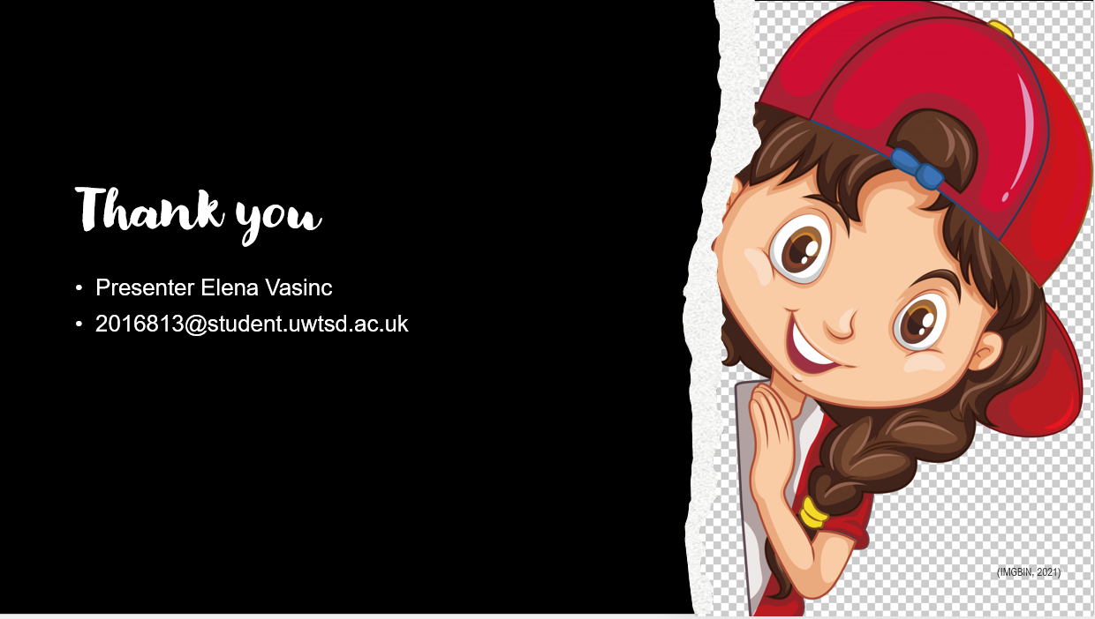

References:

1. Time and Date (2022) Universal Children's Day, Available at: https://www.timeanddate.com/holidays/un/universal-childrens-day (Accessed: 25.06.2022).
2. IMDb (2022) Natalie Winters, Available at: https://www.imdb.com/name/nm7903169/ (Accessed: 25.06.2022).
3. IMDb (2022) Mark Steyn, Available at: https://www.imdb.com/title/tt17291888/fullcredits/?ref_=tt_cl_sm (Accessed: 25.06.2022).
4. GBN (2022) Our Editorial Charter, Available at: https://www.gbnews.uk/our-editorial-charter (Accessed: 25.06.2022).
5. Mental Health Foundation (2022) Children and young people, Available at: https://www.mentalhealth.org.uk/a-to-z/c/children-and-young-people (Accessed: 25.06.2022).
6. Pixabay (2022) Mental health & brain images, Available at: https://pixabay.com/images/search/mental%20health/ (Accessed: 25.06.2022).
7. The New York Times (2022) How to Improve Your Mental Health in 2022, Available at: https://www.nytimes.com/2021/12/30/well/mind/mental-health-advice-2022.html (Accessed: 25.06.2022).
8. Web Developers Notes (2022) Walt Disney - Quit talking and begin doing, Available at: https://www.webdevelopersnotes.com/quit-talking-and-begin-doing (Accessed: 25.06.2022).
9. The New York Times (2018) The Cost of Keeping Children Poor, Available at: https://www.nytimes.com/2018/04/15/opinion/children-poverty-cost.html (Accessed: 25.06.2022).
10. SecEd (2016) Tackling the bullying of pupils with SEND, Available at: https://www.sec-ed.co.uk/best-practice/tackling-the-bullying-of-pupils-with-send/ Accessed: 25.06.2022).
11. Dreams Time (2022) Stop violence and abused children. Image, Available at: https://www.dreamstime.com/stop-violence-abused-children-stop-violence-abused-children-little-girl-sitting-floor-crying-unhappy-image130624425 Accessed: 25.06.2022).
12. IMGBIN (2021) Happy child, Available at: https://imgbin.com/png/2uhUBLKT/happy-kid-happy-child-png (Accessed: 25.06.2022).
13. The Drum (2022) GB News adopts political campaigning tactics to boost ratings, Available: https://www.thedrum.com/news/2022/01/06/gb-news-adopts-political-campaigning-tactics-boost-ratings (Accessed: 26.06.2022).
14. Campaign (2021) GB News debuts ad campaign following London Advertising appointment, Available at: https://www.campaignlive.co.uk/article/gb-news-debuts-ad-campaign-following-london-advertising-appointment/1734375 (Accessed: 26.06.2022).
15. ULC (2019) Persistent poverty affects one in five UK children, Available at: https://www.ucl.ac.uk/news/2019/jun/persistent-poverty-affects-one-five-uk-children (Accessed: 26.06.2022).
16. ONS (2021), Online bullying in England and Wales: year ending March 2020, Available at: https://www.ons.gov.uk/peoplepopulationandcommunity/crimeandjustice/bulletins/onlinebullyinginenglandandwales/yearendingmarch2020 (Accessed: 26.06.2022).
17. Women’s Aid (2018) The impact of domestic abuse on children and young people, Available at: https://www.womensaid.org.uk/information-support/what-is-domestic-abuse/impact-on-children-and-young-people/ (Accessed: 26.06.2022).

