Data Handling and Business Intelligence

Coursework

Student name: Cristina-Valentina Solomon
Student ID number: 2025748
Module code: LCBB5000
Module Leader: Khaza Ahme

Table of Contents
Part 1: Ice-Cream Data Analysis 3
1.1 Introduction 3
1.2. Ice Cream Data 3
1.3. Relationship Analysis 5
1.4. Analysis Conclusion 10
1.5. MS Excel Evaluation and Conclusion 10
Part 2: COVID-19 Cases Data Analysis 11
2.1. Introduction 11
2.2 COVID-19 Cases Data 11
2.3. COVID-19 Data Analysis 11
2.4. Different Text mining methods 15
2.5. SPSS and MS Excel Evaluation and Conclusion 17
References 18

Part 1: Ice-Cream Data Analysis

1.1 Introduction
The overall report has two-part and this first part organises and analyses the given ice-cream data to find the possible relationship between the variables such as favourite ice0cream flavour, gender, puzzle score and video game score. Descriptive statistics, correlation, scatter diagram and Pivot table has been applied for the analysis purpose.

1.2. Ice Cream Data
The ice-cream data contains the data of 200 high school students on the variables named ID, gender, favourite ice-cream flavour, puzzle score and video game scores. Among the variables, gender and ice cream flavour are qualitative or non-numeric values. Therefore, a specific dummy number has been used for these variables as follows
In case of the Gender
Male = 0
Female = 1
In case of the favourite Ice-cream Flavour,
Vanilla = 1
Chocolate = 2
Strawberry = 3
Descriptive Statistics
Descriptive statistics is a useful model for identifying the characteristics of the data set (Berenson et al., 2012).
Excel command for creating descriptive statistics: go to data analysis > descriptive statistics>Select the relevant data as input range and select the output range to direct in which part the result will be displayed (Jablonsky, 2014). The screenshots are given below-
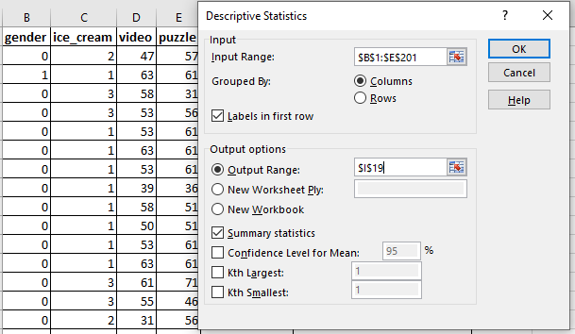
The descriptive statistics tool of MS excel has generated the following output
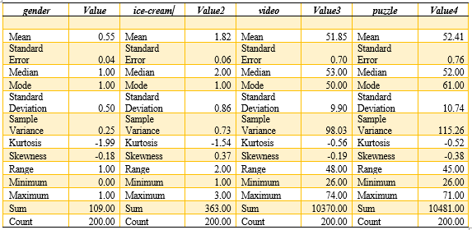
The mean value for the gender variable is 0.55. it is indicating that the number of females is higher than the male as the male is equal to 0 and the female is equal to 1. The mean value of 1.82 for the ice-cream flavour variable is indicating that majority of the students like vanilla as vanilla is equal to 1. The average score for the Puzzle and video are 51.85 and 52.41 respectively indicating the students are performing well in the case of the puzzle. The minimum and maximum values of the video game are 26 and 74 respectively. The minimum and maximum values of the puzzle are 26 and 71 respectively. So, the range is lower in the case of puzzle scores (Berenson et al., 2012). The count value of 200 is indicating there were 200 observations in the data set.

1.3. Relationship Analysis
For identifying the relationship between the variables, a correlation has been used.
Excel command for measuring: go to data analysis > correlation>Select the relent data as input range and select the output range to direct in which part the result will be shown (Jablonsky, 2014). The screenshots are given below-
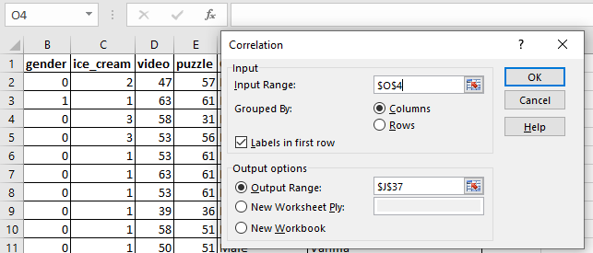
Output
 | gender | ice-cream | video | puzzle
gender | 1
ice-cream | 0.0136 | 1
video | -0.1277 | 0.1317 | 1
puzzle | 0.0523 | 0.1693 | 0.4651 | 1

Gender is very weakly positively correlated with ice cream flavour and puzzle score and it has a weak negative correlation with the video game. Ice cream flavour has a weak positive correlation with both the video game and puzzle score (Weiers, 2010).
There is a significant positive correlation (0.47) between the puzzle score and video game score. Below is given the scatter diagram of this two variables-

The scatter diagram also indicates a significant positive correlation between the puzzle score and video game score.
Pivot table analysis
Before the pivot table analysis, we need to process and organise data. So, the analyse of the data in a more meaningful way, the response of the favourite ice-cream flavour and the gender is converted to the qualitative such as male and female for gender and Chocolate, Vanilla and Strawberry for the favourite ice-cream flavour.
Organising Data using Excel
id | Video Game Score | Puzzle Scores | Gender | Formulas | Ice Cream Flavour | Formulas
70 | 47 | 57 | Male | =IF(B2=0,"Male","Female") | Chocolate | =IF(C2=1,"Vanilla",IF(C2=2,"Chocolate","Strawberry"))
121 | 63 | 61 | Female | =IF(B3=0,"Male","Female") | Vanilla | =IF(C3=1,"Vanilla",IF(C3=2,"Chocolate","Strawberry"))
86 | 58 | 31 | Male | .=IF(B4=0,"Male","Female") | Strawberry | =IF(C4=1,"Vanilla",IF(C4=2,"Chocolate","Strawberry"))
141 | 53 | 56 | Male | =IF(B5=0,"Male","Female") | Strawberry | =IF(C5=1,"Vanilla",IF(C5=2,"Chocolate","Strawberry"))
172 | 53 | 61 | Male | =IF(B6=0,"Male","Female") | Vanilla | =IF(C6=1,"Vanilla",IF(C6=2,"Chocolate","Strawberry"))

Pivot Table
Pivot Table is basically a table of grouped values that aggregates different individual items of the more descriptive and extensive table within different discrete categories. The summary of the pivot table may include average, sums, count and other relevant statistics. It is a pivot table which is a very interactive way to analyse and summarise a large amount of data within a short period of time. Businesses use a pivot table to analyse and evaluate numerical data in detail to find a pattern and answer different questions useful for managerial decision-making (Weiers, 2010). This is a very powerful and effective tool to summarise, calculate, analyse and evaluate by showing comparisons and identifying patterns and trends. It allows the users to filter and identify significant patterns. The relation or pattern of the favourite ice-cream flavour, video game scores and puzzle test scores of the 200 students of high school have been analysed using the Pivot table.
To create the pivot table in MS Excel, we have to follow the following steps-
Step-01: Selecting the data of 200 high school students
Step-02: Choosing the option Pivot Table from the Insert Tab.
Step-03: Select the required data that need to add to the Pivot Table.
Step-04: Choosing the fields of the Pivot table
Step-05: Dragging the fields to the required area.
We have added the gender and favourite ice-cream fields in the row labels and we have added Ice-cream flavour, Puzzle test score and Video game score in the value table to create the desired Pivot table. All the steps have been presented in the following screenshots.

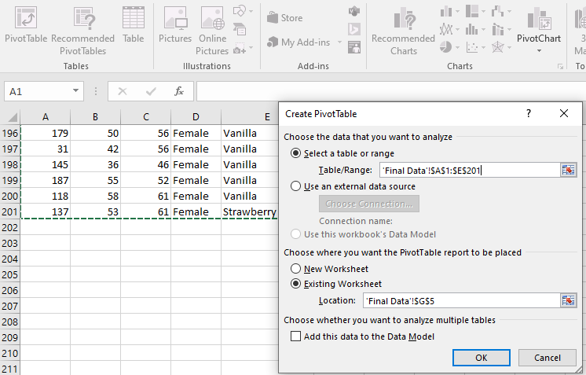
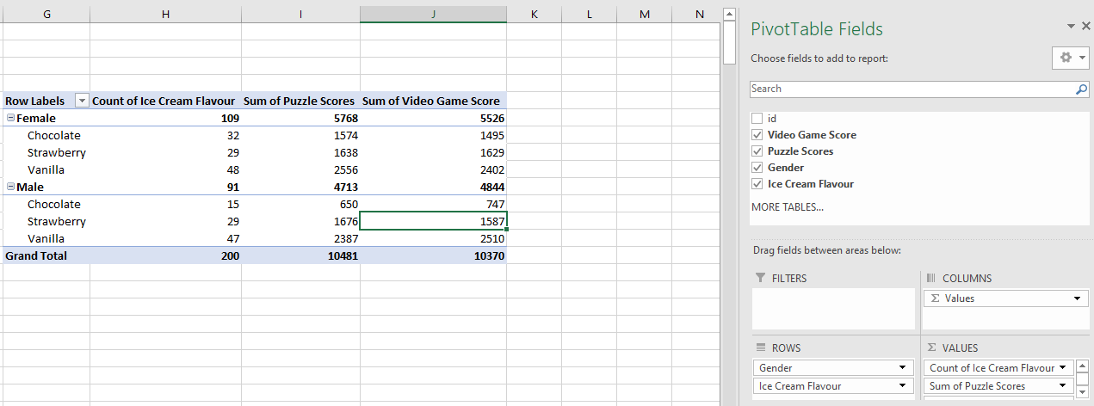

Row Labels | Count of Ice Cream Flavour | Average of Puzzle Scores | Average of Video Game Score
Female | 109 | 52.92 | 50.70
Chocolate | 32 | 49.19 | 46.72
Strawberry | 29 | 56.48 | 56.17
Vanilla | 48 | 53.25 | 50.04
Male | 91 | 51.79 | 53.23
Chocolate | 15 | 43.33 | 49.80
Strawberry | 29 | 57.79 | 54.72
Vanilla | 47 | 50.79 | 53.40
Grand Total | 200 | 52.41 | 51.85

For the Pivot table labels, count functions have been used to count the gender and ice-cream flavour and average functions have been used for the Puzzle score and video game score as average value makes the data more comparable. The Pivot table analysis finds that out of the 200 respondents 109 were female students and 91 were male students. It shows that both the male and female students love vanilla ice cream. The students who have chosen strawberry as their favourite flavour of ice cream have the highest average video game and puzzle scores. However, to identify the possible pattern and relationship from the data graphs and charts are more useful. Below is inserted the Pivot chart for this purpose.

Pivot Charts

Figure: Bar chart of the Ice-cream data
The bar chart represents the count of ice cream flavours (vanilla, Strawberry, chocolate), average puzzle score and average video game score of the students. In terms of the flavour of ice cream both the male and female students like the vanilla flavour more. However, a slightly higher building/bar on the chart is indicating that the students who like the Strawberry flavour have higher puzzle and video game scores. It means if a student like strawberry as the ice0cream flavour, his or her average video game and puzzle score will more like to be higher than the others. So, there is a positive parent between the flavour of ice cream (Strawberry) and the video game and puzzle scores.

Figure: Bar chart of the Ice-cream data
The line chart above is indicating a trend in ice-cream flavour, puzzle score and video game score for the male. All three variables are fluctuating in the same direction. However, there is also a clear trend between the puzzle scores and the video game scores. These are moving in the same direction significantly.

1.4. Analysis Conclusion
There is a weak positive correlation between gender in ice cream flavour and puzzle score and gender has a weak negative correlation with the video game. Ice cream flavour has a weak positive correlation with both the video game and puzzle score. A significant positive correlation of 0.47 has been found between the puzzle score and video game score. Pivot table analysis found that among the female student’s majority responded that their favourite ice cream flavour is Vanilla. Similarly, among the male student, the majority of the students responded that they also love vanilla as their ice-cream flavour (Weiers, 2010). So, most of the students love vanilla ice cream. Female students have a higher average puzzle score than that of the male whereas male students have higher video game scores than that female students. So, female is good at puzzle and male are good at video game which is an interesting finding. Male students whose favourite ice-cream flavour is Strawberry have the highest average puzzle score and video game score. Again, female students whose favourite ice-cream flavour is Strawberry have the highest average puzzle score and video game score. So, the students whose favourite ice-cream flavour is Strawberry are good at puzzles and video games.

1.5. MS Excel Evaluation and Conclusion
MS Excel is very effective and useful for analysing patterns and finding meaningful information that can be very fruitful for decision making. MS Excel is easy to learn and effective for small data sets. The small ice-cream data set has been analysed using the descriptive statics, correlation, scatter diagram and Pivot table. From the analysis, different interesting and useful pattern has been found for example there is a significant positive correlation between puzzle score and video game score. Another pattern that is identified is that the students who like strawberry ice cream tend to have higher video game and puzzle scores.

Part 2: COVID-19 Cases Data Analysis

2.1. Introduction
This part of the analysis includes the COVID data analysis using excel. COVID cases and death in three continents such as Asia, Europe and America have been analysed using the Subtotal and Correlation. This part also includes the description of common text mining methods and the evaluation of MS excel and SPSS

2.2 COVID-19 Cases Data
COVID cases data contains the COVID-cases and death data and population data of three selected continents. These are Asia, America and Europe. The data includes daily data of all the countries of Asia, Europe and America. The time period of the data is march 2020 to December 2020.

2.3. COVID-19 Data Analysis
Descriptive statistics
SPSS command to generate descriptive statistics: Analyse > Descriptive statistics>Descriptive>bivariate correlation>select the variables
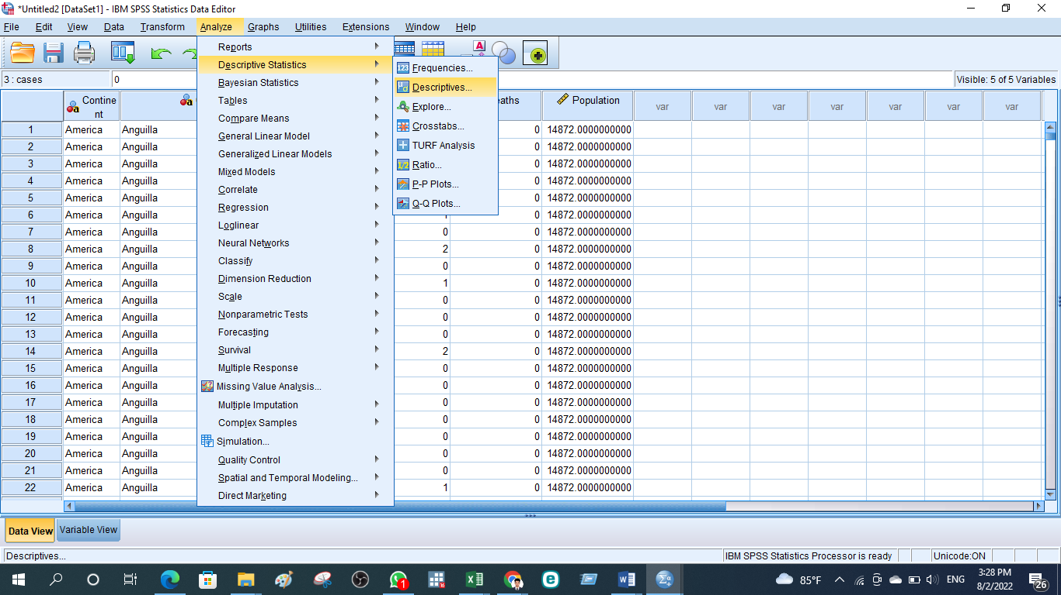
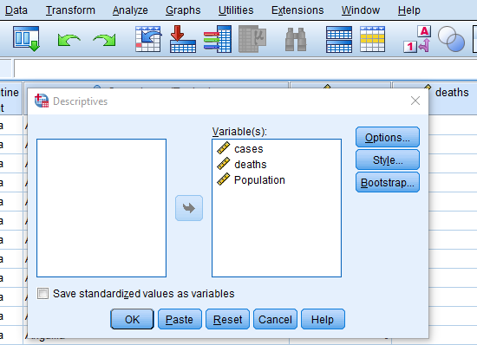
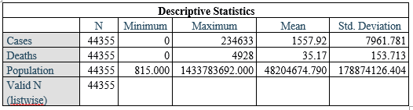
The number of observations is 44355, the mean number of cases is 1558 and the mean death number is 36. The maximum number of cases in a day is 234633
Total cases
Total cases have been generated using the SUBTOTAL functions
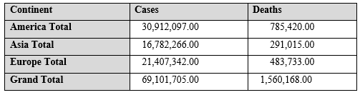
Total cases are 30,912,097 and 16,782,266 and 21,407,342 in America, Asia and Europe respectively
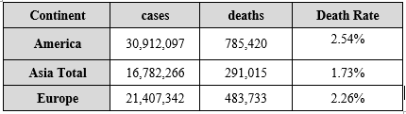
The death rate is determined by diving the number of cases using the number of deaths
Highest Death Rate |  | Lowest Death Rate
2.54% | America | 1.73% | Asia

Highest death rate: 2.54% in America
Lowest Death rate: 1.73% in Asia
Presentation of the Findings
Charts to present the result of the analysis are developed using the SPSS graph builder option. SPPSS provides excellent graphs building options (Hinton, McMurray and Brownlow, 2014). Here, we need to go to the graphs and then the graph building option to create the appropriate graphs
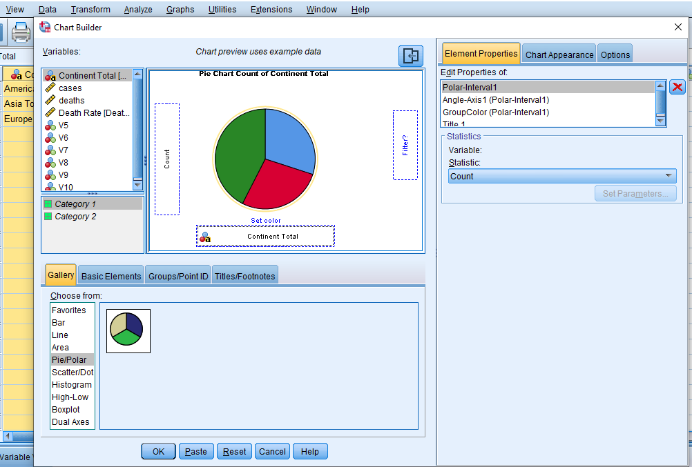

Pie chart of Covid-cases
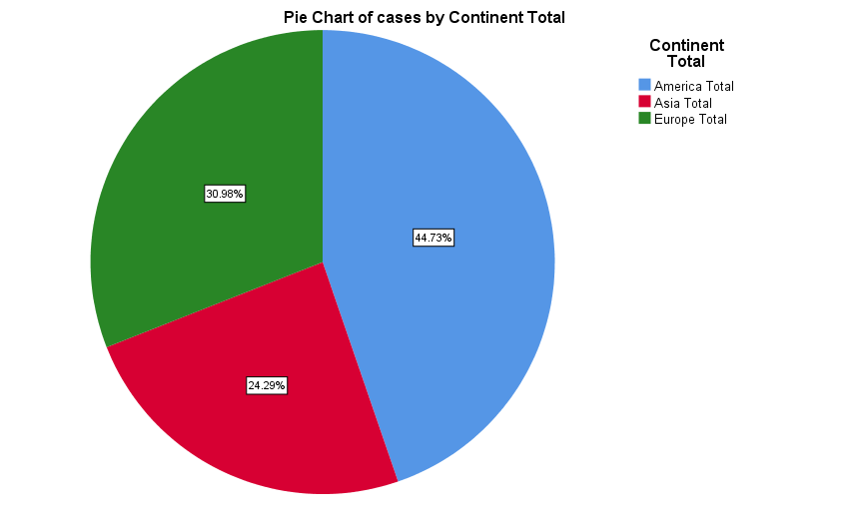
Figure: Pie chart of continent-wise COVID cases
America has the highest portion (44.73%) of COVID cases among the three contents and Asia has the lowest portion (24.29%
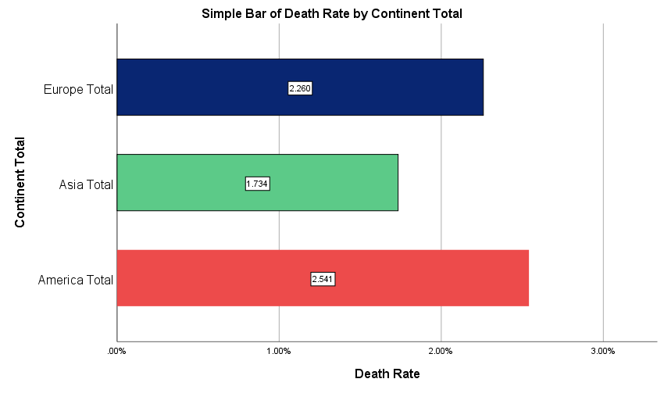
Figure: Bar chart of continent-wise death rate
America has the highest death rate (2.541%) of COVID cases among the three contents and Asia has the lowest death rate (1.734%%). So, America suffered more than Asia because of the outbreak of COVID-19
Correlation between Covid-19 cases and deaths in America
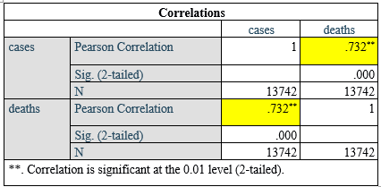
The correlation between Covid-19 cases and deaths in America is 0.73. It means COVID cases and death in America have a strong positive correlation. It means cases and death increase or decreases together significantly (Hinton, McMurray and Brownlow, 2014).

2.4. Different Text mining methods
Text mining is one kind of data mining tool that is used to deal with textual data. Text mining is used to convert semi-structured and unstructured data to structure data. Using the text mining methods textual data are analysed and evaluated to identify meaningful patterns and insights that are useful for the decision-making of the organisation. It is not necessarily that all the data useful for analysis is quantitative or numeric data. Some non-numeric or qualitative are also useful for data analysis. When the company need to analyse the textual data, text mining comes into action (Bharati and Ramageri, 2010). Text mining methods follow common several steps. It starts with collecting information. Then it converts the data into structured data using prepossessing or cleaning the data. After that, text mining methods are applied to identify the pattern in the data set. Then the pattern is analysed thoroughly to identify the insightful and meaningful information for the decision-makers. Finally, the information extracted from the text mining is used for further analysis (Bharati and Ramageri, 2010).
Below given the most important text mining methods used by the different types of businesses-
a) Information Retrieval: one of the most famous and useful text mining methods is information retrieval. Retrieval of information refers to collecting and finding useful and relevant information from a variety of sources that are basically documented in an unstructured format (Liao, Chu and Hsiao, 2012). It is basically a technique for developing mathematically the information needs of the users or decision-makers in the form of queries that are applied to fetch a document from a database collection. It helps the business organisation to extract, relevant, meaningful and useful knowledge and associated patter from given words or phrases. This model selects and ranks the document of the users or business managers who asked for it in the form of a query.
b) Information Extraction: In practice, information retrieval or retrieval of information text mining methods is the most popular technique. This technique deals with a large amount of textual data to identify meaningful and important information (Liao, Chu and Hsiao, 2012). This method of extracting meaningful knowledge from textual data emphasises extracting a lot of entities and attributes from semi-structured or unstructured data. The information that is extracted using this method is finally used in a separate database for further analysis. To check or examine the efficacy and relevancy of outcomes in this method, precision and recall processes are used. This technique is used by the company and different business organisations to extract the name of persons, locations, organisations, attributes, events and relationships between entities.
c) Text Categorisation: Text categorisation refers to a text mining technique which is basically supervised learning from hare the usual text languages are set to pre-defined topics based on their respective contents (Osman, 2019). The purpose or the aim of text mining methods in business is to enhance the detection of the information required that ultimately can improve decision-making. For example, in a healthcare organisation, the patient report is usually indexed from multiple aspects such as types of the surgical procedures, using taxonomies of disease categories, code of insurance reimbursement etc. This text mining method is also applied in the vase of spam filtering in which email messages are categorised into two types such as non-spam and spam.

2.5. SPSS and MS Excel Evaluation and Conclusion
Advantages of using SPSS
Key advantages of using SPSS are that it is a very comprehensive data management tool, it is easy to learn and it provides excellent graphical display options. Large data set can be handled using the SPSS (Leech, Barrett and Morgan, 2013). The business organisation use SPSS to solve the more advanced problem. SPSS also provide a range of statistical models that can be run and executed within a short period of time. To analyse data business organisation, use the correlation, regression, forecasting, non-parametric test and simulation of SPSS.
Disadvantages of using SPSS
SPSS is comparatively more difficult to learn than excel. It requires more advanced knowledge to run the SPSS (Leech, Barrett and Morgan, 2013). Other disadvantages of SPSS are that it is very expensive and can increase the cost of the business.
Advantages of using MS Excel
MS Excel is one of the most used data analysing tools. Most of the company takes help from them for various purpose. Excel is used for very small to large work of the business. Excel is used to keep the record of daily transactions and it is also huge for time schedules. One of the important advantages of using excel is its built-in formulas (Fernández, Orosa, and Galan, 2012). Using excel complex computation can be done within seconds. Another advantage of excel is that it is very easy to learn. One can start using excel with very basic functions. Along with basic work, advanced problems can also be solved using MS excel. Macros and templates of excel provide a great benefit to the business as it saves time and costs by allowing the users to automate repetitive tasks. Businesses can also create dashboards using excel to summarise the company performance.
Disadvantages of using MS Excel
One of the main disadvantages of excel is that it cannot handle a very large data set. It can control more than a few thousand rows (Fernández, Orosa, and Galan, 2012). Excel has some complex formulas that are very difficult to understand and data analysing using excel requires more time than other advanced tools.

References
Berenson, M., Levine, D., Szabat, K.A. and Krehbiel, T.C., 2012. Basic business statistics: Concepts and applications.
Bharati, M. and Ramageri, M., 2010. Data mining techniques and applications.
Fernández, S.O.J.G.J., Orosa, J.A. and Galan, J.J., 2012. A new methodology to teach numerical methods with MS Excel. Journal of Maritime Research, 9(2), pp.29-32.
Hinton, P., McMurray, I. and Brownlow, C., 2014. SPSS explained. Routledge.
Jablonsky, J., 2014. MS Excel based software support tools for decision problems with multiple criteria. Procedia Economics and Finance, 12, pp.251-258.
Leech, N., Barrett, K. and Morgan, G.A., 2013. SPSS for intermediate statistics: Use and interpretation. Routledge.
Liao, S.H., Chu, P.H. and Hsiao, P.Y., 2012. Data mining techniques and applications–A decade review from 2000 to 2011. Expert systems with applications, 39(12), pp.11303-11311.
Osman, A.S., 2019. Data mining techniques.
Weiers, R.M., 2010. Introduction to business statistics. Cengage Learning.

