LCBB5004
Managing People A1

Student Name: Gabriel Ciprian Muntean
Student ID: 2009466
Lecturer : Charles Oham

Table of Contents
Introduction 3
Case in favor of flexible working in relation to diversity and inclusion at work and analyze the role of Human Resources in promoting diversity and inclusion through flexible working. 3
Defining flexible working 3
Flexible working ensures diversity and inclusion at work 4
Importance of diversity in the workplace 5
Different types of diversity 6
Role of Human Resources in promoting diversity and inclusion through flexible working 7
Case against flexible working in relation to inequity at work and analyze the role of Human Resources in addressing the concerns of inequity that may arise from flexible working 8
Flexible working in relation to inequity at work 9
Role of Human Resources in addressing the concerns of inequity that may arise from flexible working 10
Conclusion 11
References 12

Introduction
The effect of covid19 has influenced the employees to work from home and influenced the managers of the organizations to maintain the flexibility of the working environment. It has provided various experiences to the employees such as it has facilitated a balanced work-life (Wangombe et al., 2013). After the recovery from covid19, the employees are interested to work from home. The report has made a case in favor of flexible working in relation to diversity and inclusion, and another case against flexible working in relation to inequity at work. The report also analyzed the role of Human Resource managers in promoting diversity and in addressing inequity in the workplace due to flexible working arrangements.

Case in favor of flexible working in relation to diversity and inclusion at work and the role of Human Resources in promoting it
A flexible working strategy in the organization attracts higher-skilled employees and retains them in the organization in the workplace. It attracts a more skilled and diverse workforce to the organization that may provide better organizational performance. A study has been conducted in the US that has indicated that the economy of the country has accrued around 2.36 trillion dollars through maintaining flexible working in the organizations (Allen and Shockley, 2009). Flexible working has reduced the recruitment costs of the organization, increased job satisfaction, and employee morality, and reduced employee absenteeism, and employee turnover. The flexible working strategy helps the employees to balance work-life which has increased employee satisfaction and performance.

Defining flexible working
Flexible work arrangement refers to the non-traditional working arrangement that provides the facility for choosing a time to work. It emphasizes the preferences of an employee in choosing working time (starting work and stopping work), working place, etc. The idea of flexible work arrangement helps to manage employee work-life balance that has benefited the employees to reduce work stress which may contribute to overall job satisfaction (Bogardus, 2006). A flexible working arrangement can be used from different concepts, it has different meanings to different people. Tesco has conducted an analysis of the concept of flexible work. Most of them voted for flexible working hours, job sharing, work from home, part-time jobs, compressed hours, and annualized hours (Allen and Shockley, 2009). Therefore, it has been clear that flexible working is the concept of flexi-time, Flexi-place from which the employees feel relaxed to work. Under the concept the employees are able to design or choose their own working time, working place, and working hours where there are no particular rules for work time and place.
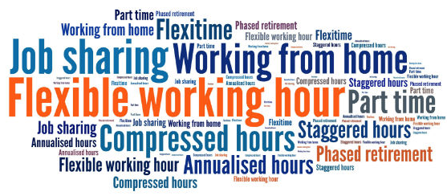
Figure 1: Flexible working
Source: (Bogardus, 2006)

Flexible working ensures diversity and inclusion at work
Diversity refers to the unique characteristics of employees who are different in terms of age, gender, ethnicity, education, religion, race, physical capabilities, and ideologies. Diversity allows for creating an inclusive working environment where individual differences have been appreciated. Through diversity, employees are enabled to use their full potential for organizational betterment and allow to achieve the highest organizational outcomes. According to Saxena (2014), workforce diversity is responsible to improve organizational productivity as it is a combination of different workforces, skills, and knowledge. Diversity has increased the competencies that make the employees more competent. A research study in 2020 has found that flexible working is responsible for improving diversity and inclusion that is related to dynamic work practice.
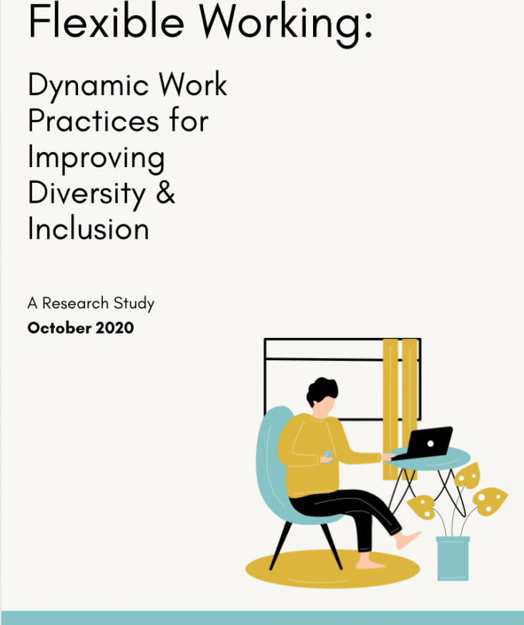
Figure 2:Flexible working
Source: (McNall et al., 2009)

Importance of diversity in the workplace
Human Resource managers have formulated different strategies and policies for improving workplace diversity in the organization. Diversity has enabled the organization more adaptable and consistent, increasing organizational growth and competitiveness. People have been considered the important powerhouse of business who are hiring from different work environments, cultures, and positions (Foma, 2014). The higher-level executives are found organizational success in a diverse workplace that is a dynamic issue and changing continuously. Below some benefits of diversity and inclusion are discussed that has explained the matters of existing diversity.
Performance of the employee: A study has conducted by Deloitte has found that higher diversity has developed higher employee engagement. The higher the employee engagement the higher the quality and quantity of work (Raewf and Mahmood, 2021).
Creativity and innovation: Diverse people have efficiency in a diverse segment that has benefited the organization to make better organizational decisions. Tesco has strength in diversity, it believes that talent and diversity are the two sides of a coin that has ensured the organization’s creativity and innovation.
Organizational revenue: Diverse working facility has enabled the organization to perform better and achieve higher revenue. Tesco has conducted a study that has concluded that the diverse leadership style has increased its revenue by 19% higher (Taylor, 2018).
Skilled and talented employees: Under diversity, different people are welcomed from different backgrounds that have made the recruitment process easier to collect skilled and knowledgeable employees. Diversity makes the availability of unique quality full employees that may help the organization to meet diverse goals.

Different types of diversity
Diversity has come from four different areas such as internal diversity, external diversity, organizational diversity, and worldview diversity. In this section the types of diversity have been discussed:
Internal diversity: Internal diversity has come from the birth of the people that have referred as demographic diversity. Gender, race, ethnicity, age, and physical ability are the internal diversity of the people (Torrington et al., 2020). Mastercard is an example of internal diversity that has been given to the employees according to their cultural background.
External diversity: Different characteristics of a person which are changed due to external factors are known as external diversity. Social status, education, socio-economic environment, geographic location, and family status are examples of external diversity. Kaiser Permente is a healthcare service that has represents 140 cultures through external diversity.
Organizational diversity: Diversity is the fact that has impacted the organization in terms of managerial status, seniority, gender, and trade unions. L’Oreal is a leading organization that has ensured gender equity by recruiting 53% of women (Patrick and Kumar, 2012). Now the organization has operated in more than 130 countries as an industry leader.
Worldview diversity: According to past experience diversity has shaped into different forms that appreciated cultural, and political beliefs. Organizations are enabled to maintain diversity through gathering experience. Marriot International Hotel & Resort is fostering workplace diversity by recruiting 174,000+ employees from different cultural backgrounds.

Role of Human Resources in promoting diversity and inclusion through flexible working
Diversity is an issue that is more than the moral factors of the organization. It has included the hiring, recruitment, and mentoring process of the employees of the organization. Today’s businesses are becoming more global with the availability of information. In this era of globalization, diversity has a great impact that provides the organization with competitive advantages that have untapped various opportunities for the company (Pilbeam and Corbridge, 2010). Below are the roles of Human Resource managers are described in promoting diversity and inclusion through flexible working.
Identifying diversity: Human Resources managers are responsible to create a diverse organizational culture where employees from different backgrounds have taken place. Managers will identify diversity to promote, grow, and contribute to better performance.
Monitoring diversity: For defining the actual or genuine picture or impact of diversity in organizational performance, it is important to monitor diversity with caution (Torrington, 2009). Managers will monitor diversity among current employees as well as the recruitment process.
Widening the pool of employees: Human Resources managers are responsible for building a diverse workforce through better recruitment and development processes. Building internal and external partnerships with different employee managers will make availability of talented employee pool (Patrick and Kumar, 2012).
Mentoring diversity: Mentoring is the process of observing employees both internally and externally. Human Resource Professionals may recruit school graduates and youth through mentoring diversity of culture and community.
Supplying diversity: For ensuring a good diverse organizational culture the managers will supply a wide range of employees from different regions, countries, ethnicity, and demography (Taylor, 2018). The availability of more employees from diverse cultures ensures the supply of diversity.

Case against flexible working in relation to inequity at work and the role of Human Resources in addressing it
Diversity in the workplace has benefited organizations through offering various opinions, ideas, and perspectives to solve different problems. It has enabled the companies to serve better services to reach new markets and gain competitive advantages (Timms et al., 2015). Although diversity booster employee performance through employee engagement it has various challenges. Let some of the challenges of flexible working has discussed below:
Communication barriers: Communication is a common term that has been used by all organizations to conduct their business activities. Diversity may create problems in communication due to language differences, ways of communication, or styles. For example, diverse-aged employees of the organization may face challenges where the older employee prefer a phone call or direct communication and the young employees prefer video conferencing or messaging (Armstrong and Taylor, 2020). Sometimes communication barriers have happened due to the diverse language of employees who are come from diverse cultures.
Cultural misunderstanding: Misunderstanding is a common phenomenon that has occurred in the organization due to cultural differences. When an organization has operated its operation with the help of a diverse workforce in that situation there may occur cultural misunderstandings. For example, thumbs up has been used as showing congratulations to others whereas other cultures have used it to ignore or demotivated individuals. Therefore, sometimes diversity can lead to various challenges.
Slower decision-making: Diversity has appreciated participating in the decision-making process. In the participatory decision-making process, the managers are responsible to listen to different opinions, ideas, and logic of different employees. The process of empowering employees and hearing their opinion has made the decision-making process lengthy which has slowed down the process of making decisions (Timms et al., 2015). As a result, sometimes organizations have missed different projects due to a slower decision-making process.

Figure 3:Challenges of flexible working arrangement
Source: (Wheatley, 2017)

Flexible working in relation to inequity at work
The flexible working arrangement has enabled the employees of the organization to work anytime from anywhere according to the interest of the employees. In the previous case, it has found that the flexible working arrangement has provided a wide range of facilities to the organizations (Wiesner and Millett, 2003). Along with a bunch of facilities of flexible working arrangements it has various challenges that have been discussed. Inequities refer to the unequal and unfair practice of organizations to the employees of the organization in terms of pay discrimination, working time discrimination, decision-making process, and career development process (Wheatley, 2017). Now a day’s organizations are investing more in flexible work arrangements for achieving better organizational success. But it has created inequities in most cases. In this section, the inequity of the workplace has been discussed in relation to flexible working conditions.
Developing employee inefficiency: Employees who are working in the organization for a longer period of time, have created a working environment. Due to the application of flexible working arrangements the employee has faced various problems that have occurred with the older teachers in conducting online classes. Therefore, the flexible working arrangement may reduce the efficiency of the employees of the organization which created inequity among the employees who are experts at a flexible working arrangement.
Discriminating in the workplace: In any organization, various types of employees are working such as part-time, full-time, project-based, hour-based, production-based, etc. The employees are different in terms of knowledge, experience, age, cultures, and many other things (Wangombe et al., 2013). Through the flexible working arrangements, all these employees have been considered under the same line although they have different qualities. Therefore, a flexible working arrangement sometimes leads to inequity in the workplace.
Standard of compensation: According to labor law, managers are responsible to pay a specific salary. Employees may achieve more compensation by working more but average employees achieve a specific salary range. Under the flexible working arrangement, some employees may enjoy the benefits of compensation with lower efforts that lead to inequity.

Role of Human Resources in addressing the concerns of inequity that may arise from flexible working
Equity in an organization refers to the relative distribution of power, authority, and resources in the workplace for achieving greater organizational success. Under the equity theory of management, Human Resources managers formulate a better working environment (Torrington et al., 2020). Managers of the organization have to be responsible to measure the loyalty, commitment, trust of the employees, and their hard-working tendency for achieving better salaries, benefits, rewards, and recognition. For reducing the inequities in the workplace, Human resource managers have to address and maintain different issues. In this section the roles of managers in addressing inequities are explained:
Use both traditional and non-traditional work environments: For getting the best organizational results and outcomes, the Human Resource managers have kept both the facility of flexible working arrangements and traditional office work. The combination of these two work environments may attract employees the most.
Work-based compensation system: In any organization, various types of employees are working under various working conditions. For reducing workplace inequity Human Resource managers are responsible to formulate a work-based compensation system (Raewf and Mahmood, 2021). Therefore, all employees get work relative compensation and interest towards work.
Arrangement of weekly meetings: Flexible working arrangements may isolate the employees from the organization. It may lose the employee relationship with colleagues and managers that leading to inequities. Human Resources managers may arrange different weekly or monthly programs to retain the rapport among managers and employees.

Conclusion
A flexible working arrangement has enabled the employees of the organization to work according to flexi-time, and Flexi-place (Armstrong, 2006). Through the flexibility of the organization the employees are being more productive, therefore, the organizational performance has been increased. The report has discussed various important factors relating to flexibility or the working environment and diversity in the workplace. The report has various important findings that may be used in managerial decision-making and in future research in similar sectors.

References
Allen, T.D. and Shockley, K., 2009. Flexible work arrangements: Help or hype. Handbook of families and work: Interdisciplinary perspectives, pp.265-284.
Armstrong, M. and Taylor, S., 2020. Armstrong's handbook of human resource management practice. Kogan Page Publishers.
Armstrong, M., 2006. Human resource management practice. Distributed Computing (10th ed.). https://doi. org/10.1002/9781118802717.
Bogardus, A.M., 2006. Human resources jumpstart. John Wiley & Sons.
Foma, E., 2014. Impact of workplace diversity. Review of Integrative Business and Economics Research, 3(1), p.382.
McNall, L.A., Masuda, A.D. and Nicklin, J.M., 2009. Flexible work arrangements, job satisfaction, and turnover intentions: The mediating role of work-to-family enrichment. The Journal of psychology, 144(1), pp.61-81.
Patrick, H.A. and Kumar, V.R., 2012. Managing workplace diversity: Issues and challenges. Sage Open, 2(2), p.2158244012444615.
Pilbeam, S. and Corbridge, M., 2010. People resourcing and talent planning: HRM in practice. Prentice Hall.
Raewf, M.B. and Mahmood, Y.N., 2021. The Cultural Diversity in the Workplace. Cihan University-Erbil Journal of Humanities and Social Sciences, 5(1), pp.1-6.
Saxena, A., 2014. Workforce diversity: A key to improve productivity. Procedia economics and finance, 11, pp.76-85.
Taylor, S., 2018. Resourcing and talent management. Kogan Page Publishers.
Timms, C., Brough, P., O'Driscoll, M., Kalliath, T., Siu, O.L., Sit, C. and Lo, D., 2015. Flexible work arrangements, work engagement, turnover intentions and psychological health. Asia Pacific Journal of Human Resources, 53(1), pp.83-103.
Torrington, D., 2009. Fundamentals of human resource management: managing people at work. Pearson Education.
Torrington, D., Hall, L., Atkinson, C. and Taylor, S., 2020. Human resource management. Pearson UK.
Wangombe, J.G., Wambui, T.W., Muthura, M.W., Kamau, A.W. and Jackson, S.M., 2013. Managing Workplace Diversity: A Kenyan Pespective.
Wheatley, D., 2017. Employee satisfaction and use of flexible working arrangements. Work, employment and society, 31(4), pp.567-585.
Wiesner, R. and Millett, B., 2003. Human resource management: challenges and future directions. John Wiley & Sons Australia, Ltd..

