Problem Solving and Decision Making

University of Wales Trinity Sant David

              - Student name : Daniela Vidrascu
              - Student number: 1817905
              - Module title: Problem Solving and Decision Making (BMSW4004_LON)
              - Assignment title : Problem Solving and Decision Making
              - Lecture’s name: Mushfiqur Rahman

Table of contents :
Introduction:……………………………………………………..…page 3
Define a complex problem ………………………………………...page 3
Analyse information on the identified problem…………………..page 4
Possible solutions: …………………………………………..…page 4 to 5
Use a decision-making technique……………………………….….page 5
Develop a plan for implementing the solution…………..……page 5 to 6
Communicate the plan to stakeholders………………………..…...page 6
Reinforcement………………………………………………….……page 6
Conclusion: …………………………..……………………………...page 6
Reference list ……………………...………………………………..page 7

Introduction:
In the UK there have been improvements in the subject of women’s rights since the 19’th century which greatly increased the equality in society and the workplace bringing many opportunities for women and elevating them in society. Nevertheless, the problem of discrimination still persists, even if it is not as obvious or direct like it was previously in written legislation, but it still a problem.
Women are facing discrimination due to the implicit bias based on societal perceptions, as well as the fact that companies can be hesitant in hiring women which might become pregnant leaving the company in need for a temporary worker and needing to pay statutory maternity pay, which even if is repaid by HMRC is still an immediate expense.
Pregnant women too can face hard work or unsupportive co-workers which can affect their and their baby’s health. (Salihu, Myers and August, 2012)
Women are vastly underrepresented in executive positions in companies, both foreign and domestic from thing like their perceived competency and existing structures dominated by men which are hard for women to get involved in due to a number of factors. They are also underrepresented in many specific industries and not necessarily because of their physical strength, but because of both previous and continuing discrimination.
Define a complex problem
The problem of discrimination against women in the workplace is complex and consists of many biases, many of which stem from the past and from the societal perception of women. For instance one bias can be that since women are the ones that get pregnant they can be prone to leave a position unfilled for the duration of their maternity leave, even if workers overall can quit their workplace at almost any time yet the bias against women still remains, especially since it stems from the previous role that society placed historically upon women- caretakers of children and home. Ignoring this is also an issue as too much hard work alienation from co-workers and management can lead to worsening health of the pregnant woman and the baby. (Kokot, 2015)
Another bias which specifically can pertain to the advancement of women in the workplace, and especially to executive roles dominated by men is the perceived lack of authority of women and their more feminine weakness of character, leading companies, especially foreign ones from less progressive countries to give men more opportunities towards advancement and more support when they become executives, as opposed to women who have a harder time forming a support structure in such positions. (Schwanke, 2013)
Some sectors of the economy have also increasingly become perceived as jobs dominated by and mostly approachable to men, which in turn compounds to a lack of role models to otherwise encourage women towards these careers, like jobs in programming and the tech sector in general (Armstrong and Riemenschneider, 2014), even if they started out with a higher percentage of women, which greatly affected and continues to affect the potential of the sector for Britain and the world in general. (Hicks, 2017)
Employability in general is lowered by the existing stereotypes and biases that women perceive which lowers their self-esteem, confidence and perceived employability. (Owuamalam and Zagefka, 2014)

Analyse information on the identified problem
Many of these problems stem from long held societal beliefs that are still prevalent ever the feminism movements of the 20’th century and they still influence working culture and hiring and advancement decisions for the employment. For instance if a woman wishes to advance to an executive position while it is not impossible it is much harder for her to enter the already existing social circles of mostly men and also harder to make connections for support in such an environment.
An example for the entire sectors that are already male dominated stem from both societal and structural reasons. Extrapolating on Armstrong and Riemenschneider, 2014, we can assume that in many other male-dominated sectors of the economy the disparity between genders can be explained by societal and family-work relations and expectations as well as a lack of material and role-models for women wishing or having an inclination towards those field which statistically makes them look for other field of work.
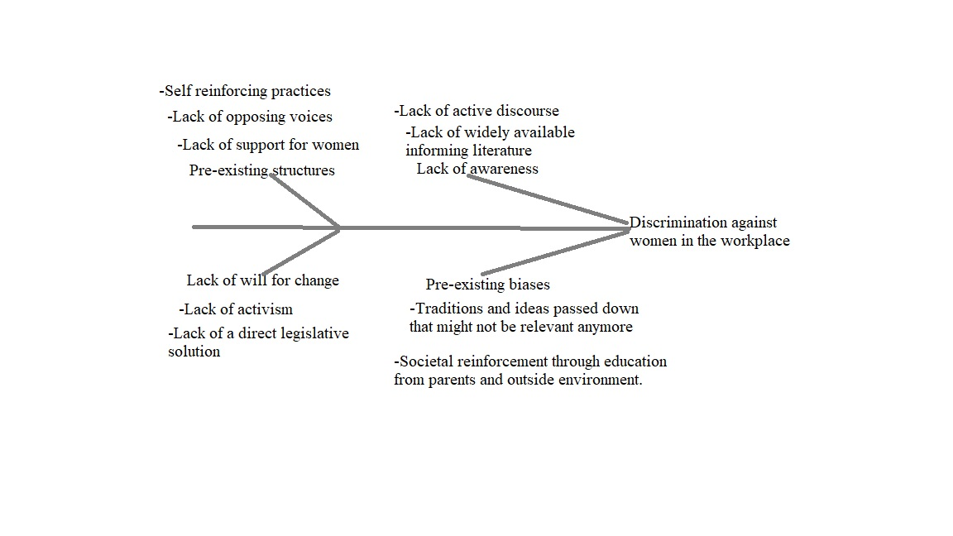
Possible solutions:
While in previous movements for equality in the workplace and society for women there was existing and far more obvious discrimination, stemming even from government policy, the current problems are far more subtle and require understanding implicit bias that the current systems of the workplace can have against women and which are fuelled by different preconceived notions that may otherwise seem natural and harmless. Because of this the solutions are not as obvious and are mostly about awareness spreading, which can be done through social media and traditional media but also more locally in a workplace through company seminars and information spreading, this would in turn slowly change the perception of women in society and the workplace. This information campaign shouldn’t just be for men but also for women who can also internalize the biases and hold themselves back due to them, though to a lesser extend as UK women are understanding of the constraints of the current status quo, at least when compared to those from Germany (Kokot, 2015).Notwithstanding this the faster solution would be government action towards a more equal workplace, and while some is in place there are still ways in which government action can be useful and even required. For instance, in protection for pregnant women in the workplace, in the interests of their health, or in programs for advancement of women in different spheres of the economy that are more approachable for them.
All of this is based around change in the societal perception for the ability of women in the workplace.

Use a decision-making technique
The decision towards which level of investment must be made into this subject is complicated, because, while there are many rewards for resolving this problem, including a fairer society, more innovation in thanks to a more diverse workforce in the affected areas, more productivity and a larger worker pool, there still needs to be a discussion over how the solution must be implemented. For instance one can argue that it is not cost-efficient for the government to try to enforce equality through policy, nor does it address the underlying reasons for them, but it would still be beneficial if the government encouraged the information campaign, either through exposure and advocacy, or through financial help, or both.
Naturally the biggest burden would fall on the number of organisations which will spread awareness and try to help address the biases that are present in the workplace based on case by case basis, as some workplaces might already have progressive understanding but just lacked the initiative to implement them into more equal policies, but these organisations should also have the support of the people.

Develop a plan for implementing the solution
The current situation in many workplaces in the UK is that women are mostly perceived as equal to men in performance and generally in most but a few crucial aspects. It is these perceptions that need to be targeted through awareness campaigns for the workers and management, though some problems do require solving by the state offering better protection for, for instance pregnant women. In the transitional state there would be implemented the information campaign but there would probably be many who would resist to the need for change for a variety of reasons from the dislike for introspection needed to overcome a bias to traditional values about women’s role in the workplace. Still it is crucial to overcome these problems as they can greatly improve the workplace equality which in turn improves worker happiness and productivity and gives a bigger pool of people to choose for important positions based on ability and not blinded by preconceptions. On the other hand ignoring these can lead to the particular industry becoming far less relevant in Britain, as seen in history with computing, which was highly advanced in World War 2 and its’ decline in the UK due to sexism against its’ majority woman workforce. (Hicks, 2017).
The final stage should bring about a more equal, productive workplace with a bigger pool of talent, ideas and perspectives for the company and society as a whole, with much of the biases gone and a far more flexible and harmonious workforce.
Communicate the plan to stakeholders.
The stakeholders affected can be all personnel within a company as well as the media view of that company and even the government if it holds a stake in it, though depending on the sector the policies can be more focused on the employers and executives in a company. Using the AKDAR model it is needed to make them aware of the existing problem and the inefficiency it causes within the workplace by not equally evaluating all workers. They must be shown the advantage of a more equal workplace as one being more harmonious, productive and flexible which serve as incentives to increase equality. The knowledge of the biases they could hold must be made clear to them and ways in which they can improve and overcome these biases through empathy, understanding and psychology are required. Obviously, barriers such as traditionalist thinking may inhibit ability to change in the short term, but they can be overcome as shown in history again and again.

Reinforcement

Finally, there have to be implemented ways in which to review and reinforce the behaviours which will stop this problem. For instance, statistics on the number of women and men in the workplace can be used in order to ensure that a company’s hiring and promotion is equal within an acceptable margin. This can be done with feedback and statistical analysis:
- Feedback from the female employees done through surveys by third parties with no involvement in the workplace can be used to get their overall feeling in the company, and a way to get individual feedback from individuals who feel they might be affected are very important.
- Analysis of the workplaces done in a case-by-case basis would also need to be done to show statistically that through awareness the divide between genders becomes either non-existent or a statistically counted as a rounding error that can be explained without discrimination.

Conclusion:
In conclusion, I think that while the problem of female discrimination in the workplace exists in a smaller proportion to how it was before, the current problems that still do exist and the biases that remain from that time and that continue to inform decisions for many workplaces should be solved through an awareness spreading and information campaign and some minimal government involvement, because it will bring about many positive effects for the individual workplaces and for society as a whole.

Reference list

Armstrong, D. and Riemenschneider, C., 2014. The barriers facing women in the information technology profession. Proceedings of the 52nd ACM conference on Computers and people research - SIGSIM-CPR '14.
Hicks, M., 2017. Programmed Inequality.
Kokot, P., 2015. Let's talk about sex(ism): Cross-national perspectives on women partners’ narratives on equality and sexism at work in Germany and the UK. Critical Perspectives on Accounting, 27, pp.73-85.
Owuamalam, C. and Zagefka, H., 2014. On the psychological barriers to the workplace: When and why metastereotyping undermines employability beliefs of women and ethnic minorities. Cultural Diversity and Ethnic Minority Psychology, 20(4), pp.521-528.
Salihu, H., Myers, J. and August, E., 2012. Pregnancy in the workplace. Occupational Medicine, 62(2), pp.88-97.
Schwanke, D., 2013. Barriers for women to positions of power: How societal and corporate structures, perceptions of leadership and discrimination restrict women’s advancement to authority. Earth Common Journal, 3(2).

