

Assessment 1 – Reading Task Template
PART 1: Upload your photo of your A3 in-class notes here:
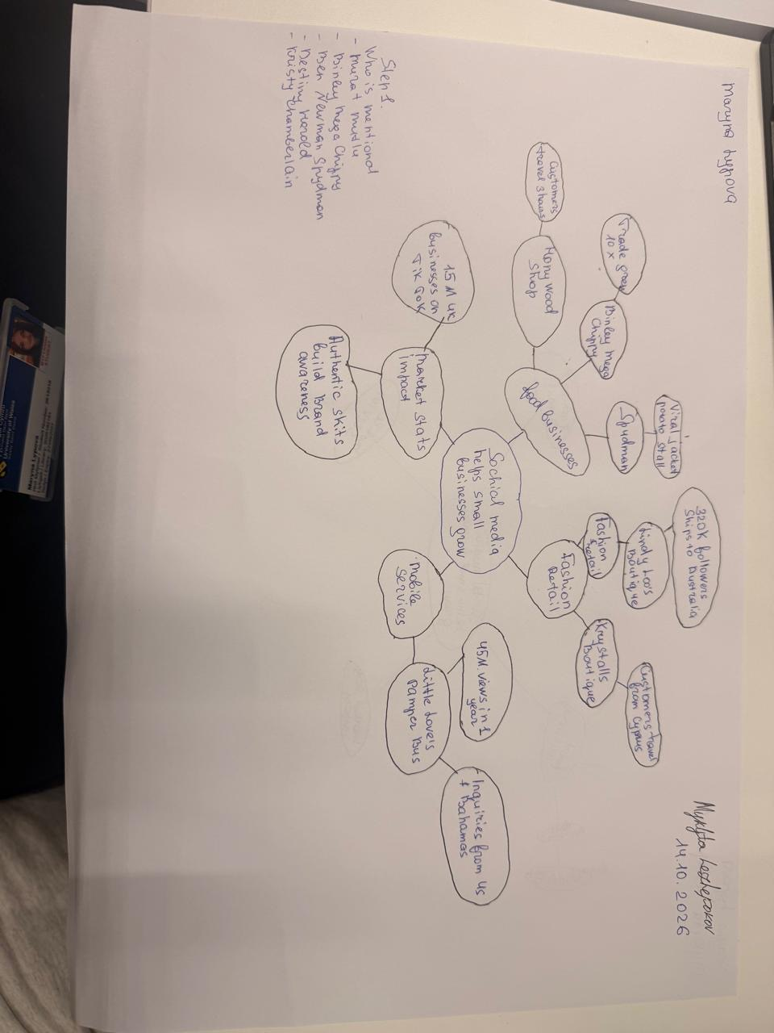

PART 2:
- Answer every question below in 1-3 full sentences.
- Use your own words. Do not use generative AI to answer these questions.
- Include a specific detail from the text when asked.
REMINDER
- The main idea is the overall message of the whole text.
- A key point helps to explain the main idea.
- A specific detail or example from the text shows that the key point is true.

- What is the main idea of the whole text?
The core message of the article is that viral engagement on social media networks such as TikTok and Instagram serves as a powerful catalyst for small business growth. By capturing online interest , local enterprises can dramatically expand their reach , gain widespread recognition , and turn digital views into physical footfall .

- What is one key point that supports the main idea, and which specific example from the text shows this?
One major point supporting this idea is that going viral can lead to a massive , immediate surge in customer demand and revenues . The text illustrates this through Binley Mega Chippy , a fast-food shop that experienced a tenfold rise in trade purely due to popular videos circulating online.

- What is a different key point that supports the main idea, and which specific example from the text shows this?
Another supporting point is that social media content can motivate people to travel long distances specifically to visit a local store. This is demonstrated by Krystalls Boutique, where teenagers made trips from overseas locations like Cyprus and the Channel Islands after discovering the shop's funny skits on TikTok.

- Which part of the text do you think is most important, and why?
I believe the most crucial section is the conclusion focusing on how "people buy from people," which highlights the value of authentic, humorous, and relatable posts over hard sales pitches. This part is essential because it explains the underlying reason why short-form user content successfully persuades modern audiences to become paying customers.

Reflection:
- What did you find difficult in this task (including in-class components), and why was it difficult?
The main difficulty I faced was narrowing down the extensive case studies in the article to select just one clear, distinct example for each point. It was also challenging to rephrase key findings in original wording while maintaining technical accuracy.

- What helped you with this difficulty, and how did it help you?
Reviewing the visual notes and mind map created during class allowed me to organize the information logically before writing. This preparation enabled me to filter out unnecessary details and focus on formulating concise, well-structured sentences in my own words.

