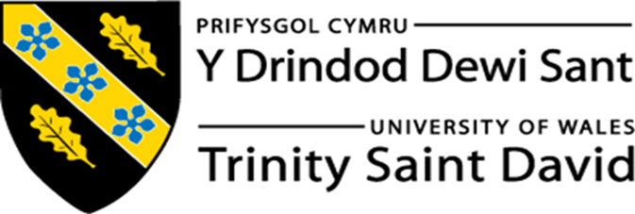

“How do broader external environmental factors along with COVID-19 affect organisational culture and its performance?”
based in MITIE Security

Student Name: Antonio Brian Fernandez Ramos
Student Number: 1818212
Module Number: BMSW5105
Module Title: Workplace Culture and its impact on Organisational Efficiency
Lecturer Name: Dr. Syed Jaffery
Executive Summary
The report is based on the changes, which the selected company, Mitie Security has been experiencing in their operating environment due to the pandemic Covid-19 outbreak throughout the operating environment. The company is facing an altered working pattern due to this situation, which must be managed by taking proper leadership and managerial intervention. This is done with the theoretical background in this context, which highlights the way that can be taken to withstand the condition. Based on the theoretical approach, the possible organisational strategies can be identified, which would help in abiding by the negative impacts associated with the business.

Table of Contents

1. Introduction 4
2. Management theories/ models/ methods/ environmental scanning tools 4
3. Functions and application of theories and methods applied 10
a. Application of above theories 11
b. Using environmental scanning tool, critical evaluation of broader environment of how the organisation operates, and affect organisational culture and performance 12
4.Development of cultural and ethical standards, values and belief of MITIE Security 14
a. Extent organisation’s present cultural and ethical standards help to attain the corporate objectives 14
b. How personal standards, values, and beliefs of most employees are sustainable 15
c. How the above aspects can help to attain corporate objectives and social responsibilities 16
5. Conclusion 16
References 17

1. Introduction
Mitie Security is a security company that deals with UK’s leading facility management and other professional services. It has around 47,500 employees with 30+ years of experience. As it has been founded in 1987, they take into account of the customer’s people and building to deliver key basics by deploying advanced technology (Mitie, 2020). The company is known for its exclusive security services for the customers, and it has already worked as security officers and CCTV operators in the security industry. The report is based on the impact of Covid-19, which has been fallen on the company in its organisational culture. The organisational culture can be influenced by the external environment of the company, on which the pandemic situation is imposed. It has changed the activities of the corporate world, which are assessed in this report.

2. Management theories/ models/ methods/ environmental scanning tools
Management theories
Contingency theory
As mentioned by Wadongo and Abdel-Kader (2014), the contingency theory is an organisational theory, which claims that there is no proper way to organise the cooperation level within a company. The way to lead the company and make the decision for any action would not be done, though the optimal course of action can depend on external and internal actions. It is an exclusive approach of leadership and it is probably the best way to lead a company (Granlund and Lukka, 2017). While dealing with the business environment of an organisation, often there come too many constraints, both internal and external way, which can alter the situation of operation. According to Otley (2016), it can be controlled with proper management intervention, through which the company can set up the action plan to handle this. It can come with leadership action that can help to sum up the situation.
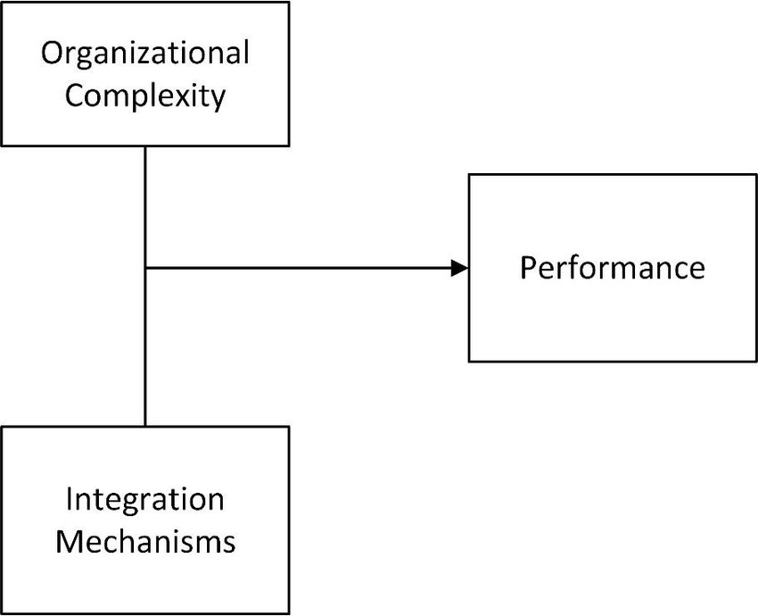
Figure 1: Contingency theory
(Source: researchgate, 2020)
The contingency management theory that can be applied in this case would cater several benefits to the company in different ways. The main aspect here is that it includes both management and leadership intervention together (Shen et al. 2020). This model is particularly suitable for the change management purpose, as the principle states that there is no proper and optimal organisational management plan, which can be used in the improvement of operating program. Thus, it must be changed whenever situational shortcomings rose. As opined by Qin et al. (2020), the situational shortcomings, which the company is presently observing are making constraints on the performance level. The leaders and management must take proper steps so that they can perform even without a proper workplace infrastructure for work.
Scientific management theories
As mentioned by Derksen (2014), the scientific management theory analyses and synthesizes the workflow. It is related to the organisational performance level, as it helps in improving the economic efficiency level of the company. It is mainly focusing on the labour productivity of the organisation, which is the earliest attempt to apply the science of management. It is focused on the belief that making someone work is hard, as they could not efficiently optimize the way of work (Caudill and Porter, 2014). It includes the principles, which guides the individual to perform the delegated task properly, even under some difficult situation. According to Ketokivi and Choi (2014), the theory discusses the economic efficiency of an organisation is highly related to the performance indicator, which must be managed with the proper managerial approach. Scientific management helps in identifying each of the factors that allow efficient management of economic development.
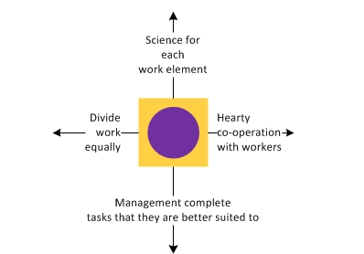
Figure 2: Scientific management theories
(Source: Taylor's Scientific Management, 2020)
The scientific management theory can also be used in context on the operational management under the pandemic situation (Kumar et al. 2020). The employees, who are working within the company, are facing several troubles, among which least scope of direct communication is involved. The delegation of tasks and navigating the employees are responsible in this context, which is related to the performance level of the employees. The theory can be used in minimizing the impacts by ensuring a proper mode of communication with them through a proper technological interface. The as opined by Gumus et al. (2020), this can be a difficult task for the company, and thus, management intervention is required. However, the leaders can also be involved in this phase, so that the entire operations remain successful in all aspects.
Management model
Edgar Schein Model of Organization Culture
As mentioned by Ahmed and Shafiq (2014), this model of organisational culture proposes a framework, which is based on some preliminary assumptions. These are required for shaping the values of the company, and it shapes the practices and behaviors within the company. These are found as a visible part of the organisational culture. Organisations rarely follow the culture within a single day of introducing this; rather they follow the experience before adopting this (Cacciattolo, 2014). The company once finds it suitable for the objectives, they start practicing this in regular tasks, and gradually it implemented in the corporate culture of the company. According to Schein (2015), the theory describes that the organisational culture results from a different level of practices, which comes suitable for them. The company practices a particular model for organisational culture, which they discover beneficial for them, and impose a minimum negative impact on them.
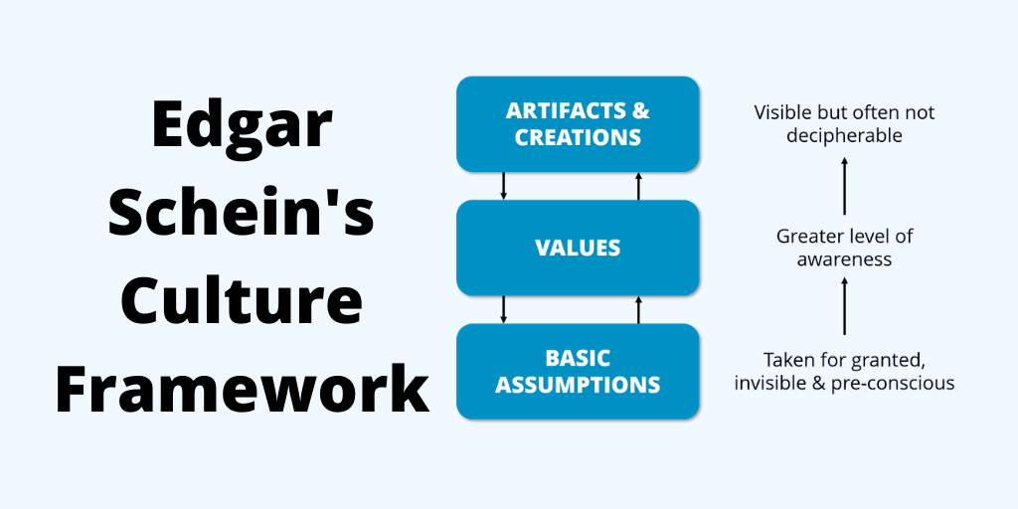
Figure 3: Edgar Schein Model of Organization Culture
(Source: think-boundless, 2020)
As opined by Cacciattolo (2014), the Edgar Schein Model of Organization Culture can be followed in an organisation to identify the organisational culture, which can be followed during the pandemic situation of Covid-19. This outbreak of the lethal virus all over the world has made a huge alteration to the business environment. The employees of the company are now working in such a condition, where they are not getting enough support from the organisational infrastructure (Ahmed and Shafiq, 2014). The office infrastructure, which the workforce follows now, is not matched with the traditional approach of the company, though it includes some benefits for them. According to Cacciattolo (2014), the approach is making some positive and negative impacts on the operating environment of the company, and thus, it can be included in the organisational culture, after checking its long-term impacts on the company.

Management methods
Lean method
As mentioned by Charron et al. (2014), the lean management is an approach to manage the organisational performance level. It supports the employee base and others for continuous improvement, which is a long-term success strategy for them. It helps to run the operations systematically by introducing some useful changes within the operational environment. In this case, the management intervention is required as it seeks some small and incremental changes in the ongoing business activities, through which they can improve the efficiency level of work and quality (Tortorella and Fogliatto, 2014). It is mostly required when the company is undergoing some change process in their business that helps in keeping the progress on track. According to Arunagiri and Gnanavelbabu (2014), it is an important way, which can be followed in the organisational context, to help the employees to perform better without losing integrity, whenever any issue arises in the operating environment.

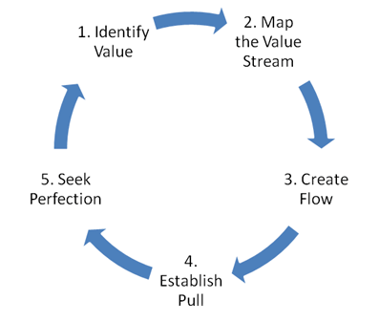
Figure 4: Lean method of management
(Source: Principles of Lean, 2020)
Management is another important method, which must be considered with a proper action plan, as mentioned by Dwivedi et al. (2020), the management approach for the organisational context should be considered cautiously so that it can cater to the continuous development of the company. In a company is facing an issue to continue the actions during the pandemic situation, and most of these are coming from the change in artifacts and working infrastructure. In this case, both external and internal environmental factors are contributing to the development of the alteration in the operating sector of the company. The efficiency level of employees is making a burden on the performance level of the company (Søreide et al. 2020). Thus, it should be taken into consideration, by which proper performance level can be achieved.
Environmental searching tool
PESTEL analysis
As mentioned by Gregorić (2014), the PESTEL analysis helps get an overview of the external environment of an organisation on which it is operating its business. The external environment includes some factors, like political, economical, social, technological, environmental, and legal domains, from which the overall business can get huge influence. These factors generally remain uncontrollable for the company, and thus, the result, which they face, often makes some shortcomings to the company due to the uncertainty (Pan et al. 2019). This analysis gives a framework for the company to monitor the macro-environmental forces for the operating environment. These forces help in determining whether the company is operating its business in a favorable environment or not. According to Song et al. (2017), the PESTEL analysis is required for the marketing department of the company, along with the managerial domain, to control the negative forces coming to the company.
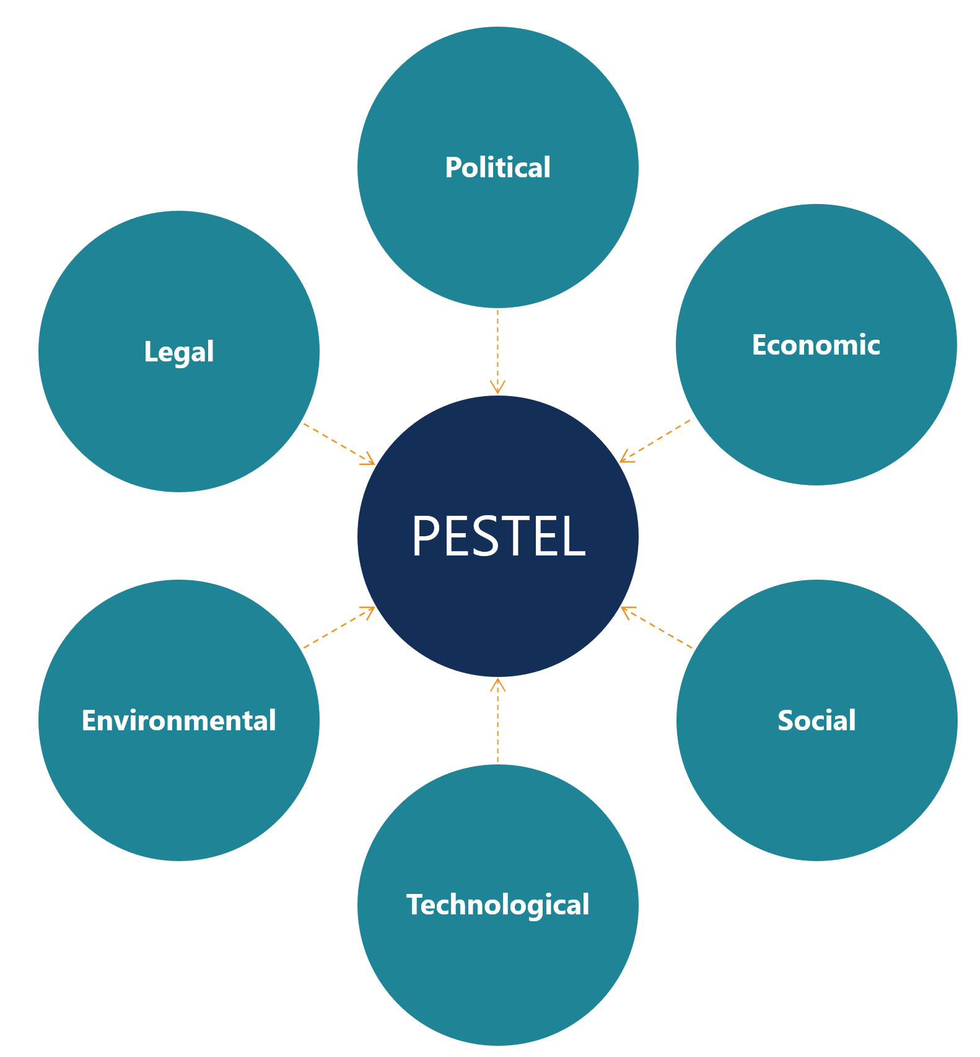
Figure 5: PESTEL analysis
(Source: Corporate Finance Institute, 2020)

3. Functions and application of the theories applied

a. Application of above theories
Contingency theory
As opined by Granlund and Lukka (2017), in case of Mitie Security, the situational shortcomings come with the external environment, as the Covid-19 pandemic situation has been changed the corporate world completely. The working style of the employees has been changed a lot, and it has come with a huge alteration in workplace. Instead of the organisational workplace infrastructure, it started penetrating the home also. This new corporate culture and conduct bring several challenges along with opportunities, which come within a very brief period (Wadongo and Abdel-Kader, 2014). It increases over time and the individuals have to adopt these changes for a long. Even, there is no such idea to terminate this situation and return to life before the pandemic. According to Mikes and Kaplan (2014), these changes require some managerial intervention, for which a proper guideline is required to withstand the situational shortcomings and help positively.
The external environment of Mitie Security is making a huge impact on the performance level under the Covid-19 pandemic situation. The managerial intervention can be taken into this account to minimize the negative issues, which have been fallen on them. The main aspect, which is observed in this case, is the altered nature of the operating environment. As mentioned by Shen et al. (2020), the situational shortcomings have been made a huge alteration in the organisation, which must be changed with proper mitigating actions. For example, the employees are now detached from the corporate culture, though they are performing similar operations. In this case, the management must take the steps, with proper leadership intervention. In this case, the constraints, which come to the performance level must be minimized (Qin et al. 2020).
Scientific management theory
As opined by Caudill and Porter (2014), the scientific management theory is used for ensuring the engagement level of the employees at a different level. During a pandemic situation, this theory can help engage the employees in their respective tasks. The economic efficiency is highly dependent on the labour productivity of the company, which is drastically declined during the outbreak of Covid-19. Mitie Security is facing trouble under this situation, as they are not getting their employees aligned for the task (Derksen, 2014). The navigation of the employees and supervising their actions remain difficult for the company, for which they need the support of this management application. According to Toma et al. (2014), in this theory, the management can influence the employees by delivering guidelines to them for optimizing their productivity level. The management simplifies the work for them so that they can uplift their productivity.
The management of the company is facing some issues, which can be handled with scientific management theory. As mentioned by Kumar et al. (2020), this particular approach is taken in the context of improving the productivity of the employees and so do the economic performance of the company. Hence, this can be an effective approach, which the management can introduce to control the shortcomings, which are coming from the external environment of the company. The delegation of tasks often sorts out the issues and ensures better productivity, thus, it is related to the performance indicator of the company (Gumus et al. 2020). This model is exclusively useful for the individuals, so the economic wellbeing can be ensured.
Lean method
As opined by Hihnala et al. (2018), lean management is exclusively required for Mitie Security to track the performance of the employees. The company is facing a serious issue with the workforce under the pandemic situation because the employees are now working in such an interface, where least organisational infrastructure is present. It is making issues in navigating the performance of the employees and managing them accordingly. The employees now work bustling in the workplace, which is replaced with home offices (Charron et al. 2014). The changes would last for a long, and thus, it makes some corporate change in cultural integrity. According to Tortorella and Fogliatto (2014), the changes bring some challenges and risks to the management bodies, to run the business differently. Under this condition, crisis management can be done by using this management model, which will deliver a strong focus on organisational culture and performance.
In managing this shortcoming due to the Covid-19 outbreak, lean management can be used. This is an interesting approach for Mitie Security, as it helps in delegating all the resources properly. This is helping to assure the improvement in the performance level, in terms of employee productivity and the workforce quality, based on which the Mitie Security can move towards betterment of efficiency level. As opined by Søreide et al. (2020), the delegating of tasks according to the ability of the employees would be beneficial for using the resources properly. The corporate change implementation can be done easily in this way, where the model would deliver support to Mitie Security for withstanding the situational shortcomings, which they face during this pandemic situation from the external operating environment (Dwivedi et al. 2020).

b. Using environmental scanning tool, critical evaluation of broader environment of how the organisation operates, and affect organisational culture and performance
As opined by Pan et al. (2019), Mitie Security is applying this framework for analysing the external environmental forces to identify the condition of the operating environment. The political factor, in this case, is not favorable for them, as the pandemic situation makes multiple restrictions for the operating environment. The economic condition of the company is completely shuttered now, due to the changed working pattern of the office. The employees are working in such a condition, which ensures the ongoing nature of the business, but rarely contribute to the growth of the company (Gregorić, 2014). The social factor is also imposing a negative impact on Mitie Security, as the altered working pattern has declined employee morale. The technological interference is somewhere beneficial in this case, as the operations require strong technological integration. According to Andrei and Prisecaru (2014), the environmental shortcomings due to a pandemic situation impose legal barriers.
The PESTEL analysis of the company Mitie Security showed some factors, which impose both positive and negative influences on the performance level of the company. It has been identified that the political impact under this pandemic situation presently comes at a moderate level. According to Bauer et al. (2020), the government intervention is taken to minimize the risks associated with the pandemic condition, and it imposes some policy to make the condition stable. The political condition of the operating sector of Mitie Security is somewhere stable for them because this pandemic situation is not making any dilemma in the political environment (Majowicz, 2020). Though the government interventions are somewhere taken to minimize the impacts, these are not making any significant negative issues for them. According to Fonseca and Azevedo (2020), the economical condition is facing a dilemma, because at the initial stage of this pandemic condition, the operating sector of the selected organisation had been shuttered. The present condition is also helping them to sustain the ongoing situation, but it is not making enough contribution to improving the overall economical condition.
According to Tomé et al. (2020), the economical condition of the market is declined due to the Covid-19 impact, and it rarely shows any growth in the last 4 years. Though there is a consistent growth rate in the economy, the contribution of this growth is very small. The investment for the business venture in the company is reduced, and thus it negatively affects the performance level. The productivity level of the employee base also gets downward, which affects the economic improvement of the company (Bauer et al. 2020). Even, some business activities were shuttered at that phase. The social factor is making a mixed impact on the performance level of Mitie Security because the biggest impact of the pandemic has been fallen from this domain. The employees are no longer able to continue their normal working pattern, and this altered work pattern has changed the efficacy level of the workers. According to Majowicz (2020), it makes several challenges in the social sector of the company, which destroy employee morale and performance. It makes a visible impact on the productivity of the company.
During this pandemic situation, the technological factor has improved a lot. The outbreak of Covid-19 in the operating market of Mitie Security has made a positive change for them. The present condition has made such a situation, where the employees are remaining integrated towards the company only with technological advancements (Islam, 2020). This is supporting the employees to remain together and connected with the organisational architecture. According to Rakshit and Paul (2020), the employees, who work for the company in the home atmosphere, follow the Information and Computing Technology or ICT, which is improving the technological condition for the company to withstand the e-activities and e-commerce. The tech sector seems not to have any negative impacts on company performance, mainly through online communities. The environmental force is somewhere contributing in this regard. The environment under which Mitie Security is operating is working to make interrelated impacts. According to Bauer et al. (2020), the environmental impacts make relevant practice in the legislation and environmental effects that are observed as both socio-cultural and human-health impacts, in respect of core infrastructure of the company.
The environmental impact of Covid-19 has made a mixed impact on the performance level of the company. The company is operating in such an environment, where the environmental concerns towards the stability of the operating sector have been followed. The employees are working in such a condition, where they get the least communication with the coworkers and other individuals apart from the office infrastructure (Rakshit and Paul, 2020). The proliferation of some substances is found working at that time, which makes the activity proactive for the public domain. According to Islam (2020), the legal framework of the company under the Covid-19 outbreak is not making any favorable scope for them. The company is undergoing such a situation, where they face too many legal barriers. The government interventions have been introduced to restrict the overspread of the pandemic situation, and it is affecting the workplace artifacts. This is altering the employee morale and workplace integrity, through which they can perform better. According to Fonseca and Azevedo (2020), the legal framework is making a strict operating sector for them in a pandemic situation, which is making negative influences.

4. Development of cultural and ethical standards, values and belief of MITIE Security

a. Extent organisation’s present cultural and ethical standards help to attain the corporate objectives
The organisational culture is a significant factor, which is helping to make a direction for the workforce. The culture defines the process and purposes of the operations, which are followed within the company. It motivates and inspires the employees to remain more engaged in their respective tasks. According to Driskill (2018), it includes some features, which collectively define the cultural set up of the company. The culture is often constructed with several external forces that are influencing the performance level. The values and artifacts are helping in this case to denote the engagement level of the employees towards productivity. The organisational culture is somewhere important to develop a strong connection to an organisation and it makes an atmosphere to cater positivity. As opined by Chowdhury (2018), the culture is responsible for developing the environment for organisational setup, on which the company is working. It is based on some external forces, and the situational shortcomings are helping them in developing a new cultural domain that can make both positive and negative impacts for the selected company (Driskill, 2018).
The organisational culture of Mitie Security has been changed in the present time due to recent pandemic attack of Covid-19 throughout the operating market. Due to this, the organisational set up for the employees has been changed largely. According to Chowdhury (2018), the employees are recently working in a home office set up, which is not suited to their existing organisational culture. They rarely get any chance to communicate directly with coworkers, and this destroys the morale of the employees (Chowdhury, 2018). This is hampering the existing organisational culture and thus it affects negatively Mitie Security setup. The navigation of employees for their tasks remains difficult for the management, and it makes poor conduct in performance. As mentioned by Driskill (2018), as the performance is hugely dependent on organisational culture, this altered working feature is responsible for such a dilemma in the company. The nudge behavior and decision-making step are getting complicated at that time, and the avoidance of direct communication develops a new cultural approach within the organisation, under the new situation on different stakeholder levels.
The organisational culture that is followed is the Edgar Schein Model of Organization Culture, which states that the cultural domain within the operating sector is not determined within short notice (Chowdhury, 2018). The impact, which has been fallen on Mitie Security due to this pandemic situation, has altered the traditional approach. The existing cultural perspective changed a lot, and hence, there comes a chance to determine a new plan for a better cultural approach. According to Chowdhury (2018), this can be done by observing the impacts of the new workplace model, in which the employees are working at their home set up and face minimum organisational interference. This is making a serious issue for the company, though the company becomes able to continue the work without making many issues. This helps in completing the tasks without making physical and direct communication and conducting the operations only with the help of technological innovation. As mentioned by Driskill (2018), the new setup is making both positive and negative effects on the company, which must be considered in cultural decision-making.
The company can decide the cultural application for the employee base, which should be followed in the operating sector, must not be based on the observed result (Driskill, 2018). The outcomes of the strategic approach make both positive and negative impacts and these must be analysed thoroughly before integrating it into the action plan. According to Chowdhury (2018), the theory suggests that the organisational culture is not set up with short-term results, rather it should be considered for long-term goals. The management bodies of the company must analyse whether these intervening steps can be able to provide long-term success for Mitie Security. The challenges, which they observed in their company due to this altered workplace and orientation, should be taken to focus on culture development. As opined by Driskill (2018), the records of the company should be taken and compared to check the compatibility of the adopted steps. Only after finding the suitability of the plan for the long-term goal achievement, these could be introduced in the crisis management and corporate cultural integrity, rather than taking its extraordinary outcomes.

b. How personal standards, values, and beliefs of most employees are sustainable
The employees presently are working in a different environment. The “new normal” of the operating sector that Mitie Security is facing comes with legal and government announcements, in which a strong restriction has been made on the corporate conduct. The environment is however challenging for them because they are not getting a suitable infrastructure for continuing the tasks. The workload in this case increases on the workers, and their workplace is replaced largely. Both of these are not compatible with the employees, and they need to adopt a lot in this situation. The changes that they face are somewhere beneficial for them because they can work at their pace through the challenge comes to conduct the task without direct communication (Driskill, 2018). The technological intervention supported them a lot, but navigating the employees and supervising them in tasks remain difficult for them. The corporate culture also altered hugely during the pandemic situation, and it is supposed to be last for a long time, as there is no proper information about ending the situation. Hence, the changes should be adopted by the employees as early as possible, as the chance of not introducing the change in existing corporate culture exists instead of its suitability.

c. How the above aspects can help to attain corporate objectives and social responsibilities
The above aspects can be introduced in the corporate culture of the company Mitie Security because these are helping them to continue the benefits for a long time. It has been found that there is no such evidence of getting rid of this pandemic situation, and it is unknown that how much time it will take to return to the life exactly before this pandemic situation. Thus, employees need to adapt to these changes. The shortcomings can be observed in multiple ways, as they are now working without the office infrastructure (Chowdhury, 2018). It has been replaced with home offices, where the domestic set up are introduced in serving the corporate goal. These changes are long lasting for Mitie Security, though there are some issues, such as low employee morale, poor conduct, and ineffective integrity, and so on. Thus, the leaders must make a mind set up to integrate these changes in the operating sector to achieve the desired opportunities from this (Fonseca and Azevedo, 2020). The challenges must be addressed properly so that these can be managed properly in the future action plan to get the opportunities from the changed pattern of action. These steps can be attained to achieve corporate objectives.

5. Conclusion
It is concluded that the external environment is making several impacts on the performance level of the company, which is influencing the performance level. In this case, the selected organisation Mitie Security is facing these environmental impacts on its performance level, which is influenced after the pandemic outbreak of Covid-19. The impact can be fallen on the cultural perspective of the company, which can be observed in terms of management intervention. The report highlights the evidence, which is discovering the forces that are operated through proper management intervention. In this case, the management theories and models are integrated into making analysis of the operating environment, so that a better intervening result can be obtained. The cultural domain of Mitie Security faces the external environmental forces, which guides it to develop a certain strategic approach for the employee base, which can help in withstand the situation.

References
Ahmed, M. and Shafiq, S. (2014) The impact of organizational culture on organizational performance: a case study on telecom sector. Global journal of management and business research. Pp. 17-23
Andrei, V. and Prisecaru, I. (2014) The use of PESTEL analysis in development of the Romanian geological repository.''. UPB Scientific Bulletin (Series C), 76, pp.247-254.
Arunagiri, P. and Gnanavelbabu, A. (2014) Identification of high impact lean production tools in automobile industries using weighted average method. Procedia Engineering, 97, pp.2072-2080.
Bauer, L.B., Bloch, D. and Merkert, R. (2020) Ultra Long-Haul: An emerging business model accelerated by COVID-19. Journal of Air Transport Management, 89, p.101901.
Cacciattolo, K. (20140 Understanding organisational cultures. European scientific journal, 2(1), pp.1-7.
Caudill, H.L. and Porter, C.D. (2014) An historical perspective of reward systems: Lessons learned from the scientific management era. International Journal of Human Resource Studies, 4(4), p.127.
Charron, R., Harrington, H.J., Voehl, F. and Wiggin, H. (2014) The lean management systems handbook (Vol. 4). CRC Press.
Chowdhury, M. (2018) Emphasizing morals, values, ethics, and character education in science education and science teaching. MOJES: Malaysian Online Journal of Educational Sciences, 4(2), pp.1-16.
Corporate Finance Institute (2020) PESTEL Analysis - Corporate Finance Institute, Corporate Finance Institute. Available at: https://corporatefinanceinstitute.com/resources/knowledge/strategy/pestel-analysis/ (Accessed: 26 November 2020).
Derksen, M. (2014) Turning men into machines? Scientific management, industrial psychology, and the “human factor”. Journal of the History of the Behavioral Sciences, 50(2), pp.148-165.
Driskill, G.W. (2018) Organizational culture in action: A cultural analysis workbook. Routledge.
Dwivedi, Y.K., Hughes, D.L., Coombs, C., Constantiou, I., Duan, Y., Edwards, J.S., Gupta, B., Lal, B., Misra, S., Prashant, P. and Raman, R. (2020) Impact of COVID-19 pandemic on information management research and practice: Transforming education, work and life. International Journal of Information Management, 55, p.102211.
Fonseca, L.M. and Azevedo, A.L. (2020) COVID-19: outcomes for Global Supply Chains. Management & Marketing. Challenges for the Knowledge Society, 15(s1), pp.424-438.
Granlund, M. and Lukka, K. (2017) Investigating highly established research paradigms: Reviving contextuality in contingency theory based management accounting research. Critical Perspectives on Accounting, 45, pp.63-80.
Gregorić, M. (2014) May. PESTEL analysis of tourism destinations in the perspective of business tourism (MICE). In 22nd International Congress, Tourism & Hospitality Industry 2014, Trends in Tourism and Hospitality Management.
Gumus, S., Bellibas, M.S., Esen, M. and Gumus, E. (2018) A systematic review of studies on leadership models in educational research from 1980 to 2014. Educational Management Administration & Leadership, 46(1), pp.25-48.
Hihnala, S., Kettunen, L., Suhonen, M. and Tiirinki, H. (2018) The Finnish healthcare services lean management. Leadership in health services. Pp. 1-7
Islam, M.S. (2020) Scenario Planning: Systematic Handling of Organisational Crises during COVID-19 Economic Recession. Available at SSRN 3684788.
Ketokivi, M. and Choi, T. (2014) Renaissance of case research as a scientific method. Journal of Operations Management, 32(5), pp.232-240.
Kumar, A., Luthra, S., Mangla, S.K. and Kazançoğlu, Y. (2020) COVID-19 impact on sustainable production and operations management. Sustainable Operations and Computers, 1, pp.1-7.
Majowicz, S.E. (20200 What might the future bring? COVID-19 planning considerations for faculty and universities. Epidemiology & Infection, 148. Pp. 15-19
Mikes, A. and Kaplan, R.S. (2014) October. Towards a contingency theory of enterprise risk management. Working Paper, 13-063
Mitie (2020) Security & Fire | Mitie. [online] Mitie. Available at: <https://www.mitie.com/all-services/security-fire/> [Accessed 25 November 2020].
Otley, D. (2016) The contingency theory of management accounting and control: 1980–2014. Management accounting research, 31, pp.45-62.
Pan, W., Chen, L. and Zhan, W. (2019) PESTEL analysis of construction productivity enhancement strategies: A case study of three economies. Journal of Management in Engineering, 35(1), p.05018013.
Principles of Lean (2020) Principles of Lean, Lean.org. Available at: https://www.lean.org/whatslean/principles.cfm (Accessed: 26 November 2020).
Qin, X., Huang, G., Shen, H. and Fu, M. (2020) COVID-19 pandemic and firm-level cash holding—moderating effect of goodwill and goodwill impairment. Emerging Markets Finance and Trade, 56(10), pp.2243-2258.
Rakshit, D. and Paul, A. (2020) Impact of COVID-19 on Sectors of Indian Economy and Business Survival Strategies. Available at SSRN 3620727.
Researchgate (2020). Available at: https://www.researchgate.net/figure/Conceptual-framework-for-Structural-Contingency-Theory-and-complexity_fig1_308816028 (Accessed: 26 November 2020).
Schein, E.H. (2015) Organizational psychology then and now: Some observations. Annu. Rev. Organ. Psychol. Organ. Behav., 2(1), pp.1-19.
Shen, H., Fu, M., Pan, H., Yu, Z. and Chen, Y. (2020) The impact of the COVID-19 pandemic on firm performance. Emerging Markets Finance and Trade, 56(10), pp.2213-2230.
Song, J., Sun, Y. and Jin, L. (2017) PESTEL analysis of the development of the waste-to-energy incineration industry in China. Renewable and Sustainable Energy Reviews, 80, pp.276-289.
Søreide, K., Hallet, J., Matthews, J.B., Schnitzbauer, A.A., Line, P.D., Lai, P.B.S., Otero, J., Callegaro, D., Warner, S.G., Baxter, N.N. and Teh, C.S. (2020) Immediate and long‐term impact of the COVID‐19 pandemic on delivery of surgical services. The British journal of surgery.
Taylor's Scientific Management (2020) Taylor's Scientific Management, Learnmanagement2.com. Available at: https://www.learnmanagement2.com/scientificmanagement.htm (Accessed: 27 November 2020).
Think-boundless (2020) Edgar Schein - Organizational Culture: Artifacts, Values & Assumptions, Boundless: Beyond The Default Path. Available at: https://think-boundless.com/edgar-scheins-anxiety-assumptions-powerful-ideas-on-culture/ (Accessed: 26 November 2020).
Toma, S.G., Grigore, A.M. and Marinescu, P. (2014) The emergence of scientific management in America. Manager, (19), p.127.
Tomé, E., Gromova, E. and Hatch, A. (2020) Did the Bubble Burst? The Portuguese Economy During COVID-19. Management & Marketing. Challenges for the Knowledge Society, 15(s1), pp.477-495.
Tortorella, G.L. and Fogliatto, F.S. (2014) Method for assessing human resources management practices and organisational learning factors in a company under lean manufacturing implementation. International Journal of Production Research, 52(15), pp.4623-4645.
Wadongo, B. and Abdel-Kader, M. (2014) Contingency theory, performance management and organisational effectiveness in the third sector: A theoretical framework. International Journal of Productivity and Performance Management, 63(6), pp.680-703.

