NAME: Muhammed shah
STUDENT NUMBER: 2131204
MODULE: LCMB7001
LECTURER: Tushara Balendran
COURSE: MBA General management
SUBMISSION DATE: 09/09/2022
TITLE: Marketing Assignment 1

CONTENTS
INTRODUCTION 03
COMMUNICATION 03
COMMUNICATION MODEL 03
INTEGRATED MARKETING COMMUNICATION 05
PROMOTIONAL STRATEGIES OF SONY A7 05
BRANDING AND BRAND EQUITY 07
KELLER’S BRAND EQUITY MODEL 07
ADVANTAGES AND DISADVANTAGES OF KELLER’S BRAND EQUITY MODEL 09
CUSTOMER JOURNEY 10
CUSTOMER JOURNEY MAP 12
CUSTOMER JOURNEY MAPPING OF SONY A7 14
TOTAL ENGAGEMENT MODEL 15
CONCLUSION 17
REFERENCES 17

INTRODUCTION
Sony Electronics is a major supplier of digital technologies and audio/video electronics products for both the consumer and business industries. The Sony A7 leads to the ability, accuracy, and flexibility to capture once-in-a-lifetime moments exactly as we desire thanks to its superb image capability and high-speed performance housed in a small chassis (Sony α7 IV full-frame hybrid camera, 2022). Sony corporation management encompasses engineering, sales, marketing, distribution, and customer service in addition to research and development. The autofocus mechanisms on Sony cameras are incredibly adept at capturing moving objects. The majority of their camera models have great image quality and work well in dim light. Because they are smaller than their competitors, they also have a tendency to be more accessible (Wierzbicki, Kedzierski and Fryskowska, 2015).
The analysis of the company's marketing strategies is the main emphasis of this study. And also evaluating the communication model and customer journey.
COMMUNICATION
The sender, the message, and the recipient are the minimum number of parties required for communication. The transmission of a message from the sender to the recipient can be affected by a wide range of factors (Azam, Velentzas and Broni, 2014). The method employed to accomplish product marketing goals is known as the product communication strategy. It's the section of a marketing strategy that illustrates how a product addresses particular client problems while also highlighting its core principles and advantages. Consequently, a strategy for product communication governs the stage of planning and execution of upcoming tasks relating to product introduction, promotion, and adoption (Damanpour and Gopalakrishnan, 2001).
COMMUNICATION MODEL
Sending and receiving information between individuals or groups of individuals, whether directly or indirectly, can be considered communication (Windahl, Signitzer and Olson, 2008). A variety of concepts are covered by the model, including information source, transmitter, noise, channel, message, receiver, channel, data destination, encoding, and decoding.

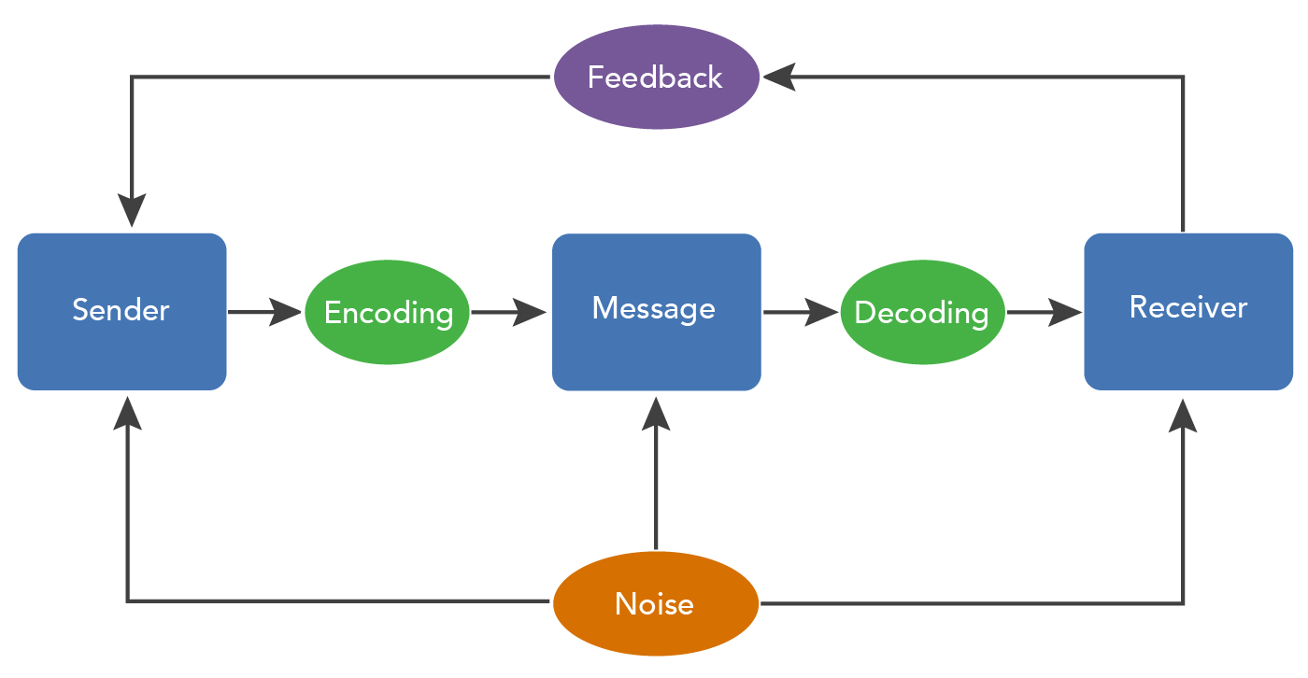
Source: (lumen, 2014)
The person who provides the information or message that has to be transmitted is the sender; the communication process starts with choosing which message to deliver and to whom. The intended message is transformed into signals using a transmitter, a procedure called encoding, and then sent across the chosen channel (Holm, 2006). The communications are either translated to binary codes or radio waves, and the encrypted messages are sent to the recipient across media like the internet, cables, or electrical lines. The procedure of decoding involves converting the binary digits or radio waves used to transmit the information into a form that can be read by the recipient. A receiver is the designated end point of a communication channel in effective communication; it is at this point that the receiver receives the message. The last and most important step in any communication procedure is feedback. After receiving a message, the recipient notifies the sender of their understanding or if they feel the message was delivered clearly (Danaher and Rossiter, 2011). When a communication channel is disrupted, it can be said that noise has occurred. This noise might be internal or external and will have an impact on how well messages are understood (Bishop and Cates, 2001).
Sony reaches its target audience with a reliable communication route. To reach its customers, SONY has employed an innovative promotion strategy.

INTEGRATED MARKETING COMMUNICATION
Under the guise of integrated marketing communications, a business meticulously blends and synchronizes its many channels of communication in order to deliver a message that is both concise and accurate (Duralia, 2018). It makes an attempt to guarantee that the message is consistent and that the media are used in conjunction. IMC represents the integration of all marketing strategies, plans, and resources utilized by a business to influence consumer opinion as much as possible and produce the most revenue with the least amount of effort. Websites, social media platforms, and commercials make up the bulk of Sony's digital integrated marketing communication strategy (Porcu, Barrio-García and Kitchen, 2012).

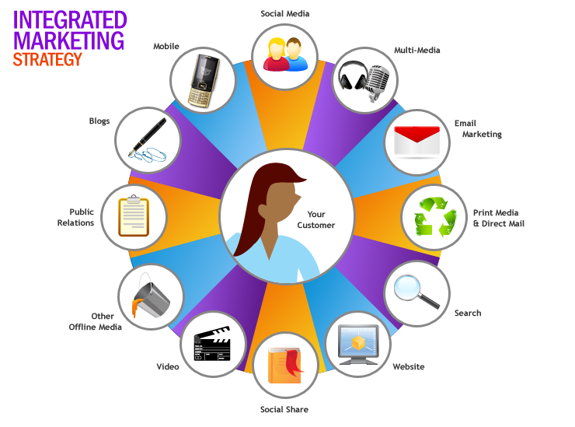
Source: (II - Integrated Marketing Communication (IMC), 2015)
PROMOTIONAL STRATEGIES OF SONY A7
It employs a number of traditional and modern channels to market. Consequently, digital marketing serves as the primary element of their marketing strategy (Li, Larimo and Leonidou, 2020). Social media is a big part of SONY A7’s overall marketing and promotion strategy. It also makes considerable use of print and broadcast media in Asian areas to promote its name and products. It is recognized for creating visually stunning and original TV ads. Additionally, In the organization's marketing plan and promotions, social media is a key component. It makes extensive use of social media to engage with and find its audience (Kirtiş and Karahan, 2011). It has distinct Facebook accounts for each of its products, and the PlayStation page has a significantly huge number of fans. The large number of likes and followers that SONY A7 has demonstrated the level of client loyalty that the brand enjoys. In addition to Facebook, it has promoted its brand and is involved with customers using Pinterest, Google Plus, and Twitter (Agrawal, Singhal and Agarwal, 2016).
Social media may be a huge help, and the business should build a unique consumer experience (Peppers and Rogers, 2016). Social media has been employed by SONY A7 for both brand promotion and customer involvement. In addition to having millions of followers and running a number of well-known Facebook and Twitter accounts, SONY A7 uses social media for a lot more things. Additionally, it has utilized Google Plus and Pinterest for advertising and promotion (Agrawal, Singhal and Agarwal, 2016). The business's advertisements can be seen in public spaces including billboards, on walls, and behind vehicles. In urban settings where awareness of the target demographic can be quite high, outdoor advertising is typically very successful (Lopez‐Pumarejo and Bassell, 2009). The advertisements for Sony A7’s high-definition televisions can be seen on gleaming, sizable billboards in urban locations. In this manner, SONY promotes and markets its brand. It has promoted a variety of products to its readers through publications like TOI. Additionally, Sony employs sales marketing techniques such as offering free samples, discounts, coupons, scratch cards, and early bird awards. In order to advertise their products, they also employ numerous celebrities. Both Mahendra Singh Dhoni and Kareena Kapoor have been spotted promoting their goods (Dhotre and Bhola, 2010). Through direct marketing, agreements are struck with businesses that use Sony products. On the other hand, discounts are used in marketing initiatives to attract customers. To make sure buyers understand their goods and company, they use a variety of pdf brochures and videos. Additionally, they provide cards with points that can be redeemed when a purchase is made (O’Brien et al., 2005). They primarily focus on using the pull method to draw in clients.

BRANDING AND BRAND EQUITY
The process of giving significance to a particular company, organization, good, or service is known as branding. It involves creating and establishing a brand in consumers' views. Businesses can give individuals a cause to choose their products over those of the competitors by clearly stating what this particular brand is and is not. This helps people instantly recognize and feel the brand (Blumrodt, Bryson and Flanagan, 2012).
Brand equity affects how much more value a company gets from a product with a strong brand compared to a generic equivalent. The development of links between people's realization of a product's advantages and disadvantages is facilitated by brand equity. Here Sony A7 has higher brand equity (Pappu, Quester and Cooksey, 2006).
KELLER’S BRAND EQUITY MODEL
Keller's Brand Equity Model commonly referred to as the Customer-Based Brand Equity (CBBE) Model, is structured like a pyramid. According to the Customer-Based Brand Equity Model, a brand's power is said to be formed from what consumers have heard, sensed, and experienced about it as a result of their encounters with it over age. The CBBE model simply measures the relationship between an organization's success and how its clients view it. The model enables customers to determine the stage to which the company brand belongs and what they need to perform to advance (Yousaf, Amin and Gupta, 2017).

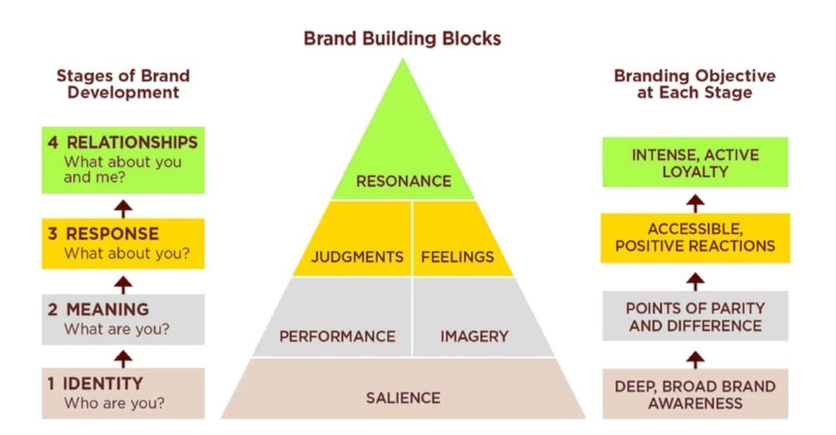
Source: (techthug99, 2020)

Identity: The goal of brand identity is to raise consumer awareness of the product. Additionally, the purchase behavior of the product is formed at this time, guaranteeing that the communications are successfully received by the target audience (Page and Lepkowska‐White, 2002). Sony A7 once held the top spot among consumer electronics brands. The business has long been acknowledged as a leader in innovation and a forerunner in technology (Joo and Keun, 2013).
Meaning: strategy entails introducing the brand to the public and helping them recognize it. At this point, consumer loyalty is established (Keller, 2001). In performance, customers continue to hunger for better digital products as they are made, and the company employs high-end and intelligent photographers who choose to utilize DRLS or mirrorless cameras. celebs to publicly support Sony products in images (Deller, 2016). It will successfully captivate consumers' attention.
Response: it is important to note that opinions about a product are typically formed based on criteria such as quality, attention, credibility, excellence, and so on (Tracy, 2010). The judgment is, that Sony specializes in several different types of technology, including headphones and TVs. The majority of Sony A7 has good image sensors, quick and dependable autofocus systems, and are portable (Lezano, 2012). Today's camera market is dominated by Sony. So, the customers are satisfied with the quality of the cameras (Apiluck Thammawimutti and Ph.D. Sirion Chaipoopirutana, 2018).
Relationship: Building an emotional, psychological, and close relationship with customers is referred to as resonance; in this context, it is implied that a sense of unity or behavioral loyalty will arise (Cheng et al., 2019). Sony is a firm believer in direct customer interaction and communication. Customer feedback serves as the foundation for market research and marketing strategy (Walsh and Godfrey, 2000). Customers who purchase products from Sony have the option to offer comments about those products. Users in the Industrial and Machinery industry gave Sony A7 customer loyalty rating the highest overall (Sony, 2020).
ADVANTAGES AND DISADVANTAGES OF KELLER’S BRAND EQUITY MODEL
Making ensuring every interaction with the brand is favorable can lead to more suggestions and evaluations. A customer-based brand equity model can assist businesses in achieving this. It is also more likely that potential clients will learn about company goods or services if company brand equity is strong (Wang, Wei and Yu, 2008). With each encounter, marketers who employ a customer-based brand equity strategy concentrate on adding value for their clients. They are able to create happy customer experiences and establish enduring relationships as a result. By applying the approach, businesses may increase the likelihood that their customers will make repeat purchases (Anselmsson, Johansson and Persson, 2007). The improved network lifetime of each consumer is also increased by boosting brand loyalty. Customers can spread the word about the business on various digital platforms using their personal social media profiles, which assists build brand awareness. As their consumers begin to advertise their brand for free, many businesses experience a rise in involvement and a decline in their advertising expenses (Ansari et al., 2019).
Building brand equity necessitates a large financial commitment from the company, particularly in the area of promotion. Although there are numerous promotional tactics available to marketers, branding is typically best achieved through advertising (Kumar and Patra, 2017).

CUSTOMER JOURNEY
A consumer's complete interaction with a brand constitutes their "customer journey." The customer journey describes the series of interactions a customer has with a company's name, goods, and services. The topics discussed include both direct interactions, such as dealing with customer service, and indirect ones, such as discovering a company during an event. The many stages of a customer's journey will familiarize the brand and aid in building a brand image in their brains (Bascur, Rusu and Quiñones, 2018). Sony A7 can examine the sales process from the customer's point of view with the help of customer journey mapping to determine what it is doing right and how to enhance its sales strategy. The customer journey is depicted graphically or narratively in a customer journey map. The customer journey map depicts each and every encounter the consumers have had with the company through time and through various service channels. It demonstrates the intersections between company customers' needs and the company's needs from the viewpoint of the customer (Dabrynin and Jing, 2019).

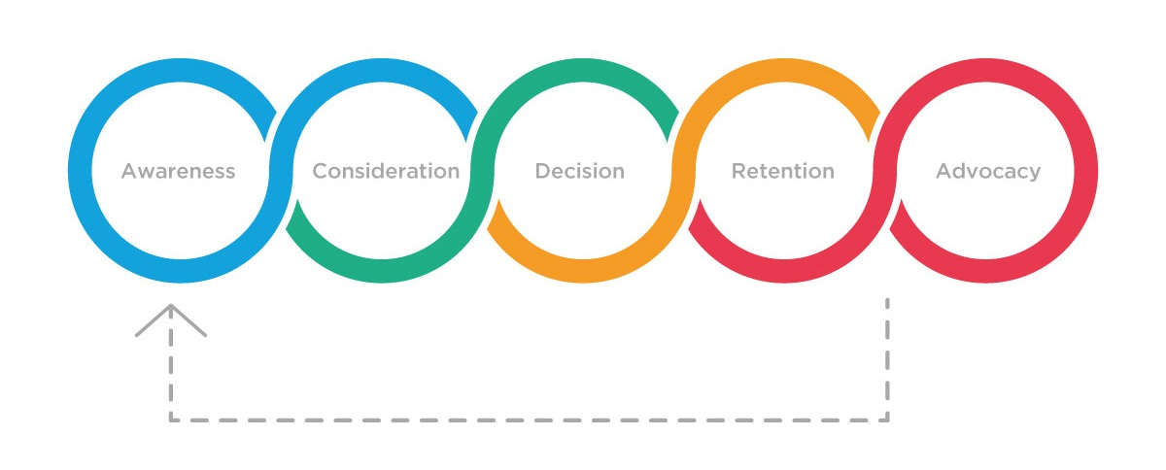
Source: (Jenkins, 2019)
AWARENESS
At this point, a potential customer is looking for a solution to an issue they are trying to solve. The potential client is not yet prepared to make a purchase. Simply put, they are looking for alternatives. The company spent 3.31 billion US dollars on advertising to market its products throughout the 2019 fiscal year of the business. Sony has utilized all of the components of the promotion mix, including advertising, direct marketing, sales promotion, and publicity (Clow, 2013). A public relation is a tool used to improve a company's image and increase brand awareness. To convince target clients to buy the company's products, workers at Sony Stores utilize personal selling. The actions that support the company's market penetration efforts are highlighted. Potential clients are directed to one of these common touchpoints by each of these attraction methods (Yi, Cha and Amenuvor, 2021).
CONSIDERATION
A prospective consumer researches the product throughout the consideration phase to determine whether it would address their problem. They might just focus on the product, or they might compare it to that of the rivals. The prospective consumers are attempting to select the greatest selections out of all of their available choices. They will contrast the advantages and characteristics of several solutions in an effort to locate the one that is reasonably priced (Gentile, Spiller and Noci, 2007). Customers think about the best image quality, smaller prime lenses, continuous eye autofocus, electronic viewfinder, and image stabilization when buying cameras (Northrup, 2014). By comparing with competitors, Sony A7 is highly attractive.
DECISION
At this point, the consumer is prepared to buy the product to satisfy their company's needs after carefully weighing all of their options, reading reviews, and looking through the price and policy details (Chan and Wu, 2002). The Sony A7, which has a huge 61 Megapixel full-frame sensor, produces outstanding image quality with extremely usable files. It generates full-frame mirrorless camera photos with exceptional resolution. It is obvious why this makes it one of the best cameras for photographing products. So, this will lead the customers to purchase Sony A7 (Yamafune, 2016).
RETENTION
An important phase of the customer journey is where the customer reconsiders whether to purchase a new product from the company or extend their current contract or subscription. Given the expenditures involved in recruiting new customers, a frequent north-star measure for businesses is the net retention rate, which is the proportion of customers that decide to keep using the services (Hamilton et al., 2020). Sony A7 is a brand that makes the satisfaction of its customers with its products. This helps to retain customers. According to Sony, retaining existing consumers would be prioritized over acquiring new ones. Sony's organizational culture has the benefit of putting a strong premium on customer satisfaction, which increases customer retention. Additionally, the business is dedicated to growing its consumer base (Chege and Bett, 2019). To accomplish this, the organization takes a variety of steps. One strategy entails a production approach focused on client happiness. Customers are given the option to switch to products that are catering to their preferences and demands. In light of this, the business draws in new clients who understand the importance of customer happiness (Vrontis and Thrassou, 2007).
ADVOCACY
When the customers are happy with the characteristics of the products, they will start to recommend them to their friends and colleagues, closing the loyalty cycle. They will also acknowledge the value contributed by the products or services (Siebert et al., 2020). To elevate its client experience, Sony leverages its Ultimate Reward program. These prizes are out-of-this-world experiences that let users use their points to bid on a variety of premium experiences (Grewal et al., 2020).
CUSTOMER JOURNEY MAP
A customer journey map is a pretty straightforward concept; it is a diagram that shows the steps that a customer takes to interact with the business, whether it is via a product, an internet encounter, a shopping experience, a service, or any combination of those (Haugstveit, Halvorsrud and Karahasanović, 2017). By using a customer journey map, businesses may adopt a different point of view and examine the sales process from the view of the consumer as opposed to the seller (Wolny and Charoensuksai, 2014). It gives standardized information on the customer's interaction with the company to all departments. This gives sales, marketing, and all other departments involved in the sales process a clear picture of the engagements a customer has with the business and gives them access to the same data, which can help them cooperate in order to achieve the shared objective of increasing sales. When a trip map is used, a company can quickly identify service gaps in its present marketing and sales procedures (Meyer and Schwager, 2007).

Advertising
Digital Marketing
Sales promotion
Publicity
AWARENESS

Image quality
Smaller prime lenses
Continuous eye autofocusses
Electronic viewfinder
Image stabilization
CONSIDERATION

DECISION
Photographing products
Retention
Production focused on customer needs
Preferences and demands

Ultimate Reward program
ADVOCACY

Source: self-created
It is clear from the customer journey map that the company uses social media and/or social networks to spread awareness about new items, which is unquestionably helpful because social media can touch a large number of individuals for a little cost and a very short amount of time. After purchase, customer retention depends on how well the after-sale experience is handled. and happy customers will tell their friends and loved ones about the company and the items, repeating the cycle.
CUSTOMER JOURNEY MAPPING OF SONY A7
Customer journey map | Awareness | Discover | Decision | Retention | Advocacy
Website |  | Evaluating the review of different brand cameras
Store |  |  | Understands the quality of the photographing product from the store
Call center
Facebook

Word of mouth |  |  |  | Review of usage
Web forum | Sharing opinion
Email
Post |  |  |  |  | Reviewing the image quality

source: self-created

TOTAL ENGAGEMENT MODEL
Everything is combined into one efficient, effective mechanism by the complete engagement concept. Focusing on coordinating all business endeavors—including marketing, customer support, sales, and internal culture around a single, cohesive strategy for customer engagement is crucial. The alignment of the company's entire brand strategy across all departments creates synergy, which is a significant advantage of the total engagement approach. When compared to its component parts, the whole is bigger (Roberts and Alpert, 2010). Employees who are engaged are those who have a strong understanding of its plan and direction and are genuinely invested in its success. They are more dedicated to amicably resolving conflicts, more productive, and generally more devoted to their employer. In order to achieve long-term growth, the complete engagement model places a strong emphasis on forging a bond between customers, staff, and the company (Cross, Cross and Parker, 2004).
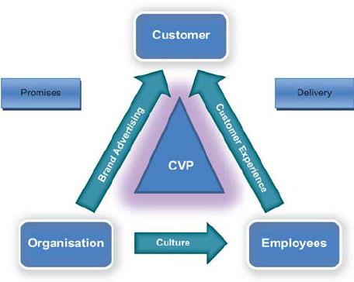
Source: (Roberts and Alpert, 2010)
The Sony company offers a value proposition including quality, innovation, and new technology. Is one of the most recognizable and esteemed brands in the world, having offered dependable and effective products for many years (Kotler and Gertner, 2002). Additionally approachable and simple to use, Sony's devices enable customers to employ cutting-edge technology without the requirement for specialized technical knowledge (Banos et al., 2014). Through its knowledge and knowledge of the industry, the company also adds value to the clients of its financial services and music publishing companies. The branding, Sony is a firm that uses aggressive marketing. Sony employs all forms of media to advertise, including TV, print, web commercials, billboards, and more, as part of its marketing mix promotional strategy (Jelassi, Enders and Leveraging, 2004). Sony bases its reputation on the caliber of its products and services. Customer satisfaction is prioritized in the organizational culture of Sony Corporation. The organizational culture of Sony has an impact on both the company's internal staff members and those working for its affiliates in the financial services, gaming, and entertainment sectors. Therefore, cultural traits are important in creating a cohesive organization and affecting the course of performance and growth of human resources (Abdolahzadeh and Mohsen, 2014). Sony maximizes employee efficiency in meeting consumer perceptions and demands through its corporate culture (Itani, Jaramillo and Paesbrugghe, 2020). When such principles are properly applied to the creation of plans and products, there will be a rise in consumer desire for those that can meet their demands, which will improve the customer's interaction with the brand (Davenport, Leandro and John, 2011).
CONCLUSION
Sony A7 is a professional-level camera and it provides high satisfaction to its customers. The Sony A7 is using social media as a marketing strategy for increasing brand awareness about the product. And also, they are using a wide variety of communication channels to boost employee engagement with the product. Brand equity model analysis shows the public image of the company. And also, the total engagement model shows the company’s value. Here the company is highly utilizing the available marketing approaches to develop its customer involvement and increase sales.
REFERENCES
Abdolahzadeh, S. and Mohsen, N. (2014) ‘Categorizing of price satisfactions base on KANO model’. https://www.researchgate.net/profile/Mohsen-Nazari-12/publication/269334346_Categorizing_of_price_satisfactions_base_on_KANO_model_Case_study_Sony_computer_company_in_IRAN/links/54870f450cf268d28f07051c/Categorizing-of-price-satisfactions-base-on-KANO-model-Case-study-Sony-computer-company-in-IRAN.pdf.
Agrawal, T., Singhal, A. and Agarwal, S. (2016) A comparative study of potential of various social networks for target brand marketing, IEEE Xplore. doi: 10.1109/INCITE.2016.7857636.
Ansari, S. et al. (2019) ‘Impact of Brand Awareness and Social Media Content Marketing on Consumer Purchase Decision’, Journal of Public Value and Administration Insights, 2(2), pp. 5–10. doi: 10.31580/jpvai.v2i2.896.
Anselmsson, J., Johansson, U. and Persson, N. (2007) ‘Understanding price premium for grocery products: a conceptual model of customer‐based brand equity’, Journal of Product & Brand Management, 16(6), pp. 401–414. doi: 10.1108/10610420710823762.
Apiluck Thammawimutti and Ph.D. Sirion Chaipoopirutana (2018) ‘THE RELATIONSHIP BETWEEN BRAND EQUITY, PRODUCT ATTRIBUTES AND PURCHASE INTENTION: A STUDY OF SONY DIGITAL CAMERAS IN BANGKOK’, AU Journal of Management, 3(1), pp. 5–10. Available at: https://www.aujm.au.edu/index.php/aujm/article/view/87 (Accessed: 6 September 2022).
Azam, N., Velentzas, J. and Broni, D. (2014) Communication cycle: Definition, process, models and examples Want more papers like this? Communication cycle: Definition, process, models and examples. Available at: https://www.academia.edu/download/56694648/FINANCE-17.pdf (Accessed: 4 May 2021).
Banos, O. et al. (2014) ‘PhysioDroid: Combining Wearable Health Sensors and Mobile Devices for a Ubiquitous, Continuous, and Personal Monitoring’, The Scientific World Journal, 2014, pp. 1–11. doi: 10.1155/2014/490824.
Bascur, C., Rusu, C. and Quiñones, D. (2018) ‘User as Customer: Touchpoints and Journey Map’, Human Systems Engineering and Design, pp. 117–122. doi: 10.1007/978-3-030-02053-8_19.
Bishop, M. J. and Cates, W. M. (2001) ‘Theoretical foundations for sound’s use in multimedia instruction to enhance learning’, Educational Technology Research and Development, 49(3), pp. 5–22. doi: 10.1007/bf02504912.
Blumrodt, J., Bryson, D. and Flanagan, J. (2012) ‘European football teams’ CSR engagement impacts on customer‐based brand equity’, Journal of Consumer Marketing, 29(7), pp. 482–493. doi: 10.1108/07363761211274992.
Chan, L.-K. and Wu, M.-L. (2002) ‘Quality Function Deployment: A Comprehensive Review of Its Concepts and Methods’, Quality Engineering, 15(1), pp. 23–35. doi: 10.1081/qen-120006708.
Chege, S. W. and Bett, S. (2019) ‘Total Quality Management Practices and Performance of Organizations in the Real Estate Industry, Case of Property Developers in Nairobi City County, Kenya’, International Journal of Current Aspects, 3(IV), pp. 14–31. doi: 10.35942/ijcab.v3iiv.44.
Cheng, Y.-Y. et al. (2019) ‘Linking relationship equity to brand resonance in a social networking brand community’, Electronic Commerce Research and Applications, 35, p. 100849. doi: 10.1016/j.elerap.2019.100849.
Clow, K. E. (2013) Integrated Advertising, Promotion and Marketing Communications, 4/e, Google Books. Pearson. Available at: https://books.google.com/books?hl=en&lr=&id=z3dd7hFCA3cC&oi=fnd&pg=PA25&dq=Sony+has+utilized+all+of+the+components+of+the+promotion+mix (Accessed: 6 September 2022).
Cross, R. L., Cross, R. L. and Parker, A. (2004) The Hidden Power of Social Networks: Understanding how Work Really Gets Done in Organizations, Google Books. Harvard Business Press. Available at: https://books.google.com/books?hl=en&lr=&id=PlPwCgAAQBAJ&oi=fnd&pg=PR5&dq=Employees+who+are+engaged+are+those+who+have+a+strong+understanding+of+its+plan+and+direction+and+are+genuinely+invested+in+its+success&ots=wEQgK-U2pw&sig=wkP03j6qbfgXbJvcGFbLRgPFkno (Accessed: 6 September 2022).
Dabrynin, H. and Jing, Z. (2019) The Investigation of the Online Customer Experience and Perceived Risk on Purchase Intention in China - ProQuest, www.proquest.com. Available at: https://search.proquest.com/openview/95c5ffa2afceffb155749dad71799ebc/1?pq-origsite=gscholar&cbl=536309 (Accessed: 6 September 2022).
Damanpour, F. and Gopalakrishnan, S. (2001) ‘The Dynamics of the Adoption of Product and Process Innovations in Organizations’, Journal of Management Studies, 38(1), pp. 45–65. doi: 10.1111/1467-6486.00227.
Danaher, P. J. and Rossiter, J. R. (2011) ‘Comparing perceptions of marketing communication channels’, European Journal of Marketing, 45(1/2), pp. 6–42. doi: 10.1108/03090561111095586.
Davenport, T. H., Leandro, D. M. and John, Lucker. (2011) ‘Know what your customers want before they do’, harvard Business review. doi: http://kevinsimms.co.nz/uploads/c11095b45d7e9df1fc158cfd49a9b5dc.pdf.
Deller, R. A. (2016) ‘Star image, celebrity reality television and the fame cycle’, Celebrity Studies, 7(3), pp. 373–389. doi: 10.1080/19392397.2015.1133313.
Dhotre, M. and Bhola, S. (2010) Analytical Study of Association Between Celebrity Advertising and Brand Recall. Available at: https://www.csus.edu/faculty/M/fred.molitor/docs/Ads%20and%20Recall.pdf.
Duralia, O. (2018) ‘Integrated Marketing Communication and Its Impact on Consumer Behavior’, Studies in Business and Economics, 13(2), pp. 92–102. doi: 10.2478/sbe-2018-0022.
Gentile, C., Spiller, N. and Noci, G. (2007) ‘How to Sustain the Customer Experience’:, European Management Journal, 25(5), pp. 395–410. doi: 10.1016/j.emj.2007.08.005.
Grewal, D. et al. (2020) ‘Frontline Cyborgs at Your Service: How Human Enhancement Technologies Affect Customer Experiences in Retail, Sales, and Service Settings’, Journal of Interactive Marketing, 51, pp. 9–25. doi: 10.1016/j.intmar.2020.03.001.
Hamilton, R. et al. (2020) ‘Traveling with Companions: The Social Customer Journey’, Journal of Marketing, 85(1), p. 002224292090822. doi: 10.1177/0022242920908227.
Haugstveit, I., Halvorsrud, R. and Karahasanović, A. (2017) Supporting redesign of C2C services through customer journey mapping. Available at: https://ep.liu.se/ecp/125/018/ecp16125018.pdf.
Holm, O. (2006) ‘Integrated marketing communication: from tactics to strategy’, Corporate Communications: An International Journal, 11(1), pp. 23–33. doi: 10.1108/13563280610643525.
II - Integrated Marketing Communication (IMC) (2015) Creative Corporate& Marketing Communication. Available at: https://studyblogccmc.weebly.com/pbl-ii/ii-integrated-marketing-communication-imc (Accessed: 7 September 2022).
Itani, O. S., Jaramillo, F. and Paesbrugghe, B. (2020) ‘Between a rock and a hard place: Seizing the opportunity of demanding customers by means of frontline service behaviors’, Journal of Retailing and Consumer Services, 53, p. 101978. doi: 10.1016/j.jretconser.2019.101978.
Jelassi, T., Enders, A. and Leveraging (2004) Wireless Technology for Mobile Advertising. Available at: https://aisel.aisnet.org/cgi/viewcontent.cgi?article=1073&context=ecis2004 (Accessed: 2 May 2020).
Jenkins, C. (2019) How to create content for the buyer journey, The UK Domain. Available at: https://theukdomain.uk/how-to-create-content-for-buyer-journey/ (Accessed: 7 September 2022).
Joo, S. H. and Keun, L. (2013) ‘Samsung’s catch-up with Sony: an analysis using US patent data’, Innovation and Industrialization in Asia, pp. 60–76. doi: 10.4324/9780203718582-9.
Keller, K. L. (2001) ‘Building customer-based brand equity: A blueprint for creating strong brands’. doi: https://www.academia.edu/download/54131126/Customer_Basedbrand_Equity_Model.pdf.
Kirtiş, A. K. and Karahan, F. (2011) ‘To Be or Not to Be in Social Media Arena as the Most Cost-Efficient Marketing Strategy after the Global Recession’, Procedia - Social and Behavioral Sciences, 24, pp. 260–268. doi: 10.1016/j.sbspro.2011.09.083.
Kotler, P. and Gertner, D. (2002) ‘Country as brand, product, and beyond: A place marketing and brand management perspective’, Journal of Brand Management, 9(4), pp. 249–261. doi: 10.1057/palgrave.bm.2540076.
Kumar, S. and Patra, D. S. (2017) ‘Does Promotion Mix Really Help to Enhance Brand Equity: A Literature Review’, Indian Journal of Commerce and Management Studies, 8(2), pp. 80–86. Available at: https://ijcms.in/index.php/ijcms/article/view/205.
Lezano, D. (2012) The Photography Bible: A Complete Guide for the 21st Century Photographer, Google Books. David & Charles. Available at: https://books.google.com/books?hl=en&lr=&id=BGbIDwAAQBAJ&oi=fnd&pg=PT7&dq=Sony+cameras+have+good+image+sensors (Accessed: 6 September 2022).
Li, F., Larimo, J. and Leonidou, L. C. (2020) ‘Social media marketing strategy: definition, conceptualization, taxonomy, validation, and future agenda’, Journal of the Academy of Marketing Science, 49(1), pp. 51–70. doi: 10.1007/s11747-020-00733-3.
Lopez‐Pumarejo, T. A. and Bassell, M. (2009) ‘The Renaissance of Outdoor Advertising: From Harlem to Hong Kong’, American Journal of Business, 24(2), pp. 33–40. doi: 10.1108/19355181200900009.
lumen (2014) The Process of Communication | Organizational Behavior / Human Relations, courses.lumenlearning.com. Available at: https://courses.lumenlearning.com/wm-organizationalbehavior/chapter/the-process-of-communication/.
Meyer, C. and Schwager, A. (2007) Understanding Customer Experience. Harvard Business Review. Available at: https://idcexed.com/wp-content/uploads/2021/01/Understanding_Customer_Experience.pdf.
Northrup, T. (2014) Tony Northrup’s Photography Buying Guide: How to Choose a Camera, Lens, Tripod, Flash & More, Google Books. Tony Northrup. Available at: https://books.google.com/books?hl=en&lr=&id=qoCaBQAAQBAJ&oi=fnd&pg=PA1&dq=Customers+think+about+the+best+image+quality (Accessed: 6 September 2022).
O’Brien, P. et al. (2005) ‘Smart card product development in an internet-based CRM environment’. doi: https://dl.acm.org/doi/abs/10.5555/1138235.1138300.
Page, C. and Lepkowska‐White, E. (2002) ‘Web equity: a framework for building consumer value in online companies’, Journal of Consumer Marketing, 19(3), pp. 231–248. doi: 10.1108/07363760210426058.
Pappu, R., Quester, P. G. and Cooksey, R. W. (2006) ‘Consumer‐based brand equity and country‐of‐origin relationships’, European Journal of Marketing, 40(5/6), pp. 696–717. doi: 10.1108/03090560610657903.
Peppers, D. and Rogers, M. (2016) Managing Customer Experience and Relationships: A Strategic Framework, Google Books. John Wiley & Sons. Available at: https://books.google.com/books?hl=en&lr=&id=8lVeDQAAQBAJ&oi=fnd&pg=PT15&dq=Social+media+may+be+a+huge+help (Accessed: 6 September 2022).
Porcu, L. (Lucía), Barrio-García, S. (Salvador) del and Kitchen, P. J. (Philip J. ) (2012) ‘How Integrated Marketing Communications (IMC) works? A theoretical review and an analysis of its main drivers and effects’, dadun.unav.edu. Available at: https://dadun.unav.edu/handle/10171/27370 (Accessed: 22 September 2020).
Roberts, C. and Alpert, F. (2010) ‘Total customer engagement: designing and aligning key strategic elements to achieve growth’, Journal of Product & Brand Management, 19(3), pp. 198–209. doi: 10.1108/10610421011046175.
Siebert, A. et al. (2020) ‘Customer Experience Journeys: Loyalty Loops Versus Involvement Spirals’, Journal of Marketing, 84(4), pp. 45–66. doi: 10.1177/0022242920920262.
Sony α7 IV full-frame hybrid camera (2022) Sony. Available at: https://www.sony.co.in/electronics/interchangeable-lens-cameras/ilce-7m4 (Accessed: 7 September 2022).
Sony, M. (2020) ‘Pros and cons of implementing Industry 4.0 for the organizations: a review and synthesis of evidence’, Production & Manufacturing Research, 8(1), pp. 244–272. doi: 10.1080/21693277.2020.1781705.
techthug99 (2020) Customer Based Brand Equity | Keller’s Brand Equity Model. Available at: https://www.geektonight.com/customer-based-brand-equity-kellers-brand-equity-model/.
Tracy, S. J. (2010) ‘Qualitative Quality: Eight “Big-Tent” Criteria for Excellent Qualitative Research’, Qualitative Inquiry, 16(10), pp. 837–851.
Vrontis, D. and Thrassou, A. (2007) ‘A new conceptual framework for business‐consumer relationships’, Marketing Intelligence & Planning, 25(7), pp. 789–806. doi: 10.1108/02634500710834223.
Walsh, J. and Godfrey, S. (2000) ‘The internet: a new era in customer service’, European Management Journal, 18(1), pp. 85–92. doi: 10.1016/s0263-2373(99)00071-7.
Wang, H., Wei, Y. and Yu, C. (2008) ‘Global brand equity model: combining customer‐based with product‐market outcome approaches’, Journal of Product & Brand Management, 17(5), pp. 305–316. doi: 10.1108/10610420810896068.
Wierzbicki, D., Kedzierski, M. and Fryskowska, A. (2015) ‘ASSESMENT OF THE INFLUENCE OF UAV IMAGE QUALITY ON THE ORTHOPHOTO PRODUCTION’, The International Archives of the Photogrammetry, Remote Sensing and Spatial Information Sciences, XL-1/W4, pp. 1–8. doi: 10.5194/isprsarchives-xl-1-w4-1-2015.
Windahl, S., Signitzer, B. and Olson, J. T. (2008) Using Communication Theory: An Introduction to Planned Communication, Google Books. SAGE. Available at: https://books.google.com/books?hl=en&lr=&id=9v1WRZLE6-IC&oi=fnd&pg=PR5&dq=Sending+and+receiving+information+between+individuals+or+groups+of+individuals (Accessed: 6 September 2022).
Wolny, J. and Charoensuksai, N. (2014) ‘Mapping customer journeys in multichannel decision-making’, Journal of Direct, Data and Digital Marketing Practice, 15(4), pp. 317–326. doi: 10.1057/dddmp.2014.24.
Yamafune, K. (2016) Using Computer Vision Photogrammetry (Agisoft PhotoScan) to Record and Analyze Underwater Shipwreck Sites, oaktrust.library.tamu.edu. Available at: https://oaktrust.library.tamu.edu/handle/1969.1/156847 (Accessed: 6 September 2022).
Yi, H.-T., Cha, Y.-B. and Amenuvor, F. E. (2021) ‘Effects of Sales-Related Capabilities of Personal Selling Organizations on Individual Sales Capability, Sales Behaviors and Sales Performance in Cosmetics Personal Selling Channels’, Sustainability, 13(7), p. 3937. doi: 10.3390/su13073937.
Yousaf, A., Amin, I. and Gupta, A. (2017) ‘Conceptualising tourist based brand-equity pyramid: an application of Keller brand pyramid model to destinations’, Tourism and hospitality management, 23(1), pp. 119–137. doi: 10.20867/thm.23.1.1.

