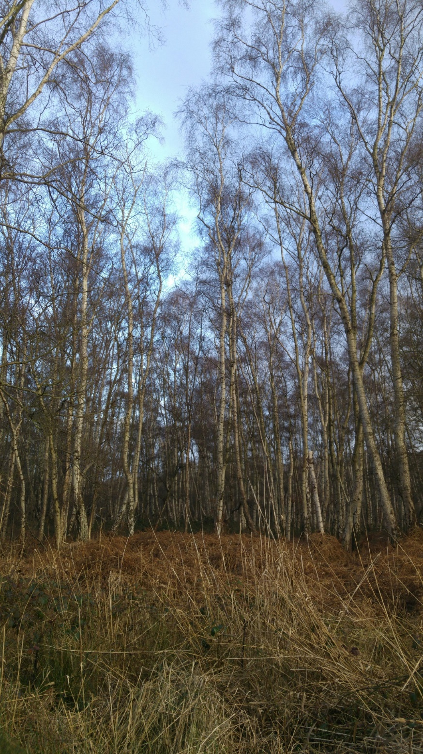

An Investigation into the Herpetofauna of Holme Fen
  - A research proposal
Jacob Quinn | Research Methods | Winter 2018
Contents
1.0 Introduction 2
1.1 Herpetofauna 2
1.2 Holme Fen 3
1.3 Aims 4
1.4 Objectives 4
2.0 Literature review 5
2.1 Herpetofauna status 5
2.2 Legislation 6
3.0 Methods 8
3.1 Reptile surveying 8
3.2 Amphibian Surveying 9
3.2.1 Counts by Torchlight 9
3.2.2 Bottle Trapping 9
3.2.3 Searching Refugia 10
3.3 Identification – Species, Age & Sex 10
4.0 Results 10
5.0 Evaluation 11
5.1 Ethics 11
5.2 Limitations 11
References 13

Figures
Figure 1: Map of Holme Fen National Nature Reserve (The Great Fen, n.d.) 3
Figure 2: Activity times of Amphibians (Gent & Gibson, 2003). 12

Tables
Table 1: Amphibian species native to the UK (Fairchild & Bowles, 2005). 3
Table 2: Reptile species native to the UK (Fairchild & Bowles, 2005). 3
Table 3: Status of British Reptile and Amphibian species (Humphreys, et al., 2011). 6
Table 4: Overview of UK legislation regarding herpetofauna (ARC, 2016). 8

1.0 Introduction

1.1 Herpetofauna
The British Isles are home to over 70,000 species of flora and fauna (Natural History Museum, 2017), 12 of which are terrestrial herpetofauna. Herpetofauna can be separated into two distinct groups; reptiles and amphibians, with the UK having 6 native species of amphibians and 6 native species of reptiles (Fairchild & Bowles, 2005). Native UK species are as follows:
Table 1: Amphibian species native to the UK (Fairchild & Bowles, 2005).
Amphibians
Newts (Caudata) | Frogs and Toads (Anura)
Palmate Newt (Lissotriton helveticus) | Common Frog (Rana temporaria)
Smooth or Common Newt (Lissotriton vulgaris) | Common Toad (Bufo bufo)
Great Crested Newt (Triturus cristatus) | Natterjack toad (Epidalea calamita)

Table 2: Reptile species native to the UK (Fairchild & Bowles, 2005).
Reptiles
Snakes | Lizards
Grass Snake (Natrix natrix) | Common or Viviparous Lizard  (Zootoca vivipara)
Adder (Vipera berus) | Slow-worm (Anguis fragilis)
Smooth Snake (Coronella austriaca) | Sand Lizard (Lacerta agilis)
It is also important to note that there are multitude of non-native species that have been introduced to the UK and have become naturalized in the countryside. Introduced species include the pool frog (Pelophylax lessonae), a species that presumably went extinct in the UK in 1995 but have since been reintroduced to once site in Norfolk (Froglife, 2018). Despite this, the pool frog is recognized as the 13th post-glacial native herpetofauna species. However, some of the species introduced can pose a threat to native species, this must be accounted for should they be discovered during surveying, with a potential plan to mitigate against any threat species, should they be found. Some non-native threat species include (Fairchild & Bowles, 2005):
- Italian Crested Newt (Triturus carnifex)
- American Bullfrog (Rana catesbeiana)
- Red-eared Terrapin (Trachemys scripta)

1.2 Holme Fen
With frequent sightings of herpetofauna during the spring and summer and no detailed surveys on the area, Holme Fen has been chosen as a prime location for conducting research.
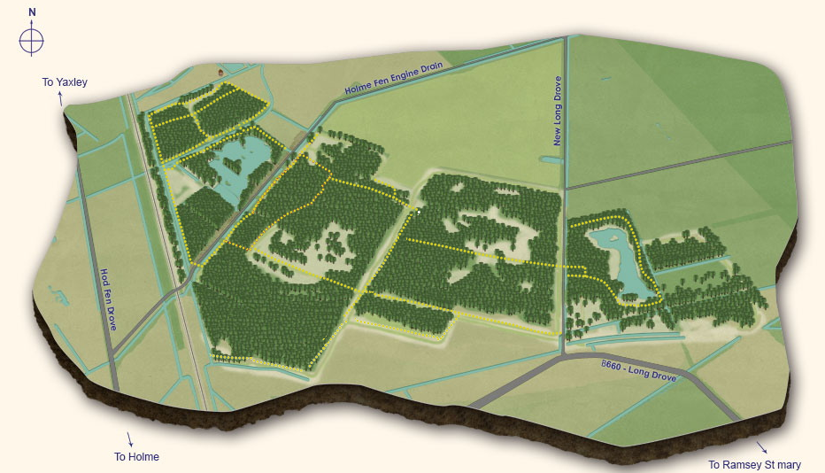
Figure 1: Map of Holme Fen National Nature Reserve (The Great Fen, n.d.)
At three miles across, Holme Fen was formerly the largest lake in southern England – Whittlesey mere. However, since the draining of the mere during the 1850’s for agricultural purposes, Holme Fen has since become host to two key geographical points of interest. At 2.75 meters below sea level, it is the lowest point in the UK (The Great Fen, n.d.).
The other key point of interest is the habitats found on site, these habitats are indicative of the draining during the 1850’s. Holme Fen is one of the last remaining locations in the UK in which fragments of ancient wild fen survive, this can be found on the southwestern part of the site where the soil is too saturated to farm (The Great Fen, n.d.). Other key habitats and points of interest include acid grassland and raised bog, some of which are found in Annex I of the EU habitats Directive (H7110 - Active raised bogs) (DEFRA, 2013 ). The drainage of the mere has also lead to succession, the site has become predominantly alluvial woodland. Holme Fen is now the largest Silver Birch (Betula pendula) woodland in lowland England (The Great Fen, n.d.).
Holme fen is a part of the Great Fen Project, a project dedicated to ceasing the drainage of fenland and preservation of fenland flora and fauna. Natural England primarily manage the site, though they are also in partnership with the Environment Agency, The Wildlife Trust, Huntingdonshire District Council, and Middle Level Commission (Natural England, 2017).
A site visit was conducted on the 24th of December 2017 to determine the suitability of Holme fen for research purposes, this couple with past visits and observations have led to this site being chosen. The site has a high-water content and tall grasses throughout the year, ideal conditions for amphibians, as they require high water content and tall grass for hibernation during winter months. Tall grasses also offer protection, for both amphibians and reptiles, from predators found at the site such as the Marsh Harrier (Circus aeruginosus) and the Grey Heron (Ardea cinereal).

1.3 Aims
The purpose and primary aim of this research is to determine the presence and or absence of a variety of herpetofauna species at the Holme Fen site, while numbers are recorded they may not be indicative of the population. By doing this distribution of species may also be simultaneously recorded around site. This is common practice during urbanization and development of areas, however it may be used to determine the best conditions for a variety of species.
Another aim is to look at the composition of the herpetofauna population of Holme fen. In that the sex of the species and growth stage will be recorded.
Secondary aims include using a variety of methods to assess factors such as population density.

1.4 Objectives
The main objective of the research to gain an insight as to what herpetofauna is found on site and from that suggest way that the habitat can be improved or maintained to further support herpetofauna - increasing species diversity and potentially increasing population numbers should they need addressing.
A secondary objective is to pass recorded data over to the relevant organizations, such as the National Amphibian and Reptile Recording Scheme (NARRS), in order to assist their own conservation efforts.

2.0 Literature review

2.1 Herpetofauna status
The majority of the UK’s herpetofauna is recognized as widespread, with just 4 species being localized: P. lessonae, B. calamita, L. agilis, and C. austriaca (Humphreys, et al., 2011). Both reptile and amphibian populations have been declining on a global scale, something that is likely due to anthropogenic influences and habitat loss, with country’s such as the U.S. retaining than 20% of the wetland area they once had (Gibbon, et al., 2000). Though the majority of species are widespread, this trend is reflected throughout the UK. It was previously though that decline amongst the amphibious orders was more prominent than other taxonomic groups (Humphreys, et al., 2011), this is supported by figures such as a 68% decline in B. bufo in all regions since 1985 (The Guardian , 2017) Though it is now recognized that within the UK, reptile populations are subject to similar levels of decline (Beebee, et al., 2009).
There has been information published as to what the foundations for this decline are (Gibbon, et al., 2000) (Reading, et al., 2010). As a result of this, most of these native species are listed under the UK Biodiversity Action Plan (Humphreys, et al., 2011) and various other UK legislation – as reviewed in the next section.
Table 3: Status of British Reptile and Amphibian species (Humphreys, et al., 2011).
Species | Distribution | Status | UK BAP priority listed
Common Frog  Rana temporaria | Widespread | Common. Documented decline up to 1970s, since when appears to have stabilized. | -
Pool Frog Pelophylax lessonae | Localised, East Anglia | Recent reintroduction to a single site. Also exists as some introduced populations from other sources. | England
Common Toad  Bufo bufo | Widespread | Common, but long-term declines | England, Scotland and Wales
Natterjack Toad Bufo calamita | Localised | Stable after period of decline | England, Scotland and Wales
Smooth Newt Lissotriton vulgaris | Widespread | Common; thought to have suffered a general decline in rural areas, though may have been offset somewhat by colonisation of new garden ponds. | -
Palmate Newt Lissotriton helveticus | Widespread, though patchily distributed. More common in Wales and Scotland; rare in East of England. | General decline | -
Great Crested Newt Triturus cristatus | Lowland species, widespread across most of England but rare or absent in north and west of UK. | General decline | England, Scotland and Wales
Common Lizard Zootoca vivipara | Widespread, but patchy | General decline | England, Scotland and Wales
Sand Lizard  Lacerta agilis | Localised | Documented decline | England, Scotland and Wales
Slow-worm  Anguis fragilis | Widespread | General decline | England, Scotland and Wales
Grass Snake  Natrix natrix | Widespread in England and Wales. Almost absent from Scotland except for introductions. | General decline but current trends unknown | England, Scotland and Wales
Adder  Vipera berus | Widespread, but restricted by habitat preferences | Declines in some areas | England, Scotland and Wales
Smooth Snake Coronella austriaca | Localised, Dorset, Surrey and Hampshire heaths | Decline, but current trends largely unknown | England

2.2 Legislation
Legislation is within the UK is developed not just for herpetofauna but for all flora and fauna, with different levels of protection dependent on species. The legislation is somewhat complicated due to a plethora of reasons – in the UK, devolved power means each country is essentially in control of how they govern with the environment (Amphibian and Reptile Conservation Trust (ARC), 2017). It should be noted that the European Union (EU) plays a vital role in developing role in the development of environmental policy and legislation. As a member state, the UK government must adhere to these policies, agreeing and implementing them (DEFRA, 2015) – though there is uncertainty as to what will happen after the UK leaves the EU.
Most widespread UK herpetofauna species do not require a license in order to carry out a survey (ARC, n.d.). However, should species such as T. cristatus or P. lessonae be discovered during surveying, the surveying should be stopped (ARC, n.d.). Species such as T. cristatus and P. lessonae are fully protected under UK Law, this makes it is an offence to kill, injure, capture disturb or sell them. It is also an offence to damage or destroy habitats in which they are found, this is applicable at all growth stages (Froglife, 2018). Although, this can be averted and licensing to handle such species can be obtained from the Amphibian and Reptile Conservation Trust (ARC).
The herpetofauna of the UK is subject to 11 acts and regulations, though as to where these apply is indicative of each country’s devolved power, as shown in Table 4.
Table 4: Overview of UK legislation regarding herpetofauna (ARC, 2016).
Legislation | England | Northern Ireland | Scotland | Wales
Wildlife & Countryside Act 1981 | ✔ |  | ✔ | ✔
Conservation (Natural Habitats & c.) Regulations 1994 |  |  | ✔
The Conservation (Nature Habitats, etc.) Regulations (Northern Ireland) 1995 |  | ✔
Countryside & Rights of Way Act 2000 | ✔ |  |  | ✔
Nature Conservation (Scotland) Act 2004 |  |  | ✔
The Conservation (Natural Habitats etc) (Amendment) Regulations (Northern Ireland) 2004 |  | ✔
Natural Environment and Rural Communities Act 2006 | ✔ |  |  | ✔
Conservation (Natural Habitats, &c.) Amendment (Scotland) Regulations 2007 |  |  | ✔
The Conservation (Natural Habitats, etc.) (Amendment) Regulations (Northern Ireland) 2007 |  | ✔
The Environmental Damage (Prevention and Remediation) Regulations 2009 | ✔ |  |  | ✔
Conservation of Habitats and Species Regulations 2010 | ✔ |  |  | ✔

3.0 Methods
The methodology used to survey will be derivative of both the ‘Herpetofauna Workers Manual’, by Gent and Gibson, 2003 and the ‘Survey protocols for the British herpetofauna’, by Beebee et al., 2013.
The collection of data will occur during the summer period, spanning a six-week period. The data will be collected between the 16th of July 2018 and the 26th August 2018, with a bi-weekly visit to the Holme Fen. The bi-weekly visit will consist of one day devoted to amphibian surveying and the other to reptile surveying, with each visit being weather dependent. This is due to climatic factors such as wind, and air and soil temperature (Gent & Gibson, 2003) – this has the potential to reduce herptile activity and may not act as representative sample, as the species may not truly be absent from the site.
Both amphibians and reptiles require different conditions, with amphibians favoring a mixture of both aquatic and terrestrial conditions and reptiles favoring primarily terrestrial conditions. Due to this, differing methods must be implemented in order to gather data on both amphibia and reptilia. It should also be noted that each herptile species has differing ecological preferences, with each surveying technique being a generalization developed in order to try and encompass as many herpetofauna as possible.
If possible, it would be ideal to record other species found at Holme Fen in order to get an idea as to the food chain is for the site. This can be done by looking at the visitors sightings book, though this is not the most reliable source of data.

3.1 Reptile surveying
Surveys will be conducted between the hours of 0900 and 1100 hrs (Gent & Gibson, 2003), this is when basking is most prominent. The weather will be checked at the beginning of each week, picking the day that ensures the conditions are ideal for the best results. These conditions can include (Gent & Gibson, 2003):
- Low wind speeds or no wind
- Morning temperatures between 10°C and 17°C – ideal temperature to bask before their active temperature is reached.
- Thundery conditions – reptiles appear to be more active during these conditions
- Sunny weather after a long period of cloudy or rainy weather
For surveying the reptilia of Holme Fen the method of refugia searching will be implemented. Refugia consisting of both natural and artificial cover objects (ACOs), such as wood or discarded materials - creating refuges for reptiles. Two weeks prior to surveying, materials such as wood, tins or roofing felts will be deposited on the south side of the reserve – A license from the relevant Statutory Nature Conservation Organization (SNCO) must be obtained for this (Natural England), this will be done in approximately 30 locations. It should be noted that the materials used to create refugia should be a mix, this is due to the solar heating capacity of each material, with materials such as tin warming more quickly but cooling faster than felt (Beebee, et al., 2013). The size of the natural or ACO refugia should be approximately 0.5m x 0.5m, at a minimum.
The south of the reserve offers ideal conditions, with reptiles preferring the sunny edge of dense vegetation (Gent & Gibson, 2003) – something the edge of the silver birch wood can provide. Access to the south is not an issue, with footpaths close by surrounding the outer perimeter of the woodland.

3.2 Amphibian Surveying
As can be expected, amphibians require a different methodology to survey them; a multitude of methods must be employed. Much like with the reptiles, the weather will be checked at the beginning of each week, this is to ensure that the number of amphibians observed is not hindered.
Due to constraints, such as time and man-power, only the smaller of the two mere’s is to be surveyed – Boston Mere, located on the south-west of the reserve. However, this works to an advantage as the water is more shallow and warmer than that of Burnham mere, making it more suitable for amphibians. The mere is easily accessible, with access to the west shore via footpaths, though the accessibility of the east shore is unknown.
Data collection is to be carried out during both night, this is due to amphibians being more active during the night (Beebee, et al., 2013; Gent & Gibson, 2003). Another reason for this is due to the methodologies have been selected to be used. Temperature of the Air and Water will be recorded during the study.

3.2.1 Counts by Torchlight
The simplest method; torchlight surveying is carried out during the night by walking around the perimeter of the pond, scanning the shoreline of the water with a torch. The site score is derivative of the number of newts observed while circuiting the pond, this is used to determine population densities. Though limitations of this are that it is dependent on the clarity of the water as to how possible it is to identify species. This method has a 95% confidence that non-detection of T. cristatus means the species is absent (Beebee, et al., 2013).

3.2.2 Bottle Trapping
Though time consuming, bottle trapping is a cost-effective method of catching all three native newt species (Beebee, et al., 2013). The trap is constructed from a large plastic drinks bottle, with measures being taken to ensure asphyxiation does not occur. Traps are to be randomly placed at three 10m stretches around the pond, consisting of five traps per 10m (every 2 meters). There is typically a male bias in L. helveticus and L. vulgaris (Gent & Gibson, 2003). The number of newts carried in traps is proportional to the number of traps set, though this varies from night to night and must be carried out multiple times.

3.2.3 Searching Refugia
A similar method to that mentioned in 3.1 will be used for amphibia also, though as with the other methods this will be conducted at night. It also differs in that the refugia will not be pre-placed, in that naturally occurring refugia, such as deadwood, will be searched.

3.3 Identification – Species, Age & Sex
The identification of species will be done using a combination of prior knowledge and reliance upon literature such as ‘Herpetofauna Workers Manual’. Photographs will be taken for further analysis should a field not be possible. The same applies when identifying the sex of the herpetofauna. Identifying individuals that are not fully grown may prove difficult while body morphology is different, this is an area that may require further research.

4.0 Results
As mentioned throughout the proposal, the type of data collected will vary. It will primarily be quantitative, recording the species (presence/absence) and numbers of herpetofauna (population and density) – this will vary dependent on species.
For both amphibians and reptiles, data will be plotted using maps in order to analyse the distribution of species.
Using graphs and tables, the correlation between temperature (air and water) and species numbers will be analysed, though it can be hypothesised that numbers of herpetofauna surveyed will rise and/or fall dependent on the temperature (air and water).
The use of the visitors’ wildlife sighting book may be used for further analysis, determining as to why species are present or absent. This can be done by researching as to what main prey and predators of the herpetofauna are, and seeing how they are supported in the Holme Fen food chain.

5.0 Evaluation
With the general trend of native herpetofauna populations in decline (Humphreys, et al., 2011), this poses a as window of opportunity to learn as to what species are found in the lowland fen. A potential opportunity arises to further improve the habitat, dependent on what the data shows - mitigating against decline in this area. The research in proposal is also a particularly financially viable one, with materials needed being primarily waste and something that can be obtained for free. Other equipment needed is a relatively ‘powerful’ torch and a copy of the ‘Herpetofauna Workers Manual’, one of which has already been obtained and the other is available as a downloadable PDF for free.

5.1 Ethics
While for some herptile species it is transcribed in legislation that it is an offence to kill, injure, capture disturb or sell them, it is also unethical to do so. The handling and trapping of species must be carefully done, which is done in a way that ensures the animals welfare – traps must be monitored after a maximum of 8 hours (Gent & Gibson, 2003), to ensure newts/trapped fauna do not die. Torching must be done with a torch that has the right amount of power (approx. 500,000 candle powers (Beebee, et al., 2013)) , too powerful and it likely to daze, potentially even blind newts.

5.2 Limitations
Though it is still viable, the main limitation of this survey is the time of year, the proposed dates are outside of spawning season so amphibious species such as R. temporaria may be absent from the site (See Figure 2). Boston mere is larger than a standard pond, this may raise issues in regard to temperature in that it may be lower – which is less ideal for recording amphibian activity. Weather is also unpredictable and there may be days in which surveys must be carried out under conditions that do not favour herptile activity. Another limitation is labour, it is unknown at this moment in time as to how much support will be needed to conduct aspects of the data collection e.g. checking traps. Contacting the reserve warden and relevant people has proved difficult with no reply as of yet, though the proposal is still in early stages of development and it is not yet relevant. A six-week study may also be an under-estimation of time required to conduct the surveys, though there is an extra two weeks committed in September should more time be needed.

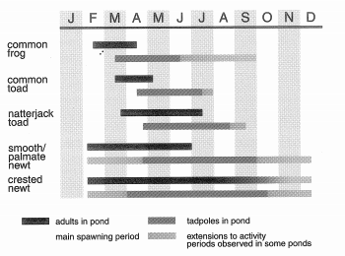
Figure 2: Activity times of Amphibians (Gent & Gibson, 2003).

References
Amphibian and Reptile Conservation Trust (ARC), 2016. UK overview. [Online]
Available at: https://www.arc-trust.org/legislation-uk-overview
[Accessed 4 January 2018].
Amphibian and Reptile Conservation Trust (ARC), 2017. Legislative protection for the UK’s herpetofauna. [Online]
Available at: https://www.arc-trust.org/legislative-protection-for-the-uks-herpetofauna
[Accessed 4 January 2018].
ARC, n.d. Amphibian Surveys PPT. s.l.:The Amphibian and Reptile Conservation Trust (ARC).
Beebee, T. J. C. et al., 2013. Survey protocols for the British herpetofauna, s.l.: Amphibian and Reptile Conservation.
Beebee, T., Wilkinson, J. & Buckley, J., 2009. Amphibian Declines Are Not Uniquely High amongst the Vertebrates: Trend Determination and the British Perspective. Diversity , 1(1), pp. 67-88.
DEFRA, 2013 . Third Report by the United Kingdom under Article 17 on the implementation of the Directive from January 2007 to December 2012 Conservation status for Habitat: H7110 - Active raised bogs, United Kingdom: The Department for Environment, Food and Rural Affairs.
DEFRA, 2015. European Legislation. [Online]
Available at: http://jncc.defra.gov.uk/page-1372
[Accessed 4 January 2018].
Fairchild, G. & Bowles, P., 2005. Species Identification - A guide to the Reptiles and Amphibians found in the UK (Reptile and Amphibian Identification). [Online]
Available at: http://www.herpetofauna.co.uk/identification.asp
[Accessed 27 December 2017].
Froglife, 2018. Great Crested Newt. [Online]
Available at: https://www.froglife.org/info-advice/amphibians-and-reptiles/great-crested-newt/
[Accessed 2 January 2018].
Froglife, 2018. Pool Frog. [Online]
Available at: http://www.froglife.org/info-advice/amphibians-and-reptiles/pool-frog/
[Accessed 2 January 2018].
Gent, T. & Gibson, S., 2003. Herpetofauna Workers Manual. Peterborough : Joint Nature Conservation Committee.
Gibbon, J. et al., 2000. The Global Decline of Reptiles, Déjà Vu Amphibians. Bioscience, 8(50), pp. 653-666.
Humphreys, E. et al., 2011. An examination of reptile and amphibian populations in gardens, the factors influencing garden use and the role of a ‘Citizen Science’ approach for monitoring their populations within this habitat, Thetford: British Trust for Ornithology.
Natural England, 2017. Cambridgeshire's National Nature Reserves. [Online]
Available at: https://www.gov.uk/government/publications/cambridgeshires-national-nature-reserves/cambridgeshires-national-nature-reserves
[Accessed 4 January 2018].
Natural History Museum, 2017. UK species. [Online]
Available at: http://www.nhm.ac.uk/our-science/data/uk-species.html
Reading, C. et al., 2010. Are snake populations in widespread decline?. Biology Letters, 6(6), pp. 777-780.
RSPB, 2018. Grey Heron. [Online]
Available at: https://www.rspb.org.uk/birds-and-wildlife/wildlife-guides/bird-a-z/grey-heron/
[Accessed 2 January 2018].
RSPB, 2018. Marsh Harrier. [Online]
Available at: https://www.rspb.org.uk/birds-and-wildlife/wildlife-guides/bird-a-z/marsh-harrier
[Accessed 2 January 2018].
The Great Fen, n.d. Holme Fen. [Online]
Available at: http://www.greatfen.org.uk/visit/places/HolmeFen
[Accessed 2 January 2018].
The Great Fen, n.d. Holme Fen Map. [Online]
Available at: http://www.greatfen.org.uk/Interactive-map/holme-fen
[Accessed 2 January 2018].
The Guardian , 2017. UK common toad numbers down two-thirds in 30 years. [Online]
Available at: https://www.theguardian.com/environment/2016/oct/06/uk-common-toad-numbers-down-two-thirds-in-30-years
[Accessed 2 January 2018].

