

A Study of The Gamification of Education

by
Lloyd Case

Supervisor: Mark Huntly
Second Marker:
Project submitted as part of the requirements for the award of
BSC Bachelor of Science (Honours)
DGCFD Computing (Games Development) with Foundation Year

April 2025
DECLARATION

I, Lloyd Case declare that I am the sole author of this Project; that all references cited have been consulted; that I have conducted all work of which this is a record, and that the finished work lies within the prescribed word limits.

This work has not previously been accepted as part of any other degree submission.

Date : 29th April 2025

FORM OF CONSENT

I Lloyd Case hereby consent that my Project, submitted in candidature for the BSC Bachelor of Science (Honours), DGCFD Computing (Games Development) with Foundation Year degree, if successful, may be made available for inter-library loan or photocopying (subject to the law of copyright), and that the title and abstract may be made available to outside organisations.

Date : 29th April 2025

Abstract
The overall aim and objective of this project is to see if gamification in education is something that could be integrated into the curriculum in the future if it has a positive impact on the way people learn. The methods used to figure this out were to do literature research discovering what is already out there to see the current landscape of gamification in education and see that it does have a lot of research already with some positive outcomes. Some of the major findings to this were that gamification was seen to improve students’ academic performance, their attitudes towards mathematics, personality and gender can affect your performance and teachers will still play a huge part, and this cannot be done without them.
There was a questionnaire that was created for the users to complete which gave a nice overview to what was expected for them when creating the mathematics game that was used for testing the game that was created, whilst all the asked features were not implemented due to time constraints, there was satisfactory from the people who did test the game.
Conclusions from this project were that there are good short-term outcomes for gamification, however the long-term effects are currently unknown due to the lack of research in long term effects. The game created for this was successful and furthers along the evidence that this could be an effective way to learn especially if you have difficulty learning in a current environment.
Contents
Abstract 3
Introduction 4
Use of Technology in Education 4
Gamification in Education 4
Research Gap 5
Aim & Objectives 5
Outline 6
Research & Review of Literature 6
Effectiveness and Impact on Student Learning 6
Design and Development of Educational Game 8
Influence of Individual Differences 10
Attitude, Engagement & Cognitive or Social Factors 11
Research and Development Methodology 13
Questionnaire results 13
MoSCoW Method 16
Project Design 17
Data Collection Methods 17
Methodology 17
Method 17
Research Onion 18
Usability Measure 18
Design & Implementation 19
Requirements 19
colours.h 19
game.h 19
renderer.h 20
game.cpp 20
main.cpp 20
renderer.cpp 21
Game 21
Evaluation 21
Conclusions & Recommendations 23
Conclusion 23
Recommendation 23
Suggestions for further work 23
Reflection 23
Bibliography 24
Coding help 24
References 25

Introduction
The decision for this independent project is to in detail discuss and research gamifying education. This document will show research on the gamification of education and seeing if this is a viable option going forward. One of the big reasons for this is because the research to this is to show that development of technology is moving very quickly and there is an opportunity to reach more people by gamifying education.

Use of Technology in Education
There is currently a lot of technology being used in education and this comes in many ways such as using computers and phones. Technology is currently part of the curriculum and is used a tool to help and make the learning experience more interactive for the users. [1](et al., Raja, Nagasubramani)

Gamification in Education
[2] (et al., Brian J. Arnold) Gamification is the concept of introducing and applying gaming elements to different non-gaming activities to encourage engagement with a product. This applies to what this project is trying to accomplish because this project will be taking mathematics and creating an application that will include gamification elements to see if these elements will help/improve the users mathematics. There is currently a gap in the market as through the research of starting to make this project it was discovered that there are not many games made for education that focus on a subject area. Minecraft [3](et al., Thorsteinsson, Niculescu) Is a great example of a game that is being used to further along education as it is a game that has an exclusive education edition, and being able to play it with the education edition is beneficial as it is used to demonstrate instead of explain.

Research Gap
This mathematics game will be created to fill that gap in the market which is to create a challenging and rewarding game that entices the user to keep playing, this will be done through adding challenges and rewards for completing certain tasks within the game. A big reason why this would also fill a gap is because of the challenge that will be with it, many of the gamified games in education right now are on the simpler side in terms of what they offer and the difficulty within them.

Aim & Objectives
Aim – Create an educational game
The aim was reached when creating this project as with all the research as well it shows that it can be successful in multiple ways, in the end the game was created and this whole project was to see if gamification would be worthwhile and everything shows that it can be.
Objective 1 – Analyse the different research points and investigate gamification
The first objective was successful as in the literature review there is a lot of research about the different and variable effects of gamification in education, these were analysed to see if the points were positive or negative towards gamification.
Objective 2 – Develop a mathematics-based game
This objective is to make a mathematics-based game, while the game is lacking some of the features that would have been nice to have implemented by this point, it is still a work in progress and this is simply a demonstration of a simpler version, the final product if it gets to that stage will be very different to the current one.
Objective 3 – Collect feedback from the game and compare to other research and see if there are similarities
For the third objective, there was a questionnaire for users who wanted to participate in the test and this got 12 users, and they filled out the questionnaire with points of what to add to the game while creating it, however only 6 people participated in the actual test, these points were taken very seriously and were implemented to what they wanted as that would show that the product would be created around the feedback and that the feedback is proven to help create the game to be a better product. While all the features from the questionnaire could not be implemented in this initial version, they would be added in the next version of the game or as soon as possible. Finally, this objective in a way that would have been beneficial, they were compared in terms of the results and seeing if there were any similarities and there were.

Outline
The outline for the independent project will be to do research and see what researchers have discovered and try and implement those into the educational game. Creating the educational game will be challenging, as the feedback must be implemented so that the best-case scenario product can be made with minimal discrepancies.

Research & Review of Literature
Beginning this research, discovering that there is already a lot of data out there about gamifying education and the fails and successes of using this method in a variety of different environments.

Effectiveness and Impact on Student Learning
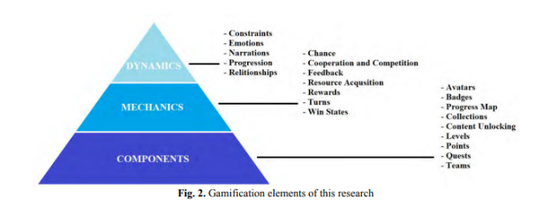
[4] (et al., Karamert & Vardar) This is a study that was conducted in 2021 to see what the effects of gamification on mathematics is in school. This study was conducted to 46 fifth-grade students to see if there were any differences on their performance or attitude towards mathematics after the gamification. In this test they used a pyramid design model in which it shows what they had in the test to see if any of these factors affected anything.
Figure 1[4]
As seen in the image we can see that had 3 different sections: Dynamics, Mechanics and Components[4]. Within these sections we can see what is in them, in Dynamics they used: constraints, emotions, narrations, progression and relationships[4]. In the Mechanics they used: chance, cooperation and competition, feedback, resource acquisition, rewards, turns, win states[4]. Finally in components they used: avatars, badges, progress map, collections, content unlocking, levels, points, quests, teams[4]. These are all the gamification elements they used to conduct this study. There are things in here relating to the questionnaires and as such asked those questions appropriately as needed.
In this study they had a control group of 23 and an experimental group of 23[4]. After the tests were conducted, they found that gamification was a positive influence on the students as it is shown that the academic achievement was statistically higher, and this is further seen in the group that did use gamification elements did see an increase in their achievement test scores compared to the group that didn’t use gamification.
In terms of the attitude of the students, this study concluded that there were no major differences between the two groups, even when compared within themselves, there was no major difference found, concluding and supporting this[4]. The gamification elements are thought to be interesting enough that the students do actively increase their participation in the mathematics course.
This is helpful for this project because it shows what the effects of gamification are on students, this shows what sort of features would be good to implement that keep the users attention for more periods of time. It shows that features like rewards and customisation helps the users because the gamification elements were shown to improve their academic performance compared to the group that did not use the gamification.
[5] (et al., Lukman H, Agustiani N, Setiani A) Gamifying mathematics is the subject of this review paper and discusses if it is valid, practical and effective. This paper discusses how they will create an education mathematics game that is aimed at students and see what the results are and if it is better or worse.
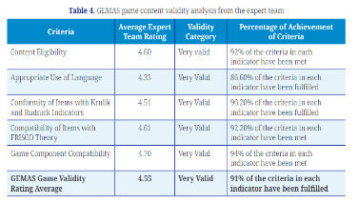
In this paper they talk about the meaning of gamification and if it is effective. From the research they conducted for this paper, they have stated that gamification can increase the learning motivation of students and has seen a positive impact on student learning.
Table 2[5]
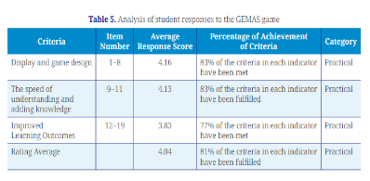
They did test to see if it will be valid, practical and effective, they measured these in different tests to individually see if these criteria would be met. For the validity we can see that everything they tested for is “very valid” meaning that each one of these criteria is good.
Table 3[5]
For the practicality test they conducted we can also see that each criterion was concluded to be practical as well. This ranges from: display and game design, how fast they understood, how the students improved and how they rated on average.
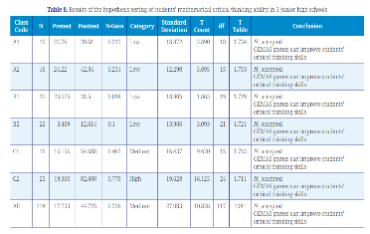
Similarly, with effectiveness and practical we can see that each conclusion is that the games can improve the students critical thinking skills, now this is important because it further shows that educational gaming is effective and can be used not only for that specific subject but also to improve the students as well.
Table 4[5]
Whilst they were conducting this study they reported that there were some problems which could cause harm to teaching, firstly one of the big problems is that the environment for teaching is completely different if taught this way, the teachers now must have more control over each student and avoid any problems that this can come with such as addiction, keeping track of every device so that nothing gets broken, it is also difficult to keep an eye on each student individually while they are learning this way. They go on to mention that personality traits are crucial in knowing if this will be effective or not, they state that introverts who use gamification are more likely to get involved as their ratings were better than the students who were extraverted but also recognises that further research would need to be done to fully see negative effects.
For the results the paper concluded that gamification learning is valid as a way to teach and thus meaning that this can be used as an official learning method for teaching, in this scenario, they go on to state that the gamification has many positivise from their research such as a major increase in the students abilities to problem solve as well as critically think about mathematics and it does this because it increases problems that require critical thinking.
This is showing that gamification could end up being a great addition to learning because like [4] it shows that gamification has a positive impact on the students that used it as it increases the students abilities with mathematics.
[6](et al., Alt D) There is a big sample size in this with 779 students from 7th to 8th grade with 374 being male and 403 being female participating and further showing the effectiveness of the gamification of mathematics. In this study they used four different ways to measure the effectiveness of the gamification, they had a problem-based gamification a non-problem-based gamification a face-to-face problem-based activity a face-to-face non-problem-based activity[6].
Through their research they found and backed up their findings by cross referencing with other resources to further prove what they discovered. They discovered that the effectiveness of problem-based gamification was higher than the other tests they conducted as it shows that the benefit of gamification is more appealing to the students because it increases their playfulness[6]. However, they do note that gamification does not make it easier for the students to be motivated to play and found that there is little correlation between the gamification raising engagement and the gamification not raising the engagement[6].
This study also shows that just using an educational game doesn’t necessarily mean that that students will automatically be engaged in it. There must be a learning reason to do this otherwise there will not be any additional motivation to the students than doing this in a non-gaming way[6]. This suggests that making it an educational game is the solution to their problem as this would give a learning reason for them to actively engage in the game.
[7](et al., Meylani R) For this study they note that the objective is to see how gamification as well as game-based learning effect students and they do this by having inclusive, equitable and high-quality education in mathematics[7]. By doing this they will be able to see if gamification is usable as a sustainable learning method.
They learn that the design of the game is very important and give different reactions to different students depending on what is in the educational game, if there are leaderboards, points, badges, objectives etc, then the students will be more competitive and engage[7] more in the elements present in the educational game. Game-based learning does have a big impact on mathematics, as shown from some of the previously mentioned studies discussed this will show that it is supported by research, and it shows that it helps the students with their problem-solving skills as well as their critical thinking skills.
Furthermore, with their study they mention that in comparison to traditional teaching methods, gamification does show improvement to the students, thus confirming that the students do perform better with higher engagement. However, they note that during their research they mention a study[8] that mentions the importance of having a teacher[9] and that a teacher helps with support for the students when needed and this also helps with students who don’t quite understand or are falling behind.
In the conclusion of their study they go on to mention the gaps in research that currently exist pertaining to gamification of education, there are no tests that show what the long term effects of gamification could be on students that only learned this way and whether they are positive or negative as every test is currently done for short term statistics, there are also little amounts of research on how this realistically effects teachers and people training to be new teachers as this would have a big impact on current teachers if they are unaware of how to do this correctly as it will take a lot of training to become efficient in gamification[7].

Design and Development of Educational Game
[10](et al., Lozano, Canlas) Developed a mobile game used for mathematics and had students and IT experts test the application. Their purpose for doing this study was to create a mobile game to help practice mathematics. They had 60 students from grade 10 and 3 IT experts who had at least 3 years of experience in the industry and had previously developed educational software.
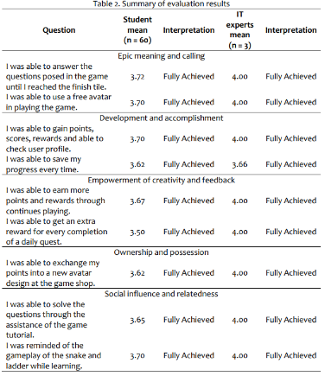
In this review as visible in the image we can see that the application made for this was successful, we can see that the IT experts really did like the mobile game that was created and the only differential in the second column, for the students their highest mean was for the first column which is being able to essentially play the game and that it works[10]. The other columns do well with the students as well. We can also see that everything was fully achieved, this means that their mobile game was able to implement all the features they wanted.
Table 1[10]
In this paper there are mentions of the practical implications of what this successful mobile based educational game could have on the education industry[10], it suggests that this can transform education by enhancing as well as having the users be engaged in the experience.
[11] (et al., Hidayat R, Qi Ying T) An online based game about learning mathematics in education among gen z. In this paper they discuss that Covid-19 did play a big part in online education because everyone had to stay at home and because of this game-based learning did play a part in helping teach during this period. There are already online games that were/are used in the classroom such as Kahoot. Kahoot is a quiz game where each student joins the game and can pick an answer and at the end there is a winner determined on how fast they clicked the answer and how many questions they got right, implementing a leaderboard of sorts.
n their literature review and analysis they did they discovered that game-based learning does have the ability to [11] facilitate meaningful learning experiences for the students it accomplishes this by including certain elements such as challenge, curiosity and fantasy[11]. There were some issues however with doing this, they found that there were some interesting findings from the students when they were using game-based learning. These include that students were interacting with the other students less and this led to more meaningful and reflective learning[11] from them as interacting outside the game led to more distractions thus the students were less focused on the game.
Continuing with their findings they say that students did prefer game-based learning for the mathematics because it helped them making it more an enjoyable experience for them as well as changing their mindset in terms of how to tackle the problem[11]. Furthering this point, research suggests learning mathematics through game-based learning allows the students to choose different approaches by using different strategies to help come up with new solutions. Their concluding thoughts further back this claim that students did enjoy learning mathematics this way by being more engaged and more enjoyable for them[11].
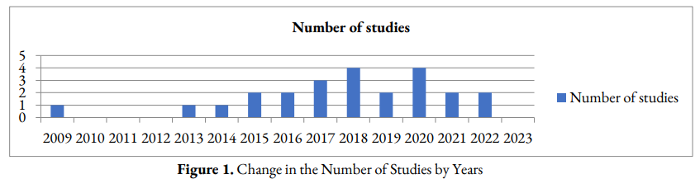
[12] (et al., Barbaros S, Saygr E, Akar Aengil S 2024) This study is about the research they did on other articles to see if gamifying mathematics in education is good. In this study they evaluate 285 different articles from which they searched for specific criteria for mathematics and gamification in education[12].
Figure 3[12]
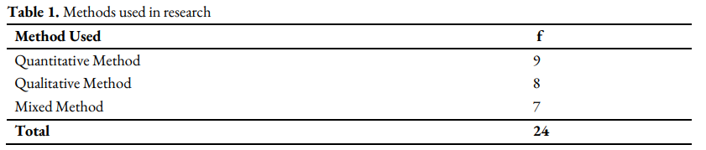
After all their filtering with the criteria they found 24 articles that fit the criteria. In this graph you can see when the studies they researched came out and 2018 and 2020 has the most, but as you can see there is a balance from 2017 until 2022, so there is a big-time difference here as a lot of technology has evolved in that time, massively including AI. Next, we can see the methods that were used in the different articles they researched with 9 being quantitative and 8 being qualitative whereas 7 used both methods[12].
Figure 4[12]
Further in their research they talk about how game-based learning is again beneficial to mathematics in education being a preferable method of being taught mathematics in education[12]. In these articles it is also mentioned that the games in these articles are electronic based and not physical.

Influence of Individual Differences
[13](et al., Smiderle R, Rigo Jose S) A discovery was made with this paper that shows there is a link between personality traits and how well the students perform when using a gamification. Mentioned in this study is how this affects women[14] (et al., Christy K, Fox J) and the negativity and opposite effects that it has on the men. Because there is a mix of good and bad results, they have concerns about how effective gamification in education really is.
The participants for their test were first year university students who were in the computing course with 40 students 7 female and 33 male ranging from ages 17 and 34. They measured the effectiveness by keeping track of how many times they logged in, badges, points as these are elements, they implemented for this. They measured the programming by accuracy to see if there was any improvement or anyone getting worse[13]. They had each participant take a personality test to see which type they were (they used IGFP-5),
The points were visible to the students so they could see how many points they would earn if they completed a task successfully and they can see if they lose points by submitting incorrect work etc. The badges[13] were given through challenges that the students could complete if they chose, they had bronze, silver and gold and these were awarded for specific challenges such as how many times a student logged in, how many times they successfully completed a task etc. Lastly there was ranking and ranking is simply how many points did the students earn total throughout the whole test[13].
The students who used the gamification educational game on average scored more points, badges and logins than the non-gamified students, it also showed that they were more engaged and saw significant improvement in the work that they submitted as well as having more accuracy in the work they did submit[13], so this suggests that it does work. However, in their findings they discovered that the introverted students performed better than the extraverted students in points, medals and logins, they also had higher accuracy in their work[13]. This further proves that the students personality types do indicate how well they can perform when using gamification.
[14] (et al., K. R. Christy, J. Fox) This study primarily focuses on how different genders are different when it comes to how successful gamification of education is to them. This primarily looks at leaderboards and how it effects people differently based on gender. Having a leaderboard in an education setting here is said to be a negative because it may create an environment for social comparison[14] and this can cause a negative effect on the performance of students. Having a leaderboard that everyone can view could potentially cause issues with stereotyping in that people can see who is worse and see that women perform worse.
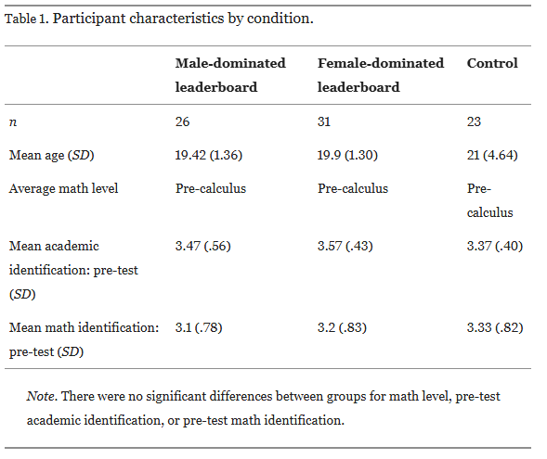
For this test they had 80 women aged 18 to 41 who were all students where they all played the educational video game where in the game, they took a math quiz[14]. The women who had the male dominated leaderboard ended up performing better than the women who had the women dominate leaderboard, because of this there is merit to saying that a leaderboard could potentially cause issues between genders as they may feel more pressure, and more being stereotyped.
Figure 2[14]
So with study it is worth noting that we only know the effects of women as no men were involved in this study and because of that we cannot know if the same negative effect applies to men in this case, however knowing that it can effect women negatively if they see a women dominated leaderboard then it is worth considering if a leaderboard would be a good addition, although the opposite could be true in that having a leaderboard of both could have no impact and be a positive.

Attitude, Engagement & Cognitive or Social Factors
[15] (et al., Hui Bii H, Mahmud Sofwan M) In this study it is noted that from their research game-based learning does have positive impacts with students when learning about mathematics[15].
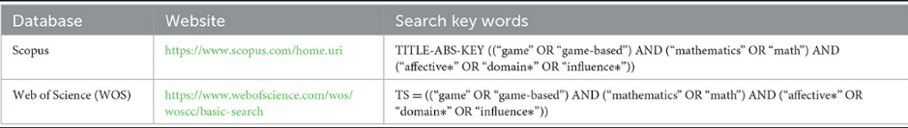
They discuss their process of how they came to this conclusion with their own tests. They discuss doing their own research and looking at all the other articles they could find and found 773 in total that had the keywords “game, game-based, mathematics, math, affective, domain, influence[15]“, these keywords were crucial for their research because it helped them discover and narrow down their search for relevant and helpful information. They further narrowed their search by having articles after 2018 specific journals.
Table 5[15]
Game-based learning affects the students cognitive function in many ways such as “attitude, motivation, involvement, interest and confidence”[15], all of these are positively affected by the game-based learning. For mathematical[15] activities they found that it provides the students with a big boost to their engagement in it as well as communicating during these activities which helped the students with any problems they may have encountered.
Learning mathematics in the game-based learning way was found to be different than learning in a more traditional non-game-based learning way, as the game-based learning way promoted an environment that helped with the students learning progress because the game had content with knowledge[15] and this made for an easier leaning environment for the students.
It is worth noting that the teacher in this test did however find it difficult to help the students in a personal way that catered towards what they needed, because of this it was a concern that while the students would be learning, if they struggled with anything the teachers would be unable to help in the game format as that would require the teacher to learn how to design and create personalisation tools for the game. This is a big factor because it would require a lot of time and preparation and could result in a time waste for teachers that they could be teaching in a more traditional manor in much less time.
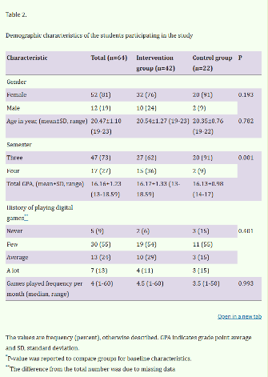
[16] (et al., Khoshnoodifar M, Ashouri A) The discussion in this paper is to see and learn about how gamification could enhance learning and attitudes of students. For this they had 64 students, 42 students were in the “intervention” group and 22 students were in the “control” group. The intervention group had the gamification, and the control group had traditional learning[16].
Table 6[16]
For this they had a “narrative, avatar, level, point, progress bar, scoreboard, challenge and feedback[16]. All these elements are crucial in understanding if any of these do change anything for the students, they measured their attitudes before and after too.
In their study they discovered that there were no significant differences[16] between the two groups in terms of learning[17](E. A. Boyle, E. W. MacArthur), however the students did have differences elsewhere, the students that used the gamification saw an improvement in their attitude in terms of difficulty of the tasks, this effected statistics as well as their cognitive function, however this was to a weaker effect. They later go on to mention from their research that gamification does not improve the students learning, but the students who had learnt in a gamification environment did have better learning[18] (D. Delgado-Gómez, F. González-Landero).
From their own tests they saw that students attitude towards statistics was improved, this was because of a narrative in the game, this narrative was to see the usefulness of the player and to see if they were helping the other students and this had a positive impact on their attitudes of statistics[16]. Having features like points, feedback and a scoreboard[16] impacted the students attitude of their cognitive competency and this is because they need to have satisfaction[19]. Having guides and tips to help in game and even with the presentation of these did lead to increased engagement and interaction[16].
Gamification was seen to be favourable for the students with the tests noting that they say improvement in knowledge, feedback and social interaction[16], however even with the students satisfaction they did not have satisfaction with the emotional aspect this is because the gamification is limiting because it’s not an actual game made for entertainment so they struggled seeing it this way[16]. If there was any feedback, focus or/and challenge[16] given by the students in the gamification environment it shows that this was because it correlated with the students learning. It is also crucial that the students pay attention and don’t get distracted because if they do get distracted then they will be unable to see the clues hidden around to assist them with the challenges[16].

Research and Development Methodology

Questionnaire results
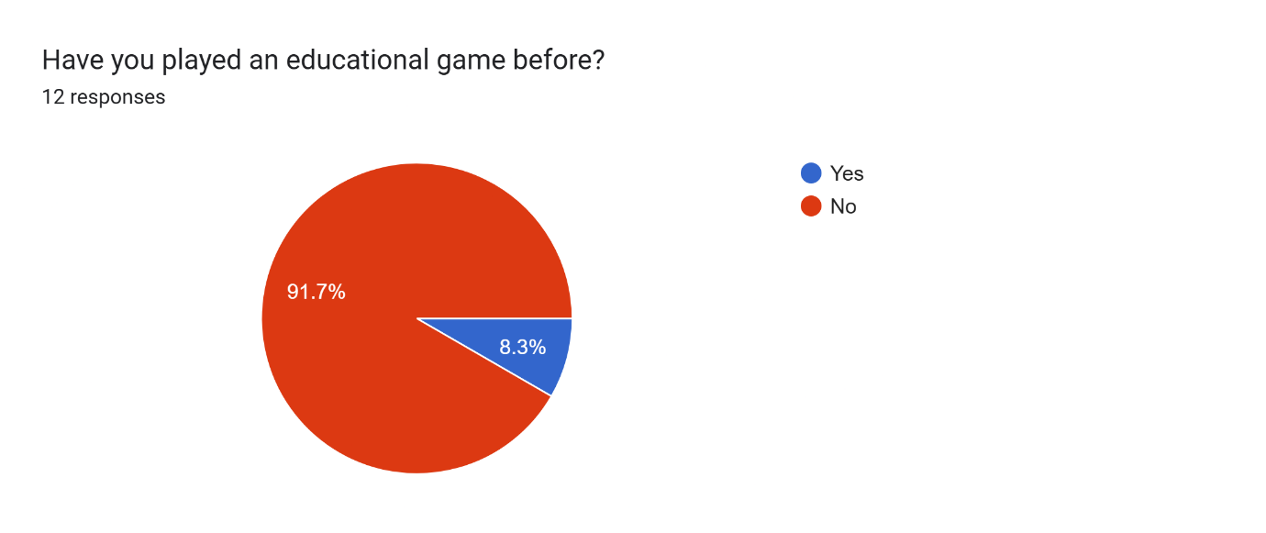
This is the first question; from this question we can see that from the people that answered the question a majority have not played an educational game before. This does make it difficult to take the answers with more than a grain of salt because they haven’t played an educational game before, however this is still valuable to know because with the other questions, it shows what they would like to see in an educational game and perhaps that would make people who haven’t played an education game before maybe consider playing one if it has stuff in it that they like. So, with this information it is going to be used to show that there could be interest in educational games with all the other questions.
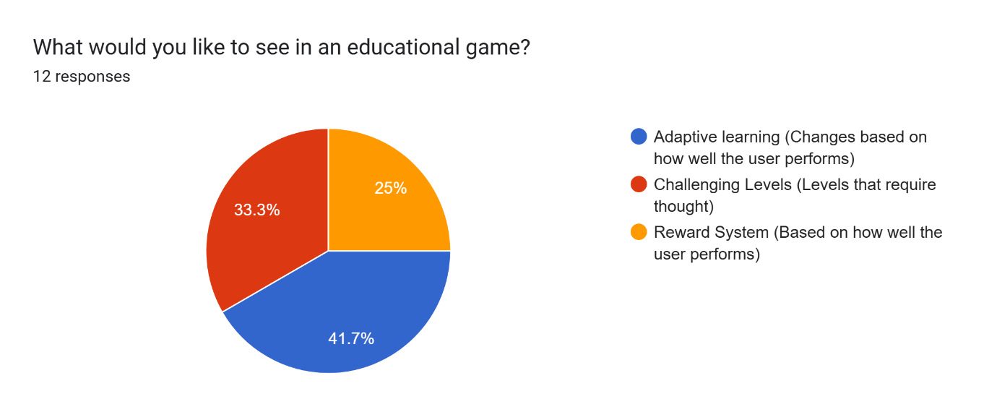
With this second question we can see what the people who answered would like to see in an educational game. There were 3 different choices to pick from: adaptive learning, challenging levels and a reward system. Going through these 3 choices adaptive learning has the most votes, what this means is the level will change difficulty depending on how well you did in the previous level. This would be performance based and for example, it would track how long it took, how many clicks etc.
Then there is the 2nd most voted and that is the challenging levels, what this means is that the levels are thought provoking and not something to auto-pilot through, making them useful for learning because of the difficulty. There could also possibly be a choice for selecting to start on more difficult levels so that there is immediate challenge instead of having to build up to a difficulty.
The 3rd, least voted option was a reward system. Having a reward system in place gives people something to strive for and show that they did complete certain tasks which give a reward to the user. This one would be difficult to implement in a short period of time; however, it would be something to consider for a version 2 of the educational game and not something that is required for the first initial release.
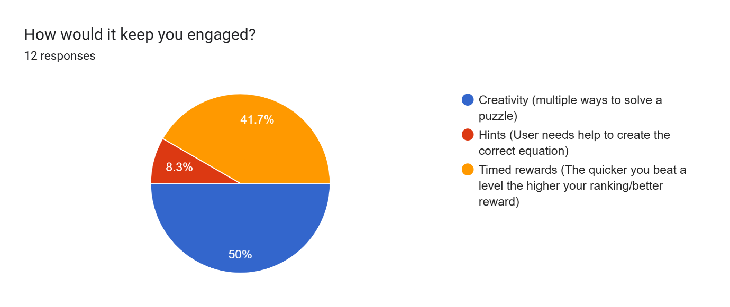
This is a question about engagement levels and what the educational game could do to keep the user engaged in the game. The most popular answer is creativity, the meaning behind this creativity is so there are multiple ways to solve a puzzle. This would be an amazing way to make sure that the game is not repetitive in any way as you can get the answers by using untraditional methods thinking outside the box instead of the easy and obvious way. This could also include rewards from the previously mentioned rewards system to show that you as the user have used creative thinking to solve the puzzles.
The second choice was timed rewards, this is admittedly like the reward system from the previous question, however this is more tailored towards speed. What is meant by that is these rewards are only for the speed of the user, such as how quick you can solve the level and thus ranking better on a theoretical leaderboard that could be implemented to show how you compare to other users.
Lastly, we have the least popular choice with only 8.3% of users selecting which is hints. Now a hints system will be mandatory for a game like this to thrive and work. You need to give users who are unsure on how to solve a puzzle a way to help them solve a puzzle. Now this can be telling the user to use a certain number or a certain calculation or it could be more theory hinted such as saying something along the lines of “try using 3 numbers to solve this equation” as an example so it doesn’t tell the user the answer but leads them down the right path.

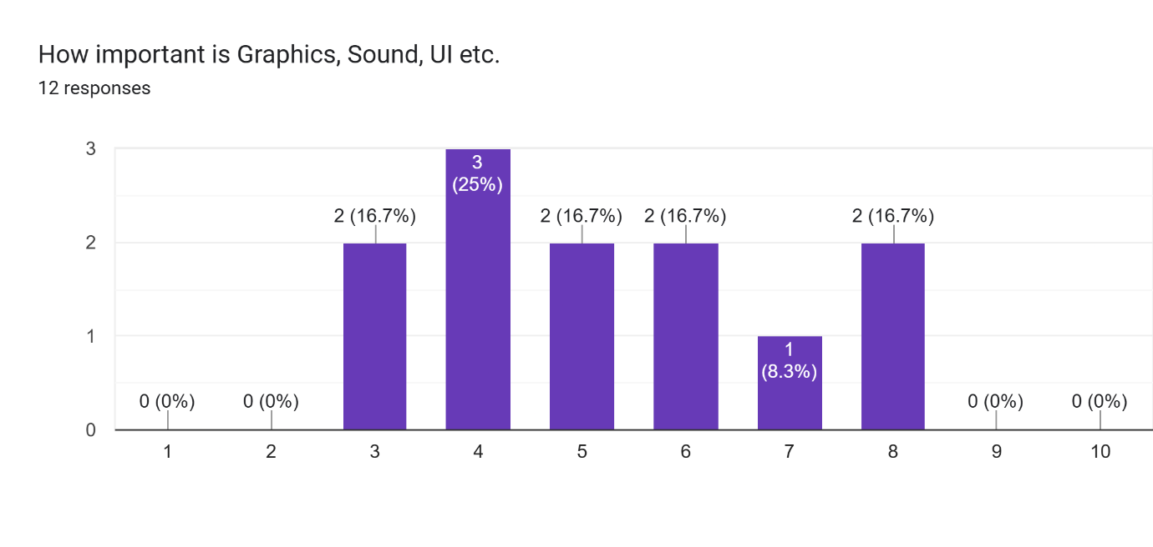
This was the last question of the questionnaire, using a scale of 1-10 for this one to figure out what percentage of the users think graphics, sound, UI are important to this educational game. So as visible above you can see that most people said 4. Now this is important especially for the early stages and a VP of this educational game because it shows that while there is some importance to these elements, it is crucial to understand that they can be minimised/less prioritised as a big main feature now because of these results. However, this does go up to 8 with 2 votes so there will still need to be an implementation of sorts and it should still however be a good implementation even if deprioritised.
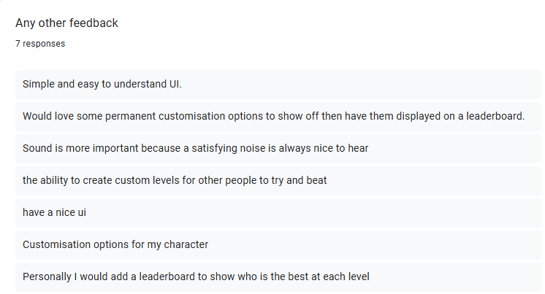
This was at the end of the questionnaire; it was just a section for people to put any additional comments related to the educational game. As we can see there are a few responses, not everyone had an additional comment which is ok as we still have 7 responses. The responses are quite varied in terms of what they want except there is 2 mentions of a leaderboard of sorts to “show off” any cosmetic and how good the person is at a certain level.
There are mentions of simple and easy to understand UI and this will be implemented so that the UI to be as easy as possible while maximising how well it is.
Customisation options will be a very nice addition to this education game; however, they are not a priority because the educational game will be able to run without them, but they are a consideration for a future version of this game.
Sound design is important and satisfying noises are good for the game because a nice soundtrack and noises to accompany the puzzles does make for a great environment with helping to solve them. Again however, the implementation of any meaningful noises and music into the game at this stage in development will be difficult.
Custom levels are another great feature that is on the radar in a later release version. Custom levels sound like a fun way to get a community of the game interested and people could make specific levels for specific difficulties that people are having that are not in a release version of the game. With the help of the community these levels could be become official levels and added to the game if there is enough demand and asking for them.

MoSCoW Method
The MoSCoW method[20] is very important to software development as it is a prioritisation technique, this stands for:
M – Must Have. The “must have” means that the software must have these features implemented for it to be complete and without them the development will fail.
For the project the must have is a title screen, tutorial whether that is showing the player what to do, or text telling the player how to play the game, a working functioning game that at the minimum is able to add, multiply, minus and divide numbers correctly as well as allowing the user to move their character and collect the numbers and operators to create the answer that is asked of them with no errors.
The reason these are must have features is because without them the basic understanding of the game for a new user will be lost upon them and could prove difficult for them to adapt without knowing what to do.
S – Should have. The “should” have part is what isn’t necessary for the software but would be great to have as it would improve the product.
For the should have in the project, looking at the questionnaire results a leaderboard would be nice to include so that the students can compare their scores with the other users to see who the better user is.
These should have features are not required for the game to be in a usable state however they vastly improve what it could be, as these features were requested through the questionnaire meaning users actively thought of these ideas and would like to see them implemented in a future release if they are not in the current version.
C – Could have. The “could” have part is what could be included in the software but isn’t needed for it to be working and should be low priority and added after.
For the could have in the project is a settings option with more customizable settings such as audio and graphics and resolution and those sorts of settings, these will be nice however they are not necessary but would be a nice addition to the game because it allows the users to change a few things they dislike.
These could have settings are more features that would just help the game such as audio and graphics settings, this is basically a settings button that is in most gaming applications, however this would be more simplified because it will include features such as accessibility only what is mentioned.
W – Will not have. The “will not have” is what isn’t currently needed for the software and will be added in a later version after everything else is complete.[20]
For the will not have in the project is customization, this was a big thing in the questionnaire however it will not be possible to add in the initial version of the game because it is not needed for the game to run but is something that will be added to the game in a later version after the initial release.
These will not have settings are more features that would just help the game in the long term as being able to customize your settings to your personal liking will improve the user experience because it will be tailored to them and this can be improved even more by making almost the whole game customisable with settings such as colours and accessibility.

Project Design

Data Collection Methods
The data collection methods used will be all research based. Case studies will be used to see if there are any major or minor differences between students that use an educational game and students that don’t. Comparing the data will be extremely useful in determining what changes will need to be made to make learning through games more effective. Using this method for all objectives will be crucial because the practical feedback will be difficult to obtain due to not having students to teach or a project to give. Research feedback will shape the independent project; these will however be researched very deeply to see what connecting factors there are to use when creating the educational game.
Credit will be given to the researchers whenever any of their research used is applicable. The statistical analysis methods used will be a varying amount, regression analysis to see if there are any correlations between specific things, independent sample tests which will put students who use educational game against the students who don’t.

Methodology

Method
For this project the goal is to measure the usability of the educational game. The reason usability was chosen was because of how different people react to an educational game, the questionnaire shows that most people have not played an educational game before, meaning it will be a new experience so timing people and seeing how many clicks it takes to complete a level will be an effective way to test that. There will be a quick tutorial to familiarise people with the concept of the educational game before they start playing just so they understand what the objective of the game is.
There is a lot of research as seen in the literature review section on how effective and how ineffective educational games are and there are pros and cons to this style of teaching, however through the literature review we can see that this does seem to have a positive effect on students under the right circumstances.
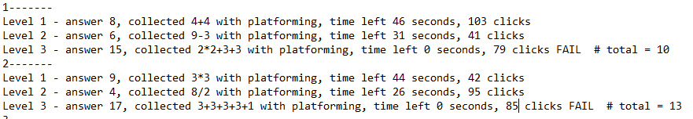
Here is an example of the data taken from after the test from one of the users, as stated each of the 6 users did this 8 times and this shows what the results were for two of the tests from one user.

Research Onion
For the philosophy, interpretivism has been chosen because it interpretates the actions of the user and what their experience is[21], so this will be helpful with the usability of the educational game because it will show what the users experience is with the educational game.
The approach of the research onion will be inductive[22]. This is because it better fits with what this project will be researching as the questionnaire will help determine certain answers needed for the creation of the educational game and will be built around the needs of the users of the questionnaire. Collecting the data and then developing the theory of this project around the research.
In this project both qualitative and quantitative will be used, however quantitative is what was used mainly because of the questionnaire, the questionnaire was used to gather data to see what would be needed in the educational game for it be successful, it also shows what could potentially be added to the educational game in a later version of it[23].
The research strategy will be difficult to perform in a real classroom due to time constraints with this project, however there will be testers of the game but it will be outside of a learning environment due to ethical considerations and because of this the project will have to be research based and will have to draw conclusions from the research that will help with this project[24].
With the techniques and procedures section of the research onion, there will be data collection methods used here which will help with analysing the data from the research and this feeds into the usability because it will be looking at how the users perform in game as well as having a questionnaire which will help determine certain aspects of the educational game[25].

Usability Measure
One of the ways usability will be measured is by potentially having a timer in the game to see how long it takes a user to complete one equation and see if the user did it quick or slow and compare each user to see the average time to complete a level. Clicks per level would also be a nice way to see how many it takes for each user to see if the user is having trouble or difficulty completing a level. The number of times retires per level, to see how many times the user potentially makes an error and must restart of even restarting just to see if they can have a different set of numbers show up for easier completion.
Looking at the questionnaire results, the educational game was built around the results of the questionnaire, as writing previously these questions were used to determine what needs to be implemented in the game for its initial release version. In this project it was made sure that the results were taken into consideration, and the top results were attempted to be implemented within the time allocated. However not every feature was implemented due to time constraints.

Design & Implementation

Requirements
The requirements for this project were to make the educational game. The process of creating it was a long and difficult process because it was very difficult to start creating a game from scratch. The previous lectures were helpful for this task as they showed how to start creating a new game/project from scratch. Using what was learned in the lectures was crucial in knowing how to start creating this project, while they didn’t fully help, they were a good start for creating this educational game. Visual studio and c++ were used to create the educational game, there were online tutorials that were used as well as some help from AI to create the game.
Visual studio and c++ were chosen because of familiarity and were taught to use in the lectures, unreal engine was considered however due to not being familiar enough with how it works was not chosen. It was a requirement to look at the questionnaire and see what could be added from it to the game. Everything added to the game was because of the questionnaire.

colours.h
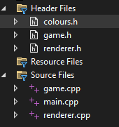
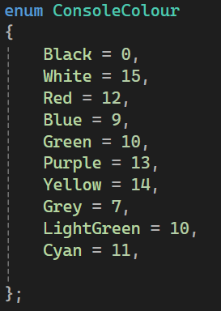
To begin creating this project, the files were created to set the blueprint for what would need to be done. Here are the necessary flies that were created for this game: “colours. h, game.h, renderer.h” are all header files that were used when creating this project. The reason for all of these is to properly implement these features. Starting with colours.h this was used to give colour to the game, when creating the game it was initially just in black and white as default, however giving it colour where needed was a nice addition to add. As visible through the code “ConsoleColour Enum” was used. This is because it is a simple way to add colour to the project as it comes with predetermined values for certain colours and this offered more than enough choice for me to choose from when adding the colour to the project.
This effects the overall game in a big way because it adds colour, the colours make everything easier to see as you can see a colour and know what it is. Everything has its own set of colours so an operator and a number will not have the same colour so you can easily distinguish the difference.

game.h
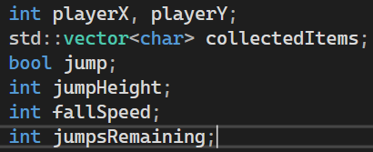
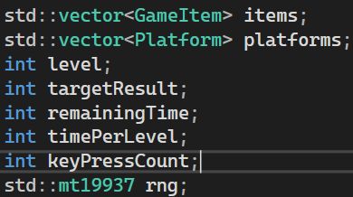
Next is game.h and for this is used for implementing everything into the game such as the numbers and platforms. This is the file where all the structuring happens. This is for the numbers and operators known in the code as items as they are collectables. This is also where the dimensions for the game are applied as well as the player properties such as jumping, jump height, how fast you fall and how many times you can jump in a row. This is where the data for level information is stored so what level you are on as well as what answer you must get; the timer is in here and the key press counter. This is where the numbers are also randomly generated using the mt19937 rng (random number generator)value.
The way this effects the game is it makes sure that the platforms and numbers are placed within the level in a way so that it should always be completable. This part also keeps track of the player properties so that the game knows how high to jump and to keep track so that you as the user can only jump so many times to make sure the user stays within the boundaries of the game level. The timer and key presses are valuable here as they will be used to keep track of the usability of the game.

renderer.h
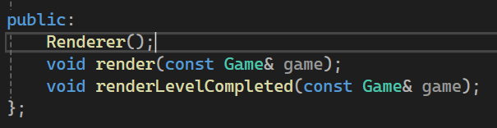
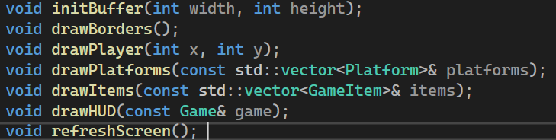
Renderer.h is used for giving the definitions to each class that is used to display the game on your screen. It uses what is in game.h and then displays it for you the user to see, it does this by rendering the screen for you. As visible in the image it is used to draw all the elements such as the player, the border, the platforms, items and the HUD. Furthermore, with this you can see a refresh screen, and this is used to stop the screen from flickering and keep it consistent, so it does not hurt the users eyes. The game and the end of level screen are also rendered here. This is where all the rendering happens and because it is in a separate file, it allows me to edit any errors without messing up any of the underlying code that could affect the game.
This uses what is in the coding and then displays it for the user to see, this effects the game because without this there would not be anything displayed on the screen for the user to interact with, there was a lot of troubleshooting to be done with this section because there were a lot of errors with displaying certain aspects of the game, as mentioned screen flickering was a problem that made the game unplayable, but was a top priority of errors to fix. The HUD is displayed through this section so it was important to make sure that it worked well and was clear to the user what was being displayed.

game.cpp
In game.cpp this is where all the declared functions in game.h are implemented into the game as seen in the game.h section. While game.h created these, game.cpp is where it gets created on the screen, This is where the random level generation happens to ensure that every level is random to the users, the detection for platforms so that you are able to jump on them, the mechanics of jumping and falling and the difficulty which does scale with less time, harder sums and more platforms making it more difficult each level. Here it handles all the procedures for the operators as well.

main.cpp
The main.cpp is where the main game loop is located, this will initialise the game as well as making sure the timer is working correctly and steadily counts down a second at a time. The main file is where all the other files that are made come together to get the game running, the separation of the files makes it easier to manage the main file. It also handles the key inputs, the frames so that it remains consistent and doesn’t flicker, the transitions between the levels and quitting the game.

renderer.cpp
Finally, the renderer.cpp file is where it implements what was in the renderer.h file, this is where all the screen rendering will happen for the visual aspect of the game, this handles how everything is displayed such as the platforms, numbers, operators, draws the borders that are used as well. Everything has a colour to show that there are differences between it all. It shows the HUD such as the level, the timer. It uses ASCII characters to render the game because it is console based, and this is the foundation of the game because everything is represented by this.

Game
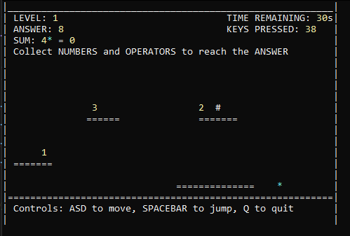
Here is what the game looks like once running as visible you can see that it renders the level for you to complete. The HUD elements on the top are clear and show what level you are on and what answer you need to get it, it also displays your current sum which is what you have currently collected, it also shows the time remaining on the level as well as the keys pressed which is used for the usability and does not affect the gameplay in any aspect. It shows the control scheme at the bottom of the screen, displaying how to move, jump and quit the game.
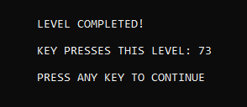
Next, we have what the level complete screen looks like. This simply shows up after you complete the level you are currently on and shows how many key presses it took the user to complete the level and then the user presses any key, and it will bring them to the next level which will be more difficult with each level meaning you are required to complete the levels without any errors.
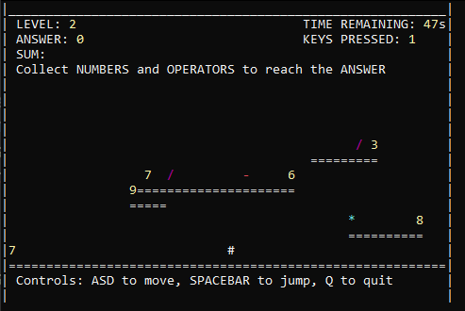
This screenshot simply shows a level 2, and it is intended to be more difficult than the previous and this screenshot shows this because every level must be completed with no errors as there is no retry button and this level shows that the user must be able to platform effectively to avoid collecting the wrong numbers and operators.
Then the process just repeats for every level that the user completes until they fail a level or run out of time. This is the current first version of the game and it is simply a demo of sorts to show the baseline of the game and what it could play like.

Evaluation
Unfortunately, due to time constraints, the same amount of people who tested the game was not the same amount of people who did the questionnaire, 12 people did the questionnaire and only 6 people were able to test the educational game. This does affect the results of the data collected from the game, however there was still data to be extrapolated with the results that were gathered.
From the testing, the measurables were to see how many clicks and how long it would take the user on average to complete a level. There are some factors here to consider when looking at this data. The numbers, operators and platforms and the answer are randomly placed on the map so in theory someone could get a very easy level as their first and complete it in a few seconds and another user could get a difficult level requiring more than 2 numbers and more platforming.
To combat this issue effectively everyone played the game 8 separate times to see if there was any consistency to clicks and how long it took for certain numbers big or small and if it is because of the randomly generated platforming or the difficulty. It is also worth noting that I didn’t take a test before to see how good their mathematics skills are, so the results could be skewed because of the difference in mathematics skill between each person, this would likely result in less levels complete as well as less time left per level. This is a good thing however because it shows if this is helpful to the users or not and tests their mathematics knowledge.
So, the conclusion from the data gathered was that there actually was consistency between the users who were testing the educational game. Now there were averages for each person made from the 8 tests that each person did and then were looked at as individual data seeing if there was any overlap in answers to see of there was any similarity there and then seeing how long it took them to complete each level in general as well. Knowing what the answer was did impact how long it took some people to complete a level depending on of it was a big number or a small one, the small ones usually took much less time and key presses as they were statistically easier for each user compared to the bigger numbers which were sometimes too difficult for the users and would fail the level.
This did in fact back up the literature research that was completed for this project, as the majority showed that it was better for the students who tested gamification. For this all the testers found it way a more enjoyable way to learn mathematics, but the game that was made for needs much more refining than it currently has as it is missing a lot of features which would help with learning. The literature research also showed that gamification was on the rise and the testers had said that they would be interested in learning mathematics this way because it feels new and could be more interesting to learn this way once all the features would get implemented such as leaderboards, custom levels etc.
After doing all the research and then testing with the game that was created for this project, the answers were predictable, and it does align with what was researched. There were a few things that were unable to get tested to get an answer on such as if it did make the users learn better, but from the test and the research, this shows that it is going in the right direction in that the users did feel more confident and paying more attention to the game then they did when they were learning mathematics before and this does line up with the literature research. Of course this is not an accurate enough assumption to make, but through the research suggesting it and the testers agreeing, that it is most likely correct.
If this project were to be done again, the expectation would be to make sure that the all the needs from the questionnaire were met so that the users can have a full experience from their feedback. Having more users partake in the test would have been nice because the more users that you can test with the better the results and more consistent, they would be as well. Creating a questionnaire for the people that did test as feedback one would also be a great addition to this because it would be evident what needs improving and what needs changing based on their feedback.

Conclusions & Recommendations

Conclusion
Concluding this project, there was a lot of research done to create this and knowing that the research shows a potential positive future for gamification in education is a good step to prove that this project was worth creating, there are still a lot of details that need to be ironed out about this in the future such as the long term effects of this and what can be done to help teachers learn about this so they are still caught up and not left behind because they didn’t learn it before becoming a teacher for example.
From the research gamification has seen to improve students’ academic performance as well as their engagement with the mathematics. Their attitudes towards mathematics were also seen to shift more positively however this was not always the case. Research also suggests that your personality traits can affect your performance in gamification, gender also seems to have an impact on performance. Involving teachers is still crucial for the students to succeed as they will still teach, and the students will still learn as there is no shortcut to this. Long term effects are still currently unknown as it is very difficult to test this in a real environment as if it is detrimental then it will be unfair to the students that were taught this in that it could give them an advantage, or a disadvantage compared to students who were or were not taught this way.

Recommendation

Suggestions for further work
For the future it will be good to see what the long term effects are on people to see if there is truly a difference in how they learn or keep information, the short term effects seem to be good on some people, but it could still however be a bad thing overall unless more research is done to see the impact on people. Having teachers keep their jobs in one of the most important things to make sure happens as we do not want a scenario where a teacher does not know how to teach this way and not able to teach. There are many ways to help with this problem with one being to teach the teachers, now this itself has issues, but could be a good way to start with this as there are many ways to approach this, which is why if this were to happen there needs to be regulations in place to help with this sort of transition.

Reflection
In my time creating this project and creating the game, one of the first things to touch on is time management as I am not good at doing this as I learned with this task, everything to do with this task I did not manage well at all, and I know that I could have done a much better job at this if I had started doing this when it first got released to us instead of waiting some time before truly beginning this task. Having other modules to complete took up time for this as well so it was difficult for me to switch between them as I like focusing on one at a time, but for this task you must do it in between while doing the other modules, which was difficult for me.
The most difficult part was creating the game, through the other modules, learning to code was fun but I did struggle to remember everything about the coding. Creating this game was a huge challenge that I do think I could have done better. I was stuck with this at varies points and learnt that I really struggle at coding. Even after doing what I have for this project I am not satisfied with the game as I believe I could have done better if I really sunk my teeth into this with better time management. Overall, with the game presented here I am disappointed with myself as I don’t think it is as satisfactory as I had hoped, but I hope it is good enough to show the potential of what this could be like. I felt I never truly put the time into this and that it shows with the quality of the game.
Creating this document was a long road full of research and discovering more about this subject. Through the research I did learn a lot about educational games and that they are somewhat used and are in a testing phase right now, but I believe with all this research that there is a bright future ahead with gamifying education and the research shows this. Researching for this was a long task that took many hours to complete; however, I am satisfied with the research I have done for this project as I think it shows the dos and don’ts of gamification, and it has shined a light into this for me personally.
Through this document I have improved my research skill as there was a lot of studies and literature papers to look through and I feel that I now know how to more efficiently look through the papers and see what will be relevant to me or not, I do this by looking at the abstract and looking for certain keywords to see the relevancy of them to me. I felt I did this efficiently enough to where I personally feel my research was done well and shows what people are doing with gamification at this time as well as showing the pros and cons, fully understanding what this could to do people with gamification.

Bibliography
N. Smith and W. Howard. N. Smith and W. Howard. Of the requirements for the degree doctorate of education. Of the requirements for the degree doctorate of education. 2018. .
https://papers.academic-conferences.org/index.php/ecgbl/article/view/1593/1652

Coding help
https://en.cppreference.com/w/cpp/numeric/random/mersenne_twister_engine
https://www.sciencedirect.com/science/article/abs/pii/B9780123877666000347?via%3Dihub
https://en.cppreference.com/w/cpp/chrono/time_point/time_since_epoch
https://learn.microsoft.com/en-us/dotnet/api/system.consolecolor?view=net-9.0
https://www.youtube.com/watch?v=oJvJZNyW_rw
https://www.youtube.com/watch?v=T-scGi6a8Zw
https://www.youtube.com/watch?v=Df-U3BjlnDo

References

References
[1] R. Raja and P. C. Nagasubramani. R. Raja and P. C. Nagasubramani. Impact of modern technology in education. Impact of modern technology in education. Journal of Applied and Advanced Research Journal of Applied and Advanced Research 33(1), pp. 33–35. pp. 33–35. 2018. .
[2] B. J. Arnold. B. J. Arnold. Gamification in education. Gamification in education. Proceedings of the American Society of Business and Behavioral Sciences Proceedings of the American Society of Business and Behavioral Sciences 2121(1), pp. 32–39. pp. 32–39. 2014. .
[3] G. Thorsteinsson and A. Niculescu. G. Thorsteinsson and A. Niculescu. Pedagogical insights into the use of minecraft within educational settings. Pedagogical insights into the use of minecraft within educational settings. Studies in Informatics and Control Studies in Informatics and Control 2525(4), pp. 507–516. pp. 507–516. 2016. .
[4] Ö KARAMERT and A. KUYUMCU VARDAR. Ö KARAMERT and A. KUYUMCU VARDAR. The effect of gamification on young mathematics learners’ achievements and attitudes. The effect of gamification on young mathematics learners’ achievements and attitudes. Journal of Educational Technology and Online Learning Journal of Educational Technology and Online Learning 44(2), pp. 96–114. pp. 96–114. 2021. . DOI: 10.31681/jetol.904704.
[5] H. S. Lukman, N. Agustiani and A. Setiani. H. S. Lukman, N. Agustiani and A. Setiani. Gamification of mathematics teaching materials: Its validity, practicality and effectiveness. Gamification of mathematics teaching materials: Its validity, practicality and effectiveness. International Journal of Emerging Technologies in Learning International Journal of Emerging Technologies in Learning 1818(20), pp. 4–22. pp. 4–22. 2023. . DOI: 10.3991/ijet.v18i20.36189.
[6] D. Alt. D. Alt. Assessing the benefits of gamification in mathematics for student gameful experience and gaming motivation. Assessing the benefits of gamification in mathematics for student gameful experience and gaming motivation. Computers and Education Computers and Education 200200pp. 104806. pp. 104806. 2023. . DOI: 10.1016/j.compedu.2023.104806.
[7] Rusen Meylani. Rusen Meylani. Gamification and game-based learning in mathematics education for advancing SDG 4: A systematic review and qualitative synthesis of contemporary research literature. Gamification and game-based learning in mathematics education for advancing SDG 4: A systematic review and qualitative synthesis of contemporary research literature. 55(2), pp. e04567. pp. e04567. 2025. Available: https://sdgsreview.org/LifestyleJournal/article/view/4567.
[8] M. Höyng. M. Höyng. Encouraging gameful experience in digital game-based learning: A double-mediation model of perceived instructional support, group engagement, and flow. Encouraging gameful experience in digital game-based learning: A double-mediation model of perceived instructional support, group engagement, and flow. Comput. Educ. Comput. Educ. 179179pp. 104408. pp. 104408. 2022. Available: https://www.sciencedirect.com/science/article/pii/S0360131521002852. DOI: 10.1016/j.compedu.2021.104408.
[9] Abdul Jabbar, A. I., & Felicia, P. Abdul Jabbar, A. I., & Felicia, P. Gameplay engagement and learning in game-based learning: A systematic review. Gameplay engagement and learning in game-based learning: A systematic review. Original Work Published 2015 Original Work Published 2015 pp. 740–779. pp. 740–779. Available: https://doi.org/10.3102/0034654315577210.
[10] A. Lozano, J. C. Reister, K. Coronel, J. Canlas, J. Duya, R. Macapagal, E. Dungca and P. M. John. A. Lozano, J. C. Reister, K. Coronel, J. Canlas, J. Duya, R. Macapagal, E. Dungca and P. M. John. A game-based learning application to help learners to practice mathematical patterns and structures. A game-based learning application to help learners to practice mathematical patterns and structures. International Journal of Computing Sciences Research International Journal of Computing Sciences Research 77pp. 2212–2226. pp. 2212–2226. 2023. . DOI: 10.25147/ijcsr.2017.001.1.156.
[11] R. Hidayat, T. Y. Qi, P. N. B. T. Ariffin, M. H. B. M. Hadzri, L. M. Chin, J. L. X. Ning and N. Nasir. R. Hidayat, T. Y. Qi, P. N. B. T. Ariffin, M. H. B. M. Hadzri, L. M. Chin, J. L. X. Ning and N. Nasir. Online game-based learning in mathematics education among generation Z: A systematic review. Online game-based learning in mathematics education among generation Z: A systematic review. International Electronic Journal of Mathematics Education International Electronic Journal of Mathematics Education 1919(1), pp. em0763. pp. em0763. 2024. . DOI: 10.29333/iejme/14024.
[12] S. Barbaros, E. Saygı and S. S. Akar. S. Barbaros, E. Saygı and S. S. Akar. Games in mathematics education: Systematic literature review. Games in mathematics education: Systematic literature review. 2024. . DOI: 10.5281/zenodo.14599876.
[13] R. Smiderle, S. J. Rigo, L. B. Marques, J. A. Peçanha de Miranda Coelho and P. A. Jaques. R. Smiderle, S. J. Rigo, L. B. Marques, J. A. Peçanha de Miranda Coelho and P. A. Jaques. The impact of gamification on students’ learning, engagement and behavior based on their personality traits. The impact of gamification on students’ learning, engagement and behavior based on their personality traits. Smart Learn. Environ Smart Learn. Environ 77(1), pp. 1–11. pp. 1–11. 2020. . DOI: 10.1186/s40561-019-0098-x.
[14] K. R. Christy and J. Fox. K. R. Christy and J. Fox. Leaderboards in a virtual classroom: A test of stereotype threat and social comparison explanations for women's math performance. Leaderboards in a virtual classroom: A test of stereotype threat and social comparison explanations for women's math performance. Comput. Educ. Comput. Educ. 7878pp. 66–77. pp. 66–77. 2014. Available: https://www-sciencedirect-com.ezproxy.uwtsd.ac.uk/science/article/pii/S0360131514001195. DOI: 10.1016/j.compedu.2014.05.005.
[15] B. H. Hii and S. M. Muhammad. B. H. Hii and S. M. Muhammad. Influence of game-based learning in mathematics education on the students' cognitive and affective domain: A systematic review. Influence of game-based learning in mathematics education on the students' cognitive and affective domain: A systematic review. Frontiers in Psychology Frontiers in Psychology 14142023. . DOI: 10.3389/fpsyg.2023.1105806.
[16] M. KHOSHNOODIFAR, A. ASHOURI and M. TAHERI. M. KHOSHNOODIFAR, A. ASHOURI and M. TAHERI. Effectiveness of gamification in enhancing learning and attitudes: A study of statistics education for health school students. Effectiveness of gamification in enhancing learning and attitudes: A study of statistics education for health school students. Journal of Advances in Medical Education & Professionalism Journal of Advances in Medical Education & Professionalism 1111(4), pp. 230–239. pp. 230–239. 2023. . DOI: 10.30476/jamp.2023.98953.1817.
[17] E. A. Boyle, E. W. MacArthur, T. M. Connolly, T. Hainey, M. Manea, A. Kärki and P. Van Rosmalen. E. A. Boyle, E. W. MacArthur, T. M. Connolly, T. Hainey, M. Manea, A. Kärki and P. Van Rosmalen. A narrative literature review of games, animations and simulations to teach research methods and statistics. A narrative literature review of games, animations and simulations to teach research methods and statistics. Comput. Educ. Comput. Educ. 7474pp. 1–14. pp. 1–14. 2014. .
[18] D. Delgado-Gómez, F. González-Landero, C. Montes-Botella, A. Sujar, S. Bayona and L. Martino. D. Delgado-Gómez, F. González-Landero, C. Montes-Botella, A. Sujar, S. Bayona and L. Martino. Improving the teaching of hypothesis testing using a divide-and-conquer strategy and content exposure control in a gamified environment. Improving the teaching of hypothesis testing using a divide-and-conquer strategy and content exposure control in a gamified environment. Mathematics Mathematics 88(12), pp. 2244. pp. 2244. 2020. .
[19] M. Sailer, J. U. Hense, S. K. Mayr and H. Mandl. M. Sailer, J. U. Hense, S. K. Mayr and H. Mandl. How gamification motivates: An experimental study of the effects of specific game design elements on psychological need satisfaction. How gamification motivates: An experimental study of the effects of specific game design elements on psychological need satisfaction. Comput. Hum. Behav. Comput. Hum. Behav. 6969pp. 371–380. pp. 371–380. 2017. .
[20] S. Vijayakumar. S. Vijayakumar. Assessing the effectiveness of MoSCoW prioritization in software development: A holistic analysis across methodologies. Assessing the effectiveness of MoSCoW prioritization in software development: A holistic analysis across methodologies. EAI Endorsed Transactions on Internet of Things EAI Endorsed Transactions on Internet of Things 10102024. .
[21] H. H. Alharahsheh and A. Pius. H. H. Alharahsheh and A. Pius. A review of key paradigms: Positivism VS interpretivism. A review of key paradigms: Positivism VS interpretivism. Global Academic Journal of Humanities and Social Sciences Global Academic Journal of Humanities and Social Sciences 22(3), pp. 39–43. pp. 39–43. 2020. .
[22] L. K. Soiferman. L. K. Soiferman. Compare and contrast inductive and deductive research approaches. Compare and contrast inductive and deductive research approaches. Online Submission Online Submission 2010. .
[23] J. Brannen. J. Brannen. Combining qualitative and quantitative approaches: An overview. Combining qualitative and quantitative approaches: An overview. Mixing Methods: Qualitative and Quantitative Research Mixing Methods: Qualitative and Quantitative Research pp. 3–37. pp. 3–37. 2017. .
[24] R. K. Yin. R. K. Yin. How to do better case studies. How to do better case studies. The SAGE Handbook of Applied Social Research Methods The SAGE Handbook of Applied Social Research Methods 22(254-282), 2009. .
[25] G. A. Morgan and R. J. Harmon. G. A. Morgan and R. J. Harmon. Data collection techniques. Data collection techniques. Journal-American Academy of Child and Adolescent Psychiatry Journal-American Academy of Child and Adolescent Psychiatry 4040(8), pp. 973–976. pp. 973–976. 2001. .

