Lowri Grindle

Student Number: 1802309

Fine Art

Module: ADAD4010

I’ve decided to set up an exhibition in Singleton Hospital because, after spending three years walking up and down there corridors helping my sister fight cancer, you don’t really realise how dull the walls are until your not allowed to leave that one place> I want to bring colour and life back to the walls of Singleton Hospital! Not only do I want to put something there for the patients but for the staff also because no one gives the amazing staff at Singleton Hospital enough thanks for what they do for the patients they care for. I want to set this exhibition up in the main corridor of the hospital.

I decided that I wanted to put artists in this exhibition that use bright vibrant colours in their work. I didn’t want anything dull and sad. I wanted to lift peoples spirits not bring them down, so the artists and art works I decided on were:-

Roy Lichtenstein – we rose up slowly
Created in 1964
I decided on Roy Lichtenstein because he’s not only my favourite artist but his work is so vibrant and eye catching and I liked the cartoon idea. I decided on his piece We Rose Up Slowly because it is quite passionate and intense. Also the quote that goes with it made me know it had to be in the exhibition, “we rose up slowly... as if we didn’t belong to the outside world any longer… like swimmers in a shadowy dream... who didn’t need to breathe” (Roy Lichtenstein 1964) also I love how intimate this piece is, everyone knows while in hospital all you want is your loved ones around you. Lichtenstein 1964) also I love how intimate this piece is, everyone knows while in hospital all you want is your loved ones around you.
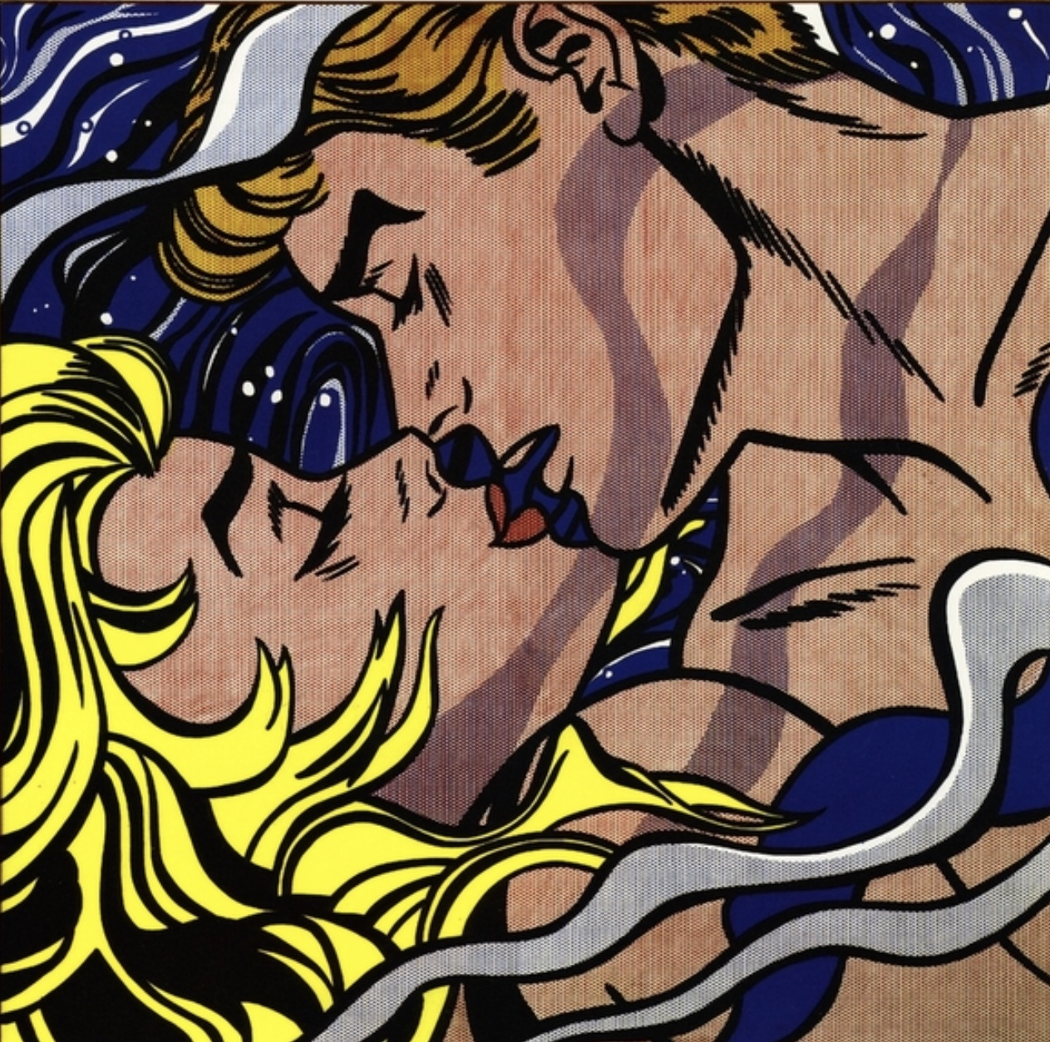
Andy Warhol – Shot Marilyn’s
Created in 1964
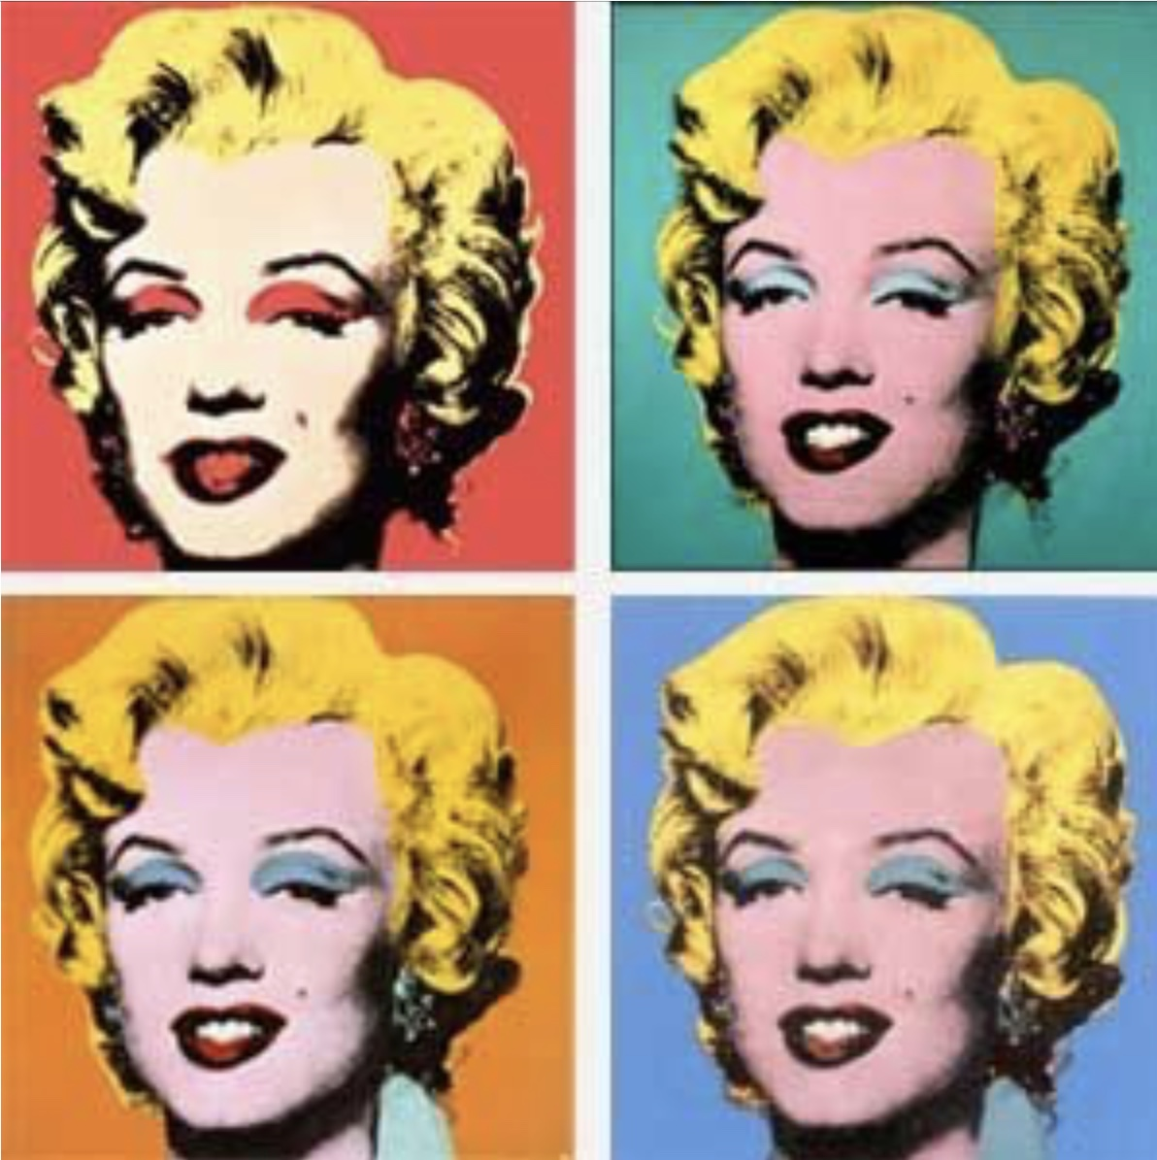
I chose Andy Warhol as the second artist as most of his art works are colourful and happy. While looking into Andy Warhol to chose which piece would fit into this exhibition, I came across one of his quotes that I thought I would have to some how fit into the exhibition, “it does not matter how slowly you go so long as you do not stop” (Andy Warhol no date). This quote hit home because if my sister had stopped fighting cancer as she had been fighting it for 3 years she would not be here today! I chose his piece, Shot Marilyn’s because I find Marilyn Monroe such a strong female figure and the piece is so popular and famous and if you ask me it just lights up any room and would light up Singleton and catch everyone’s eye.

Jean–Michel Basquiat – untitled (Boxer)
Created in 1982
“I don’t think about art when I’m working. I try to think about life” (Jean – Michel Basquiat no date).

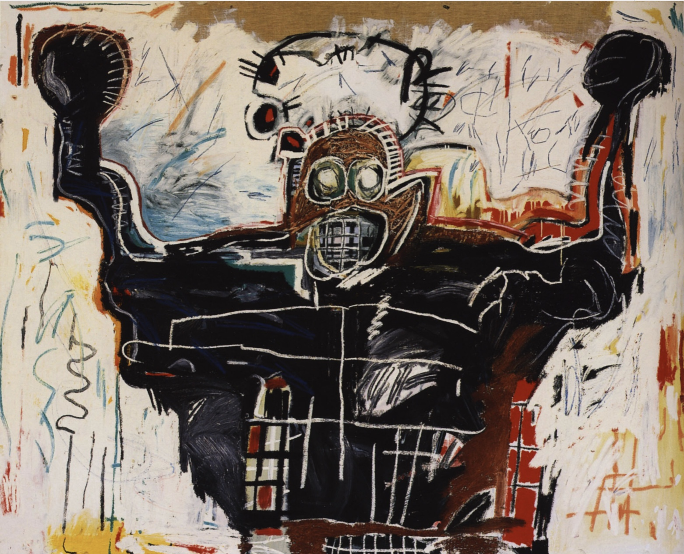
I did not chose him as my third artist because of the quote but because of the piece Boxer! Everyone in that hospital is putting up a fight no matter how big or how small. Everyone is fighting for something. So I thought it was a perfect piece to add to the exhibition.

Pablo Picasso – Girl Before A Mirror
Created in march 1932
I chose Pablo Picasso as my fourth artist as he is such a famous artist and most people enjoy his work. To me, his work is wonderfully weird and even puts a smile on my face. The piece Girl Before Mirror stood out to me a lot even though the way I see it is completely different to why Pablo Picasso painted it. I see it as you can look in the mirror as much as you want but you still are the same beautiful person no matter what you think.

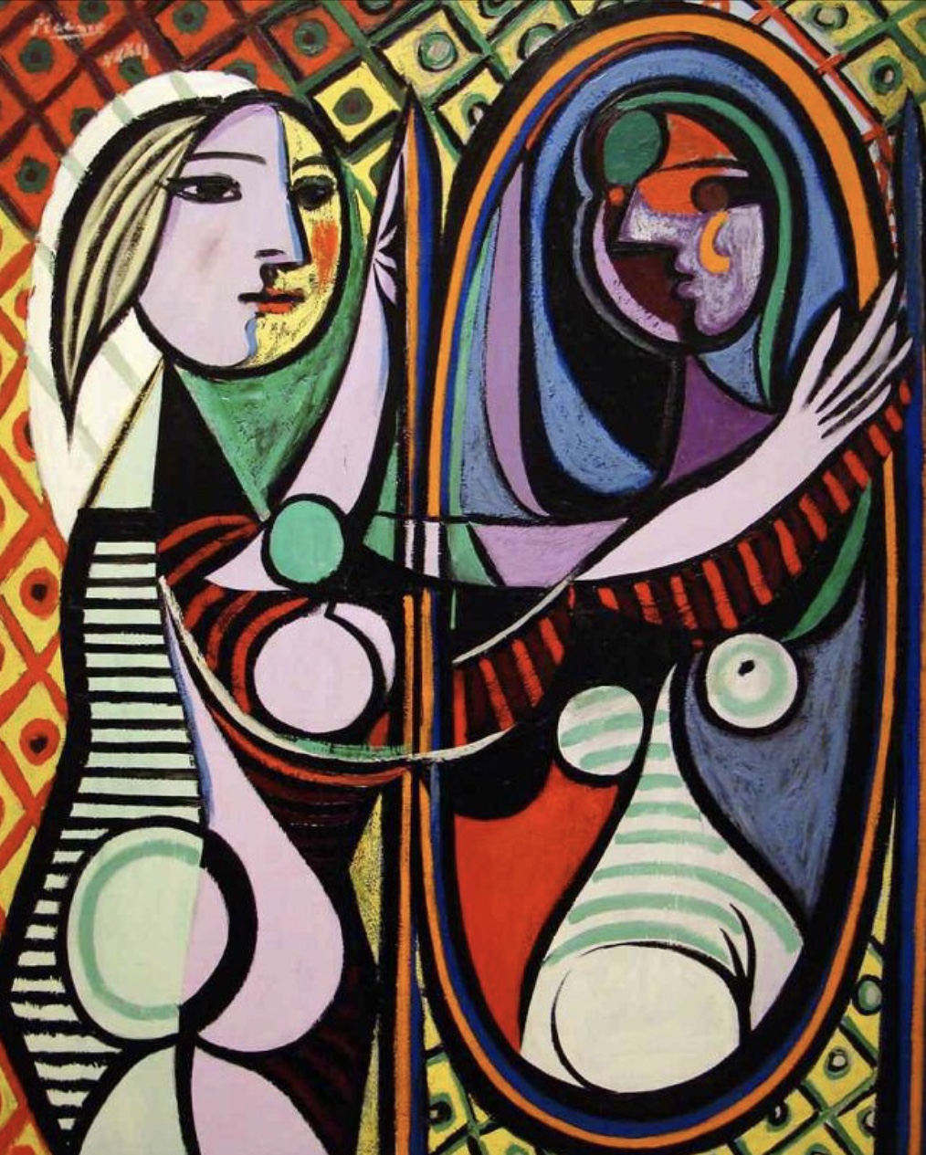
“Art washes away from the soul the dust of everyday life.” (Pablo Picasso no date)

Vincent van Gough – Wheat Field With Cypresses
Created in July 1889
Even though Vincent van Gough work isn’t as bright and colourful as the other artists I wanted to have one mellow piece among the five artists just so they weren’t all in your face. And out of all his pieces I found the Wheat Field With Cypresses was the most mellow piece. It caught my eye and I could honestly just stare at it for hours.

“I feel that there is nothing more truly artistic than to love people” (Vincent Van Gough no date)
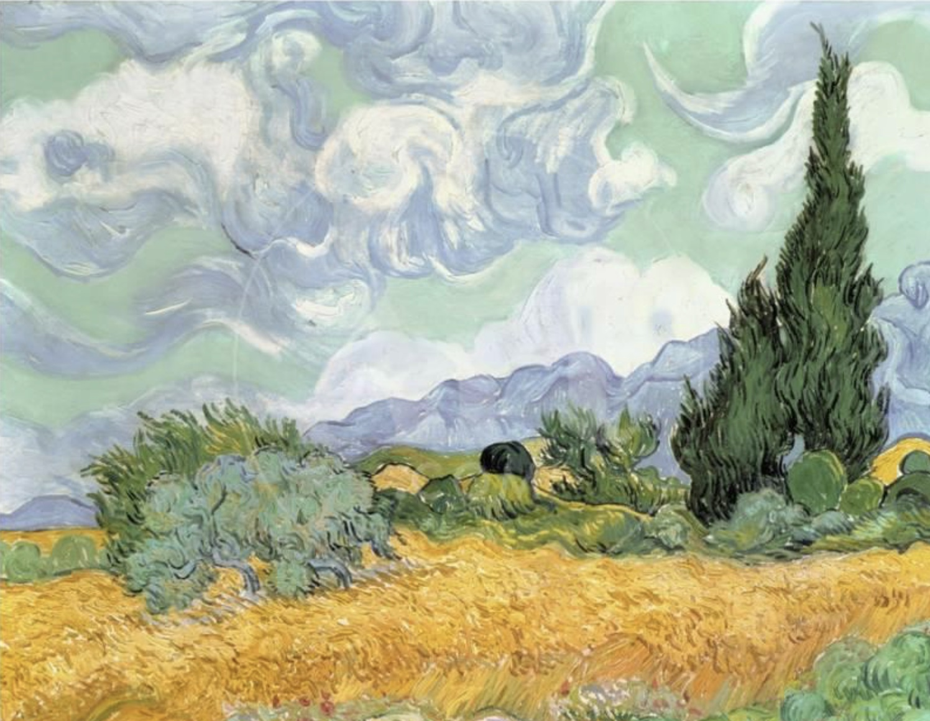

After deciding on my five artists, I found quotes for every artist that inspired me and so I decided to also place them into the exhibition under each of the artist’s pieces.

I also decided that I wanted to use this exhibition to raise money for the hospital. I thought that and as it would be in a hospital corridor I could ask for donations/entry fees. I thought I could contact charities and get donation pots placing them on stands beside each art work, going up the corridor. People could donate as much or as little as they wish for the charity of their choice.

Singleton hospital floor plan

The corridor where the exhibition will be held
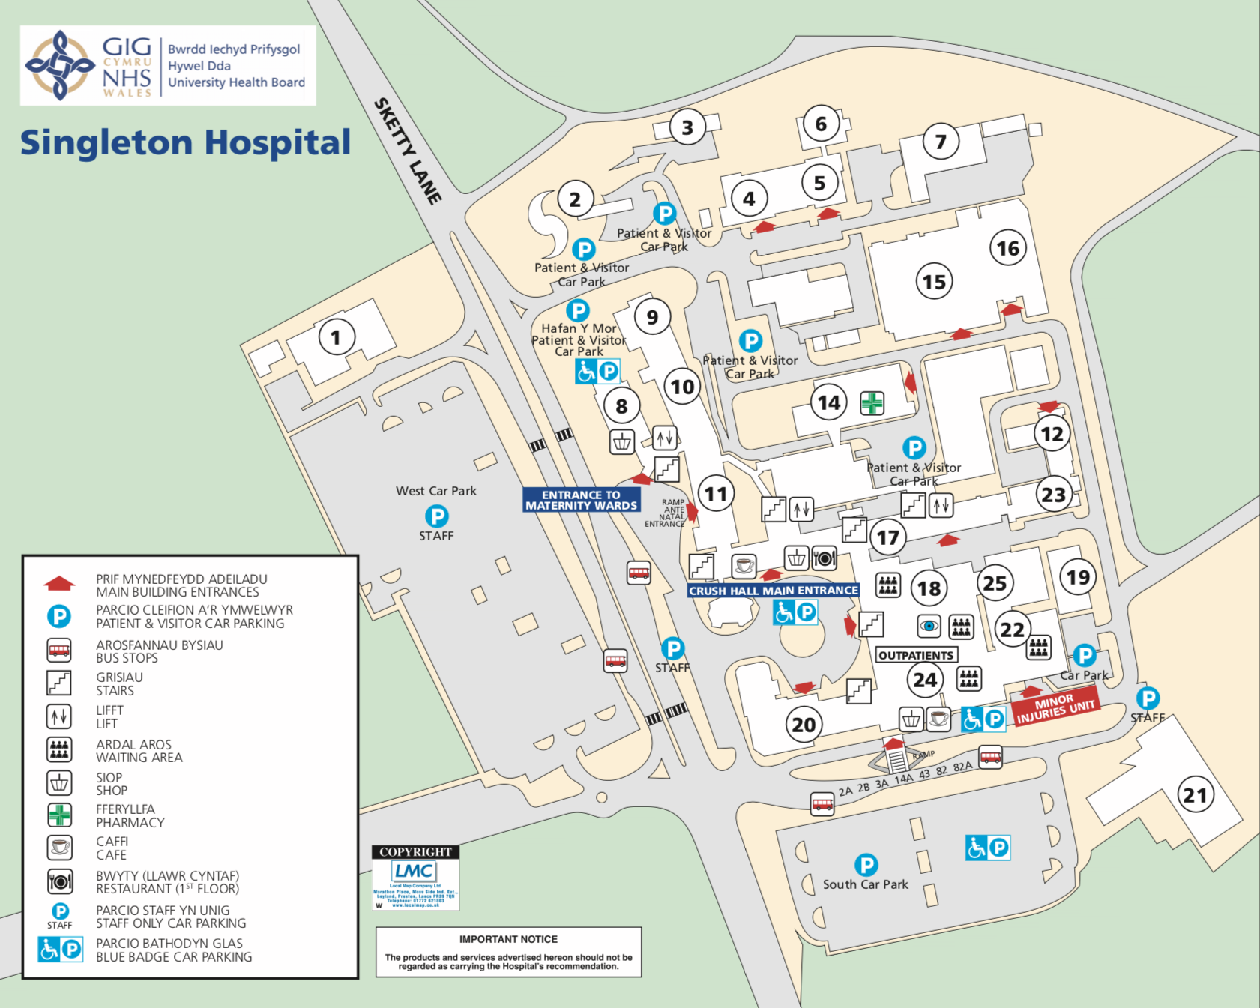

Entrance

Below is a rough sketch of the corridor and where I would put each piece of work. It is a very simple corridor and it’s quite straightforward. The corridor is a lot longer in reality so the pieces wouldn’t be too close together and wouldn’t be too overwhelming.

With each artist’s quote, I would like to put them in bold on the wall next to each of their pieces. I don’t want them to be small and not noticeable but bold and in your face so they are remembered.
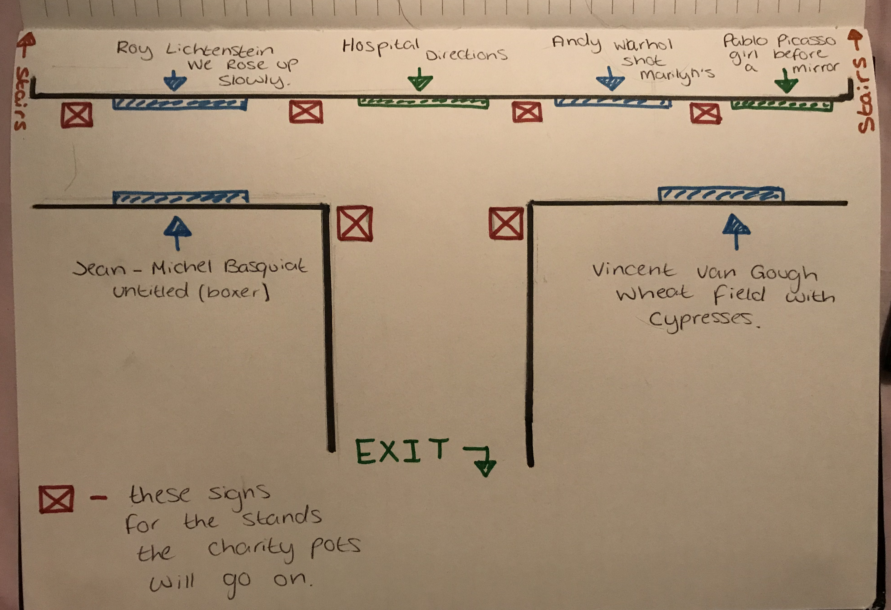

I would also like to set up a few charity buckets to raise money for Singleton Hospital Ward 12 (cancer ward) after reading the news recently, “an oncology ward at a Swansea hospital will be closed for up to three months following a fire.”

A fire broke out on ward 12 at the hospital and that was the cancer ward that helped my sister and I would like to try and give something back to the ward and help them get back on their feet so they can help more patients.

The charities I would like to put charity buckets up for are:

The British Lung Foundation: because Roy Lichtenstein passed away from pneumonia and I thought it was appropriate.

Arrhythmia Alliance: I would also like to put a charity bucket up for Arrhythmia Alliance as Andy Warhol passed away from an arrhythmia.

British Hearth Foundation: I want to put another charity bucket up for the British Hearth Foundation as Pablo Picasso passed away from congestive heart failure.

Suicide Prevention: I would also like to put a charity bucket up for Suicide Prevention charity as Vincent Van Gough committed suicide.

Blood And Breast Cancer Research: for myself I could like to put up a charity bucket for Blood And Breast Cancer Research as they are both important charity’s to me. Whatever is raised in that one bucket I will half it and put half into each of the charities. Also, on each of the charity buckets I would like to put each artist’s quote relevant to the charity that goes with them so people can also read them when donating.

Every artist I have chosen has a similar but completely different style. I did this because I want people to hopefully see what I see that even though people are similar we are all completely different and are fighting our own battles inside ourselves and at home.

After a lot of thought I would like to name the exhibition, “Fighters” because all the artists I chose fought their own battles and everyone in Singleton Hospital are fighting their own battles, no matter how big or how small. Everyone is fighting something and becoming stronger because of it.

Below is a rough idea of the posters and leaflets I am going to make to hand out to the public so we can get as many people in to this event to raise as much money as possible for each charity selected for this event. On the poster I wanted to keep it as simple as I possibly could. I didn’t want it to be in your face and hard to read but straight to the point which I think it is. I made sure I put a little description of what is going to be in this exhibition and why we are holding the exhibition and some of the charities and artists involved.

I also made sure I put the address of the hospital on the poster as I want to get these posters out there to the public. As it’s held in Swansea, I want posters and leaflets handed out as far as Cardiff and Pembroke. I’ve also put the days the exhibition is gonna be open to the public and I’ve decided to only have it there for a week and to have people manning the exhibition to make sure everything runs smoothly.

I also want to place posters in shop windows, busses, etc. I would also like the patients of Singleton Hospital to have a private viewing so they can time to embrace the work before the public come.
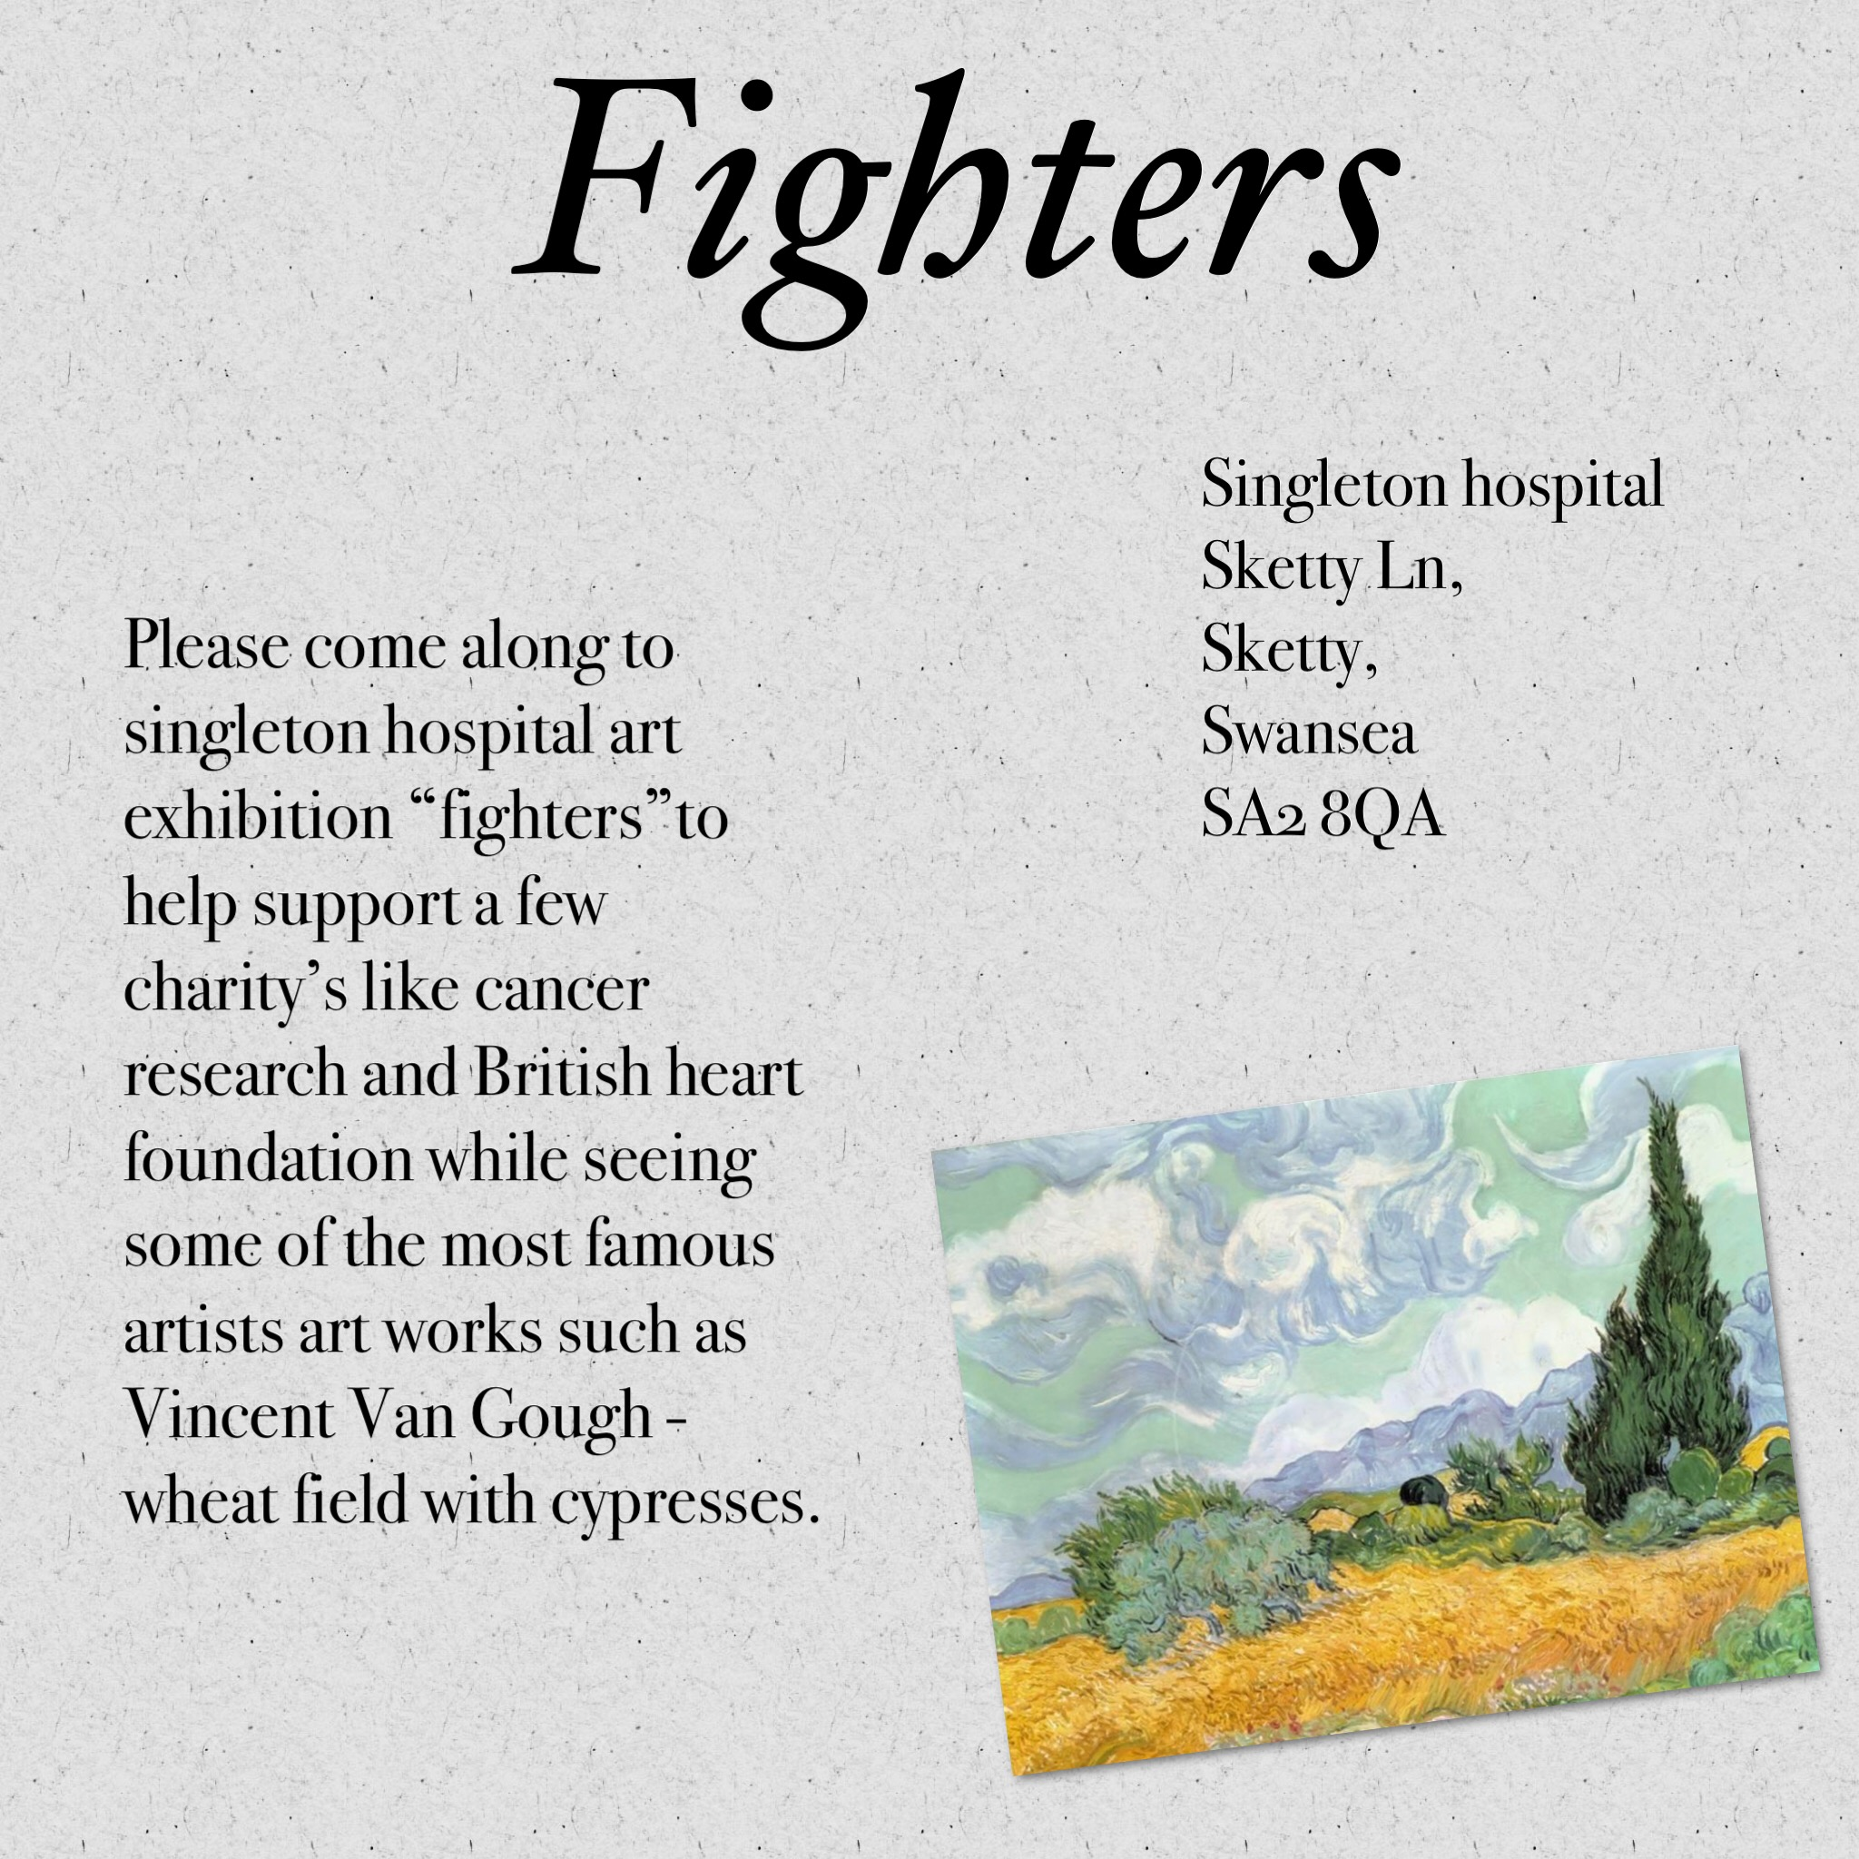

Reference:

“We rose up slowly… as if we didn’t belong to the outside world any longer …. Like swimmers in a shadowy dream….. who didn’t need to breathe….” https://theartstack.com/artist/roy-lichtenstein/we-rose-up-slowly This relates to my essay when I’m explaining why I chose Roy Lichtenstein as an artist and this is his quote that was attached to the painting.

Reference:

“It doesn’t matter how slowly you go so long as you do not stop” https://www.goodreads.com/quotes/235746-it-does-not-matter-how-slowly-you-go-so-long this relates to my essay as it helped me decide on Andy Warhol as an artist to add to my exhibition as it’s a powerful quote.

Reference:

“I don’t think about art when I’m working. I try to think about life.” https://www.brainyquote.com/quotes/jeanmichel_basquiat_351282 this relates to my essay as I found this quote when I was looking into Jean – Michel Basquiat and I thought it went with my theme as I don’t want the patients to look at the art and think about there treatment or life to just be in the moment with art.

Reference:

“Art washes away from the soul the dust of everyday life” https://medium.com/@mihalachecatalin/art-washes-away-from-the-soul-the-dust-of-everyday-life-pablo-picasso-afa62ece41e8 this relates to my essay because after finding three amazing quotes by the other three artists I had to see if Pablo Picasso had a quotes that would go with my exhibition and he did.

Reference:

“I feel that there is nothing more truly artistic than to love people”
https://www.brainyquote.com/quotes/vincent_van_gogh_383837 this relates to my essay because it’s such another strong quote that I had to add to the exhibition as Vincent Van Gough I felt knew what it meant to love and be hurt and to fight a losing battle.

Reference:

Singleton hospital floor plan http://www.wales.nhs.uk/sitesplus/documents/863/162787%20Singelton%20Map.pdf this relates to my project so I can point out where I want the exhibition to be and how far into the hospital it is.

Reference:

“An oncology ward at a Swansea hospital will be closed for up to three months following fire.” https://www.bbc.co.uk/news/uk-wales-47712631 this relates to my project as it shows in the news website the incident I was talking about relating to the cancer ward being closed.

