Name: Adam Japp
Mechanical and Manufacturing Engineering Higher Degree Apprenticeship
Group Project
ACMA5009
Word count (Excluding contents page, logbook, and reference list) - 4612.

Contents page

Introduction - Page 3

Abstract - Page 4

Feasibility study - Page 5 - 9

PDS (Product Design Specification) - Page 10 - 14

Research - Page 15 - 16

CPA (Critical Path Analysis) - Page 16 - 17

Product/component ideas - Page 17 - 19

Analysis of project findings - Page 19

Logbook - Page 21 - 22

Reference list - Page 23

Appendices - Page 24 - 28

Introduction

Sustainability is the theme of this project:

There shall be a new design for lifting equipment within the crane maintenance sector amongst other departments throughout the steel work industry as well as any other industries looking to use a more ergonomic, safe, sustainable/environmentally friendly, and cost-effective product to enhance work productivity and employee longevity.

Sustainability is a must when producing a new piece of equipment. We all need to help with the protection of natural resources and this product will help with that, implementing recycling as well as re-use of all components within the product.

Most companies have lifting jacks which often require to be packed up to achieve the height required to carry out a task. This means that something must be designed to improve the ability to carry out this work task and to do it safely.

Throughout this project, I will update and follow my Gantt chart and logbook. I will produce sketched designs as well as final designs on CAD software to showcase my product and how it should look. I will produce case/feasibility studies to show where the gaps in the market exist and how this product will improve the lives of workers and ultimately save time, money and physical strain for all companies and its employees.

Safety will be number one priority throughout this project/design with product longevity and costs also taken into consideration.

Abstract

This project is about an issue that different companies (including the Steel Industry) are facing daily. The project will involve the designing of a new packer to help Jack up predominately gantry cranes, although it will have the ability to be used for various other lifting requirements. The current process has experienced packers/Jacks falling over in the past so this will extinguish the issue. The new idea will be designed off a feasibility study, along with research and PDS (Product Design Specification). Three initial ideas will then be produced via sketch, along with a brief overview of each idea and why a specific one has been chosen. The chosen idea will then be designed professionally with the use of CAD software and will have write ups alongside explaining the reason for its design and how it will help companies’ safety and work output globally. The project will be constantly monitored with the use of Gantt charts and Logbook reports and all work will be presented to the customer after the design has been finalised. All images and information will be referenced, and the project will meet all British Standards and be fit for purpose.

Feasibility study.

PACKER FOR CRANE JACK

TATA STEEL (UK)
ABBEY WORKS
PORT TALBOT
SA13 2NG

DATE – 12/05/2021

Table of Contents

1. EXECUTIVE SUMMARY 3
3. TECHNICAL FEASIBILITY 3
4. OPERATIONAL FEASIBILITY 4
5. SCHEDULING FEASIBILITY 4
6. COSTING FEASIBILITY 4
7. FINDINGS AND RECOMMENDATIONS 5
8. SUMMARY 5

EXECUTIVE SUMMARY
Tata Steel is one of the world’s most geographically varied steel producers, with operations in 26 countries and commercial offices in over 35 countries and is one of the largest steel producers in Europe. Tata Steel believes their strength is how they build collaborative relationships that create new success for their customers. Tata steel serves many demanding markets worldwide, including construction/infrastructure, automotive, packaging (Heinz and PG tips) and white goods companies (Fridges, freezers etc).

DESCRIPTION OF PRODUCTS AND SERVICES
Tata Steel Port Talbot/Llanwern produces strip products for the European market. Their main customer is the automotive industry which requires hot rolled steel as well as high quality annealed steels for the body work of cars, steel produced by the Continuous Annealing Process Line (CAPL). At Cold Rolled Products (CRP) Tata steel UK (Port Talbot), there is currently a higher-than-expected number of health and safety reports, this includes near misses and unsafe conditions and injuries. In response to this, Tata have initiated a programme to drive the improvement of their health and safety which includes projects, initiatives, and communications.
Following on from this initiative, there have been several near misses raised within the Cold Rolled Products that need attention. In line with this Tata have been tasked to reduce these incidents which includes this project to remove the use of unsafe packing underneath Jacks. The current issue involved a fitter using the only packing currently available without the Jack being properly secured, meaning it had the potential to slip and cause injury. Tata have proposed to design a product which removes this hazard and can also be functional in a day-to-day environment.

TECHNICAL FEASIBILITY
The intended design is to adapt a piece of packing so that it can be safely bolted to the rails to stop movement, as well as being able to bolt the Jack to the packing, again removing unwanted movement. The adaptation of the packing shall not compromise the integrity of the current setup and should improve overall safety. The design of this product will be produced in such a way that no special requirements are needed to engineer the design. The product will be made within the company’s workshops with TATA Steels own employees and skills. The product shall be of a low technical requirement, cheap to produce and as such costs shall be at a minimum. The product shall comply with all relevant British standards such as BS EN 1494 and shall not introduce any additional hazards. (European Standards 2009).
The product shall be made from aluminium, which is easily manipulated and worked with, as opposed to other materials such as stainless steel or plastics. It will also reduce the weight of the product which will again make it easier for the person using it to manoeuvre and place it wherever is required. This will enable any repairs to be carried out with minimal effort and not require and special tools, however when welding repairs are carried out, they will need to be carried out by a coded welder and inspected by a specialist in that area (x-ray to check weld condition etc).

OPERATIONAL FEASIBILITY
The new packer design will drastically reduce the hazards associated with the operation of jacking up cranes (long travel or cross travel). As such it is also important that that operation cycle time is not increased as this task is completed many times during the day, however this product should reduce overall working times. Working times should be reduced because people will not be so tentative as to whether the packing is positioned correctly etc due to the new design ensuring the packing and jack are in a fixed position. In addition to this, positive improvements can be proactive engagement from the company which will increase confidence of employees within the organisation. The modification may also encourage a boost in morale, as an improved set of work equipment which makes the task/operation easier, quicker, and simpler and will encourage more reluctant employees to complete the task.

SCHEDULING FEASIBILITY
Scheduling feasibility is not seen as a concern with regards to this project. Once initial measurements and drawings have been provided then most of the product will be manufactured on plant with no disruption to production. Upon installation of the product, a short level of downtime for the crane will be expected, this is to check that the final product will fit in place and is operational. It is not anticipated that any prolonged interruption will occur. A short training course is expected to be supplied to train the employees on the new design, this will also include familiarisation with any Standard Operating Procedures that will be produced. The project timescale will be managed via a Gantt chart and will be closely monitored to ensure the project plan is followed and is accepted by the client.

COSTING FEASIBILITY
The design is intended to be cost effective, resulting in fast manufacturing times. The materials that are forecast to be used are of low cost and readily available. It is expected that the product will cost below £170 which includes materials, labour, machining, and design. The manufacturing time is anticipated to take one day once initial designs have been produced and drawings are supplied to the people producing the product. This is considering the work will be carried out by an experienced fabricator with clear and concise technical drawings. Approximate costs are illustrated in the following table.
Description of cost | Estimated cost
Material (Aluminium) | £50
Bolts | £15
Manning (Labour) | 6hrs x £11 = £66
Installation & Functional testing | 2hrs x £11 = £22
TOTAL | £163

Taking the manufacturing and installation costs into account and using them in a cost/risk consideration, then the project should be considered feasible. This is the recommended outcome as the average lost time (LTI) for an accident with the use of a crane Jack can range anywhere from a few hours up to 4 weeks depending on the severity of the injury. This is not including any further costs associated with claims and further LTI due to medical appointments.

FINDINGS AND RECOMMENDATIONS
Based on relevant information and research carried out throughout this feasibility study, it clearly shows that the product is a viable venture which will not only reduce any risk of serious injury, but also of any financial repercussions resulting from an injury. TATA Steel Port Talbot have clearly stated that their main goal is to reduce risk in the workplace and this product will help fight that cause. From a scheduling point of view, the design will not have any major impacts on any working procedures or times within the Central Engineering Shops and will not result in any major financial commitments.

SUMMARY
This study has showed that in a technical, operational, scheduling and costing basis, there will be no major problems or issues with designing and manufacturing this product. In summary, the design should be a feasible project with no major commitments from TATA Steel Port Talbot/Llanwern and will provide many positives as discussed in this document.
(Mary Lewinson 2010).

PRODUCT DESIGN SPECIFICATION (PDS)

- Performance
  - Will increase safety when working with jacks.
  - Should mean less accidents will occur while in the workplace.
  - Shall be able to lock the jack and packing in place independently.
  - Should be easy to maintain.
  - Should improve the stability of the jack.
- Maintenance
  - Should be easy to repair with the use of a coded welder.
  - Maintenance shall be minimal with the piece of equipment.
  - Downtime should be minimal.
- Life in service
  - The unit will work until fatigue is reported/found. Will be repaired when required.
- Target product cost
  - Aluminium £50
  - Bolts £15
  - Miscellaneous should cost less than £15.
  - Building product costs should be around £66-£88 (labour time to fabricate packer)
  - Total cost should be less than £170.
- Quantity
  - Will likely be made and sent out in bulk to each department/workplace (numbers can be adjusted to suit the client’s needs)
- Size/shipping and transport/packing
  - Shall be no bigger than 1.5ft x 1.5ft in delivery package.
  - Should be packed and secured within wooden box.
- Weight
  - Shall weigh no more than 10kg total.

- Aesthetics, appearance and finish
  - Unit shall be sprayed to minimise damaged from the elements and substances in the workplace.
  - Can be finished as desired/required.
- Materials
  - Steel for jack packer
  - Thicker steel for pates on underside of packer to hold securing bolts.
  - Bolts to allow bolting of jack to packer and packer to crane rails.
- Product life span
  - Should last for many years if maximum weight is not exceeded.
  - Should be inspected on a 6 monthly basis thoroughly for cracks, wear or any other issues that could cause failure, should be checked before every use to inspect for new damage.
- Standards
  - BS EN 1494.
- Ergonomics
  - Shall be light enough to comply with manual handling restrictions.
  - Shall be able to move with the use of a hole in the top of the packer to making movability easier (this will not affect the strength of the packer)
- Customer
  - Shall come in different finishes if requested (different colour paint)
  - Shall come fully assembled with the bolts included (8.8 tensile)

- Quality and reliability
  - Shall be built from a strong enough material to support a minimum weight of 75T.
  - Quality shall be up to required British standards to ensure safety, longevity, and efficiency of product.
- Shelf life
  - Product shall be made as and when required but will be able to be stored for up to 5 years if stored correctly.
- Timescales
  - Product should take no longer than 1 day to manufacture per packer once technical drawings have been produced.
  - Product shall take no time to assemble as it comes fully assembled.
- Testing
  - Product shall be tested with a weight of 112.5T (150% of packers maximum recommended lifting capacity)
  - Product shall be tested to British standards BS EN 1494
  - Testing shall be carried out in real life situations to confirm efficiency of product.
- Safety
  - Shall meet required British standards BS EN 1494
  - Shall have fail safe barriers in place (The packer will start to show deformation before failing occurs, this will give the fitter time to release the jack and change the packer)
- Company constraints
  - Shall need to be under a certain size to allow easy fitting in allocated location.
- Political and social implications
  - Will need to be made from a sustainable material to decrease pollution.
Summary:

Although the above points have been recommended/suggested, these can change further on into the project. Things can change at any time and changes will need to be made. A PDS is a good basis to start a project, giving you things to look back on and giving you an idea of things that will need to be incorporated into the chosen product.
A PDS is not a set-in stone step by step guide but an overview of some of the things that would like to be incorporated into a product.
Compare and Contrast my P.D.S with the BS7373 provided:

When writing this Product Design Specification (P.D.S) I tried to follow the BS7373 to the best of my ability. I tried to incorporate all the points given as well as following requirements from the customer. The use of words such as “shall* and “must” were used throughout the P.D.S, these were used to give the customer the reassurance that the product would be made to their exact specification that they have requested. This is a standard practice when producing a P.D.S and follows the standards given in the BS7373.
With all P.D.S documents there are several categories that are required to be filled in. In the P.D.S I have produced there have been several categories that have been dropped as they were not a requirement for the product I am designing. The P.D.S covers what the product will be capable of and what its limitations are. Some P.D.S documents will describe how the product is operated; however, this was not essential with the one provided as these operations would be outlined in the safe working procedure that would be provided to team members working with the product so they will be able to safely use the product. (British Standards Institute 2005).

Conclusion:
We see that some of the points recommended by the BS7373 have been followed in the P.D.S above. Some of the points have been left out and some things have been added in to add more clarity to what the product is and to follow the requirements of the company. The company requested a product that will increase work output, safety and sustainability and I feel that all these points have been covered in the P.D.S provided.

Research
When initial research was carried out to find packing alternatives for tangye jacks there was not much available on the market. A lot of websites, articles and forums recommend the use of a standard steel or aluminium block to put underneath or on top of the jack to gain the required height, ensuring that the blocks are to correct engineering standards and meet the loading requirements (Figure 1.3). With this product that I have put forward, we are able to offer a packer that is able to be versatile and made for the task in hand. This packer will have the ability to lock the jack in place on the packer, as well as being able to lock the packer in place on the gantry rails. The bolts will be able to hold any size jack from 5T up to 75T, dependant on the footprint of the jack, as we will see in the CAD drawings produced.
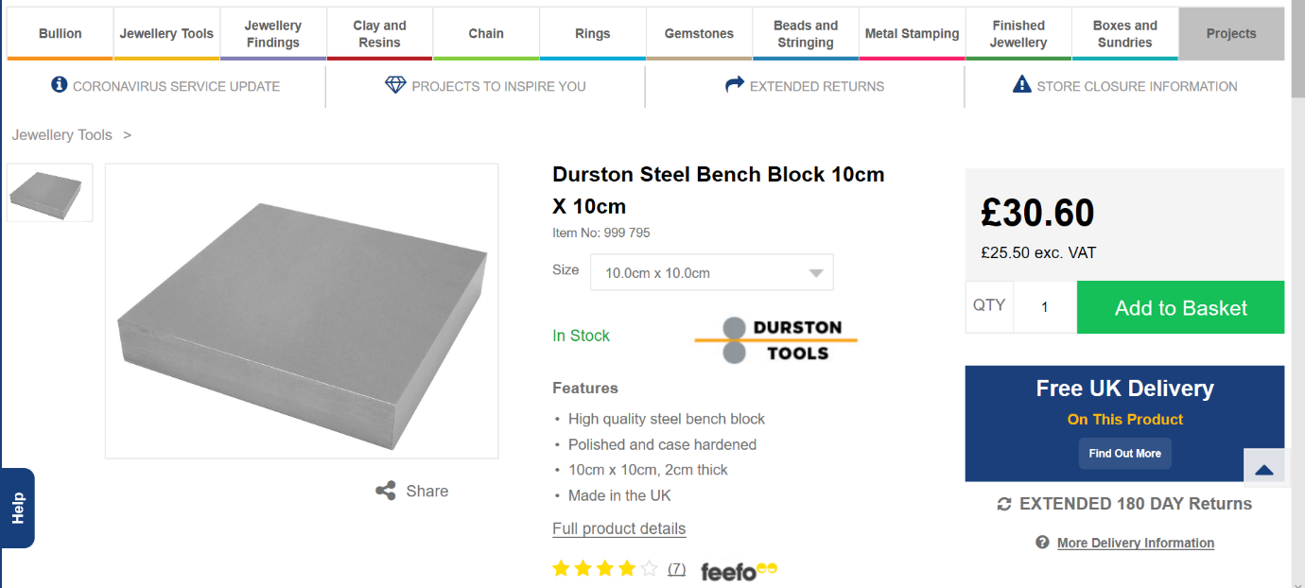
The jack will be made from a lightweight aluminium to decrease overall weight without compromising the strength and structure of the packer. It will have a hole in the middle to help with manoeuvrability, again not affecting the strength. It will fill a gap in the market as there is no companies at current that offer a specific packer which has the versatility of the packer being offered in this project and this means that there is definitely room within the marketplace for this project to be put forward, designed, and built for the use in the steel industry as well as any other industry that uses jacks.
Figure 1.3
The image (Figure 1.3) shows the kind of packing that is used within the industry at present which currently makes jacking up cranes and other objects quite unsafe, it does fulfil requirements, however, has the potential to slip out from underneath the jack, resulting in packers and jacks potentially falling from height and causing serious harm to those who are walking within the area below the gantry. (Cooksongold 2021).

Critical Path Analysis:

Critical Path Analysis (C.P.A) is achieved using something such as a Gantt chart (Figure 1.4) This is used to make a list of what work is to be carried out, detailing specific times to achieve the project end goal. It will evaluate what tasks are critical and which are not. The critical path analysis will prioritise the critical work, as if this work were to go over the planned deadline then it would prolong the whole project. Noncritical work has some leeway and will allow this task to go over the recommended duration given and not have an adverse effect on the entire project. The critical path will give us an idea of the total amount of time required to complete the project and this again is why the use of Critical Path Analysis is advantageous. The application of a Gantt chart or any form of C.P.A will mean being able to compare project progress, meaning we can see if the deadlines set are viable and allow us to cut back times on noncritical activities to create some room for the activities which are more critical to the project deadline.
My reason for using a simple Gantt chart as my form of planning is the simplicity of it. You can easily look at your plan and know exactly where in the project you currently are, whether you are working to the time frame allocated for each task and make easy changes if required (can be easily edited). If producing a more complex Gantt chart it can become messy and make changes more difficult to implement. Other forms of planning applications are Project Management Timelines, Project Network Diagrams and Checklists. These other applications are used throughout project planning, however I felt that a basic Gantt chart was the best option for myself as I knew that timelines would not be changing much due to the fact, I would be able to carry out this project on a close to full-time basis. However, when carrying out a project on a part time basis it is still advantageous to use the Gantt chart route for the reasons discussed earlier. It allows tasks to be easily changed, and noncritical activities can have some reduced time so critical tasks will have the ability to be extended when required.
I feel the Gantt chart worked well for myself as I had the time to complete the project on a full-time basis, so I was able to dedicate a lot of time to each task to easily keep to the allocated time. I do however feel I could have used the C.P.A in more depth and allowed more time for critical tasks to allow me more breathing space for other noncritical tasks and take some pressure of myself to complete things in a tight time frame.
Legislation and ethics were a big part of this project. I decided to use renewable products, or products that can be fully recycled such as aluminium and steel. This is thought about before planning commences as it can mean extra tasks could be required during the project. If using non-recyclable items, then planning would be required to dispose of these correctly. (Investopedia 2021).

Product/component ideas

Idea 1:

For idea 1, I decided to design a piece of packing with a gripping agent on the top, this will minimise the Jack slipping of the packer while being used. This will be an improvement to the products currently on the market which will just have the Jack sitting on top of a plain steel/aluminium block with no other barriers in place to help with minimising the Jack from slipping.

Idea 2:

For idea 2, I decided on a plain packer similar to other products currently being sold, however I have installed some uprights on each side of the packer to allow the Jack to be bolted in place. This will mean the Jack is now unable to move in any direction, resulting in complete stability of the Jack. This is something that has not been designed and used in other industries that I could see in my research, so this will mean that this product is now a viable option to take forward.

Idea 3:

For idea 3, I used the same principles as with idea 2 but decided to add some plates on the underside of the block to allow the Jack to be held onto the packer but also allowing the packer to be bolted to the crane tracks and therefore making everything stable and meaning the Jack will never slip out of place. This is an idea that has never been used within our industry and will revolutionise the way we work on cranes. It will not only speed up the working process but will also make the workplace safer meaning less accidents.

All three ideas above are hand drawn at the back of this project in Appendices.

Evaluation of Final design being taken forward

I chose to take the third idea forward as my final design for a few reasons. I feel it was the most versatile of the three ideas and improves the overall safety more than the other two. It will have the ability to be used on a number of different size Jacks and will secure them not only to the packing itself, but also to the rails so there will be no movement, this will stop slippage of the Jack on the packing and the rails on the gantry. This will result in saving companies time and money, as well as resulting in less accidents and making the workplace safer while increasing work output. The packer will be made of aluminium so it will be light weight and will also have a hole is the centre to allow the packer to be easily manoeuvred without effecting the overall strength of the packer itself. This will follow BS EN 1494 standards to ensure that all materials used are capable of holding the weight limits supplied/requested.
You can bolt both the Jack and Packer which cannot be achieved with using the other two. This idea uses Aluminium material whereas the first idea uses Steel. The third design also has a hole in the centre of the packer allowing for easier manoeuvrability whereas the other ideas did not offer this (this does not affect overall strength of packer).
I have concluded this is the best idea of the three that have been provided and feel that the customer will benefit best from this design. It will increase work output and will mean shorter working times and therefore save money, however the most important thing achieved by this product is the improved safety which is highlighted throughout this project.

Final hand sketch and CAD produced sketch are at the back of this project in the Appendices.

Analysis of Project Findings

Before commencement of the project, it was obvious that there were some issues with the current products being used to Jack up the gantry cranes within the engineering sector. I had established that issues have recently come up within my own workplace, and this was the reason for the project being carried out. An improvement had to be found and I feel I have succeeded in doing this by carrying out several different stages to calculate what would work and what would not.
I firstly carried out a feasibility study, this was to put forward to see whether a new product had the ability to be designed and succeed in the marketplace, this meant carrying out research to check what products are currently available, and whether the product I have designed would meet the criteria and fill a gap within the market. I then proceeded to make a Product Design Specification (P.D.S) and this gave the ability to determine what the issues were with the current products being used. We could see that Jacks falling from packers was becoming a bit of an issue within the steel industry in particular which resulted in a recent lost time accident, meaning the mechanical fitter had to go off work long term due to injury from a Jack slipping from a packer that was being used. This was detrimental in pushing for this new product and to re-design what has been used for the last several years causing numerous lost time accidents and slowing down work processes.
Conclusion

We can see that our project findings have allowed us to have meetings/consultations with our customers. This allowed us to get exact reasons for the product re-design being implemented and gave me an idea of how to plan things and re-design the product to what I felt would be required. I used Gantt charts and logbook reports, produced CAD drawings and sketches and produced documents such as a Feasibility study and Product Design Specification (P.D.S) to ensure all the relevant information to design the product that would best benefit the customer and their work process was included. All of these stages are vital in producing a successful project, allowing products/ideas to be designed as accurately and as efficiently as possible.
On reflection, I feel more research into specific materials and their strengths, weaknesses etc would have resulted in more technical information so that management would have an easier time deciding which material they would wish to use for their product.
Extra time dedicated to certain areas would have been beneficial when trying to carry out extensive research on my specific project. I carried out high amounts of research with minimal findings, however with even more time available, I may have got more of the technical information that would have benefited. I could have potentially got in contact with different companies to obtain specifications etc, this was something that could be improved on for the next project I encounter.

Engineering project logbook
Date | Person responsible | Action/comment | Target date | Result
12/04/21 | Adam Japp | Idea has been decided and project has commenced. Logbook has been created and Introduction has been produced. | 12/04/21 | Idea has been confirmed, logbook has been designed and introduction and abstract have been produced.
16/04/21 | Adam Japp | Create Gantt chart with all tasks set out for project. | 16/04/21 | Gantt chart has been crated and feasibility study to commence on 19/04/21.
19/04/21 | Adam Japp | Feasibility study commencement, this is planned in for 5 days to acquire the relevant information. | 25/04/21 | Feasibility is ongoing and is to be finished before 26/04/21.
26/04/21 | Adam Japp | Feasibility study has been completed and next task can begin. PDS (Product Design Specification) to commence which is planned for 3 days. | 29/04/21 | PDS is underway and is to be completed by 29/04/21.
30/04/21 | Adam Japp | PDS was finished by target date and research can now begin. 3 days have been allowed to find the required information. | 05/05/21 | Research is now underway and is to be completed by 06/05/21 as work commitments will prolong the 3-day timeframe.
06/05/21 | Adam Japp | Research finished by planned time of 06/05/21 and initial ideas can now be produced with a bit of information with each to decide which idea will be chosen. | 13/05/21 | Initial ideas are underway, however will go slightly beyond 3-day timeframe due to work commitments, this has been planned in on Gantt chart.
13/05/21 | Adam Japp | Initial ideas have been produced and put forward and evaluation of design going forward can no commence. | 17/05/20 | 2 days have been allocated for evaluation; however, work commitments mean later start on final design is required.
17/05/21 | Adam Japp | Final sketch can be produced, and CAD drawing will also be supplied, along with dimensions, components list and price list. | 20/05/21 | Final sketch and CAD drawings are underway and are to be completed by 20/05/21
20/05/21 | Adam Japp | All sketches and CAD drawings have been supplied. Evaluation can be completed, discussing how product turned out and whether it can be put into service. | 20/05/21 | Final evaluation of product has been completed and conclusion and reflection to be carried out on 21/05/21
21/05/21 | Adam Japp | Conclusion and reflection to be carried out. Reference list and appendices to be added to assignment and assignment to be submitted by end of day. | 21/05/21 | Design Brief was completed and P.D.S is to be carried out next.

(Dr Nick Oswald 2016)
Reference List

European Standards. (2009). BS EN 1494. Available: https://www.en-standard.eu/bs-en-1494-2000-a1-2008-mobile-or-movable-jacks-and-associated-lifting-equipment/. Last accessed 14th May 2021.

Mary Lewinson. (2010). How to Write a Feasibility Study Report (FSR). Available: https://mymanagementguide.com/feasibility-study-reporting-steps-to-writing-a-feasibility-study-report-fsr/. Last accessed 14th May 2021.

British Standards Institute. (2005). BS 7373. Available: https://shop.bsigroup.com/ProductDetail/?pid=000000000030106093. Last accessed 14th May 2021.

Cooksongold. (2021). Durston Steel Bench Block 10cm X 10cm. Available: https://www.cooksongold.com/Jewellery-Tools/Durston-Steel-Bench-Block-10cm-X---10cm-prcode-999-795?gclid=EAIaIQobChMIyoXwvYLZ8AIVy-5RCh0UcwDTEAQYBCABEgL6-vD_BwE&gclsrc=aw.ds. Last accessed 14th May 2021.

Will Kenton. (2021). Critical Path Analysis. Available: https://www.investopedia.com/terms/c/critical-path-analysis.asp. Last accessed 14th May 2021.

Subjectmoney. (2013). Gantt Chart Excel Tutorial - How to make a Basic Gantt Chart in Microsoft Excel 2013. Available: https://www.youtube.com/watch?v=-oD50HSBBBI. Last accessed 21st May 2021.

Dr Nick Oswald. (2016). Top Tips to Keeping Your Logbook in Shipshape. Available: https://bitesizebio.com/24852/top-tips-to-keeping-your-logbook-in-shipshape/. Last accessed 21st May 2021.

Appendices
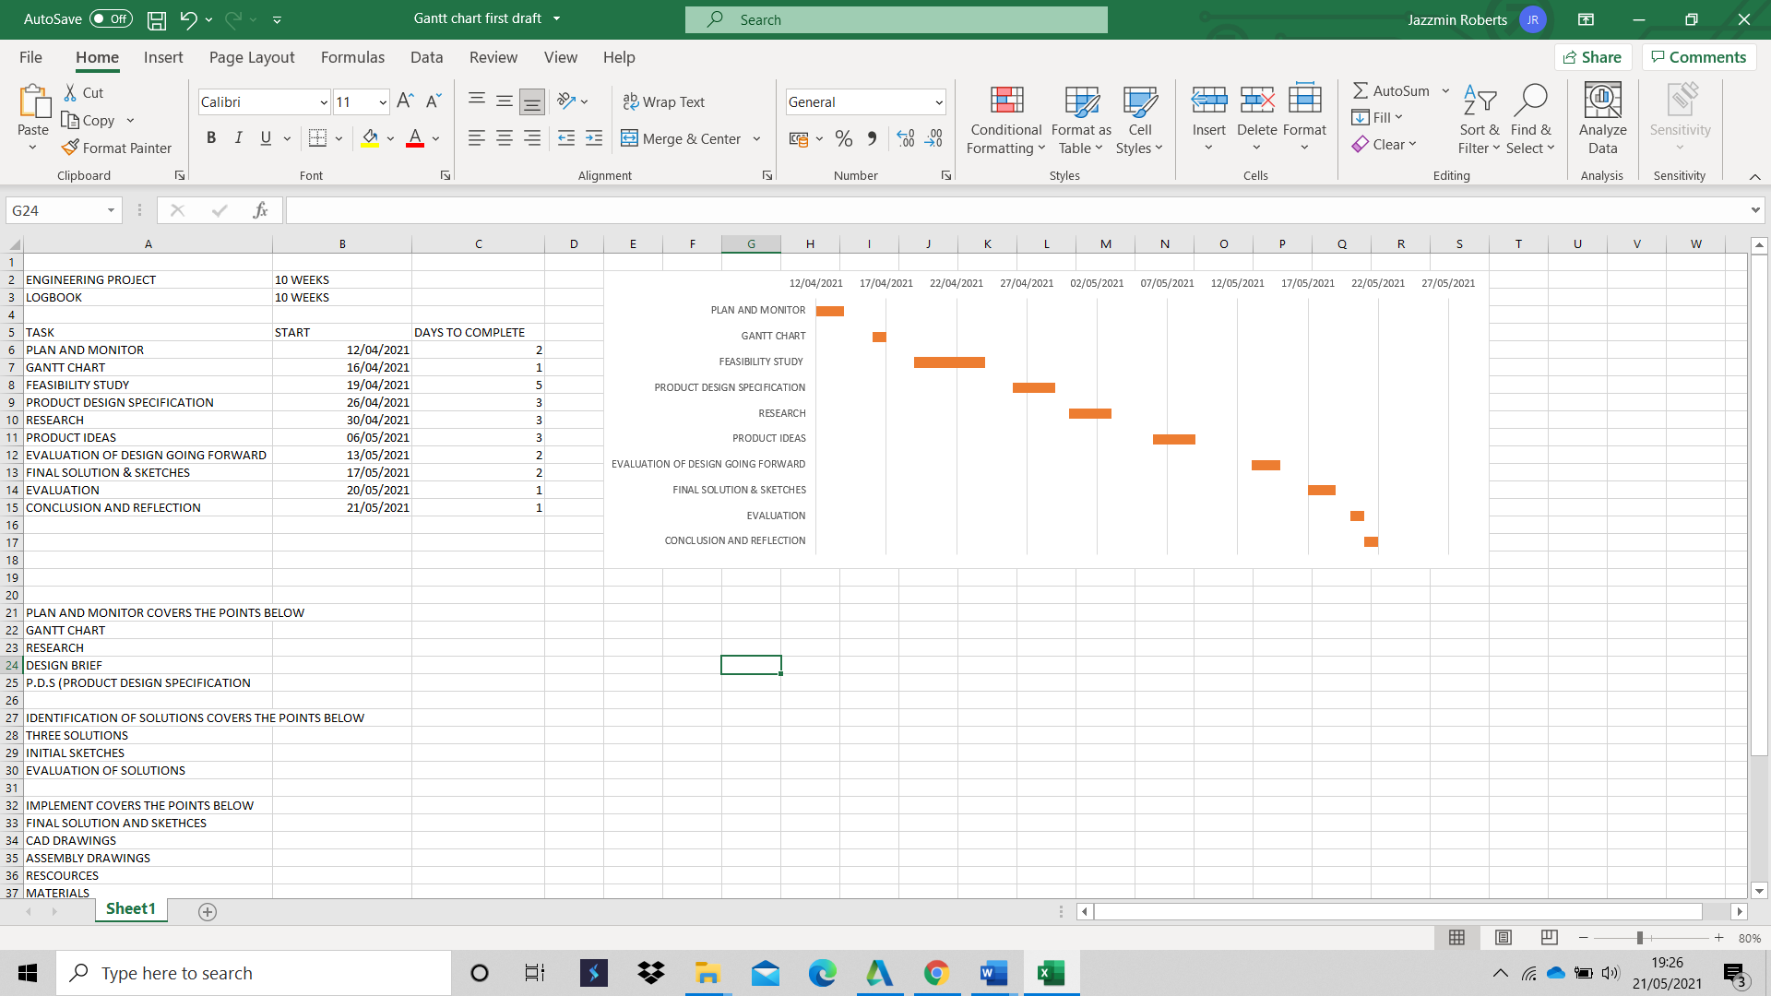
(Subjectmoney 2013)



