University of Wales Trinity Saint David
Wales Institute of Science and Art


Predictive Maintenance Strategies
Control Technology ACMA6001

Parry Phillips
2011664
28/09/2026

Contents
Table of Figures 2
1 Introduction 3
2 Maintenance Strategies in Industrial Operations 4
3 Condition Monitoring Techniques and Fault Diagnosis 6
3.1 Conventional approaches 6
3.2 Machine-learning approaches 8
4 Case Study Model and Dataset Preparation 10
5 Comparative Analysis 12
5.1 Model development and evaluation 12
5.2 Cross-validation comparison 13
5.3 Effect of Neural Network Tuning 14
6 Discussion and Industrial Implications 17
7 Conclusions and Recommendations 19
References 20
Appendices 22
Confusion Matrices from Matlab 22
Matlab Code SVM model 27
Matlab Code NN Model 43

Table of Figures

Figure 1. Condition by Time Graph stating differing intervention stages based on technique. (https://www.researchgate.net/figure/Preventive-versus-reactive-maintenance_fig1_281662973) 5
Figure 2. Vibration Signals, acceleration by time graph from Matlab Script. 7
Figure 3. Vibration Waveform converted by FFT from Matlab Script. 7
Figure 4. 18 Selected features and four binary fault codes. 8
Figure 5. Linear SVM graphical representation of linear selection of binary answer (https://link.springer.com/chapter/10.1007/978-3-030-93639-6_36) 8
Figure 6. Simulink Model to generate data. 10
Figure 7. NCA feature weights for sensor drift, shaft wear and gear tooth faults across 208 simulated runs. 12
Figure 8. Confusion Matrices of all revelant results. 14
Figure 9. NN Tuned and Untuned Alarm Rate. 15
Figure 10. Untuned SD NN Confusion Matrix 22
Figure 11. Untuned SW NN Confusion Matrix 23
Figure 12. Untuned TF NN Confusion Matrix 23
Figure 13. Tuned SD NN Confusion Matrix 24
Figure 14. Tuned SW NN Confusion Matrix 24
Figure 15. Tuned TF NN Confusion Matrix 25
Figure 16. Linear SVM SD Untuned Confusion Matrix 25
Figure 17. Linear SVM SW Untuned Confusion Matrix 26
Figure 18. Linear SVM Untuned TF Confusion Matrix 26

Introduction

Maintenance decisions in process operations must balance equipment availability, safety and product quality against the costs of intervention. Reactive maintenance exposes assets to unexpected failure, while scheduled preventive maintenance can require servicing before deterioration justifies it. Predictive maintenance uses condition-monitoring data to plan interventions, although its effectiveness depends on reliable measurements, accurate diagnosis and effective alarm management of developing faults.
This report critically evaluates these strategies through a crude charge pump, driven by an induction motor and two-speed gearbox with monitoring equipment. A MATLAB and Simulink model generates vibration data representing gear tooth damage, output shaft wear and sensor drift, addressing the limited availability of historical failure records. Two classification approaches are compared, one a support vector machine (SVM) which uses feature data and the other a neural network using raw data which is signal processed. Both are machine learning techniques to analyse data and suggest when a fault is present.
The report reviews conventional and machine learning diagnostic methods, then evaluates the models using test results such as confusion matrices and cross-validated accuracy results. The findings are interpreted against refinery requirements, including downtime, spare part planning, loss-of-containment risk and instrumentation reliability, to develop an evidence-based recommendation.

Maintenance Strategies in Industrial Operations
Maintenance strategy should reflect asset criticality, deterioration and failure consequences. Swanson (2001) links maintenance strategy with operational performance, for the crude charge pump, this means evaluating maintenance costs alongside availability, safety and product quality.
Reactive maintenance is the act of repairing components after failure, which can be economical for inexpensive, non-critical assets because it limits monitoring costs and avoids premature replacement of components (Sullivan, 2010).
For the crude charge pump however, safety takes priority over these savings. Excessive vibration can damage seals and cause hazardous leaks, making operation until failure difficult to justify for this service (HSE Executive, n.d.). Kelly (2006) states such failures can also reduce availability, as initial troubleshooting can take time to ensure all effected parts are accounted for, the lead-time of spare-parts can be unknown, and potential secondary damage only introduces more variables. The resulting interruption of the crude feed could disturb downstream distillation. Given the dependence of product specifications on controlled temperatures and conditions, this disruption could also increase the risk of off-specification production (Martin, Zanin and Odloak, 2019).
Preventive maintenance involves inspecting and servicing components on time-based intervals or running hours to reduce the likelihood of failure (Kelly, 2006). For the crude charge pump, maintaining bearings and seals supports safe containment (HSE Executive, n.d.), while planning allows labour and spare parts to be available when work is required. Servicing can then be coordinated with production to limit downtime. These benefits are illustrated by Bevilacqua et al. (2012), who reported shorter outages and lower production losses following structured turnaround planning in a refinery. However, fixed schedules may replace serviceable components unnecessarily, while faults can still develop between interventions (Kelly, 2006). The maintenance task can also introduce failures through incorrect installation or faulty components, highlighting that effective preventive maintenance depends on both competent execution and service intervals suited to the components’ failure mechanisms and machines operating conditions (Geitner and Bloch, 2019).
Predictive maintenance uses condition information to support intervention before functional failure. Timing interventions to developing problems in components offers opportunities to retain useful component lifespan and schedule maintenance before a breakdown disrupts production (Kelly, 2006). However, installing instrumentation and software integration require investment and additional maintenance of their own. According to Jiang (2024) successful intervention depends on reliable data and sufficient warning time. False alarms may trigger unnecessary shutdowns, whereas missed alarms leave safety, availability and quality risks unresolved. Figure one shows the interaction between time and condition of the components and the decided intervention stage.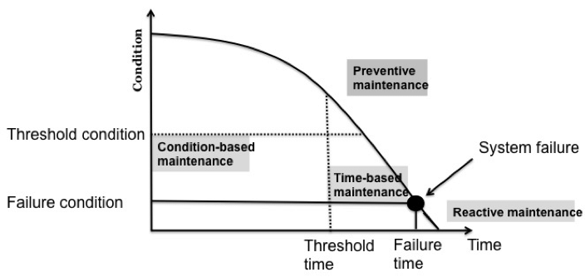
Figure 1. Condition by Time Graph stating differing intervention stages based on technique. (https://www.researchgate.net/figure/Preventive-versus-reactive-maintenance_fig1_281662973)

Condition Monitoring Techniques and Fault Diagnosis

The model examines three fault mechanisms in the crude charge pump. The first, gear tooth damage, the second, output shaft wear. Both mechanical faults affect vibration readings and can accelerate component deterioration. The third is sensor drift which is a gradual change in a sensor’s reading even when the measured quantity remains constant. It can result from ageing or changing environmental conditions and must be distinguished from genuine mechanical faults to ensure accurate readings (Dunn, 2006)

Conventional approaches

Manual vibration analysis involves technicians collecting vibration measurements at designated locations on machinery. These measurements can be displayed as a time waveform, as shown in Figure 2, and processed to reveal their frequency data. The fast Fourier transform (FFT) converts the time-domain signal into a frequency spectrum showing the strength of each frequency component (Muhlisin and Rusyadi, 2019). Figure 3 illustrates how this makes abnormal frequencies easier to identify.
Technicians interpret these waveforms and spectra to identify patterns associated with imbalance, misalignment, bearing defects and gear faults (Muhlisin and Rusyadi, 2019). Comparing measurements with historical baselines supports trend analysis, provided sensor positioning and operating conditions remain comparable. This approach benefits from engineering judgement and experience, although poor measurement quality or misinterpretation can lead to incorrect diagnoses (Alsalaet, 2012).
Threshold alarms complement this analysis by automatically flagging measurements that exceed predefined limits, providing simple warning labels. However, changes in operating conditions can trigger false alarms, while developing faults may remain below the limit. An alarm therefore indicates that a limit has been exceeded without necessarily identifying the underlying cause, making further investigation necessary before deciding on maintenance action (Strączkiewicz, Barszcz and Jabłoński, 2015).
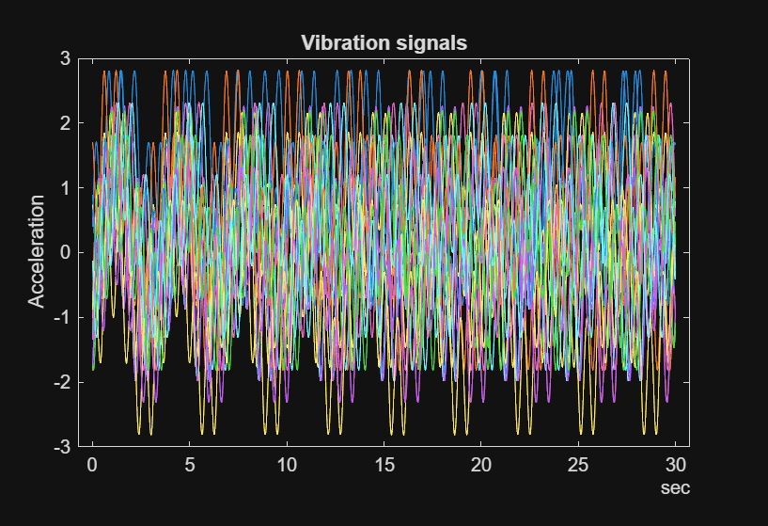
Figure 2. Vibration Signals, acceleration by time graph from Matlab Script.
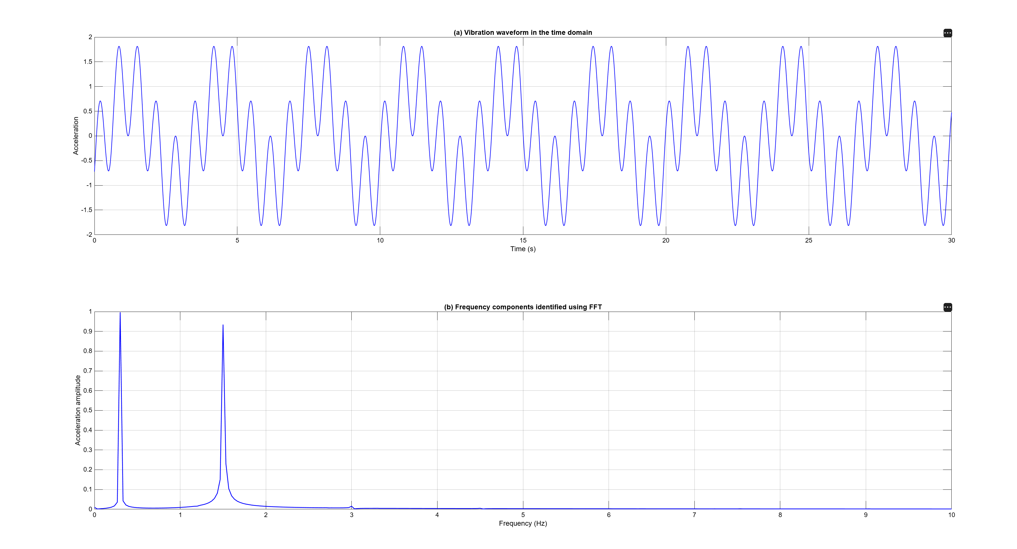
Figure 3. Vibration Waveform converted by FFT from Matlab Script.

Statistical methods summarise and assess signal behaviour. An example of these features is Root-mean-square (RMS) which measures overall vibration level, while kurtosis indicates impulsiveness associated with sudden impacts (Tummalapalli and Konakalla, 2025). Comparing these feature examples with healthy baselines can identify deviations from normal operation. However, different faults can produce overlapping indicator values, limiting identification from any single measurement (Tummalapalli and Konakalla, 2025).

Machine-learning approaches

Machine learning builds on conventional condition monitoring by learning relationships between vibration characteristics and known fault states. Each training example contains signal information and a label indicating whether a particular fault is present. The trained model then applies these relationships to data not used for training, supporting automated fault classification (Sadiku, Ajayi and Sadiku, 2025). A support vector machine (SVM) learns a decision boundary that separates examples of fault presence and absence. In this study, the linear SVM uses 18 engineered features portrayed in figure four.
Figure 4. 18 Selected features and four binary fault codes.
These provide a summed representation of vibration behaviour and allow engineers to relate inputs to recognisable signal properties. However, summarising recordings can exclude useful diagnostic information, while a linear boundary of the SVM may not adequately represent complex relationships between features highlighted in figure five (Mathworks, n.d.).

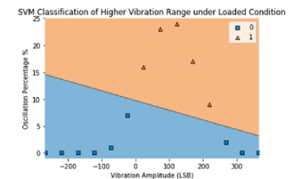
Figure 5. Linear SVM graphical representation of linear selection of binary answer (https://link.springer.com/chapter/10.1007/978-3-030-93639-6_36)
A neural network uses interconnected mathematical processing units, called neurons, arranged in layers. During training, it adjusts the weights of their connections to improve its predictions. The shallow network in this study uses FFT-derived spectral values, allowing it to learn nonlinear relationships across frequency components (Mathworks, n.d.). This reduces reliance on predefined summary features. However, it can be difficult to explain which signal characteristics led to a particular prediction (fault present or not) due to complexity of the data (Mathworks, n.d.).
Both approaches combine several signal characteristics, reducing dependence on individual alarm thresholds. However, they can overfit by learning details specific to their training examples, achieving high training accuracy but performing less reliably on new data (IBM, 2021). Given the small dataset of 208 simulated runs, evaluation on data excluded from training is essential. Nevertheless, strong performance on simulated data alone cannot establish reliability under real refinery conditions.

Case Study Model and Dataset Preparation
The Simulink transmission model in Figure six generates synthetic condition-monitoring data because the refinery lacks sufficient historical data for classifier training. It includes drive and output shafts, high and low ratio gears, vibration and tachometer sensors, with subsystems representing gear tooth damage, shaft wear and sensor drift.
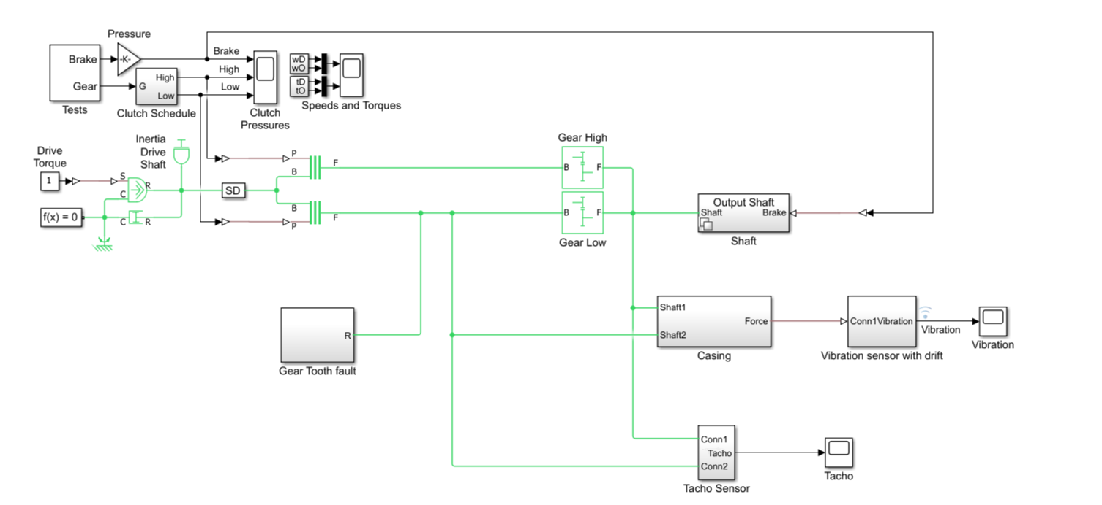
Figure 6. Simulink Model to generate data.

An ensemble contains multiple simulations with different parameter combinations. The supplied workflow combines 110 systematically selected combinations with 98 combinations derived from randomly generated values, producing 208 runs. Sensor drift, shaft wear and gear tooth damage are varied, including simultaneous faults (Mathworks, 2026).
Both workflows remove the first ten seconds of vibration data to exclude start-up behaviour. For the SVM workflow, tachometer pulses also identify shaft rotations for time-synchronous averaging, which aligns and averages vibration measurements across rotations.
For the SVM, eighteen engineered features are extracted per run, including statistical, nonlinear and spectral indicators. Each run forms one row of the 208 × 22 feature table. The remaining four columns contain three binary fault labels and a combined fault code representing eight possible fault combinations. Labels are derived from simulation parameters and provide the target classifications.
For the neural networks, the vibration recordings undergo a separate preparation process. Each vibration recording is converted into 1,024 data points spaced evenly over time. The FFT converts these measurements into frequency components, from which 512 spectral magnitudes are retained. Logarithmic scaling compresses the range of spectral values, producing a 208 × 512 spectrum matrix (Mathworks, 2021). The corresponding fault labels are taken directly from the simulation records. These inputs support three separate binary classifiers for sensor drift, shaft wear and gear tooth damage.

Comparative Analysis

Model development and evaluation
The SVMs were trained in MATLAB Classification Learner with standardisation enabled. Each feature was rescaled using its training mean and standard deviation, reducing the risk of features with larger numerical ranges disproportionately influencing the model.
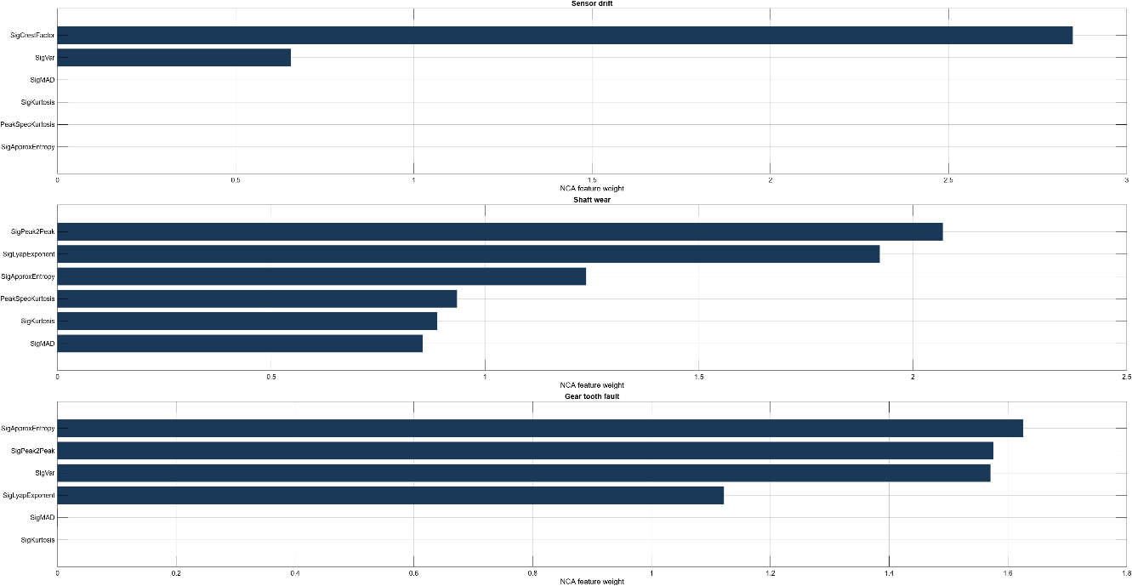
Figure 7. NCA feature weights for sensor drift, shaft wear and gear tooth faults across 208 simulated runs.
Neighbourhood component analysis (NCA) assessed which features helped distinguish fault-present runs across the 208 simulations. Figure seven shows the six highest ranked features for each fault. Crest factor ranked highest for sensor drift, peak-to-peak amplitude for shaft wear, and approximate entropy for tooth faults. These rankings describe feature affect in this analysis, but do not explain individual SVM predictions (Mathworks, 2026a).
Each NN used 512 spectral values, one hidden layer of 20 neurons and tanh activation to learn nonlinear relationships. Network settings were adjusted manually through trial and error to increase accuracy of the machine learning.
Both approaches were evaluated using five-fold cross-validation. In each fold, the model was trained on four groups and assessed on the remaining group. Each group was used for evaluation once, producing 208 predictions per fault from models that had excluded those runs during training. NN inputs were standardised using statistics calculated within each training fold. All three CV networks used Lambda 0.001, which penalises large connection weights to reduce overfitting risk.

Cross-validation comparison

Table one compares classification accuracy across 208 simulated runs per fault. The neural networks achieved higher observed accuracy for all three faults. The largest difference occurred for shaft wear, with 100% NN accuracy compared with 55.3% for the linear SVM. Sensor drift accuracy was 92.8% for the NN and 89.4% for the SVM, while tooth fault accuracy was 100% and 93.3%, respectively.

Fault | Runs per model | SVM accuracy | NN accuracy | NN - SVM Difference
Sensor drift | 208 | 89.4% | 92.8% | +3.4
Shaft wear | 208 | 55.3% | 100.0% | +44.7
Tooth fault | 208 | 93.3% | 100.0% | +6.7
Table 1. SVM vs Tuned NN
The confusion matrices in Figure eight reveal the errors underlying these percentages. The shaft wear SVM missed 40 of 104 fault present runs and falsely flagged 53 of 104 fault absent runs. For sensor drift, the SVM achieved 89.4% accuracy but generated 11 false alarms among 36 faults absent runs, giving a false-alarm rate of 30.6%. The NN reduced false alarms to eight among 36 fault-absent runs, giving a false-alarm rate of 22.2%, while missing seven fault-present runs.
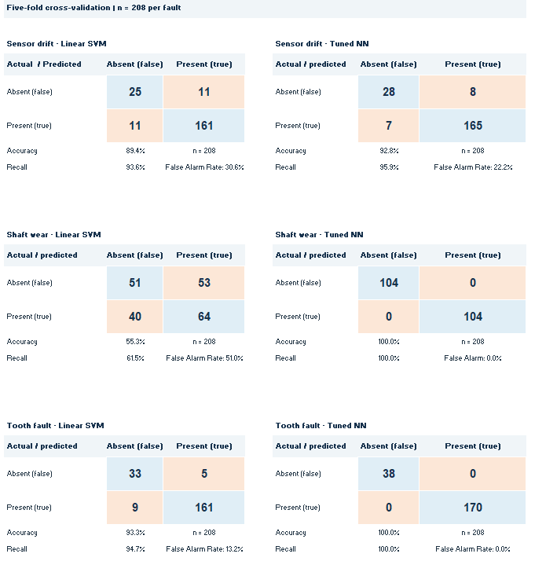
Figure 8. Confusion Matrices of all revelant results.
Sensor drift remained the most difficult fault for the NN. It missed seven of 172 fault-present runs and produced eight false alarms among 36 fault-absent runs. This gives 95.9% recall and a 22.2% false-alarm rate, compared with 93.6% and 30.6% for the SVM. However, the approaches use different input representations. Their performance difference therefore cannot be solely attributed to classifier choice.

Effect of Neural Network Tuning

Table two compares the baseline and manually tuned neural networks using five-fold cross-validation, with 208 predictions per fault and configuration. Sensor-drift accuracy increased from 82.7% to 92.8%, while shaft-wear accuracy increased from 36.5% to 100%. These represent improvements of 10.1 and 63.5 percentage points, respectively. Tooth fault accuracy remained at 100%.

Initial and tuned NN cross-validation accuracy
Five-fold cross-validation. Each result uses 208 predictions per fault.
Fault | Initial NN accuracy | Tuned NN accuracy | Change  (percentage points)
Sensor drift | 82.7% | 92.8% | +10.1
Shaft wear | 36.5% | 100.0% | +63.5
Tooth fault | 100.0% | 100.0% | 0.0
Table 2. Baseline NN vs tuned NN
The initial sensor-drift network predicted that drift was present in every run. Its 82.7% accuracy therefore reflected the proportion of runs containing drift, despite incorrectly flagging all 36 runs without drift. This demonstrates how class imbalance can lead to high overall accuracy while hiding poor recognition of the less common fault state. Following tuning, the alarm rates can be seen in figure nine.
Figure 9. NN Tuned and Untuned Alarm Rate.
The false alarms decreased from 36 to eight, reducing the false alarm rate from 100% to 22.2%. However, the tuned network also missed seven actual drift cases. Its higher accuracy therefore represents a better overall classification result, while some faults remained undetected.
For shaft wear, errors decreased from 132 to zero. Although this improvement is substantial, perfect classification within the simulated dataset does not establish reliable performance on plant measurements.

Discussion and Industrial Implications

The hardest fault depended on the approach, sensor drift for the NN and shaft wear for the linear SVM. Drift is modelled as an offset affecting the signal baseline and zero-frequency FFT component. Small offsets may be harder to distinguish from normal variation, although checking missed cases against fault severity would be necessary to confirm this explanation. The SVM missed 40 of 104 shaft-wear cases, indicating a substantial detection weakness in this configuration. Poor SVM shaft-wear detection may reflect poor feature representation or the linear decision boundary. Although NCA ranked peak-to-peak amplitude highest for shaft wear, this does not demonstrate that a linear boundary can separate the fault states.
The initial drift NN classified every run as faulty, so its 82.7% accuracy reflected the prevalence of drift labels. Following tuning, false alarms fell from 36 to eight among 36 runs without drift, but seven of 172 drift cases were missed. This produced 95.9% recall and a 22.2% false-alarm rate. These results demonstrate why accuracy must be considered alongside missed detections and false alarms. A lower threshold for declaring a fault might recover missed cases while increasing false alarms, but threshold sensitivity was not tested.
Although the NN recorded no mechanical-fault errors, the synthetic dataset cannot establish safe performance under plant conditions. Missed drift cases also show that unreliable measurements may remain undetected. Alerts should therefore support engineering assessment, including calibration checks where drift is suspected, with representative plant testing required before deployment.
Availability also depends on warning time. The scenario specifies outage costs of £45,000/hour and a 10–12-week gearbox lead time. Reliable warnings could support parts procurement and maintenance planning (Sullivan, 2010), but classification does not establish how long remains before failure. Avoiding breakdowns and unnecessary stoppages could protect crude-feed stability and product quality, although these downstream effects were not modelled.
The NN advantage applies to the tested workflows as inputs and tuning differed, and identical cross-validation groups were not confirmed. With only 208 simulated runs, strong performance may depend on patterns specific to the simulator. Plant fault frequencies may alter from the simulated dataset, so the proportion of alerts that prove genuine remains uncertain. Cawley and Talbot (2010) argue repeated tuning against cross-validation scores can also produce optimistic estimates, for those reasons limitations restrict the recommendation to further evaluation of the tested NN configuration.

Conclusions and Recommendations

The NN is the preferred candidate for a monitoring trial overseen by engineers. It achieved cross-validation accuracies of 100% for shaft wear and tooth faults and 92.8% for sensor drift, exceeding the untuned linear SVM baselines. However, the 22.2% drift false-alarm rate requires further assessment, and performance on 208 simulated runs cannot establish plant reliability. This recommendation is limited to the tested workflows because the models received different inputs and unequal tuning.
For P-2201A, safety should govern maintenance decisions. Predictive monitoring should complement preventive maintenance, assisted by manual vibration analysis if trends suggest emerging issues. This combined approach could support earlier intervention to protect containment, improve spare-parts planning and reduce interruptions affecting availability and product quality, consistent with condition-based maintenance principles (Kelly, 2006). However, these operational benefits remain unquantified, and the cost may not warrant a change in system.
Before deployment, further comparison should use matching data partitions and investigate SVM feature selection and tuning. Testing should examine robustness to measurement noise, fault severity and changing operating conditions.
If a new machine learning model is to be introduced, settings and alarm thresholds should be fixed before independent evaluation on new data, followed by validation using representative plant recordings (Cawley and Talbot, 2010). During the trial, predictions should be checked against engineering findings, recording false alarms, missed faults and warning times. Wider use should depend on acceptable detection performance and sufficient warning for maintenance planning, particularly given the gearbox’s 10–12-week lead time.

References

Alsalaet, J. (2012). Vibration analysis and diagnostic guide. [online] ResearchGate. Available at: https://www.researchgate.net/publication/311420765_Vibration_Analysis_and_Diagnostic_Guide [Accessed 2 Sept. 2026].
Bevilacqua, M., Ciarapica, F. and Marchetti, B. (2014). Safety management on a refinery maintenance turnaround. Occupational Safety and Hygiene II, [online] pp.519–524. doi:10.1201/b16490-90.
Cawley, G. and Talbot, N. (2010). On over-fitting in model selection and subsequent selection bias in performance evaluation. Journal of Machine Learning Research, [online] 11. Available at: https://www.jmlr.org/papers/volume11/cawley10a/cawley10a.pdf [Accessed 15 Sept. 2026].
Dunn, W.C. (2006). Introduction to instrumentation, sensors and process control. Boston ; London: Artech House, Cop.
Geitner, F.K. and Bloch, H.P. (2019). Machinery component maintenance and repair. [online] Gulf Professional Publishing. Available at: https://www.google.co.uk/books/edition/Machinery_Component_Maintenance_and_Repa/Z5adDwAAQBAJ?hl=en&gbpv=1 [Accessed 26 Aug. 2026].
HSE Executive (n.d.). Design codes - plant. [online] www.hse.gov.uk. Available at: https://www.hse.gov.uk/comah/sragtech/techmeasplant.htm#SpecificEquipment [Accessed 20 Aug. 2026].
IBM (2021). What is overfitting? [online] Ibm.com. Available at: https://www.ibm.com/think/topics/overfitting [Accessed 5 Sept. 2026].
Jiang, H. (2024). Analysis of safety and reliability of instruments and instruments in mechanical engineering. International Journal of New Developments in Engineering and Society, [online] 8(2). doi:10.25236/ijndes.2024.080215.
Kelly, A. (2006). Plant maintenance management set. Butterworth-Heinemann.
Mathworks (2021). Train neural network classifier. [online] Mathworks.com. Available at: https://uk.mathworks.com/help/stats/fitcnet.html [Accessed 7 Sept. 2026].
Mathworks (2026a). Detect relevant features in data using NCA for classification. [online] MathWorks. Available at: https://uk.mathworks.com/help/stats/fscnca.html [Accessed 8 Sept. 2026].
Mathworks (2026b). Using simulink to generate fault data - MATLAB & simulink. [online] Mathworks.com. Available at: https://uk.mathworks.com/help/predmaint/ug/Use-Simulink-to-Generate-Fault-Data.html [Accessed 7 Sept. 2026].
Mathworks (n.d.). Support vector machine (SVM). [online] uk.mathworks.com. Available at: https://uk.mathworks.com/discovery/support-vector-machine.html [Accessed 5 Sept. 2026].
Mathworks (n.d.). What is a neural network? [online] uk.mathworks.com. Available at: https://uk.mathworks.com/discovery/neural-network.html [Accessed 6 Sept. 2026].
Muhlisin, I. and Rusyadi, R. (2019). Vibration analysis on rotating machines using fast fourier transform (FFT). ACMIT Proceedings, [online] 3(1), pp.67–75. doi:10.33555/acmit.v3i1.28.
Sadiku, M.N.O., Ajayi, S.A. and Sadiku, J.O. (2025). Machine learning: An overview. International Journal of Advanced Scientific Research, [online] 9(5), pp.1121–1131. Available at: https://www.researchgate.net/publication/397000720_Machine_Learning_An_Overview [Accessed 5 Sept. 2026].
Strączkiewicz, M., Barszcz, T. and Jabłoński, A. (2015). Detection and classification of alarm threshold violations in condition monitoring systems working in highly varying operational conditions. Journal of Physics: Conference Series, [online] 628, p.012087. doi:10.1088/1742-6596/628/1/012087.
Sullivan, G.P. (2010). Operations & maintenance best practices a guide to achieving operational efficiency. [online] Available at: https://www.energy.gov/sites/default/files/2020/04/f74/omguide_complete_w-eo-disclaimer.pdf? [Accessed 23 Aug. 2026].
Swanson, L. (2001). Linking maintenance strategies to performance. International Journal of Production Economics, 70(3), pp.237–244. doi:10.1016/s0925-5273(00)00067-0.
Tummalapalli, V. and Konakalla, K. (2025). Statistical techniques for feature selection in machine learning models. International Journal of Innovative Research in Engineering & Multidisciplinary Physical Sciences, [online] 13(3). doi:10.37082/ijirmps.v13.i3.232566.

Appendices

Confusion Matrices from Matlab

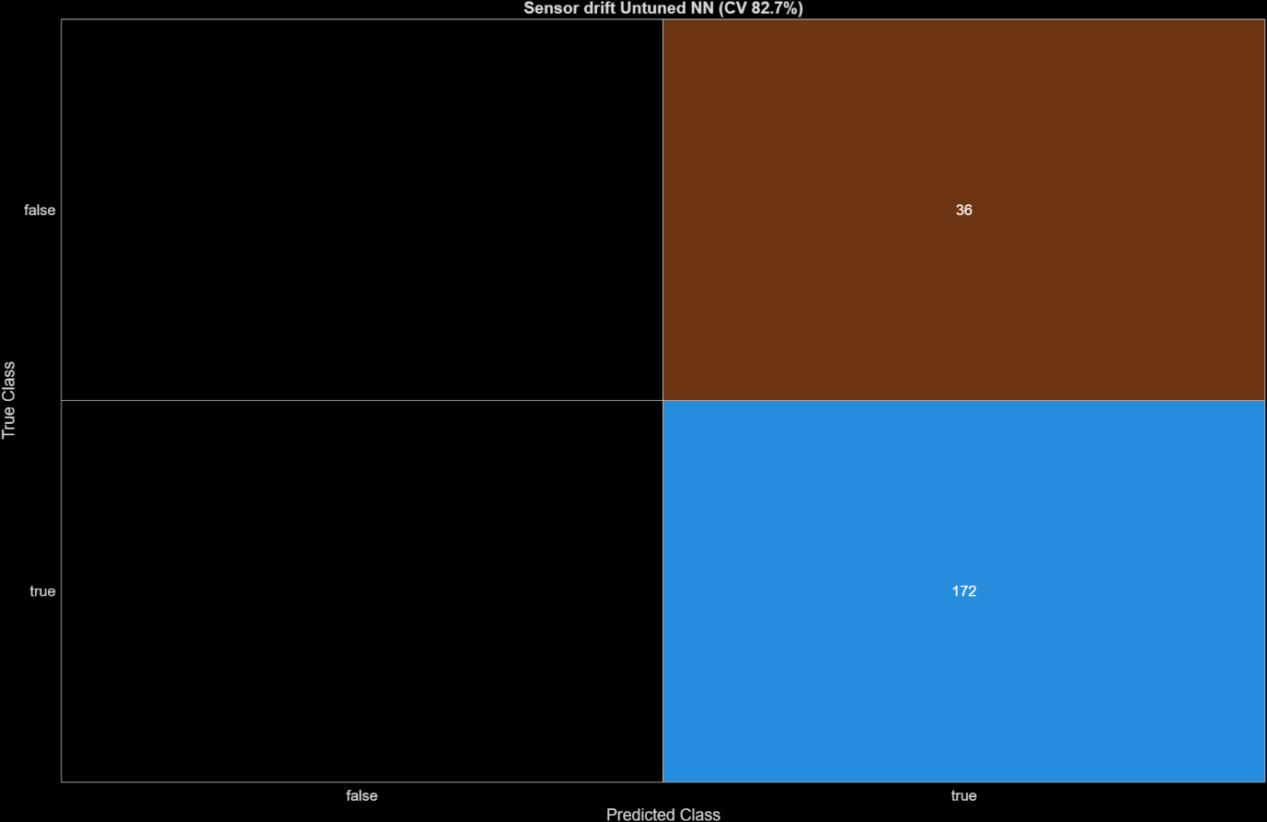
Figure 10. Untuned SD NN Confusion Matrix
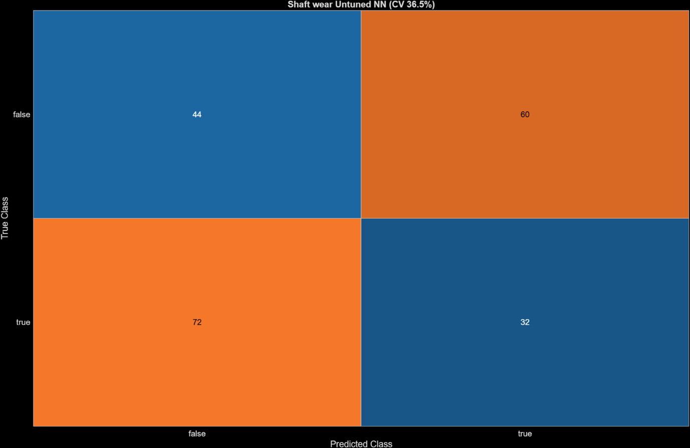
Figure 11. Untuned SW NN Confusion Matrix
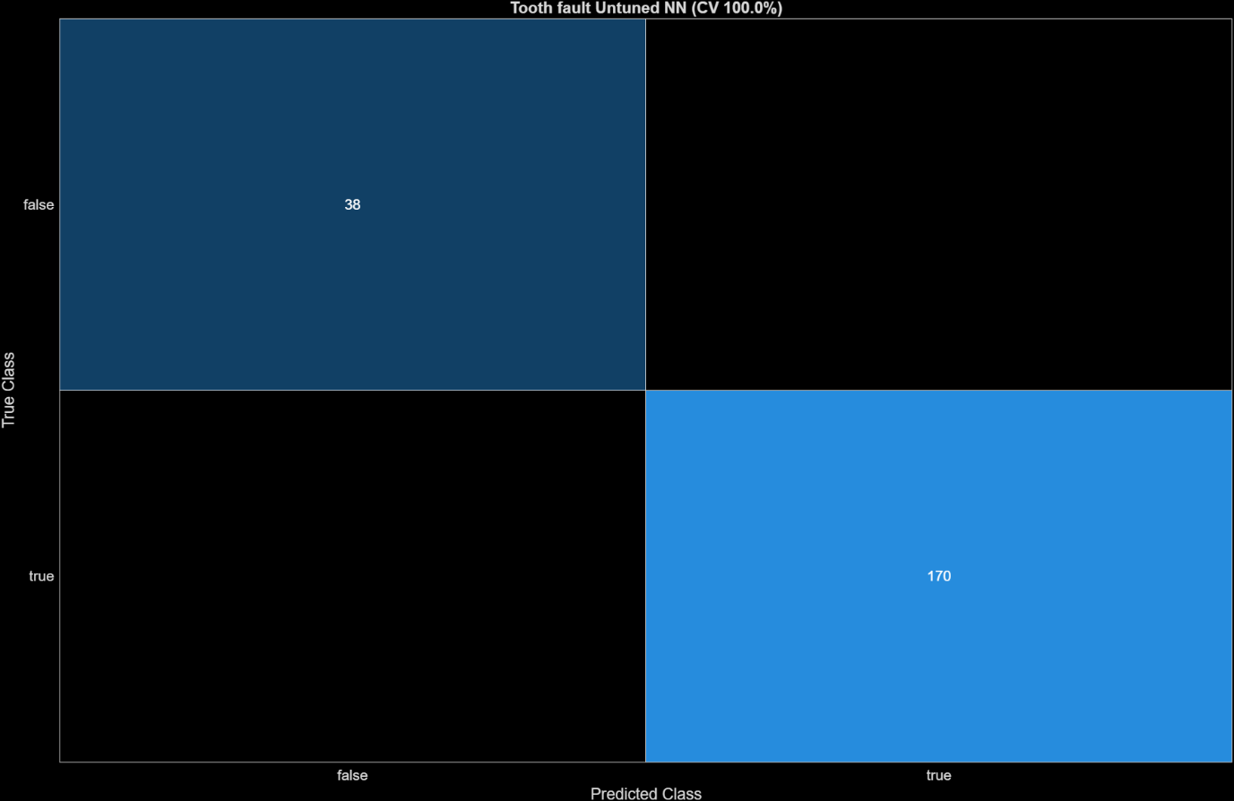
Figure 12. Untuned TF NN Confusion Matrix
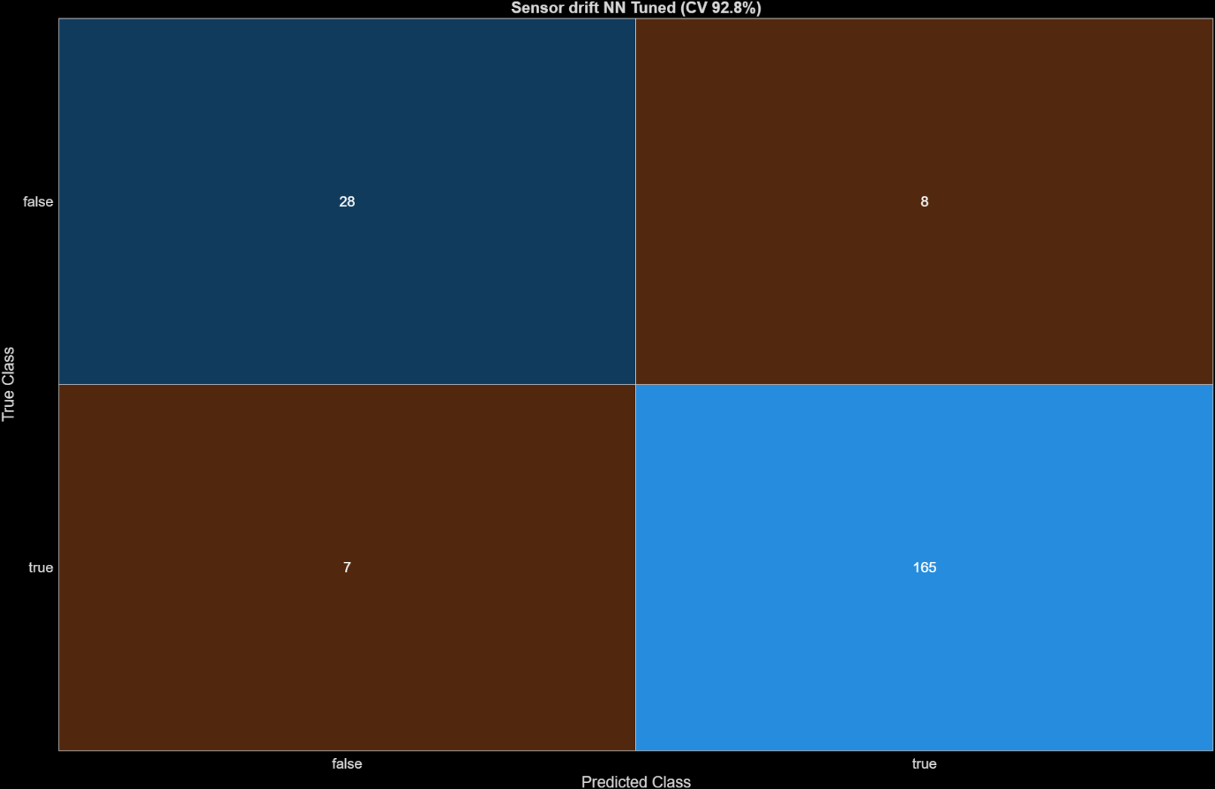
Figure 13. Tuned SD NN Confusion Matrix

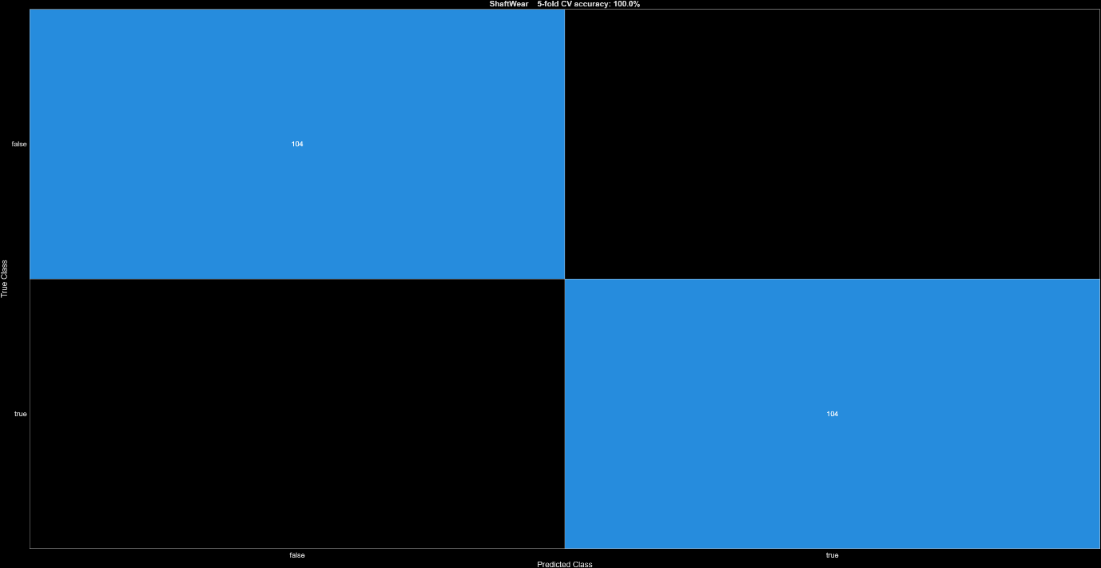
Figure 14. Tuned SW NN Confusion Matrix
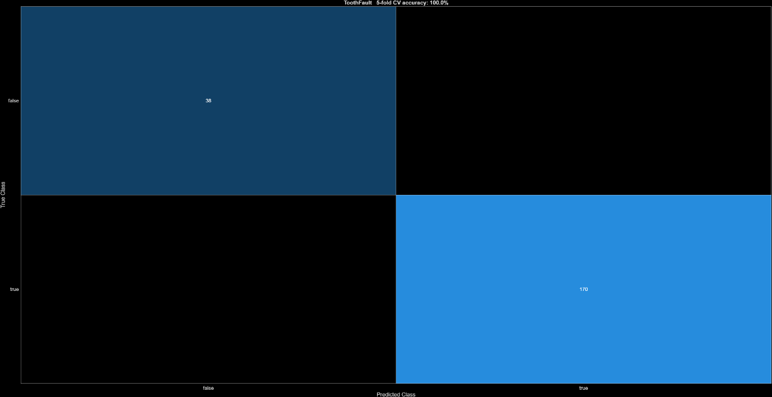
Figure 15. Tuned TF NN Confusion Matrix
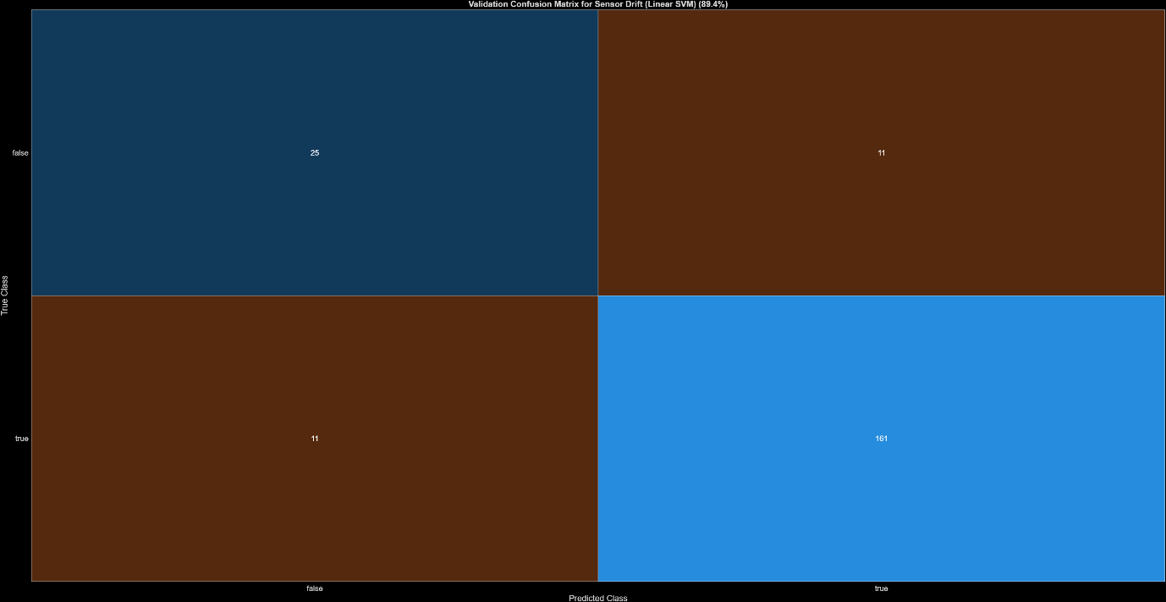
Figure 16. Linear SVM SD Untuned Confusion Matrix
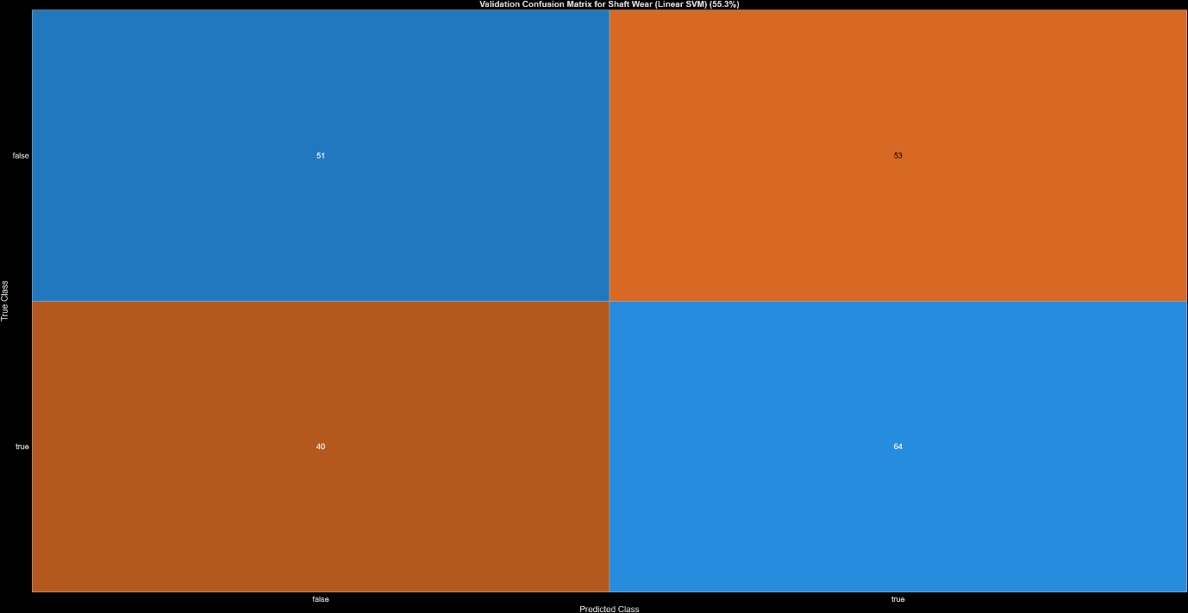
Figure 17. Linear SVM SW Untuned Confusion Matrix

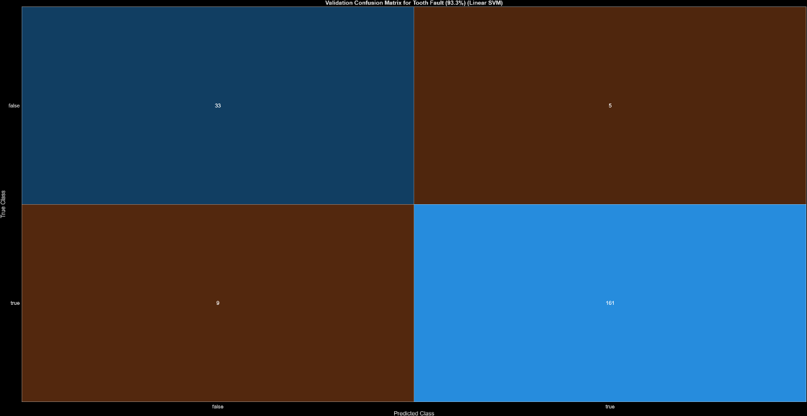
Figure 18. Linear SVM Untuned TF Confusion Matrix

Matlab Code SVM model

- PdM Assignment - Using Simulink to Generate Simulated Machine Data
Scenario:
Aberdaron Point Refinery is a mid-sized oil refinery on the South Wales coast processing around 130,000 barrels of crude per day. At the heart of the crude distillation unit (CDU) is Pump P-2201A, the crude charge pump: a heavy-duty centrifugal pump that takes desalted crude from the surge drum and forces it through the preheat train and fired heater into the atmospheric distillation column.
P-2201A is one of the most critical rotating machines on site. If it trips and its standby cannot be brought online in time, crude feed to the column is lost, the unit must be brought down in a controlled shutdown, and restart takes many hours. An unplanned CDU outage costs the company on the order of £45,000 per hour in lost margin, and a rebuild of the pump's drive gearbox has a lead time of 10–12 weeks from the original equipment manufacturer.

The pump drivetrain
P-2201A is driven by a 630 kW induction motor through a two-speed gearbox:
- Torque drive (motor plus coupling) provides the input torque.
- Drive shaft connects the motor to the gearbox.
- Clutch engages the drive smoothly and switches between the two gear ratios.
- Low gear is used for unit start-up and turndown operation, when the column is being brought up slowly and the pump must deliver reduced flow against a partially lined-out system.
- High gear is used for normal full-rate operation, running the pump at its best-efficiency point.
- Output shaft transmits drive to the pump impeller.
Instrumentation
After a gearbox failure during a start-up in 2024, traced back, in hindsight, to gear damage that had been developing for months — the reliability team fitted the P-2201A gearbox with a condition-monitoring system:
- A casing-mounted accelerometer measuring gearbox casing vibration. The casing behaves approximately as a mass–spring–damper excited by shaft motion; this is the `Vibration` signal in the model below
- A Tachometer counts pulses on both the drive shaft and the slower turning output shaft (one pulse per revolution). This is the `Tacho` signal, and it enables time-synchronous averaging (TSA) of the vibration signal — essential for isolating shaft-synchronous gear faults from general pump and process noise.
Data streams into the refinery historian/database, but at present a Maintenance engineer reviews it manually about once a fortnight. Your job, as the reliability / control engineer in the rotating equipment team, is to automate the interpretation of this data.

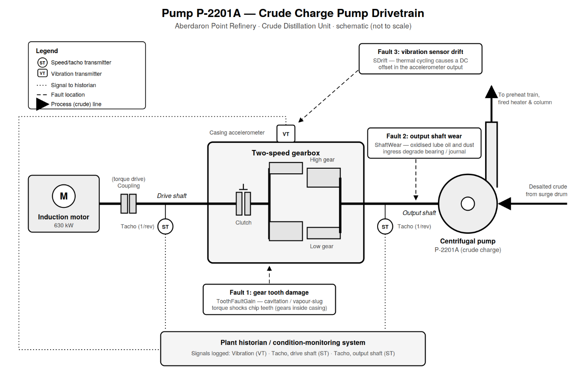
Fault modes of concern
The site's maintenance history for P-2201A and similar gearbox-driven pumps identifies three recurring degradation mechanisms. Each maps onto a fault parameter in the Simulink model.
1. Gear tooth damage — model variable `ToothFaultGain`
The crude charge service is prone to **cavitation and vapour slugging**: upsets in the desalter or surge drum can drop the suction pressure below the vapour pressure of the hot crude, and collapsing vapour pockets at the impeller send violent torque transients back through the output shaft into the gearbox. These shocks chip or spall individual gear teeth. A damaged tooth produces a **torque disturbance once per revolution of the drive shaft**, at a fixed angular position — exactly how the fault is modelled in Simulink (a disturbance injected in a narrow window around a fixed shaft angle). `ToothFaultGain = 0` means a healthy gear; increasingly negative values represent increasingly severe tooth damage. Left undetected, a chipped tooth propagates to full tooth loss and a wrecked gear set — the failure mode behind the 2024 outage.
2. Output shaft wear — model variable `ShaftWear`
The gearbox sits beside the fired-heater structure and runs hot. Elevated oil temperatures accelerate **lubricant oxidation**, and occasional seal weepage allows fine airborne catalyst dust and coke fines into the oil. The combination degrades the output-shaft bearing and journal surfaces, changing the effective damping of the shaft. In the model this is represented as a **variant subsystem** on the output shaft: `ShaftWear = 0` selects the healthy shaft, `ShaftWear = -1` selects the worn-shaft variant with altered damping. A worn shaft runs hotter still, accelerates seal failure, and risks seizure — and on a crude charge pump, a seized shaft is a potential loss-of-containment event, not just a production loss.
3. Vibration sensor drift — model variable `SDrift`
The accelerometer lives in a harsh spot: radiant heat from the fired heater, steam from nearby traps, and continuous vibration. Thermal cycling and ageing of the sensor electronics cause a **DC offset (drift)** to develop in its output. This is an instrumentation fault rather than a mechanical one, but it matters operationally — refinery safety culture treats untrustworthy instruments seriously, since a drifting sensor can mask a real developing fault or generate false alarms that erode operator confidence. The monitoring system must therefore recognise sensor drift and flag the channel for recalibration. `SDrift = 0` means a healthy sensor; nonzero values are offsets. (In the labelling code, offsets with magnitude below 0.01 are treated as within calibration tolerance, i.e. not a fault.)
Note that faults can occur simultaneously and at varying severities - for example a mildly worn shaft together with a drifting sensor, which is why the example sweeps grids and random combinations of all three parameters.

Why Simulate / use synthetic data?
Aberdaron Point has exactly one P-2201A gearbox in this service, and (fortunately) very few recorded failures. The one catastrophic failure it did have produced no usable early-warning data, because monitoring was only installed afterwards. There is nowhere near enough labelled fault data from the plant to train a classifier. The reliability team therefore uses the physics-based Simulink model of the drivetrain to generate synthetic vibration data for healthy and faulty conditions across a range of severities, following the workflow below:
1. Define arrays of fault-parameter values (gridded and random combinations, including zeros so that healthy and single-fault cases are represented).
2. Build an array of `Simulink.SimulationInput` objects and run `generateSimulationEnsemble` to simulate all scenarios.
3. Manage the results with a `simulationEnsembleDatastore`; discard the first 10 s of each run (start-up transient), extract tacho pulse times, and attach fault labels derived from the parameter values.
4. Extract condition-indicator features per ensemble member: signal statistics (mean, RMS, variance, peak-to-peak, skewness, kurtosis, crest factor, MAD, cumulative-sum range), nonlinear features (approximate entropy, correlation dimension, Lyapunov exponent), and spectral features computed from the TSA signal (peak frequency, high-frequency power, envelope power, peak spectral kurtosis).

Each ensemble member becomes one row of a feature table with 18 features plus labels: SensorDrift, shaftWear, ToothFault (booleans) and a combined FaultCode = SensorDrift (1) + ShaftWear (2) + ToothFault (4) (FaultCode values 0–7).
Your task
The model finishes by training an support vector machine (SVM) for one fault type. The refinery's reliability manager instead wants a neural network classifier, and wants the choice justified. Using the feature table you generate:
1. Complete the Simulink model & Generate the data - Run the ensemble simulation and produce the 208 × 22 feature table.
2. Explore the features - Conduct feature-importance analysis. Comment on which features discriminate each fault a
3. Train a shallow neural network. Design a network (e.g. few hidden layer; you choose the width and activation) to classify either (a) each fault as a separate binary output, or (b) the 8-class `FaultCode` directly. Be sure to normalise inputs, split the data into training / validation / test sets, evaluate the risk of overfitting on this small dataset.
4. Evaluate - Report confusion matrices on held-out data, and compare your network against the example's SVM baseline. Which fault is hardest to detect, and what does that tell you about the features or the physics?

Suggested extensions (Optional)
- Investigate sensitivity to fault severity thresholds - the labelling code treats small drifts and small tooth-fault gains as healthy; move the thresholds and study the effect on classifier performance.
- Add measurement noise to the vibration signal and study robustness.
- Investigate why the feature-importance analysis outputs make physical sense - e.g. why should cumulative-sum range respond to a DC sensor offset? Why should TSA spectral features respond to a once-per-revolution tooth impact but not to sensor drift?
- Reduce the feature set to the minimum needed for acceptable accuracy - fewer features means a cheaper, more maintainable deployed system.
- Estimate the economic and safety case: given the £45,000/h outage cost, the 10–12 week gearbox lead time, and the loss-of-containment risk of a seized shaft, roughly what detection performance (and false-alarm rate) justifies the monitoring system?
- Transmission System Model - Fault Modelling
The transmission casing model uses Simscape™ Driveline™ blocks to model a simple transmission system. The transmission system consists of a torque drive, drive shaft, clutch, and high and low gears connected to an output shaft.
mdl = 'pdmTransmissionCasing';
open_system(mdl)
open_system([mdl '/Casing']) % The transmission system includes fault models for vibration sensor drift, gear tooth fault, and shaft wear. The sensor drift fault is easily modeled by introducing an offset in the sensor model. The offset is controlled by the model variable SDrift, note that SDrift=0 implies no sensor fault.
open_system([mdl '/Vibration sensor with drift']) % The transmission system includes fault models for vibration sensor drift, gear tooth fault, and shaft wear. The sensor drift fault is easily modeled by introducing an offset in the sensor model. The offset is controlled by the model variable SDrift, note that SDrift=0 implies no sensor fault.
open_system([mdl '/Shaft']) % The shaft wear fault is modeled by a variant subsystem. In this case the subsystem variants change the shaft damping but the variant subsystem could be used to completely change the shaft model implementation. The selected variant is controlled by the model variable ShaftWear, note that ShaftWear=0 implies no shaft fault.
open_system([mdl,'/Shaft/Output Shaft']) % The gear tooth fault is modelled by injecting a disturbance torque at a fixed position in the rotation of the drive shaft. The shaft position is measured in radians and when the shaft position is within a small window around 0 a disturbance force is applied to the shaft. The magnitude of the disturbance is controlled by the model variable ToothFaultGain, note that ToothFaultGain=0 implies no gear tooth fault.

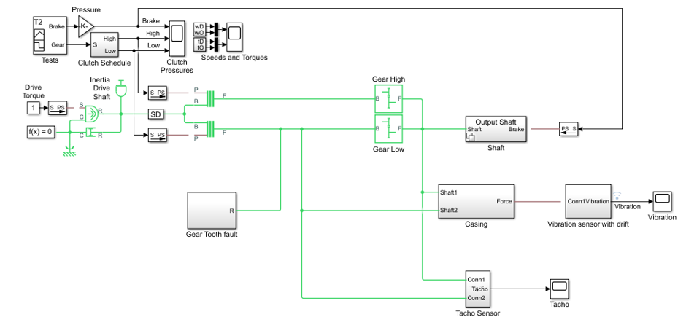
- Simulating Faulty and Healthy Data
The transmission model is configured with variables that control the presence and severity of the three different fault types, sensor drift, gear tooth, and shaft wear. By varying the model variables, SDrift, ToothFaultGain, and ShaftWear, you can create vibration data for the different fault types. Use an array of Simulink.SimulationInput objects to define a number of different simulation scenarios. For example, choose an array of values for each of the model variables and then use the ndgrid function to create a Simulink.SimulationInput for each combination of model variable values.
toothFaultArray = -2:2/10:0; % Tooth fault gain values
sensorDriftArray = -1:0.5:1; % Sensor drift offset values
shaftWearArray = [0 -1]; % Variants available for drive shaft conditions

% Create an n-dimensional array with combinations of all values
[toothFaultValues,sensorDriftValues,shaftWearValues] = ...
ndgrid(toothFaultArray,sensorDriftArray,shaftWearArray);

for ct = numel(toothFaultValues):-1:1
% Create a Simulink.SimulationInput for each combination of values
siminput = Simulink.SimulationInput(mdl);

% Modify model parameters
siminput = setVariable(siminput,'ToothFaultGain',toothFaultValues(ct));
siminput = setVariable(siminput,'SDrift',sensorDriftValues(ct));
siminput = setVariable(siminput,'ShaftWear',shaftWearValues(ct));

% Collect the simulation input in an array
gridSimulationInput(ct) = siminput;
end
Here we create combinations of random values for each model variable. We must be sure to include the 0 value (no fault) so that there are combinations where only subsets of the three fault types are represented.
rng('default'); % Reset random seed for reproducibility
toothFaultArray = [0 -rand(1,6)]; % Tooth fault gain values
sensorDriftArray = [0 randn(1,6)/8]; % Sensor drift offset values
shaftWearArray = [0 -1]; % Variants available for drive shaft conditions

%Create an n-dimensional array with combinations of all values
[toothFaultValues,sensorDriftValues,shaftWearValues] = ...
ndgrid(toothFaultArray,sensorDriftArray,shaftWearArray);

for ct=numel(toothFaultValues):-1:1
% Create a Simulink.SimulationInput for each combination of values
siminput = Simulink.SimulationInput(mdl);

% Modify model parameters
siminput = setVariable(siminput,'ToothFaultGain',toothFaultValues(ct));
siminput = setVariable(siminput,'SDrift',sensorDriftValues(ct));
siminput = setVariable(siminput,'ShaftWear',shaftWearValues(ct));

% Collect the simulation input in an array
randomSimulationInput(ct) = siminput;
end
With the array of Simulink.SimulationInput objects defined we use the generateSimulationEnsemble function to run the simulations. The generateSimulationEnsemble function configures the model to save logged data to file, use the timetable format for signal logging and store the Simulink.SimulationInput objects in the saved file. The generateSimulationEnsemble function returns a status flag indicating whether the simulation completed successfully.
The code below creates 110 simulation inputs from the gridded variable values and 98 simulation inputs from the random variable values, providing 208 total simulations in the base confguration. Running these 208 simulations in parallel can take some time and generates around 10GB of data. There is also an option to only run the first 10 simulations is provided for testing / debugging (set runAll = false;).
% Run the simulations and create an ensemble to manage the simulation results
if ~exist(fullfile(pwd,'Data'),'dir')
mkdir(fullfile(pwd,'Data')) % Create directory to store results
end

runAll = true; % this variable defines run control true = all simulations (208) false = sample of simulations (10)

if runAll
[ok,e] = generateSimulationEnsemble([gridSimulationInput, randomSimulationInput], ...
fullfile(pwd,'Data'),'UseParallel', true);
else
[ok,e] = generateSimulationEnsemble(gridSimulationInput(1:10), fullfile(pwd,'Data'));
end
The generateSimulationEnsemble runs and logs the simulation results. Below we create a simulation ensemble to process and analyze the simulation results using the simulationEnsembleDatastore command.
ens = simulationEnsembleDatastore(fullfile(pwd,'Data'));

- Processing the Simulation Results
The simulationEnsembleDatastore command created an ensemble object that points to the simulation results. Use the ensemble object to prepare and analyze the data in each member of the ensemble. The ensemble object lists the data variables in the ensemble and by default all the variables are selected for reading.
ens
ens.SelectedVariables
For analysis only read the Vibration and Tacho signals and the Simulink.SimulationInput. The Simulink.SimulationInput has the model variable values used for simulation and is used to create fault labels for the ensemble members. Use the ensemble read command to get the ensemble member data.
ens.SelectedVariables = ["Vibration" "Tacho" "SimulationInput"];
data = read(ens)
Extract the vibration signal from the returned data and plot it.
vibration = data.Vibration{1};
plot(vibration.Time,vibration.Data)
title('Vibration')
ylabel('Acceleration')
The first 10 seconds of the simulation contains data where the transmission system is starting up; for analysis discard this data.
idx = vibration.Time >= seconds(10);
vibration = vibration(idx,:);
vibration.Time = vibration.Time - vibration.Time(1);

The Tacho signal contains pulses for the rotations of the drive and load shafts but analysis, and specifically time synchronous averaging, requires the times of shaft rotations. The following code discards the first 10 seconds of the Tacho data and finds the shaft rotation times in tachoPulses.
tacho = data.Tacho{1};
idx = tacho.Time >= seconds(10);
tacho = tacho(idx,:);
plot(tacho.Time,tacho.Data)
title('Tacho pulses')
legend('Drive shaft','Load shaft') % Load shaft rotates more slowly than drive shaft
idx = diff(tacho.Data(:,2)) > 0.5;
tachoPulses = tacho.Time(find(idx)+1)-tacho.Time(1)
The Simulink.SimulationInput.Variables property contains the values of the fault parameters used for the simulation, these values allow us to create fault labels for each ensemble member.
vars = data.SimulationInput{1}.Variables;
idx = strcmp({vars.Name},'SDrift');
if any(idx)
sF = abs(vars(idx).Value) > 0.01; % Small drift values are not faults
else
sF = false;
end
idx = strcmp({vars.Name},'ShaftWear');
if any(idx)
sV = vars(idx).Value < 0;
else
sV = false;
end
if any(idx)
idx = strcmp({vars.Name},'ToothFaultGain');
sT = abs(vars(idx).Value) >= 0.1; % Small tooth fault values are not faults
else
sT = false
end
faultCode = sF + 2*sV + 4*sT; % A fault code to capture different fault conditions
The processed vibration and tacho signals and the fault labels are added to the ensemble to be used later.
sdata = table({vibration},{tachoPulses},sF,sV,sT,faultCode, ...
'VariableNames',{'Vibration','TachoPulses','SensorDrift','ShaftWear','ToothFault','FaultCode'})
ens.DataVariables = [ens.DataVariables; "TachoPulses"];
The ensemble ConditionVariables property can be used to identify the variables in the ensemble that contain condition or fault label data. Set the property to contain the newly created fault labels.
ens.ConditionVariables = ["SensorDrift","ShaftWear","ToothFault","FaultCode"];
The code above was used to process one member of the ensemble. To process all the ensemble members the code above was converted to the function prepareData and using the ensemble hasdata command a loop is used to apply prepareData to all the ensemble members. The ensemble members can be processed in parallel by partitioning the ensemble and processing the ensemble partitions in parallel.
reset(ens)
runLocal = true;
if runLocal
% Process each member in the ensemble
while hasdata(ens)
data = read(ens);
addData = prepareData(data);
writeToLastMemberRead(ens,addData)
end
else
% Split the ensemble into partitions and process each partition in parallel
n = numpartitions(ens,gcp);
parfor ct = 1:n
subens = partition(ens,n,ct);
while hasdata(subens)
data = read(subens);
addData = prepareData(data);
writeToLastMemberRead(subens,addData)
end
end
end
Plot the vibration signal of every 10th member of the ensemble using the hasdata and read commands to extract the vibration signal.
reset(ens)
ens.SelectedVariables = "Vibration";
figure,
ct = 1;
while hasdata(ens)
data = read(ens);
if mod(ct,10) == 0
vibration = data.Vibration{1};
plot(vibration.Time,vibration.Data)
hold on
end
ct = ct + 1;
end
hold off
title('Vibration signals')
ylabel('Acceleration')

- Analyzing the Simulation Data
Now that the data has been cleaned and pre-processed the data is ready for extracting features to determine the features to use to classify the different faults types. First configure the ensemble so that it only returns the processed data.
ens.SelectedVariables = ["Vibration","TachoPulses"];
For each member in the ensemble we compute a number of time and spectrum based features. These include signal statistics such as signal mean, variance, peak to peak, non-linear signal characteristics such as approximate entropy and Lyapunov exponent, and spectral features such as the peak frequency of the time synchronous average of the vibration signal, and the power of the time synchronous average signal. The analyzeData function contains a full list of the extracted features. By way of example consider computing the spectrum of the time synchronous averaged vibration signal.
reset(ens)
data = read(ens)
vibration = data.Vibration{1};

% Interpolate the Vibration signal onto periodic time base suitable for fft analysis
np = 2^floor(log(height(vibration))/log(2));
dt = vibration.Time(end)/(np-1);
tv = 0:dt:vibration.Time(end);
y = retime(vibration,tv,'linear');

% Compute the time synchronous average of the vibration signal
tp = seconds(data.TachoPulses{1});
vibrationTSA = tsa(y,tp);
figure
plot(vibrationTSA.Time,vibrationTSA.tsa)
title('Vibration time synchronous average')
ylabel('Acceleration')

% Compute the spectrum of the time synchronous average
np = numel(vibrationTSA);
f = fft(vibrationTSA.tsa.*hamming(np))/np;
frTSA = f(1:floor(np/2)+1); % TSA frequency response
wTSA = (0:np/2)/np*(2*pi/seconds(dt)); % TSA spectrum frequencies
mTSA = abs(frTSA); % TSA spectrum magnitudes
figure
semilogx(wTSA,20*log10(mTSA))
title('Vibration spectrum')
xlabel('rad/s')
The frequency that corresponds to the peak magnitude could turn out to be a feature that is useful for classifying the different fault types. The code below computes the features mentioned above for all the ensemble members (running this analysis can take up to an hour on a standard desktop. Optional code to run the analysis in parallel using the ensemble partition command is provided.) The names of the features are added to the ensemble data variables property before calling writeToLastMemberRead to add the computed features to each ensemble member.
reset(ens)
ens.DataVariables = [ens.DataVariables; ...
"SigMean";"SigMedian";"SigRMS";"SigVar";"SigPeak";"SigPeak2Peak";"SigSkewness"; ...
"SigKurtosis";"SigCrestFactor";"SigMAD";"SigRangeCumSum";"SigCorrDimension";"SigApproxEntropy"; ...
"SigLyapExponent";"PeakFreq";"HighFreqPower";"EnvPower";"PeakSpecKurtosis"];
if runLocal
while hasdata(ens)
data = read(ens);
addData = analyzeData(data);
writeToLastMemberRead(ens,addData);
end
else
% Split the ensemble into partitions and analyze each partition in parallel
n = numpartitions(ens,gcp);
parfor ct = 1:n
subens = partition(ens,n,ct);
while hasdata(subens)
data = read(subens);
addData = analyzeData(data);
writeToLastMemberRead(subens,addData)
end
end
end

- Selecting Features for Fault Classification
The features computed above are used to build a classifier to classify the different fault conditions. First configure the ensemble to read only the derived features and the fault labels.
featureVariables = analyzeData('GetFeatureNames');
ens.DataVariables = [ens.DataVariables; featureVariables];
ens.SelectedVariables = [featureVariables; ens.ConditionVariables];
reset(ens)
Gather the feature data for all the ensemble members into one table.
featureData = gather(tall(ens))
Consider the sensor drift fault. Use the fscnca command with all the features computed above as predictors and the sensor drift fault label (a true false value) as the response. The fscnca command returns weights for each feature and features with higher weights have higher importance in predicting the response. For the sensor drift fault the weights indicate that two features are significant predictors (the signal cumulative sum range and the peak frequency of the spectral kurtosis) and the remaining features have little impact.
idxResponse = strcmp(featureData.Properties.VariableNames,'SensorDrift');
idxLastFeature = find(idxResponse)-1; % Index of last feature to use as a potential predictor
featureAnalysis = fscnca(featureData{:,1:idxLastFeature},featureData.SensorDrift);
featureAnalysis.FeatureWeights
idxSelectedFeature = featureAnalysis.FeatureWeights > 0.1;
classifySD = [featureData(:,idxSelectedFeature), featureData(:,idxResponse)]
A grouped histogram of the cumulative sum range gives us insight into why this feature is a significant predictor for the sensor drift fault.
figure
histogram(classifySD.SigRangeCumSum(classifySD.SensorDrift),'BinWidth',5e3)
xlabel('Signal cumulative sum range')
ylabel('Count')
hold on
histogram(classifySD.SigRangeCumSum(~classifySD.SensorDrift),'BinWidth',5e3)
hold off
legend('Sensor drift fault','No sensor drift fault')
The histogram plot shows that the signal cumulative sum range is a good featured for detecting sensor drift faults though an additional feature is probably needed as there may be false positives when the signal cumulative sum range is below 0.5 if just the signal cumulative sum range is used to classify sensor drift.
Consider the shaft wear fault. In this case the fscnca function indicates that there are 3 features that are significant predictors for the fault (the signal Lyapunov exponent, peak frequency, and the peak frequency in the spectral kurtosis), choose these to classify the shaft wear fault.
idxResponse = strcmp(featureData.Properties.VariableNames,'ShaftWear');
featureAnalysis = fscnca(featureData{:,1:idxLastFeature},featureData.ShaftWear);
featureAnalysis.FeatureWeights
idxSelectedFeature = featureAnalysis.FeatureWeights > 0.1;
classifySW = [featureData(:,idxSelectedFeature), featureData(:,idxResponse)]
The grouped histogram for the signal Lyapunov exponent shows why that feature alone is not a good predictor.
figure
histogram(classifySW.SigLyapExponent(classifySW.ShaftWear))
xlabel('Signal lyapunov exponent')
ylabel('Count')
hold on
histogram(classifySW.SigLyapExponent(~classifySW.ShaftWear))
hold off
legend('Shaft wear fault','No shaft wear fault')
The shaft wear feature selection indicates multiple features are needed to classify the shaft wear fault, the grouped histogram confirms this as the most significant feature (in this case the Lyapunov exponent) has a similar distribution for both faulty and fault free scenarios indicating that more features are needed to correctly classify this fault.

Finally consider the tooth fault, the fscnca function indicates that there are 3 features primary that are significant predictors for the fault (the signal cumulative sum range, the signal Lyapunov exponent and the peak frequency in the spectral kurtosis). Choosing those 3 features to classify the tooth fault results in a classifier that has poor performance. Instead, use the 6 most important features.
idxResponse = strcmp(featureData.Properties.VariableNames,'ToothFault');
featureAnalysis = fscnca(featureData{:,1:idxLastFeature},featureData.ToothFault);
[~,idxSelectedFeature] = sort(featureAnalysis.FeatureWeights);
classifyTF = [featureData(:,idxSelectedFeature(end-5:end)), featureData(:,idxResponse)]
figure
histogram(classifyTF.SigRangeCumSum(classifyTF.ToothFault))
xlabel('Signal cumulative sum range')
ylabel('Count')
hold on
histogram(classifyTF.SigRangeCumSum(~classifyTF.ToothFault))
hold off
legend('Gear tooth fault','No gear tooth fault')
Using the above results a polynomial svm to classify gear tooth faults. Split the feature table into members that are used for training and members for testing and validation. Use the training members to create a svm classifier using the fitcsvm command.
rng('default') % For reproducibility
cvp = cvpartition(size(classifyTF,1),'KFold',5); % Randomly partition the data for training and validation
classifierTF = fitcsvm(...
classifyTF(cvp.training(1),1:end-1), ...
classifyTF(cvp.training(1),end), ...
'KernelFunction','polynomial', ...
'PolynomialOrder',2, ...
'KernelScale','auto', ...
'BoxConstraint',1, ...
'Standardize',true, ...
'ClassNames',[false; true]);
Use the classifier to classify the test points using the predict command and check the performance of the predictions using a confusion matrix.
% Use the classifier on the test validation data to evaluate performance
actualValue = classifyTF{cvp.test(1),end};
predictedValue = predict(classifierTF, classifyTF(cvp.test(1),1:end-1));

% Check performance by computing and plotting the confusion matrix
confdata = confusionmat(actualValue,predictedValue);
h = heatmap(confdata, ...
'YLabel', 'Actual gear tooth fault', ...
'YDisplayLabels', {'False','True'}, ...
'XLabel', 'Predicted gear tooth fault', ...
'XDisplayLabels', {'False','True'}, ...
'ColorbarVisible','off');
The confusion matrix indicates that the classifier correctly classifies all non-fault conditions but incorrectly classifies one expected fault condition as not being a fault. Increasing the number of features used in the classifier can help improve the performance further.

Matlab Code NN Model

- Fault Classification from Raw Vibration Spectra - 3 Binary Neural Networks
This script skips the hand-crafted features of the main model entirely. Instead, each simulation's raw vibration signal is converted into a frequency spectrum, and that spectrum is fed straight into the neural networks.
Three separate shallow networks are trained, one per fault type:
- Network 1 : Sensor drift (SDrift) - instrumentation fault
- Network 2 : Shaft wear (ShaftWear) - mechanical fault
- Network 3 : Gear tooth (ToothFaultGain) - mechanical fault
Each network predicts the answer answer to a yes/no question (is this fault present?).
Note
The table `rawData` must be in your workspace (created by the extraction script). Each of its 208 rows is one simulation, holding the Vibration signal as a timetable plus the fault labels.
If you are using your own PC/Laptop this task requires the Statistics and Machine Learning Toolbox (R2021a or later for the fitcnet function). Alternatively, just use MATLAB Online

- Turning every raw signal into a fixed-length spectrum
A neural network needs every example to have the SAME number of inputs, but the simulations have slightly different lengths and sample times.
So for each run we must:
- Cut off the first 10 seconds (start-up transient - not steady running, so not representative),
- Resample the signal onto a common grid of `samplesPerRun` points,
- Take the FFT to get the frequency spectrum,
- Keep the first half (the spectrum of a real signal is mirrored, so the second half is a duplicate),
- Take log10, which compresses the huge range between the biggest spectral peaks and the noise floor so small features still count.
Why a spectrum instead of the time signal?
The gear shafts start at a random angle in every run, so in the TIME signal a fault's pattern lands at a different position each time - very hard for this type of network to learn. The magnitude SPECTRUM does not depend on where the pattern starts, so the same fault always affects the same inputs.
samplesPerRun = 1024; % time samples taken from each signal
spectrumBins = samplesPerRun / 2; % spectrum points kept (one-sided)
numberOfRuns = height(rawData); % should be 208

spectrumMatrix = zeros(numberOfRuns, spectrumBins); % one row per run

for runNumber = 1:numberOfRuns
% Get this run's vibration signal (a timetable: Time + Data columns)
vibrationSignal = rawData.Vibration{runNumber};

% (a) discard the 10-second start-up transient
vibrationSignal = vibrationSignal(vibrationSignal.Time >= seconds(10), :);

% (b) resample onto an evenly spaced time grid
timeInSeconds = seconds(vibrationSignal.Time);
evenTimeGrid = linspace(timeInSeconds(1), timeInSeconds(end), samplesPerRun);
resampledSignal = interp1(timeInSeconds, vibrationSignal.Data, ...
evenTimeGrid, 'linear');

% (c) frequency spectrum via the FFT (magnitude only)
% Note: we deliberately KEEP the very first spectrum value (the "DC" or zero-frequency component) - a drifting sensor shows up there!
spectrum = abs(fft(resampledSignal)) / samplesPerRun;

% (d) keep the first half, (e) log-compress, store as one row
spectrumMatrix(runNumber, :) = log10(spectrum(1:spectrumBins) + eps);
end

% The fault labels for each run (columns of true/false values)
sensorDriftLabels = rawData.SensorDrift; % true = sensor is drifting
shaftWearLabels = rawData.ShaftWear; % true = shaft is worn
toothFaultLabels = rawData.ToothFault; % true = gear tooth damaged
faultCodeLabels = rawData.FaultCode; % combined 0-7 code

- Split the data: 70% training, 15% validation, 15% test
- Training data: used to adjust the network weights.
- Validation data : watched during training to decide when to stop (prevents over-training / memorising).
- Test data: locked away until the end - used ONCE to measure real performance on runs the network has never seen.
Note: We must "stratify" by FaultCode so that every fault combination appears in all three sets, even the rare ones.
rng(0) % fix the random number seed so everyone gets the same split

% First split: keep 70% for training, put 30% aside (validagtion & test)
firstSplit = cvpartition(categorical(faultCodeLabels), 'HoldOut', 0.30,'Stratify',false);
trainingRows = find(training(firstSplit));
heldOutRows = find(test(firstSplit));

% Second split: divide the held-out 30% equally into validation and test
secondSplit = cvpartition(categorical(faultCodeLabels(heldOutRows)), 'HoldOut', 0.50,'Stratify',false);
validationRows = heldOutRows(training(secondSplit));
testRows = heldOutRows(test(secondSplit));

fprintf('Data split: %d training, %d validation, %d test runs\n', ...
numel(trainingRows), numel(validationRows), numel(testRows));

- Normalising the spectrum values (z-score)
Every input is rescaled to mean 0 and standard deviation 1 so that no single frequency bin dominates the training just because its numbers are bigger.
IMPORTANT: the mean and standard deviation are calculated from the TRAINING rows only. If we used the whole dataset, information about the test data would "leak" into training and the test result would look better than it really is.
trainingMean = mean(spectrumMatrix(trainingRows,:), 1);
trainingStd = std(spectrumMatrix(trainingRows,:), 0, 1);
trainingStd(trainingStd == 0) = 1; % avoid dividing by zero

normalisedSpectra = (spectrumMatrix - trainingMean) ./ trainingStd;

- Building Network 1: Sensor Drift
Class weights: if one class (e.g. "fault") has many more examples than the other, the network can score well by always predicting the common class. Weighting each class to contribute equally to the training loss removes that issue. Use the same three lines for each network.
driftTrainingLabels = sensorDriftLabels(trainingRows);

driftWeights = zeros(size(driftTrainingLabels));
driftWeights(driftTrainingLabels) = 0.5 / sum(driftTrainingLabels); % faulty runs
driftWeights(~driftTrainingLabels) = 0.5 / sum(~driftTrainingLabels); % healthy runs
Train a shallow network: one hidden layer of 20 neurons.
- normalisedSpectra(trainingRows,:), driftTrainingLabels — The training data and their true drift/no-drift answers; only the training rows go in so the validation rows stay unseen.
- 'Weights', driftWeights — Gives some samples more influence during training; useful here because of the unbalance in the number of drift / no drift samples.
- 'LayerSizes', 20 — One hidden layer of 20 neurons; bigger means more pattern-learning power but more overfitting risk.
- 'Activations', 'relu' — The nonlinearity each neuron applies; 'relu' is the standard default, 'tanh' is worth trying if results are poor.
- 'Lambda', 1e-3 — Regularization strength; this is a light penalty, so raise it if the model overfits and lower it if it underfits.
- 'Standardize', false — Turns off automatic rescaling because the spectra were already normalised in Step 3; leaving it on would rescale twice.
- 'ValidationData', {…} — A held-out set the model is scored on while training, so you can see performance on data it never learns from.
- 'ValidationPatience', 10 — Stops training once validation performance fails to improve for 10 checks in a row, preventing overfitting.
- 'IterationLimit', 2000 — The maximum number of training iterations allowed; raise it if training halts before converging.
- 'ClassNames', [false; true] — Fixes the class order so false (no drift) is class 1 and true (drift) is class 2, keeping confusion matrices and scores consistent.
rng(0)
sensorDriftNet = fitcnet( ...
normalisedSpectra(trainingRows,:), driftTrainingLabels, ...
'Weights', driftWeights, ...
'LayerSizes', 20, ...
'Activations', 'tanh', ...
'Lambda', 1e-4, ...
'Standardize', false, ... % we already normalised in Step 3
'ValidationData', {normalisedSpectra(validationRows,:), sensorDriftLabels(validationRows)}, ...
'ValidationPatience', 20, ...
'IterationLimit', 2000, ...
'ClassNames', [false; true]);

% Predict on the unseen test rows and report accuracy
driftPredictions = predict(sensorDriftNet, normalisedSpectra(testRows,:));

driftTestAccuracy = mean(driftPredictions == sensorDriftLabels(testRows));
driftTrainAccuracy = mean(predict(sensorDriftNet,normalisedSpectra(trainingRows,:)) == driftTrainingLabels);

fprintf('SensorDrift test accuracy: %5.1f%% (training: %5.1f%%)\n', ...
100*driftTestAccuracy, 100*driftTrainAccuracy);

figure('Name','Per-fault confusion matrices (raw spectra)')
confusionchart(sensorDriftLabels(testRows), driftPredictions, ...
'Title', 'Sensor drift')

- Building Network 2: Shaft Wear
Using the code above as a guide, develop a neural network model to predict shaft wear fault conditions
%% Enter Your Code Here %%
rng(0)
driftTrainingLabels = shaftWearLabels(trainingRows);

driftWeights = zeros(size(driftTrainingLabels));
driftWeights(driftTrainingLabels) = 0.5 / sum(driftTrainingLabels); % faulty runs
driftWeights(~driftTrainingLabels) = 0.5 / sum(~driftTrainingLabels); % healthy runs

sensorDriftNet = fitcnet( ...
normalisedSpectra(trainingRows,:), driftTrainingLabels, ...
'Weights', driftWeights, ...
'LayerSizes', 20, ...
'Activations', 'tanh', ...
'Lambda', 1e-3, ...
'Standardize', false, ... % we already normalised in Step 3
'ValidationData', {normalisedSpectra(validationRows,:), shaftWearLabels(validationRows)}, ...
'ValidationPatience', 20, ...
'IterationLimit', 2000, ...
'ClassNames', [false; true]);

% Predict on the unseen test rows and report accuracy
driftPredictions = predict(sensorDriftNet, normalisedSpectra(testRows,:));

driftTestAccuracy = mean(driftPredictions == shaftWearLabels(testRows));
driftTrainAccuracy = mean(predict(sensorDriftNet,normalisedSpectra(trainingRows,:)) == driftTrainingLabels);

fprintf('Shaft Wear test accuracy: %5.1f%% (training: %5.1f%%)\n', ...
100*driftTestAccuracy, 100*driftTrainAccuracy);

figure('Name','Per-fault confusion matrices (raw spectra)')
confusionchart(shaftWearLabels(testRows), driftPredictions, ...
'Title', 'Shaft Wear')

- Building Network 3: Gear Tooth Fault
%% Enter Your Code Here %%
rng(0)
driftTrainingLabels = toothFaultLabels(trainingRows);

driftWeights = zeros(size(driftTrainingLabels));
driftWeights(driftTrainingLabels) = 0.5 / sum(driftTrainingLabels); % faulty runs
driftWeights(~driftTrainingLabels) = 0.5 / sum(~driftTrainingLabels); % healthy runs

sensorDriftNet = fitcnet( ...
normalisedSpectra(trainingRows,:), driftTrainingLabels, ...
'Weights', driftWeights, ...
'LayerSizes', 20, ...
'Activations', 'tanh', ...
'Lambda', 1e-3, ...
'Standardize', false, ... % we already normalised in Step 3
'ValidationData', {normalisedSpectra(validationRows,:), toothFaultLabels(validationRows)}, ...
'ValidationPatience', 20, ...
'IterationLimit', 2000, ...
'ClassNames', [false; true]);

% Predict on the unseen test rows and report accuracy
driftPredictions = predict(sensorDriftNet, normalisedSpectra(testRows,:));

driftTestAccuracy = mean(driftPredictions == toothFaultLabels(testRows));
driftTrainAccuracy = mean(predict(sensorDriftNet,normalisedSpectra(trainingRows,:)) == driftTrainingLabels);

fprintf('Tooth Fault test accuracy: %5.1f%% (training: %5.1f%%)\n', ...
100*driftTestAccuracy, 100*driftTrainAccuracy);

figure('Name','Per-fault confusion matrices (raw spectra)')
confusionchart(toothFaultLabels(testRows), driftPredictions, ...
'Title', 'Tooth Fault')

- STEP 9 - Cross-validation: A Fairer Accuracy Estimate
Our test set has only 31 runs, so one lucky or unlucky run changes the accuracy by about 3%. Five-fold cross-validation gives a better estimate: the 208 runs are divided into 5 groups ("folds"); the model is trained 5 times, each time testing on a different fold. Every run is therefore used as test data exactly once.
Note: we pass the un-normalised spectra and let fitcnet normalise inside each fold ('Standardize', true). Normalising the whole dataset first would leak test information into training (see step 3 warning).
Network Parameters
- LayerSizes, 20 — Sets how many neurons the hidden layer has; bigger numbers let the model learn more complex patterns but risk overfitting.
- Lambda, 1e-1 — Controls regularization strength; raise it to reduce overfitting, lower it to let the model fit the data more closely.
- Standardize, true — Rescales every spectral channel to a comparable range; keep it on so the training is stable and fair across channels.
- KFold, 5 — Splits the data into 5 parts to test accuracy on unseen data; use more folds for a more reliable estimate.
- Activations (default 'relu') — Chooses the type of nonlinearity in the neurons; try 'tanh' if 'relu' isn't working well on your spectra.
- IterationLimit (default 1000) — Limits how long training runs; increase it if the model stops before it has finished learning.
- ValidationData / ValidationPatience — Stops training early when performance on held-out data stops improving, which is another way to prevent overfitting.
% --- Sensor drift ---
rng(0) % same fold assignment for every fault, for a fair comparison
driftCrossValModel = fitcnet(spectrumMatrix, sensorDriftLabels, ...
'LayerSizes', 20, 'Lambda', 1e-3, 'Standardize', true, 'KFold', 5, 'Activations', 'tanh');
driftCrossValPredictions = kfoldPredict(driftCrossValModel);
driftCrossValAccuracy = mean(driftCrossValPredictions == sensorDriftLabels);
fprintf('SensorDrift 5-fold CV accuracy: %5.1f%%\n', 100*driftCrossValAccuracy);

% --- Shaft wear ---
rng(0)
shaftCrossValModel = fitcnet(spectrumMatrix, shaftWearLabels, ...
'LayerSizes', 20, 'Lambda', 1e-3, 'Standardize', true, 'KFold', 5, 'Activations', 'tanh');
shaftCrossValPredictions = kfoldPredict(shaftCrossValModel);
shaftCrossValAccuracy = mean(shaftCrossValPredictions == shaftWearLabels);
fprintf('ShaftWear 5-fold CV accuracy: %5.1f%%\n', 100*shaftCrossValAccuracy);

% --- Gear tooth fault ---
rng(0)
toothCrossValModel = fitcnet(spectrumMatrix, toothFaultLabels, ...
'LayerSizes', 20, 'Lambda', 1e-3, 'Standardize', true, 'KFold', 5, 'Activations', 'tanh');
toothCrossValPredictions = kfoldPredict(toothCrossValModel);
toothCrossValAccuracy = mean(toothCrossValPredictions == toothFaultLabels);
fprintf('ToothFault 5-fold CV accuracy: %5.1f%%\n', 100*toothCrossValAccuracy);

% Confusion matrices over ALL 208 runs (every prediction was made by a model that never saw that run during training)
figure('Name','5-fold cross-validation per fault (raw spectra)')

confusionchart(sensorDriftLabels, driftCrossValPredictions, ...
'Title', sprintf('Sensor drift (CV %.1f%%)', 100*driftCrossValAccuracy));

confusionchart(shaftWearLabels, shaftCrossValPredictions, ...
'Title', sprintf('Shaft wear (CV %.1f%%)', 100*shaftCrossValAccuracy));

confusionchart(toothFaultLabels, toothCrossValPredictions, ...
'Title', sprintf('Tooth fault (CV %.1f%%)', 100*toothCrossValAccuracy));

