Daniel Phillips 2305529

Preparing for research within policing

Contents
Task 1: Mind Map of Ideas 2
Task 2: Research Proposal 3
Task 3: Ethics Form 7
Task 4: Justification of the Chosen Research Method 8
Task 5: Draft Research Questions 9
Task 6: Evaluation of the Chosen Data Analysis Method 10
References 11

Task 1: Mind Map of Ideas

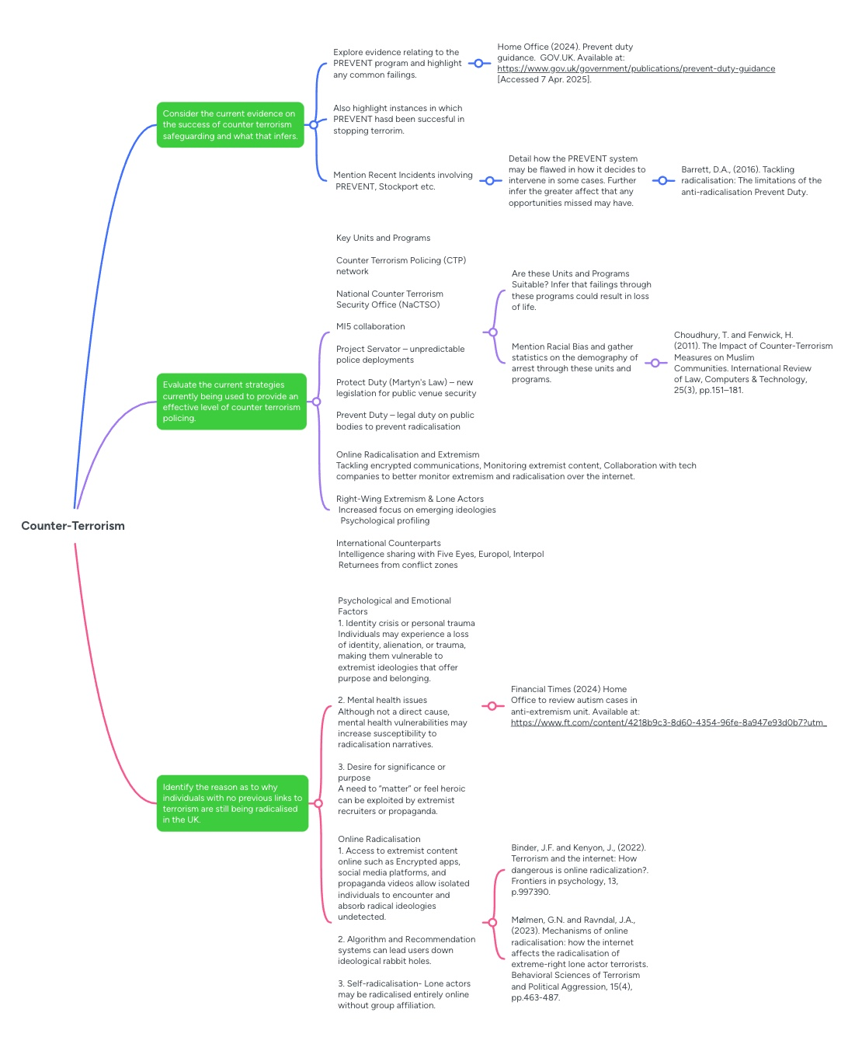

Task 2: Research Proposal



UNDERGRADUATE DISSERTATION
RESEARCH PROPOSAL FORM

NAME: Daniel Phillips | Student number: 2305529
DRAFT RESEARCH TITLE QUESTION:
Are the current counter terrorism policing strategies, safeguarding processes effective and successful?
I have decided to focus my research project on counter terrorism as it is an area of policing that I have a major interest in. This topic is becoming far more prevalent in the United Kingdom, especially after the recent events in Stockport in which terrorism safeguarding measures failed. This topic is also a key area of policing so therefore there is a large interest in how police forces in the UK are keeping the public safe. The research will be focused on a review of current counter terrorism procedures and safeguarding programs such as PREVENT. These procedures and safeguarding programs will be thoroughly evaluated and supported with the relevant literature. This topic and question is worth the consideration for an undergraduate dissertation as there is a substantial amount of information related to the subject. This topic is constantly scrutinised by police chiefs and the government as it is important that the population in the UK is kept from harm. This topic will encourage the exploration of current legislation and procedures that are put into place by the government. Therefore, by undertaking research on this topic there will be a detailed and varied range of research available. The current research available will also highlight statistics that will show if current procedures and safeguarding measures are effective.

SUMMARY OF RESEARCH AIM & OBJECTIVES:
An important aim of this study is to identify whether the public also feel that current counter terrorism policing and safeguarding is effective. This will include creating a questionnaire and studying research to identify these opinions. A crucial part of this study however is to identify the current issues with counter terrorism policing and failures of the safeguarding measures currently in place.

The first objective is to consider the current evidence on the success of counter terrorism safeguarding and what that infers.

The second objective is to identify the reason as to why individuals with no previous links to terrorism are still being radicalised in the UK.

The final objective is to evaluate the current strategies currently being used to provide an effective level of counter terrorism policing.

THEORETICAL CONTEXT:
In the UK, safeguarding programs and counterterrorism plans, particularly the Prevent strategy, have generated a range of opinions from the general population, including both praise and criticism. The CONTEST strategy, the UK's counterterrorism policy, has come under fire for its effects on Muslim communities. The Prevent component, which aims to prevent radicalisation, has come under scrutiny for unfairly targeting out Muslims and creating a climate of distrust and isolation. Research has indicated concerns that Prevent would stigmatise certain groups, which could hinder its goals. (Choudhury and Fenwick, 2011), reinforces this notion due to Muslim individuals making up a major proportion of the PREVENT program. Furthermore, discussions concerning the strategy's viability and implementation have flared up in light of incidents like the referral of two young boys to Prevent for possessing toy firearms. (The Guardian, 2017), supports that incidents like this can have racial bias that can attribute to a referral to the PREVENT program. This supports the view of the PREVENT program creating mistrust among Muslim communities. In dealing with various forms of extremism, perceptions of bias further confuses the publics attitude. While Islamist radicals' identical actions are classified as terrorism, far-right violence is sometimes dismissed as simple hooliganism. (Pearson, Winterbotham and Brown, 2020). From this it can be inferred that the public's perception of the fairness of counterterrorism measures is impacted by this unfair inconsistency.

SUMMARY OF RESEARCH –SURVEY METHOD:
One research method that I will be using is an online survey. This survey will gauge the opinions of a wide range of individuals and will give me the necessary data to be able to identify the publics opinions on the current state of counter terrorism in the United Kingdom. The online survey will be created and shared through google forms. An online survey was chosen as my research method because it is a successful technique of gathering data. It is also quite simple and not complicated so this will ensure that it will be able to be shared with a wide range of individuals. A survey will also be able to provide both qualitative and quantitive data. This is important as from this I will be able to gather a range of opinions on the current state of safeguarding and counter terrorism policing.
The data from the questionnaire will be analysed by thematical analysis. This will ensure that any patterns and results will be able to be clearly identified and analysed. This will also ensure that any consistent themes of opinion are clearly identified. One limitation regarding an online survey is that they may not reach certain populations, such as those without internet access or those who are digitally excluded, leading to sampling biases and limiting the generalisation of the findings. Another limitation is self-selection bias which could lead to findings that are not representative of the general population. This may result from respondents who are more inclined to participate if they are passionate about the subject or have strong opinion on terrorism.

SUMMARY OF SAMPLING FRAMEWORK:
The survey will be answered by members of the public aged 18 years and older. The online survey will be used gather opinions from the public. This will allow more responses that will accurately represent the opinions of the public overall. By asking members of the public the data provided will be reliable and useable for the topic. The survey will also provide many responses as it will be straightforward to complete therefore supporting the research that I would have collected. The target sample will provide different perspectives as age demographics will play a part as more mature respondents may be aware of the current threat of terrorism and poor safeguarding measures currently in place. This will contrast with the younger age demographic that the online survey will also target because they are less likely to be as informed of terrorism. This infers that my findings will provide a large range of data to analyse.

INITIAL REFERENCE LIST:
ACT Early (2020). Prevent Radicalism and Extremism by Acting Early. Available at: https://actearly.uk/ [Accessed 7 Apr. 2025].
Choudhury, T. and Fenwick, H. (2011). The Impact of Counter-Terrorism Measures on Muslim Communities. International Review of Law, Computers & Technology, 25(3), pp.151–181.
Halford, E. (2023). A scoping analysis of the counter terrorism command policing structure and its impact on intelligence sharing between the police and the security services. Journal of Policing, Intelligence and Counter Terrorism, 18(3), 353-374.
Home Office (2024). Prevent duty guidance. GOV.UK. Available at: https://www.gov.uk/government/publications/prevent-duty-guidance [Accessed 7 Apr. 2025].
Pearson, ER, Winterbottom, E & Brown, KE. (2020). Countering Violent Extremism: Making Gender Matter. Palgrave Macmillan.
Spiller, K., Whiting, A., Awan, I., & Campbell, B. (2023). The Politic of Everyday Counter-Terrorism: Online Performances and Responsibilities of the Prevent Duty in UK Higher Education Institutions. Sociology, 57(2), 267-284
The Guardian (2017). Council admits racially discriminating against two boys over Prevent toy gun referral. Available at: https://www.theguardian.com/uk-news/2017/jan/27/bedfordshire-local-education-authority-admits-racial-discrimination-brothers-toy-gun-school-police. (Accessed on 4/05/25).
Zempi, I., & Tripli, M. (2022). Islamophobia, the 'Prevent' Duty and the Surveillance of Muslim Students in UK Universities. Race, Ethnicity and Education, 25(1), 1-18.

Task 3: Ethics Form
Dan Phillips ethics Form.docx

Task 4: Justification of the Chosen Research Method

The research method I have chosen to use is a survey which will collect both qualitative and quantitative data. A survey is an effective research method for collecting both qualitative and quantitative data due to its versatility, efficiency, and ability to reach a broad audience. By using a survey, I will be able to gather a large amount of quantitative data, which I can then statistically analysed to identify trends, patterns, and correlations (Creswell and Creswell, 2018). Secondly, if I use open-ended questions in my survey, I will be able to record qualitative insights that reflect my participants’ perceptions, attitudes, and experiences (Fink, 2013). This dual capability makes surveys particularly useful in mixed-methods research, where both numerical data and deeper contextual understanding are necessary. This is very important for my research as I will gather both qualitative and quantitative data about Terrorism. Using a survey in my research will also be time effective due to their relatively low cost of distribution to large, different populations across geographical location. This infers that surveys are particularly useful when generalisability is the desired outcome (Bryman, 2016). According to (Dillman, Smyth, and Christian, 2014), surveys also provide respondents with a certain amount of anonymity. This infers that using a survey will be very beneficial to my research as surveys will promote more honest and considerate responses, especially when discussing delicate subjects such as terrorism. According to Diamond (2011), structured surveys also enhance consistency and improve the interpretability of data. This infers that if a survey is structured, respondents are guaranteed to be consistent, which makes data comparison and interpretation easier.

Task 5: Draft Research Questions

- What is your Gender?

- What age group are you apart of?

- How confident are you in the UK police’s ability to prevent terrorism?

- To what extent do you feel informed about the UK’s counter-terrorism strategies (e.g. Prevent, CONTEST)?

- Do you believe that counter-terrorism policing in the UK tends to consist of racial bias?

- Have you ever received information or training related to safeguarding individuals from radicalisation (e.g. through schools, workplaces, or community centres)?

- In your opinion, how well does the Prevent strategy support vulnerable individuals at risk of radicalisation?

- Do you think communities are adequately involved in counter-terrorism and safeguarding efforts?

- Have you ever reported concerns related to radicalisation or extremism?

- How much trust do you have in counter-terrorism police to safeguard vulnerable individuals without discrimination?

- What improvements, if any, would you suggest for counter-terrorism policing or safeguarding practices in the UK?

Task 6: Evaluation of the Chosen Data Analysis Method

The data analysis method that I have chosen for my survey is a method called statistical analysis. Statistical analysis is the process of gathering, arranging, analysing, and displaying numerical data to find trends, evaluate theories, and reach reliable conclusions. The reason I have chosen this method is because it is essential to research as it gives a non-bias evaluation of the data presented (Field, 2018). There are two main areas of statistical analysis that can take place. Descriptive statistics, which describe what's in the data, and inferential statistics, which help make guesses about bigger groups based on a small sample (Pallant, 2020). An effective standard of statistical analysis helps make research results clear, trustworthy, and based on real evidence. When used correctly, it makes a study stronger and more reliable (Tabachnick and Fidell, 2019). I will also be deciding to use statistical analysis since it provides a transparent, methodical way to managing quantitative data and will make the process of producing results transparent. It is also unlikely to make a mistake as providing decision-making a quantitative basis is one of its main advantages (Gravetter and Wallnau, 2017). Therefore, I will be able to confidently support or reject ideas using statistical analysis, which is crucial for generating reliable study findings. Furthermore, statistical analysis makes studies easier to replicate. The study's academic value is increased when results are given using standardised procedures so that other researchers may test and validate the findings (Dancey and Reidy, 2017). Because of these factors, I think statistical analysis is not only useful but also necessary to produce solid, significant findings for my dissertation.

References

ACT Early (2020). Prevent Radicalism and Extremism by Acting Early. Available at: https://actearly.uk/ [Accessed 7 Apr. 2025].
Bryman, A., (2016). Social research methods. 5th ed. Oxford: Oxford University Press.

Choudhury, T. and Fenwick, H. (2011). The Impact of Counter-Terrorism Measures on Muslim Communities. International Review of Law, Computers & Technology, 25(3), pp.151–181.
Creswell, J.W. and Creswell, J.D., (2018). Research design: Qualitative, quantitative, and mixed methods approaches. 5th ed. Thousand Oaks, CA: SAGE Publications.

Dancey, C.P. and Reidy, J., (2017). Statistics Without Maths for Psychology. 7th ed. Harlow: Pearson.

Diamond, S.S., (2011). Reference guide on survey research. In: National Research Council, Reference manual on scientific evidence. 3rd ed. Washington, DC: The National Academies Press, pp.359–423.

Dillman, D.A., Smyth, J.D. and Christian, L.M., (2014). Internet, phone, mail, and mixed-mode surveys: The tailored design method. 4th ed. Hoboken, NJ: Wiley.

Field, A., (2018). Discovering Statistics Using IBM SPSS Statistics. 5th ed. London: SAGE Publications.

Fink, A., (2013). How to conduct surveys: A step-by-step guide. 5th ed. Thousand Oaks, CA: SAGE Publications.

Gravetter, F.J. and Wallnau, L.B., (2017). Statistics for the Behavioral Sciences. 10th ed. Boston: Cengage Learning.

Halford, E. (2023). A scoping analysis of the counter terrorism command policing structure and its impact on intelligence sharing between the police and the security services. Journal of Policing, Intelligence and Counter Terrorism, 18(3), 353-374.
Home Office (2024). Prevent duty guidance. GOV.UK. Available at: https://www.gov.uk/government/publications/prevent-duty-guidance [Accessed 7 Apr. 2025].
Pearson, ER, Winterbottom, E & Brown, KE. (2020). Countering Violent Extremism: Making Gender Matter. Palgrave Macmillan.
Pallant, J., (2020). SPSS Survival Manual. 7th ed. Maidenhead: McGraw-Hill Education.
Spiller, K., Whiting, A., Awan, I., & Campbell, B. (2023). The Politic of Everyday Counter-Terrorism: Online Performances and Responsibilities of the Prevent Duty in UK Higher Education Institutions. Sociology, 57(2), 267-284
Tabachnick, B.G. and Fidell, L.S., 2019. Using Multivariate Statistics. 7th ed. New York: Pearson.
The Guardian (2017). Council admits racially discriminating against two boys over Prevent toy gun referral. Available at: https://www.theguardian.com/uk-news/2017/jan/27/bedfordshire-local-education-authority-admits-racial-discrimination-brothers-toy-gun-school-police. (Accessed on 4/05/25).
Zempi, I., & Tripli, M. (2022). Islamophobia, the 'Prevent' Duty and the Surveillance of Muslim Students in UK Universities. Race, Ethnicity and Education, 25(1), 1-18.

