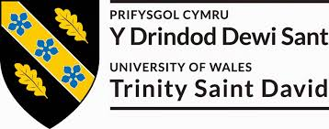

BMSW5104
MANAGING PROJECTS IN THE ORGANISATION

Prepared for
Mr Paul Jenkins
UNIVERSITY OF WALES: TRINITY SAINT DAVID
PRIFYSGOL CYMRU: Y DRINDOD DEWI SANT

Prepared by
Pinar Altintas (1818319)

August 24, 2020
Table of Contents
Introduction 3
1. Provide a critical assessment of the usefulness of project management tools and techniques. 4
2. Prepare a plan for the implementation of the project and specify the relevant steps that must be followed and how the plan is going to be implemented. Communicate the project plans with appropriate colleagues and stakeholders. 9
3. Critically evaluates your ability to manage a project. Use feedback from others to evaluate your own ability to plan and implement a project by identifying strengths and weaknesses. Create a self-development plan to improve your own performance in managing projects 12
Conclusion 17
References 18

Introduction
During the outset of any project, a variety of thoughts and views will emerge about the intent and nature of the project, the final result and the project implementation. The Project Initiation Process seeks to move these thoughts and goals into an organized, scheduled, supported project. For the definition of a project this way, the aim of the project and its range of interest must first be clearly and explicitly defined. In identifying that first, the consistency of what actually gets achieved at the end of the project needs to be measured by a standard. The report focuses on project management plan with context to the Arcadia group which is a fashion company in UK. The company wants to grow at any possible rate that’s why it introduces various projects. The new project of the company is to open top-shop counter. The Top-shop retail fit-out contained structural changes to allow new escalators and elevators to be installed from the basement to the third floor. The building is designed to restrict the extent of changes in the warehouse and façade, although new glasses, mullions and doors have been installed after approval by Landmark.
There are three questions in the report. The first question concerns debates on project management methods and strategies. The second issue requires an action strategy and project management contact. It also involves how I plan a project. It involves a self-development strategy for enhancing project management efficiency.

1. Provide a critical assessment of the usefulness of project management tools and techniques.
Project management tools and techniques provide the efficiency and effectiveness in managing the methods and strategies for project management provides productivity and performance in project formulation. Some methods and strategies have been thoroughly developed and used by project management all over the world for a long time, with considerable benefit to project performance. The Arcadia group come from its own tools. Below are some significant items in the planning toolkit of a project manager that helps to plan, evaluate progress, and identify key paths and other tasks needed for a proper project to work. Some of the tools and techniques used by the Arcadia group are as follows:
Network Diagrams: Network diagrams are one of the tools used by the project manager of Arcadia group for project planning. This is often called an arrow map occasionally, since it uses arrows to connect activities and reflects the priority and interdependencies of a project's activities (Harding, et. al., 2016). When constructing the Network Diagram certain hypotheses need to be made. Second, all ongoing operations will be done before a new operation starts. The second theory is that any arrow is rational. This means that the arrow's direction is the sequence that must be followed by activities.
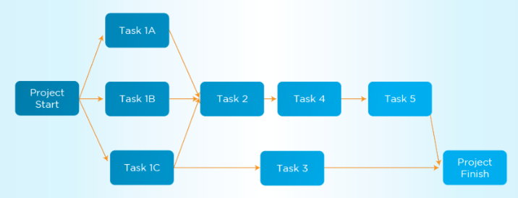
Source: Dickerson, et. al., 2016
The plan and work sequence for the project are mapped and their progress is followed through each stage and completed. Because it contains each project-related behaviour and effect, a network diagram often shows the project's reach. A network diagram is fit with Arcadia group as it not only enables a project manager to monitor each project item and easily differentiate its position with other project items, but as evidence indicates that visual representation of data may maximize awareness and retention, a network diagram can also improve success and efficiency and minimize tension among team leaders (Wang, et. al., 2017).
Critical Path Method: The "Critical Path Method" is a common project management approach for measuring the progress of the project. Plan preparation in the Arcadia community is often responsible for project creation. The crucial line of the project is the longest sequence of activities for network diagrams and a nil slack for all functions. Under other terms, any critical activities will require the least time to expand the total project timeline. For the project manager of arcadia Community, it is also highly necessary that he closely tracks the vital path operations to ensuring that the research is completed properly. The Arcadia Community shall, where appropriate, move money from certain non-essential tasks to main operations so that the project will not be disrupted. When the project manager reduces funding, it must ensure that the task does not become an essential route operation when funding are that. There are several explanations why the main instructions can be easily changed during project implementation and the project manager can have to monitor them. Those are important directions for a broad project like the top shop counter (Heagney, 2016).
Project Evaluation and Review Technique: The Project Evaluation and Review Technique are the Network Diagram Management Methods, also known as Project Evaluation and Review Technique. In addition, Project Evaluation and Review Technique is used for defining the project's vital route. This methodology has been used by the Arcadia group to streamline the preparation and preparing of big, complicated programs and to offer more accurate forecasts of the length of specific operations.
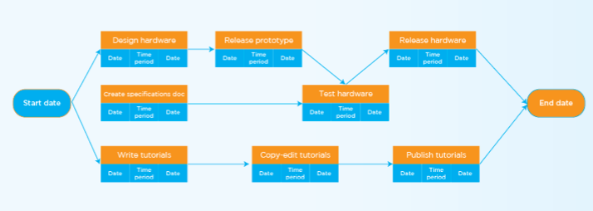
Source: Chen, et. al., 2016
While Project Evaluation and Review Technique uses one estimate for each operation's duration, the standard network diagram contains 3 types of assessments per operation. The optimistic estimate takes into account all factors which benefit the activity. For example, positive assumptions presume that no complications exist and that all resources at their maximum rates of performance in Arcadia group. Therefore, optimistic estimates are slightly lower than others.
The second estimation is the "most probable" estimation and is defined as T-M. This estimation supposes that during the operation of the task other difficulties occur in Arcadia group and certain backup reserves are included in the calculation.
The third calculation is the "pessimistic" estimation and is expressed by T-P. This estimate assumes that whatever is wrong is wrong while the activity is being executed. Therefore, this estimate covers large contingency buffers and is the highest of all three estimates.
The realistic estimate for the activity is shown as T-E and is calculated by averaging all three. The weight of the prediction is given a weight of 4 in estimation of the average, whereas the other two figures are considered as follows. The actual, accurate estimation calculated by Arcadia group using Project Evaluation and Review Technique takes far longer than estimates calculated without Project Evaluation and Review Technique, but is much more practical (Newton, 2016).
Gantt chart: The Gantt map includes a visual timeline for project preparation, project scheduling and advancement towards project completion. It reflects the project schedule because bar charting is spread over a span of time. This is a perfect project organizing method for Arcadia group. In a contrasting shade from the expected period of each task, the progress is shown. Color distinction and bar chart duration allow Arcadia group to define project problems or overrun plans. For preparation and coordination of tasks, Gantt maps are useful. It allows Arcadia group to calculate the scope of a job, to decide the resources available, and to schedule the sequence of the activities. These are also useful to manage mission dependencies. Gantt maps are helpful to track the development of a project after it has already been launched. So long so Arcadia group know what will be done at any stage it should take steps to return things to completion because it's behind budget.
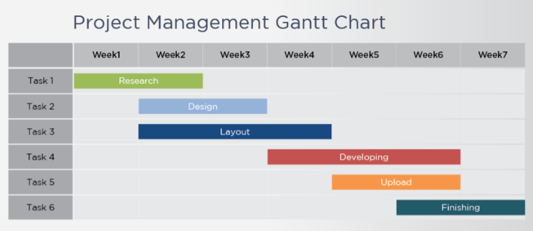
Source: Papke-Shields, et. al., 2017
Work Breakdown Structure: The Work Breakdown Structure is a delivery-oriented hierarchical decomposition of jobs. A Work Breakdown Structure is a task breakup system. It often serves as a tool for planning projects to define the project's total scope and to identify necessary project results. With comprehensive project outcomes, Arcadia group will appreciate the complexity of the project and each team understands precisely what needs to be created. Each project and project work is divided into smaller, more minable components by Work Breakdown Structure. A job kit should be separately prepared, calculated and tracked for expenses.
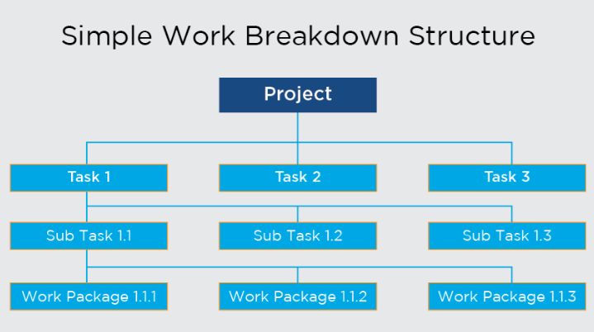
Source: Wroblewski and De Micheli, 2017
The division of a large project into smaller work packages allows for better planning, monitoring and administration of the project. This allows describing and coordinating the concept of the whole project more clearly and explicitly. The usage of a Work Breakdown Structure in the project of Arcadia group allows delegate tasks, distribution of money, project control and project management. The Work Breakdown Structure precise and concretes the deliverables such that the project manager understands precisely what has to be achieved inside each deliverable. This also enables better cost, risk, and time estimation, as Arcadia group can work from the small parts to the entire project level.
Project Documentation: Project Documentation refers to the creation of documents which provide project details. Such papers are used to help explain the project, to avoid and address conflicts of interest between partners and to update schedules and progress status. It is essential to log a project across all phases of the project. The report is recorded information to enable project managers of Arcadia group to achieve a common knowledge of the project specifications and the progress of the project (Young, 2016).
Growing project creates many separate documents based on the complexity of the project. Additional examples of project documentation include reporting on project status, key milestones, risk elements and actions pending. The duration of these reports depends on the requirement and the scope of the project; all relevant people are aware of the progress of the project by submitting them these reports.

2. Prepare a plan for the implementation of the project and specify the relevant steps that must be followed and how the plan is going to be implemented. Communicate the project plans with appropriate colleagues and stakeholders.
The implementation stage of project management is an integral aspect of the performance of the business strategy overall. Additionally, moreover, it allows employees to feel as though they have a sense of responsibility over the long-term future of an organization when sharing both their Strategic Strategy and its execution therein. Strategic preparation at the executive level decides the course of the policy for the private sector and allocates money to allow the policy come into being. The execution strategy also tracks the boundaries of that, decides whether a development approach will better be executed from the beginning and how to execute the program efficiently (Andres Imaz, 2020).
Arcadia group can use PPRINCE2 model in order to implement the project management plan. One of the most significant project management elements for the business enterprise is a Project Initiation Document (PID). PPRINCE2 is a project management tool commonly employed in numerous industries and sectors around the world. It's a versatile method of handling productive ventures, irrespective of form or size which is important. PRINCE2 may be customized to suit unique requirements of cantered Arcadia group on seven concepts, patterns and processes. The PRINCE2 process includes the steps leading to the project goal. Seven processes guide the project, and each has a series of related activities to assist in the direction, administration and implementation of the project are as follows:
Start Up the Project: It is here where the feasibility of the project is decided. It shall be approved by the Project Board once it has been confirmed. It incorporates a project summary that includes the business scenario, the correct approach to execute the job, the identity of the individual assigned to carry it out and a comprehensive process schedule that outlines the research to be carried out. Such operation requires the spark, a high-level document that lays forth the purpose of the initiative. This is therefore necessary for Arcadia group to take due diligence to save time and resources before the project is implemented (Van Rijn, 2016).
Initiate the Project: Several issues need to be answered throughout this process such as What project research needs to be done? What are the factors for the initiative and how they are found and addressed, including the costs and benefits? To react, describe the nature of the project, including whether the goods can be supplied without losing quality. Defining how the success of the project will be tracked and who will be told and how. The practices of Arcadia group involved in this phase include risk creation, design, quality control and communications. In addition to project plans and implementation documents, create project controls.
Direct the Project: This process is designed to help the project board of Arcadia group make its decisions accountable for the project. They are motivated to launch the project, create it and finish the project. During the project they also provide guidance and control. They often consult with business organisations or system managers and analyze the effects of the post-project. Approving the initiative, the project itself and the project stages included activities relating to that process (Swann, 2018).
Control Stages: The project manager performs duties, tracks the job, manages issues and communicates to the management committee on development. This requires the acceptance of a teamwork plan, the performance and success of the project and the evaluation of its output. The project plan of Arcadia group must also be checked and evaluated, any problems and threats found and addressed.
Manage Product Delivery: This method governs the production of the Arcadia group result and the project manager's collaboration with the team. The work package approval and implementation of the work package and the distribution of the work package involve tasks relevant to this process to ensure it is complete.
Manage Stage Boundary: The project manager presents the project committee with a summary of its results, reviews the draft plan, and plans the roadmap for the next phase. Additionally, reports from the Arcadia Group's Project Manager will help the project committee review the present process, authorize the next step and amend the revised schedule. Plans for the next step and documentation on the completion of the stage require events (Kusters, 2016).
Close the Project: The method helps to insure that the initiative achieves its priorities and targets by the deadline. Project managers of Arcadia group may also plan the scheduled closing and early termination, but this is not sufficient. Obligatory activities include the delivery of the product, assessment of the project and recommendation to closure the project board formally.
Communicating plan for stakeholders
A complicated project involves coordination and cooperation and effective communication with team leaders in order to achieve it successfully. When the team leaders operate at the Arcadia group, they may schedule daily sessions, pause at one workplace or even speak informally about a project at another office. Many large initiatives in the global economy currently require workers from vastly disparate places so it is not feasible to arrange meetings in the same structure. Digital teams are named teams can use online networking tools without face-to-face sessions. There may be two types of communication include intermittent and synchronous. talking. When all the communicating groups engage concurrently in the conversation, the correspondence becomes synchronous. An example of synchronous contact is a mobile conference call. The conversation becomes intermittent because the parties do not communicate concurrently (Kdenian and klado, 2019). Communication infrastructure allows for a number of compatible computers, applications and service providers and several specific time zones may contribute to connectivity with a multinational virtual team in Arcadia group. Efficient communications involves the development of a communication strategy.
Communications are a cornerstone to every effective project and are a crucial soft specialist in project management. It might not be the goal of the Arcadia group or business, but that is how each consumer and growing customer needs successful relations to heart. Project contact is something that Arcadia group are accountable for directly and it has a significant effect on the progress or loss of the project. Personally speaking, the strongest initiatives have been told, executing on both their commitments on schedule and on budget will also be poorly reputed and viewed as disasters (Yaniv, et. al., 2019). The project manager could not provide their partners with a proper role to demonstrate project progress. Arcadia group hope that in this segment, the details and design can allow to choose the correct information, schedule and vehicles of communication for project. Arcadia group have-various ways of communication such as face by face, fax, intranet, twitter, regular mail, television, video conferences, and more.
Definitions of pull correspondence involve blogs and standardized servers, while email and meetings are definitions of push communications. Push or pull communication styles are normally personal habits. Some individuals are better able to absorb information as introduced to them, and others tend to discover it for themselves. Prepare the stakeholder organizations for contradictory criteria. If Arcadia group have competing demands, it can have to determine which form to use. Instead, a company representative who is allowed to define the criteria of the community is identified (Bigorra Puente, 2017).

3. Critically evaluates your ability to manage a project. Use feedback from others to evaluate your own ability to plan and implement a project by identifying strengths and weaknesses. Create a self-development plan to improve your own performance in managing projects
It is difficult to communicate and management of project of company. There are so many people with whom Arcadia group need to communicate from the beginning to planning and management and all of them want to talk to different people. Arcadia group interactions often differ depending on the role that we perform in the project, the stage of the project in which we reside and interact. Some of my priorities as managing the project is that I want to interact well with our partners as I have what we intend to accomplish in the project. In order to communicate properly I used Gantt chart. These details can be expressed by Gantt charts. I will define all activities and order involved in a project within a timeline (Zafar, 2019). It offers me an instant summary of a mission, its relevant activities and when they have to be finished. Once I build a Gantt map, all the activities included with the project need to be remembered. It involves who is accountable for each job as part of this phase, how long each assignment is going to take and what challenges the team will experience.
Activities | Starting date | Ending date | Duration
On-site meetings | 2 July 2020 | 3 July 2020 | 2
Discussion with stakeholders | 4 July 2020 | 6 July 2020 | 3
Analysis complete | 7 July 2020 | 10 July 2020 | 4
Draft of Project plan | 11 July 2020 | 15 July 2020 | 5
Develop project system | 16 July 2020 | 22 July 2020 | 7
Perform initial testing | 23 July 2020 | 27 July 2020 | 5
Perform system testing | 28 July 2020 | 30 July 2020 | 3
I believe that life is a learning opportunity which can make me understand our own weaknesses and strength in anything I choose to do, whether it's positive skills or negative personal areas that can help me achieve my goals. I can understand and resolve my shortcomings by recognizing myself and what I can do. One of my biggest attributes in my college would be my willingness to be a well-organized human (Rockcastle, et. al., 2016). It allows me to plan and carry out my work and meet critical deadlines. I must consider the strengths and weaknesses of its employees in the position of organizational leadership. Successful businesses recognize their assets and develop them.
My strength and weakness related to managing a project are as follows:
Strength | Weakness
- Ask concerns to insure that people grasp my advice.  - In my communications, using encouraging words.  - I am willing to assign research efficiently.  - Simple and efficient decision-making.  - Before taking some statement, analyze alternatives.  - While becoming interested in social jobs.  - May inspire individuals to do their work.  - Had strong ability to connect.  - Understand my audience during lectures well.  - Seek to identify the backup strategy for the daily operations. | - Ability to develop expertise of leadership.  - Make priorities between the goals and specific priorities of the company.  - To seek continuing input on my work and coaching.  - Regularly evaluate the priorities and relevant action plans.  - Organizational skills do need to be established.  - Another aspect that needs to be changed is power.  - Keep in line with and develop the expertise required to meet the new technologies.  - For efficient collaboration, collaboration is another field to improve.  - Coordination growth  - Improving organizational capabilities
Self-development plan
Objectives | Priorities | Duration
To boost my results with my strength points to increase my production. | Low | 3 months
Increase my job experience every day and improve my own capacity to succeed reliably at a certain stage. | Medium | 6 months
To help me evaluate my strengths and limitations and draw on my potential for continuing development and progress. | High | 12 months

A professional growth plan is some of the most effective tools for students and professionals who wish to excel in their respective fields. It incorporates the concept of reflection to describe the acts required to learn knowledge and skills. It lets me chart the required changes in life and reinforces the vulnerabilities. The program measures the performance of a individual and decides the attributes to develop in the future. This is targeted at meeting personal and professional development objectives. As development needs to be planned and goals set. Clear and measurable goals must be met in the plan.
Review of the initial PDP: According to my Personal Development Plan, the key aim for the project is to learn listening and social skills. In the places with my shortcomings, I had hoped to chat more with my employees. The utilization of the working hours of leaders and additional opportunities to interact with them for a better comprehension of business concepts. I needed to make this the biggest improvement’s I have gone through everything I learnt during training (Vijayan and Sharma, 2020).
Interpersonal skills: In social growth even, my Personal Development Plan played a significant role. I noticed that I wanted job expertise in contrast to other people. Such talents have a significant value, so I decided to develop them to eliminate gaps in expertise at work. Two primary goals of my Personal Development Plan is to improve collaboration with others. While running the project I changed my relationships with people by having more time with them. I might achieve so by searching for an alternative place in one of the professional clubs in the community. This leading role was central to my growth of leadership skills. The development of this position has helped me in improve organizational skills as I had to remind the group members of the needs and problems. It also made me a stronger listener and a more centered individual, as it had more duties than as an employee.
Extra-curricular activities: I always tried to develop my social connections in company and abroad. One approach I wanted to do that was by participating in out-of-school sports. It was not convenient to pick a sport or a party because I'm not that sporty. I still understood the importance of this and wanted to join the badminton team and over time have become an involved and professional badminton player (Darmaningrat, et. al., 2019).
Time management: In respect to the allocation of resources, every week I arranged a list of stuff I’d do to make sure I don't slip off on resources. The weekly routines have been successful, but some of the overall goals set for the organization have been difficult for me. Owing to overcrowding and inadequate execution, the timetable has been challenging to execute.
Conclusion
Above report summarizes together the conclusions on the use of project management instruments and techniques and on the obstacles in Arcadia group. The aim of the investigation is to study the use of tools and techniques for project management. A range of strategies must be enforced to do this. First, it is necessary to examine the use level in Arcadia group's market environment regarding project management terminology, despite the low level of awareness about the kind of PTTs used. The second goal is to explore the usage of PTTs in Arcadia group. And the overall aim is to recognize the obstacles to the adoption of PTT by organizations. Gantt chart is the most commonly used in terms of project management that is in usage in Arcadia group. People agree every indeed, the important duties will be weighed and the amount of time to spend in. Throughout the stages of installation and deployment, the Work Breakdown System often has the same condition. It was also a well-known tool and definition for Arcadia group market adaptation. Nevertheless, the usage and application of project management is still challenging for organizations.

References
- Andres Imaz, A., 2020. Project management plan definition for the implementation of a European Railway Traffic Management System in Australia (Master's thesis, Universitat Politècnica de Catalunya).
- Bigorra Puente, D., 2017. Project management plan of the creation of a travellers-oriented mobile application (Master's thesis, Universitat Politècnica de Catalunya).
- Chen, H.H., Kang, H.Y. and Lee, A.H., 2017. A project management plan to reach sustainable competitive advantage for a photovoltaic (PV) manufacturer. Sustainability, 9(9), p.1496.
- Darmaningrat, E.W.T., Muqtadiroh, F.A. and Bukit, T.A., 2019. Communication Management Plan of ERP Implementation Program: A Case Study of PTPN XI. Procedia Computer Science, 161, pp.359-366.
- Dickerson III, C.L., Wang, J., Witherspoon, J. and Crumley, S.C., 2016. Work zone management in the district of Columbia: Deploying a citywide transportation management plan and work zone project management system. Transportation Research Record, 2554(1), pp.37-45.
- Harding, S., Nelson, L. and Glover, T., 2016. Solent oyster restoration project management plan. Blue Marine Foundation, p.47.
- Heagney, J., 2016. Fundamentals of project management. Amacom.
- Kdenian, A. and klado, A., 2019. AYA CONSULTANCY GROUP: Karma Kitchen Project Management Plan.
- Kusters, J.F., 2016. The value and necessity of the project management plan: the pre-award phase of BVP projects from the vendor’s perspective.
- Newton, R., 2016. Project management step by step: how to plan and manage a highly successful project. Pearson UK.
- Papke-Shields, K.E. and Boyer-Wright, K.M., 2017. Strategic planning characteristics applied to project management. International Journal of Project Management, 35(2), pp.169-179.
- Rockcastle, G.C., Adomaitis, R.A. and Binder, M.P., 2016. Solar Decathlon 2017 D-1: Project Management Plan.
- Swann, M., 2018. Elementary Stem Program project management plan.
- Van Rijn, J., 2016. Part 4: risk management plan: project management. IMIESA, 41(8), pp.74-76.
- Vijayan, V.K. and Sharma, D., 2020. Relationship Between Organizational Cultural Drivers and Risk Management Plan From Enterprise Risk Management (Erm) Perspective– (a Study With Reference to the Projects Handled by It Companies in the UAE). International Journal of Management, 11(5).
- Wang, X., Ren, A. and Liu, X., 2017, August. Researching on quantitative project management plan and implementation method. In AIP Conference Proceedings (Vol. 1864, No. 1, p. 020176). AIP Publishing LLC.
- Wroblewski, A. and De Micheli, B., 2017. TARGET. D 7.1-Project Management Plan.
- Yaniv, S.H.O.R., Project Map Ltd, 2019. A method and system for generating and displaying a project management plan. U.S. Patent Application 16/084,539.
- Young, T.L., 2016. Successful project management. Kogan Page Publishers.
- Zafar, M.A., 2019. A Study of Project Management Plan of Dasu Hydropower Project Executed by Water and Power Development Authority, Government of Pakistan (Doctoral dissertation, CAPITAL UNIVERSITY).

