Dylan Payne
2214463
Renishaw Quality Technician

Andrew Thorne & Kelvin Lake
Lecturers



AGILITY CMM QUILLS DEVELOPMENT & QUALITY IMPROVEMENTS
BEng Mechanical and Manufacturing Engineering independent project (acma 6013 – 2025)
Word Count: 10,646

Declaration of Authority

This thesis is the result of the author’s original research. It has been composed by the author and has not been previously submitted for examination which has led to the award of a degree.

Acknowledgements

I would like to express my deepest gratitude to my wife, Sharan Singh Payne, for her constant support, encouragement, and patience during this degree program. Her confidence in my abilities has been a constant source of motivation and strength.
I am also sincerely grateful to Renishaw for providing me with the opportunity and flexibility to undertake this degree alongside my professional responsibilities. The company’s commitment to personal and professional development has been instrumental in the successful completion of this project.
Lastly, I want to express my gratitude to the Renishaw Quality Team for their outstanding help, advice, and cooperation throughout this dissertation. Their knowledge, perceptions, and readiness to help have greatly influenced the findings of this study.

Abstract

This dissertation investigates the quality challenges associated with the production of Agility CMM quills at Renishaw and proposes systematic improvements using the Six Sigma DMAIC methodology. Quills, critical Z-axis components in coordinate measuring machines, were found to suffer from high scrap rates due to cosmetic and structural defects, primarily material splits and anodising staining. An initial analysis of 374 quills revealed a 73% failure rate, resulting in over £100,000 of scrap-related losses. According to root cause analysis, inconsistent inspection criteria and variation in aluminium alloy extrusions were responsible for the majority of failures. A controlled experiment of virgin aluminium was carried out to resolve this. An estimated £24,300 was saved per 100 quills due to the trial's zero material splits and 26.63% staining reduction, which also reduced the overall scrap rate by 86.24%. Ergonomic inspection jigs, updated inspection standards, operator training, and long-term control methods including supplier agreements and SPC monitoring were all complementary enhancements. The results support the strategic move to virgin aluminium and demonstrate how well DMAIC-led interventions may improve manufacturing efficiency, cut waste, and improve product quality in high-precision settings.

Contents
Declaration of Authority i
Acknowledgements ii
Abstract iii
Figures vii
Tables vii
13.3 Equations viii
1. Introduction 1
1.1 Company Background 1
1.2 Agility CMMs 1
1.3 Aims 2
1.4 Objectives 2
2. Research / Literature Review 3
2.1 Aluminium Alloys 3
2.1.1 Aluminium Alloy Extrusion 3
2.2 Virgin Aluminium 4
2.2.1 Virgin Aluminium Extrusion 4
2.3 Microcracks 5
2.4 Anodising 5
2.5 Six Sigma & DMAIC 6
2.5.1 Failure Mode and Effects Analysis (FMEA) 6
2.5.2 Root Cause Analysis (RCA) 6
2.5.3 Statistical Process Control (SPC) 7
2.6 Environmental Impact 7
3. Define 8
3.1 Problem Definition 8
3.2 Project Scope 8
3.2 Agility CMM Quills 9
3.3 Initial Data Collection 10
3.4 Inspection Criteria 10
4. Measure 12
4.1 Data Collection 12
4.1.1 Overview of Data Sources 12
4.1.2 Baseline Metrics 12
4.1.3 Inspection Failure Breakdown 13
4.1.3 Failure Types 14
4.1.4 Pareto Analysis 15
4.1.4 Scrap vs. Salvage Rate 16
4.1.5 Financial Impact of Scrap 16
4.1.6 Financial Impact of Salvage 17
4.2 Defect Examples 18
4.2.1 Material Splits 18
4.2.2 Anodising Staining 18
4.2.3 Corrosion 19
4.2.4 Flow Defects 19
5. Analyse 20
5.1 Root Cause Analysis 20
5.1.1 Ishikawa (Fishbone) Diagram 20
5.1.2 5 Whys Analysis 21
5.2 FMEA 22
5.3 Insights Gained 23
6. Improve (I) 24
6.1 Trials 24
6.1.1 Costs 24
6.1.2 Design for Six Sigma (DFSS) 25
6.2 Implementation 26
6.3 SIPOC Diagram 26
6.4 Vertical Inspection Jig 27
6.4.1 Initial Prototype 27
6.4.2 Dual-Orientation Inspection Bench 28
7. Improve (II) 29
7.1 Validation 29
7.2 Metric Comparison 30
7.3 Key Takeaways 30
8. Control 31
8.1 Sustainable Improvements 31
8.2 Monitoring 32
8.3 Full FMEA 33
8.4 Limitations 35
8.5 Statistical Process Capability (Hypothetical) 36
9. Results 37
9.1 DMAIC Outcome Analysis 37
9.1.1 Define 37
9.1.2 Measure 37
9.1.3 Analyse 37
9.1.4 Improve 37
9.1.5 Control 37
9.2 Achievements 38
9.3 Challenges 38
10. Conclusion 39
11. Recommendations 40
12. Bibliography 41
13. Appendix 44
13.1 Timing Plan 44
13.2 Supporting Equations 44
13.3 Inspection Summary Aid 45

Figures

Figure 1 - AGILITY CMMs (Renishaw, 2023) 2
Figure 2 - Quill Assembly (Renishaw, 2023) 9
Figure 3 - Agility S CMM (Renishaw, 2023) 9
Figure 4 - Jigged Quill (Renishaw, 2024) 10
Figure 5 - Surface Classification (Renishaw, 2024) 11
Figure 6 - Failure Rates at Each Inspection Stage 13
Figure 7 - Most Common Defects by Frequency 14
Figure 8 - Quill Defect Pareto Chart 15
Figure 9 – Salvage Jobs 17
Figure 10 - Material Splits 18
Figure 11 - Staining Patch 18
Figure 12 - Staining Marks 18
Figure 13 - Pitting Corrosion 19
Figure 14 - Flow Defects 19
Figure 15 - Ishikawa diagram (Canva, 2025) 20
Figure 16 - Initial Prototype 27
Figure 17 - Prototype Fitment 27
Figure 18 - Prototype Alignment 27
Figure 19 - Inspection Bench View 1 28
Figure 20 - Inspection Bench View 2 28

Tables

Table 1 - Baseline Metrics 12
Table 2 - Inspection Stage Failures 13
Table 3 - Scrap vs. Salvage Rate 16
Table 4 - Simplified FMEA 22
Table 5 - SIPOC Diagram (Pyzdek & Keller, 2018) 26
Table 6 - Metric Comparison 30
Table 7 - Full FMEA (www.six-sigma-material.com, 2025) 33
Table 8 - Achievements 38
Table 9 - Timing Plan 44

13.3 Equations

Equation 1 - RPN Calculation 34
Equation 2 - Process Capability Ratios (Montgomery, 2009) 36
Equation 3 - Cp Calculation 36
Equation 4 - Cpk Calculation 36
Equation 5 - Percentage Improvement 44
Equation 6 - Scrap Cost Calculation 44
Equation 7 - Cost Savings After Improvement 44

1. Introduction

This dissertation focuses on the development and quality improvement of quills used in Renishaw’s Agility Coordinate Measuring Machines (CMMs). Quills are large aluminium extrusions that are essential for precise vertical movement and control in the Z-axis. Despite their importance, the current production process faces significant quality challenges, including cosmetic defects, anodising issues, and material inconsistencies, leading to high scrap rates and extended inspection times. In order to improve the quality and efficiency of quill production, this project aims to systematically address these challenges using the Six Sigma Define, Measure, Analyse, Improve, Control (DMAIC) methodology.

1.1 Company Background

Renishaw is a world-leading supplier of measuring systems and manufacturing systems, founded in 1973 and headquartered in Wotton-under-Edge, Gloucestershire. Its products give high accuracy and precision, gathering data to provide customers and end users with traceability and confidence in what they're making. This technology aids its customers to innovate their products and processes.
Renishaw is a global business that specializes in metrology, healthcare diagnostics, and additive manufacturing, employing over 5,000 people across 36 countries. The majority of R&D work takes place in the UK, with the largest manufacturing sites located in the UK, Ireland and India.
For the year ending June 2023 Renishaw recorded sales of £688.6 million of which 95% was due to exports. The company's largest markets are China, USA, Japan and Germany.
Renishaw is guided by its purpose: Transforming Tomorrow Together. This means working with its customers to make the products, create the materials, and develop the therapies that are going to be needed in the future (Renishaw, 2024).

1.2 Agility CMMs

The Agility CMMs from Renishaw combine surface roughness inspection and dimensional measurement to improve manufacturing quality and efficiency. These devices use cutting-edge 5-axis technology, which enables precise, fast measurements in controlled and shop floor settings. Some other benefits would include cycle times that can be reduced by 15% to 50% as compared to 3-axis measurement systems, surface roughness measurement and dimensional examination are combined, and streamlined processes result in a reduction of part handling and inspection time, which in turn enhances throughput and saves on costs.

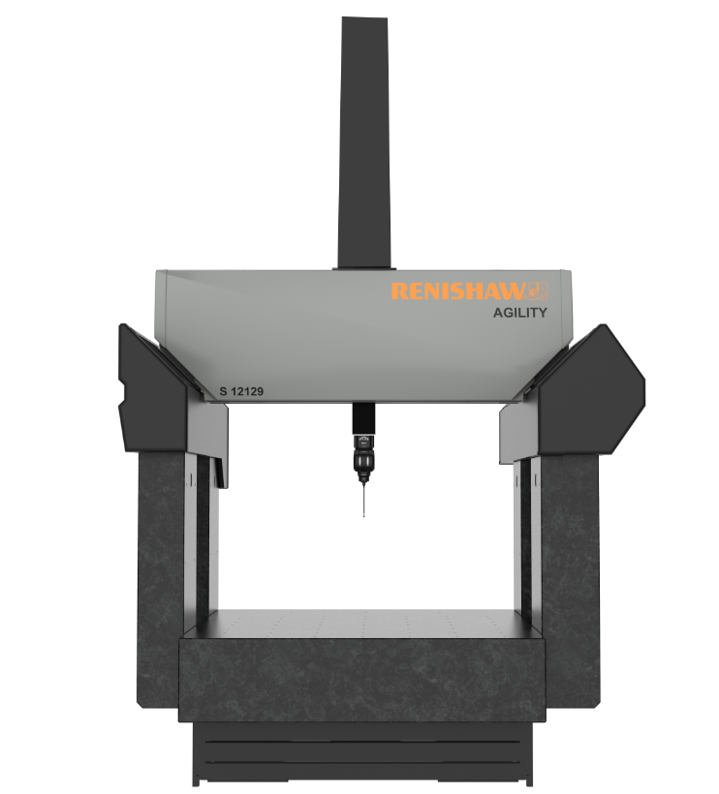
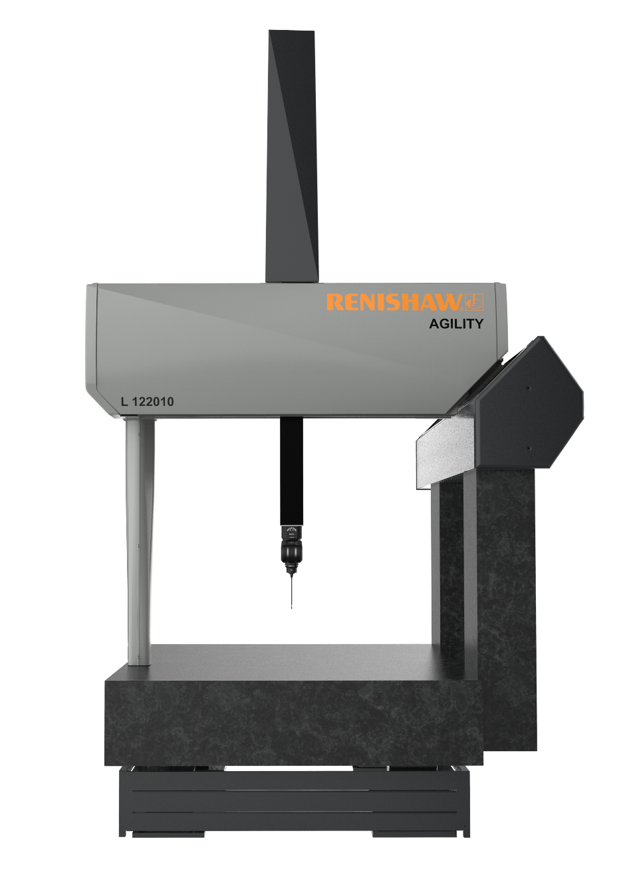
A low mass-to-stiffness ratio results in less inertia, which allows for lower power motors which in turn reduce heat dissipation. Most measuring is done by movement of the head, meaning that dynamic errors that are usually introduced by the X, Y and Z motion of the structure are dramatically reduced. Thermally stable materials have been chosen to ensure that a consistent and repeatable measuring platform can be maintained even if the environmental temperature is constantly changing (Renishaw, 2025).
Figure 1 - AGILITY CMMs (Renishaw, 2023)

1.3 Aims

The primary aim of this project is to improve the overall quality of the Agility CMM quill by reducing the scrap rates and enhancing the inspection process, which in turn will decrease the overall production time of the quill. This will be achieved by analysing root causes of defects, implementing process improvements and corrective actions, and optimising inspection processes to achieve measurable improvements.

1.4 Objectives

The fundamental goal of this dissertation is to increase the quality and efficiency of quill production using a structured Six Sigma DMAIC (Define, Measure, Analyse, Improve, Control) framework. The following goals are established to accomplish this goal:
- Conduct a thorough analysis of quill production to identify key defects and their root causes.
- Examine possible improvements to coating and raw material procedures.
- To increase inspection efficiency through the implementation of a vertical inspection jig.
- Verify enhancements using trials to make sure they satisfy efficiency and quality standards.
- Put control measures in place to maintain the progress made and set up long-term monitoring systems.

2. Research / Literature Review

2.1 Aluminium Alloys

Aluminium alloys are used in manufacturing due of their lightweight, corrosion-resistant, and high strength-to-weight ratio. Aluminium alloys provide unique combinations of characteristics, making it one of the most versatile, affordable, and desirable metallic materials for a wide range of applications. Aluminium alloys are the second most commonly used structural metals, after steel (ASM International Handbook Committee, 1998). The 6061-T6 aluminium alloy, which is used in the quill extrusions, has high machinability and mechanical qualities, making it an ideal material for components such as the quills found in Renishaw's AGILITY CMMs. However, production issues such as porosity, surface defects, and microcracks have been identified, which degrades the final product's quality and surface finish.

2.1.1 Aluminium Alloy Extrusion
In order to create complicated shapes with a set cross-sectional profile, an aluminium alloy billet is heated and then forced through a die in the manufacturing process known as extrusion. Components for the construction, automotive, and aerospace sectors are frequently made using this method (Misiolek & Kelly, 2013). Aluminium alloy extrusions are ideal for applications in the automotive and aerospace industries because of their great strength-to-weight ratio, lightweight nature, and shape versatility. Its longevity under challenging conditions is further increased by the material's natural resistance to corrosion. However, several authors highlight persistent drawbacks. (Davis, 2013) identifies that its use in high-strength applications is limited by its relatively inferior strength compared to steel, and the extrusion process can be expensive, particularly when customised dies are needed. Common surface defects that can affect both appearance and functionality include oxidation, die marks, and scratches. (Kaufman, 2012) further argues that dimensional inaccuracies may result from the high temperatures involved, and microcracks commonly develop during cooling, particularly as a result of inadequate die design or temperature management. Finally, differences in alloy composition may result in inconsistent material qualities that impact corrosion resistance and strength. In contrast, while these drawbacks are acknowledged, (Misiolek & Kelly, 2013) maintains that the process remains viable when controlled properly, especially with investment in high-precision die design and temperature regulation. Nevertheless, the occurrence of dimensional inaccuracies and cooling-induced microcracks, as noted by both (Davis, 2013) and (Kaufman, 2012), suggests that extrusion quality is highly sensitive to process conditions and material uniformity.

2.2 Virgin Aluminium

Virgin aluminium, sometimes referred to as pure aluminium, is an alloy of aluminium that is extremely pure, usually having a concentration of more than 99% aluminium. Because of its exceptional electrical and thermal conductivity, this material is well suited for applications like heat exchangers and electrical wiring that call for effective heat transfer or electrical conductivity. (Terryn & Vereecken, 1991) expands on this, explaining that the material is very malleable and ductile, which makes it easy to form without breaking or cracking. This is useful for procedures like extrusion and rolling. Furthermore, raw aluminium has better corrosion resistance than alloyed aluminium because it naturally develops a persistent oxide coating that shields it from environmental deterioration. (Davis, 2013) challenges this by suggesting that pure aluminium is not appropriate for structural applications requiring high mechanical strength because it lacks the strength seen in alloyed forms. Its softness also makes it more likely to get scratched and dented, which can be a drawback in situations where surface integrity is crucial. Also, alloyed alloys are typically less expensive than virgin aluminium, which could be an issue for large-scale manufacturing operations where cost effectiveness is crucial.

2.2.1 Virgin Aluminium Extrusion
Like standard aluminium extrusions, virgin aluminium extrusions are made by heating high-purity aluminium billets and pushing them through a die. The main benefit of virgin aluminium extrusions is their exceptional resistance to corrosion since the material's extreme purity creates a persistent oxide layer that offers better defence against environmental deterioration. Furthermore, (Kaufman, 2012) states that virgin aluminium has exceptional thermal and electrical conductivity, making it perfect for use in heat exchangers and electronics. However, (Arif, et al., 2002) argues that virgin aluminium extrusions are not suitable for structural applications that require great mechanical strength due to the material's reduced strength when compared to alloyed aluminium. Because of its softness, the material is also more vulnerable to surface deterioration, including dents and scratches. (Davis, 2013) proceeds further stating that surface flaws including die lines, oxidation, and, infrequently microcracks, are common faults in virgin aluminium extrusions. These might happen during cooling or as a result of inadequate temperature management during the extrusion process. Furthermore, the material's temperature sensitivity during extrusion may result in dimensional inaccuracies, which could pose problems with tight tolerances.

2.3 Microcracks
According to (McCullough, et al., 2019), fatigue failure is a significant component of material behaviour that necessitates in-depth investigation and testing. In addition to intrinsic characteristics like grain size, crystallographic orientations, inclusion morphology, void morphology, and the extent of damage accumulation, external factors like heat environment and loading history also have an impact on the fatigue performance of aluminium alloys. Four separate stages: fatigue crack incubation, microstructurally small crack development, physically small crack growth, and lengthy crack growth, have been shown to co-ordinately move towards the creation of fatigue cracks in these materials.
This is also supported by (Peng & Sheppard, 2004), where they explain that it is widely acknowledged that one of the primary flaws that arises during the extrusion of aluminium alloys, is surface cracking. According to earlier tests, this kind of flaw is brought on by the process's increasing temperature. Despite the possibility of high temperatures during extrusion, certain experiments show that the surface quality is good. It is also common knowledge that crack criteria have been used to explain the cracking that happens during rolling, blanking, and extrusion, among other processes.

2.4 Anodising

Through the electrochemical process of anodising, a thicker oxide layer is formed on the surface of aluminium, improving its resistance to corrosion, wear, as well as its aesthetic qualities. In order to create an oxide layer that is integrated with the metal rather than put on top, the aluminium is submerged in an electrolyte solution while an electric current is run through it (Prasad & Prakash, 2022). Anodised aluminium is perfect for tough situations because of its greatly enhanced corrosion resistance, which is its main benefit. Furthermore, it improves scratch and wear resistance by increasing surface hardness. It can also be coloured to provide a variety of hues, which are then sealed to enhance retention. (Stacey, 2020) notes that anodising can be an expensive process and result in dimensional changes, especially for complex parts. Critically, (Aggerbeck, et al., 2014) highlights that variations in alloy composition can have an impact on the final qualities when anodising aluminium alloys. Higher copper or silicon concentration alloys can have uneven colouring, weaker corrosion resistance, and less consistent oxide layers. In contrast, (Yu, et al., 2023) provides evidence that pure aluminium usually generates a more consistent and long-lasting oxide coating due to its greater purity, which improves corrosion resistance and consistency of appearance. Because of this, anodising virgin aluminium usually produces better results than alloyed aluminium.

2.5 Six Sigma & DMAIC

The goal of the data-driven Six Sigma methodology is to improve processes by lowering variance and faults. By bringing the defect rate down to less than 3.4 defects per million chances (DPMO), it aims to achieve nearly perfect process performance. Long-term gains are achieved by the identification, analysis, and resolution of process inefficiencies using Six Sigma's structured methodology, DMAIC (Define, Measure, Analyse, Improve, and Control). While the Measure phase gathers data to comprehend present performance, the Define phase entails precisely defining the problem and objectives. After evaluating the data to determine the underlying causes of variance, the Improve phase concentrates on putting the recommendations into practice. Lastly, by putting in place controls and monitoring systems, the Control phase makes sure that gains are maintained over time (McCarty, et al., 2005).

2.5.1 Failure Mode and Effects Analysis (FMEA)
A proactive technique for identifying and ranking possible failure modes in a process or product, as well as evaluating their impact on system performance, is Failure Mode and Effects Analysis (FMEA). It entails methodically assessing every possible mode of failure, the reasons for these failures, and the possible outcomes. The findings are utilised to create mitigation plans that stop failures from happening. FMEA is helpful for increasing reliability and lowering risk and is frequently carried out in the early phases of process or product development. To prioritise actions, it employs a scoring system known as the Risk Priority Number (RPN), which combines the severity, occurrence, and detection values. Corrective measures are required to reduce risks when RPN values are high (Sartor & Cescon, 2019).

2.5.2 Root Cause Analysis (RCA)
Instead of only treating the symptoms of issues or defects in a process, RCA is a methodical approach that finds the fundamental reasons. Finding, comprehending, and removing the underlying causes of problems is the aim of RCA (Vanden-Heuvel, et al., 2024). The Fishbone Diagram (Ishikawa diagram), which aids in grouping potential causes into categories including people, processes, materials, and environment, and the 5 Whys technique, which entails asking "why" repeatedly until the root cause is found, are common tools used in RCA. This is also supported by (Pyzdek & Keller, 2018) expressing it facilitates the creation of long-lasting corrective measures and allows for deeper insights into process breakdowns, RCA is essential to Six Sigma. Organisations can avoid reoccurring problems and increase the dependability of their operations by removing the underlying causes.

2.5.3 Statistical Process Control (SPC)
Utilising statistical techniques to monitor and regulate a process in order to make sure it runs as efficiently as possible is known as statistical process control, or SPC. SPC is used to monitor process fluctuations, spot anomalies, and keep control over process parameters. It is a crucial part of Six Sigma. Control charts are the main tool used in SPC because they allow data trends over time to be visually represented and trends that can point to issues to be identified (Oakland & Oakland, 2024). SPC helps guarantee that a process stays stable and able to generate goods or services that meet required standards by keeping an eye on variation. Organisations can enhance overall process quality, cut waste, and identify problems early with the usage of SPC (Montgomery, 2009).

2.6 Environmental Impact

There are major environmental ramifications when deciding between virgin and recycled aluminium. On the one hand, because of its higher material uniformity and lower chance of surface and structural faults, virgin aluminium is frequently used in precision manufacturing (Aggerbeck, et al., 2014). This makes it especially appealing for uses like CMM components that demand standardised cosmetics and consistent anodising outcomes. Nevertheless, a number of studies draw attention to the environmental cost of this appeal. In contrast to recycled aluminium, which emits only 1.02 kg of CO₂ per kilogram (a 93% reduction in emissions), the manufacture of virgin aluminium releases about 16.4 kg of CO₂ per kilogramme, according to (Burrows, 2024). Additionally, according to (Novelis, 2024), recycled aluminium uses up to 95% less energy, which greatly lowers the carbon footprint and environmental damage brought on by the mining of bauxite. Although virgin aluminium may offer technical benefits in situations where quality is crucial, its sustainability disadvantages cannot be disregarded. According to (Spitzer, 2023), reaching decarbonisation goals in materials processing requires a greater dependence on recycled aluminium. Future plans should therefore balance the advantages of material performance with the urgent requirement for sustainable production methods, especially in settings with high production volumes.

3. Define

3.1 Problem Definition

The existing quill production process exhibits an unacceptably high rate of non-conformance, with multiple failure modes emerging across different manufacturing stages. These defects are not only contributing to material waste but are also causing significant disruptions to workflow, inspection resources, and assembly lead-times. Material related problems such as porosity, material splits, and inconsistencies are evident during the inspection process. Machining processes introduce additional risks, including burrs, inconsistent surface brushing, and tool marks, which affect both the functional and visual acceptability of the component.
Post-machining, the anodising process frequently results in cosmetic issues such as staining, bright patches, or uneven oxide layers. These outcomes are particularly problematic due to the highly visible nature of the quill and its requirement for a consistent, clean finish. In addition to these manufacturing defects, a number of quills are rejected due to physical damage sustained during handling and transport. Scratches, dents, and minor dinks are common when components are insufficiently protected or moved manually between process steps. Besides these issues, there are inconsistencies within the inspection process itself. Subjective judgement, variable lighting, and differing levels of inspector experience have all contributed to marginal components being scrapped or passed on concession, further undermining process control.

3.2 Project Scope

This project will apply the Six Sigma DMAIC methodology to reduce defect rates and improve the efficiency of the inspection process for AGILITY CMM quills. The scope includes every stage of production that influences the quality and conformity of the quill, beginning with the raw material, continuing through machining and anodising, and ending with inspection and packaging. In particular, this project will focus on material suitability, machining consistency, anodising process control, operator handling practices, and visual inspection standards.
The primary goal is to reduce the overall scrap rate, with an emphasis on decreasing the volume of post-anodising failures, which currently represent the largest contributor to waste. A secondary objective is to increase inspection efficiency, aiming to reduce the average inspection time without compromising quality standards. Furthermore, the project aims to lower the rate of rework, reduce quality-related delays, and identify where costs are being driven by poor process control. Ultimately, the intention is to provide a robust and measurable improvement in both output quality and process reliability.

3.2 Agility CMM Quills

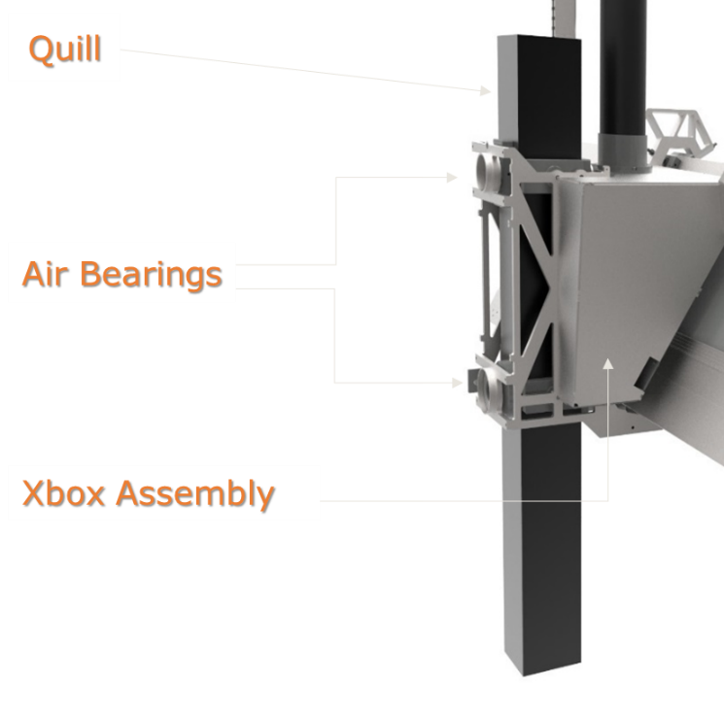
The quill is a customer visible component that holds a high precision measuring device on its tip. These are large aluminium alloy extrusions that are essential for controlling the Z-axis, and range in length from 1090mm to 1690mm. Every face is functional and requires a strict flatness tolerance, as air bearings fly over the surface at a height of 10µm, approximately 1/5 of the thickness of a human hair.
Figure 2 - Quill Assembly (Renishaw, 2023)

The quill needs to be scratch resistant, as a burr from a scratch can interfere with the air bearing flight, affecting machine accuracy and potentially cause damage to either the bearing or the quill. An etching process is also required to remove any light scratches picked up during manufacture.
Unsealed surfaces are badly marked by the machine brake, as this applies pressure to the air bearing surfaces. This is why the machined extrusions are clear anodised, as well as to leave a clean, industrial finish.
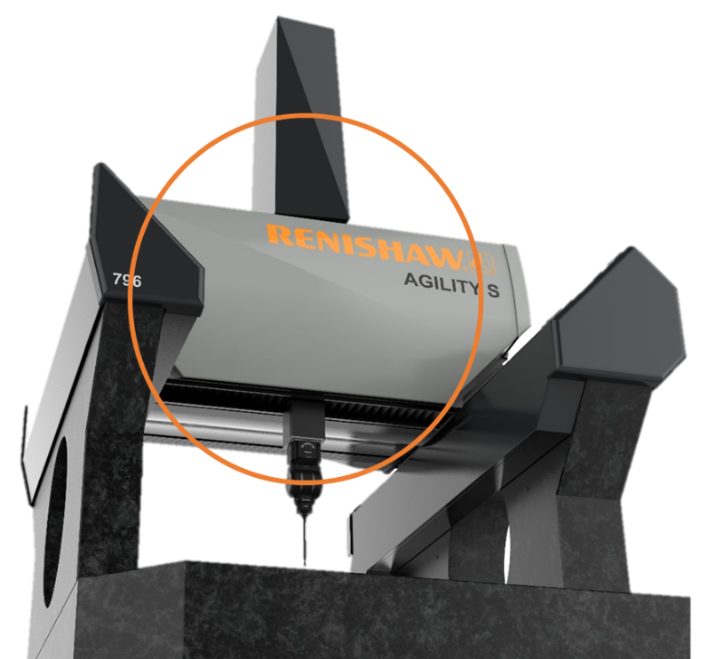
The quill is the part of the system that is most likely to be under day-to-day visual scrutiny. Typical usage of a CMM gives a very high likelihood that the operator would regularly view the quill at 500mm distance or less, and from multiple angles. It is therefore important that these quills remain defect and blemish free on receipt after anodising and within the acceptable limits.
Figure 3 - Agility S CMM (Renishaw, 2023)
Given their importance, any issues with their quality directly affect the machine's overall performance. These quills are moved up and down using pneumatic controls, and the distance it travels is controlled by a strip of FSP-2 scale which is read by a Renishaw Readhead. This is then fed to the server which would be output as the Z Axis coordinate within the CMM software (Renishaw, 2023).

3.3 Initial Data Collection

To support the definition of the problem and establish meaningful baselines, data was collected from a variety of internal sources such as Renishaw’s Syteline system and a dedicated spreadsheet, maintained by the quality team under the name “Quill Situation”, which provides job-by-job detail of inspection outcomes. This spreadsheet includes results from pre-anodising, post-anodising, and final assembly stages, as well as information on specific failure types and concession decisions. The data enabled clear categorisation of defect types, frequencies, and trends over time.
Additionally, physical inspection records and concession logs were reviewed to understand the context behind pass/fail decisions, particularly in borderline cases where cosmetic judgement influenced outcomes. Informal discussions were also conducted with operators, inspectors, and machining personnel to identify sources of variability not captured in formal documentation. These included variations in inspection lighting, differences in quality standards, and handling-related practices that may be contributing to damage. This combination of quantitative and qualitative data formed the foundation for the next phase of the project, where detailed measurement and analysis will be used to prioritise corrective action and validate improvements.

3.4 Inspection Criteria

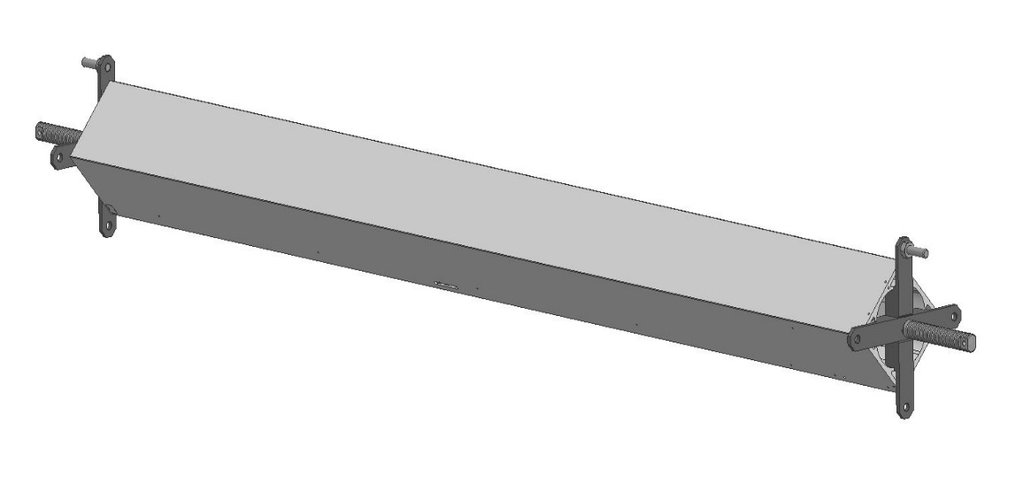
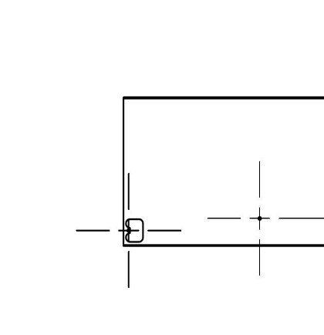
Visual inspection is a critical stage in the manufacturing process of Renishaw’s Agility CMM quills, given their highly visible role in the final assembled machine. Quill inspection 1 takes place after machining is complete, where the quills are cleaned using acetone, inspected, then jigged with two “X” brackets and a rod that connects through the middle of the extrusion. Quill inspection 2 takes place after the quills have been returned from sub-con anodising, where they are once again cleaned and inspected. This inspection is the most in-depth visual inspection conducted on any part manufactured at Renishaw and can be a time-consuming and logistically demanding process. This inspection roughly takes around 20 minutes per quill and often requires 2 people for manual handling purposes.
Note end identification feature.
Figure 4 - Jigged Quill (Renishaw, 2024)
When conducting the inspection, the operator must complete the MS653 (Inspection Summary Aid – Appendix 13.3) which records the inspection, Quill ID, date and Job number/Purchase Order. Any defects found during the inspection are also recorded here, as well as the accept/reject status. Inspections are carried out under a minimum of 1000 lux lighting, simulating bright office conditions to ensure all potential defects are detectable. Every face of the quill is inspected individually, with the inspector encouraged to assess from multiple angles to account for changes in surface reflection and finish. Each face is examined for approximately 5–10 seconds, and inspectors are required to wear non-textured nitrile gloves to prevent contamination. In cases of uncertainty, particularly in borderline areas such as “Class B” surfaces, the quill is inspected vertically, simulating its operational orientation within the CMM.

The anodised surfaces of the quill are divided into four classes based on visibility and criticality:
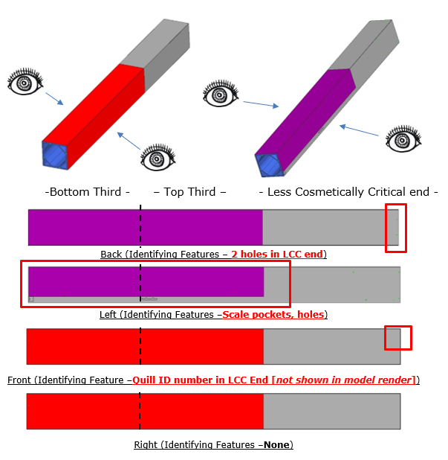
Figure 5 - Surface Classification (Renishaw, 2024)
- Class A (Red): High-visibility areas that are regularly viewed by the customer. These surfaces are inspected from 400–600mm and held to the most stringent criteria.
- Class B (Purple): Moderately visible areas where minor blemishes may be tolerated depending on their severity and location.
- Class C (Grey): Rarely visible regions where only functional impact is considered critical.
- Exempt (Blue): Not subject to cosmetic inspection but reviewed for structural or functional issues if observed.

Defect types are categorised by both their nature and severity. Common rejection reasons include anodising flaws, machining defects, and damage caused by handling. Each defect is subject to a set of pass/fail criteria based on its visibility, extent, and position on the quill. The standard also allows for multiple defects to be considered collectively. The inspection criteria therefore reflects both quantitative and qualitative judgement, relying on experienced inspectors and peer consultation where necessary.

4. Measure

4.1 Data Collection

4.1.1 Overview of Data Sources
The data for this project has been collected from Renishaw’s internal tracking systems, primarily through the "Quill Situation" spreadsheet and the Syteline system. The dataset includes information on 374 quills produced between 2023 and 2024, covering various stages of the production and inspection process. This data provides a quantitative basis for analysing defect rates, identifying common failure modes, and setting performance benchmarks. The total number of failed inspections recorded was 272, representing a failure rate of 73%, with a salvage rate of only 7%.

Quills are purchased from our raw material supplier Aalco as Aluminium Alloy (M-6218-0206-02) in 3-meter lengths at a cost of £126.9 each. Each length can usually produce two Quills.

Table 1 - Baseline Metrics

4.1.2 Baseline Metrics

Metric | Value
Total Quills Inspected | 374
Total Failed Inspection | 272
Total Scrap (Unsalvageable) | 253
Salvaged Quills (Reworked) | 19
Concessed Quills | 24
Scrap Cost (£410 per Quill) | £103,730
Overall Scrap Rate | 68%

These values reveal an urgent need to improve material quality, reduce anodising defects, and standardise inspection outcomes.

4.1.3 Inspection Failure Breakdown
A total of 374 quills were tracked, with inspection conducted at three key stages:
Table 2 - Inspection Stage Failures

Inspection Stage | Failed Quills | Fail Rate
Pre-Anodising | 62 | 17%
Post-Anodising | 205 | 55%
Assembly | 5 | 1%
Total | 272 | 73%

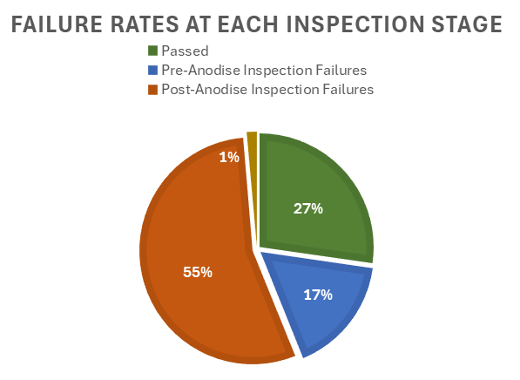
Figure 6 - Failure Rates at Each Inspection Stage

Figure 6 confirms that the majority of failures occur after the anodising process, emphasising the importance of surface condition and process consistency. The inspection results also showed a heavy concentration of visual and cosmetic issues.

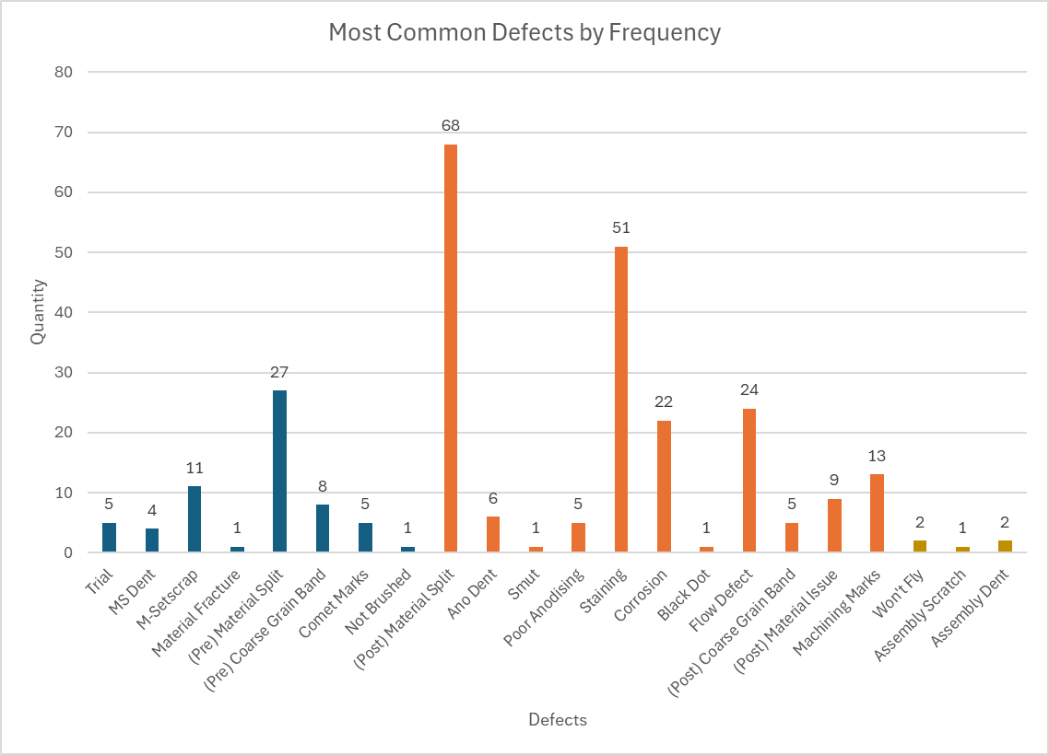
4.1.3 Failure Types
Figure 7 - Most Common Defects by Frequency

Defects were logged against their cause and stage of identification. From the dataset in Figure 7, the most frequent defects leading to failures are material splits and staining at the post-anodising inspection process.
Material splits collectively account for 95 out of 272 failures (35%). These are particularly critical due to their functional and cosmetic severity and are discussed in detail in the Analyse Phase. Staining and corrosion were also prevalent, pointing toward pre-anodising surface preparation and process control issues.

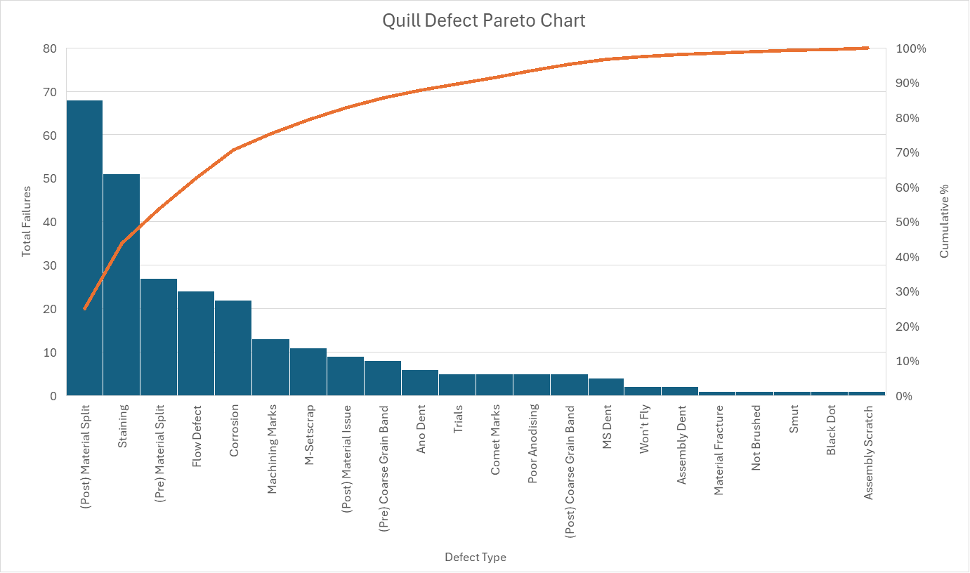
4.1.4 Pareto Analysis
Figure 8 - Quill Defect Pareto Chart

The Pareto analysis clearly demonstrates that a small number of defect types are responsible for the majority of quill rejections. As shown in Figure 8, the top three failure modes are Material Splits, Staining, and Flow Defects, collectively accounting for over 50% of all defects. This aligns with the Pareto Principle (80/20 rule), indicating that focused improvement efforts on a limited number of critical defect types could yield disproportionately large quality gains (Pyzdek & Keller, 2018). With 95 occurrences, Material Splits in particular are the most common and serious failure mode due to their functional and cosmetic implications. Staining, often linked to surface contamination or inconsistent anodising, follows closely and presents further opportunities for process optimisation. The improvement strategy's cornerstone is addressing these major contributors with enhanced cleaning procedures, more stringent anodising controls, and material upgrades. While not disregarded, lower-frequency flaws can be temporarily deprioritised to maximise initial effect and resource efficiency.

4.1.4 Scrap vs. Salvage Rate
The data also captures whether failed quills were scrapped entirely or salvaged through rework. An analysis of the quill inspection data reveals a high scrap rate at each stage of the process, with minimal Quills being able to be reworked.
Table 3 - Scrap vs. Salvage Rate

Inspection Stage | Total Failures | Reworked Successfully | Scrapped | Value
Pre-Anodising | 62 | 8 | 54 | £22,140
Post-Anodising | 205 | 11 | 194 | £79,540
Assembly | 5 | 0 | 5 | £2,050

At the pre-anodising stage, out of 62 failed Quills, only 8 were successfully reworked, resulting in an 87% scrap rate. The post-anodising stage indicates the most significant loss, with 205 failures of which 194 were scrapped, representing a staggering 95% scrap rate. The assembly stage recorded only 5 failures, all of which were scrapped and not reworkable. These figures highlight a clear opportunity for process improvements, especially at the post-anodising stage, where the inability to salvage parts is having a substantial impact on both productivity and cost.

4.1.5 Financial Impact of Scrap
The high volume of scrapped quills represents a significant financial burden. Given that each quill costs approximately £410 to manufacture, this results in a total estimated scrap cost of £103,730 across the data collection period. Not only does this underline the importance of effective defect prevention, but it also demonstrates the potential financial return of investing in improved material quality, surface treatment processes, and more consistent inspection methods. Reducing scrap by even 10% could translate to savings of over £10,000, reinforcing the economic justification for DMAIC-led quality improvements.

4.1.6 Financial Impact of Salvage
Rework of non-conforming quills introduces a significant and often underestimated strain on production resources. While reworking may seem like a cost-saving alternative to scrapping, it diverts valuable assets, such as people, machines, and time, away from production.

Firstly, the CNC machines and operators assigned to reworking defective quills are taken away from their scheduled production tasks. This reduces output capacity, extends lead times, and introduces scheduling conflicts within the machine shop. In many cases, rework must be prioritised to meet delivery commitments, disrupting planned workflow and possibly even leading to an increase in overtime costs.
Secondly, reworking requires additional energy, materials, and consumables such as Acetone and lint-free cloths, and even shortens the overall tool life of the cutting tools used. These are often not accounted for in standard costing, inflating the true cost of the rework operation. When anodised parts are returned for rework, they may also require chemical stripping, which introduces even more additional risks and costs.

Salvage routes require additional inspection time, often involving inspectors buddy checks to ensure quality compliance. This adds labour cost and removes inspection staff from their standard workload. The administrative overhead also increases as non-conforming quills must be logged, concession forms completed, and quality review meetings scheduled, all of which consume engineering and quality personnel time. Each salvage job increases the risk of further damage or unplanned failure, especially on large components like quills, where repeated handling and processing can introduce additional defects. Taken together, these factors compound into a substantial hidden cost, often approaching or exceeding the cost of scrapping and remanufacturing a new part entirely.

Figure 9 – Salvage Jobs
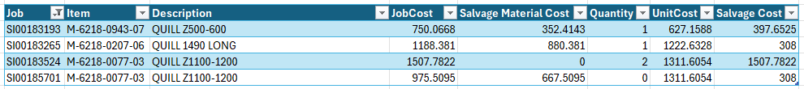

So far only x4 Quills have been successfully salvaged through a rework, resulting in the additional cost of £2,521. This cost would only account for the additional of machine time as well as the cost of additional operators / operations.

In summary, the financial impact of rework is not limited to the time spent on the part itself. It ripples through the production system, affecting planning efficiency, labour allocation, equipment utilisation, and overall delivery performance. Reducing the need for rework through defect prevention and robust process control is not only a quality objective but a strategic imperative for production efficiency and cost control (Hessing, 2014).

4.2 Defect Examples

4.2.1 Material Splits
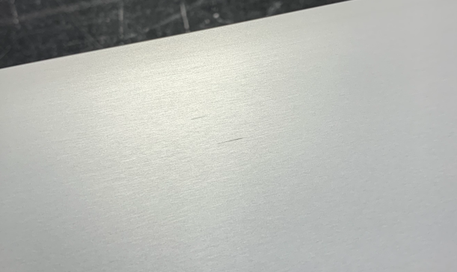
Material splits are one of the most serious defects observed during the pre and post anodising inspections. These appear as visible linear cracks along the surface of the quill and vary in size. They originate from microstructural inconsistencies within the extrusion, typically due to internal stress, porosity, or inclusions, and become even more evident following machining or anodising. Any level of splits renders the quill unfit for use, as they compromise both cosmetic and structural integrity. This defect is non-repairable and always results in scrap (Corrosionpedia, 2024).
Splits
Figure 10 - Material Splits

4.2.2 Anodising Staining
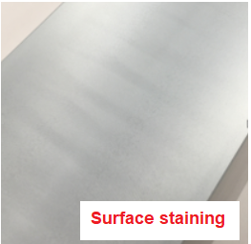
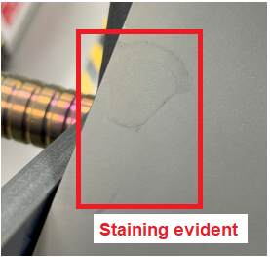
Figure 11 - Staining Patch

Figure 12 - Staining Marks

Staining appears as discoloured patches or streaks on the anodised surface and can vary from faint tinting to dark blemishes. This defect is usually caused by inconsistent surface preparation or contamination during the anodising process, such as residual coolant, improper cleaning, or handling marks. While this defect is not vital to the structural integrity of the Quill, this staining fails against the cosmetic standards stated in the inspection criteria. Its subjective nature often leads to frequent debates during inspection and concession review and often requires input from both Agility management and marketing (Torkar, et al., 2009).

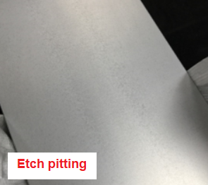
4.2.3 Corrosion
Pitting corrosion is occasionally observed on quills, particularly after anodising. (Wiley, 2024) states that this is often due to impurities or uneven surface sealing, which allows corrosive agents to interact with the base metal. These small, dark craters degrade the cosmetic appearance of the component and may spread over time. While some isolated corrosion spots can be polished and re-anodised, widespread cases typically result in full rejection.
Figure 13 - Pitting Corrosion

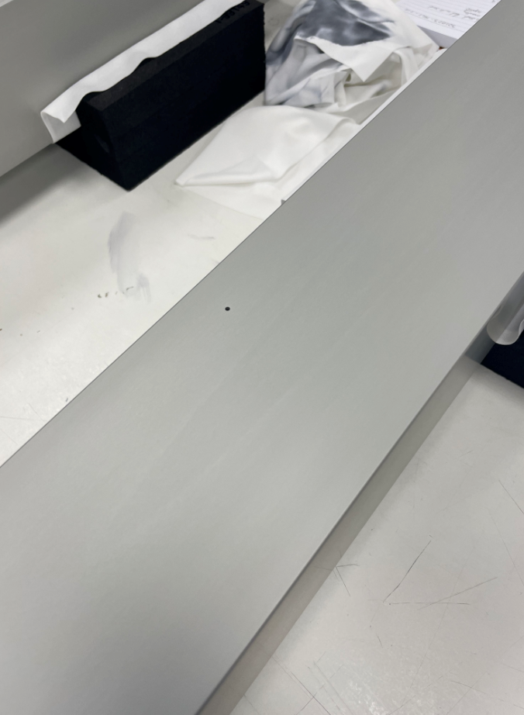
4.2.4 Flow Defects
Flow defects
Flow defects can be caused by a variety of operations, including casting, extrusion, and machining. These defects appear as inconsistent directional patterns, often causing a visual discrepancy on the quill faces (Arif, et al., 2002). While not functionally detrimental, they are classed as a cosmetic failure to Class A surfaces.
Figure 14 - Flow Defects

5. Analyse

5.1 Root Cause Analysis

Initial analysis of defect data highlighted that the highest-impact failure modes were Material Splits, Staining, and Flow Defects. These defects predominantly emerged during post-anodising inspection and were most likely influenced by upstream process variables such as material quality, surface preparation, and machining-induced stress. Secondary contributors such as handling and inconsistent inspection criteria were also recognised as contributing to either the creation or misclassification of defects.

5.1.1 Ishikawa (Fishbone) Diagram
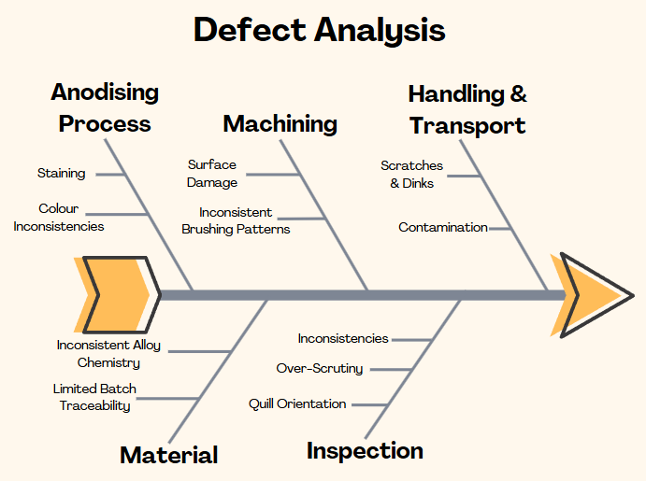
To organise this information and ensure a structured view of the root causes, an Ishikawa diagram was created. This visual tool groups causes into logical categories: Anodising, Material, Machining, Inspection and Handling/Transport. Each of these "bones" of the diagram represents a major contributor to overall quill defects, with specific sub-causes identified during analysis populating each branch. This diagram does not aim to deliver solutions, but rather to expose complexity and interdependence within the process. By seeing the issue not as a single point of failure, but a web of contributing factors, improvement efforts could be focuses where they would have the greatest impact (Pyzdek & Keller, 2018).
Figure 15 - Ishikawa diagram (Canva, 2025)

Root cause analysis was carried out to investigate why defects are occurring so frequently, particularly focusing on material splits, which were the most reported defect during the Measure phase. These splits have been consistently linked to the supplied aluminium alloy extrusion and frequently lead to rejection during either pre- or post-anodising inspection.

5.1.2 5 Whys Analysis
A high number of quills are being scrapped due to visible material splits, often detected during the pre- or post- anodising inspection (Businessmap, 2015).

- Why are quills being scrapped?
Quills are being scrapped because they contain visible splits or microcracks on the surfaces that fail the cosmetic and structural inspection criteria.
- Why do these splits appear on the surface?
They appear because they are inherent in the aluminium extrusion and become more pronounced during machining or anodising.
- Why are these defects present in the aluminium extrusion?
They are present because the raw material contains inconsistencies such as inclusions, voids, or microcracks due to variable extrusion quality.
- Why is the quality of the raw material inconsistent?
This is due to the material being supplied as standard grade aluminium alloy which is more prone to impurities, inclusions, and grain structure variations, as it is not designed for high cosmetic or structural consistency.
- Why is aluminium alloy used for quill production?
This material has been the default material specified for production due to its availability, machinability, and cost-effectiveness, without evaluating its suitability for high-precision and cosmetic components.

The continued use of standard aluminium alloy as the material for quill extrusion has introduced inherent material properties that lead to surface splitting and cosmetic failures, especially after machining and anodising. The material may not be appropriate for components where both cosmetic quality and dimensional stability are critical.

5.2 FMEA

Failure Mode | Effect | Severity (S) | Occurrence (O) | Detection (D) | RPN
Material Supply | Material Split | 9 | 6 | 5 | 270
Machining | Machining Marks | 6 | 5 | 4 | 120
Surface Cleaning | Contaminated Surface | 7 | 5 | 4 | 140
Anodising | Staining | 7 | 6 | 4 | 168
Inspection | Inspection Inconsistency | 6 | 6 | 7 | 252
Assembly | Assembly Damage | 6 | 4 | 5 | 120
Table 4 - Simplified FMEA
Table 4 represents a simplified Failure Mode and Effects Analysis (FMEA) that was conducted to prioritise the most impactful failure modes based on Severity (S), Occurrence (O), and Detection (D) ratings (ASQ, 2015).

Material Splits had the highest RPN due to their moderate detectability and high severity. The quill's structural soundness and cosmetic appeal are both directly impacted by these splits.
Despite not being a material failure, inspection inconsistency has a high RPN because it frequently affects decision-making and results in needless scrap.
Staining and flow defects were also highly rated as they are common and have a low cosmetic tolerance on surfaces that are visible.

This FMEA confirms that improvements should first target material selection and standardisation, followed by inspection discipline and anodising preparation.

5.3 Insights Gained

The Analyse Phase has revealed several important insights that will shape the direction of improvement activities:
- Material splits are not random, they’re systemic. They consistently originate from a root cause, variability in extrusion quality. This points directly to supplier practices and material specifications as the first area for intervention.
- Post-anodising defects contribute to the highest scrap volumes. Staining, corrosion spots, and bright patches continue to occur even after passing pre-anodising checks. This reinforces the need for better surface preparation, cleaning procedures, and perhaps process control improvements at the anodising supplier.
- Handling practices are introducing unnecessary damage. Scratches, dents, and dinks remain common and are often preventable. Simple fixes such as revised packaging and clearer handling procedures could reduce these defects considerably.
- Inspection is a bottleneck with variability risk. Over-inspection and inconsistent defect classification, especially for Class B and C surfaces, are leading to unnecessary scrap and rework.
- The cost of poor quality is too high to ignore. With scrap losses exceeding £100,000, this analysis highlights the clear financial incentive for quality-led improvements.

Additionally, a series of team-based discussions were held with operators, quality inspectors and section supervisors. The aim was to identify consistent patterns or recurring factors that might be contributing to the most common defects. Alongside production inspections, defect patterns were examined to assess the potential roles of environmental, material, process, and human factors in quality loss. The outcome of this exercise was an improved understanding of how each defect category links back to wider process failures. The high occurrence of material splits was consistently linked to variations in extrusion quality purchased from the supplier. Anodising defects like staining and bright patches can be traced to inadequate cleaning and pre-treatment, or contamination introduced during handling. Meanwhile, scratches and dinks were observed to originate not during machining, but during transit of parts between processes. These findings were further supported by the fact that inspection time was often spent debating borderline rejections, particularly for cosmetic issues on Class B surfaces, pointing to inconsistency in visual inspection standards and training.

6. Improve (I)

6.1 Trials

The root cause analysis in the previous phase identified the use of standard aluminium alloy extrusions as a key contributor to material splits, which was one of the most severe and costly defect types. As a result, the primary improvement strategy centred around evaluating the effectiveness of switching to a higher-grade raw material, which offers superior structural integrity and consistency.
To isolate the effect of material quality, a focused trial was conducted using 20 quills manufactured from virgin aluminium. All other variables within the process were deliberately held constant, including tooling, inspection methodology, surface preparation, and anodising procedures. This ensured that any observed improvements could be attributed solely to the change in raw material, thereby adhering to the Six Sigma principle of controlled experimentation.
The results were significant. None of the 20 quills produced using virgin aluminium exhibited material splits, either post-machining or post-anodising. This is a complete contrast to historical data, where splits frequently appeared during or after the finishing process. While three of the twenty quills did fail for post-anodising staining, this was expected, given that no changes were made to the anodising supplier’s processes for this initial material trial. These results provide strong experimental evidence that material quality has a direct influence on both functional and cosmetic outcomes in quill production.

6.1.1 Costs
The cost implication of switching to virgin aluminium was carefully evaluated during the trial. As stated in section 4.1.1 Overview of Data Sources – ‘Quills are purchased from our raw material supplier Aalco as Aluminium Alloy (M-6218-0206-02) in 3-meter lengths at a cost of £126.9 each’.
From the same supplier, virgin aluminium was purchased at £237 per 3-meter length, bringing the new value of Quills up to approximately £520 each.
While the material is marginally more expensive on a unit basis than the previously used aluminium alloy, the financial return is favourable when viewed from a total cost of quality perspective. Virgin aluminium offers superior material consistency, which translates directly to improved process stability and reduced defect occurrence, especially the prevention of material splits, which have previously led to high rates of irreversible scrap.
Each scrapped quill carries a direct loss of approximately £410, excluding additional costs such as lost labour time, inspection hours, and administrative overheads linked to rework, concessions, and production delays. This change aligns with the principle of investing in prevention rather than absorbing the recurring costs of internal failure. While initially perceived as a cost increase, the introduction of virgin aluminium is in fact a strategic cost avoidance measure, helping to stabilise the process, reduce variation, and ultimately lower the long-term cost per conforming unit.

6.1.2 Design for Six Sigma (DFSS)
This strategy aligns closely with Design for Six Sigma principles, which emphasises on proactive quality design from the beginning, rather than relying exclusively on reactive process monitoring to catch defects after they occur. In DFSS, emphasis is placed on understanding the voice of the customer, translating those needs into critical-to-quality (CTQ) characteristics, and ensuring that these are consistently achieved through robust design choices (Peterka, 2008). In the context of quill production, material selection sits evenly within the design criteria, as it directly influences both cosmetic finish and structural integrity, two key CTQ requirements for Renishaw’s AGILITY CMM product range.

By selecting virgin aluminium as the new default input, the process design is inherently more capable of producing quills that meet visual and functional expectations. From these trials, evidence suggests that virgin aluminium provides greater material consistency, significantly reducing the likelihood of material issues such as splits, flow defects and fractures. This proactive design decision not only enhances product quality but also simplifies downstream operations by reducing the need for rework, concessions, or excessive inspection.

In contrast, attempting to compensate for variable material quality through additional inspections or more rigorous cosmetic standards is a fundamentally reactive approach, which does not address the root cause of the issue and often leads to increased cost-of-quality through review and internal failure. DFSS encourages organisations to "design it right the first time," and the results of the material trial clearly demonstrate that a stable, defect-resistant input is more effective at achieving consistent results rather than relying on process controls to catch and correct defects further down the manufacturing process.
This shift in mindset, from monitoring variation to actively removing it at the source, is a hallmark of Six Sigma maturity and provides long-term benefits in terms of capability, throughput, and customer satisfaction. As the quill production process evolves, this material decision serves as a future improvement where input quality is directly tied to performance outcomes (Lunau, et al., 2013).

6.2 Implementation

The controlled nature of this internal trial serves as a Phase 1 Validation. The next stage will involve expanding this approach through Phase 2, increasing the batch size to 50 - 100 quills. If results remain positive, a formal Process Change Authorisation (PCA) can be initiated to permanently update the bill of materials and supplier quality documentation to reflect virgin material as the default requirement.
The implementation of this improvement began with a tightly monitored internal trial, designed to minimise risk and gather data under consistent, repeatable conditions. The 20 trial quills were introduced into the existing production flow, undergoing machining, cleaning, and anodising under normal operating conditions. Inspection followed standard procedures, with each quill being evaluated post-machining and post-anodising by trained operators using existing criteria and visual standards.

Key performance indicators tracked during the trial included:
- Material splits (post-machining and post-anodising): 0 reported.
- Staining or anodising rejection: 3 reported.
- Scrap cost: This resulted in the total scrap cost of £1,560. Based on the previous scrap rate of 73%, this figure could have been approximately £5,986.
- Process disruption: None observed; virgin material handled and machined identically to standard alloy.

Table 5 - SIPOC Diagram (Pyzdek & Keller, 2018)

6.3 SIPOC Diagram

Supplier | Input | Process | Output | Customer
Aluminium Supplier  (Aalco) | Aluminium alloy / virgin aluminium extrusions | Receive and inspect raw material at goods in | Approved material and process to stock | Machine Shop
Machine Shop | Approved material from stock location | Machine quills to drawing specification | Machined quill | Quality Inspection (Pre-anodising)
Quality Technicians | Machined quill | Pre-anodising visual inspection | Accepted/rejected part | Anodising Supplier
Anodising Supplier | Machined quill | Apply clear anodising coating | Anodised quill and return to Renishaw | Quality Inspection (Post-anodising)
Quality Technicians | Anodised quill | Final inspection against visual criteria | Pass/Fail quill | Agility Assembly

6.4 Vertical Inspection Jig

As part of the broader effort to improve inspection consistency and reduce unnecessary scrap, particular attention was paid to the ergonomics and repeatability of visual inspections. Dedicated inspection jigs have been proposed to stabilise the quill during inspection and simulate its operating position within the final assembly.
Figure 16 - Initial Prototype

6.4.1 Initial Prototype
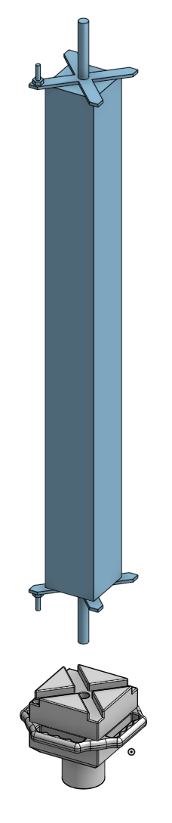
The initial prototype is a small portable jig that can safely hold the quill in a vertical position during inspection. The device can be installed immediately on existing inspection benches because it is made to mount onto a sturdy base plate with a small footprint. The quill can be freely rotated for a complete surface examination, but the jig has a precisely positioned handle slot and X-brace cutout to guarantee constant alignment. This initial prototype is intended as a proof of concept and will help validate the effectiveness of vertical orientation on inspection accuracy and operator comfort. Delivery and trial use of the prototype are planned for August 2025, following which ergonomic evaluations and performance input will guide future revisions.
Figure 17 - Prototype Fitment
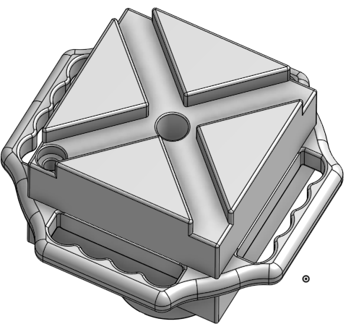
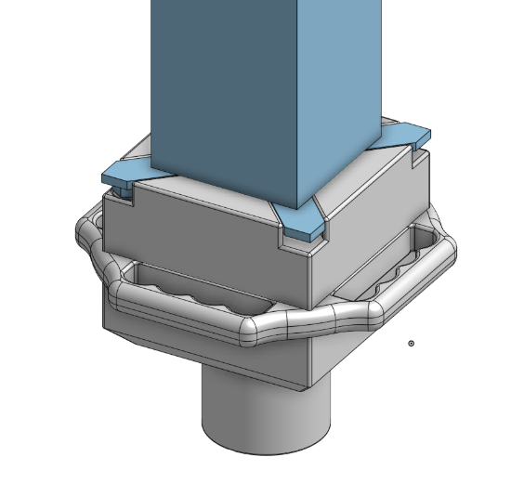
Figure 18 - Prototype Alignment

6.4.2 Dual-Orientation Inspection Bench
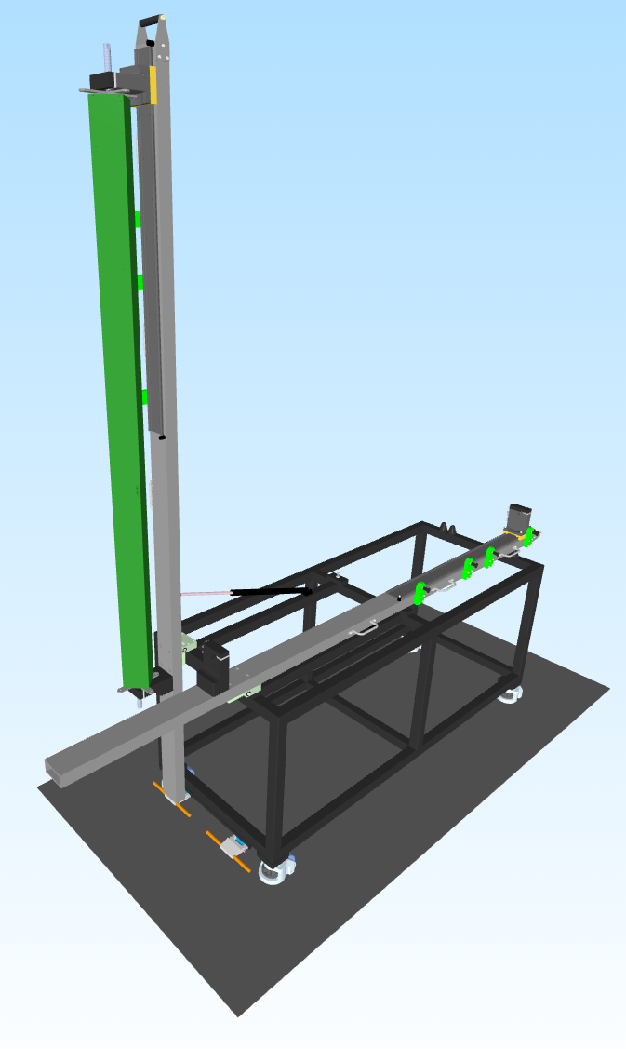
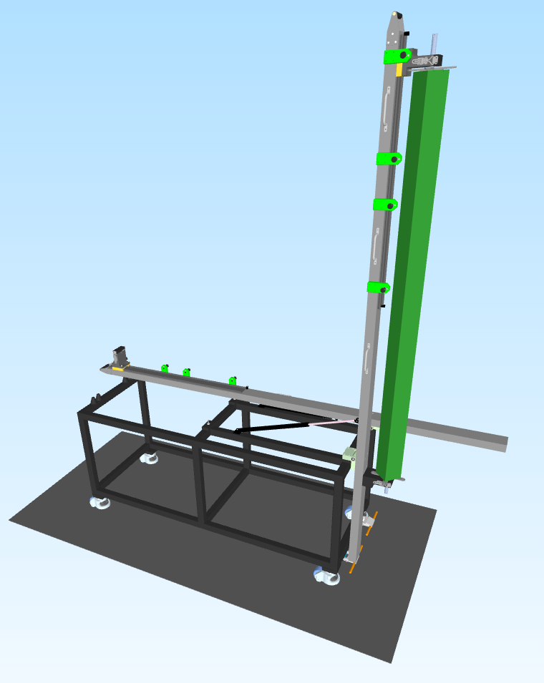
A permanent solution is being designed concurrently: a specialised examination table with a lever-operated jig fixed at its edge. The Quills are mounted horizontally to the lever and can be lifted into the vertical position with ease. There are several staged along the jig to facilitate varying lengths of Quill. With one bench supporting two of these advanced fixtures, simultaneous inspection of two Quills can be conducted. In addition to preserving stability and avoiding accidental contact that could result in scratches or handling damage, the lever design will facilitate safe operation that can be performed by one individual operator.
Figure 19 - Inspection Bench View 1

The development of this dual-orientation bench is anticipated to progress towards the end of 2025 due to the workload demands present in the Low Volume Production (LVP). Nonetheless, its implementation is regarded as a long-term, high-priority expenditure, especially to support future inspection requirements.
Figure 20 - Inspection Bench View 2

7. Improve (II)

7.1 Validation

Following the successful initial trial with virgin aluminium on a batch of 20 quills, an increased batch trial was conducted to validate the improvements on a larger scale and under standard production conditions. This second trial involved the manufacture and processing of 100 quills using virgin aluminium sourced from the same supplier. As with the initial trial, all other process variables including machining techniques, anodising methods, and inspection protocols were intentionally kept constant to isolate the material effect.
Inspections were carried out using the specified visual standards once again at the post-machining and post-anodising stage. The important validation parameters tracked were the frequency of material splits, anodising staining, inspection time, and operator conformance to material handling standards.

The results of the second trial reinforced the findings from the initial trial with the following results:
- Material splits: 0 occurrences out of 100 quills.
- Staining: 10 occurrences (10%), which is marginally higher than in the initial trial but still lower than historical defect rates with standard aluminium alloy.
- Inspection time: Average of 17 minutes per quill, compared to a historical baseline of 20 minutes due to less defects being found.
- Operator feedback: No handling difficulties reported; machinability was rated comparable to standard alloy material.

In response to feedback following the initial trial, operators became more thoughtful when cleaning the quills with acetone prior to anodising. Because the coolant from machining is known to contribute to anodising staining, extra care was taken to ensure surfaces were completely degreased and free of contamination prior to being jigged for inspection. This increased awareness and better cleaning method seems to lessen surface contamination and contribute to more consistent anodising results.

The absence of material splits and the noticeable reduction in staining has confirmed that the use of virgin aluminium, combined with improved operator diligence during surface preparation, provided a statistically significant improvement in quill quality. These validated results formed the evidence base for progressing confidently towards formal production implementation.

7.2 Metric Comparison

A direct comparison between the baseline data (2023–2024) and the increased batch trial demonstrates clear improvements in both quality and process efficiency.
Table 6 - Metric Comparison

Metric | Aluminium  Alloy | Virgin Aluminium | Improvement
Material Splits Rate | 25.40%  (95/374 Quills) | 0%  (0/100 Quills) | Eliminated
Staining Defects Rate | 13.63%  (51/374 Quills) | 10%  (10/100 Quills) | 26.63% Reduction
Overall Scrap Rate | 72.72%  (272/374 Quills) | 10%  (10/100 Quills) | 86.24% Reduction
Average Inspection Time  (Per Quill) | 20 Minutes | 17 Minutes | 15% Reduction
Scrap Cost  (Per 100 Quills) | £29,500 | £5,200 | 82.37% Reduction

7.3 Key Takeaways

- The elimination of material splits removed the single largest contributor to quill scrap, contributing to a dramatic 86% reduction in total scrap rate.
- Although staining defects still occurred, their rate was noticeably lower than historic trends.
- Inspection efficiency improved by 15%, driven by reduced defect detection and less time spent classifying borderline failures.
- Financially, the scrap cost reduction translates to a saving of approximately £24,300 per 100 quills, easily offsetting the marginally higher cost of virgin material.

The success of the material change is validated by these improvements, which are both statistically significant and operationally important. This supports the argument for formal process control handover and full-scale implementation during the Control Phase.

8. Control

The Control Phase guarantees that process improvements are not undermined by variation or noncompliance with new procedures, and that the improvements made throughout the project are sustained over time. To protect the enhanced process capability, this phase integrates continuous monitoring systems into daily operations, standardises best practices, and creates systematic controls.

8.1 Sustainable Improvements

Several control measures will be formally implemented throughout the manufacturing workflow to integrate the process improvements made possible using virgin aluminium and enhanced inspection procedures:

- Material Specification Control: All quill extrusions must use virgin aluminium, as required by an update to the drawing specification. New purchase orders, supplier quality agreements, and incoming products inspection standards will all be used to enforce this. Compliance will be continuously checked via supplier audits from our Vendor Assurance (VA) department and Certificate of Conformity (CofC) will be required with each delivery of material. These CofC’s will be electronically scanned and stored within our syteline system indefinitely.
- Modified Standard Discipline Procedures (SDPs): To consider the new material, updated quality requirements, and best handling methods, SDPs for material reception, machining, pre-anodising cleaning, and visual inspection will be changed. These will include clear visual acceptability criteria based on Class A/B/C surface designations and unambiguous requirements for thorough acetone cleaning.
- Operator Re-certification and Training: All relevant operators, inspectors, and quality technicians will get refresher training on the most recent inspection standards and SDPs. Modules for training will include:
- Handling techniques to minimise dents/scratches.
- Refresher training on defect classification using visual inspection standards.
- Correct acetone cleaning practices to minimise anodising defects.
(Competency will be assessed post-training to ensure consistent application)
- Process Audits: To guarantee SDP compliance, process audits will be implemented on a quarterly basis. Reviews of corrective actions and, if required, refresher training will be initiated if new processes are not followed. This guarantees that process discipline is upheld, and that unrecorded, informal practices don't gradually resurface.

8.2 Monitoring

To maintain control and encourage ongoing progress, a strong monitoring system will be implemented:
- SPC Implementation: Control charts will be used at critical process stages (surface finish post-machining, inspection fault rates). Every month, Quality Engineering will examine SPC dashboards to identify any new patterns or changes. Rapid corrective action before quality degradation starts will be made possible by early notification of deviation.
- Quality Performance Reviews: Every Quarter, representatives from Quality, Production, and Purchasing will attend a formal meeting to discuss the important metrics such as scrap rate trends, defect type frequency, supplier non-conformances and SPC signals.
- Customer Feedback Loops: To guarantee that the quills functional and cosmetic quality remain acceptable while in use, input from internal assembly teams and external customers (if applicable) will be obtained every two years.
- Opportunities for Continuous Improvement (CI): Recurring Kaizen events and workshops on root cause problem-solving will be used to integrate Lean Six Sigma ideas into continuing operations, especially if new defect trends or quality issues surface. Using a straightforward impact/effort matrix, improvement suggestions found through SPC, or quality reviews will be prioritised and implemented appropriately.
- Sustainability metrics: To make sure the project's financial improvements are maintained, cost-of-quality measures (scrap cost, rework cost, and inspection time) will continue to be monitored and compared.

By combining these steps, a closed-loop quality management system is established. This guarantees that the improved process practices and material change are not only maintained but also expanded upon by ongoing observation and improvement. This is in line with Renishaw's dedication to high-performance precision production and offers long-term assurance of consistent quill quality, decreased waste, and enhanced operating efficiency.

8.3 Full FMEA
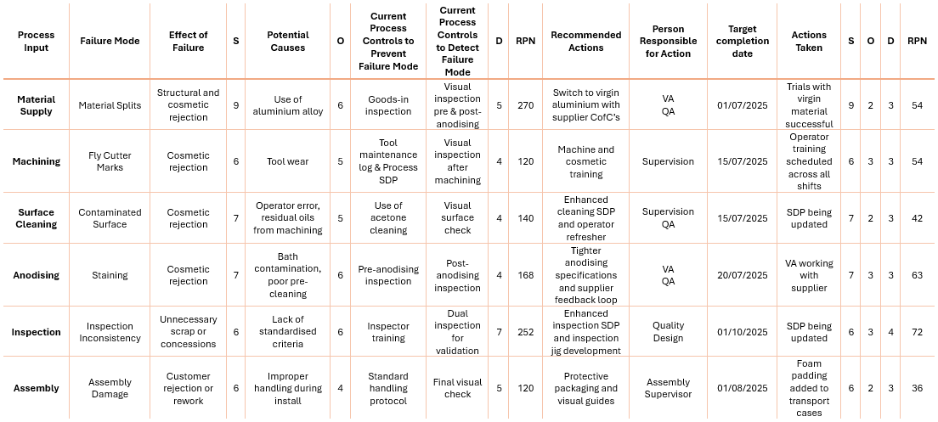
Table 7 - Full FMEA (www.six-sigma-material.com, 2025)

An extensive Failure Mode and Effects Analysis (FMEA) was carried out throughout the quill production process in order to methodically rank failure risks and define improvement measures. Material supply, machining, surface cleaning, anodising, inspection, and assembly were the six main phases of this process. Severity (S), Occurrence (O), and Detection (D) were used to identify and assess known or expected failure modes for each phase (Sartor & Cescon, 2019). The following standard formula was used to determine the Risk Priority Number (RPN):

Equation 1 - RPN Calculation
$$RPN=Severity \left(S\right)×Occurance \left(O\right)×Detection (D)$$

The analysis highlighted that the most critical failure mode was Material Splits, identified at both the pre- and post- anodising inspection but traced back to the structural inconsistencies of the aluminium alloy material. This failure mode presented the biggest danger to both functional integrity and cosmetic conformity, with an initial RPN of 270. Its RPN dropped to 54 when virgin aluminium was introduced, indicating a significant reduction in the chance of occurrence and detection.
Inspection Inconsistency (RPN: 252) was another high-priority failure, where subjective assessments of cosmetic standards resulted in inconsistent concession decisions, scrap or salvage. Its RPN dropped to 72 after post-improvement actions, such as updating the SDP and the initial design / implementation of a vertical inspection jig.
Other notable findings include:
- Staining and Contaminated Surface were shown to be linked, with pre-anodising cleaning identified as a major contributing factor. Improved operator awareness and stricter acetone cleaning protocols reduced both risks significantly.
- Despite being less common, assembly damage remained moderately severe and required careful handling procedures. When transport cases were equipped with protective foam padding, the corresponding RPN decreased from 120 to 54.

Post-action RPNs shown a significant improvement across all failure modes, demonstrating the relevance and effectiveness of targeted interventions. By designating each improvement action to a responsible owner with a specific deadline for completion, the FMEA not only helped prioritise the actions but also made cross-functional accountability possible. The research consequently produced a well-organised road map for long-term risk reduction and quality control. This data-driven strategy promotes a continuous improvement culture throughout the CMM quill production process and aligns directly with best practices for Six Sigma.

8.4 Limitations

Although the DMAIC improvement stages showed significant improvements in quality and cost management, it is important to recognise a number of limitations:
- Sample Size and Scope: The trial batch of 120 virgin aluminium quills offers promising results, but it only makes up a small portion of the entire manufacturing. Variations not seen in the experiment might be revealed by broader application.
- Subjectivity of Inspection: Visual inspections are still somewhat subjective, even with advancements like more distinct surface classifications and the creation of vertical inspection jigs. Even after being trained, inspectors may still differ from one another.
- External Supplier Unawareness: The anodising provider was not made aware of the trial modification, which made it more difficult to regulate every input variable. The uncontrolled factor may explain residual staining defects.
- Costs Analysis Scope: Material and scrap rates were the main focus of the cost analysis. Potential long-term effects like tool wear during the processing of virgin aluminium or sustainability trade-offs were not taken into consideration.

8.5 Statistical Process Capability (Hypothetical)

A basic Process Capability Analysis (PCA) was developed based on the supposition that anodising defects, in particular staining, can be quantified and characterised in terms of frequency per 100 parts in order to give a hypothetical statistical validation of the improvements attained. The main goal is to determine whether the process can reliably produce within acceptable fault limits after switching to virgin aluminium as the material. If a process is centred, Cp shows how well it fits inside the parameters of the specification. Within those bounds, Cpk takes into account both the process's spreading and centring (Pyzdek & Keller, 2023).

Assumptions:
- The allowable staining specification limit is ≤ 5 stained quills per 100 units (5%).
- Three out of 120 quills failed the virgin aluminium trial, indicating a 2.5% defect rate.
- Assumed standard deviation (σ): 1.2 (based on historical fluctuation among batches after anodising).

Using the Formulas:
Equation 2 - Process Capability Ratios (Montgomery, 2009)
$$Cp=\frac{USL-LSL}{6σ}, Cpk=min⁡(\frac{USL-μ}{3σ} , \frac{μ-LSL}{3σ})$$
Where:
- USL = 5
- LSL = 0
- μ = 2.5
- σ = 1.2
Equation 3 - Cp Calculation
$$Cp=\frac{5-0}{6×1.2}=\frac{5}{7.2}≈0.694$$
Equation 4 - Cpk Calculation
$$Cpk=\min\left(\frac{5-2.5}{3×1.2} , \frac{2.5-0}{3×1.5}\right)=\min\left(\frac{2.5}{3.6} , \frac{2.5}{3.6}\right)=0.694$$

Although the process is significantly better than the previous one, which showed scrap rates above 70%, a Cp and Cpk value of roughly 0.69 indicates that it would still fall short of the Six Sigma industry benchmark (Cp/Cpk 1.33) if scaled up without stricter process control.

9. Results

9.1 DMAIC Outcome Analysis

9.1.1 Define
The project's scope was defined during the Define phase, which also verified that the majority of quill failures were structural or cosmetic in origin, with the most common flaws being material splits and staining. It was evident that more control over the consistency of inspections and the quality of the raw material was required. Early process mapping and a review of the visual inspection standards revealed inconsistent defect classification and variation in inspector interpretation.

9.1.2 Measure
272 units failed at least one inspection stage, according to baseline data gathered from 374 quills; post-anodising accounted for the majority of failures (205 failures; 55%). According to a thorough defect breakdown, the most frequent reasons for scrap were Material Splits (95), Staining (51), and Flow Defects (24). The overall scrap rate was 68%, resulting in an estimated financial loss of around £103,730. The prioritising technique was guided by Pareto analysis, which verified that these top three flaws alone were responsible for over 50% of all failures.

9.1.3 Analyse
The use of aluminium alloy extrusions was identified as the primary cause of material splits using Root Cause Analysis tools, such as an Ishikawa diagram and the Five Whys. Additional validation was obtained by a comprehensive Failure Mode and Effects Analysis (FMEA), which revealed that Material Splits were the most severe failure mode with an RPN of 270. Inspection Inconsistency (RPN: 252) and Staining (RPN: 168) were next in line. These results validated that inspection discipline and input quality were important variables for improvement.

9.1.4 Improve
Virgin aluminium obtained from the current supplier was used in two initial trials. To isolate material performance, all other variables, such as the machining and anodising procedures, were kept consistent. No material splits were observed in any of the two trials (120 quills), and staining rates decreased by 33.7%. Clearer surface finishes and fewer borderline cases contributed to a 15% reduction in inspection time. Cost analysis revealed that the decrease in scrap greatly offset the marginally higher price of the new material, resulting in an estimated £24,300 savings per 100 quills.

9.1.5 Control
Several control mechanisms were implemented to sustain these developments. These included material specification control, modified SDP's, operator re-certification / training, and process audits. To identify process changes early and guarantee ongoing process improvements, statistical process controls will be developed to be integrated into the machining and inspection phases. Quality Performance Reviews will also be conducted as part of the initiative to keep an eye on important defect patterns and uphold departmental accountability.

9.2 Achievements
Table 8 - Achievements

Objective | Outcome
Reduce Overall Scrap Rate | 86.24% Reduction
Eliminate Material Splits | 0 Splits Recorded Across Trials
Reduce Staining Defect Rate | 26.63% Reduction
Improve Inspection Efficiency | 15% Reduction
Financial Scrap Savings | 82.37% Reduction - Estimated £24,300 Savings Per 100 Quills

After reviewing the data in Table 8, it is evident that all objectives stated at the beginning of this report have been achieved and some even exceeded.

9.3 Challenges

Several operational and methodological challenges were encountered:
- Maintaining Variable Control During Trials: Anodising suppliers were not made aware of the trial in order to isolate the impact of the material modification. Although data integrity was maintained, staining rates were not immediately improved but improved overall with discussions and re-training with the operators.
- Inspector Variability and Subjectivity: Concessions and disagreements were common as a result of inconsistent inspector judgements. This was improved by re-examining the surface class definitions and enhancing visual guide documents.
- Supplier Cost Concerns: Initially, the Purchasing department had concerns with the cost increase associated with virgin aluminium, which is why two trials were used in order to confirm the overall savings.

10. Conclusion

This project set out to enhance the quality and efficiency of Renishaw’s Agility CMM quill production by applying the Six Sigma DMAIC methodology. Through a detailed investigation of over 370 units, the study revealed that material splits and staining were the dominant contributors to scrap and rework, leading to excessive scrap costs, inspection time, and planning disruption.
Using data-driven techniques including Root Cause Analysis, FMEA, and controlled trials, it was determined that the existing aluminium alloy introduced unpredictable variation due to internal inconsistencies and structural weaknesses, which was also confirmed by both (Davis, 2013) and (Kaufman, 2012). Switching to virgin aluminium resulted in a complete elimination of material splits and a significant reduction in cosmetic staining, ultimately improving both functional and aesthetic outcomes. Trial results demonstrated a scrap rate reduction of 86.24%, a 15% decrease in inspection time, and projected cost savings of £24,300 per 100 quills, thereby validating the financial and operational benefits of the intervention.
Process control enhancements, including revised inspection standards, training programmes, and supplier agreements, were implemented to preserve these developments and build a foundation for sustainable improvement. The project exceeded its initial objectives, delivering measurable quality improvements and setting a precedent for future defect-prevention strategies within high-precision manufacturing environments.

11. Recommendations

The following recommendations are provided in order to strengthen and expand upon the study's findings:
- Formalise Material Specification Updates: To guarantee long-term material consistency, the usage of virgin aluminium should be incorporated into supplier contracts, procurement specifications, and technical documentation. A formal PCA will be raised as a result of this project.
- Collaborate Closely with Anodising Suppliers: Even if staining has improved, more optimisations might be achievable by working with anodising suppliers to jointly create improved surface preparation and pre-treatment procedures. Bath chemistry evaluations and shared process audits could be conducted in order to improve staining frequency.
- Enhance Visual Inspection Infrastructure: In order to decrease subjective judgement, vertical jigs should be implemented at all inspection stations together with updated cosmetic standards that include enhanced Class A/B/C references.
- Expand Trials to Other High-Scrap Components: The methodology and successes of this project provide a strong framework that can be applied to other components within the CMM or similar product ranges facing cosmetic or structural quality challenges.

This project has demonstrated the value of structured quality methodologies and reinforces the importance of proactive material and process control in high-precision manufacturing. With continued monitoring and expansion of these improvements, Renishaw can expect not only sustained gains but also broader organisational learning.

12. Bibliography
Aggerbeck, M. et al., 2014. Appearance of anodised aluminium: Effect of alloy composition and prior surface finish. Surface & Coatings Technology, Volume 254, pp. 28-41.
Arif, A. F. et al., 2002. Product defects in aluminum extrusion and their impact on operational cost. The 6th Saudi Engineering Conference, Volume 5, pp. 137-154.
ASM International Handbook Committee, 1998. Aluminum and Aluminum Alloys. In: J. R. Davies, ed. Metals Handbook Desk Edition. 2nd ed. s.l.:ASM International, pp. 351-416.
ASQ, 2015. Learn About Quality. [Online]
Available at: https://asq.org/quality-resources/fmea?srsltid=AfmBOoog-Z6RRuSx-pKoGYsSXCSDVwsl0zAw1fUzYjDT_Y8JM3v2s6Jp
[Accessed 12 April 2025].
Burrows, D., 2024. How durable are sustainability claims made for aluminium packaging?. [Online]
Available at: https://www.just-drinks.com/features/how-durable-are-sustainability-claims-made-for-aluminium-packaging/
[Accessed 27 April 2025].
Businessmap, 2015. Unlock the Power of 5 Whys: Root Cause Analysis Made Easy. [Online]
Available at: https://businessmap.io/lean-management/improvement/5-whys-analysis-tool
[Accessed 11 April 2025].
Canva, 2025. https://www.canva.com/graphs/fishbone-diagrams/. [Online]
Available at: https://www.canva.com/graphs/fishbone-diagrams/
[Accessed April 08 2025].
Corrosionpedia, 2024. Microcrack. [Online]
Available at: https://www.corrosionpedia.com/definition/5709/microcrack
[Accessed 05 April 2025].
Davis, J., 2013. Aluminum and Aluminum Alloys. Alloying: Understanding the Basics, Issue DOI:10.1361/autb2001p351, pp. 351-416.
Hessing, T., 2014. Cost of Poor Quality (COPQ). [Online]
Available at: https://sixsigmastudyguide.com/cost-of-poor-quality/
[Accessed 30 March 2025].
Kaufman, J. G., 2012. Introduction to Aluminum Alloys and Tempers. 1st ed. United States of America: ASM International.
Lunau, S. et al., 2013. Design for Six Sigma + LeanToolset: Mindset for Successful Innovations. 2nd ed. s.l.:Springer.
McCarty, T., Daniels, L., Bremer, M. & Gupta, P., 2005. The Six Sigma black belt handbook. Motoralo: McGraw-Hill.
McCullough, R. R. et al., 2019. Fatigue crack nucleation and small crack growth in an extruded 6061 aluminum alloy. International Journal of Fatigue, Volume 119, pp. 52-61.
Misiolek, W. Z. & Kelly, R. M., 2013. Extrusion of Aluminum Alloys. ASM Handbook, Volume 14A, pp. 522-527.
Montgomery, D. C., 2009. Introduction to Statistical Quality Control. 6th ed. Arizona: Wiley.
Novelis, 2024. Top Five Sustainable Attributes of Aluminum: A Closer Look at Aluminum’s Environmental Benefits. [Online]
Available at: https://novelis.com/top-five-sustainable-attributes-of-aluminum-a-closer-look-at-aluminums-environmental-benefits/
[Accessed 27 April 2025].
Oakland, J. & Oakland, R., 2024. Introduction to Statistical Quality Control. Wiley.. 8th ed. London: Routledge.
Peng, Z. & Sheppard, T., 2004. Study of surface cracking during extrusion of aluminium alloy AA 2014. Materials Science and Technology, Volume 20, pp. 1179 - 1191.
Peterka, P., 2008. Design for Six Sigma. [Online]
Available at: https://www.6sigma.us/lean-six-sigma-articles/design-for-six-sigma-2/
[Accessed 20 April 2025].
Prasad, A. R. & Prakash, S., 2022. A Review on Anodizing Process of Aluminum and Non-Aluminium Alloys. Mangalore, Srinivas University.
Pyzdek, T. & Keller, P., 2018. The Six Sigma handbook. 5th ed. s.l.:McGraw-Hill.
Pyzdek, T. & Keller, P., 2023. Six Sigma Handbook, Sixth Edition: A Complete Guide for Green Belts, Black Belts, and Managers at All Levels. 6th ed. s.l.:McGrawHill.
Renishaw, 2023. H-1000-8021-03-A - Renishaw AGILITY ®. s.l.:s.n.
Renishaw, 2024. Agility Quills: Standards and Process for Visual Inspection. s.l.:Renishaw Internal Procedure.
Renishaw, 2024. Company biographies. [Online]
Available at: https://www.renishaw.com/en/company-biographies--32462
[Accessed 24 11 2024].
Renishaw, 2024. PD-6218-4791-03 Quill Anodising Procurement Spec. s.l.:Renishaw Internal Procedure.
Renishaw, 2025. AGILITY® CMMs with 5-axis technology. [Online]
Available at: https://www.renishaw.com/en/agility-cmms-with-5-axis-technology--48532?srsltid=AfmBOooQqzNgh1izT-8H0U5ysnYUlLx4hpzm0Wi2FFavfiYE93MJVqGX
[Accessed 09 March 2025].
Sartor, M. & Cescon, E., 2019. Failure Mode and Effect Analysis (FMEA). In: G. Orzes, ed. Quality management: tools, methods and standards. s.l.:Emerald, pp. 72-78.
Spitzer, M., 2023. The Environmental Impact of Aluminum. [Online]
Available at: https://trayak.com/the-environmental-impact-of-aluminum/
[Accessed 27 April 2025].
Stacey, M., 2020. Aluminium: Sympathetic and Powerful. 1st ed. Canada: Riverside Architectural Press: Toronto.
Terryn, H. & Vereecken, J., 1991. Surface engineering of aluminium and its alloys. In: EMC ’91: Non-Ferrous Metallurgy - Present and Future. Dordrecht: Springer, pp. 473-480.
Torkar, M., Godec, M. & Lamut, M., 2009. Origin of stains on anodized aluminium profile. Engineering Failure Analysis, 16(3), pp. 909-913.
Vanden-Heuvel, L. N. et al., 2024. Root Cause Analysis Handbook: A Guide to Efficient and Effective Incident Investigation. 3rd ed. Connecticut: ROTHSTEIN ASSOCIATES INC..
Wiley, B., 2024. Aluminum Corrosion: Why it Happens and What to Do When It Does. [Online]
Available at: https://www.wileymetal.com/aluminum-corrosion-why-it-happens-and-what-to-do-when-it-does/
[Accessed 06 April 2025].
www.six-sigma-material.com, 2025. Failure Mode and Effects Analysis. [Online]
Available at: https://www.six-sigma-material.com/FMEA.html
[Accessed 27 April 2025].
Yu, X., Zhang, G., Zhang, Z. & Wang, Y., 2023. Research on corrosion resistance of anodized and sealed 6061 aluminum alloy in 3.5 % sodium chloride solution. International Journal of Electrochemical Science, 18(5), p. 100092.

13. Appendix

Table 9 - Timing Plan

13.1 Timing Plan
Month | Week(s) | Activity
November 2024 | Week 1–2 | Interim viva presentation and feedback review
 | Week 3–4 | Refine problem statement and project aims (Define phase)
December 2024 | Week 1 | Begin extended literature review
 | Week 1–2 | Finalise Literature Review (Research section)
 | Week 3–4 | Begin data collection and Pareto/FMEA for Measure phase
January 2025 | Week 1–2 | Continue data analysis - complete root cause analysis (Fishbone, 5 Whys)
 | Week 3–4 | Complete Measure and Analyse sections
February 2025 | Week 1–2 | Designing prototype inspection jig (Improve phase)
 | Week 3–4 | Virgin aluminium trial testing and begin Improve write-up
March 2025 | Week 1-3 | Virgin aluminium trial testing and Improve write-up
 | Week 4 | Improve write-up and data collection for validation
April 2025 | Week 1–2 | Validate results; compare scrap and salvage rates (Control phase)
 | Week 3– May Week 1-2 | Start writing Discussion and Conclusion.  Final reviews of sections
May 2025 | Week 3 | Submit final report by 19th April 2025
 | Week 4 | Prepare final viva presentation and poster

13.2 Supporting Equations

Equation 5 - Percentage Improvement
$$Percentage Improvement= \frac{Baseline-New Value}{Baseline}×100$$
Equation 6 - Scrap Cost Calculation

$$Scrap Cost=Number of Scrapped Quills ×Cost per Quill$$

Equation 7 - Cost Savings After Improvement
$$Cost Saving=\left(Baseline Scrap-Improved Scrap\right)×Cost per Quill$$

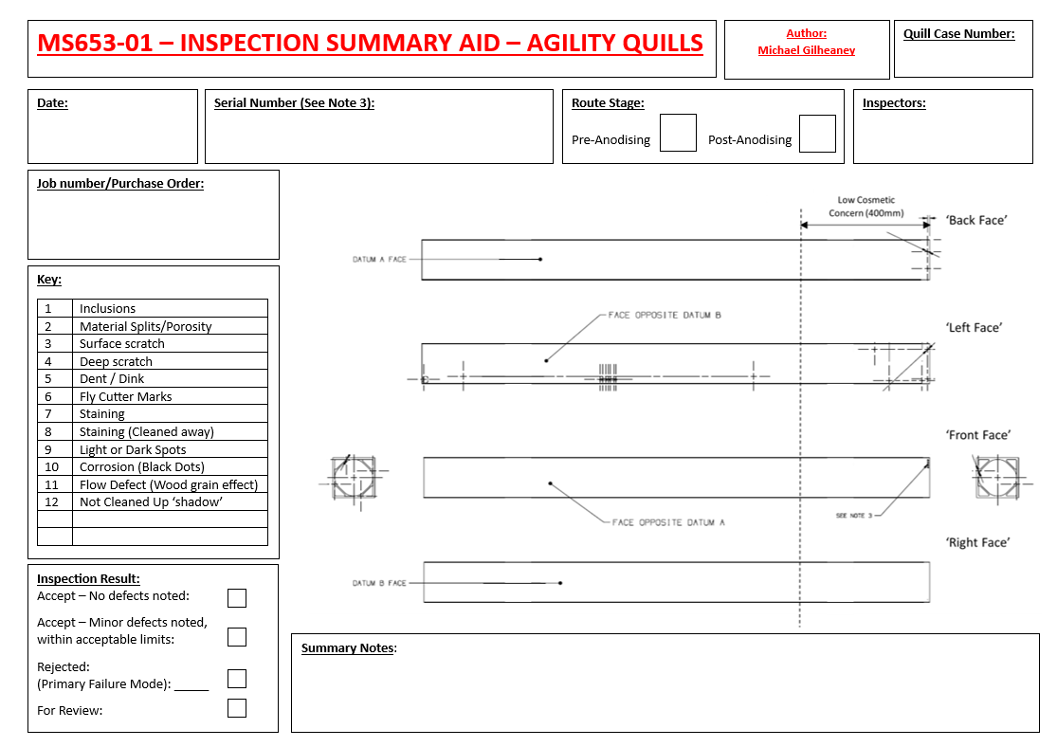
13.3 Inspection Summary Aid

