MBA Leading and Managing Projects
BMMB7010
Student name: Tao Wang
Student Number: 1904588
Report Title: The Report of a Project for Business Plan

Date of Submission: 15th January 2020

Contents
Executive Summary 1
1. Introduction 2
1.1 Project Description 2
1.2 The Motivations for the Project 2
1.3 Customer Analysis 3
1.4 The Reasons Why Customers Choose the Project Store 3
2. Environmental Analysis 4
2.1 PESTLE Analysis 4
2.1.1 Political factors 4
2.1.2 Economic factors 4
2.1.3 Social factors 5
2.1.4 Technological factors 5
2.1.5 Legal factors: 5
2.1.6 Environmental factors: 5
2.2 SWOT analysis 5
2.2.1 Strength 5
2.2.2 Weakness 6
2.2.3 Opportunities 6
2.2.4 Threats 7
2.3 Stakeholder Analysis 7
3. Operational requirements 7
3.1 Time 7
3.2 Facilities 8
3.3 Cash 8
4. Financial Projections 8
5. Recommendations and Findings 9
5.1 Recommendations 9
5.2 Findings 9
References 10

Executive Summary
The development of modern technology has brought great changes to every aspect of people’s life. In this report, a project of new shopping style – online shopping prospering from advanced technology will be discussed in detail. The report will talk about the process to start up a new small online clothing company – Trend Line Fashion Co., Ltd. In the first part, the report will give a detailed overview about the business and what are the reasons and benefits of the project business. In this section, the introduction and objectives of the business project will be presented. In the second part, the report will give a clear situational analysis using SWOT and Stakeholder analysis. Also, the analysis of the market and the competitors as well as the targeting customers of the business project will be clearly stated. The third part is about the operational requirements. In this section, the needed resources and associated actions for the business project will be discussed and outlined. In the fourth part, a financial projection will be assessed. This includes the costs for every business use and the time and process for break even. Based on the previous analysis, the report will talk about the recommendations and findings for the project business.

- Introduction
  - Project Description
With the rapid development of network technology, electronic commerce and e-marketing has gained fast development and great popularity (Chen, Xie and Jing, 2011). Internet is changing the way consumers shop and buy goods and services, and has rapidly evolved into a global phenomenon (Shergill and Chen, 2005). A variety of international online shopping websites has sprung up like mushrooms by the end of 20th century such as Amazon, DHgate and Alibaba, etc, providing a brand new shopping style for consumers. The project aim of the report is to launch an online shopping store – Trend Line Fashion Co., Ltd on DHgate which is an international online wholesale marketplace gathering many small and medium-sized suppliers in China to provide services for many small and medium-sized buyers abroad (DHgate, 2019) and make profits.
Trend Line Fashion Co., Lid is an online shopping store which sells clothes and shoes to male and female between 18 to 35 years old internationally. The store gets its products from the manufacturers on Alibaba.com. When there is order in our store, it will get the order products from Alibaba.com and pack it then send it out to the targeting countries. Because of the high international logistics cost for each product is very high, the store is operated in a wholesale form and the list number for each order is 8. In order to reduce costs, our store will have a long-term partnership with three or four manufacturers on Alibaba.com and with one international logistics company – EMS. It will be a waste of time and money if I deliver the parcel the time I receive the product sent from the manufacturer. So I will fix a day to send out parcels.
Project objectives
- To explore the possibilities of setting up an online store.
- To develop marketing strategies for rising the business reputation.
- To sell apparel that is in trend for male and female
- To reach a break even within 3 months
  - The Motivations for the Project
    - According to Statista, revenue in e-service is expected to increase annually (Statista, 2019). In this trend, online business will still have a blossom in the future.
    - People with increasingly work pressure don’t have much time to shop on real stores. Consumers increasingly are more comfortable shopping on the Internet (Arvidson). Online shopping is more convenient and time-saving (Wolfinbarger and Gilly, 2000).
    - Online stores have a more expanded customer reach (Williamson, 2013). Compared to real stores, online stores aren’t limited to those who visit your store in person. Whether you’re just starting out or an existing seller, you can reach someone online that you couldn’t before.
    - The costs of launching online stores are lower (Hufford, 2019). Compared to real store, it costs less to start an ecommerce store. Firstly, it is free for online shopping stores to sign-up on websites or on any electronic business platforms. Secondly, it does not need a real store for inventory. Online stores just use drop shipping to procure inventory without any other large investment. Thirdly, at the beginning of setting up, the online business can totally be run and managed by myself, thus eliminating the costs of payrolls.
    - Once having effectively utilizing the suitable technologies such as big data analysis, the ecommerce business will be able to increase the competitive advantages over offline shopping (Chitraknor, 2018). By analyzing the customer data of buying and viewing history, the online store will know the customer preferences and provide the right products to the targeting customers.
    - The fact that enhancement in technology have helped lower barriers to market entry in a variety of industries (Laudon, 2016) made startups easier to reach the business of online marketplace. The launcher doesn’t need many steps or time to start an online shopping business.
  - Customer Analysis
The main target customers of Trend Line Fashion Co., Ltd are European and American between 18 to 35 years old. It sells clothes and shoes to men and women who like fashion and popular style. In 2021, an estimated 2.1 billion people worldwide will purchase goods online (Statista, 2019). 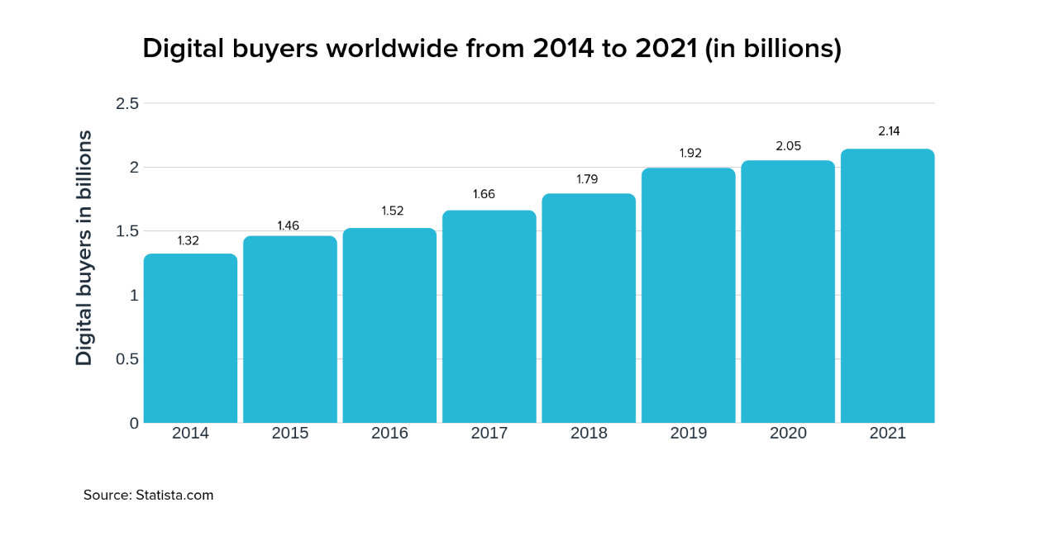 The large amount of people shopping online indicates that there is a great consuming demand for online stores. According to the graph, global digital buyers is growing annually, and the number will be still increase in the future. Under such circumstances, the project store faces a big market. According to a survey in 2018, 63 percent of shopping occasions begin online (Thinkwithgoogle, 2018). This means that no matter where customers are finally making the purchase decision, their customer journey starts online, showing the fact that the number of online shopping buyers is more than that of offline shopping buyers.
  - The Reasons Why Customers Choose the Project Store
For every business, the first thing they should think about is the reasons thy customers choose over your competitors. As for the project store, I will do the following things to attract customers.
The first is the price of our store provides. Price is considered the most efficient weapon of the organization (Bretcu, 2014). In the star-up period, the prices of our store products will not be set too high. The lower prices will attract more customers.
The second is the quality of the products. Product quality is the key element that brings value to the customer (Kotler and Armstrong, 2010). Only those companies with products which have high quality will they grow rapidly, and after a long period they will be more successful than others (Tamunu and Tumewu, 2014). The store will have a long relationship with three or four manufacturers in Alibaba who provides rather high-quality products.
The third thing excellent feedback of the store. In the beginning, I will ask some of my friends to buy products in my store. Then after they receive the parcels, they will give 5-star feedback to the products. The approach will increase the reputation of my store.
The style of our clothes and shoes can also be advantage. Targeting male and female between 18 to 35 years old. Our store provides fashion and beautiful clothes and shoes in style to customers.
Last but not least, what is most likely to be ignored are detailed descriptions for products. Our store will offer very clear descriptions for every product including the photos, size, material and transportations details to eliminate buyers’ concern for products.
- Environmental Analysis
Here the report will use strategic and analytic frameworks to analyse the development environment for the project store.
  - PESTLE Analysis
    - Political factors
Different countries have different rules and regulations for cross-border online trades. One of the common issues is from taxation rules. DHgate is a Chinese marketplace which sells products globally. As a cross-border business, the project store has to comfy with different rules and regulations of every country.
Taxation and tariff exert great influences on the prices of the products on DHgate. If the taxation of the targeting country is very, it will directly impact the price of our store.
The stability of a country can also have a chance to impact the revenue of online business (Onyusheva and Seenalasataporn, 2018). For example, all products will have to pass customs and product conformity procedures. So serious disruptions can be happened to cross-channel trade. This will prolong the waiting periods for customers to get their parcels. Under such circumstances, there will be a serious downturn in online shopping business to the UK.
    - Economic factors
Economic factors can be the most significant one in terms of business (Pratap, 2018). During the period of recession, purchasing power will decrease, which will have a direct impact on the profits and revenue of online business.
The rise and fall of exchange rate is another economic factor for cross-border online shopping business. For example, the price of a T-shirt is $10 and the cost of it is $6. The rise of dollars to RMB can be an advantage for our store in GHgate. Likewise, the fall of dollars to RMB can lead to the decrease of the profits of our store.
The rise of inflation rate of the targeting countries can affect our store’s pricing strategy for our products. In addition, it would affect the purchasing power of targeting consumer and change demand/supply models for that country. Other economic factors include inflation rate, interest rates economic growth patterns etc. also are likely impact the development of our business.
    - Social factors
Socio-cultural factors too have deep impact on the development of global online business. Most importantly e-retail brands find it the easiest to prosper locally. Growth in foreign markets can be full of challenges and difficulties (Pratap, 2018). The use of mobile phones and the coverage of network in that country can also have direct relationship with the flourish and failure of the online business.

2.1.4 Technological factors
Because online shopping business relies heavily on the development of technology, technological factors have great importance on our project store. From the payment pattern to the customer service, everything of the project store is base on the advanced technology. For example, online stores try to attract potential and actual buyers by targeting advertisements and shop decorations in the first page on their stores (Lee, 2013). This approach is achieved by the network technology.

2.1.5 Legal factors:
Legal factors are as important to the development of global e-commerce. Different countries have different e-commerce laws on matter for online business or offline one (Bribeck, 2017). So our online shopping store which sell product to different countries internationally should be careful about the laws and regulations on e-commerce of that country it sell to. False advertising, fraud, copyright infringement and others you can think of are illegal online. So, online shopping stores should also never break any laws even they don’t have real shops.

2.1.6 Environmental factors:
Because our online shopping store is operated on the website, basically direct environmental impact is very low and nearly zero. But the packaging waste in logistics can be a big problem.
  - SWOT analysis
    - Strength
- Boundary less (Awais and Samin, 2012). Our shopping store is operated online and sells products globally. There is no boundary for such no-real-store model.
- Time saving. Trend Line Fashion is an online shopping store in GHgate where Consumer can buy clothes and shoes anytime and anywhere without going out physically on purpose.
- Cost-effective. The online store reduces logistical problems and doesn’t need a physical store.
- Lower price. Trend Line Fashion has no rent costs or employee salaries, so the product prices are lower than those in physical stores.
- Faster buying procedure. The buying procedure can be finished rapidly just by a click from the buyer. There is no bargaining or no physical movement from the buyer or seller.
    - Weakness
- Long delivery time. Because our targeting main customers are European and American. So it takes long time to deliver parcels from China to those countries. From a customer’s perspective, long waiting for a parcel can be a terrible problem.
- Fewer discounts and bargaining. Usually the prices on online stores are fixed unless there is any discount day. Bargaining can be impossible.
- Security and fraud concerns. Buyers still have the worries about the online payment system.
- No idea about quality and physical condition of the product. Customers cannot touch or see the physical products before they receive them.
- Absence of communication. Because our targeting customers are European or American, there is time difference between buyers and the seller. In addition, unlike in physical stores, there will have few conversations between the seller and buyers. And the seller doesn’t introduce or promote the products when the buyer is making the purchasing decision.
    - Opportunities
- Growing market. Here is a graph showing the digital buyer penetration worldwide from 2016 to 2021 (Statista, 2019). From the graph we can know that, 58.3 percent of global internet users had online purchasing experience in 2016. In 2021, the number is expected to surpass 65 percent of internet users globally. With such growing trend, the e-commerce industry is set to evolve and expand.

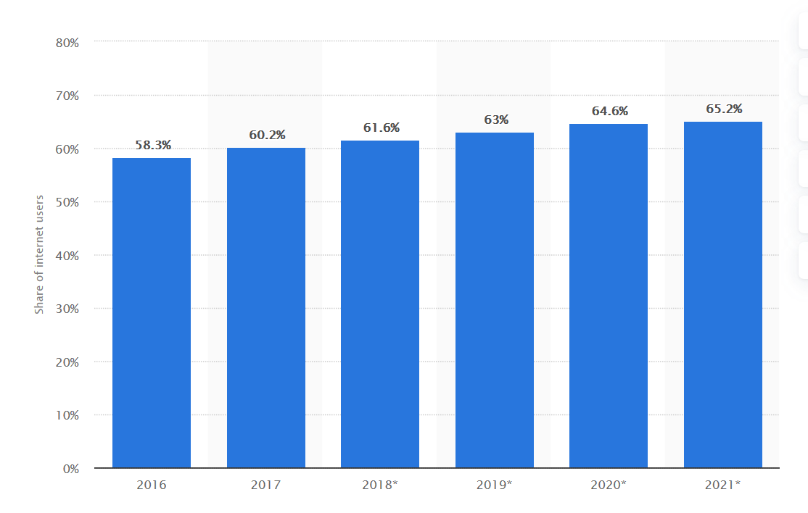
Source: Statista.com

- Big data technology. Using Big Data analytics could be an opportunity for online shopping business to better understand customer preferences.
- High availability. Online shopping stores are open 24 hours. With e-business, buyers can purchase products without travelling to a certain place. Customers can make a purchasing decision online anytime.
    - Threats
- Competitors. As for international e-business platforms, DHgate has many competitors such as ebay, Amazon, Alibaba. And in DHgate, there are plenty of stores. So competitors can be a big problem for Trend Line Fashion.
- Low barrier to entry. Its easy to set up an online business, leading to small market share for our store.
- Fraud. Persons using illegal means to operate online stores can damage the confidence and faith of common people.
- Government Regulations. Government regulations for online business are becoming more stringent, which will inadvertently increase the cost of products.
  - Stakeholder Analysis
As for the launch of the project, there are mainly four stakeholders, which namely are consumers, the launcher, the selling platform, the competitors and the supplying manufacturers.
- For Consumers: First, online shopping is effective, time-saving and convenient. Customers can shop anytime anywhere. Secondly, customers buy products at a lower price than that of physical stores.
- For the Launcher: Setting up an online store takes the launcher less cost. Online stores need no real inventory and display places. It’s free to sign up on the website and the selling platform. Competitive prices give launcher have higher incomes.
- For the selling platform: The project store is also a way of promoting itself. If the business has a good reputation, the project business will also attract more consumers buying the items that the platform offers.
- For the supplying manufacturers: The project provides the related manufactures another way of supplying their goods.
- Operational requirements
Trend Line Fashion Co., Ltd is an online shopping store which doesn’t need a physical place to display or store the products. Heavily relying on internet technology, our project business only needs some resources including time, cash, facilities. The business is operated online by the launcher. In the start-up period, in order to cut down the balance, the project doesn’t need employees. So the people resource is not included.
3.1 Time
Time: For a start-up business, it’s important to first do market research and then analyse the results, thus thinking up the project design. For starters, it takes a lot of time to come up with the whole project design before it gets implemented. The first open day for the store will be on 13 April 2020, the day after Easter Day for promoting the store and its products. Before the store is officially opened, it needs about 3 months and at least one month to implement the project design. Here, I will give a detailed timeline for every step.
Step 1: Do a market research. In this step, I will collect all the research data from the Internet like the existed questionnaires or the website data and review all the information and work experiences that I gained from the last part-time job during the summer. Then analyse those research result. It will take about 1 month during January to February 2020. In this step, no cost will be needed.
Step 2: Make a business plan. Think up a blueprint that will guide the business from the start-up phase through establishment and eventually business growth. It involves the business name, the business location and financial support, etc. It will take at least one month from February to March.
Step 3: Plan the business finance. It concludes licences and permits, equipment, market research, marketing and advertising and my own money. It will take a week during March.
Step 4: Get licences and permits. In this step, I will research what license and permits apply to my business during the start-up process. It takes about 1 month from March to April.
Step 5: Promote the business. Cause it’s an online shop targeting young western people, so I will make an advertisement video on Youtube, Instagram, Facebook. Promotion will always be a part of the business project especially at the beginning of the starting period. There will be different ways of promotion at different time of the project development.
  - Facilities
Because the project is an online shopping store, the facilities it will need include a laptop and a printer to sell items online and printing logistics label. In additions, it will also need packing supplies like parcel wrappings. All the technology facilities will get from Taobao – the biggest Chinese online shopping website.
  - Cash
In the project store, costs include website advertisements in step 2 of the timeline and asking my friends to buy what the store sells and give excellent feedbacks. Other cost goes to purchasing technology equipment like a computer and a printer. Also, the cost for packing supplies will be included.
- Financial Projections
To assess the costs for the online shopping store, I will give a budget chart to show the costs for each aspect.
Budget
Advertisement | $2000
Product feedbacks | $1430
Computer | $4000
Printer | $1000
Packing supplies | $50
Total | $8480
As for advertisement, it will include costs for DHgate platform so that our store can have a higher presence frequency. If customers see our store a lot of times while scrolling the product pages, our store will have higher chances to sell the products customers need. The store will also put advertisements on social media website like Instagram, Facebook, Google, YouTube, etc. All the promotion budget will cost approximately $1000.
As for product feedbacks, the costs include the commission for my friends and the logistics cost for each product. The commission of each product is $4. Here is a chart
For international logistics.
International epacket charge standard
Zone | Country | Freight (RMB/G) | Registration
America | The US | 0.069 | 10
Europe | The UK | 0.06 | 17
Europe | Spain | 0.06 | 14
Europe | Italy | 0.06 | 25
Europe | France | 0.06 | 19
Europe | Germany | 0.06 | 19
Europe | Swiss | 0.06 | 25
Europe | Norway | 0.065 | 19
Source: ems.com

As the chart shows, if I plan to send 300 products to those countries, the approximate costs will be 1600RMB, which will be around $230. So the total costs including commission will be around $1430.
Other facilities including a computer and a printer as well as packing supplies will come from Taobao.
As for the projected income, it will be decided by the product number the store sells. In the first quarter of the operating period, I plan to make profits of $3 for each product. Because the international freight cost is quite high, so the minimum number for each order is 8. In the first month, the expected transactions will be quite small, which is around 50. So the revenue will be $150. In the next month, the transactions will get increase, around100. The revenue in the second month will be $300. After 3 months when the transaction number is increased and the store reputation gets higher, the profits for each product will be $3.5. According to this trend, the first annual income will be approximately $7200. As analysed before, the total budget costs will be$8480. So it will take around one year and another 3 months to realise a break even on costs.
- Recommendations and Findings
Trend Line Fashion Co., Ltd is one of the stores in the rapidly changed e-commerce industry. If the project can be implemented successfully, here are some recommendations and findings for thousands of online stores.
  - Recommendations
Because the barrier to entry the DHgate market and the big market share for online shopping, and the project will break even on costs after a year and a half, the projects should go forward. In addition, if the project is operated appropriately, the number of transactions will be larger and larger, the time to reach the break-even is shorter.
5.2 Findings
The project store heavily relies on the development of technology, so the launcher should always keep an eye on the changes of Internet technology. For this, the launcher be flexible for the adjustment of information and communication technology, merging information and communications into every aspect of the store operation.
Besides the changes on technology, the project store should always comfy to laws and regulations of different countries. Different countries have different laws and regulations for global e-commerce. If the project is implemented successfully, when selling products to the targeting country, the launcher should be aware of every detail of trading laws and rules.
The third finding is build loyalty between customers and the store. In a world where competitors are only a click away, building customer-loyalty becomes an essential aspect of business strategy (Bossenbroek and Gringhuis, 2015). The launcher can improve loyalty by creating a value-added relationship between the site and the customer. Every time when there is a customer visits the store, the store should learn know the customer’s browse history and learn his/her preferences.
Fourth, if the store is operated successful, the launcher should increase the investment for advertising. Adverting can help to raise awareness of a product or service, generate leads for a sales force or selling directly and increase the reputation for the products (Lonton). If promoted properly by advertisements, the store will higher chances to sell products.
Fifth, invest more money to expand the library contents of clothes and shoes and the decoration of the store. Customers will be more trust those big stores with a number of products to choose from.
Most importantly, create an independent store website. Now the store is operated on DHgate which has millions of competitive stores. If the store embraces a great success, the launcher can create an independent website, thus paying no platform commission for DHgate.

References
Awais M, Samin T. Advanced SWOT Analysis of E-commerce[J]. International Journal of Computer Science Issues (IJCSI), 2012, 9(2): 569.
Ardison, E. (n.d.) The Internet’s Influence on Retail. Available at: https://smallbusiness.chron.com/internets-influence-retail-26824.html (Accessed: 30 October 2019)
Bossenbroek, H and Gringhuis, H. (2015) Recommendation in E-commerce. Available at: https://www.luminis.eu/wp-content/uploads/2015/08/White-Paper-Recommendation-in-e-commerce.pdf
Bretcu, A. (2014) ‘MARKETING CONTROLLING AND PRICE POLICY FOR SMEs’, Analele Universitatii ‘Eftimie Murgu’ Resita. Fascicola II. Studii Economice, pp. 34-41.
Bribeck, M(2017) 4 Legal Considerations for E-commerce Business) Available at: https://minutehack.com/guides/4-legal-considerations-for-ecommerce-businesses (Accessed: 30 Nctober 2019)
Chen J, Xie X, Jing F. The security of shopping online[C]//Proceedings of 2011 International Conference on Electronic & Mechanical Engineering and Information Technology. IEEE, 2011, 9: 4693-4696.
Chitrakorn, K. (2018) Technologies Transforming retail in 2018[J]. The Business of Fashion, 5.
DHgate, 2019. Basic Document – Dhgate Open Platform Available at: https://open.dhgate.com/docs/getting-started (Accessed: 10 Dctober 2019)

Hufford, J. (2019) The Top Advantage of 3Commerce: Why you Should Sell Online. Available at: https://www.nchannel.com/blog/advantages-of-ecommerce/. (Accessed: 19 November 2019)
Kotler, P. and Armstrong, G. (2010) Principles of Marketing. Pennsylvanis State University. Prentice Hall, Pennsylvania.
Laudon K C, Traver C G. E-commerce: business, technology, society[M]. 2016.
Onyusheva I, Seenalasataporn T. STRATEGIC ANALYSIS OF GLOBAL E-COMMERCE AND DIVERSIFICATION TECHNOLOGY: THE CASE OF AMAZON. COM INC[J]. The EUrASEANs: journal on global socio-economic dynamics, 2018 (1 (8)): 48-63.
Linton, L(n.d.) How Do Companies Use Advertisements. Available at: https://smallbusiness.chron.com/companies-use-advertisements-37711.html
Pratap, A. (2018) Pestle Analysis of the E-commerce Industry. Available at: https://notesmatic.com/2017/11/pestel-analysis-e-commerce-industry/ (Accessed: 25 November 2019)
Shergill G S, Chen Z. WEB-BASED SHOPPING: CONSUMERS'ATTITUDES TOWARDS ONLINE SHOPPING IN NEW ZEALAND[J]. Journal of electronic commerce research, 2005, 6(2): 78.
Statista (2019) Market forecast for eService in the World through 2023. Available at: https://www.statista.com/outlook/261/100/eservices/worldwide (Accessed: 1 January 2019)
Williamson, W. (2013) Why You Should Sell Online: 7 Benefits of Ecommerce Websites. Available at: https://blog.jdrgroup.co.uk/digital-prosperity-blog/ecommerce-website-benefits (Accessed: 20 November 2019)
Statista, 2019. Number of digital buyers worldwide from 2014 to 2021. Available at:
https://www.statista.com/statistics/251666/number-of-digital-buyers-worldwide
Statista (2019) Digital Buyer Penetration Worldwide From 2016 to 2021. https://www.statista.com/statistics/261676/digital-buyer-penetration-worldwide/
Thinkwithgoogle, 2018. How Search Enables People to Create a Unique Path to Purchase. Available at: https://www.thinkwithgoole.com/feature/path-to-purchase-search-behavior/ (Accessed: 29 December 2019)
Tamunu M, Tumewu F. Analyzing The Influence Of Price And Product Quality On Buying Decision Honda Matic Motorcyles In Manado[J]. Jurnal EMBA: Jurnal Riset Ekonomi, Manajemen, Bisnis dan Akuntansi, 2014, 2(3).
Lee, I. Trends in E-business, E-services, and E-commerce: Impact of technology on goods, services, and business transactions: Impact of technology on goods, services, and business transactions[M]. IGI Global, 2013.
Wolfinbarger M, Gilly M. Consumer motivations for online shopping[J]. AMCIS 2000 proceeding, 2000: 112.

