Level 4 Assessment
Computer Architecture and Networks
Module ACCD4001

Donna Kennett

Contents
- Lab: Building a Simple Network
- Lab: Building a Switch and Router Network
- Lab: IPv4, Subnetting, VLSM and IPv6 Addressing
- Lab: Securing and Accessing Network Devices with SSH
- Lab: Understanding Ethernet Cable
- References
- Bibliography

- Lab: Building a Simple Network
Record the interface status for the following interfaces
Interface | S1 |  | S2
Interface | Status | Protocol | Status | Protocol
F0/1 | Up | Up | Up | Up
F0/6 | Up | Up | Down | Down
F0/18 | Down | Down | Up | Up
VLAN 1 | Administratively Down | Down | Administratively Down | Down

Reflection
I learnt it was important to use the correct cable instead of the automatic cable connection on Packet Tracer. I enjoyed doing the lab but I found using Packet Tracer a lot easier than the real equipment. I think the more practice I get with the real equipment the more confident I will become.
It is important to erase the startup-configuration files before making any configuration changes. By deleting any previous configurations and return them to its basic configuration after reloading. This ensures only the new configurations are set which makes troubleshooting easier.
It is also important not to enable the initial configuration dialogue or save the running configuration when prompted so that the switch is saved correctly for the next student.
The pings were successful. However, incorrect IP address, firewall, incorrect configurations or switches powered off could prevent a ping from being sent between the two PC’s.

- Lab - Building a Switch and Router Network
Answers
- Ping PC-B from a command prompt window on PC-A. Why were the pings not successful? The request timed out.

- Ping PC-B from a command prompt window on PC-A. Were the pings successful? Why? The pings were successful this time because the router is routing the ping packets across the network.
- What is the name of the IOS image that the router is running? IOS Software, C1900 Software (C1900-UNIVERSALK9-M), Version 15.2(4)M3
- How much DRAM memory does the router have? 512MB
- How much NVRAM memory does the router have? 255K bytes
- How much Flash memory does the router have? 250880K bytes
- What is the name of the IOS image that the switch is running? IOS Software, C2960 Software (C2960-LANBASEK9-M), Version 15.0(2)SE
- How much dynamic random access memory (DRAM) does the switch have? 65536K
- How much nonvolatile random-access memory (NVRAM) does the switch have? 64K bytes.
- What is the model number of the switch? WS-C2960-24TT-L.
- What code is used in the routing table to indicate a directly connected network? C
- How many route entries are coded with a C code in the routing table? 2
- What interface types are associated to the C coded routes? G0/0 and G0/1.
- What is the operational status of the G0/1 interface? GigabitEthernet0/1 is up, line protocol is up
- What is the Media Access Control (MAC) address of the G0/1 interface? fc99.4775.c3e1
- How is the Internet address displayed in this command? Internet address is 192.168.1.1/24.

Reflection
- If the G0/1 interface showed administratively down, what interface configuration command would you use to turn the interface up? R1(config-if)# no shut
- What would happen if you had incorrectly configured interface G0/1 on the router with an IP address of 192.168.1.2? PC-A would not be able to ping PC-B. As PC-A and PC-B are on different networks the default-gateway router is used to route these packets. If you configured the router incorrectly the traffic would not reach its destination.
- Explain the operation of a Router and a Switch.
A Layer 2 switch is a layer 2 (OSI model) device that connects networked devices such as clients/nodes and servers. Its function is to allow connections to multiple devices, manage ports and VLAN security settings.

These switches use content accessible memory (CAM) tables and forwards traffic based on the device’s MAC address.

A layer 3 switch is a layer 3 (OSI model) device which has combines some functions of a layer 2 switch and some of a router. These switches use a MAC address table and an IP routing.
Switches transmits data in the form of frames at speeds of 10/100 Mbps for Gigabit Ethernet and speed up to 1 Gigabit with multigigabit technology [1]. Switches normally have one broadcast domain (unless VLAN implemented).
There are several different types of network switches [2]:
- LAN switch. Local Area Network (LAN) switches. These are also known as a data switch or Ethernet switch
- Unmanaged switch – plug and play device used in SOHO networks
- Managed switch – advanced features controlled by an administrator
- Smart switch – type of managed switch usually used for VLANS
- Power over Ethernet (PoE) Gigabit Switch – also supports power and data transmission over the network cable
- Stackable Switch – several switches function as one switch with a single agent, Spanning Tree domain and CLI.
A router is a layer 3 (OSI model) device that connects two or more networks together and forwards traffic based on its IP address. Its function is to direct data in a network. Routers can also perform network address translation (NAT), which allows all devices on a subnetwork to share the same public IP address, keeping private IP addresses hidden from the Internet.
There are typically two types of routers: commercial routers which are more powerful than consumer routers and are used in businesses, hospitals and universities as part of a wide area network (WAN). Consumer routers are suitable for SOHO networks and also act as a wireless access point (WAP) [3].
Routers use Routing Tables and forwards traffic based on the device’s IP address using broadcast then unicast and multicast as needed. Routers transmits data in the form of packets at speed of 1-100 Mbps (for wireless) and 100 Mbps - 1 Gbps (for wired).

- Lab: IPv4, Subnetting, VLSM and IPv6 Addressing
Features of IPv6
Internet Protocol version 6 (IPv6) was developed by the Internet Engineering Task Force (IETF) as a replacement to Internet Protocol version 4(IPv4) [4]. The first IPv6 specification was published in 1995 as RFC 1883[4], it formally became a full standard in 2017 as RFC 8200 (STD 86) [4].
IPv6 uses 128-bit addresses as opposed to the 32-bit addresses used by IPv4. This provides a significantly larger number of possible addresses. As each bit corresponds to a ‘0’ or a ‘1’, this allows for approximately 2^128 combinations or 340 undecillion addresses. IPv4 permits 2^32 combinations for approximately 4.2 billion addresses.
An IPv6 address is made up of 8 groups of 16-bit numbers separated by colons [5] each number is written as 4 hexadecimal (hex) digits. IPv6 addresses range from:
0000:0000:0000:0000:0000:0000:0000:0000
to
FFFF:FFFF:FFFF:FFFF:FFFF:FFFF:FFFF:FFFF
When writing an IPv6 address there are a number of shortcuts. You can omit any leading zeros in each group of four hex digits. If all four digits are zero you can just write one. For example
3436:0000:0000:0000:0004:0400:201C:322B becomes 3436:0:0:0:4:400:201C:322B
You can also replace one sequence of single zeros and colons with a double colon. For example
3436:0:0:0:4:400:201C:322B becomes 3436::4:400:201C:322B
IPv6 reserves a number of addresses for special purposes. This includes:
Loopback address: The loopback address is 0:0:0:0:0:0:0:1 (or ::1) this is used by the system to send a message to itself for testing.
Site-Local address: Site-local addresses begin with FEC0 and are used within an organisations intranet and cannot be routed on the Internet.
Link-local address: Link-local addresses begin with FE80. These are designed for use on a single network and allow communication with neighbouring systems without needing a router.
Unspecified address: The unspecified address is 0:0:0:0:0:0:0:0 (or ::) and is used by a system to send a packet for broadcasting or DHCP client requests. It cannot be used as a destination address.
IPv6 addressing architecture is defined in RFC4291 [6] and allows the following address types:

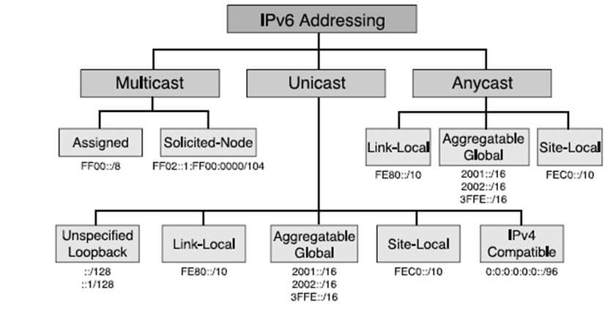
Fig 1: IPv6 Address Types [7]
IPv6 packets are made up of a header and a payload. The IPv6 header has a length of 40-bytes. Minimum packet size is 1280 bytes, from 40 bytes of header plus 1240 bytes of payload [8]. IPv6 headers only have 5 fields compared with IPv4’s 12 fields.
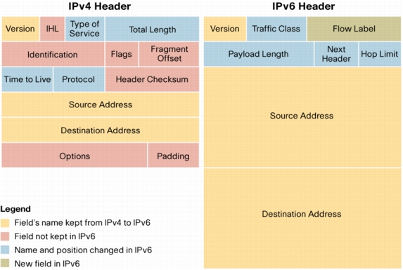
Fig 2: IPv4 and IPv6 header comparison [9]

The header consists of a fixed portion with minimal functionality required for all packets and may be followed by optional extensions to implement special features.
The fixed header takes up the first 40 octets (320 bits) of the IPv6 packet. It contains the source and destination addresses which take up 128 bits each, traffic classification options, a hop counter, and the type of the optional extension or payload.
This ‘Next Header’ field tells the receiver how to interpret the data and is used to define authentication and encryption capabilities.
Extension headers are required in the following order [8]:
- 000 Hop-by-hop. Packet is examined by every device it passes through until it reaches its destination.
- 043 Routing header. List of devices which need to be visited.
- 044 Fragment header. Used when packet is too big.
- 050 Encapsulated security payload. Part of IPSec.
- 051 Authentication header. Part of IPSec.
- 060 Destination options. Processed by routers along the path.
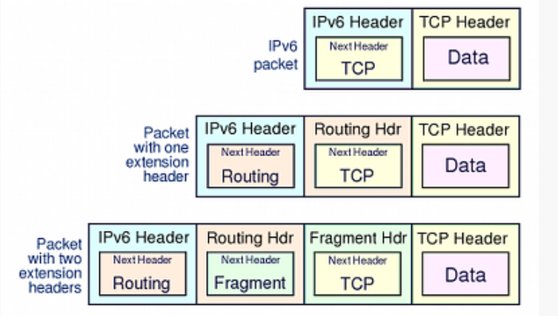
Fig 3: (top row) with a TCP header and data payload. The second row shows the packet with an additional Routing header, third row has Routing and Fragment headers [8]

IPv6 uses three data flow methods which are defined in “IP Version 6 Addressing Architecture (RFC4291) [10].
Unicast – data travels from a single source device to a single destination device.
Multicast – data travels from a single source device to multiple (but specific) destination devices.
Anycast – this is new for IPv6, data travels from a single host device to the device nearest to multiple (but specific) destination devices. Designed to let one host update router tables for a group of hosts. That host can anycast to another host in the group until all routing tables are updated.
Cryptographic based security, also known as IPsec was built into IPv6 and is defined in RFC8221 [11]. This is carried out by the following two new headers which can be used separately or together along with security key exchange:
Authentication Header (AH) provides integrity, data-origin authentication and protection against replay attacks using an Integrity Check Value (ICV) which is calculated over the entire packet. AH does not provide privacy and confidentiality of packet contents.
Encapsulating Security Payload (ESP) also provides integrity, data-origin authentication and protection against replay attacks. ESP also limited traffic flow confidentiality, but also provides confidentiality by encrypting the payload.
IPsec can operate using Transport mode (host-to-host) using the original IPv6 header or by Tunnel mode (gateway-to-gateway or gateway-to-host) which used a new IPv6 header which encapsulates the AH or ESP header and the original packet [12].
IPv6 supports two different auto configuration techniques [13]. Stateless auto configuration with allows systems to generate their own IPv6 address, and stateful auto-configuration which uses DHCPv6 to request an IPv6 address from a nearby DHCPv6 server
IPv6 Neighbour discovery (ND) replaces Address Resolution Protocol (ARP) and Internet Control Message Protocol (ICMP) used by IPv4 [14].
Internet Protocol version 6 (IPv6) Neighbour Discovery (ND) is a new protocol which determines relationships between neighbouring devices (defined in RFC4861) [15]. ND replaces the Address Resolution Protocol (ARP) and the Internet Control Message Protocol (ICMP) used by IPv4.
In addition to IPsec IPv6 provides a number of benefits including no broadcast address [5] as this is too resource intensive. It can also be used with IPv4 during transmission using dual stacking [16].
IPv6 adoption has been slow but is now at its highest level reaching nearly 30% at the beginning of this month.
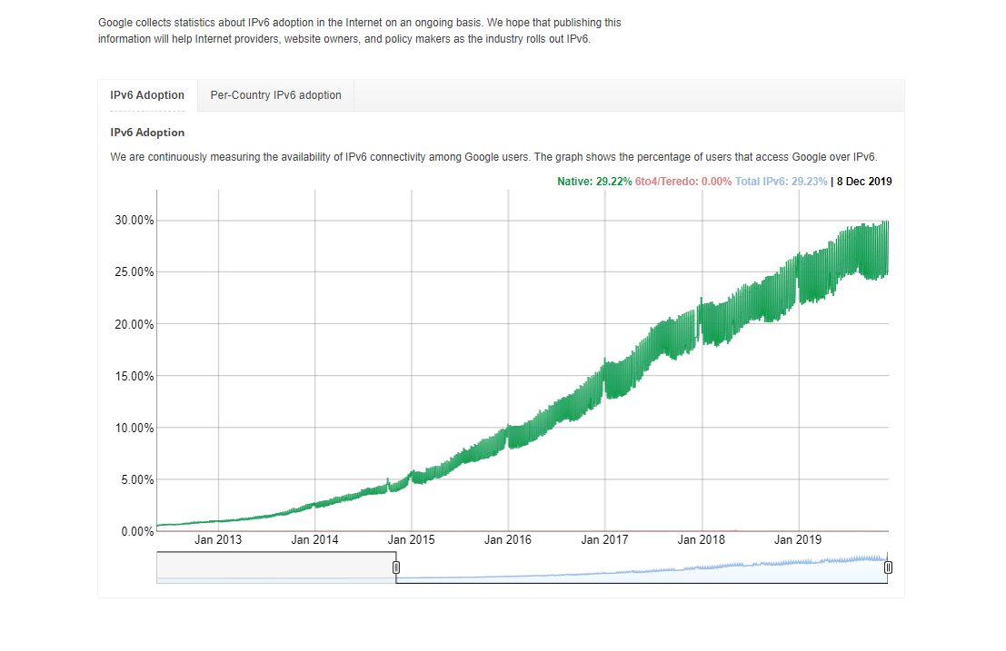
Fig 4: Google statistics showing the raise in IPv6 adoption since 2013 [17]

Subnetting and VLSM

Subnet | Network Address | Subnet mask | First Address | Last Address | Broadcast Address
B | 172.16.2.0 | 255.255.248.0 | 172.16.2.1 | 172.16.9.254 | 172.16.9.255
D | 172.16.10.0 | 255.255.254.0 | 172.16.10.1 | 172.16.11.254 | 172.16.11.255
F | 172.16.12.0 | 255.255.255.0 | 172.16.12.1 | 172.16.12.254 | 172.16.12.255
E | 172.16.13.0 | 255.255.255.192 | 172.16.13.1 | 172.16.13.62 | 172.16.13.63
A | 172.16.13.64 | 255.255.255.224 | 172.16.13.65 | 172.16.13.94 | 172.16.13.95
C | 172.16.13.96 | 255.255.255.248 | 172.16.13.97 | 172.17.13.102 | 172.16.13.103

- Lab - Accessing Network Devices with SSH
Answers
- The following command impedes brute force login attempts. The router blocks login attempts for 30 seconds if someone fails two attempts within 120 seconds. This timer is set especially low for the purpose of this lab. R1(config)# login block-for 30 attempts 2 within 120. What does the 2 within 120 mean in the above command? Access will be blocked if two failed authentication attempts are made within 120 seconds.
- What does the block-for 30 mean in the above command? If access blocked the device will wait 30 seconds before login access can be tried again.
- Does R1 accept the Telnet connection? Explain. The connection was refused. Telnet was disabled with the transport input ssh command.
- Does R1 accept the SSH connection? Yes
- Intentionally mistype the user and password information to see if login access is blocked after two attempts.
- What happened after you failed to login the second time? You have to wait 30 seconds before you can try again.
- After the 30 seconds has expired, SSH to R1 again and login using the SSHadmin username and Admin1p@55 for the password.
- After you successfully logged in, what was displayed? The R1 login banner.
- Enter privileged EXEC mode and use Enablep@55 for the password.
- If you mistype this password, are you disconnected from your SSH session after two failed attempts within 120 seconds? Explain. No I was not disconnected because this wasn’t set up. The login block-for 30 attempts 2 within 120 command was only set up to for normal session authentication attempts.
- Are you able to establish an SSH session with the switch? Yes. I used the same commands on the switch that I used on the router.
- What versions of SSH are supported from the CLI? Versions 1 and 2.
- How would you provide multiple users, each with their own username, access to a network device? I would add each user’s username and password to a local database.

Reflection – Research report comparing AES and DES
Cryptography is the practice and study of writing and solving codes in order to hide the true meaning of the information [18].
Encryption is the process of changing ordinary information (plaintext) into an indecipherable form (cipher text). Encryption strength comes from the key not the algorithm [19].
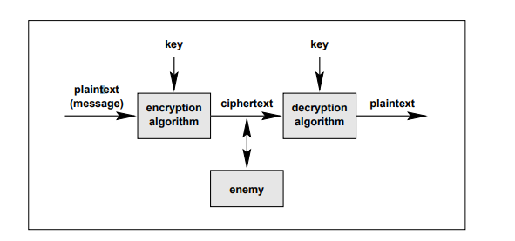
Fig 5: Basic cryptosystem layout [20]

There are two types of encryption – Symmetric (private key) and Asymmetric (public key). Symmetric encryption uses the same secret key to encrypt and decrypt the data. Asymmetric encryption uses different keys to encrypt and decrypt the data.
A block cipher breaks the input into fixed-length blocks of data and encrypts each block. A stream cipher encrypts data bit by bit [21].
Data Encryption Standard (DES) and Advanced Encryption Standard (AES) are both examples of symmetric block ciphers [22].

DES
Working with National Security Agency, the National Bureau of Standards released DES in 1997. DES is based on the IBM’s Lucifer algorithm [23] .
DES was the main encryption standard until the key was eventually cracked nearly 20 years later by the Electronic Freedom Foundation in 56 hours in 1998 [24].
DES uses 64-bit blocks and uses transposition and substitution to create cipher text using a 56 bit key. DES used to be the main standard for encryption but was replaced with Triple DES (3DES). 3DES uses three separate symmetric keys to encrypt, decrypt and then encrypt the plaintext into a cipher text in order to increase the strength of DES.

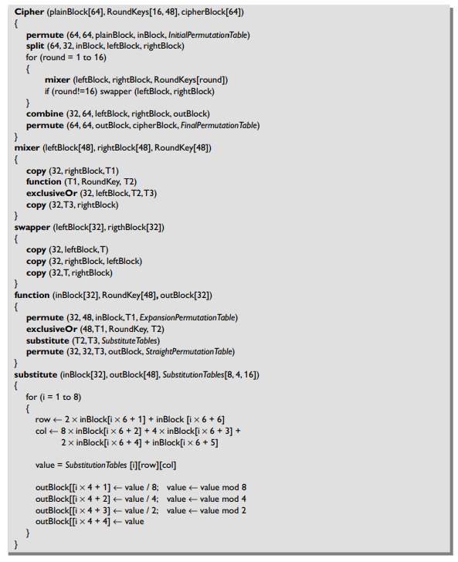
Fig 6: Pseudocode for DES cipher [25]

DES is vulnerable to brute force, differential crypto analysis, linear crypto analysis and the Improved Davies’ attack [26].

AES
AES is based on the Rijndael algorithm, created by Joan Daemen and Vincent Rijmen.
AES was published in 2001 by the National Institute of Standards and Technology (NIST) following a competition to find a replacement to DES [24].
AES is a substitution permutation network (SPN) block cipher algorithm which uses 128-bit (and ten rounds of encryption), 192-bit (12 rounds of encryption) or 256-bit (14 rounds of encryption) keys to encrypt 128-bit blocks of data.

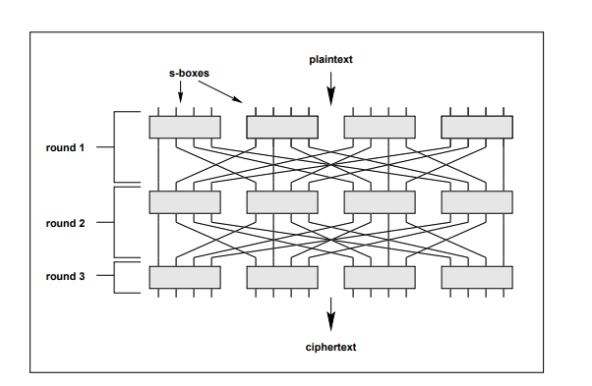
Fig 7: SPN example [20]

The algorithm takes a block of plain text and applies alternating rounds of substitution and permutation to it. The encryption key is generated during this process.

'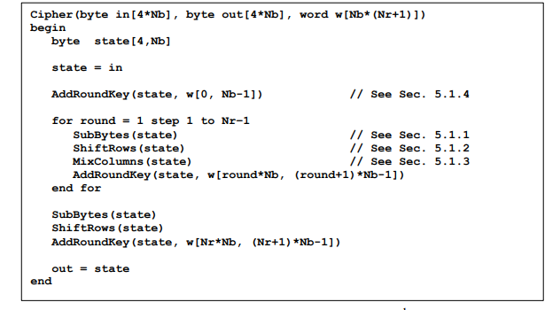

Fig 8: Pseudo code for AES cipher [27].

AES has four functions: SubBytes, ShiftRows, MixColumns and AddRound Key which provide confusion, diffusion and XOR encryption.

Comparison
In DES the data block is divided into two before being processed. In AES the whole data block is processed.
DES works on the Fiestel cipher while AES work on the substitution and permutation principle

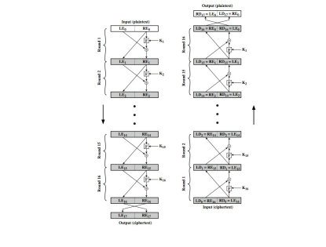
Fig 9: Fiestel Cipher Structure [28]

The plaintext block for DES is limited to 64 bits but AES supports 128, 192 and 256 bits.
DES has shorter and weaker encryption key size compared with AES. At 50 billion keys/second it would take 5105 years to check all possible key combinations for AES-128. However, 3DES with a 56 bit key would only take 400 days.
DES undergoes 16 rounds. AES-128 undergoes 10 rounds, AES-192 undergoes 12 rounds and AES-256 undergoes 14 rounds.
3DES encryption takes longer than DES and AES because of the repeating steps.
AES is a more advanced algorithm which is faster and more secure than DES.

- Lab - Understanding Ethernet Cable
Reflection: Write a research report (Max word count 600) on Cat 5e and 6 Ethernet cable standards.
Ethernet, developed by the Electrical and Electronic Engineers Institute, IEEE Standard 802, is the most popular LAN (local area network) technology used today [29].
In 1991, the TIA (Telecommunications Industry Association) and the EIA (Electronic Industries Association) published the ANSI/TIA-568 standard to support a uniform Ethernet cabling system for multivendor products and environments. [1]
ANSI/TIA-568 standard sets minimum requirements for unshielded twisted pair cables.
Part of the 568 standard is the 568A and 568B wiring schemes which specify pin and pair assignments, and UTP cable terminations. Each wiring pair corresponds to an assigned colour. There is no functional difference between 568A and 568b. The only difference is the position of the green and orange wires in the straight-through and crossover cables.
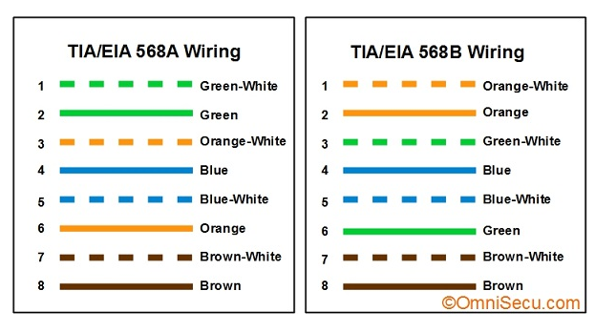
Fig 10: TIA/EIA 568A & TIA/EIA 568B wiring standards [30]
If the RJ45 jacks at both ends of a patch cable with the same TIA568 standard (for example both 568A or both 568B) it is a straight through cable.
If the RJ45 jacks at both ends of the patch cable with different TIA568 standards (for example one 568A and one 568b) it is a crossover cable.
Unshielded Twisted Pair (UTP) Ethernet cables have no shielding, instead they are twisted together to cancel out electromagnetic interference (EMI) from external sources and crosstalk between neighbouring pairs. The advantage of twisting is that all wires are equally affected by external influences, the higher the number of twists the more EMI is blocked [31]
Crosstalk is the electrical interference that results when one wire's signal affects another wire's signal. CAT 5e cable has been improved over CAT 5 cable in this respect, and crosstalk has been greatly reduced.
UTP cables can support a distances of up to 100 meters without signal distortion.
There are different categories of UTP cables which are each designed for a different communication or transfer rates.
Cat 5e and Cat 6 are the most popular types in use today and can reach transfer rates of over 1000Mbps (1 Gbps) which is normally more than sufficient for the speed of most internet connections [32].

Cat 5e
Cat 5e, also known as Category 5e or Category 5 Enhanced, is a network cable standard introduced as an improvement to Cat5. It was first approved in 1999 and last revised in 2001 [33].
Cat 5e can reach speeds up to 10 faster that Cat 5 and able to travel further distances without signal distortion or crosstalk
CAT5e cables are typically 24-gauge twisted pair wires, which can be used for 100Base-T and 1000Base-t Gigabit Ethernet networks at segment distances up to 100 m.
Crosstalk is the electrical interference that results when one wire's signal affects another wire's signal. CAT 5e cable suffers less crosstalk than Cat5.

Cat 6
Cat6, also known as Category 6 was introduced in and provides a significant improvement in performance of Cat 5e. During manufacture Cat6 cables are wound more tightly than Cat 5e cables and often have an outer foil or braided shielding. The Cat6 cables generally have 2+ twists per cm and some include a nylon spline to reduce crosstalk [33].
Cat 6 cables are often thicker than Cat 5e due to the thicker copper wires used in production.
CAT6 features more stringent specifications for crosstalk and system noise. CAT6 provide significantly lower interference or Near-End Crosstalk (NEXT) in the transmission compared to CAT5e, it also improves Equal-Level Far-End Crosstalk (ELFEXT), Return Loss (RL) and Insertion Loss (IL). This produces less system noise, fewer errors and higher data transmission rates [34].

Comparison
The main difference between CAT5e and CAT6 cable is the size of bandwidth the cable can support for data transfer. CAT6 cables are designed for operating frequencies up to 250 MHz, compared to 100 MHz for CAT5e. This allows CAT6 cables to process more data at the same time. Due to this Cat 6 tends to be more expensive that Cat 5e cables.
Reflection
Which part of making cables did you find the most difficult?
I found holding the wires in the correct order while pushing them into the RJ45 plug connector the most difficult.
Why do you have to learn how to make a cable if you can easily buy pre-made cables?
It is sometimes cheaper to make your own cable if you need a special number or length.

References

[1] |  |  |  |  |  | Cisco, “What is a switch vs. a router?,” [Online]. Available: https://www.cisco.com/c/en/us/solutions/small-business/resource-center/networking/network-switch-what.html. [Accessed 3 November 2019].
[2] |  |  |  |  |  | Cisco, “Different types of network and Ethernet switches,” [Online]. Available: https://www.cisco.com/c/en/us/solutions/small-business/resource-center/networking/understanding-the-different-types-of-network-switches.html#~what-to-consider. [Accessed 4 November 2019].
[3] |  |  |  |  |  | “Routers, To See Different Types of Routers,” 20 June 2011. [Online]. Available: ciscorouterswitch.over-blog.com/article-routers-to-see-different-types-of-routers-77257064.html. [Accessed November 4 2019].
[4] |  |  |  |  |  | S. K. Bob Hinden, “IPv6 is an Internet Standard,” IETF, 17 October 2018. [Online]. Available: https://www.ietf.org/blog/ipv6-internet-standard/. [Accessed 1 November 2019].
[5] |  |  |  |  |  | “IPv6 Basics,” Cisco, [Online]. Available: https://www.cisco.com/c/en/us/td/docs/voice_ip_comm/uc_system/IPv6/vtgs_b_ipv6-deployment-guide-for-cisco/vtgs_b_ipv6-deployment-guide-for-cisco_chapter_01.pdf . [Accessed 1 November 2019].
[6] |  |  |  |  |  | B. Haberman, Unicast-Prefix-based IPv6 Multicast Addresses, The Internet Society, 2002.
[7] |  |  |  |  |  | S. Tech, “Types of IPv6 Addresses,” CCNA academy, 9 January 2019. [Online]. Available: https://www.ccnaacademy.com/2019/01/types-of-ipv6-addresses.html. [Accessed November 1 2019].
[8] |  |  |  |  |  | “IPv6 Packet Security,” [Online]. Available: http://www.ipv6now.com.au/primers/IPv6PacketSecurity.php. [Accessed 3 November 2019].
[9] |  |  |  |  |  | “IPv6 Extension Headers Review and Considerations,” Cisco, 2006.
[10] |  |  |  |  |  | R. Hinden, “IP Version 6 Addressing Architecture,” The Internet Society, 2006.
[11] |  |  |  |  |  | P. Wouters, “Cryptographic Algorithm Implementation Requirements and Usage Guidance,” IETF, 2017.
[12] |  |  |  |  |  | IBM, “Transport mode and tunnel mode,” [Online]. Available: https://www.ibm.com/support/knowledgecenter/en/SSLTBW_2.1.0/com.ibm.zos.v2r1.halz002/ipsecurity_ipsec_ah_esp_encap_modes.htm. [Accessed 4 November 2019].
[13] |  |  |  |  |  | IPv6 Stateless Address Autoconfiguration, The Internet Society, 1998.
[14] |  |  |  |  |  | Cisco, IPv6 Neighbor Discovery.
[15] |  |  |  |  |  | T. Nartren, “Neighbor Discovery for IP version 6 (IPv6),” September 2007. [Online]. Available: https://tools.ietf.org/html/rfc4861.
[16] |  |  |  |  |  | Cisco, “Dual Stack Network,” [Online]. Available: https://www.cisco.com/c/dam/en_us/solutions/industries/docs/gov/IPV6at_a_glance_c45-625859.pdf.
[17] |  |  |  |  |  | “Google IPv6 Statistics,” [Online]. Available: https://www.google.com/intl/en/ipv6/statistics.html. [Accessed 9 December 2019].
[18] |  |  |  |  |  | “cryptography,” [Online]. Available: https://dictionary.cambridge.org/dictionary/english/cryptography.
[19] |  |  |  |  |  | “Kerckhoffs's principle,” [Online]. Available: http://www.crypto-it.net/eng/theory/kerckhoffs.html.
[20] |  |  |  |  |  | L. Kelhier, “Substitution-Permutation Network Cryptosystems Using Key Dependent S-Boxes,” Queen's University, Kingston, 1997.
[21] |  |  |  |  |  | A. Biryukov, “Block Ciphers and Stream Ciphers: The State of the Art,” Katholieke University, Leuven.
[22] |  |  |  |  |  | N. Aleisa, “A comparison of the 3DES and AES encryption standards,” International Journal of Security and its Applications, vol. 9, no. 7, pp. 241-246, 2015.
[23] |  |  |  |  |  | J. O. Grabbe, “The DES Algorithm Illustrated,” Laissez Faire City Times.
[24] |  |  |  |  |  | “The History of Encryption,” 4 May 2012. [Online]. Available: https://visual.ly/community/infographic/technology/history-encryption. [Accessed 12 November 2019].
[25] |  |  |  |  |  | D. S. Mal-Sarkar and D. C. Yu, An Integrative Hands-on Approach to Security Education for Undergraduate Students., 2015, p. 152.
[26] |  |  |  |  |  | J. Li, Attack on DES, Ottawa: Charlton University, 2019.
[27] |  |  |  |  |  | “ADVANCED ENCRYPTION STANDARD (AES) - Federal Information Processing Standards Publication 197,” National Institute of Standards and Technology , 2001.
[28] |  |  |  |  |  | L. Brown, “Cryptography and Network Security,” School of Computer Science at the University of Manchester, 2019.
[29] |  |  |  |  |  | J. Casad, “Introduction to TCP/IP: The Network Access Layer,” 7 November 2003. [Online]. Available: http://www.informit.com/articles/article.aspx?p=101740&seqNum=6. [Accessed 1 December 2019].
[30] |  |  |  |  |  | “TIA/EIA 568A & TIA/EIA 568B standards,” [Online]. Available: http://www.omnisecu.com/basic-networking/tia-eia-568-standards.php. [Accessed 15 November 2019].
[31] |  |  |  |  |  | “Twisted-Pair Impedance Calculator,” [Online]. Available: https://www.allaboutcircuits.com/tools/twisted-pair-impedance-calculator/]. [Accessed 15 November 2019].
[32] |  |  |  |  |  | “Cat5 vs Cat6 Cable,” [Online]. Available: https://www.multicominc.com/training/technical-resources/cat5-vs-cat6-cable/. [Accessed 20 November 2019].
[33] |  |  |  |  |  | “What’s the Difference between CAT5e and CAT6?,” [Online]. Available: https://www.blackbox.co.uk/gb-gb/page/43869/Resources/Technical-Resources/Black-Box-Explains/Copper-Cable/Category-5e-And-6. [Accessed 12 November 2019].
[34] |  |  |  |  |  | J. Ellis, “EIA/TIA Standard Category 5e and Cat6,” [Online]. Available: https://www.comms-express.com/infozone/article/eiatia-standard-category-5e-and-cat6-comms-express/]. [Accessed 12 November 2019].

Bibliography
https://www.ofcom.org.uk/__data/assets/pdf_file/0020/108128/ip-address-usage.pdf
https://datatracker.ietf.org/wg/6man/about/
http://www.ipv6forum.com
https://www.cisco.com/c/en/us/solutions/ipv6/overview.html
https://www.auvik.com/franklymsp/blog/ipv6-network-design/
http://www.ietf.org/html.charters/ipv6-charter.html
https://csrc.nist.gov/projects/cryptographic-standards-and-guidelines
https://www.esat.kuleuven.be/cosic/publications/article-197.pdf
https://blog.siemon.com/standards/tia-standards
https://learningnetwork.cisco.com/
https://www.utm.edu/staff/leeb/568/568.htm
https://www.csd.uoc.gr/~hy435/material/Cabling%20Standard%20-%20ANSI-TIA-EIA%20568%20B%20-%20Commercial%20Building%20Telecommunications%20Cabling%20Standard.pdf
https://www.cablinginstall.com/cable/article/16477222/cat-5e-vs-cat-6-vs-cat-6a-which-should-you-choose

