yasmin suleman
2235152
ruth taylor-davies
Marketing Essentials-BMIH4005
Individual Assessment 2

Word count: 1,312

Table of Contents
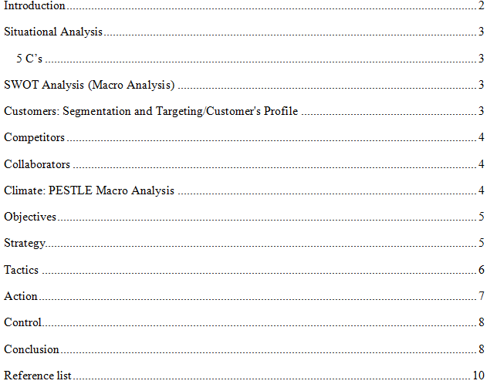

Introduction
The biggest hotel chain in the UK, Premier Inn, was founded in 1987. The parent business of Premier Inn is Whitbread PLC. The main office of the enormous hotel network is in Dunstable, England. The hotel network operates in many nations across the globe, and there are more than 800 hotels in total with 72 000 rooms (Force For Good, 2022). This essay creates a marketing strategy for the business to draw in new clients and boost sales as they were before the epidemic.

Situational Analysis

5 C’s

SWOT Analysis (Macro Analysis)
The SWOT analysis of Premier Inn looks at the benefits, risks, opportunities, and threats associated with the company.
Strengths: The advantages of the Premier Inn's SWOT analysis are shown below:
- The year's top hotel chain according to the British Travel Awards
- Hotels with significant marketing
- Hotels with high-end names
Weaknesses: The following are the Premier Inn SWOT Analysis's weaknesses:
- Due to the brand's intense competition, its margins are constrained.
- Compared to international hotel networks, global reach is less complicated.
Opportunities: A brand may benefit from regional growth, product improvements, better communication, etc.
- Strategic partnerships
- Invest additional money via the digital platform.
Threats: Due to the recent arrival of competitors, political upheaval, and alternative low-cost services provided by competitors, this hotel business is exposed to a number of dangers. competitors ACCOR, DAYS INN worldwide Inc., and Travelodge hotels ltd. have a similar target market.

Customers: Segmentation and Targeting/Customer's Profile
The hotel Premier Inn often uses geographic segmentation to divide the market into smaller segments. In terms of physiographic segmentation, the hotel Premier Inn divides guests into groups according to socioeconomic class, such as economical, business, etc. In terms of behavior segmentation, Hotel Premier looks for those who utilize their services on a regular basis.

Competitors
- One of the most well-known high capital businesses in the world is the hotel sector. because there aren't many new competitors in this market.
- Short labor productivity, high demand for skilled workers, and low supply all contribute to the weak performance of this industry.
- Due to the fact that the service used has a variety of possibilities, buyers' leverage over providers is substantially greater.

Collaborators
The greatest services may be offered when two or more hotels work together rather than by themselves. In B2B Relationships, Partnerships, and Franchises, the name of a branded firm might do this. Premier Inn collaborates with a wide range of hotel booking services and travel management companies.

Climate: PESTLE Macro Analysis
Political
Government laws governing immigration, taxes, and other issues have a significant impact on the tourist business along with the recent Covid-19 epidemic (OECD, 2020).
Economic
Due to the COVID-19 pandemic's travel restrictions and health dangers, fewer individuals traveled. People are also traveling less because of the high pound rates (Ianioglo and Rissanen, 2020).
Social
Because international visitors are traveling less than previously, Premier Inn is suffering from the growing social trend of local tourism (Putra et al., 2020).
Technological
The Technology-wise services are crucial in the post-pandemic era for keeping clients happy by enhancing convenience. Customer information submitted online needs to be protected against misuse.
Legal
The Data Protection Regulation Act is a significant legal requirement that Premier Inn must follow. The business must closely adhere to environmental standards due to growing concerns about environmental sustainability.
Environmental
Environmentally sound tourist practices are crucial for Premier Inn to adhere to. It has to keep trying to source from sustainable sources and deploy energy-efficient technology (Force For Good, 2022). To be recognized to clients as an ecologically friendly firm, it must meet its pledge to cut carbon emissions by the specified date (World Earth Day, 2022).

Objectives
The marketing strategy's SMART goal is to boost Premier Inn's profit margin by 5%. The firm has a strong brand image, thus the goal may be reachable. This target may be attracted by using appropriate advertising techniques. Therefore, a 5% increase in Premier Inn's net profits is important. This goal can be accomplished in a year.

Strategy
The service must be better than what rivals are offering in order to draw in more customers. The value proposition of Premier Inn Hotels should also be understood (Parvez and others, 2018). They could provide the quickest and most user-friendly online booking option. The value proposition would be the segmentation of different services provided to the targeted clientele. For instance, a tourist may get a discount if they book two or more places to stay in a calendar year.
Bowman's approach: The Bowman Strategic Clock has three different positions where there is no competition. When the cost surpasses the value that the customer sees, it pertains to positions of low-priced, high-quality services, internet marketing, travel services, etc. Businesses in one of these scenarios should either lower the price or change the product to enhance the customer's perception of value.

Tactics
Marketing Mix
The marketing mix, as defined by Chaffey and Ellis-Chadwick (2019), is the collective name for a company's strategic marketing instruments. Below is a description of the marketing mix used by Premier Inn hotels.
Product
The hospitality and travel services offered by Premier Inn are its goods. For tourists and customers on business, it offers hotel and transport services. The amenities provided to the consumers as services include hotel rooms, restaurants, lawns, swimming pools, etc.
Price
Premier Inn uses the best-cost-provider model. It provides customers with excellent services at a reasonable price. A variety of lodging options and hospitality services are offered by the hotel chain at competitive prices. The cost of a night in one of its rooms begins at only £50. Rates vary depending on the location and the bundle (Force For Good, 2022).
Place
In the UK, Ireland, Germany, and several other European nations, Premier Inn hotels may be found in towns, suburbs, and close to airports, as well as in popular tourist areas. Customers may make reservations via phone, online, or through an app. The least-used Premier Inn booking channel is online travel agencies.
Promotion
Premier Inn advertises its products and services on television, on social media, and via targeted email marketing. The company's website and mobile app serve as additional platforms for marketing (Chaffey and others, 2019).

Action
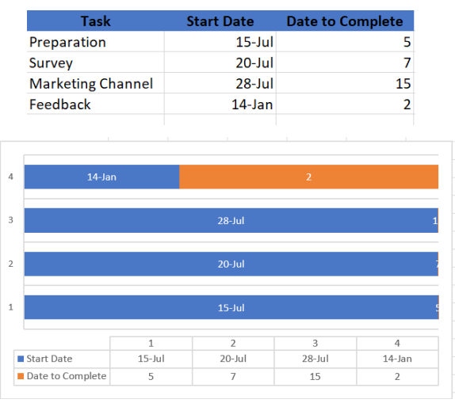

Gantt chart of marketing activities
The planning of the Premier Inn marketing campaign will take four to five days. Through the use of primary and secondary data, a survey will be carried out among the target audience. To collect all the data from the target audience, it will take 7 days. The data will be used to schedule a marketing channel. The 15-day duration of the event. After that, you'll get feedback. The appropriate adjustments will be made based on the comments.

Control

The unique selling proposition (USP) of a product is the feature or advantage that distinguishes it from similarly priced rivals in the market (Jobber, 2020). One product may employ small-batch processing rather than, say, one of its rivals. If a business provides a service instead of a product, it might decide that its USP is the fact that it goes to the client rather than expecting them to come to its office. You may also alternately use the terms "USP" and "unique selling position statement."

Ways to measure
- The client is eager to repurchase the services.
- Competitive businesses provide better services.
- The identical actions that the rivals take are taken

Conclusion
The tactics and procedures described in the marketing strategy may be costly and time-consuming. However, it is hoped that they will become lucrative and earn money over time. Premier Inn must make an investment right now in order to ensure the long-term viability, profitability, and growth of its business as well as the interest and satisfaction of its clients. In addition to putting these marketing strategies and methods into practice, the business should regularly do market research to understand both existing and future industry trends.

Reference list
- Alina, I. and Marko, R. (2020). Global trends and tourism development in peripheral areas. Scandinavian Journal of Hospitality and Tourism, [online] 20(5). Available at: https://ibn.idsi.md/vizualizare_articol/125311 [Accessed 15 Feb. 2023].
- Buttle, F., Bowie, D., Brookes, M. and Mariussen, A. (2017). Hospitality Marketing. [online] Google Books. Taylor & Francis. Available at: https://books.google.nl/books?hl=en&lr=&id=Oi4lDwAAQBAJ&oi=fnd&pg=PP1&dq=Bowie [Accessed 15 Feb. 2023].
- Carlo, C. (2021). Critical Success Factors in Hotel Companies: a Managerial Perspective. Journal of Tourism and Hospitality Management, [online] 9(2), pp.2372–5133. doi:https://doi.org/10.15640/jthm.v9n2a1.
- Chadwick, S. (2018). Routledge Handbook of Football Business and Management. [online] Routledge. doi:https://doi.org/10.4324/9781351262804.
- Eganael Putra, Q., Jiwa Husada Tarigan, Z., Br Sitepu, R. and Kumar Singh, S. (2020). The Impact of Marketing Mix on the Consumer Purchase Decision in the Surabaya - Indonesia Hotel Residence. SHS Web of Conferences, 76, p.01038. doi:https://doi.org/10.1051/shsconf/20207601038.
- Force For Good (2012). Force For Good. [online] Available at: https://www.premierinn.com/gb/en/why/force-for-good.html.
- Javed Parvez, S., M. Moyeenudin, H., Arun, S., Anandan, R. and Kumar Janahan, S. (2018). Digital marketing in hotel industry. International Journal of Engineering & Technology, [online] 7(2.21), p.288. doi:https://doi.org/10.14419/ijet.v7i2.21.12383.
- Jobber, D. and Ellis-Chadwick, F. (2019). EBOOK: Principles and Practice of Marketing, 9e. [online] Google Books. McGraw Hill. Available at: https://books.google.nl/books?hl=en&lr=&id=IMovEAAAQBAJ&oi=fnd&pg=PR1&dq=Jobber [Accessed 15 Feb. 2023].
- Khalayleh, M. and Al-Hawary, S. (2022). The impact of digital content of marketing mix on marketing performance: An experimental study at five-star hotels in Jordan. International Journal of Data and Network Science, [online] 6(4), pp.1023–1032. Available at: http://growingscience.com/beta/ijds/5533-the-impact-of-digital-content-of-marketing-mix-on-marketing-performance-an-experimental-study-at-five-star-hotels-in-jordan.html.
- Lock, S. (2022). Most popular hotel brands in the UK 2019. [online] Statista. Available at: https://www.statista.com/statistics/951262/most-popular-hotel-brands-uk/.
- OECD (2020). OECD Tourism Trends and Policies 2020. OECD Tourism Trends and Policies. OECD. doi:https://doi.org/10.1787/6b47b985-en.
- Premier Inn (2021). Premier Inn Home. [online] Premier Inn. Available at: https://www.premierinn.com/gb/en/home.html.
- Premier Inn (2022). Covid-19 FAQs. [online] www.premierinn.com. Available at: https://www.premierinn.com/gb/en/covid-19.html.
- Premier Inn, World Earth Day (2022). World Earth Day. [online] www.premierinn.com. Available at: https://www.premierinn.com/gb/en/news/2018/world-earth-day.html.
- Wahyuntari, N.L.P., Sutarma, I.G.P. and Antara, D.M.S. (2020). The Implementation of Marketing Mix to Increase Room Sales. Jurnal Bali Membangun Bali, 1(1), pp.55–64. doi:https://doi.org/10.51172/jbmb.v1i1.108.



