DATA HANDLING AND BUSINESS INTELLIGENCE
STUDENT NAME: MARILENA RALUCA BOTANOIU
Module code: LCBB5000

Executive Summary
This report has going to identify the various evaluations and techniques to evaluate the crime rates and records within the UK. It includes the various analysis through the help of SPSS such as descriptive, Anova, and clustering methods to identify the participant’s interest on behalf of different flavors of ice creams. Moreover, it has been going to evaluate the various bars facts and figures regarding the several identifications of crime rates and records within the UK.
Table of Contents
Introduction 4
Part 1 4
Pre-processing 4
Crime rate using LOOKUP 4
Crime rate 10 using LOOKUP 5
Evaluate the crime rates through IF analysis 7
Analyzing and visualizing the data 10
Conclusion 12
Part 2 12
Introduction 12
2.1 Results and Findings 12
2.2 Clustering analysis 15
2.3 data mining and text mining methods 16
2.4 various advantages and disadvantages of SPSS and excel 17
Conclusion 18
Reference list 19

Introduction
Handling of data is an appropriate process that has been able to ensure the overall research and data that restored or disposed of in a safe and secure way during the research of the project within the business. It includes various procedures and policies that have been able to evaluate the data in terms of managing it in an organized way. However, the main aim of the report is to identify the various business development policies and handle the business intelligence to improve or facilitate better management accounting in the UK.

Part 1

Pre-processing
In the context of preprocessing, it is the primary processing data that has been prepared through various primary process analyses in order to transform the raw data. It is an initial step in data mining and intelligence to identify the work quality before applying any machine and learning practices. As opined by Haron et al. (2020, p. 2), it is based on high-quality and accurate data models that ultimately help to predicate the data pieces of information.However, it is essential to process the valuable data with the best possibility of practices through the below-mentioned data regarding the various crime rate and crime rates 10 including wages and graph rates. It is due to identify the visualization or analysis of crime rates.

Crime rate using LOOKUP
crime rate | Youth | Southern | Education | ExpenditureYear0 | LaborForce | Males | MoreMales
52.3 | 140 | 0 | 10.9 | 55 | 535 | 1045 | 1

states | youth unemployment | MatureUnemployment | HighYouthUnemployed | Wage | BelowWage
6 | 135 | 40 | 1 | 453 | 200
Table 1: Crime rate evaluation
(Source: self-created)
From the above-mentioned table that has been represented the various rate of crimes has been detected through evaluation with various participants and several age groups and sections. It also includes the majority of state structure populations, youth, and their overall wages. The above-mentioned table identifies the crime rate that has been estimated as 52.3 with an annual expenditure that approx.500. Hence, it leads to various employment and unemployment among over or under-age groups. In addition, the overall wages of the participant in terms of evaluating the crimes rates that identify as 453, as well as the fundamental approach of the education system has been defined as 10.9.

Crime rate 10 using LOOKUP
CrimeRate10 | Youth10 | Education10 | ExpenditureYear10 | LabourForce10 | Males10 | MoreMales10 | StateSize10
37.1 | 153 | 11 | 44 | 529 | 959 | 0 | 24

YouthUnemploy10 | MatureUnemploy10 | HighYouthUnemploy10 | Wage10 | BelowWage10
98 | 33 | 0 | 359 | 256
Table 2: Crime rate 10 using LOOKUP
(Source: Self-created)
In the context of crime rate, it is an estimated count regarding the crime that emerges through several violence and illegal terms. However, the above representation of the table identifies the number of crime rates as 10. It evaluates the overall result regarding the crime rate 10 has been estimated as 37.1 with a multiple collaboration of youth and expenditures all are 10. Therefore, the majority of males has been estimated as 959 with a state size of 24. Moreover, the preprocessing of data evaluation faces issues sometimes due to the wages and the expenditure rates that has been fluctuated in terms of detecting the rates of crime within the UK.

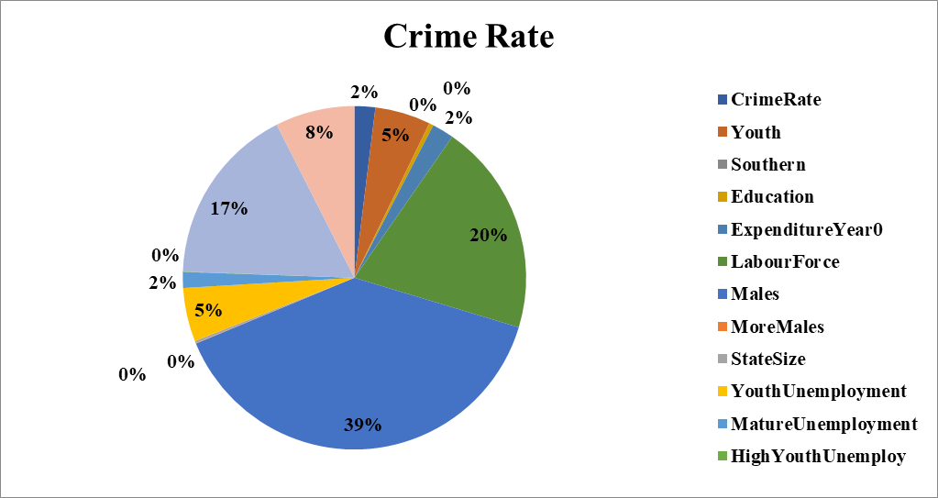
Figure 1: Chart Representation of Crime rates
(Source: self-created)
From the above-mentioned figure, it has been identified that there are various pros and cons, in terms of identifying the various crime rates and deficiencies within the UK. However, the above-mentioned chart identifies the multiple participants that collaborate in the list of crime rates in both officially and unofficially. It has been stated that the overall male participants have estimated as 39%. The labor force has been exceeded up to 39% followed by the influence of a high youth unemployment rate such as 20%. However, the cost of expenditure remains the same at 2% followed by education, and the wage rate has been low due to the crime rate. The overall aspects have become appropriate in terms of identifying the crime rates. Therefore, the operational department of research needs to carefully focus on the overall expenditure and wages rate to mitigate the issue of the crime.
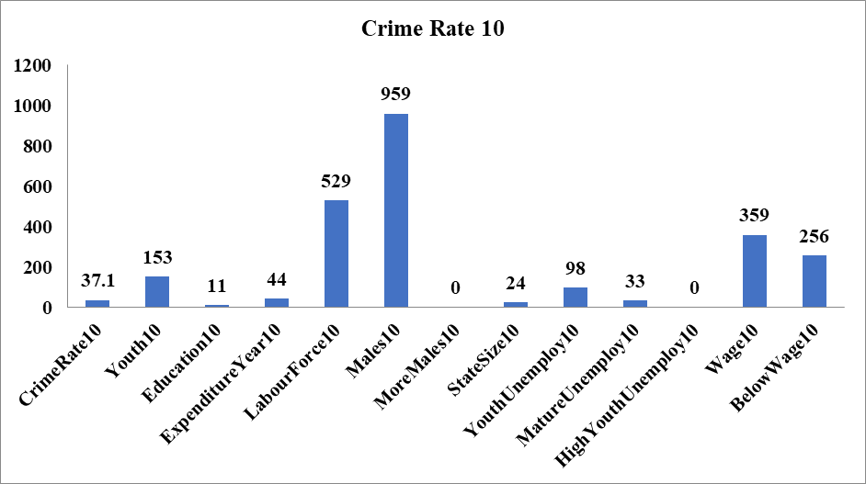
Figure 2: Graph representation of Crime rate 10
(Source: self-created)
From the above-mentioned graphical representations regarding the crime rate 10, that evaluate the majority of the male part such as 959. However, the majority of youth unemployment 10 obtains a negative result in terms of providing any contribution on behalf of crime rate identifications. The majority of participants including their wages and expenditure have been done due to identify the various crime rates and a majority of offenses within the UK. Furthermore, labor force palsy has a huge role in terms of mitigating the issue while identifying the crime rates through data preprocessing.

Evaluate the crime rates through IF analysis
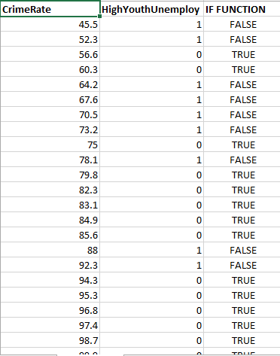
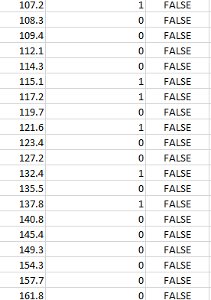
Figure 3: Crime rate evaluation through IF analysis
(Source: Self-created)
It has been identified through the above-mentioned figure regarding the citations of IF, in terms of identifying the various crime rates within the UK. However, the average crime rate has been estimated as 45.5. Thus, it has been mentioned as False compliances through IF analysis includes with high youth employment has counted as 1.
Various advantages and consequences have been identified through analyzing the data preprocessing steps within the business to automate the initial outlays and financial prospectus within the company.
Advantages
It provides appropriate information regarding the accuracy of the work through consistency, validity, and timeliness. Such as the various processing stages have been operating successfully as per the innovative techniques of the business are considering below:
Data Cleaning
Preprocessing data helps to provide accuracy within the data cleaning and processing techniques by removing the missing terms and values of irrelevant data. Such techniques have been used in the process of cleaning data and foxing the overall problem to look in order to solve it. As per the statement of Sowmya (2018, p. 6), various outlays and initiatives have been identified through the processing stage in order to fix the overall issue on behalf of cleaning data.
Data reduction
It is used to reduce the various amount of data and its associated cost through analysis of the overall data. As opined by Krisper et al. (2017, p. 95), various reductions of data identify the actual volume of the original data. However, it is an appropriate processing step that has been crucial in terms of working with the big data processing step and involvement.
Disadvantages
Debugging harder
Such techniques create a crucial step in order to maintain the debug within the machine or any software while detecting any errors or threats. It is a hard process to identify the various plan and pieces of information regarding the work. As opined by Qutieshat (2021, p. 5), It is a hazard to identify the overall program and solutions.
Compilations slowdowns
It utilizes the best source of operating and that feels to operate better and faster services in terms of detecting the threats and errors within the machine. As a result, it slows down the entire performance of the company while processing data and tools.

Analyzing and visualizing the data
The overall analysis has been done by representing the various graphs and figures or data regarding to evaluate the crime rates and the majority of male or labor force wages or expenditure in terms of detecting crimes. As per the statement of Polaka et al. (2021, p. 15), the analysis of preprocessing data and records regarding the crime has authentic and generate a huge relationship between the various types of groups and their annual wages or expenditures. It has been done through various graphs and structured data to identify the crime rate of local or individual communities in the UK.
s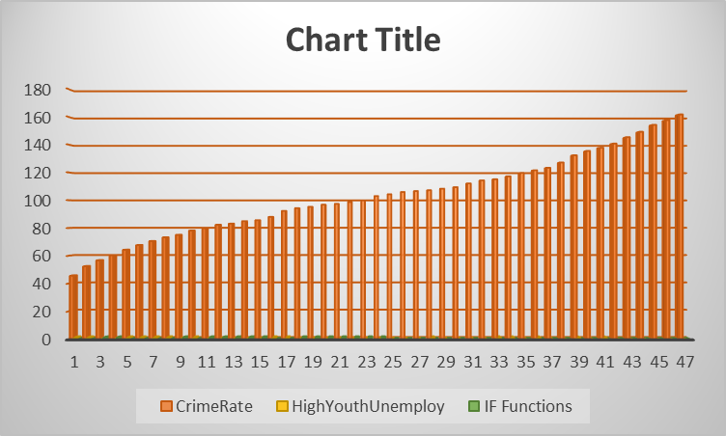
Figure 4: Graph representation
(Source: Self-created)
From the above-mentioned graph, it has been evaluated as various crime rates and high employment authenticity have been identified by the IF functional analysis. Therefore, the analysis has been made by the connotation of 1-47 majority of participants. With a remarkable of 0-180.
In the context of data visualizations towards the crime rate identifications, it has been identified that the various inputs and data and graphical representation ha sbeen mentioned above to restrain data preprocessing methods. As opined by Cowart et al. (2018, p. 8), it helps to identify the actual data in a proper analysis and interpretation. It works through evaluating various images and facts that accurately communicate or interact to involve with various numerical data on behalf of crime records. Moreover, data visualizations provide an authentic piece of information regarding the context of bars and graphs. This could be done through various trending patterns and analysis of different data sets and skills. Furthermore, it helps to exceed the business growth in a better way systematically.
As per the various groups and majority of participants, it has been done through the proper level of skills and pieces of knowledge within the data set and crime recording bars and scale. As opined by Kniesner and Leeth (2022, p. 89), it is the most common challenging task sometimes regarding evaluating the relationship between the different variables and coefficients through making sense of visualizations or analyzations during detecting any frauds and threats. However, it has been done through various closed frequencies in order to examine the effective rate of interest. It evaluates the potential of the participants. In addition, the analytical skills help to identify the proper solution regarding the various difficulties and decisions on behalf of the data analysis within the business to evaluate the crime records. It has been more affected while making any learning practices and training skills to implement the strategy to mitigate the criminal records in an organized way. This needs to maintain simplicity and functionality among the majority of security groups as well as to boost their annual wages.
Visualizations or analyses identify the effective benefits and needs regarding identifying the various crime rate in the UK. Such as various infographics and data charts that help the participants and the operational security department to perfectly identify the threats and crime aspects.

Conclusion
It has been concluded that the overall report has been done on behalf of various analyses or evaluations of data visualization through identifying the crime records and justification of entire group of participants such as male, labor, youth, youth expenditure, a sum of various crime rates and many more. It included multiples charts and graphs, data, and figures regarding both crime rate, and crime rate 10. It has been done by analyzing proper facts and methods of evaluating the crime records and rates through the condition of IF Function analysis. Therefore, the overall crime rates have been identified by pie charts and graphical functions followed by the wages and expenditure rates within the criminal records.

Part 2

Introduction
Data mining and training refer to a process of analyzing big data and threats in meaningful patterns. However, it is an appropriate set of data analyses that helps to identify the business and map out the business structured appropriately. As per the statement of Mironiuc et al. (2018, p. 59), it is an appropriate process that extracts various recommendations and analyses through identifying the opportunity to evaluate the various flavors and demand for ice cream rates. Therefore, the main purpose is to identify the interest of the majority of participants of both male and female.

2.1 Results and Findings
1. How many students like the vanilla flavor ice cream?
(1) Number of students who like Vanilla

ice-cream
 |  | Frequency | Percent | Valid Percent | Cumulative Percent
Valid | Vanilla | 95 | 47.5 | 47.5 | 47.5
Valid | Chocolate | 47 | 23.5 | 23.5 | 71.0
Valid | Strawberry | 58 | 29.0 | 29.0 | 100.0
Valid | Total | 200 | 100.0 | 100.0

Table 2.1: Share of response who likes Vanilla
(Source: created by the researcher)
From the above making table and analysis regarding the majority of participants who like the vanilla flavor in order to determine the valuation percentage of individuals who like ice cream. In the context of making the proper evaluations regarding the ice cream flavor, the majority of participants have been 200. As per the number of participants who like to choose vanilla flavors ice cream is 95 it has been calculated as the overall rate of cumulative frequency has been 47.5% as well as the number of participants who love to voice the vanilla flavors ice creams.
(2). Category of Male and Female
Gender
 |  | Frequency | Percent | Valid Percent | Cumulative Percent
Valid | Male | 91 | 45.5 | 45.5 | 45.5
Valid | Female | 109 | 54.5 | 54.5 | 100.0
Valid | Total | 200 | 100.0 | 100.0

Table 2.2: Evaluate the Participants through gender
(Source: Self-created)

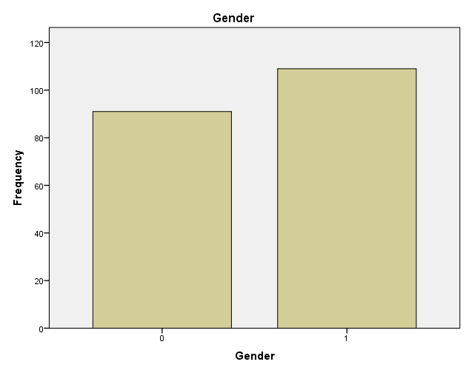
Figure 1: graphical representation of Male and Female
(Source: created by the researcher)
From the above make an appropriate analysis or evaluation of the majority of male and female participants throughout the entire response. The overall research and analysis have been done by making proper tables and graphs. The overall information has been done by evaluating the table and graphs. However, 91 male individuals have participated with several totals of 200 responses. The overall cumulative percentage has been identified as 45.5%. Conversely, there are more than 100 female participants have been identified while making choices regarding the various ice cream flavors.
(3) Calculation of mean and median participants regarding choice of strawberry and chocolate

Report
Gender
ice_cream | Mean | N | Std. Deviation | Median
Vanilla | .51 | 95 | .503 | 1.00
Chocolate | .68 | 47 | .471 | 1.00
Strawberry | .50 | 58 | .504 | .50
Total | .54 | 200 | .499 | 1.00

Table 2.3: Descriptive statistical analysis
(Source: Self-created)
Analysis based on various descriptive performances and statistics on behalf of evaluating the mean median through the help of SPSS has been noted as different variables and segments. Therefore, in the context of several varieties and categories of ice cream flavors such as chocolate, vanilla, strawberry, and many more. The entire validation and calculation of different flavors and interests of the participants have been done through making compete for analysis such as the mean of chocolate as .51 and median as 1.00. However, the majority of participants have been estimated as 95, followed by the number of participants who like the strawberry flavors ice cream as .50 and the median is also the same. Therefore, the overall interest of the majority of participants has been counted through various calculations of mean and median or proper descriptive analysis through the help of SPSS.

2.2 Clustering analysis

ANOVA
 | Cluster |  |  |  | F | Sig.
 | Mean Square | df | Mean Square | df | F | Sig.
Gender | .030 | 1 | .250 | 198 | .120 | .729
ice-cream | 3.095 | 1 | .723 | 198 | 4.284 | .040
video | 8700.783 | 1 | 54.579 | 198 | 159.415 | .000
puzzle | 12815.244 | 1 | 51.116 | 198 | 250.709 | .000

Table 2.4: Cluster analysis of the ice cream
(Source: Created by the researcher)
From the above-mentioned data, and table identifies the various models and methods of ice cream data set that signifies the overall evaluations through cluster analysis with a difference of about 1. However, the gender variances in mean square participants as 0.30 with a Df 198 as it evaluates the overall frequency of mean square that suggest or estimate as .120. In such a case the data valuation regarding the different variables has effectively identified the entire mean and median square level and approaches in a significant way. However, the ice cream dataset of the main square has been estimated as 3.95 followed by the videogames and puzzles as 8700 and 121 along with the evaluation of frequency 15.4 and 25.7. Furthermore, the ice cream data has been evaluated to identify the majority of various ice cream flavors and video games.

2.3 data mining and text mining methods
Big data mining refers to the overall process of existing huge data through the various sets of identifications in meaningful patterns and ways to analyze the data in a structured format. As per the statement of Cretu et al. (2018, p. 32), various formats and technological tools have been utilized in terms of identifying the several sequences and order within the multiple financial organizations. However, the proper facts and analysis have been recommended through the various data techniques and possibilities regarding evaluating the data mining throughout the research as per the relevant topics or study.
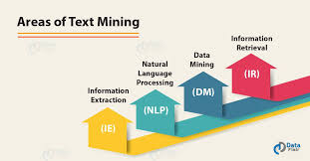
Figure 2.5: Text mining
(Source: Belciug et al. 2018, p. 32)
In the context of text mining, it is an innovative technique that has been identified scientifically by the operational financial leaders of the business to transform the documents into a structured format appropriately. However, it is a data-driven structured pattern that exists within the operational financial operations of multinational companies.

2.4 Various advantages and disadvantages of SPSS and excel

Factors | Advantages | Disadvantages
Excel | The extraordinary utilization and effective use of excel help the majority of the group or any individual to evaluate the various understanding in terms of identifying any basic to advance level of calculations  It has also evolved throusgh various approaches and analyses in a systematic way. | In order to identify the various data set and analysis within the large-scale enterprises, using excel functions provide strategic results and analysis through a limited number of columns and rows.
SPSS | It is indefinite models and methods that ha been used to gain an effective analysis and information regarding the various factors such as ANOVA, Descriptive analysis, and many more. | Such innovative tools and software have been effective as well as lack proper functions and accessibility through statistical pieces of information that have not to be able to found or deliver.
Table 2.5: Differentiate between excel and SPSS
(Source: Nwachukwuet al. 2019, p. 12)

Conclusion
It has been concluded that the above-mentioned analysis and table has been done through proper evaluations of multiple analysis with the help of various SPSS analysis. It includes several graphs and data in descriptive or statistical ways. However, it needs more facts and representations to evaluate the proper analysis regarding the various products such as ice cream, videogames, puzzles, and many more, as well as the multiple majorities of the various participants regarding evaluating their interests.

Reference list
Journals
Alif, R.K., Alwee, R. and Haron, H., 2020. A Comparative Analysis Of Artificial Intelligence Techniques In Forecasting Violent Crime Rate. Iop Conference Series.Materials Science And Engineering, 864(1),.
Asongu, S., Nwachukwu, J., Stella-Maris Orim And Pyke, C., 2019. Crime And Social Media. Information Technology & People, 32(5), Pp. 1215-1233.
Belciug, A.V., Cretu, D. andGegea, C., 2019. Utilizarea Tehnicilor De Data Mining Ca Metoda Complementara În Audit: The Use Of Data Mining Techniques As A Complementary Audit Method. Audit Financiar, 8(7), Pp. 30-35.
Chersan, I., Carp, M. and Mironiuc, M., 2018. Data Mining - O Provocare Pentru Auditorii Financiari/Data Mining - A Challenge For Financial Auditors. Audit Financiar, 11(10), Pp. 57-64.
Kniesner, T.J. and Leeth, J.D., 2022. Data Mining Mining Data: Msha Enforcement Efforts, Underground Coal Mine Safety, And New Health Policy Implications. Journal Of Risk And Uncertainty, 29(2), Pp. 83-111.
Lu, S., Jin, B., Cowart, L.A. andLu, X., 2018. From Data Towards Knowledge: Revealing The Architecture Of Signaling Systems By Unifying Knowledge Mining And Data Mining Of Systematic Perturbation Data. Plos One, 8(4),.
Polaka, I., Razuka-Ebela, D., Jin, Y.P. and Leja, M., 2021. Taxonomy-Based Data Representation For Data Mining: An Example Of The Magnitude Of Risk Associated With 0rw1s34rfesdcfkexd09rt2h. Pylori1rw1s34rfesdcfkexd09rt2 Infection. Biodata Mining, 14, Pp. 1-21.
Qutieshat, E., 2021. The Jordanian Legal Approach On Educational Data Mining: Privacy Of Individuals V. Data Mining. Journal Of Legal, Ethical And Regulatory Issues, 24(7), Pp. 1-11.
Rupnik, R., Kukar, M. andKrisper, M., 2017. Integrating Data Mining And Decision Support Through Data Mining Based Decision Support System. The Journal Of Computer Information Systems, 47(3), Pp. 89-104.
Sowmya, Y., 2018. A Review On Big Data Mining, Distributed Programming Frameworks And Privacy Preserving Data Mining Techniques. International Journal Of Advanced Research In Computer Science, 6(1),.

Bibliography
Belciug, A.V., Cretu, D. And Gegea, C., 2019. Utilizarea Tehnicilor De Data Mining Ca Metoda Complementara În Audit: The Use Of Data Mining Techniques As A Complementary Audit Method. Audit Financiar, 8(7), Pp. 30-35.
Chersan, I., Carp, M. And Mironiuc, M., 2018. Data Mining - O Provocare Pentru Auditorii Financiari/Data Mining - A Challenge For Financial Auditors. Audit Financiar, 11(10), Pp. 57-64.
Dhanalakshmi, R.A. And Jacob, G., 2021. An Exploration Of Crime Type And Prediction Using Ralasd Feature Selection Algorithm With Deep Learning Technique. Turkish Journal Of Computer And Mathematics Education, 12(11), Pp. 4516-4531.
Hyeon-Woo, K. And Hang-Bong Kang, 2017. Prediction Of Crime Occurrence From Multi-Modal Data Using Deep Learning. Plos One, 12(4),.
Kaur, S., 2017. Systematic Review Of Crime Data Mining. International Journal Of Advanced Research In Computer Science, 8(5), Pp. 1336-1342.
Kniesner, T.J. And Leeth, J.D., 2022. Data Mining Mining Data: Msha Enforcement Efforts, Underground Coal Mine Safety, And New Health Policy Implications. Journal Of Risk And Uncertainty, 29(2), Pp. 83-111.
Nabi, R.M., Saeed, S.A.M. And Haron, H., 2021. Using Ai Techniques To Predict Property Crime Rates - A Comparison And Analysis. Turkish Journal Of Computer And Mathematics Education, 12(10), Pp. 4167-4171.
Polaka, I., Razuka-Ebela, D., Jin, Y.P. And Leja, M., 2021. Taxonomy-Based Data Representation For Data Mining: An Example Of The Magnitude Of Risk Associated With 0rw1s34rfesdcfkexd09rt2h. Pylori1rw1s34rfesdcfkexd09rt2 Infection. Biodata Mining, 14, Pp. 1-21.

