ACCA5023 Network Operating Systems and Services
Coursework 2 – Task 1 screenshots
David Sheppard 2306723
- Routing
Figure 1 shows the installation of Remote Desktop Services via PowerShell, active routing within the Swansea network via IPCONFIG and PING to Swansea client and firewall rules defined to allow ICMP traffic.
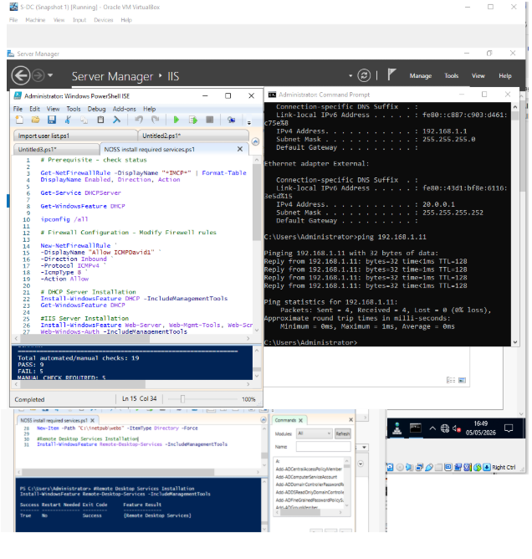
Figure 1
- Domain Server (Swansea)
Figure 2 shows forward and reverse lookup zones created within david.acca domain.
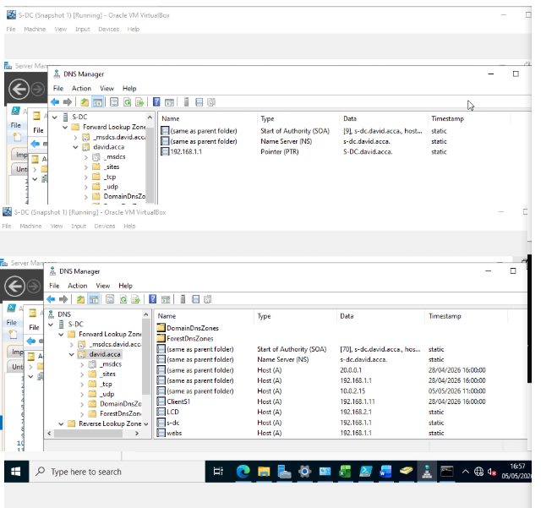
Figure 2

- Site to site encryption Swansea to London

Figure 3 shows the attempt to configure pptpd VPN between Swansea and London networks, which is unable to connect despite widescale troubleshooting.

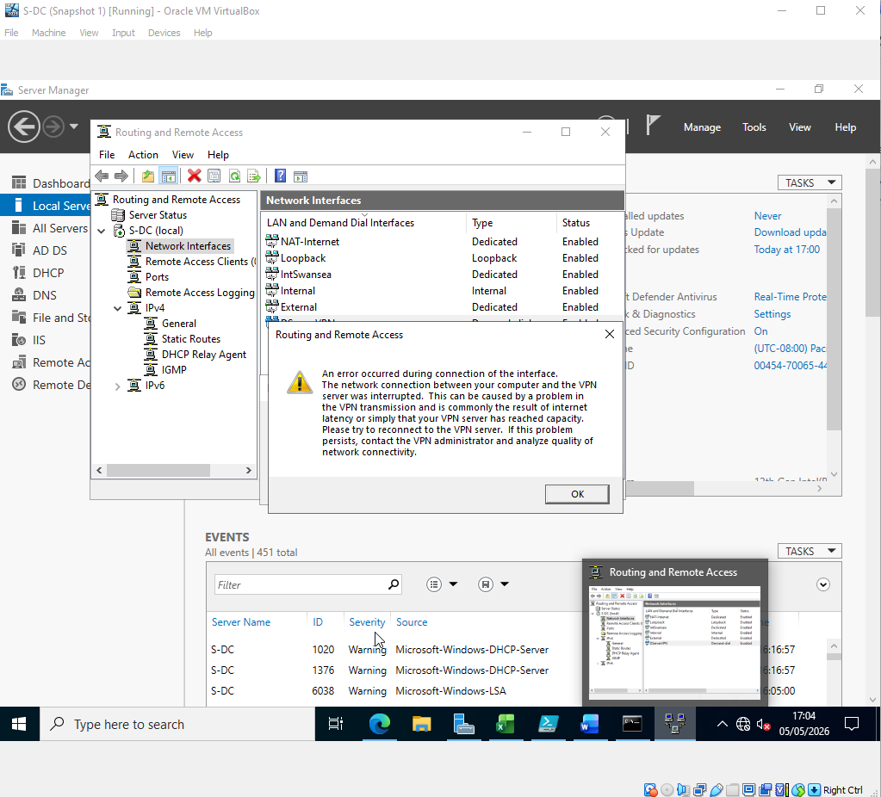
Figure 3
- Users

Figure 4 shows the PowerShell script and output produced to return the list of users, removing inappropriate records (i.e. OLDNAME.ACCA) and performing the data cleanse within PowerShell.

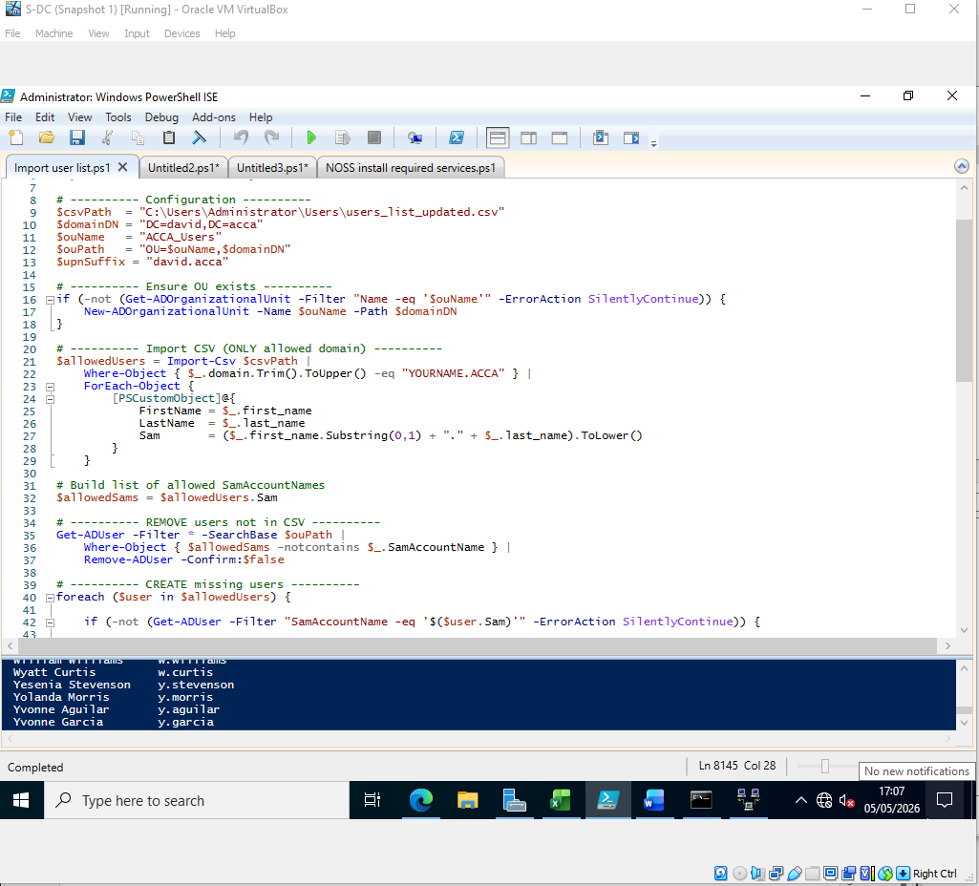
Figure 4
- Domain Membership

Figure 5 shows the Windows client machine as belonging to the david.acca domain

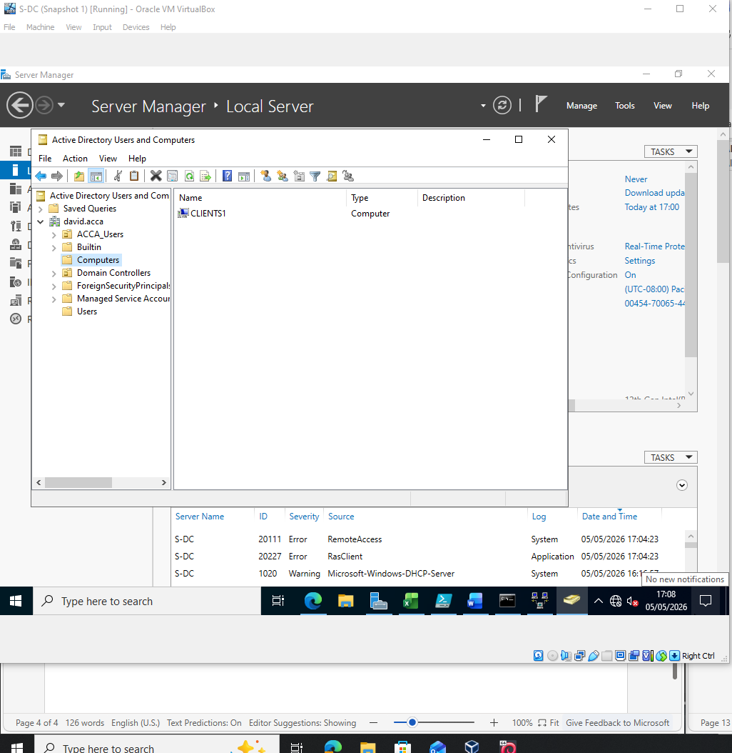
Figure 5

- DHCP server

Figure 6 shows S-DC configured as a DHCP server, including PowerShell scripts. Clients are automatically assigned IP addresses via DHCP server and lease policies.

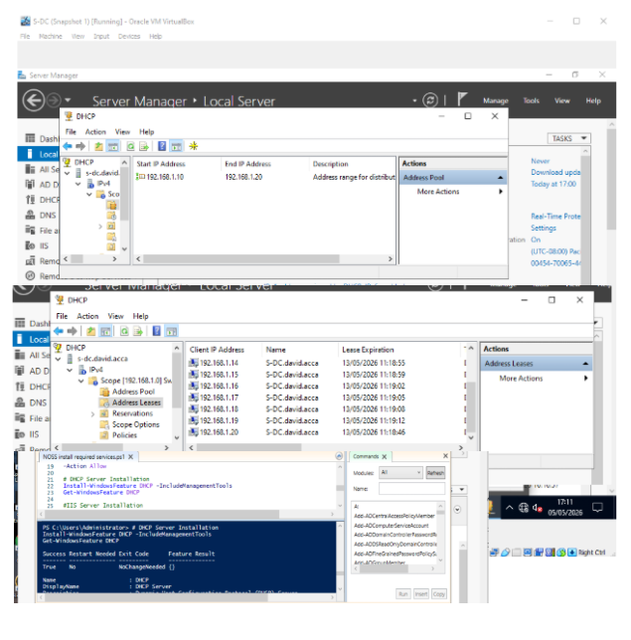
Figure 6

- Testing and troubleshooting
Figure 7 shows the connectivity between networks and machines.
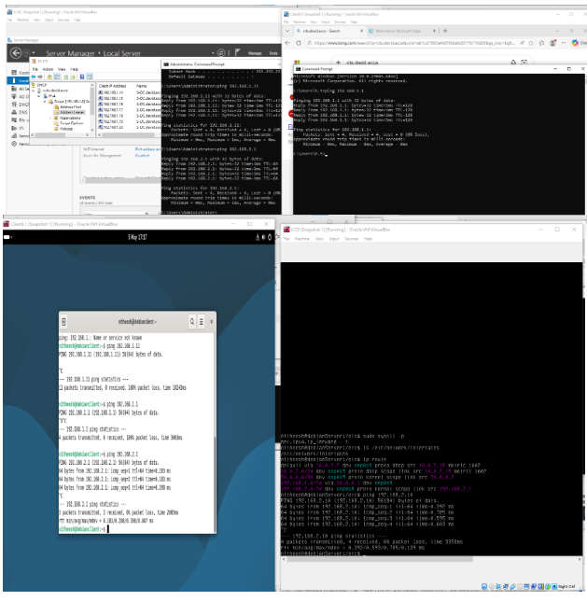
Figure 7

- Disk drive

Figure 8 shows the second drive mounted to E:\SwanseaFiles and related permissions

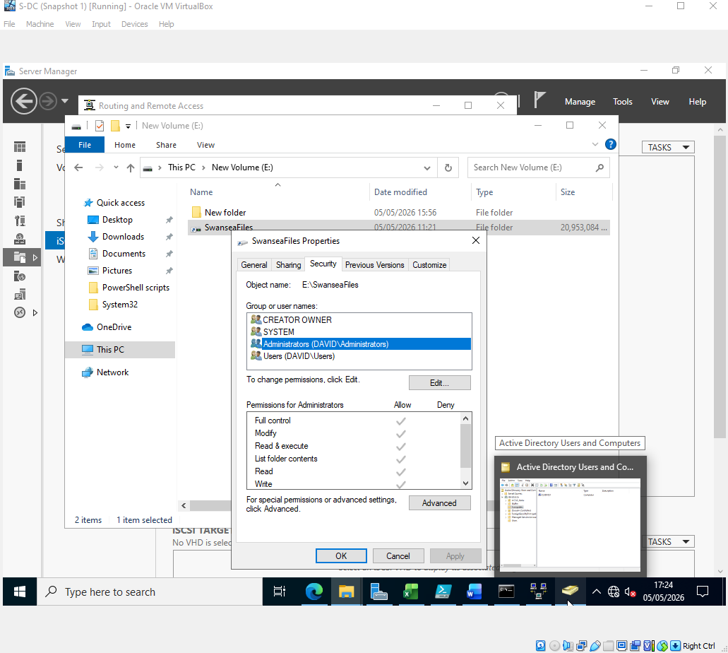
Figure 8
- IIS Server
Figure 9 and 10 show the set up of IIS Server and user login prompt to access webs.david.acca and the user authentication log in screen.
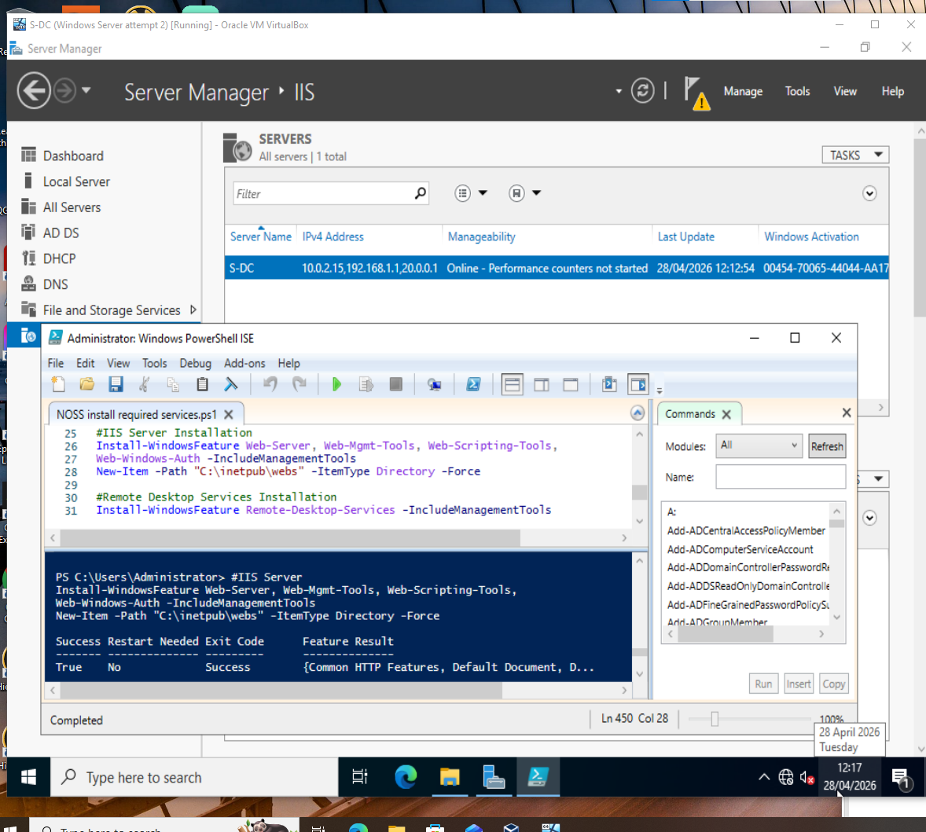
Figure 9
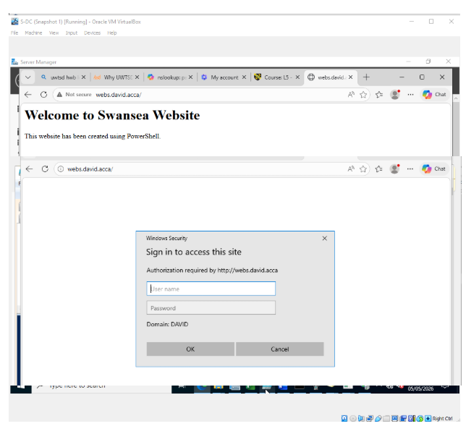
Figure 10

10. Remote desktop services
Figure 11 shows access to S-DC remote connection from Windows client.
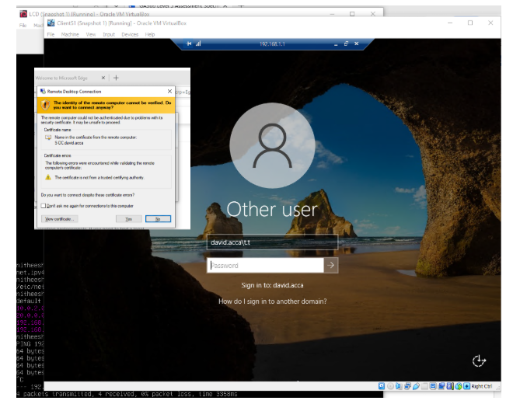
Figure 11

