

Title: EXPLORING HOW DIGITAL MARKETING SUPPORTS INTERNATIONAL BRAND EXPANSION IN BANGLADESH’S TEXTILE SECTOR AND ITS IMPACT ON ECONOMIC GROWTH

Name: Afsara Tasnim Nila
Student Id: 2426564
Module Name: Quantitative Research Methods

Abstract
This research explores the role of digital marketing in helping international brands to grow in the textile industry of Bangladesh. The introduction chapter presents the research background, problem, objectives and significance associated with economic growth. This research will look at how online marketing helps in international branding across the textile industry of Bangladesh and the consequences of the same to the growth of the economy. The literature review has focused on digital capabilities as the important enablers of global visibility and competitiveness basing on the Uppsala model and resource-based view. Empirical findings are discussed showing high levels of relationship between the adoption of digital marketing, international brand expansion, export performance, and perceived economic contribution. On the whole, the research predisposes digital marketing as a firm-level strategic competence that determines internationalisation and the growth outcomes of the entire sector. The research methodology employed in the study is outlined in this chapter. It justifies the approach, philosophy and quantitative design to be followed. Chapter outlines the primary data collection based on an online survey, the sampling technique, data analysis in SPSS and ethical issues. This chapter examines empirical data to determine the effect of digital marketing on global company expansion in Bangladesh's textile industry. SPSS was used to perform both qualitative and quantitative statistical analyses. The findings show significant positive connections between internet marketing adoption, recognition of the brand, export performance, as well as economic growth, lending strong support to all submitted research hypotheses.

Table of Contents
Chapter 1: Introduction 8
1.1 Background of the Study 8
1.2 Research Problem and Rationale 8
1.3 Research Aim and Objectives 9
1.4 Research Questions and Hypotheses 9
1.5 Significance of the Study 10
1.6 Structure of the Dissertation 10
Chapter 2: Literature Review and Theoretical Framework 11
2.1 Digital Marketing in International Business 11
2.2 International Brand Expansion 11
2.3 Digital Marketing and Brand Expansion Linkages 12
2.4 Textile Sector in Bangladesh 13
2.5 Digital Marketing and Economic Growth 14
2.6 Critical Evaluation of Literature 15
2.7 Conceptual Framework Development 16
Chapter 3: Research Methodology 17
3.1 Chapter Overview 17
3. Research Philosophy 17
3.3 Research Approach 17
3.4 Methodological Choice 18
3.5 Research Design 18
3.6 Population and Sampling 18
3.7 Data Collection Method 19
3.8 Questionnaire Design 19
3.9 Data Analysis Techniques 19
3.10 Ethical Considerations 19
3.11 Time Scale 20
3.12 Conclusion 21
Chapter 4: Results and Analysis 22
4.1 Introduction 22
4.2 Descriptive Statistics 22
4.3 Hypothesis Test 23
4.3.1 Hypothesis 1: Digital marketing adoption has a positive influence on the international brand expansion of Bangladeshi textile firms. 23
4.3.2 Hypothesis 2: Higher use of digital marketing tools significantly improves international brand awareness and customer reach. 24
4.3.3 Hypothesis 3: Digital marketing practices have a positive relationship with the export performance of textile brands in Bangladesh. 25
4.3.4 Hypothesis 4: Effective use of digital marketing contributes positively to economic growth outcomes within Bangladesh’s textile sector. 27
4.4 Summary 29
Chapter 5: Discussion 31
5.1 Introduction 31
5.2 Findings and Discussion 31
5.2.1 Findings from the descriptive statistics 31
5.2.2 Findings from the literature review 31
5.2.3 Comparison between the findings from thematic analysis and literature review 32
5.2.4 Overall discussion 33
5.3 Summary 33
Chapter 6: Conclusion and Recommendations 34
6.1 Summary of findings 34
6.2 Linking with Objectives 34
6.3 Recommendations 34
6.4 Implications of the study 35
6.5 Limitations of the study 35
6.6 Future scope of the study 35
References 36
Appendices 41
Appendix 1: Data Set 41
Appendix 2: SPSS Input and Output 42

List of Figure
Figure 2.1: Conceptual Framework 15

List of Tables
Table 1: Descriptive Statistics 22
Table 2: Model Summary 23
Table 3: ANOVA 23
Table 4: Coeeficient 24
Table 5: Correlation Result 25
Table 6: Model Summary 26
Table 7: ANOVA 26
Table 8: Coefficient 27
Table 9: Model Summary 28
Table 10: ANOVA 28
Table 11: Coefficient 29
Table 12: Independent Sample T-test 29

Chapter 1: Introduction

1.1 Background of the Study
The textile and apparel industry is a major component of the economy of Bangladesh. It is second second-largest exporter of ready-made garments in the world after China, with approximately USD 38.5 billion in exports in 2024. The sector contributes to over 84% of the total export earnings of Bangladesh and provides over 13% of the national GDP (Investbangladesh, 2026). It also employs millions of people, and it has contributed to decreasing poverty and allowing the growth of the industries.
Over the past years, an increasing number of Bangladeshi textile brands have begun to explore alternative contract manufacturing (Islam et al. 2022). Such brands will develop their own image in the international markets and minimise dependence on foreign brands.
Simultaneously, online marketing has been advancing at a very fast pace as e-commerce, social media, and online platforms provide textile companies with additional avenues to communicate with overseas clients (Yang, 2024). This is particularly relevant in the emerging markets in which the adoption rate of the internet and mobile phones is surging rapidly. Digital strategies enable small and medium-sized brands to compete internationally without massive investments into a brick-and-mortar store or conventional advertising.

1.2 Research Problem and Rationale
The textile industry in Bangladesh is rapidly expanding, and gradually, there remains a knowledge gap regarding how digital marketing can aid in brand expansion at the global level. The majorities of research on the Bangladeshi industry is local adoption of digital and overall business development, rather than clear digital marketing and market entry in foreign countries or brand performance in those countries (Fregidou-Malama et al. 2023). The effect of digital platforms on export performance or brand visibility abroad is not well-investigated empirically. A small number of quantitative studies also relate the use of digital marketing to the bigger economic effects in demand economies such as Bangladesh. Such absence of solid statistics makes it difficult to make investment decisions in the digital strategy of international growth within firms and policymakers.
The digital economy in Bangladesh is fast developing and transforming the way business accesses the world. It currently boasts more than 134 million internet subscribers with extensive 4G access, which simplifies online platforms to conduct business both small and large (Ficci, 2026). Access to the internet and low-cost mobile data enables more firms to utilise digital means for marketing and sales.
The already global textile industry has started exploiting digital marketing and e-commerce to present products to the foreign customer segment and access new markets. Social media and internet channels assist companies in creating brand recognition and directly interacting with customers overseas (Utomo et al. 2023).
Although this has happened, few studies associate the application of digital marketing with quantifiable brand growth and broader economic returns in Bangladesh. It requires quantitative data to comprehend how digital initiatives can enhance the export performance, competitiveness, and economic growth contribution. This research will seek to bridge that gap with the existing evidence and figures.

1.3 Research Aim and Objectives
Aim:
This study aims to examine how digital marketing supports international brand expansion in Bangladesh’s textile sector and its impact on economic growth.
Objectives:
- To examine the extent of digital marketing adoption by textile brands in Bangladesh for global market expansion.
- To analyse how digital marketing activities influence international brand awareness and customer reach.
- To evaluate the relationship between digital marketing use and export performance of Bangladeshi textile brands.
- To assess perceptions of industry professionals on the impact of digital marketing on economic growth outcomes.

1.4 Research Questions and Hypotheses
RQ1: To what extent do textile brands in Bangladesh apply digital marketing for international market expansion?
RQ1: How does digital marketing affect international brand awareness and customer reach in the textile sector?
RQ1: What is the connection between digital marketing adoption and the export performance of Bangladeshi textile brands?
RQ1: How do industry professionals perceive the influence of digital marketing on economic growth in Bangladesh’s textile sector?
Research Hypotheses:
H1: Digital marketing adoption has a positive influence on the international brand expansion of Bangladeshi textile firms.
H2: Higher use of digital marketing tools significantly improves international brand awareness and customer reach.
H3: Digital marketing practices have a positive relationship with the export performance of textile brands in Bangladesh.
H4: Effective use of digital marketing contributes positively to economic growth outcomes within Bangladesh’s textile sector.

1.5 Significance of the Study
This research contributes to the body of academic literature by bridging the gaps in empirical research on digital marketing and the global expansion of the brand in emerging markets. It talks of primary data evidence of the textile sector in Bangladesh. This assists in bridging research gaps. The results present viable advice on how managers should exploit digital networks to access international markets and enhance brand awareness. The research also aids the policy makers because it indicates that digital marketing would reinforce export growth and competitiveness. This has the potential to inform digital trade policies, SME support programs and national sustainable economic growth strategies.

1.6 Structure of the Dissertation
This dissertation is divided into six major chapters. The literature review reviews major theories and recent research on digital marketing and global brand expansion. The chapter on the methodology defines the research design, methods of data collection and analysis in the study. The findings and results chapter gives a clear outline of the findings of the online survey. The discussion chapter connects the findings and the literature, and the research objectives. The last chapter presents conclusions, practical suggestions, as well as future research suggestions.

Chapter 2: Literature Review and Theoretical Framework

2.1 Digital Marketing in International Business
Digital marketing is described as the exploitation of internet-related products and electronic avenues to market products, services, or brands to consumers and business clients. It involves the use of social media, search engines, email, content marketing, and online advertising to reach out to audiences and make people change their behaviour. As per Bala (2024), digital marketing, in an international context, allows firms to access international customers without the geographical limitations of the traditional marketing strategy. It is also used to track campaign performance in real-time and make adjustments on a fast basis depending on measurable results.
Digital channels in international business are key to current-day marketing plans. The main digital channels are social media platforms (Facebook, Instagram, LinkedIn), search engines (Google, Bing), search engine optimisation (SEO), email campaigns, online display and video advertising, and e-commerce markets. According to Ahmad et al. (2024), these channels assist the companies to create awareness as well as create customer insights and customise messages based on the linguistic and cultural context of the new market. Multichannel digital clustering techniques especially prove to be relevant in targeting cross-border segmented audiences.
The strategic use of digital marketing in brand visibility has to do with the fact that it enhances the presence of a company in international markets. The use of digital makes entry barriers lower because it decreases the cost associated with physical distribution and conventional advertisements, making small and medium-sized firms able to compete on a global level (Niu et al., 2023). The ability to target and personalise based on data leads to an increase in relevance among foreigners, whereas online content and social engagement create credibility and brand recognition abroad. It has been observed that global online marketing provides greater visibility to the brand and helps in creating a durable relationship with overseas customers.

2.2 International Brand Expansion
International brand expansion can be defined as the means by which companies can expand into other markets and compete internationally beyond their original country (Rupeika-Apoga and Petrovska, 2022). This has been studied using theories of internationalisation, which offer a format of how and why companies internationalise.
Uppsala Model
The Uppsala model is an initial stage theory referring to the fact that companies internationalise in steps. The initial stages of foreign participation are low, and a company engages in the market as it gathers market knowledge and certainty. This position argues that through the connections with partners, distributors, and other stakeholders, firms seek access to resources and knowledge that can help them to enter and grow along with the market (Wu and Vahlne, 2022). Networks assist in lessening foreignness liabilities and enhance responsivity of the market.
Resource-Based View (RBV)
Resource-Based View (RBV) brings the emphasis away from the process of internationalisation and provides a narrower focus on the internal resources and capabilities that are sources of competitive advantage. The resources that facilitate successful entry into foreign markets are strong brand equity, digital capabilities, distribution know-how, and product-specific competencies. As per Lubis (2022), companies can invest in different capabilities characterised as valuable, rare, and hard to copy, and they would assist in maintaining their competitive advantage in a global market.
Global branding entails brand equity. It is defined as the worth of a brand in the minds of consumers based on brand awareness, brand perception, and associated feelings. Strong brand equity increases consumer confidence and loyalty, which allows companies to earn high prices and venture into new markets with relative ease. In the opinion of Parris and Guzmán (2023), the global branding strategies in many cases are based on a compromise between global consistency and the local adaptation to avoid disrespect of the cultural differences and preserve a coherent brand identity.

2.3 Digital Marketing and Brand Expansion Linkages
Digital marketing takes an increasing part in assisting with international brand growth, particularly corporate units in emerging and developing economies. It has been proven that geographical barriers can be overcome by using online platforms like social media, e-commerce websites, and mobile marketing, which help firms to access global markets at a low cost compared to traditional methods of advertisement (Kandasamy et al., 2023). Digital marketing will be able to promote brand awareness and extend way past the local markets, which is essential to a company that aims to measure global expansion. Research points out that digital marketing applications are the ability to enable businesses to create a brand name internationally, connect and communicate with customers in different countries, and to track the success of the campaign live, which are all contributing to an enhanced competitive positioning in other countries.
Specific empirical studies on the use of digital marketing among the emerging market situations have exhibited that adoption of digital marketing is associated with greater brand visibility and better performance outcomes (Chakraborty and Jain, 2022). Studies in the developing world reveal that digital marketing plans enable companies to increase the scope of their market, efficiently interact with consumers across boundaries, as well as enhancing the recognition of their brand compared to companies that employ conventional marketing strategies. Digital marketing also enhances the use of data to make informed decisions, whereby the firms are able to differentiate customers based on their international segments.
In the case of the textile industry, research indicates that a digital channel has a central role in creating brand recognition and retention. As mentioned by Godara et al. (2023), an illustration, the study of the textile industries has shown that social media and digital marketing have an effect on consumer intentions to purchase and brand confidence, and brand awareness is a key moderating variable between the two.

2.4 Textile Sector in Bangladesh
The textile and ready-made garment (RMG) sector in Bangladesh is one of the leading sectors in the national economy, as it contributes a significant part of the entire exports and workforce. According to Raihan (2024), the industry is the largest contributor of about 80% in the export earnings of Bangladesh, as well as providing jobs to millions of people, where most of them work in the RMG factories serving consumers around the world, including the US, the European Union, and other regions. It is such intensive export-led strategies that have made Bangladesh become the second largest garment exporter in the world, with only China showing greater figures.
On a structural level, the industry is filled with hundreds of garments and textile manufacturing enterprises that make simple and middle-range clothes on behalf of the international brands (Nim et al., 2024). Although the resulting specialisation has seen the rapid rise in export volumes, it also implies that the industry is extremely tied to a limited number of products and markets that are susceptible to changes in global demand and changes in trade policies.
Global competitiveness and branding are still burning issues in the Bangladesh textile industry. Historically, the competition strategies used by the Bangladeshi producers are mainly based on price and decisions made on their production efficiency as opposed to brand identity and differentiation of their value-added products. As per Anumula (2025), numerous manufacturers are the original equipment manufacturers (OEMs) of foreign brands instead of creating their own global brands, which restricts their chances of earning higher margins and brand equity in foreign countries. The gap toward global competitiveness is defined as the development of unique brand narratives and the utilisation of digital engagement tools.

2.5 Digital Marketing and Economic Growth
Digital marketing helps in the growth of the economy both at the firm level and macroeconomic level, though the routes are various (Aancy et al., 2023). At the company level, the implementation of digital marketing will increase market coverage, customer interactions, and brand value, which may result in revenue expansion and competitiveness. In the case of small and medium enterprises (SMEs), studies show that digital marketing techniques, such as social media, online advertising, and optimization of the search engine, enhance the performance of the firm by enhancing visibility and interactivity with customers. In the opinion of Sunggara et al. (2022), such advances in the performance of firms can be converted into increased sales, increased presence in the market, and eventually into increased economic contribution to the economy by the digitalized firms.
The benefits for firms may accumulate into the overall economy when numerous firms switch to digital technologies. Greater use of digital marketing and digitalization in general would facilitate the area of productivity improvements by facilitating an efficient communication process, lowering transaction costs, and enhancing the allocation of resources. According to Pattanayak et al. (2023), increases in firm-level productivity, particularly in manufacturing and service industries, also lead to overall economic growth and an increase in output and firm competitiveness in the global market.
In the Bangladesh context, research work on digitalization revealed a positive connection between the indicators of digital infrastructure and economic growth, therefore indicating that online service and network preparedness facilitate wider economic performance. The policymakers are being advised to enhance digital infrastructure to enhance all these impacts (Li et al., 2023). Although digital marketing is a subset of the digitalization process, its contributions to connecting the firms with the global market indirectly facilitate export-driven development and foreign exchange revenues.

2.6 Critical Evaluation of Literature
The recent literature widely accepts that digital marketing continues to play an increasingly significant role in global brand expansion, especially within export-driven sectors like textiles (Xames and Topcu, 2024). Literature on the topic of emerging markets indicates that digital marketplaces, search engine optimisation, and social media marketing are effective tools that increase the discernibility of the brand and reach an international market. This evidence is, however, based on cross-country or firm-level type of data that lacks adequate consideration of the dynamics of the sectors in the Bangladesh textile industry.
Literature Gap
The gap in context is because the conclusions drawn in larger manufacturing or retail industries might not indicate the full extent of the constraints of the structure, compliance forces, and valuation chains driven by buyers like those in the textile industry (Deepal and Jayamaha, 2023). There are some contradictory findings on the intensity of the correlation between the adoption and adoption of digital marketing and export performance. Some of the studies show that digital marketing has had a direct positive impact on export growth and diversification of the market; at the same time, some claim that it serves as the basis of brand recognition and no immediate export effect is generated, especially in business-to-business textile companies that depend on long-term contracts and relations (Silva et al., 2025). This contradiction indicates that the effect of digital marketing is contingent upon the size of the firm, its orientation towards the markets, and its place in global value chains, which is usually understudied.
In terms of methodology, previous research has some significant flaws. Some of them are based on small sample self-report surveys, which limit their external validity and heighten analysis bias. The literature is mainly based on cross-sectional designs, which limit the possibility of making any causal inferences related to the use of digital marketing and economic growth outcomes (Kumar et al., 2023). These constraints underscore the importance of an increasingly conservative, sector-tiered, and perception-based study which connects the digital marketing adoption with not only the firm-related internationalisation but also the economy at large in the context of the textile industry in Bangladesh.

2.7 Conceptual Framework Development
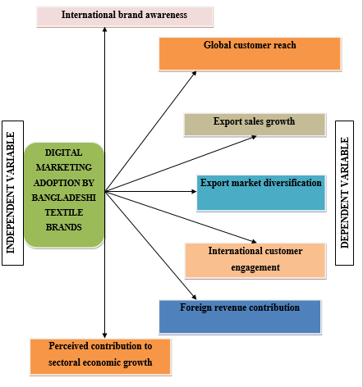

Figure 2.1: Conceptual Framework
(Source: Self-developed)
Justification for variable selection
These variables have been chosen to assess major results associated with the adoption of digital marketing in the textile industry in Bangladesh. The visibility in international markets is captured through international brand awareness and access to the global customer. Export market diversification and export sales growth are tangible performance outcomes that are linked to international expansion. The international interaction with customers evaluates the quality of interaction that is facilitated by online platforms. Foreign revenue contribution represents the straightforward economic value of exports, whereas perceived contribution to sectoral economic growth represents the industry's understanding of the overall economic impact. Collectively, they holistically associate computer marketing utilisation with growth and economic interventions.

Chapter 3: Research Methodology

3.1 Chapter Overview
The chapter provides the research methods employed in the study to meet the objectives of the study. It describes the way in which primary data was gathered to investigate the digital marketing adoption, international brand extending, export performance and economic impact, in the textile industry of Bangladesh. The chapter gives the research philosophy, approach and design. It also describes the sampling, online survey as the method of data collection, and data analysis using SPSS.

3. Research Philosophy
The research philosophy developed in this study is positivist since it is all about objective measurement and testing of hypotheses. Positivism promotes the use of the structured questionnaire and numbers. It enables one to analyse the relationship among digital marketing, brand expansion, export performance and economic outcomes readily (Junjie and Yingxin, 2022). The philosophy is quite appropriate for the quantitative online survey and statistical testing by use of SPSS. It also enhances reliability and minimises biases by the researcher. The reason why interpretivism was not selected is simply the fact that it dwells on the individual meanings and qualitative understandings (Joshi et al. 2023). The choice of pragmatism was not because the study does not confuse methods. Critical realism was ruled out with its focus on profound societal frameworks as opposed to quantifiable consequences.

3.3 Research Approach
The present research employs a deductive research method in that it is focused on verifying the current theories and previous studies regarding digital marketing and international brand expansion. It begins with specific hypotheses and analyses them with primary survey data. Deductive reasoning is the one that underpins statistical analysis, and allows for confirming the existence of relationships between variables (Kumar and Ujire, 2024). It is compatible with a positivist school of thought and a quantitative design. The method also enables generalisation of results to the overall textile industry. The inductive approach had not been selected since the aim of that approach is to construct a new theory using the qualitative data. The abductive approach was discounted because the study does not revolve around unexpected revelation and the building of theories.

3.4 Methodological Choice
The present research uses a quantitative methodological selection since it aims at quantifying the links between digital marketing, global brand growth, and export performance, as well as economic performance. Quantitative methods enable the researcher to gather the maximum respondents in an online survey. This helps in statistical analysis and objective comparison with variables (Dehalwar and Sharma, 2024). Statistics increase the precision and trustworthiness of the results. It also enables results to be analysed in SPSS and directly correlated to the hypotheses of the research. The strategy facilitates generalisation in the textile industry of Bangladesh. A qualitative approach was not selected since it concentrates on deep-seated views rather than quantifiable trends. The mixed-methods approach was avoided to preserve the clarity, consistency, and focus on statistical testing.

3.5 Research Design
The study employs an experimental research design in exploring the cause-and-effect relationship between the results of digital marketing adoption and the international expansion of the brand. The design assists in testing hypotheses with measurable variables. It enables comparison of answers according to various levels of digital marketing usage (Gupta et al. 2023). This will be useful in determining its effect on brand awareness, exports and the economic results. Experimental design is beneficial because it backs statistical analysis and enhances internal validity. It is also very suitable for a quantitative and deductive approach. A descriptive design was not adopted since only patterns are described. An exploratory design was ruled out because the study does not focus on trying to invent something new.

3.6 Population and Sampling
This research study targets the textile and apparel industry professionals in Bangladesh. This is comprised of managers, marketing executives and export officers who are engaged in digital marketing or international activities. The number of people chosen to participate was through randomly in order to have equal opportunities for selection. The approach assists in minimising bias and enhancing representativeness (Makwana et al. 2023). One hundred respondents were involved in the online survey. The sample size used in the study is adequate to be analysed quantitatively and to be tested statistically. This kind of sampling can be used to provide results that can be representative of larger industry trends.

3.7 Data Collection Method
The data collection method employed in this research was primary data collection in terms of an online survey. A questionnaire was prepared in the form of a structured questionnaire, and questions were closed-ended. The survey referral was sent via email. The approach enabled rapid access to the respondents in various textile companies. Data collection through the internet saved time and money. It also enhanced the convenience response of the participants (Soluade et al. 2022). The survey was done voluntarily. The questionnaire had clear instructions as the questionnaire began. Automatic responses are recorded to minimise mistakes in data entry. This approach provided a measure of reliable and consistent data collection according to the objectives of the research.

3.8 Questionnaire Design
The questionnaire was developed in a clear and structured way. It employed closed-ended questions to gather quantitative data. The research objectives and proposals were in line with the questions. The questionnaire was split into blocks that addressed the use of digital marketing, the extension of the brand, export performance, and the economic impact. The level of agreement was measured using a Likert scale. It was done in simple language to ensure there is no confusion. The design assisted in making consistency, accuracy, and analysis in SPSS easy.

3.9 Data Analysis Techniques
The responses that were received from the online survey were analysed by use of SPSS software. The preliminary screening of data was carried out to verify missing values and errors. Demographic information and other important variables were summarised using descriptive statistics. The reliability test was used to determine the consistency of the scales of measurement. The hypotheses were then tested through the inferential analysis (Afifah et al. 2022). The relations between the use of digital marketing and the performance outcomes were investigated by means of correlation analysis. Brand expansion and exports were measured using regression analysis to gauge the effect that digital marketing had on these. Where necessary, the t-tests and ANOVA were employed to test differences between groups. These methods provided valid and reliable findings.

3.10 Ethical Considerations
The research process was conducted using ethical standards. The survey used was entirely voluntary. The purpose of the study was explained to the respondents. Before data collection, consent was signed. Personal or sensitive data was not gathered. Responses were confidential and anonymous. All the answers were anonymous and confidential. Data has been utilised for an academic purpose. The participants were entitled to drop out. The research adhered to the accepted ethical standards of the university and maintained fairness, transparency and respect towards all the respondents.

3.11 Time Scale
Activities | Weeks
Activities | 1 | 2 to 4 | 5 to 9 | 10 to 14 | 15-18 | 19 to 21 | 22
Topic selection
Planning process
Existing literatures are reviewed
Research plan Development
Choosing techniques of research
Online databases
Analysis of collected data
Collecting findings
Conclusion and recommendation
Development of a rough outline of the project
Submission
Table 1: Time-Scale
(Source: Self-Created)

3.12 Conclusion
This chapter described the methods of research that were employed in the study. It supported the research philosophy, approach and methodology used. The chapter entailed the research design, population, sampling, and data collection process. It also described the questionnaire design and methods of data analysis. Ethical concerns and timescale were also defined. In general, this chapter presented a clear and systematic basis towards the achievement of the research objectives.

Chapter 4: Results and Analysis

4.1 Introduction
This chapter provides and examines the survey results using SPSS. Inferential as well as descriptive statistical techniques were used to address the investigation's objectives and test the hypotheses. To investigate differences across demographic groups, t-tests and ANOVA were used, while regression and correlational analyses were used to assess connections between online advertising adoption, international company expansion, performance in exports, and economic development in Bangladesh's textile industry.

4.2 Descriptive Statistics
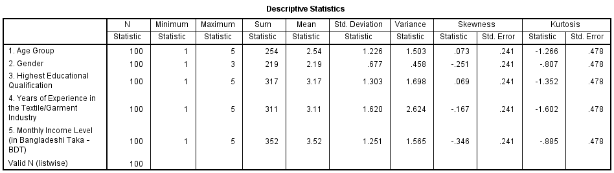

Table 1: Descriptive Statistics
(Source: SPSS output)
The descriptive statistics table highlights the demographic information of the 100 respondents who participated in the survey. The mean results show that respondents are moderately dispersed throughout different ages (M = 2.54), education levels (M = 3.17), industry experience (M = 3.11), as well as income levels (M = 3.52), indicating a well-balanced sample. Standard deviations demonstrate acceptable variety among responders. All variables have skewness and kurtosis values within acceptable ranges below 2, indicating near normal distribution. This establishes the dataset's eligibility for subsequent inferential statistical analysis such as t-tests, correlation, as well as regression.

4.3 Hypothesis Test

4.3.1 Hypothesis 1: Digital marketing adoption has a positive influence on the international brand expansion of Bangladeshi textile firms.
Simple Linear Regression
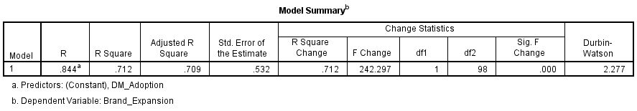

Table 2: Model Summary
(Source: SPSS output)
The Model Summary table shows a substantial correlation between digital marketing usage and worldwide brand expansion. The R value of 0.844 indicates a strong positive connection between the variables. With a R Square value of 0.712, digital marketing adoption accounts for 71.2% of the variance in international brand expansion. The corrected R-squared (0.709) indicates the model's robustness. The standard error of estimate (0.532) shows an acceptable forecast accuracy. The Durbin-Watson value of 2.277 indicates no significant synchronisation issues.
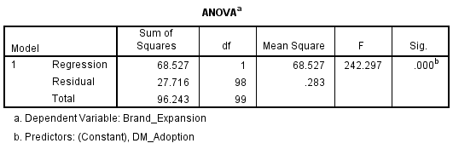

Table 3: ANOVA
(Source: SPSS output)
The regression model's statistical significance is shown by the ANOVA findings. International brand expansion is consistently predicted by the model, as indicated by the F-value of 242.297 at a significance level of p = 0.000. Adoption of internet advertising explains a considerable percentage of the variance in the dependent variable, as seen by the regression statistic's sum of squares (68.527) being significantly higher than the remaining number of squares (27.716). These results validate the suitability as well as significance of the regression model for hypothesis testing.
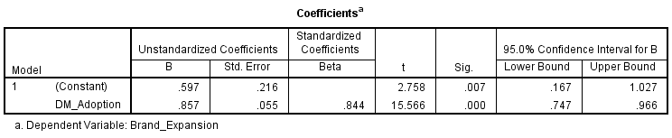

Table 4: Coeeficient
(Source: SPSS output)
Adoption of digital marketing has a considerable as well as significantly positive impact on foreign expansion of brands, as the coefficients table demonstrates. According to the unstandardised coefficient (B = 0.857), brand expansion rises in tandem with an increase in the use of digital marketing. A strong effect size is indicated by the standardised beta value (β = 0.844). The predictor's high relevance is confirmed by the t-value (15.566) along with the significance level (p = 0.000). The estimate's dependability is further supported by the confidence interval.
The regression analysis gives substantial empirical evidence for Hypothesis 1, which states that internet marketing adoption has a beneficial impact on Bangladeshi textile manufacturers' globally recognised brand expansion. The high R-squared value indicates that internet marketing adoption accounts for a significant part of the variance in worldwide brand expansion. The statistically significant ANOVA results support the overall model fit, as well as the positive and substantial regression coefficient shows a strong direct influence. Collectively, these findings demonstrate that increased use of digital marketing methods improves global market access as well as worldwide company growth, thereby validating Hypothesis 1.

4.3.2 Hypothesis 2: Higher use of digital marketing tools significantly improves international brand awareness and customer reach.
Pearson Correlation Analysis
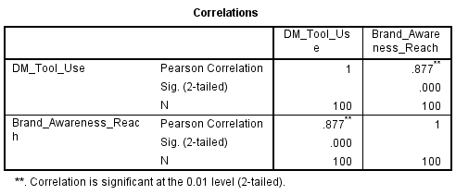

Table 5: Correlation Result
(Source: SPSS output)
The association between the use of digital marketing tools and global brand awareness as well as customer reach is shown in the correlation table. The two variables have an extremely potent positive link, according to the coefficient of Pearson's correlation (r = 0.877). This link is considered significant at the 0.01 level, according to its statistical significance score (p = 0.000). The results are solid and trustworthy with a sample size of 100 respondents. This finding implies that Bangladeshi textile firms' greater global visibility and consumer reach are closely linked to higher instances of digital advertising tool utilisation.
The results firmly confirm Hypothesis 2, which postulated that increased usage of online marketing instruments greatly increases customer reach as well as international brand awareness. The robust positive association shows that brand awareness and customer reach rise sharply with increased use of digital marketing tools. The statistically significant finding confirms the significance of digital marketing tools in improving worldwide brand awareness as well as consumer interaction in the textile industry by showing that this association is not the result of chance.

4.3.3 Hypothesis 3: Digital marketing practices have a positive relationship with the export performance of textile brands in Bangladesh.
Simple Linear Regression
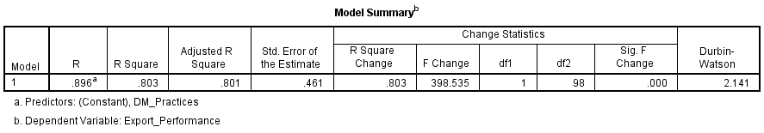

Table 6: Model Summary
(Source: SPSS output)
Export success as well as digital marketing strategies are strongly correlated, as the Model Summary table demonstrates. A strong positive correlation between the variables is indicated by the R value of 0.896. The R-squared score of 0.803 indicates that digital marketing strategies account for 80.3% of the variation in export performance. The model's stability is confirmed by the adjusted R-squared (0.801). While the Durbin–Watson score of 2.141 indicates no autocorrelation issues, the normative error of the estimate (0.461) shows strong prediction accuracy.
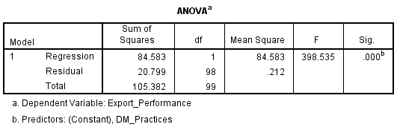

Table 7: ANOVA
(Source: SPSS output)
The statistical significance of the regression framework is confirmed by the ANOVA results. Export performance is significantly predicted by digital marketing strategies, according to the F-value of 398.535 at a significance threshold of p = 0.000. The regression total of squares (84.583) is significantly greater than the residual sum of squares (20.799), indicating that the model accounts for the majority of the variations in the performance of exports. These findings show that the regression model is trustworthy and appropriate for evaluating the suggested theory.
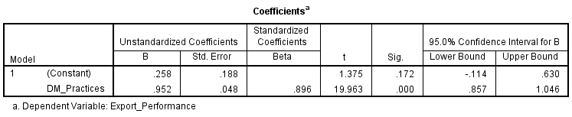

Table 8: Coefficient
(Source: SPSS output)
Digital marketing strategies have a substantial as well as statistically significant positive impact on export success, according to the coefficient table. Greater export performance is correlated with more digital marketing strategies, according to the unstandardised coefficient (B = 0.952). A significant effect size is indicated by the standardised beta coefficient (β = 0.896). The predictor's significance in statistical terms is confirmed by the t-value (19.963) along with the significance level (p = 0.000). The relationship's dependability is further supported by the small confidence interval.
The regression results lend substantial empirical support to Hypothesis 3, which predicted a favourable association between digital marketing strategies and export performance in Bangladesh's textile industry. The high R-squared value indicates that digital marketing techniques account for a significant percentage of the variability in export outcomes. The highly significant ANOVA findings validate the model's overall strength, while the positive and substantial regression coefficient demonstrates a strong direct association. Overall, these findings demonstrate that successful digital marketing tactics have an important role in improving export performance for textile firms, supporting Hypothesis 3.

4.3.4 Hypothesis 4: Effective use of digital marketing contributes positively to economic growth outcomes within Bangladesh’s textile sector.
Simple Linear Regression
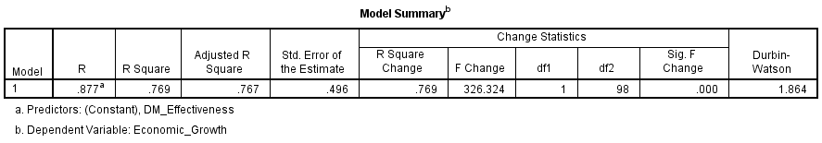

Table 9: Model Summary
(Source: SPSS output)
The Model Summary demonstrates a high positive correlation between digital marketing effectiveness as well as economic growth results. The R-value of 0.877 suggests a strong association between the variables. The R Square score of 0.769 indicates that 76.9% of the variation in economic growth outcomes can be explained through digital marketing performance. The modified R Square (0.767) indicates model dependability. The standard error of 0.496 implies satisfactory prediction accuracy, however the Durbin-Watson value of 1.864 indicates no autocorrelation.
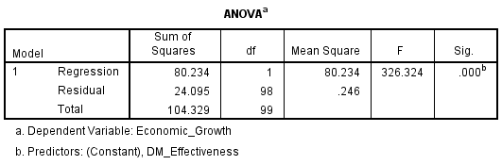

Table 10: ANOVA
(Source: SPSS output)
The statistical significance of the regression model is shown by the ANOVA table. Economic growth results are significantly predicted by digital marketing efficacy, as shown by the F-value of 326.324 at a significance level of p = 0.000. The regression total of squares (80.234) is significantly greater than the residual sum of squares (24.095), indicating that the model accounts for the majority of the variation in economic growth outcomes. This validates the overall fit's goodness.
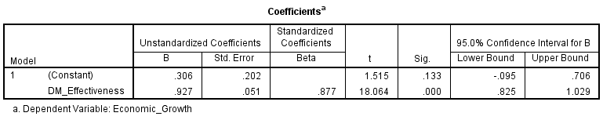

Table 11: Coefficient
(Source: SPSS output)
The coefficients table shows that the results of economic growth are strongly positively impacted by the efficacy of digital marketing. A one-unit improvement in digital marketing effectiveness results in a significant boost in economic growth outcomes, according to the unstandardised coefficient (B = 0.927). A significant impact size is indicated by the standardised beta (β = 0.877). Statistical significance is shown by the t-value (18.064) as well as p-value (0.000). The dependability of the results is further supported by the confidence interval.
Independent Sample T-test
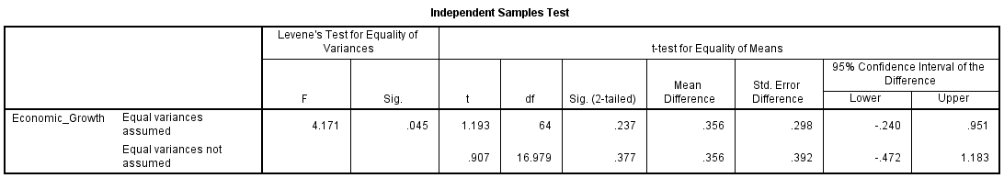

Table 12: Independent Sample T-test
(Source: SPSS output)
The independent samples t-test looks at how two groups perceive economic growth differently. Levene's test shows uneven variances and is significant (p = 0.045). There is no significant difference between the groups, according to the t-test results (p > 0.05). This indicates consistency in replies irrespective of group classification and implies that views of economic growth consequences do not differ considerably across the examined groups.
The findings lend substantial support to Hypothesis 4, which stated that successful use of online advertising improves economic growth outcomes in Bangladesh's textile sector. The regression results demonstrate that digital marketing performance explains 76.9% of the variation in economic growth outcomes. The significance of the ANOVA as well as a positive regression coefficient indicate a substantial and direct impact. Although the t-test finds no group differences, the regression result clearly reveals that higher digital marketing efficacy improves economic growth outcomes, validating Hypothesis 4.

4.4 Summary
The findings and analysis of the study, which used SPSS to investigate the function of digital marketing in Bangladesh's textile industry, are reported in this chapter. Respondent demographics were described using descriptive statistics, and the hypotheses were tested using regression, correlation, and t-tests. The research objectives of the study were met by the findings, which showed that internet advertising greatly enhances export performance, economic growth outcomes, as well as international brand extension.

Chapter 5: Discussion

5.1 Introduction
The chapter is therefore a critical interpretation of the empirical results in relation to the theoretical and empirical information that is presented in the literature review. The debate assesses the impact of the adoption of digital marketing on international brand growth, export, and economic results in the textile industry of Bangladesh. Instead of providing a repeat of results, the current chapter provides the reasoning as to why the identified relationships are found, how they are similar or differ from the findings of previous research, and how they reflect structural realities and strategic constraints of the sector.

5.2 Findings and Discussion

5.2.1 Findings from the descriptive statistics
The descriptive analysis proves the fact that the dataset is sound in terms of statistics and can be applied in terms of inferential testing. The spread of age (M = 2.54), education level (M = 3.17), experience in the industry (M = 3.11), and income-level (M = 3.52) demonstrates the presence of a well-represented respondent profile, which eliminates the possibility of the dominance of one group of respondents. The reasonable values of standard deviation promote sufficient variability, which validates the representativeness of managerial and professional views among textile companies.
Importantly, the values of skew and kurtosis ranged between +/- 2 between variables, which confirmed the normality properties, which enhanced the dependability of regression and correlation results. This statistical stability enhances the belief in the high explanatory power, as is to be released in later analysis, such as R 2 values over 0.70 in all regression models. The strength of the descriptive portrait connotes that the results obtained were not caused by sampling bias and distributional anomalies, and this is a weakness commonly reported in new market studies.

5.2.2 Findings from the literature review
Digital marketing is a tool of enabler of internationalisation identified in the literature by the fact that it reduces the barriers to entry, increases the visibility of the brand, and allows cross-border data-driven interaction (Chakraborty and Jain, 2022). The theories of internationalisation, like the Uppsala model, focus on incremental market commitment, whereas the Resource-Based View as a source of advantage involves internal resources (such as digital competence and brand equity) (Wu and Vahlne, 2022).
In the textile case scenario, other scholars always put forward the argument that digital platforms would allow global access but result in different performance based on the positioning of firms in global value chains (Lubis, 2022). A structural limitation in the textile industry in Bangladesh, as noted in the literature, is that its OEM reliance does not allow for expansion through brand development. Notably, a number of studies indicate that the role played by digital marketing in export growth is indirect and acts as a mediator between brand awareness and relationship-building, as opposed to a direct benefit on the rapid enhancement of sales.

5.2.3 Comparison between the findings from thematic analysis and literature review
The results of the empirical studies have a powerful supporting influence on the current literature and, in certain instances, extend it. The regression of Hypothesis 1 shows that the use of digital marketing predicts 71.2% variance of international brand expansion (R 2 = 0.712, 9 = 0.844, p = 0.001). This scale is greater than those announced in most of the previous emerging market research, and as such, it is insinuated that the digital tools are more definitive in the textile sector of Bangladesh as compared to earlier, as stated by Bala (2024).
Equally, the relationship between the utilisation of digital marketing and the international brand recognition and the ability to reach customers is remarkably high (r = 0.877, p < 0.001). This empirical power directly substantiates the literature statement that visibility and engagement are the main channels through which digital strategies are exerted to affect global presence. The findings dispute research findings that branding excuses less in business-to-business textile markets, and that contract-oriented companies gain advantages of more robust digital signalling (Niu et al., 2023).
The performance results of export performances also expand the literature. The level of variation in export performance attributed to digital marketing practises is 80.3% (R 2 = 0.803, 0.896, p = 0.001), which is contrary to studies that show weak or slow export effects. This deviation can represent enhanced platform integration, online sourcing of buyers, and post-pandemic adaptation to online supplier discovery, to which old research was not able to respond (Kandasamy et al., 2023).

5.2.4 Overall discussion
Together, the results put digital marketing as a structural capacity and not an additional promotional factor in the textile industry of Bangladesh. The ability and stability of the statistical associations imply that the digital adoption can reduce the historical traditional disadvantage associated with the geographic distinctions, poor branding history, and buyer monopoly.
The findings also suggest consistency of the internationalisation theory with the capability-based explanation. Digital marketing creates a speed of learning experience, which is in line with the Uppsala model, yet at the same time plays the role of a valuable and hard-to-copy-resource under the Resource-Based View. Companies which implement digital tools successfully seem to be more equipped to leave cost-based competition to relational and reputational differentiation.
Nevertheless, the results also suggest that not all structural constraints are eliminated by digital marketing only. As much as the performance of the export increases in turn, the continued prevalence of OEM ensures that the branding gains can continue to be disproportionately shared throughout the value chain. The association of high economic growth implies the potential of contribution and not the certain value appropriation. This subtlety provides more strength to the position in the literature according to which digital strategies should be integrated into wider upgrading paths.

5.3 Summary
This chapter has critically analysed the interaction of empirical findings with the existing theory and evidence. The discussion validates that the use of digital marketing reflects a substantial growth in the expansion of international brands, export into a given economy, and the perceived economic value in the textile sector of Bangladesh. The statistical findings reveal significant potential when compared to most of the existing literature that reflects a paradigm shift in the workings of digital capabilities in export-oriented manufacturing firms. The results confirm resource-based arguments and internationalisation and demonstrate sector-related limitations that influence the results. On the whole, the discussion highlights digital marketing as a disruptive yet specific force of global competitiveness and economic influence.

Chapter 6: Conclusion and Recommendations

6.1 Summary of findings
The results reveal that digital marketing is a powerful factor in expanding international brands in the Bangladesh textile industry. Findings of regression verified that increased digital marketing adoption results in increased global brand growth. The digital marketing tools and international brand awareness, and customer reach also had a strong positive relationship. This analysis revealed that the companies that had successfully adopted digital marketing demonstrated improved export performance. Digital marketing was also revealed to have positive effects to financial growth outputs in the textile sector. A checked sample was ensured by descriptive statistics. Significant statistical outcomes also supported all hypotheses. The results indicate that online applications enable clothing brands to enhance presence, enter new markets and reinforce exports. Digital marketing is a significant force of competition and development in the sector.

6.2 Linking with Objectives
All the research objectives were directly covered in the results, as well as in other sections. Descriptive statistics and regression were used to test the level of digital marketing adoption. This assisted in evaluating it as a global market expansion. Correlation analysis was used to analyse the effect of digital marketing on international brand awareness and customer reach. Positive relationships were found to be strong. Regression analysis was used to test the relationship between the use of digital marketing and export performance. The impact was positive and significant. Attitudes towards industry actors towards the performance of economic growth were measured by survey data and regressions. These results demonstrated that digital marketing favours broader economic gains. The findings presented clear and quantifiable evidence based on every research objective.

6.3 Recommendations
According to the results, textile companies in Bangladesh ought to use more digital marketing to expand into the global market. The companies ought to invest in social media marketing strategy, search engine marketing and e-commerce spheres (Khrais and Gabbori, 2023). This will assist in enhancing the awareness of the brand in the international market and customer reach. The data analytics should be employed by firms in order to know the overseas customer behaviour and preferences. Employees should be trained to increase their digital skills. Low-cost digital tools should be used by small and medium textile firms to compete globally (Ulugbek, 2025). There should be a sharing of knowledge on digital best practices through the industry associations. The policymakers are to enhance the quality of digital infrastructure and the internet for businesses. There should be more government support for training on digital marketing and export promotion. Web trade regulations ought to be clearly established to facilitate e-commerce across borders. The government, industry, and digital service providers should be urged and encouraged to cooperate (Ahi et al.2023). This measure can boost the export performance and help in the economic growth of the textile industry in the long term.

6.4 Implications of the study
Various stakeholders have significant implications for this study. In the case of businesses, it demonstrates that digital marketing is critical to expanding global brands and achieving success in export. The findings would enable managers to enhance digital strategies. To the policymakers, the research shows that powerful digital support and export-oriented policies are needed. It goes into the digital skills and infrastructure investment as well. To the researchers, the research offers empirical evidence in an emerging economy. It provides the foundation of future research in the area of digital marketing and economic development.

6.5 Limitations of the study
There are certain limitations in this work. The study relied solely on primary data gathered in the form of an online survey. It did not involve secondary data, and this could be a limitation for further comparison with industry reports. Only 100 respondents were utilised in the sample size. This could minimise broader generalisation. Doing long data collection and follow-up responses was limited by time constraints. The limitations of the resources did not allow more complicated analysis either. The research was based on the self-released answers and might contain subjectivity. Such limitations must be taken into account during the interpretation of the findings.

6.6 Future scope of the study
Further research can increase the sample size to enhance generalisation. The researchers will be able to access some textile companies in various regions and markets. Survey data can be merged with secondary data such as export records, industry reports. Interviews can be used to capture more information using the qualitative approach. The effect of digital marketing can also be seen through longitudinal studies. Other emerging countries can also have comparative studies. Other studies in the future can look into other specific tools like social media, e-commerce, and data analysis.

References
- Aancy, H.M., Bandyapadhyay, M., Taneja, S., Rao, P.V. and Srivastava, B., 2023. Identifying the factors influencing digital marketing and brand-consumer relationship. Risk and Decision Analysis, 9(1), pp.19-29.
- Afifah, S., Mudzakir, A. and Nandiyanto, A.B.D., 2022. How to calculate paired sample t-test using SPSS software: From step-by-step processing for users to the practical examples in the analysis of the effect of application anti-fire bamboo teaching materials on student learning outcomes. Indonesian Journal of Teaching in Science, 2(1), pp.81-92.
- Ahi, A.A., Sinkovics, N. and Sinkovics, R.R., 2023. E-commerce policy and the global economy: a path to more inclusive development?. Management International Review, 63(1), pp.27-56.
- Ahmad, U.F., Mahdee, J. and Bakar, N.A., 2024. Search engine optimisation (SEO) strategy as determinants to enhance the online brand positioning. F1000Research, 11, p.714.
- Anumula, S.K., 2025. A Novel Process Framework for Manufacturing Supplier Collaboration in Original Equipment Manufacturing (OEM). European Journal of Logistics, Purchasing and Supply Chain Management, 13(1), pp.75-92.
- Bala, A., 2024. Digital Marketing in International Business. Latest trends in business, p.61.
- Chakraborty, A. and Jain, V., 2022. Leveraging digital marketing and integrated marketing communications for brand building in emerging markets. In Marketing Communications and Brand Development in Emerging Economies Volume I: Contemporary and Future Perspectives (pp. 281-305). Cham: Springer International Publishing.
- Deepal, A.G. and Jayamaha, A., 2023. Audit Expectation Gap: A Comparative Literature Analysis of Private Sector and Public Sector. Wayamba Journal of Management, 14(1).
- Dehalwar, K.S.S.N. and Sharma, S.N., 2024. Exploring the distinctions between quantitative and qualitative research methods. Think India Journal, 27(1), pp.7-15.
- Ficci, (2026), Bangladesh's Growing Digital Economy, Available at: https://www.ficci.org.bd/ficci-stories/bangladeshs-growing-digital-economy [Accessed on 6th January 2026]
- Fregidou-Malama, M., Chowdhury, E.H. and Hyder, A.S., 2023. International marketing strategy of emerging market firms: the case of Bangladesh. Journal of Asia Business Studies, 17(4), pp.804-823.
- Godara, R.S., Nayak, A.K., Senapati, S.B. and Kullu, B.P., 2023. Role of Digital Marketing in Business Expansion. International Research Journal of Economics and Management Studies IRJEMS, 3(4).
- Gupta, P., Raza, K., Mini Agrawal, D.H.B.J., Patil, H. and Somashekhar, I.C., 2023. Antecedents of Pharmaceutical Digital Marketing Challenges and opportunities: A Descriptive Research Design. Journal of Pharmaceutical Negative Results¦ Volume, 14(3), p.1816.
- Investbangladesh, (2026), Textiles and apparel, Available at: https://www.investbangladesh.gov.bd/investment-sector/textiles-apparels [Accessed on 6th January 2026]
- Islam, M.T., Hassan, M.N., Kabir, M., Robin, M.A.H., Farabi, M.M.H. and Alauddin, M., 2022. Sustainable Development of Apparel Industry in Bangladesh: A Critical Review. Journal of Management Science & Engineering Research, 5(2), pp.45-62. (Islam et al. 2022)
- Joshi, A., Roy, S., Manik, R.K. and Sahoo, S.K., 2023. Scientific Philosophy: Exploring Existential, Metaphysical, and Ethical Research Philosophy Behind the Question “WHO AM I?”. Journal of Pharmaceutical Negative Results, pp.1648-1671.
- Junjie, M. and Yingxin, M., 2022. The Discussions of Positivism and Interpretivism. Online Submission, 4(1), pp.10-14.
- Kandasamy, J., Venkat, V. and Mani, R.S., 2023. Barriers to the adoption of digital technologies in a functional circular economy network. Operations Management Research, 16(3), pp.1541-1561.
- Khrais, L.T. and Gabbori, D., 2023. The effects of social media digital channels on marketing and expanding the industry of e-commerce within digital world. Periodicals of Engineering and Natural Sciences, 11(5), pp.64-75.
- Kumar, D., Phani, B.V., Chilamkurti, N., Saurabh, S. and Ratten, V., 2023. Filling the SME credit gap: a systematic review of blockchain-based SME finance literature. Journal of trade science, 11(2/3), pp.45-72.
- Kumar, S. and Ujire, D.K., 2024. Inductive and deductive approaches to qualitative research. International Journal of Multidisciplinary Educational Research, 13(1), pp.58-63.
- Li, S., Shi, Y., Wang, L. and Xia, E., 2023. A bibliometric analysis of brand orientation strategy in digital marketing: Determinants, research perspectives and evolutions. Sustainability, 15(2), p.1486.
- Lubis, N.W., 2022. Resource based view (RBV) in improving company strategic capacity. Research Horizon, 2(6), pp.587-596.
- Makwana, D., Engineer, P., Dabhi, A. and Chudasama, H., 2023. Sampling methods in research: A review. International Journal of Trend in Scientific Research and Development, 7(3), pp.762-768.
- Nim, N., Pedada, K. and Hewett, K., 2024. Digital marketing ecosystems and global market expansion: current state and future research agenda. International Marketing Review, 41(5), pp.872-885.
- Niu, Y., Wen, W., Wang, S. and Li, S., 2023. Breaking barriers to innovation: The power of digital transformation. Finance Research Letters, 51, p.103457.
- Parris, D.L. and Guzmán, F., 2023. Evolving brand boundaries and expectations: looking back on brand equity, brand loyalty, and brand image research to move forward. Journal of Product & Brand Management, 32(2), pp.191-234.
- Pattanayak, M., Shankar, A.U., Rathod, M.K., Srinivas, A. and Tyagi, S., 2023. Analyzing effect of digital marketing on the expansion of the retail sector. Rivista Italiana di Filosofia Analitica Junior, 14(1), pp.996-1005.
- Raihan, S., 2024. Informal institutions, the RMG sector, and the present challenge of export diversification in Bangladesh. Is the Bangladesh Paradox Sustainable, pp.101-136.
- Rupeika-Apoga, R. and Petrovska, K., 2022. Barriers to sustainable digital transformation in micro-, small-, and medium-sized enterprises. Sustainability, 14(20), p.13558.
- Silva, N.S.E., Castro, R. and Ferrao, P., 2025. Smart Grids in the Context of Smart Cities: A Literature Review and Gap Analysis. Energies, 18(5), p.1186.
- Soluade, O., Idowu, S.O. and Sofadekan, A.O., 2022. Attitudes of Undergraduate Teachers Towards the Application of Statistical Package for Social Science When Teaching Statistics in Social Studies. Journal of Lexicography and Terminology (Online ISSN 2664-0899. Print ISSN 2517-9306)., 6(1), pp.134-144.
- Sunggara, A.D., Nurhaliza, P., Ferdinand, A.T. and Dirgantara, I.M.B., 2022. Digital marketing on sales effectiveness and market expansion for MSMEs: A literature review. Arthatama: Journal of Business Management and Accounting, 6(2), pp.55-65.
- Ulugbek, Y., 2025. INNOVATIVE MANAGEMENT PRACTICES AND THE STRATEGIC DEVELOPMENT OF SMALL AND MEDIUM-SIZED TEXTILE ENTERPRISES. AMERICAN JOURNAL OF EDUCATION AND LEARNING, 3(11), pp.721-736.
- Utomo, S.B., Nugraha, J.P., Indrapraja, R. and Panjaitan, F.A.B.K., 2023. Analysis of The Effectiveness of Integrated Digital Marketing Communication Strategies in Building MSMEs Brand Awareness Through Social Media. Jurnal Sistim Informasi dan Teknologi, pp.8-13.
- Wu, J. and Vahlne, J.E., 2022. Dynamic capabilities of emerging market multinational enterprises and the Uppsala model. Asian Business & Management, 21(5), pp.690-714.
- Xames, M.D. and Topcu, T.G., 2024. A systematic literature review of digital twin research for healthcare systems: Research trends, gaps, and realization challenges. IEEE Access, 12, pp.4099-4126.
- Yang, G., 2024. Exploration of marketing strategy of cross-border e-commerce enterprises under digital marketing mode. American Journal of Religious, Culture, and Archaeological Studies, 1(5), pp.27-33.

Appendices

Appendix 1: Data Set

Appendix 2: SPSS Input and Output

