
Skills for the Workplace
Module Assignment Submission
Student Name: | Tamin Miah
Student Number: | 1818711
Module No: | BMSK4002
Module Title: | Effective Team Working and Communication  Part 1

Statement of Confirmation of Authenticity
By the act of making this submission, the student declares that this is the work of the student named above. The work has not, in whole or in part, been knowingly presented elsewhere for assessment, or where assessment has been built on a previous assessment, this has been identified. Where materials have been used from other sources it has been properly acknowledged. If this statement is untrue, the student acknowledges that an assessment offence has been committed.
Attention is drawn to the plagiarism and unfair practice policies of both the University and of ILM.

Contents
Introduction…………………………………………………………………………………………………………………………………………………………………..3
Name of Presenter…………………………………………………………………………………………………………………………………………………………3
Aim:……………………………………………………………………………………………………………………………………………………………………………… 3
Objectives: 3
Presentation Content 4
Manangement Sypnosis: 5
Evaluation of presentation and feedback: 6
Tamin’s Reflection: 8
Conclusion: 10
References: 11
Appendix A……………………………………………………………………………………………………………………………………………………………………12
Appendix B 17
Appendix C……………………………………………………………………………………………………………………………………………………………………25
Appendix D……………………………………………………………………………………………………………………………………………………………………26
Appendix E……………………………………………………………………………………………………………………………………………………………………27
Appendix F……………………………………………………………………………………………………………………………………………………………………31
Appendix G……………………………………………………………………………………………………………………………………………………………………32

Introduction

Effective teamwork is important in a workplace for the company to succeed and progress. A team is a group of people who work together to complete a common goal and therefore it is important to build a great performing team so that productive results are produced at work (Kukhnavets, 2018). A team development requires different stages of formation which the report writer will explain using the Tuckman theory on a PowerPoint presentation.

Name of Presenter

Student Name: Tamin Miah

Aim:

To give the audience an understanding between the differences between a group and a team and explain the stages of how the formation of a team building occurs based on the Tuckman theory.

Objectives:

- Describe what is a team and a group and explain the differences between them both so that the audience can understand that they are different from each other.
- Introduce Tuckman theory and explain how the model is used for team formation.
- Discuss the five stages of Tuckman theory, so that the audience can gain an understanding of what each stage means and the process for team development.
- Explain the conclusion so that the audience can understand the overall presentation.

Presentation Content

Slide | Content
1 | Presentation Title
2 | Introduction
3 | What is a Team?
4 | What is a Group?
5 | Differences between a team and a group?
6 | Team development models
7 | Tuckman’s Theory
8 | Forming
9 | Storming
10 | Norming
11 | Performing
12 | Adjourning
13 | Conclusion
14 | References
15 | Questions

Management Sypnosis:

The report writer had to conduct an online PowerPoint presentation on effective team working, in a timeframe of 8-10 minutes using Microsoft Teams. The presentation needed to explain what is a team and a group, the differences between the both and explain the Tuckman’s five stages of team development formation followed by a conclusion.
Unfortunately, due to the current pandemic situation caused by the COVID-19 virus the report writer will not be able to work in small groups and present this at the university. Therefore, they must use Microsoft Team to deliver the presentation online on their laptop. This was a challenging situation for the report writer as they have not completed an individual presentation before and will not also be able to attend university for guidance. However, the report writer was happy to complete the task and take full ownership and responsibility in doing so.
The report writer had to do thorough research on effective team working and create a PowerPoint presentation. They had to make sure relevant information was added on the PowerPoint slide, ensuring the slides are simple and clear for the audience to understand. Along with the presentation, they had to create a lesson plan, handouts and feedback form as well.
By attending the online tutor classes regularly and having catchups on the university WhatsApp group enabled the report writer to complete their presentation before the deadline and they were also able to provide help to other students if required.
The report writer successfully delivered their presentation on effective team working using Microsoft Teams, within 10 minutes which is the maximum time-limit. Once the presentation was finished the report writer answered any questions sufficiently and attached accompanying handouts and feedback form on Microsoft Teams for the audience to review.

Evaluation of presentation and feedback:

Feedback from the audience was analysed and it would suggest the audience found my presentation interesting as two audience rated my presentation 5 and the remaining three audience rated 4 for first impression (Appendix A). The audience commented that the presentation layout was brief and colourful which helped them follow the presentation and understand the information presented on the slide. However, they felt I was a bit away from the laptop and the background lighting was a bit dark which prevented me from receiving the highest rate.
First impressions matter a lot in a presentation as the audience will straightaway make an initial judgement on the presentation including the presenter which can have lasting effects (Arora, 2020). Although, I am pleased my first impression score was good, I know the areas I can improve on for future online presentations.
My tone of voice was scored mainly four based on my feedback form (Appendix A). This could be because to start off with I was feeling anxious as this was my first solo presentation, so my voice sounded nervous at the beginning. However, within few seconds I controlled my tone of voice and presented the information in a clear manner with a calm tone of voice. It is important for one to have the appropriate tone of voice so that the audience stays engaged with the message you are trying to convey through the presentation (Boyd, 2019).
I am happy about my confidence score as I received the score five from all the audience (Appendix A). I was not expecting a high score as I have never delivered a presentation before alone, so it was a challenging situation for me from the beginning of creating the presentation to completing it by presenting it to the audience. However, I believe practising my presentation beforehand a few times has really helped with building my confidence and this contributed towards me achieving a high score. Confidence enables the audience to have a better understanding of the information and helps you become better focused and stay calm (Ashish, 2019).
My body language received a mix score of four and five based on the feedback form (Appendix A). I received positive and negative comments regarding my body language where some commented that my hand gesture was good during the presentation and I presented naturally, however the room lighting was not the greatest, so the audience felt my face was not as clear as the room was a bit dark.
Therefore, I am happy that I tried to deliver my presentation naturally and use hand gestures to draw attention, however my room lighting will be an area that I can improve on for future presentation. Body language is important in a presentation as it allows the presenter to express their emotions and focus on what they are saying which helps connect with the listeners (Totalcommunicator, 2019).
My communication score was mainly five and one audience scored me four (Appendix A). I am happy with my communication score as it was the first time I was presenting so being anxious and nervous would have impacted on my speech. I did speak a bit fast to begin with but realising this I slowed down and tried to communicate clearly and slowly throughout the presentation where I managed to complete the presentation within the timeframe of 10 minutes. It is important to have clear communication during a presentation so that the audience can understand the message one is delivering (Sharma, 2019).
The areas that I would need to improve on would be my tone of voice, background setting and communication. As this was a first-time experience, I was anxious to present in front of a group which had an impact on my tone of voice, but I now know to practise on this for upcoming presentations. Unfortunately, my room lighting was out of my control that day but again I would ensure my background is clear so that no lighting affects my face or body language and I will also make sure my laptop is closer if I was to present on this again. My communication was good however I will make sure that I speak slower and pause in between slides so that it gives the audience more better understanding of my presentation.
Overall, the presentation went well on a positive basis as three audience rated my presentation 9 and two audience rated 8 out of 10 which I am happy about especially being my first presentation. The audience agreed that my presentation conveyed the message clearly and they all gained additional knowledge and the handouts supported my presentation as well (Appendix A).

Tamin’s Reflection

Reflecting on myself I would say I am very pleased with my presentation, as based on the whole situation of being lockdown and not being able to present in a group and having to do it by myself was somewhat terrifying and challenging. However, I am proud that I did manage to overcome this by going out of my comfort zone and presenting alone in front of the audience.
I had to deliver a presentation on effective team working within a timeframe of 8-10 minutes which also included any questions. I first thought this may be difficult for me as I may deliver my presentation under 8 minutes especially if I talk too fast or go over the time limit especially if lots of questions were asked. Therefore, I first had to mentally prepare myself in making sure that I will keep calm and speak slow throughout the presentation and that I will rehearse my presentation a few times so that I can check my time is within the 8-10 minutes timeframe.
As I had to complete the task alone, I had to plan my workload efficiently by understanding how to create a PowerPoint presentation as I have never created one before and doing research on effective teamwork. When creating my PowerPoint, I made sure all the slides were consistent with regards to the slide design and background colour. The information added was in bullet point and in the same writing style and size format so that its clear and simple for the audience to read. Along with the presentation slides (Appendix B), I had to also create a lesson plan (Appendix C), feedback form (Appendix D) and handouts (Appendix E).
I attended the online tutor classes as Beth (our tutor) was helpful in providing guidance on what is required in the presentation and that we should just try to be our natural self when presenting. We also created a group chat WhatsApp group (Appendix F) so that we all can provide help to each other or even give words of encouragement for the presentation as we all are individually completing this and pretty much in the same boat.
When delivering our presentation we had to use the system Microsoft Teams on our laptop which I have not done before so again I had to understand how to do this including how to upload the presentation and accompanying documents. As we had to present on the laptop, we were told we need to upload a rehearsed presentation on Microsoft Teams and complete a live presentation as well. This is because if there were any technical issues on the live presentation day then there would need to be a back-up of our presentation as we cannot come to the university and present due to the lockdown situation.
Therefore, I had to understand how to upload my presentation on Microsoft Teams including the accompanying documents. I must admit this was not the easiest as no one is familiar with using Microsoft Teams system and how to record a presentation on there. However, I managed to figure it out and uploaded a backup of my presentation for my tutor Beth to view. Some students also found this difficult to do, however, as I managed to complete this I gave them advise on the WhatsApp group in how to upload the presentation recording (Appendix G).
Generally, I suffer from anxiety and therefore I knew this will have an impact on my presentation and would be one of my weaknesses. When I started presenting my voice sounded nervous and I did speak quite fast and did even mess up a word, however, I quickly picked up on this and started speaking at a slower pace and tried to stay calm. I know this is something I can work on for the future by keep practising and taking time and even looking at tips on how to overcome my anxiety.
Overall, I felt my presentation was delivered successfully as I managed to complete it within 10 minutes and completed it individually which is a great achievement I can always reflect on. My feedback from the audience commented that my presentation was good and clear, but the main drawback was the lighting of the room where it looked dark. Again, this was out of my control however this is an area I can improve on for future presentation so that I can gain higher marks for the body language section.

Conclusion

To conclude, the report writer managed to cope and deliver a good presentation individually on effective team working. Through their feedback and reflection analysis the report writer gathered areas they were weak on such as tone of voice, lighting. However, the report writer will take into board the areas of improvement so that they can perform better for future presentations.
It has been found that in order to have an effective team it is important for everyone to help each other out by providing support towards a common goal and to have a good leader (Teamwork Definition, 2020). Even though our university team was not able to gather together due to the current pandemic situation, having online classes with the tutor and support on the WhatsApp group chat enabled everyone to keep on track with the presentation and be able to deliver it appropriately on the day. Therefore, in a way we all helped each other out as a team towards delivering our presentation.

References

Arora, A. (2020) 5 Ways Presenters Can Make a Great First Impression Available at: https://visme.co/blog/first-impressions/ (Accessed: 13th May 2020).
Ashish, A. (2019) Why confidence is important in public speaking Available at: https://www.sketchbubble.com/blog/why-confidence-is-important-in-public-speaking/ (Accessed: 13th May 2020).
Boyd, S. (2019) Presentation skills: How you speak it, tone of voice Available at: https://www.skillsociety.com/presentation-skills-tone-of-voice.html (Accessed: 13th May 2020).
Kukhnavets, P. (2018) How to define an effective team? Available at: https://hygger.io/blog/11-characteristics-of-effective-team/ (Accessed: 13th May 2020)
Sharma, V. (2019) Importance of presentation skills – Effective communication Available at: https://www.klientsolutech.com/importance-of-presentation-skills/ (Accessed: 14th May 2020).
Teamwork Definition, (2020) Support each other for better teamwork. Available at: https://teamworkdefinition.com/examplesofteamwork/support/ (Accessed: 16th May 2020).
Totalcommunicator, (2019) While Your talking, what is your body saying? Available at: http://totalcommunicator.com/body_article.html (Accessed: 14th May 2020).

Appendix A

TAMIN’S FEEDBACK FORM
Student Name: Abdur Rahim
Rate 1-5 on each component of Tamin’s presentation skills (1-lowest to 5 highest)

First Impression | Tone of Voice | Confidence | Body Language | Communication
5 | 4 | 5 | 5 | 5

Did the accompanying PowerPoint slides support and convey the message properly?
Circle – YES NO

Did the accompanying handout support the presentation adequately?
Circle – YES NO

Did you feel you have gained additional knowledge on the subject?
Circle – YES NO

Overall how did you feel the presentation went? (between 1 lowest - 10 highest)
Circle – 1 2 3 4 5 6 7 8 9 10

Any feedback/comments for future presentations? (comment below)
Very good presentation and colourful, really liked the background as it was consistent, spoke well and explained the slides.

TAMIN’S FEEDBACK FORM
Student Name: Ripa Begum
Rate 1-5 on each component of Tamin’s presentation skills (1-lowest to 5 highest)
First Impression | Tone of Voice | Confidence | Body Language | Communication
5 | 5 | 5 | 4 | 5

Did the accompanying PowerPoint slides support and convey the message properly?
Circle – YES NO

Did the accompanying handout support the presentation adequately?
Circle – YES NO

Did you feel you have gained additional knowledge on the subject?
Circle – YES NO

Overall how did you feel the presentation went? (between 1 lowest - 10 highest)
Circle – 1 2 3 4 5 6 7 8 9 10

Any feedback/comments for future presentations? (comment below)
Enjoyed the presentation, it was simple and clear however light setting was not good.

TAMIN’S FEEDBACK FORM

Student Name: Louise Rickett
Rate 1-5 on each component of Tamin’s presentation skills (1-lowest to 5 highest)
First Impression | Tone of Voice | Confidence | Body Language | Communication
4 | 5 | 5 | 4 | 5

Did the accompanying PowerPoint slides support and convey the message properly?
Circle – YES NO

Did the accompanying handout support the presentation adequately?
Circle – YES NO

Did you feel you have gained additional knowledge on the subject?
Circle – YES NO

Overall how did you feel the presentation went? (between 1 lowest - 10 highest)
Circle – 1 2 3 4 5 6 7 8 9 10

Any feedback/comments for future presentations? (comment below)
A bit away from the laptop otherwise a good presentation

TAMIN’S FEEDBACK FORM

Student Name: Holly Gauci
Rate 1-5 on each component of Tamin’s presentation skills (1-lowest to 5 highest)
First Impression | Tone of Voice | Confidence | Body Language | Communication
4 | 4 | 5 | 5 | 4

Did the accompanying PowerPoint slides support and convey the message properly?
Circle – YES NO

Did the accompanying handout support the presentation adequately?
Circle – YES NO

Did you feel you have gained additional knowledge on the subject?
Circle – YES NO

Overall how did you feel the presentation went? (between 1 lowest - 10 highest)
Circle – 1 2 3 4 5 6 7 8 9 10

Any feedback/comments for future presentations? (comment below)
Hand gestures were good, natural presentation however background lighting not good.

TAMIN’S FEEDBACK FORM

Student Name: Shorni
Rate 1-5 on each component of Tamin’s presentation skills (1-lowest to 5 highest)
First Impression | Tone of Voice | Confidence | Body Language | Communication
4 | 4 | 5 | 5 | 5

Did the accompanying PowerPoint slides support and convey the message properly?
Circle – YES NO

Did the accompanying handout support the presentation adequately?
Circle – YES NO

Did you feel you have gained additional knowledge on the subject?
Circle – YES NO

Overall how did you feel the presentation went? (between 1 lowest - 10 highest)
Circle – 1 2 3 4 5 6 7 8 9 10

Any feedback/comments for future presentations? (comment below)
Clear presentation, nothing to improve just lighting to be better.

Appendix B

Presentation Slides
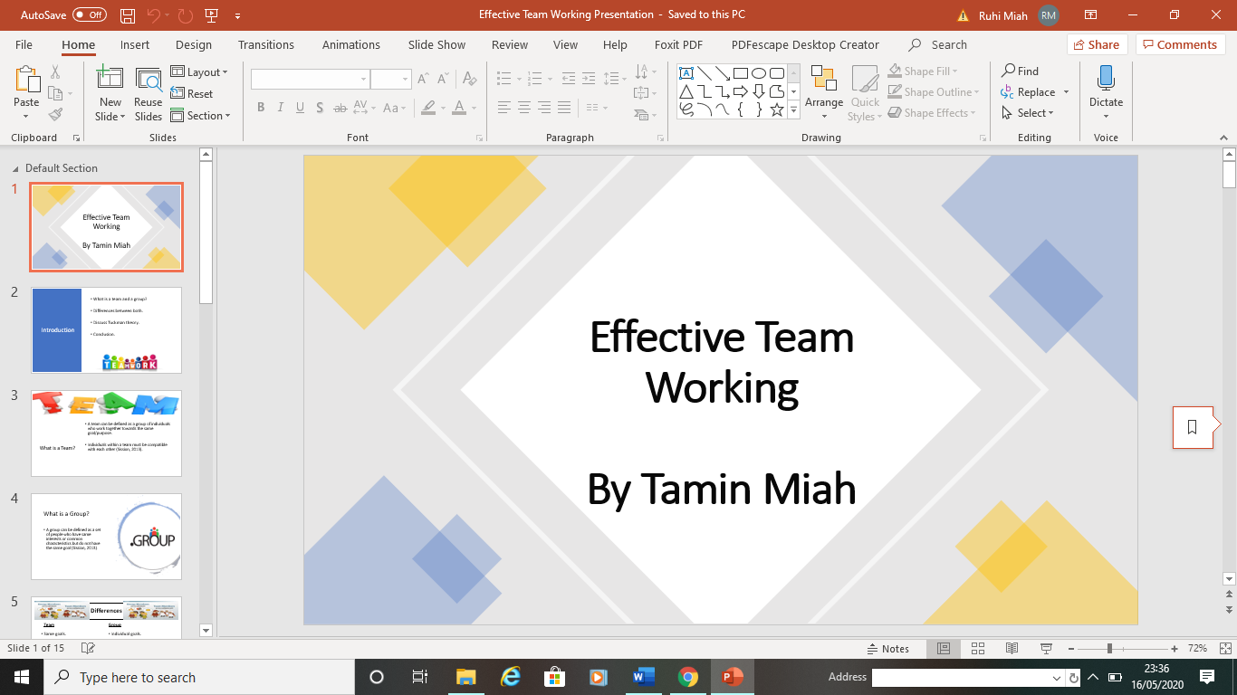

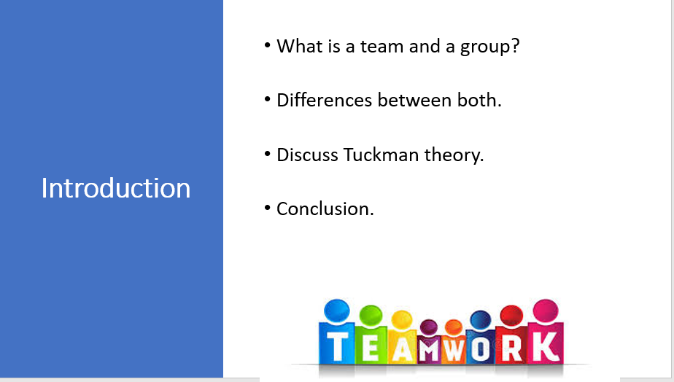
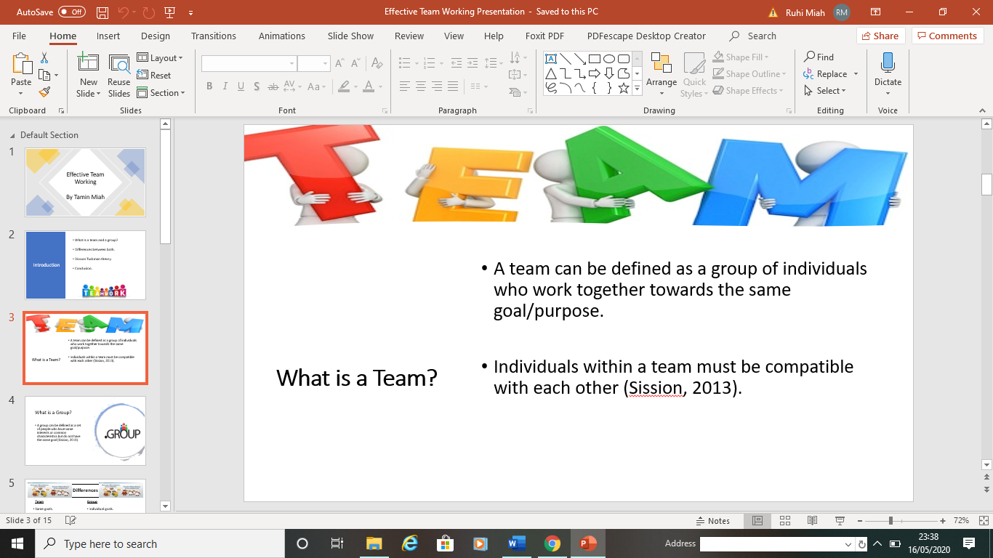

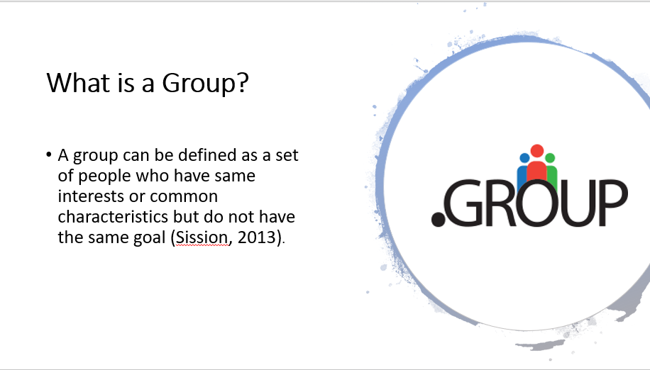

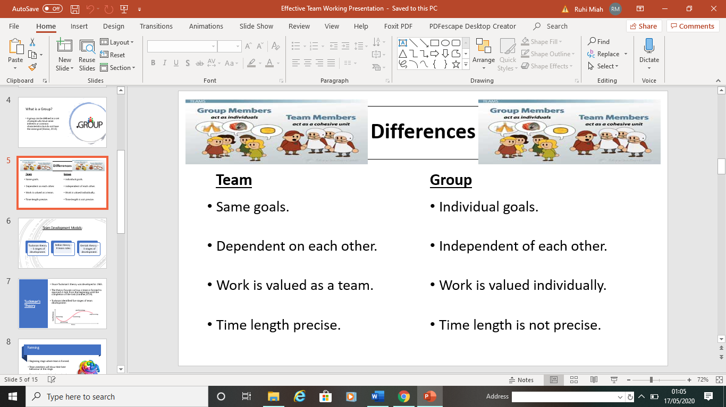

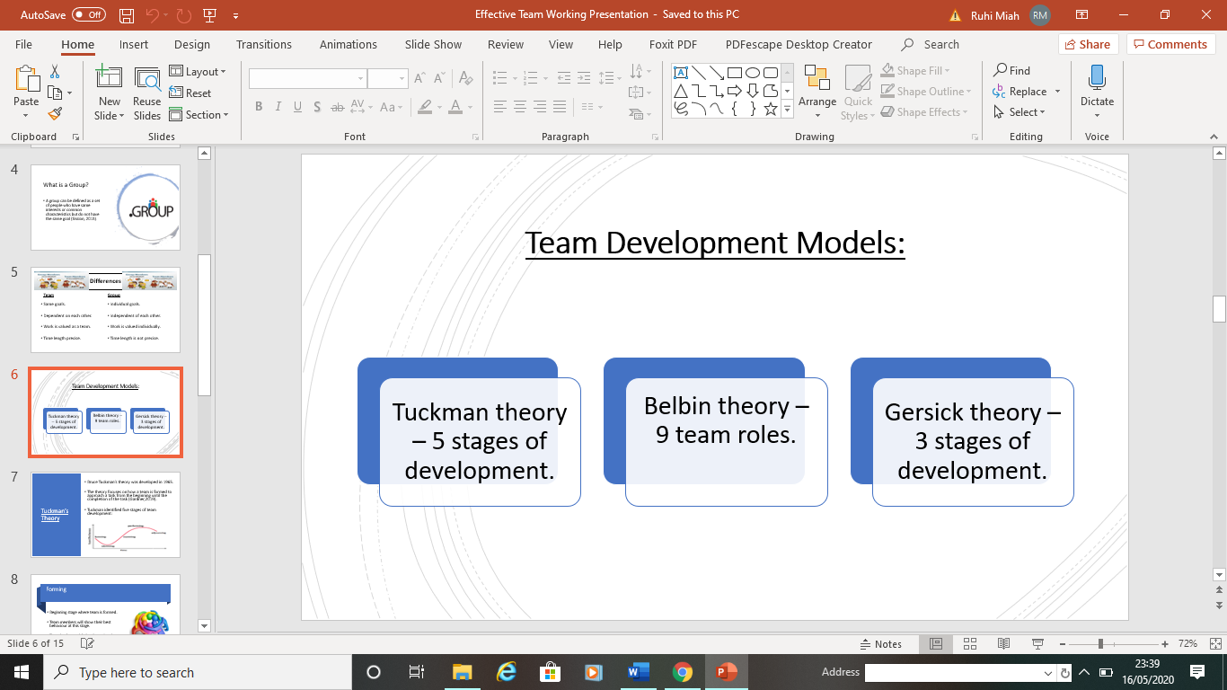

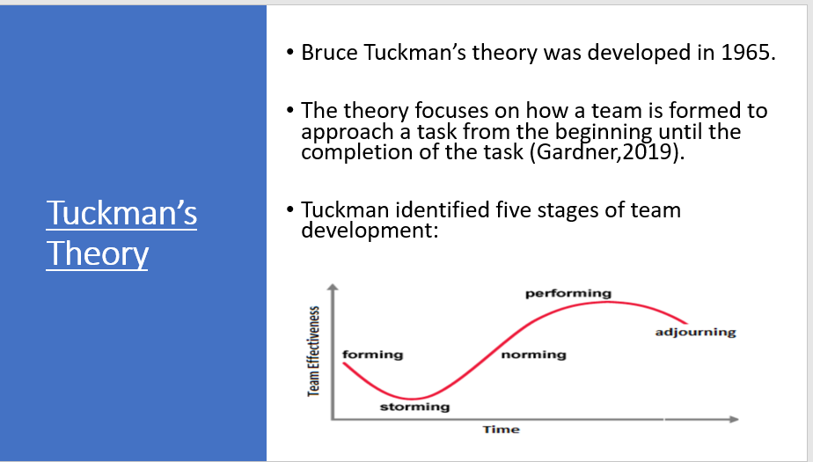

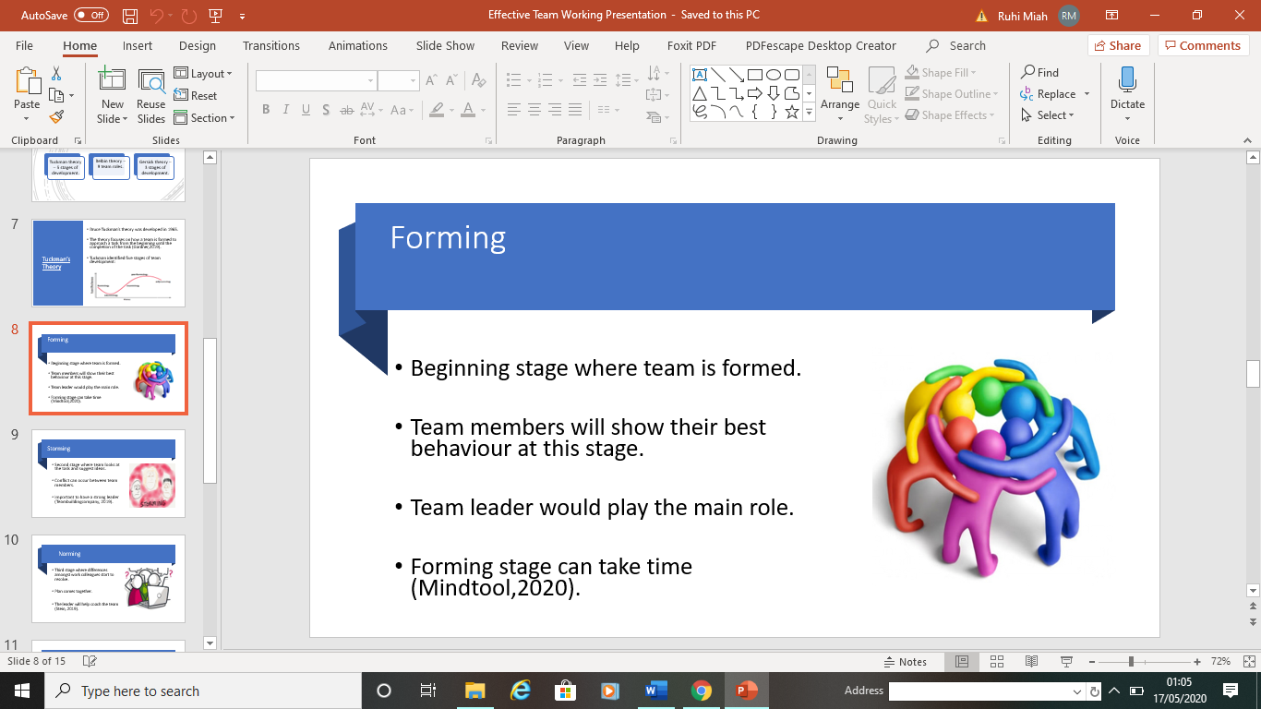

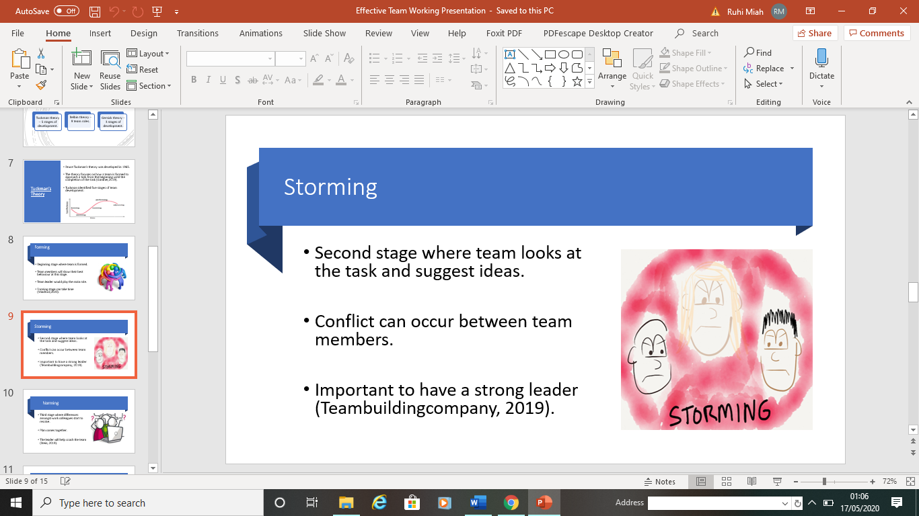

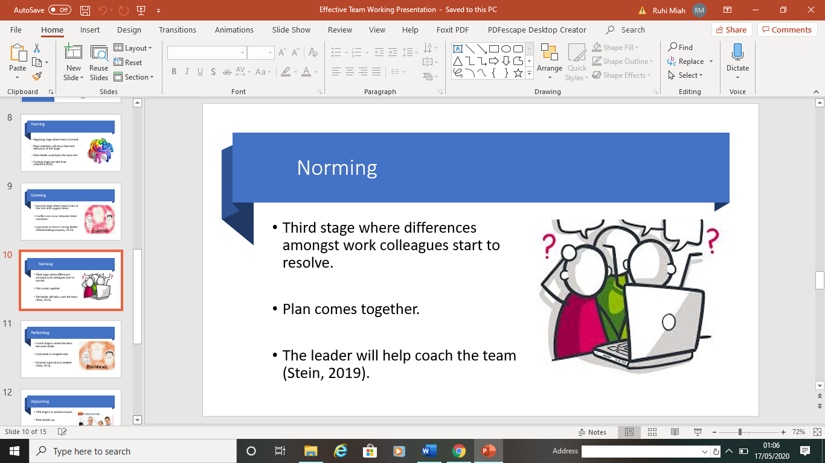

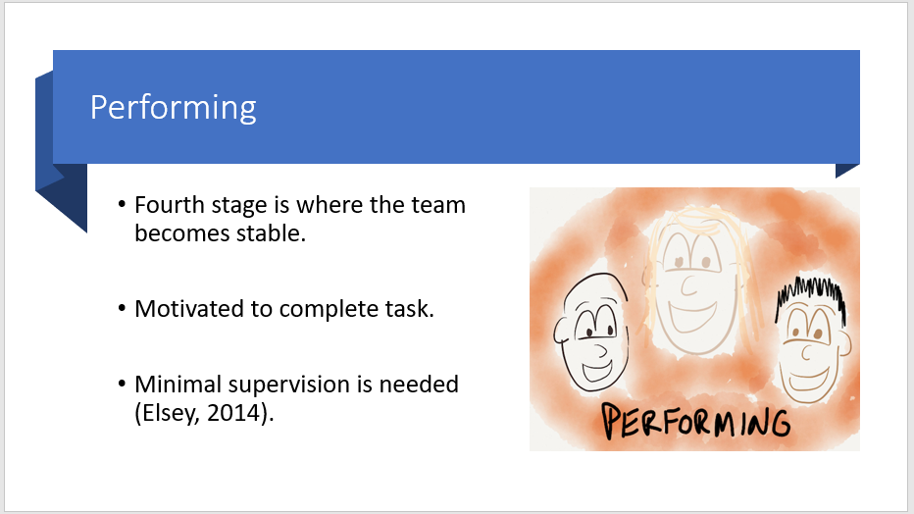

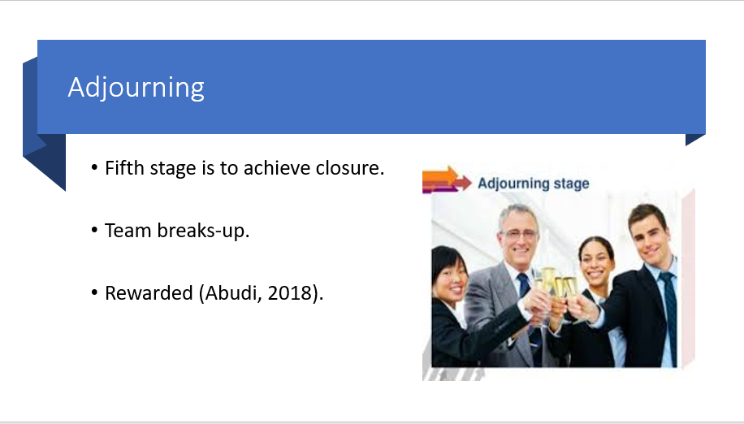

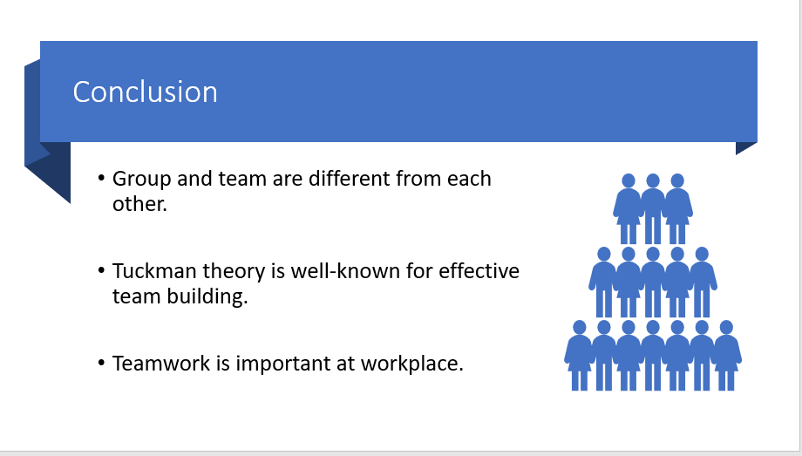

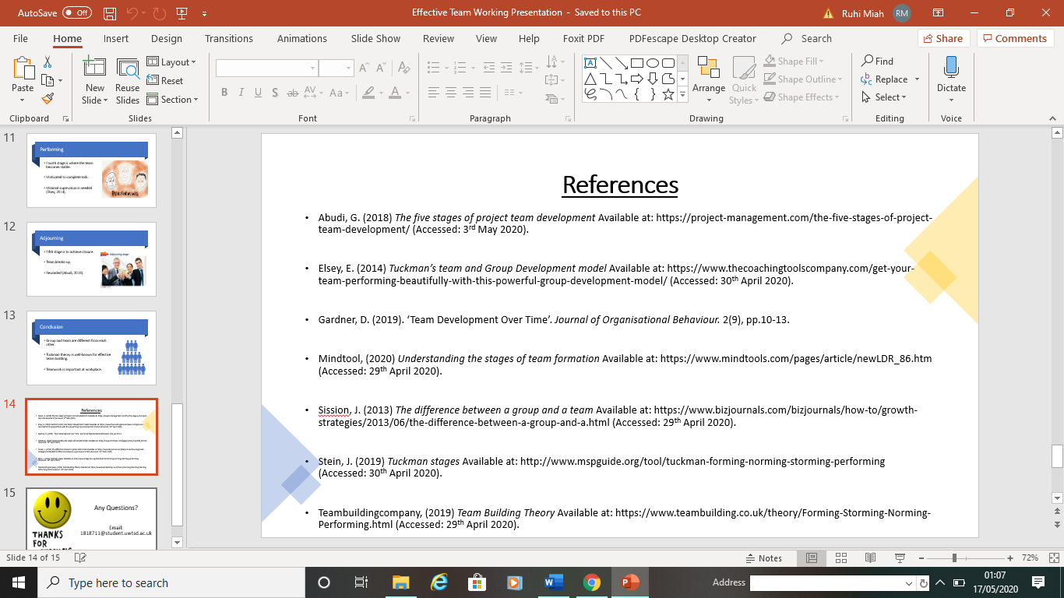

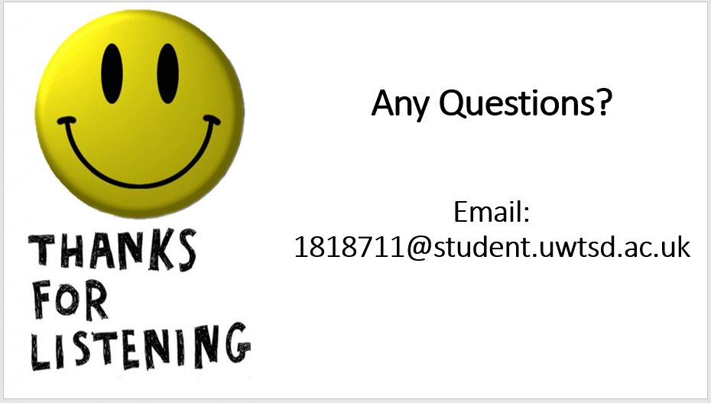

Appendix C

Lesson Plan
Slide | Content | Duration
1 | Presentation Title | 5 seconds
2 | Introduction | 20 seconds
3 | What is a Team? | 10 seconds
4 | What is a Group? | 10 seconds
5 | Differences between team and group | 1 minute
6 | Team development models | 15 seconds
7 | Tuckman’s Theory | 20 seconds
8 | Forming | 1 minute
9 | Storming | 1 minute
10 | Norming | 40 seconds
11 | Performing | 40 seconds
12 | Adjourning | 30 seconds
13 | Conclusion | 30 seconds
14 | References | 5 seconds
15 | Questions | 15 seconds

Appendix D

Feedback form
TAMIN’S FEEDBACK FORM

Rate 1-5 on each component of Tamin’s presentation skills (1-lowest to 5 highest)
First Impression | Tone of Voice | Confidence | Body Language | Communication

Did the accompanying PowerPoint slides support and convey the message properly?
Circle – YES NO

Did the accompanying handout support the presentation adequately?
Circle – YES NO

Did you feel you have gained additional knowledge on the subject?
Circle – YES NO

Overall how did you feel the presentation went? (between 1 lowest - 10 highest)
Circle – 1 2 3 4 5 6 7 8 9 10

Any feedback/comments for future presentations? (comment below)

Appendix E

Handouts

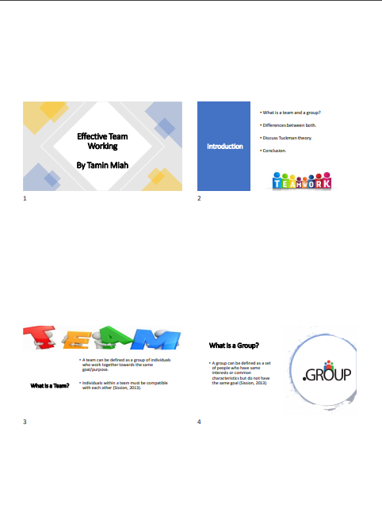

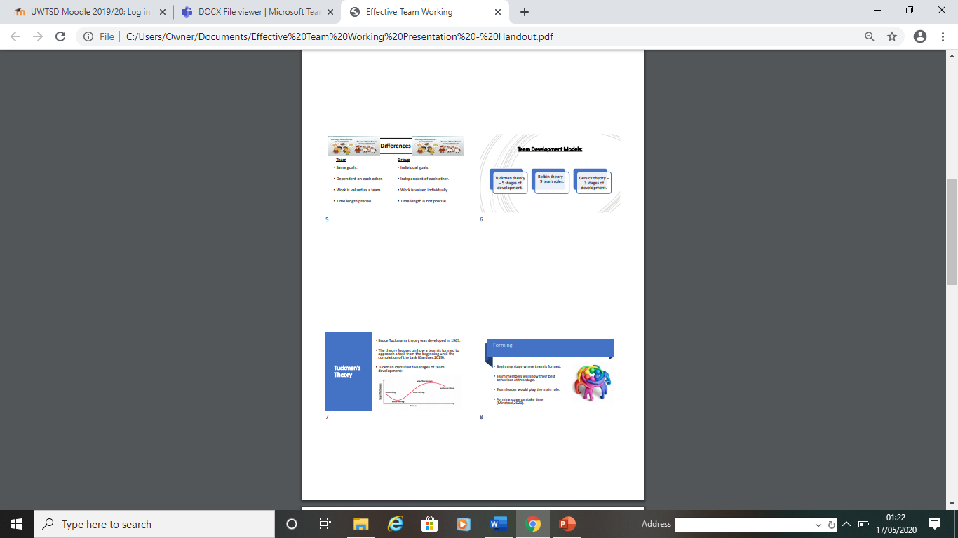

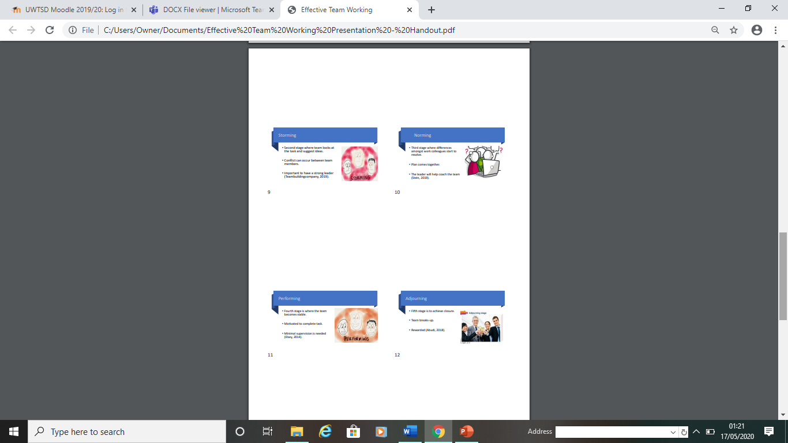

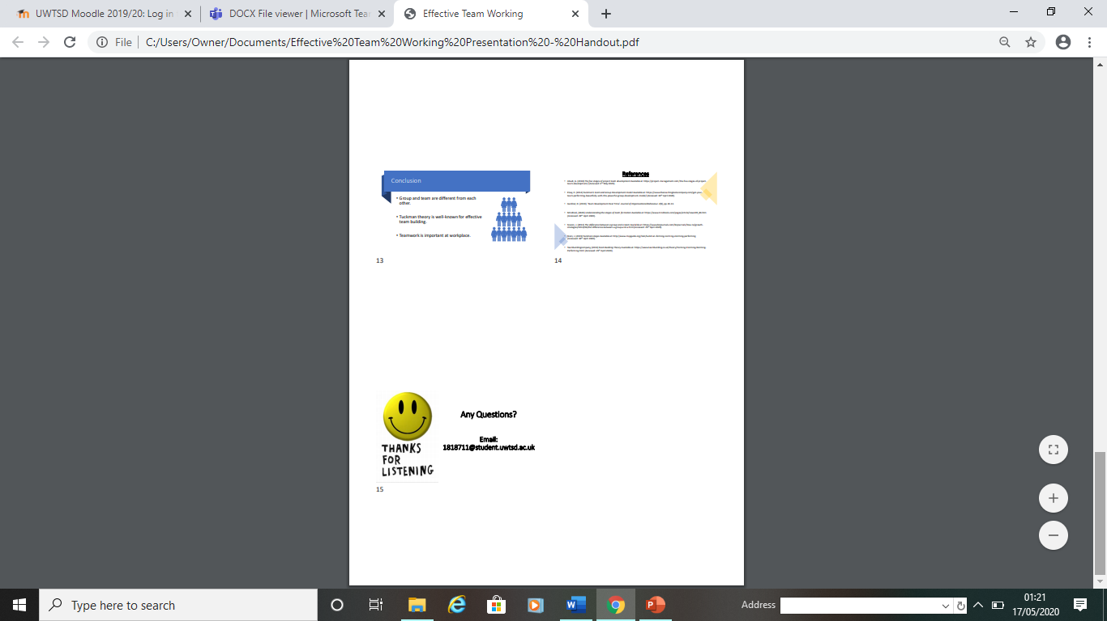

Appendix F

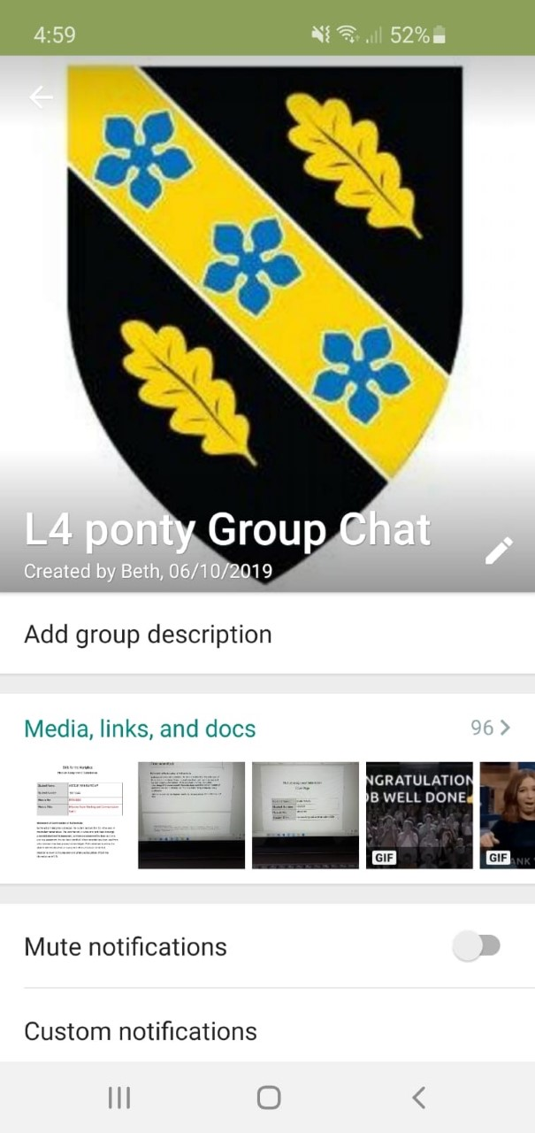
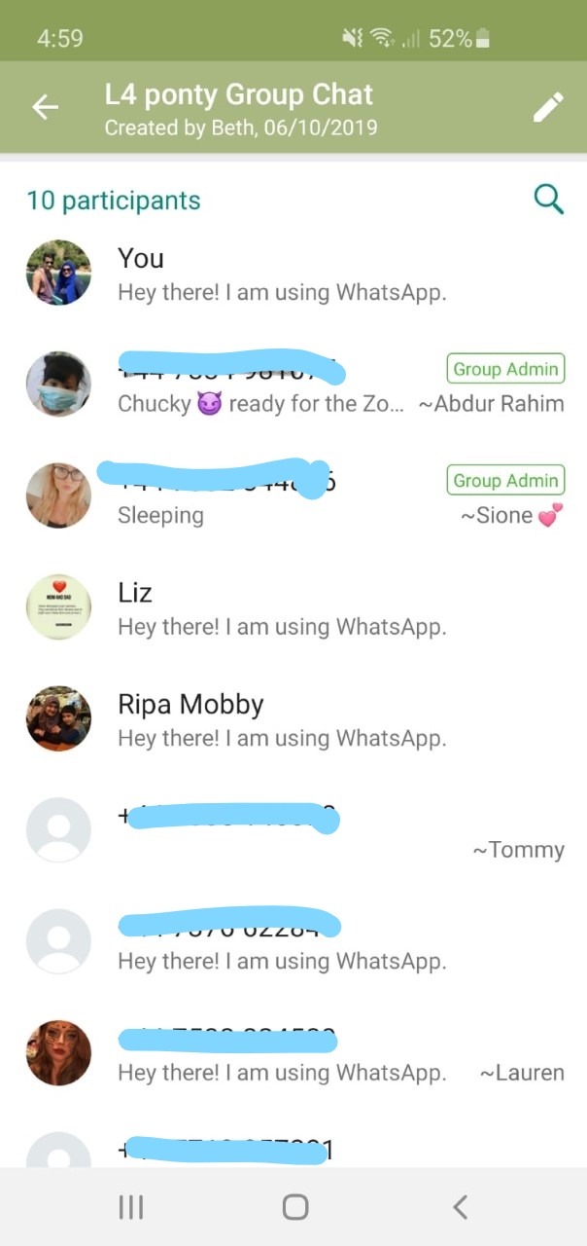

Appendix G



