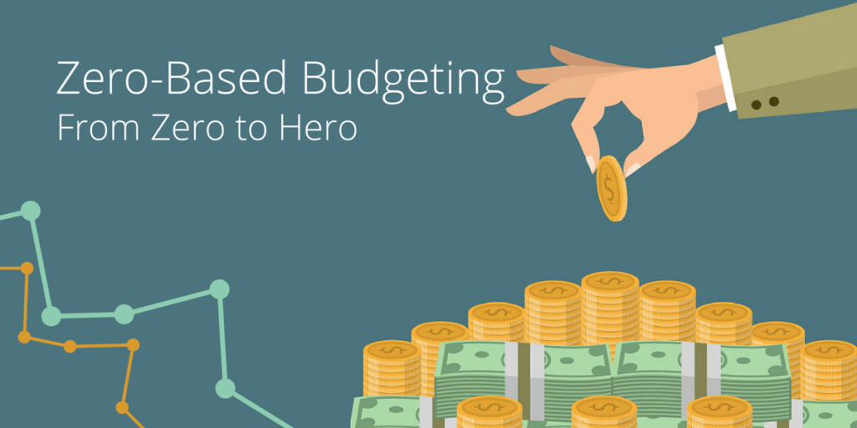

Haversons Ltd.
Zero-Base Budgeting

M5X01922_LON
Lecturer Dale Clarke

Erol Asan
1814997
1814997@student.uwtsd.ac.uk

December 2019

Executive Summary

The purpose of this proposal is to analyze the level of effectiveness of Zero-Based Budgeting, as it relates to Haversons Ltd's future . It will present when and how it was created, its benefits to the financial stability of the company, reasons why it is preferable to the old systems in place, and predictions on potential drawbacks created from using such a complicated bureaucratic system.
This report will also give examples of major corporations that have switched to this new system of budgeting and present reasons why they did so.

Table of Contents

Executive Summary 1
Table of Contents 2
Introduction 3
Zero Based Budgeting 3
Advantages of Using Zero-Based Budgeting in favor of Traditional Based Budgeting 4
How the Company Might introduce Zero-based Budgeting 5
Conclusion 6
Reference List 7

Introduction

In the world of business today, the primary system in place for budget monitoring is the Line Item Budget, that entails as according to (Drury, 2009), ‘’assumes extrapolating past activities and cost’’.This old way of creating a budget has many drawbacks, including but not limited to the fact that money ends up being spent just so the budget for the following year can be justifiable, leading to wasted funds and a potential for high unnecessary expenditures (Abdullahi, 2011) . The way to counteract this is by using Zero Based Budgeting, (ZBB) that requires forward thinking, and the use of explanations on how and why the funds, are/will be used.

Zero Based Budgeting

ZBB is a system that is based on calculations on future possible activity, and not just past performance. Each year the starting budget begging at 0, with costs predicted and calculated for the new year , each line of expenditures being considered well in advance and justifiable , so that the budget remains as thin, and small as possible, reducing excess cost, extra expenditures requiring explanations and approvals from the management team and thus a decision package being created for the new fiscal year, (Uluum, 2004). It is a system that uses deep analysis from managers, that are required to give extra attention in cutting costs, and streamlining their departments projects (Kamlet and Mowery, 1985)
Advantages of using Zero-based budgeting in favor of Traditional Based Budgeting

A reasons why ZBB is a viable alternative for a companies budgeting system is that it promotes cost cutting, the front line managers being required to analyze past performance and extrapolate for the new year, budget requirements, project expenses as well as cheaper options that can be used to achieve a ‘’lighter’’ and effective budget, with fewer redundant expenditures, all starting from a 0 budget, not calculating past expenses but trying to start at the beginning with a whole new agenda for the year to come (Shelby, 2013).
It was created in Texas in 1969, credited to Peter Pyhrr and his team of analysts as a strategy of dealing with fiscal stresses. In its early form it showed how costs can be reduced (Lin and Miklos, 1979). It was used and showed significant resource allocation, and strategic goal mismatches associated with miscommunication inside of a company. This work led to the development of new guidelines that helped with better revenue volatility, improved product and process evolution and even improved response to outside shocks to the organisation (Pyhrr and Kneese, 1973).

Major advantages:
- Avoiding waste.
- Prioritisation, focus on task.
- Questioning the status quo, creating an internal debate on the direction of the company, and ways to avoid problems in the future.

The goal is to achieve less expenditures, with a greater level of efficiency, and redirecting funds to projects that require them.
How the Company Might introduce Zero-based Budgeting

Because of recent economic distress in the private sector, ZBB has reappeared in the spotlight as a major tool that can help organisations , privately owned and operated, to reach a level of security in their finances and be more prepared for external threats. ‘’Unilever’s CEO Paul Polman announced that his company would approach the new planning year with a zero-based budgeting programme”. .“Belt-tightening move” and proof of “tougher cost controls” were key terms used by the marketing team, when talking to the press (Ritson, 2019) suggesting that the new budgeting System was chosen for ways to cut down costs and expenses.
The introduction of this approach must take care with:
- Adopting a positive attitude (not just being a cost slashing process, but a way to move forward and grow)
- Identifying quick wins when it comes to financial discoveries.
- Assembling a cross-functional team, finance, IT, marketing,to work together and share information, and discover new things within the company structure.
- Selecting the right informational parameters from the old budgeting system that can aid in the new systems implementation, (not all information is relevant and triage might be necessary).
- Once the system is in place, avoiding complacency , by continuously monitoring projects in order to avoid other issues that might emerge.

Conclusion

In conclusion, the imposition of Zero Based Budgeting System in the finances of Haversons LTD would help the company achieve a better ratio when it comes to expenses/ profits, this would be achieved by cutting down non important expenses, reorienting to a new business perspective, prioritization and the information derived from the internal analysis would further reveal ways to avoid potential threats from the outside, and either delineate the shocks or cancel them out completely. It would require a major reorganisation of both the accounting department as well as possible changes to the first line , lower level managers that deal mostly with the day to day problems. But in the end, if larger companies like Unilever, can implement such drastic changes to achieve better results, it is then applicable to smaller teams as well.

Reference List

Abdullahi, S. (2011). Mastering Cost and Management Accounting. 1st ed. Kano, Nigeria: Gidan Dabin.

Davis, B. (2019). What is zero-based budgeting? And what are its benefits for marketers? – Econsultancy. [online] Econsultancy. Available at: https://econsultancy.com/what-is-zero-based-budgeting-and-what-are-its-benefits-for-marketers/ [Accessed 20 Dec. 2019].

Drury, C. (2009). Management and cost accounting. 7th ed. London: Cengage Learning EMEA.

Kamlet, M. and Mowery, D. (1985). The first decade of the Congressional Budget Act: Legislative imitation and adaptation in budgeting. 18th ed. Policy Sciences, pp.313-334.

Kagan, J. (2019). Zero-Based Budgeting (ZBB). [online] Investopedia. Available at: https://www.investopedia.com/terms/z/zbb.asp [Accessed 20 Dec. 2019].

Kweilin, E. (2019). Four Reasons Why Zero-Based Budgeting Works. [online] Forbes.com. Available at: https://www.forbes.com/sites/kweilinellingrud/2019/04/01/four-reasons-why-zero-based-budgeting-works/#6e1e27c019dc [Accessed 19 Dec. 2019].

Lin, T. and Miklos, V. (1979). Zero Based Budgeting Analysis. Proceedings of Western AIDS Conference.

Pyhrr, P. and Kneese, A. (1973). Zero-base budgeting. New York: Wiley.

Ritson, M. (2019). Mark Ritson: Why Unilever is right to adopt zero-based budgeting – Marketing Week. [online] Marketing Week. Available at: https://www.marketingweek.com/why-unilever-is-right-to-adopt-zero-based-budgeting/ [Accessed 20 Dec. 2019].

Shelby, R. (2013). Zero Base Budgeting for the 21st Century Public Administrator. Atlanta: Fiscal Research Center, (5).

Uluum, L. (2004). Accounting of Public sector. Yogyakarta: Umm Press, pp.7-9.

