University of Wales Trinity Saint David
Wales institute of Science & Art



Application of CAE Processes
Structural & Fluid Analysis (ACHA6010)

Aaron Lilly
2314260
14/12/2025

Table of Contents
Introduction 3
Task 1 - Modelling and Assembly 4
Materials 6
Kinematic Simulation and Structural Analysis 6
Limitations of the Kinetic Model 7
Thermal and Structural Analysis of the Piston Head 8
Component Selection 8
Thermal Analysis 8
Structural Analysis 10
Results and Critical Regions 11
Iterative Improvement and Optimisation 13
Baseline Design Performance 13
Design Modifications – Iteration 1 13
Iteration 1 - Performance Comparison 14

Introduction
Computer Aided Engineering (CAE) tools are widely used in mechanical design to predict structural, thermal, and dynamic behaviour prior to physical testing. They enable efficient performance evaluation and design iteration, but results remain dependent on modelling assumptions, numerical methods, and user-defined inputs, making validation and critical interpretation essential.
The aim of this coursework is to apply CAE techniques to a mechanical assembly and a selected component under realistic operating conditions. An engine assembly is modelled, from which a piston head is selected for detailed thermal and structural analysis. Loading conditions are derived from kinematic analysis rather than assumed values, and the component is iteratively improved to enhance performance while considering mass optimisation. Validation is performed using simplified analytical cases to assess solver accuracy, mesh independence, and boundary condition sensitivity.

Task 1 - Modelling and Assembly
A multi-component engine assembly was created to represent the kinematic and load-transfer behaviour of a single-cylinder mechanism. The assembly includes a crankshaft, connecting rod, gudgeon pin, piston, and bearing, modelled with accurate relative dimensions to ensure realistic motion and force transmission.
The geometry was simplified by omitting small features such as fillets and surface details that have negligible influence on global kinematic behaviour. This approach preserves correct mass distribution and joint locations while improving computational efficiency.
Assembly constraints were applied to replicate mechanical joints with appropriate rotational and translational degrees of freedom, enabling a rigid body dynamics analysis to be performed. Realistic loading conditions acting on the piston were extracted from this analysis and used as inputs for subsequent thermal and structural studies, ensuring that loading was physically derived rather than assumed.
Component flexibility, lubrication effects, and clearances were neglected at this stage. While this represents a modelling limitation, these assumptions are considered acceptable for load generation purposes.

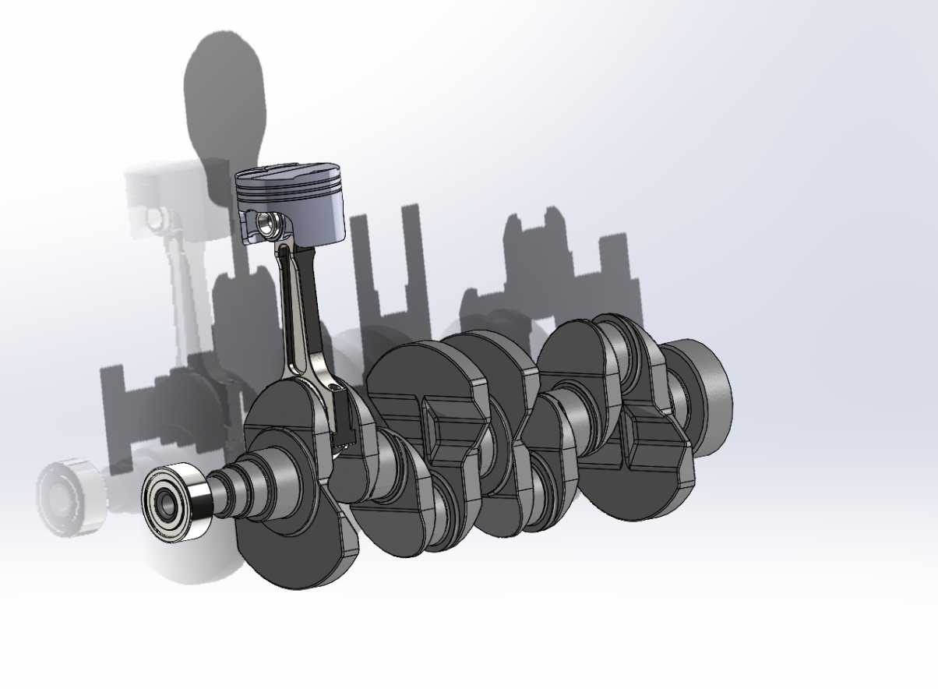
Figure 1- Engine Components Assembly

To enable efficient simulation while retaining physically meaningful behaviour, several modelling assumptions and simplifications were applied. Small geometric features such as fillets, chamfers, and surface details were omitted, as they have negligible influence on global kinematic behaviour but significantly increase computational cost. Components were assumed to be geometrically perfect, with manufacturing tolerances and surface roughness neglected.
Material properties were sourced from the ANSYS Engineering Data library. The piston was modelled using Aluminium 6061-T6, selected for its favourable strength-to-weight ratio and good thermal conductivity, with linear elastic, isotropic behaviour assumed. All remaining assembly components were assigned preset stainless-steel properties, as they primarily serve a kinematic and load-transfer role within the rigid body dynamics model. (5.2. Define Engineering Data, n.d.)

Assembly joints were idealised using frictionless pin and revolute constraints, neglecting backlash, clearance, and wear. The kinematic analysis was performed using rigid body dynamics, neglecting component flexibility, damping, lubrication effects, and temperature-dependent material behaviour. These simplifications are considered acceptable for load generation but represent limitations when interpreting subsequent structural results.

Kinematic Simulation and Structural Analysis
The engine assembly was imported into the ANSYS Rigid Dynamics environment, where kinematic connections were defined to replicate the motion of a crank–slider mechanism. These connections enabled realistic relative motion between the crankshaft, connecting rod, gudgeon pin, and piston, allowing the assembly to represent simplified engine operation.
The kinematic model was used to resolve inertial and reaction forces acting on the piston throughout the motion cycle. Loads at the piston–gudgeon pin interface were extracted at the identified critical operating condition and applied to a static structural analysis to evaluate stress and deformation within the piston head. A thermal analysis was also performed to determine the temperature distribution within the component, enabling a combined thermo-mechanical assessment.
Boundary conditions were applied to represent constraint from the cylinder bore at an operating speed of 4000 rpm. Radial motion of the piston was restricted while axial deformation was permitted, ensuring kinematic stability without artificial over-constraint.

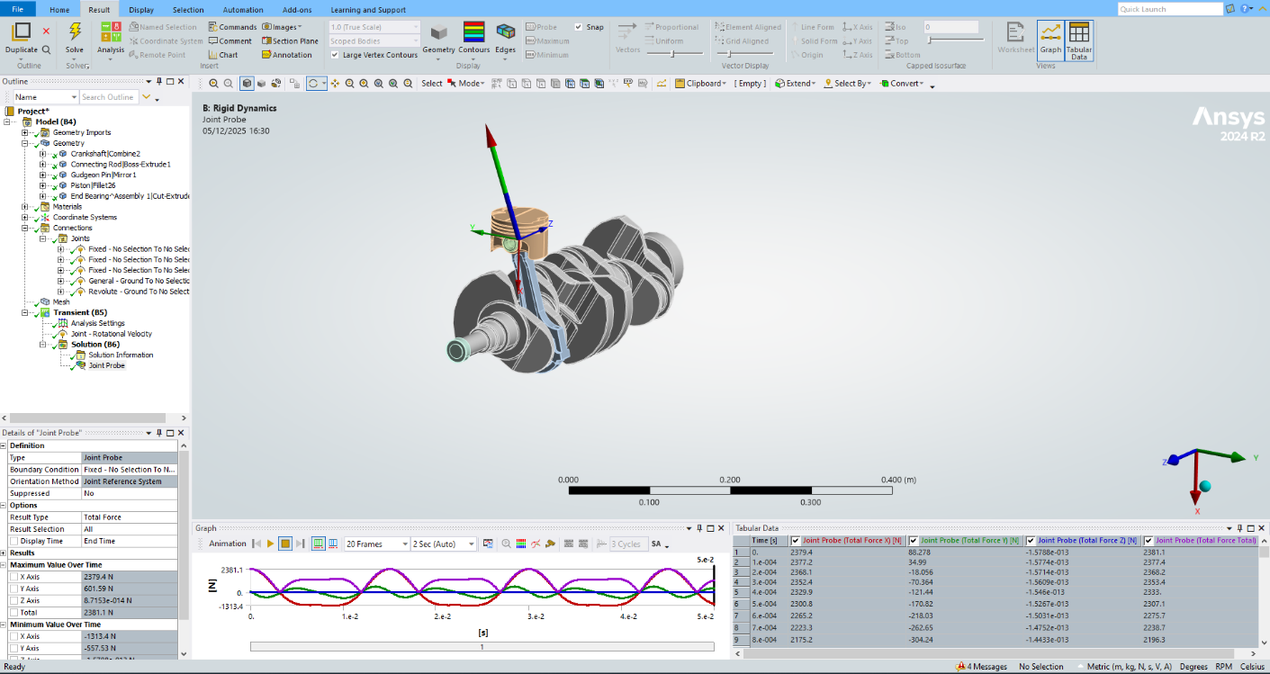
Figure 2 - Joint Probe being calculated through a rotation of the crank to find max load value

Limitations of the Kinetic Model
The kinematic analysis was performed using a rigid body dynamics approach, introducing inherent limitations. All components were assumed to be perfectly rigid, neglecting structural flexibility and local compliance present in a real engine assembly. As a result, elastic deformation and dynamic stress wave effects are not captured, and reaction forces may be slightly over-predicted.
Assembly joints were idealised as frictionless with no clearance or backlash, ensuring stable and repeatable motion but omitting losses and impact effects encountered in service. The analysis was conducted at a single operating speed of 4000 rpm, with loads extracted at the most critical point in the cycle. While this enables efficient identification of peak loading conditions, it does not represent transient or cyclic behaviour across a full operating range.
Thermal effects were not included in the kinematic simulation, and material properties were assumed constant. Although acceptable for load generation, these simplifications may influence load magnitude and are considered when interpreting subsequent structural and thermal analysis results.

Thermal and Structural Analysis of the Piston Head

Component Selection
The piston head was selected for detailed thermal and structural analysis due to its critical role in engine operation and exposure to high mechanical and thermal loading. During operation, it experiences significant inertial forces transmitted through the connecting rod as well as elevated temperatures from combustion, making it a suitable candidate for evaluating thermo-mechanical behaviour using CAE tools.

Thermal Analysis
A steady-state thermal analysis of the piston head was conducted using thermal boundary conditions provided in a technical reference document. These boundary conditions defined representative heat input and heat transfer conditions acting on the piston during engine operation. (Finite Element Analysis for the Temperature and Stress Fields of the Diesel Piston Based on CAE, 2012)
The analysis was intended to capture the overall temperature distribution rather than transient combustion effects. Heat input was applied at the piston crown, with heat dissipation through the piston body. The resulting temperature field showed elevated temperatures at the crown with a gradual reduction through the piston, consistent with expected in-service behaviour.
The temperature distribution was subsequently imported into the static structural model to account for thermally induced strain. Although simplified and based on reference data, the applied thermal boundary conditions provide a realistic basis for assessing combined thermo-mechanical behaviour.
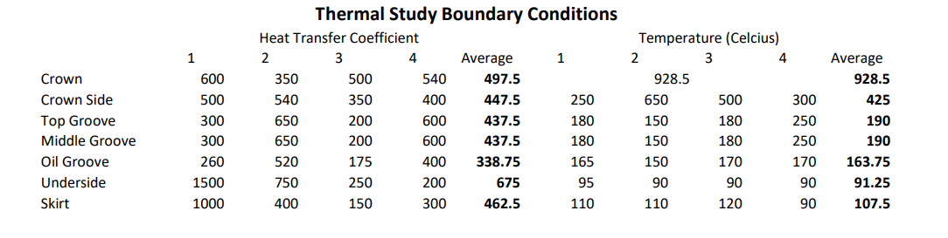
Figure 3 - Thermal Study Boundary Conditions

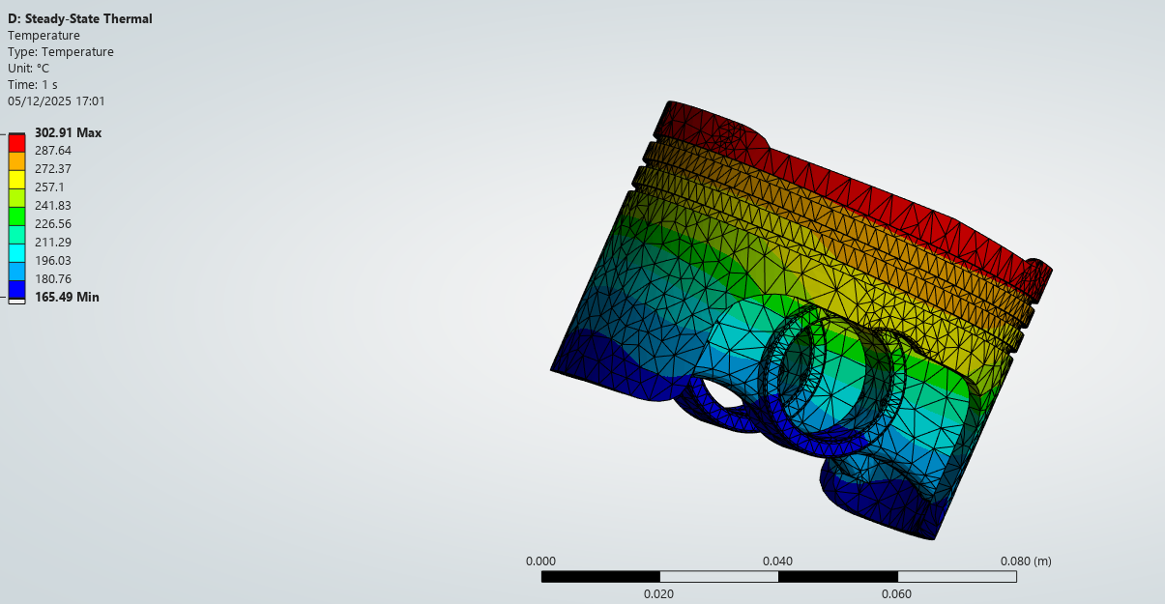
Figure 4 - Steady State Thermal Study Profile

Structural Analysis
A static structural analysis of the piston head was conducted to evaluate stress and deformation under combined mechanical and thermal loading. Mechanical loads corresponding to the peak operating condition at 4000 rpm were imported from the rigid body dynamics simulation, representing inertial forces transmitted through the gudgeon pin.
The temperature distribution obtained from the steady-state thermal analysis was imported into the structural model to account for thermally induced strain, enabling a combined thermo-mechanical assessment of piston behaviour.
To prevent rigid body motion and ensure numerical stability, weak springs were applied. These provide minimal artificial stiffness to aid solver convergence while having negligible influence on global stress and deformation trends. However, as weak springs do not represent physical support conditions, they introduce a limitation in accurately replicating constraint from the cylinder bore and connecting rod assembly. Consequently, absolute stress values may be influenced by the stabilisation method and should be interpreted with appropriate caution.

Results and Critical Regions
The results of the static structural analysis highlight the regions of the piston head most susceptible to elevated stress and deformation under combined thermal and mechanical loading. Von Mises stress contours indicate that peak stresses occur in areas of geometric transition beneath the piston crown and around internal features where load paths change direction. These regions are subject to stress concentration effects caused by both mechanical loading from the gudgeon pin and thermally induced expansion.
Figure 5- Equivalent (Von-Mises) Stress
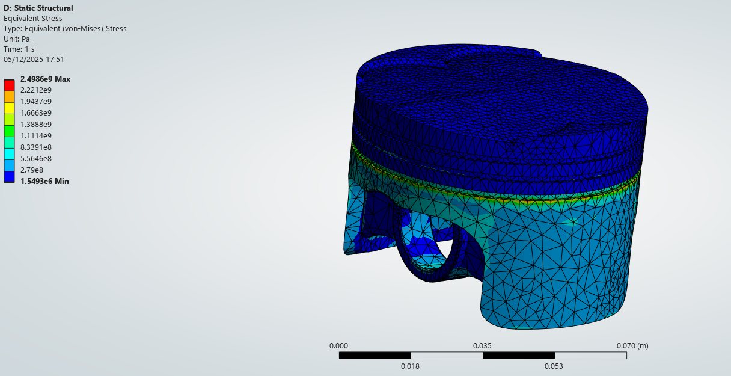
Total deformation results show maximum displacement at the piston crown, primarily driven by thermal expansion and the applied inertial loading. The deformation pattern is consistent with expected piston behaviour, with comparatively lower deformation observed in regions supported by the gudgeon pin interface.
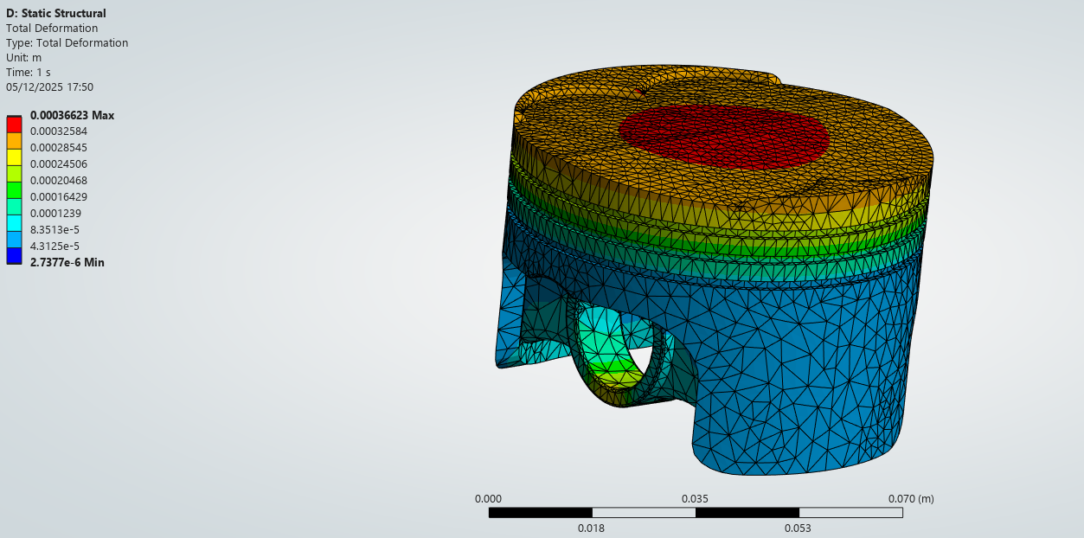
Figure 6 - Total Deformation
While the absolute magnitude of stress and deformation is influenced by modelling assumptions and boundary condition simplifications, the analysis provides clear insight into the distribution of loads within the piston head. The identified high-stress regions represent critical areas for potential fatigue damage or material failure and therefore form the focus for subsequent design iterations. These baseline results are used to guide targeted geometric and material modifications aimed at reducing stress concentrations and improving overall structural performance.

Iterative Improvement and Optimisation

Design Modifications – Iteration 1
The first design iteration focused on improving load distribution beneath the piston crown. Localised stiffening struts were added to the upper internal region of the piston to support areas of high stress identified in the baseline analysis.
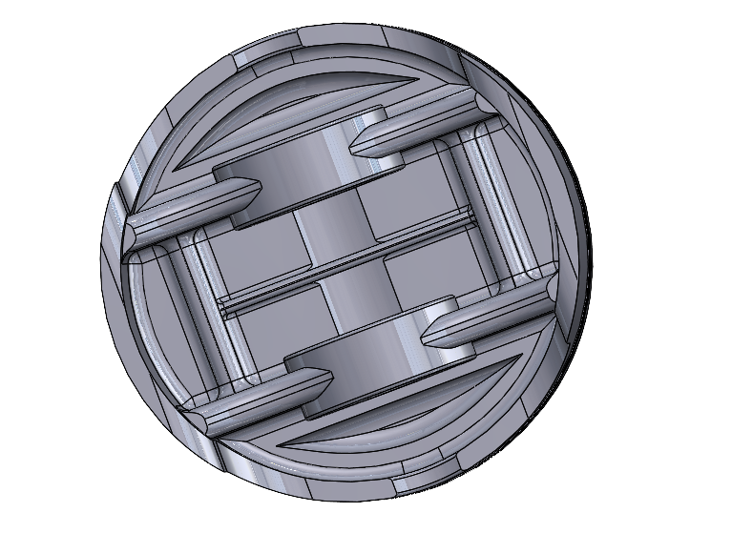
To offset the mass increase from the added struts, material was selectively removed from low-stress regions identified from baseline stress contours. This approach aimed to improve structural performance while maintaining overall component mass.
Figure 7- Design Iterations 1

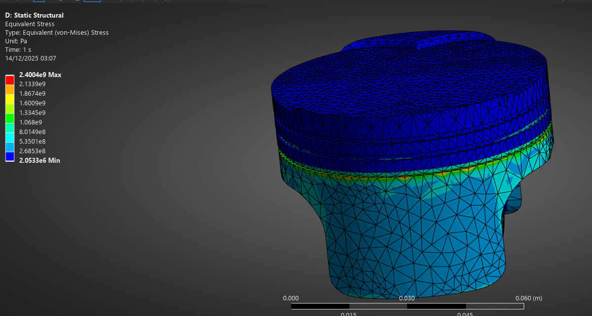
Iteration 1 - Performance Comparison
Figure 8 - Iteration 1 Stress Plot

Original Max Stress – 2.5GPa
Iteration 1 Max Stress – 2.4GPa
The baseline and modified piston designs were analysed under identical thermal and mechanical loading conditions to enable a direct comparison of structural performance. The baseline design exhibited a pronounced stress concentration beneath the piston crown, with peak von Mises stress occurring at regions of geometric transition.
Following the introduction of localised struts in the upper region of the piston, the modified design demonstrated a redistribution of stress beneath the crown. The added structural support resulted in a broader load path, reducing the intensity of local stress concentrations. A modest reduction in peak von Mises stress was observed in comparison to the baseline design.
Although the overall reduction in maximum stress was limited, the results indicate that the added struts increased local stiffness and improved load distribution without introducing new critical stress regions. Material removal from low-stress areas ensured that these improvements were achieved with minimal impact on overall component mass. The comparison highlights the effectiveness of targeted geometric modification as an iterative design strategy guided by CAE results.

Design Modifications – Iteration 2
The second design iteration investigated the influence of material selection while retaining the baseline piston geometry. The material was changed from Aluminium 6061-T6 to Aluminium 2618-T6 to assess structural performance under identical thermo-mechanical loading conditions.
Aluminium 2618-T6 is commonly used in high-performance piston applications due to its improved high-temperature strength and thermal fatigue resistance. The modified material model was analysed using the same imported mechanical loads and temperature distribution as previous iterations to ensure a valid comparison, isolating the effect of material properties on stress and deformation behaviour.
Temperature-dependent material degradation was not explicitly modelled, with material properties sourced from Granta. This represents a limitation when interpreting absolute stress values.

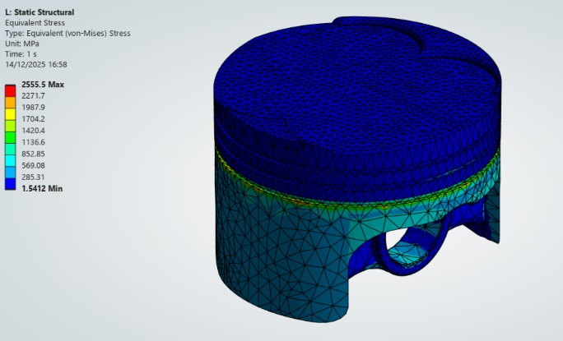
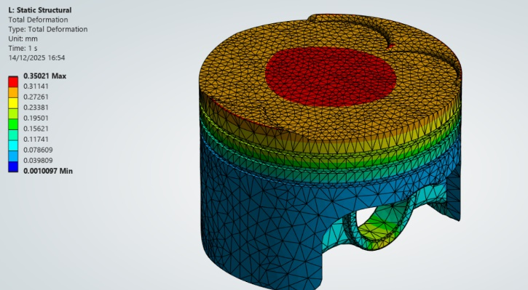
Iteration 2 – Performance Comparison
Figure 9 -Max Stress Iteration 2
Figure 10 - Max Deformation Iteration 2
Compared to the baseline piston, the Aluminium 2618-T6 iteration exhibited a similar stress distribution, with peak stresses located around the ring/skirt transition and local geometric features. The maximum von Mises stress increased slightly from approximately 2.50 GPa in the baseline model to 2.56 GPa in Iteration 2, indicating that the material changes alone did not reduce peak stress under identical loading. This increase is attributed to differences in material stiffness and load redistribution and should be considered alongside deformation behaviour.
Total deformation remained dominated by crown displacement in both cases, indicating that the overall thermo-mechanical response was unchanged. Maximum deformation reduced slightly from approximately 0.366 mm to 0.350 mm, representing a modest (~4%) reduction and suggesting a marginal increase in stiffness. The deformation shape remained consistent, confirming that the material substitution did not introduce abnormal structural behaviour.
.

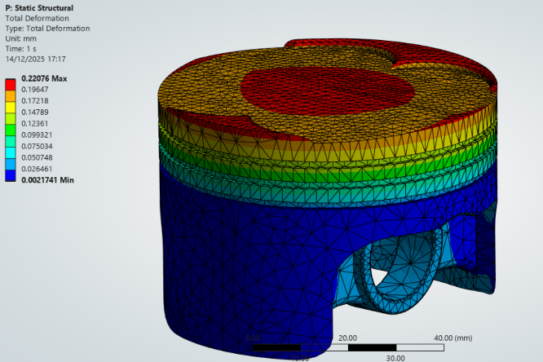
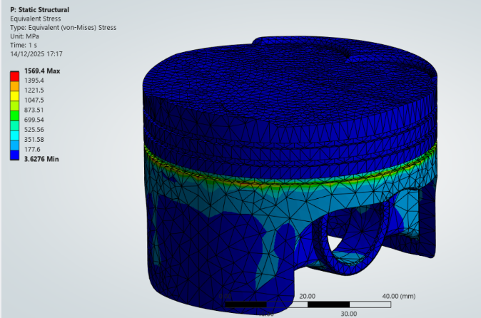
Design Modification - Iteration 3
Figure 11 - Titanium Max Deformation
Figure 12 - Titanium Max (Von-Mises) Stress
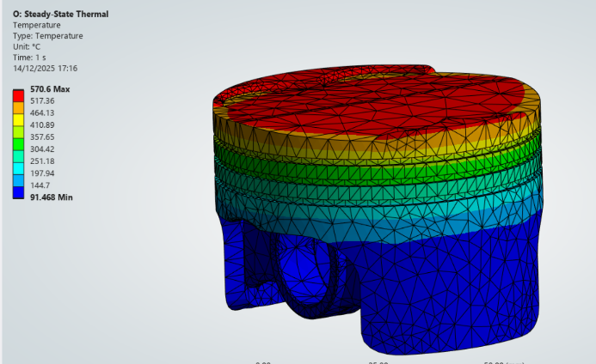
Figure 13 - Titanium Thermal Study

A third design iteration was conducted by assigning a titanium alloy material model to the piston head while retaining the same geometric configuration and loading conditions as previous iterations. This iteration was performed to evaluate whether a higher-strength material could further improve structural performance under combined thermal and mechanical loading.
A steady-state thermal analysis was re-run using titanium material properties to account for differences in thermal conductivity and heat transfer behaviour. The resulting temperature field was subsequently imported into the static structural analysis, enabling a fully coupled thermo-mechanical assessment consistent with the material change.

Iteration 3 – Performance Comparison
The titanium piston exhibited a significant reduction in peak von Mises stress compared to the baseline aluminium design, decreasing from approximately 2.50 GPa to 1.57 GPa, while maintaining a similar stress distribution beneath the piston crown and upper skirt. This reduction is primarily attributed to the higher stiffness and strength of the titanium alloy rather than a change in load path.
Total deformation was also substantially reduced, with maximum displacement decreasing from approximately 0.36 mm to 0.22 mm, indicating a marked increase in global stiffness. Deformation behaviour remained dominated by crown displacement, consistent with previous iterations.
However, thermal analysis revealed a substantial increase in operating temperature for the titanium piston, with peak temperatures reaching approximately 570 °C, significantly higher than those observed in aluminium-based designs. This increase is attributed to titanium’s lower thermal conductivity, which limits heat rejection. As a result, despite favourable structural performance, the titanium piston was deemed unsuitable due to excessive thermal loading and increased material density, highlighting the importance of considering thermal and system-level effects alongside structural metrics during optimisation.

Performance Comparison of all Iterations
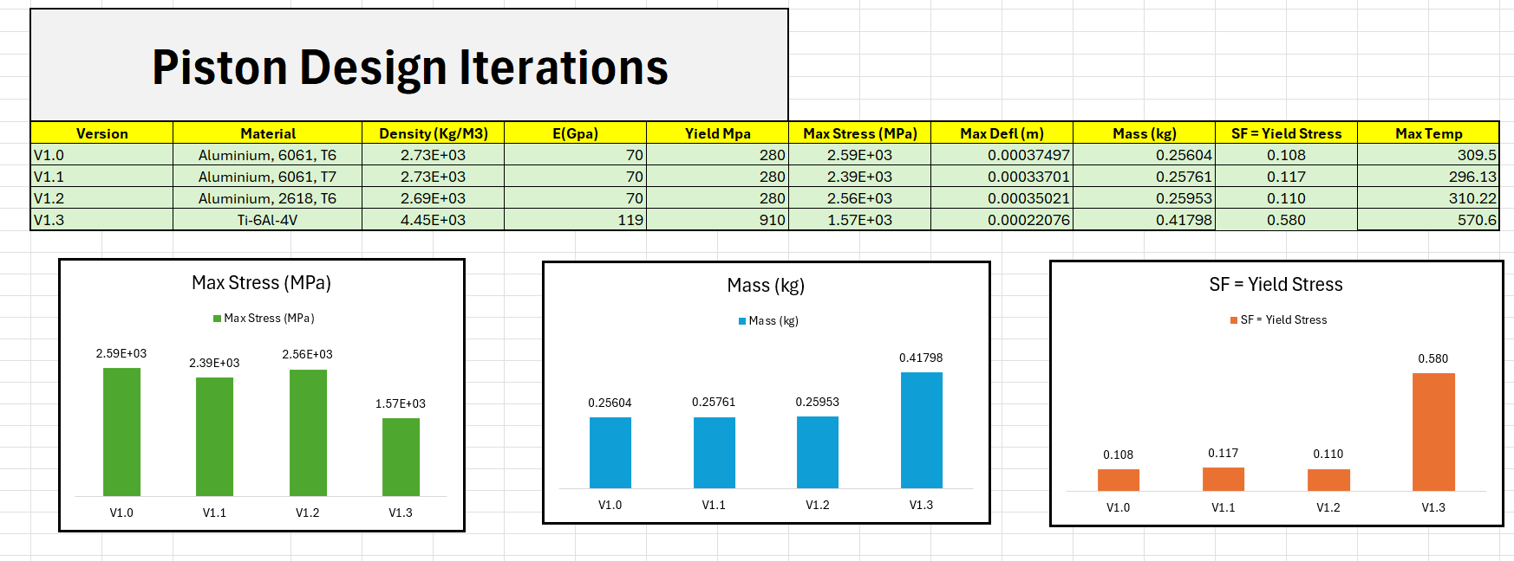
The material-modified aluminium iteration (V1.2, Aluminium 2618-T6) produced a peak stress comparable to the baseline (≈ 2.56 GPa), indicating that material substitution alone did not significantly reduce stress when geometry and loading were unchanged. In contrast, the titanium iteration (V1.3) reduced peak stress substantially to approximately 1.57 GPa, reflecting the higher stiffness and strength of the titanium alloy.
Figure 14 - Table and Plots of Excel Analysis, Max results Recorded
Deformation behaviour was similar across aluminium-based designs, with maximum displacement occurring at the piston crown. The geometric iteration (V1.1) produced a modest reduction in deformation, while the 2618-T6 iteration (V1.2) showed deformation comparable to the baseline, suggesting deformation is primarily governed by geometry and thermal expansion. The titanium iteration (V1.3) reduced maximum deformation from approximately 0.37 mm to 0.22 mm, indicating increased global stiffness.
Aluminium-based designs maintained a consistent mass of approximately 0.26 kg, minimising reciprocating inertia. In contrast, the titanium piston mass increased to approximately 0.42 kg, significantly increasing inertial loading at 4000 rpm. Thermal analysis further highlighted titanium’s limitations, with peak temperatures rising to approximately 570 °C, compared to around 300 °C for aluminium designs, due to its lower thermal conductivity.
Overall, the results show that targeted geometric modification (V1.1) provides the most balanced performance improvement with minimal mass penalty. Aluminium 2618-T6 (V1.2) offered limited structural benefit but remains a viable piston material. Despite favourable structural performance, the titanium iteration (V1.3) was deemed unsuitable due to excessive mass and thermal penalties, reinforcing the need for holistic optimisation.

Validation Studies

Validation Case Selection
To validate the finite element methodology used in this study, a bimetallic strip subjected to thermal loading was selected as a simplified analytical test case. This validation case was chosen because it demonstrates deformation driven by differential thermal expansion, which is directly relevant to the piston analysis where thermal gradients significantly influence stress and deformation behaviour.
The validation model is based on a published bimetallic strip example consisting of two bonded materials with different coefficients of thermal expansion. When subjected to a uniform temperature increase, the mismatch in thermal expansion causes the strip to bend. An analytical solution for the resulting tip deflection can be derived from classical thermoelastic beam theory, making this an appropriate case for validating the accuracy of the finite element model
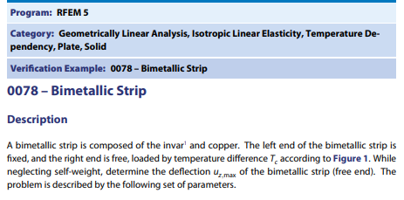
Figure 15 - Bimetallic Strip Validation

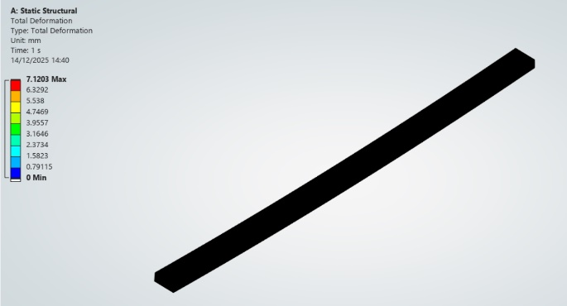
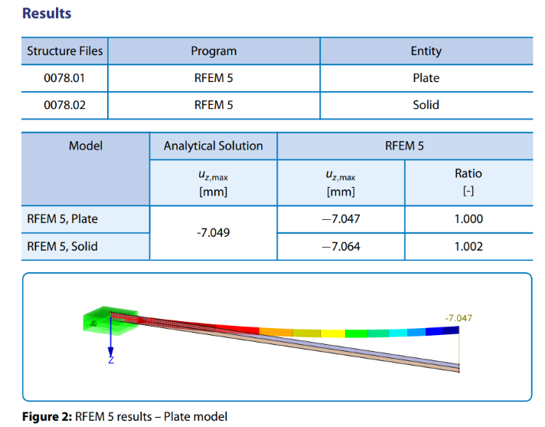
Analytical and Finite Element Analysis Comparison
Figure 16 - Bimetallic Strip FEA Analysis
Figure 17 - Results Provided in Case Study for Bimetallic Strip

The analytical solution for the bimetallic strip predicts a maximum tip deflection of approximately −7.049 mm under thermal loading. Replicating the same geometry, material properties, and boundary conditions in ANSYS produced a maximum deformation of approximately 7.12 mm at the free end, representing a deviation of around 1%.
The deformation profile and location of maximum displacement were consistent between the analytical and numerical solutions, indicating that the finite element model accurately captures thermo-mechanical bending behaviour. The minor discrepancy is attributed to numerical discretisation, three-dimensional modelling effects, and simplifying assumptions in the analytical solution. Overall, the close agreement provides confidence in the validity of the finite element methodology applied in this study.

Independent Mesh Study
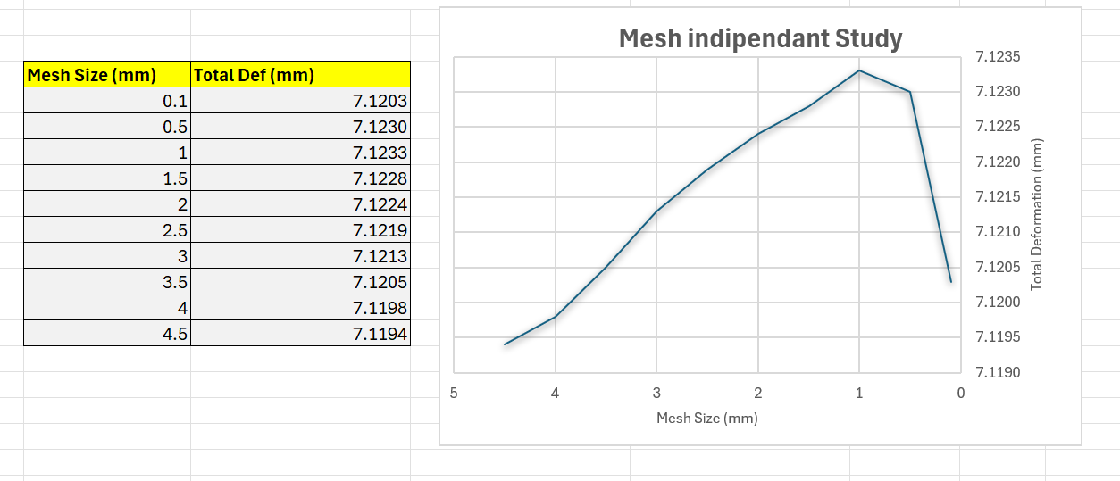
Figure 18 - Mesh Independent Study Results
A mesh independence study was conducted using the bimetallic strip validation model to assess sensitivity to mesh refinement. Total deformation at the free end was used as the comparison metric, as it represents a suitable global response for convergence assessment.
Mesh sizes ranging from 4.5 mm to 0.1 mm were evaluated. Results showed only marginal variation in total deformation, converging to approximately 7.12 mm, with overall variation below 0.1%. Although deformation did not vary monotonically with mesh refinement, this behaviour is attributed to numerical discretisation effects rather than physical response.
Once the mesh size was reduced below approximately 2 mm, further refinement produced negligible changes in deformation, indicating mesh independence. A mesh size within this converged region was therefore selected for subsequent analyses to balance accuracy and computational efficiency.

Boundary Condition Sensitivity
Figure 19 - Boundary Conditions Test in Excel
Boundary conditions are a critical aspect of finite element analysis, as they define how a component is constrained and how loads are transmitted. For engine components such as pistons, true support conditions are difficult to represent accurately due to contact, clearance, and dynamic effects, requiring simplifying assumptions.
To assess sensitivity to these assumptions, alternative constraint definitions were applied to the piston model while all other inputs were held constant. The results showed that boundary condition selection alone significantly influences predicted stress and deformation. More restrictive constraints reduced global deformation but increased local stress concentrations, while less restrictive constraints produced greater deformation with lower peak stresses.
This highlights a fundamental limitation of CAE: absolute results are strongly dependent on boundary condition definition. Consequently, boundary conditions should be selected to best represent physical behaviour, and results should be interpreted comparatively rather than as exact predictions, particularly when numerical stabilisation methods such as weak springs are used.

Conclusion
This study employed a CAE-driven workflow to analyse and optimise a piston head under combined mechanical and thermal loading representative of engine operation at 4000 rpm. Kinematic simulation was used to generate realistic inertial loads, which were transferred into coupled thermal and static structural analyses to evaluate stress and deformation behaviour.
Iterative design changes showed that targeted geometric modification delivered the most effective performance improvement, reducing stress and deformation with minimal mass impact. Material substitution alone provided limited benefit, while a titanium piston, despite improved structural response, was deemed unsuitable due to increased mass and operating temperature. These results demonstrate the importance of evaluating optimisation strategies holistically rather than on structural metrics alone.
Validation using a thermally loaded benchmark case confirmed the accuracy of the modelling approach, while mesh independence and boundary condition sensitivity studies highlighted key numerical and modelling limitations. Overall, the study demonstrates the value of validated CAE methods for informed engineering decision-making in engine component design.

References
ANSYS Inc. (2024) ANSYS Mechanical User’s Guide. Canonsburg, PA: ANSYS Inc.
ANSYS Inc. (2024) ANSYS Rigid Dynamics User’s Guide. Canonsburg, PA: ANSYS Inc.
Granta Design (2024) Material Property Data for Engineering Alloys. ANSYS Granta Database.
Provided Technical Reference Document (n.d.) Bimetallic Strip Thermal Validation Case.
Budynas, R.G. and Nisbett, J.K. (2020) Shigley’s Mechanical Engineering Design. 11th edn. New York: McGraw-Hill Education.
(n.d.). Material Property Data for Engineering Materials. ansys.com. https://www.ansys.com/content/dam/amp/2021/august/webpage-requests/education-resources-dam-upload-batch-2/material-property-data-for-eng-materials-BOKENGEN21.pdf
(2012). Finite Element Analysis for the Temperature and Stress Fields of the Diesel Piston Based on CAE. Applied Mechanics and Materials 538-541, pp. 815-818. https://www.scientific.net/AMR.538-541.815
(2025). Optimization and finite element analysis of an aluminum piston in the Peugeot XU7JPL3 engine for enhanced efficiency and durability. Discover Mechanical Engineering 4. https://link.springer.com/article/10.1007/s44245-025-00091-w

