Electronics 2

ACDA6001

Critical Evaluation of Braun’s Multiplier and Wallace Tree Multiplier Using VHDL

Student ID: 2214461

Word count:2500

Author: Owen Wild

Table of Contents
Table of figures 3
Abstracted: 6
Introduction: 6
Background research: 6
Multiplies: 7
Flowchart & block diagrams: 7
Braun’s: 7
Wallace’s tree: 7
Methodology & code: 7
Simulations and testing: 8
Recommendations & further work: 9
Conclusions: 9
References: 10
Appendix: 11

Table of figures
Figure 1: Braun's multiplier flowchart 11
Figure 2: Braun’s block diagram 12
Figure 3: Braun’s block diagram (1) 12
Figure 4: Braun’s block diagram (2) 13
Figure 5: Brans A & B inputs 13
Figure 6: Wallace Tree flowchart 14
Figure 7: Wallace Tree block diagram 15
Figure 8: Wallace Tree block diagram 16
Figure 9: Wallace Tree A & B inputs 17
Figure 10: set-up of adders 17
Figure 11: set-up of adders (1) 18
Figure 12: Declaring signals Brauns 19
Figure 13: Declaring signals Brauns (1) 20
Figure 14: Declaring signals Brauns (2) 21
Figure 15: Declaring signals Braun’s (3) 21
Figure 16: Declaring signals Braun’s (4) 22
Figure 17: Declaring signals Braun’s (5) 22
Figure 18: Declaring signals Braun’s (6) 23
Figure 19: Component declaration 23
Figure 20: Assigning A and B 24
Figure 21Assigning A and B 25
Figure 22: Port mapping of Braun’s 26
Figure 23: Port mapping of Braun’s (1) 27
Figure 24: Port mapping of Braun’s (2) 28
Figure 25: Wallace Tree signals 28
Figure 26: Wallace Tree port mapping 29
Figure 27: Wallace Tree port mapping (1) 30
Figure 28: Wallace Tree port mapping (2) 30
Figure 29: timing constant code for Braun’s 31
Figure 30: timing constant code 32
Figure 31: timing constant code (1) 33
Figure 32: Braun’s 5*A simulations 33
Figure 33: Braun’s 2*E simulations 34
Figure 34: Braun’s 6*B simulations 34
Figure 35: Braun’s A*F simulations 35
Figure 36: Braun’s 2*7 simulations 35
Figure 37: Clock leading and trailing edge 36
Figure 38: Braun’s 3*C simulations 37
Figure 39: RTL schematic of Braun's multiplier 37
Figure 40: RTL schematic of Braun's multiplier (1) 38
Figure 41: Implementation schematic of Braun's multiplier 38
Figure 42: implementation schematic of Braun's multiplier (1) 39
Figure 43: Braun's Devices layout 40
Figure 44: Braun's Devices layout (1) 41
Figure 45:Braun's input/output pin locations 41
Figure 46: Braun’s longest and shortest delay 42
Figure 47: Simulations of Braun’s longest delay 42
Figure 48: Braun’s individual delays 43
Figure 49: Braun’s individual delays (1) 44
Figure 50: Braun’s individual delays (2) 45
Figure 51: Braun’s individual delays (3) 46
Figure 52: Braun’s individual delays (4) 47
Figure 53: Braun’s individual delays (5) 48
Figure 54: Braun’s individual delays (6) 49
Figure 55: Braun’s individual delays (7) 50
Figure 56: Braun’s individual delays (8) 51
Figure 57: Braun’s individual delays (9) 52
Figure 58: Braun's utilisation 52
Figure 59: Braun's utilisation (1) 52
Figure 60: Braun's utilisation (2) 53
Figure 61: Braun’s power 53
Figure 62: Wallace tree 5*A simulations 54
Figure 63: Wallace tree 2*E simulations 54
Figure 64: Wallace tree 6*B simulations 55
Figure 65: Wallace tree A*F simulations 55
Figure 66: Wallace tree 2*7 simulations 56
Figure 67: Wallace tree 3*C simulations 56
Figure 68: RTL schematics of Wallace tree 57
Figure 69: RTL schematics of Wallace tree (1) 57
Figure 70: Implementation schematics of Wallace tree 58
Figure 71: Implementation schematics of Wallace tree (1) 58
Figure 72: Device layout of Wallace tree 59
Figure 73: Wallace tree input/output pin locations 60
Figure 74: Longest and shortest delay of Wallace tree 60
Figure 75:: timing constant code for Wallace tree 61
Figure 76: simulations of Wallace tree longest delay 61
Figure 77: Wallace tree individual delays 62
Figure 78: Wallace tree individual delays (1) 63
Figure 79: Wallace tree individual delays (2) 64
Figure 80: Wallace tree individual delays (3) 65
Figure 81: Wallace tree individual delays (4) 66
Figure 82: Wallace tree individual delays (5) 67
Figure 83: Wallace tree individual delays (6) 68
Figure 84: Wallace tree individual delays (7) 69
Figure 85: Wallace tree individual delays (8) 70
Figure 86: Wallace tree individual delays (9) 71
Figure 87: Wallace tree individual delays (10) 72
Figure 88: Wallace tree utilisation 72
Figure 89: Wallace tree utilisation (1) 73
Figure 90: Wallace tree utilisation (2) 73
Figure 91: Wallace tree power 74
Figure 92: Practical simulations of both multipliers F*6=5A 74
Figure 93: Practical simulations of both multipliers 2*B=16 75
Figure 94: Practical simulations of both multipliers F*F=E1 75
Figure 95: Practical simulations of both multipliers 2*C=18 76
Figure 96: Practical simulations of both multipliers D*7=5B 76
Figure 97: Practical simulations of both multipliers E*9=7E 77
Figure 98: Practical simulations of both multipliers 5*8=28 77

Abstracted:
This report will look at how a Braun multiplier compares to a Wallace tree multiplier. This report looks at coding, simulating, and implementing on hardware for both multipliers. With the Wallace tree performing better than the Braun’s multiple.

Introduction:
With the world relying on technology to do simple to complex daily tasks, they all have one thing in common is the need for multiple for most modern-day hardware. This paper looks into two common multipliers, like the Brauns and the Wallace tree. To be able to compare these, both need to be coded and simulated using Vivido. Then can use analysis techniques to compare both to each other and get the results to determine which one performs best. How this is done and what results each one produces are detailed in this report.

Background research:
Both the Wallace tree and the Braun multipliers include AND gates, full and half adders. The combination logic of the Half and full adder is as follows.
The Half adder requires two 4-bit inputs to give a sum and a carry output. This is laid out with an XOR gate for the sum and an AND gate for the carrier, with both getting the same input from A and B.
For a full adder, it’s a bit different as the inputs move up to three eight-bit inputs. For the Sum side of the full adder, the logic level includes NOT gates, AND gates and OR gates to produce the Sum output. For the Carry output, it's slightly different as it only requires AND and OR GATES. When doing the K-map and Logic diagrams, it can be simplified by combining both, which has two half adders and an OR gate to produce both the Sum and Carrier output [1]. For the K-map, truth tables and logic diagrams for both full and half adders are in the appendix.
A Braun multiplier is a type of binary multiplier that multiplies two unassigned bits together. A Braun multiplier is composed of a collective of AND gates and Full and half adders. How a Braun multiplier is laid out is that the AND gates, full and half adders are in parallel, with the sum of each block fed into the next one in parallel with it. When the output is summed to the next block, a carrier is added and moves to the next adjacent block to do a carry save; this is called the ripple carry added. [2]
For the Wallace Tree binary multiplier, it works and looks different to the Braun multiplier, but they both are parallel multipliers. The same inputs are multiplied together, but in stages. The sum output is the same as it is fed to the next one down, but the carrier is passed down and across to the next one in the next stage. This is continued on all stages with one input A*B till they output the OP product. The final product is done via carry propagation adder. [3]
One other method to look at when considering binary multipliers is the Vedic multiplier. The Vedic multiplier is highly efficient at breaking down large, complex product tasks into small subtasks. The Vedic multiplier is based on ancient Indian mathematics. The Vedic utilises Urdhva-Tiryagbhyam and Nikhilam Navatashcaramam Dashatah methods to make it highly efficient. The Urdhva-Tiryagbhyam portion of it does a vertical and crosswire multiplication of the bits. Nikhilam Navatashcaramam Dashatah method does a power of ten complement. Both methods help do digit shuffling and symmetry to condense the number of partial products, thus making it more efficient. How the Vedic is put into practice is for an 8x8 bits, it does the Urdhva-Tiryagbhyam first to multiply vertically and add crosswise to get it into small bit size pieces, like 4 bits. Finally, it multiples and adds the segments together. These fewer steps make it more efficient [4].

Multiplies:
For the Braun’s multiplier, some applications include digital signal processing, image processing, and it can be used in an FPGA [5]. The advantage of using a Braun multiplier it works at high speed, so it is able to compute faster. This led to the ability to do the image and DSP processing.
The applications and advantages of a Wallace tree multiplier are widely used in digital architecture circuits, high-speed wireless communications and DSP. The Wallace tree is another high-speed multiplier with the benefit of being able to be widely used in digital circuits [6].

Flowchart & block diagrams:

Braun’s:
Braun’s flowchart depicts a very brief overview of what the Braun multiplier is doing with the full adder, half adder and AND gates. After the first half or full adder, two decision blocks are there as depending on the stage of the multiplication depends whether it's finished and can output or needs to be added again. The subblocks on the left show that the carry is fed to the next adder on the next stage of multiplication.
The block diagram of Braun's multiplier shows the parallel array and the carry-save functions. The carrier signal is fed to the next block, and the sum is fed to the next one down. The outputs are the creation of the bit where it goes down from top to bottom, it shifts one to the right and continues till it outputs. In Figure 5, Brans A & B inputs show what the block diagram follows regarding what multiplications for what outputs.

Wallace’s tree:
The Wallace tree flowchart shows briefly how the Wallace tree works, and that the carry signal is fed to the next one down that is across. This is different to the Brauns, where the Carrier signal is fed to the next one.
For the block diagram, the Wallace tree flows what’s in Figure 9: Wallace Tree A & B inputs in seven stages. Where the first stage is the inputs added together, and the rest is the sum, carry signal from the one across and above and another A&B input. This is repeated seven times till all are outputted.

Methodology & code:
To be able to compare both the brains and Wallace’s tree, a practical application needs to be done on both of these models. A theory can only go so far, so a simulation and hardware approach is required. This is done on a VHDL process in Vivado, and the use of a Basys 3 is used for the physical application.
To be able to produce a Braun's multiplier code on Vivido, an understanding of how the inputs are multiplied together and the block diagram is important to do first. The first stage is to declare and set up the adders. Figure 10 and Figure 11 show how both full and half adders are coded with the knowledge of the logic level and k mapping of both of them. Within this code segment, the declarations of A, B, P, Cin, C and OP are all input and output signals that must be declared. For the half adder, P is A XOR B, and C is A AND B. For the full adder, P is A XOR B XOR Cin, and C is A AND B OR Cin AND B OR Cin AND A [1]. This was decided from the K mapping and logic diagrams of a full and half adder. A, B and OP have a vector amount assigned to them, as this is the number of bits that these have. Figures 12 to 18 illustrate all the signals that must be declared to route the correct signal to the appropriate component. This ranges from A and B, which are multiple together and the carrier and Product signal that lead to the final OP signal. Figure 19 shows what inputs and outputs of both the full adder and the half adder on a component level. One of the last coding steps is to assign what A and B represent regarding their position in the multiplication of them. The final step to coding this Braun’s multiplier is the port mapping. Port mapping brings everything together by assigning the half adder or full adder with its correct input and output signals. This port mapping follows the block diagrams in order to map the correct signals to each block.
For the Wallace tree multiple most of the code is the same as the Braun, except for the signals s, which will be slightly different from the Braun’s. The Wallace tree is built differently and solves the same problem differently. The port mapping fundamentals are the same, but it's done in stages other than the output line.

Simulations and testing:
Firstly, to be able to compare these multiples together, a controlled test was completed to make sure the code works and the mapping of the signals to the blocks is all correct to get the accurate output. Six controlled tests were carried out with the first two clocks set to 10ns leading and 0ns trailing for 5*A and 2*E; 5ns leading and 0ns for 6*B and A*F, and 20ns leading and 5ns trailing for 2*7 and 3*C. Setting the clocks to different time delays with the same constant input for both the Braun’s and Wallace tree gives a comprehensive overview to make sure they both are programmed correctly, which they are shown to be.
Another way to compare the Wallace tree to the Braun is by looking at their schematics. Two design schematics have been done, with one being the RTL and the other being the implementation one. The RTL schematic shows the logic level of both where the AND gates are present and the Blocks of the full and half adders. The implementation schematics show the same layout as the RTL, but have grouped them all and added buffers to the design to aid with practical implementations onto a PCB or FPGA. The Wallace tree schematics follow the block diagram more closely, and can see the seven different stages where the Braun doesn’t seem to follow it more closely. One thing to note it for the RTL schematics, the Wallace tree has fewer components and signal lines than Braun’s. But when we look at the implementation, once the signal and component blocks increase as buffers and more suitable paths are added to be able to put it onto hardware. The hardware devices of both multipliers have been simulated with the input and output pin locations as well. Both multiplier devices' layout looks similar as they are both in the same quadrant and stretch to the same sections. For the pin locations, they are also very similar, as the Grounds and input and output signals are in the same places. This is because they are both programmed on the device xc7a15tcsg324-1, which is part of the Artix-7 family.
To be able to compare the performances of both multipliers, the longest and shortest delays must be measured, and the timing constant must be coded in with the data about the longest and shortest delays. Both delays are calculated with the formula of the amount of full/half adder plus AND gate for both the longest and shortest paths. Full added are given 2ns for the signal to pass through, and AND gates are given 1ns.Figure 46 and Figure 74 show the paths of the shortest delay in orange and the longest delay in green. For the Braun, the longest is 41ns and the shortest is 15ns, whereas the Wallace tree has a longest of 29ns and a shortest of 15ns. The Brauns has a longer delay time than the Wallace as the signal has to pass through full/half adders to get to the final output. This leads to the brauns taking longer to produce an output, but not necessarily the least efficient, as taking slightly longer can mean lest mistakes are made. The timing constant had to be programmed with the parameters of the longest and shortest delays of both multiples to be able to do a practical application. The Worst negative stack shows that Braun is a lot worse than Wallace, as Braun has a 16ns WNS and Wallace has an 8ns WNS. This is also confirmed by the longest and shortest delays being calculated previously. The individual pins show a variation between the ranges of delays of the Braun and Wallace. Brauns has a bigger range from 10ns to 20ns, whereas Wallace has a range from 10ns to 18ns.
The utilisation of both the Wallace and Braun shows that they both use 30% of the IO for both post-synthesis and post-implementations of both multipliers. The power, on the other hand, shows that Wallace draws slightly more power than the Brauns by 0.002W, and the IO draw 0.002W more as well. But for static, Braun draws more power; it draws 0.005W more. This is also shown as the Bruans have lower dynamic power utilisation than the Wallace by 2% which leaves it with a high static load.

Practical simulation on both the Wallace tree and the Braun was completed on a Basys 3, which shows the correct output when multiplying two bits on both multipliers.

Recommendations & further work:
To be able to better understand multipliers, more can be explored, like the Booth multiplier and the Dadda multiplier. A way to improve Wallace Tree and Bruan's is to use an array matrix to shorten the computation time and speed it up.

Conclusions:
In conclusion, the Wallace tree multiplier performed better overall compared to the Brauns multiplier. The Wallace tree had a considerably lower WNS, with it being half that of the Brauns. The power consumption was higher for the Wallace Tree than the Braun, but the utilisation remained the same for both. Over all the Wallace tree performed the best.

References:

[1] | R. Teja, “Half Adder Circuit and Full Adder Circuit,” Electronics Hub, 17 09 2024. [Online]. Available: https://www.electronicshub.org/half-adder-and-full-adder-circuits/. [Accessed 01 07 2025].
[2] | K. N. C. K. M. A. S. A. S Karthick, “Design and Analysis of Braun Multiplier Using CMOS/GDI,” in International Journal of Emerging Trends in Engineering Research, India, Wares, 2020, pp. 6917-6924.
[3] | K. G. S. T. S. Himanshu Bansal, “Vol 5, No.5, 2014,” in Innovative Systems Design and Engineering, vol. 5, India, iiste, 2014, pp. 60-67.
[4] | K. S. R. K. D. V. K. R. S. K. L. a. K. V. S. Nagaraj, “Performance Analysis of Vedic Multiplier using Different Adders,” 2024. [Online]. Available: https://ieeexplore.ieee.org/document/10722279/references#references. [Accessed 02 07 2025].
[5] | A. M. A. S. Anukrati Sharma, “Design and Implementation of Braun Multiplier using Verilog: Research,” 19 5 2024. [Online]. Available: https://www.ijraset.com/research-paper/design-and-implementation-of-braun-multiplier-using-verilog-research. [Accessed 03 07 2025].
[6] | G. T. H. S. S. R. Sharmila, “High Performance, Low Power Wallace Tree,” 2 07 2023. [Online]. Available: https://ijrte.org/wp-content/uploads/papers/v12i2/B76850712223.pdf. [Accessed 03 07 2025].

Appendix:
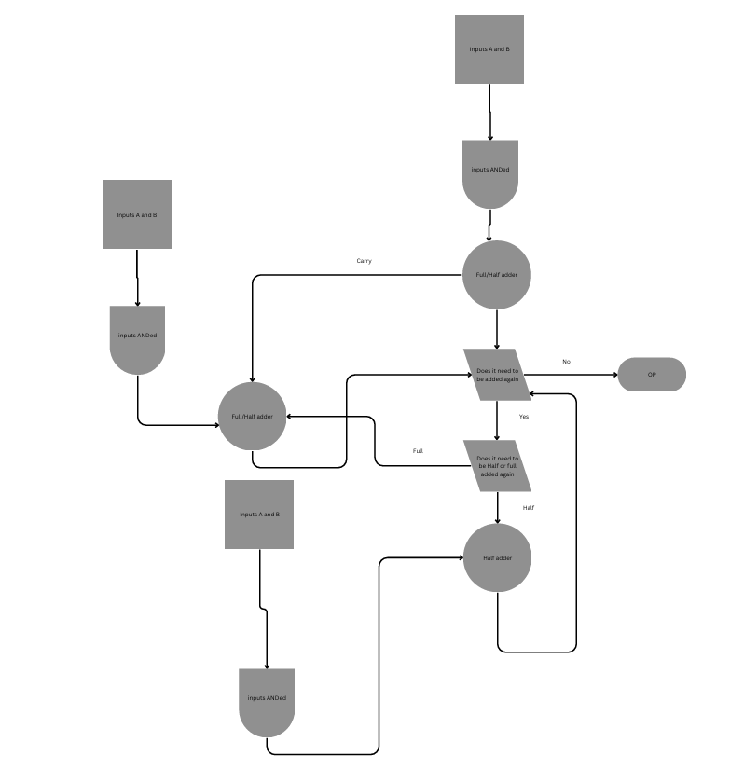
Figure 1: Braun's multiplier flowchart
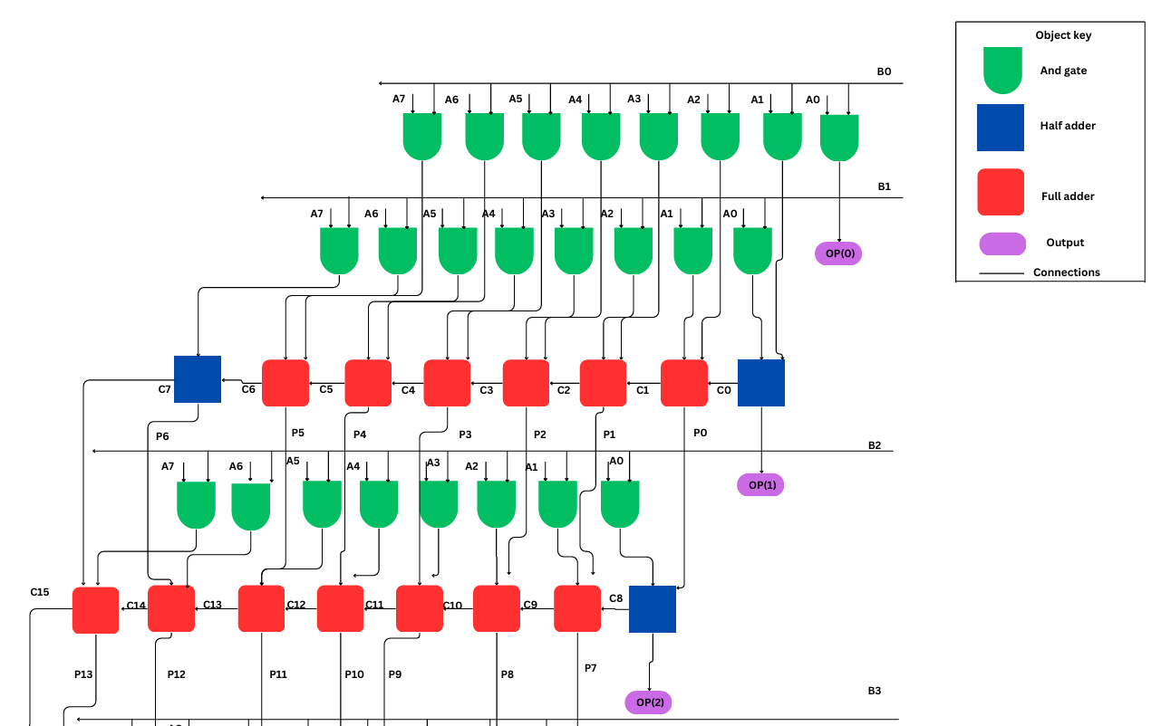
Figure 2: Braun’s block diagram
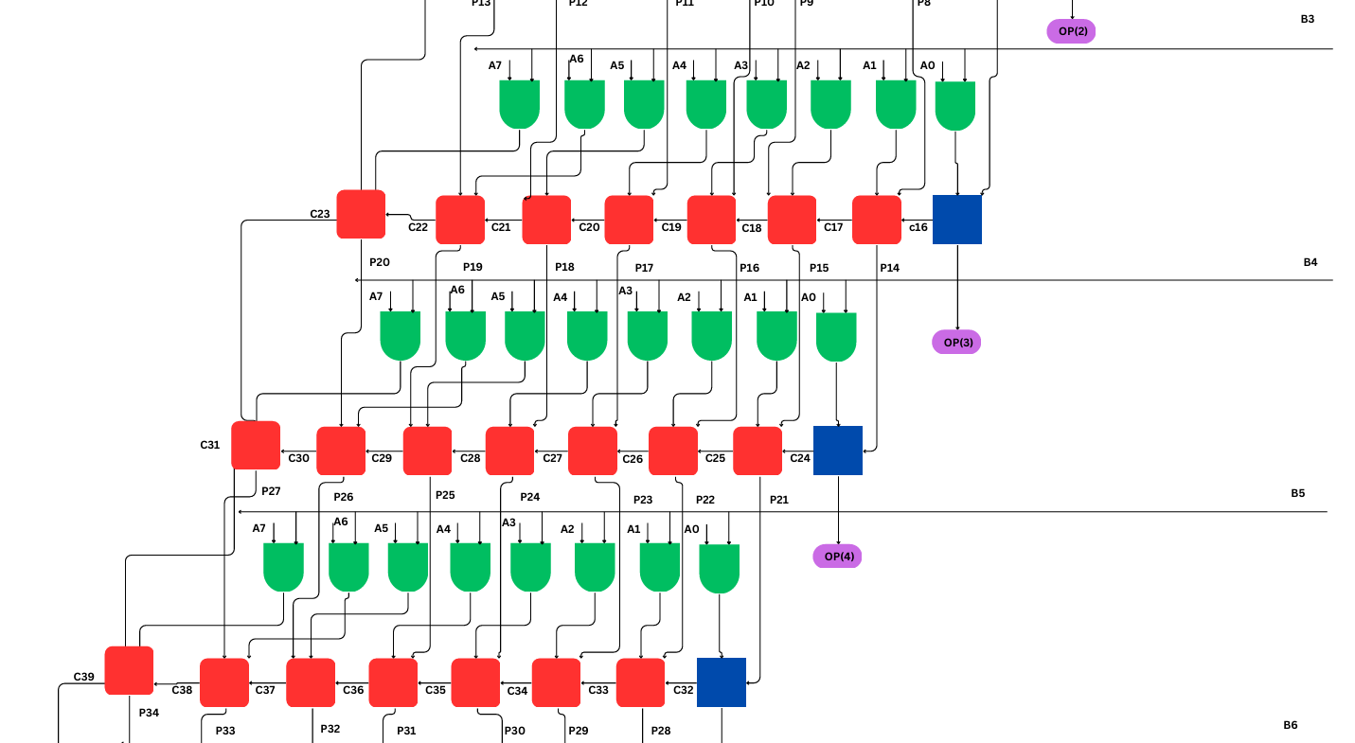
Figure 3: Braun’s block diagram (1)

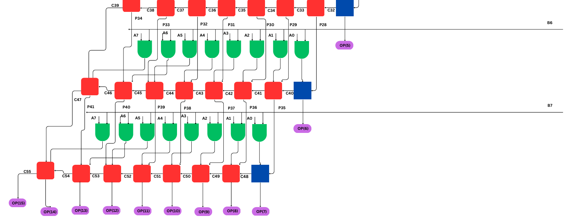
Figure 4: Braun’s block diagram (2)
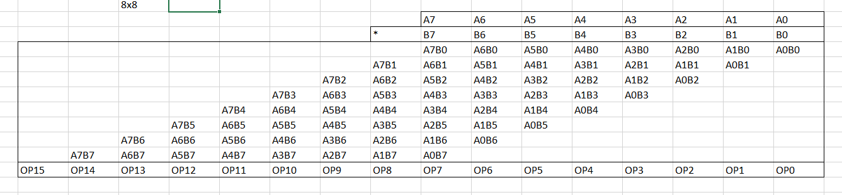
Figure 5: Brans A & B inputs
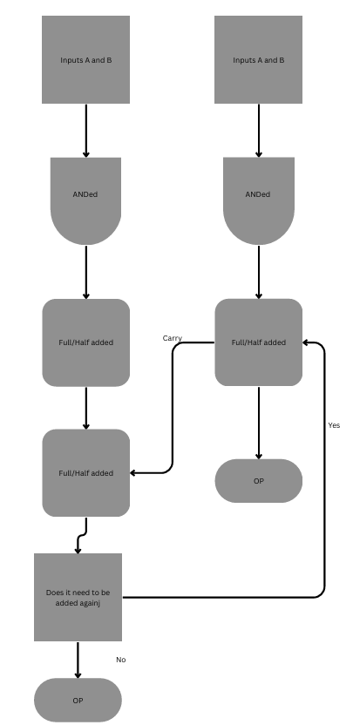
Figure 6: Wallace Tree flowchart

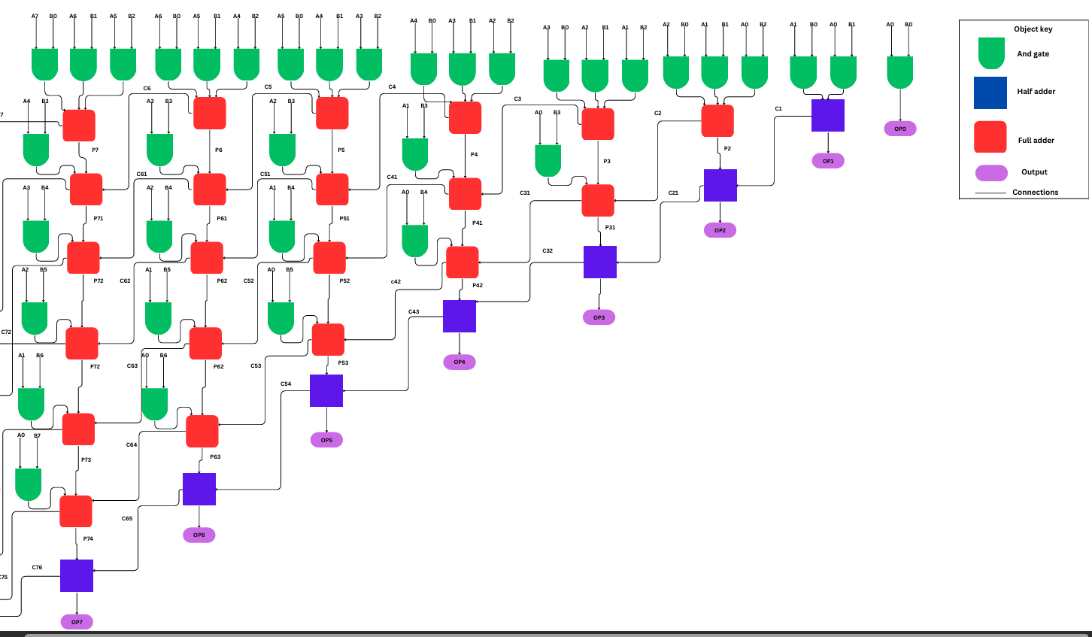
Figure 7: Wallace Tree block diagram

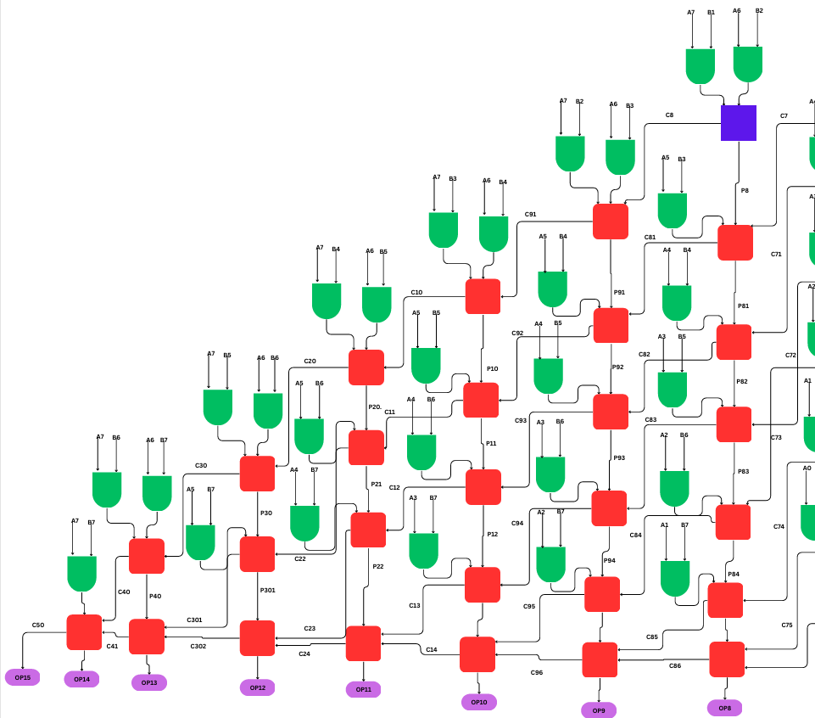
Figure 8: Wallace Tree block diagram

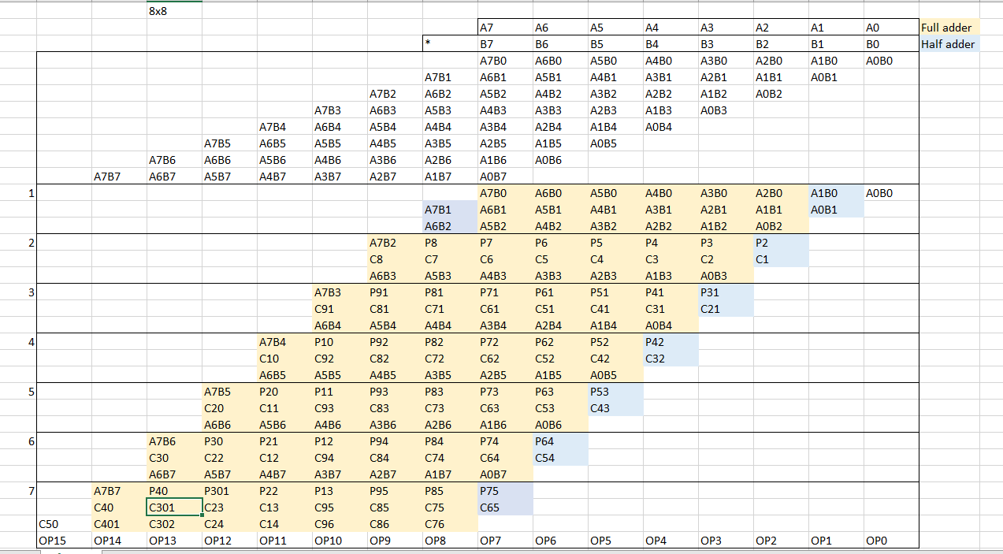
Figure 9: Wallace Tree A & B inputs
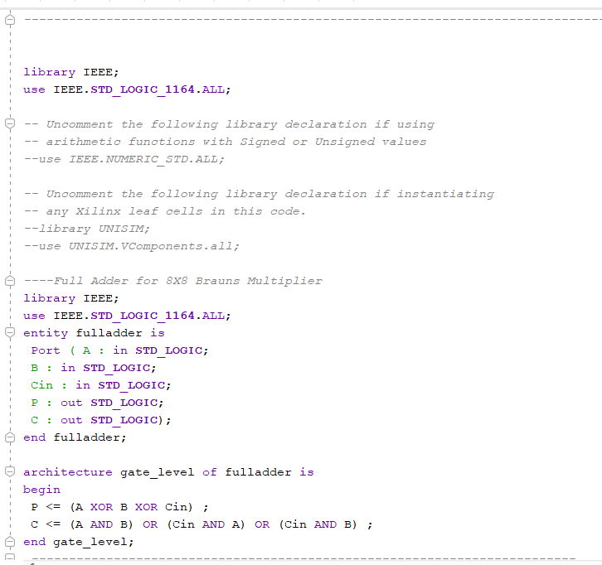
Figure 10: set-up of adders

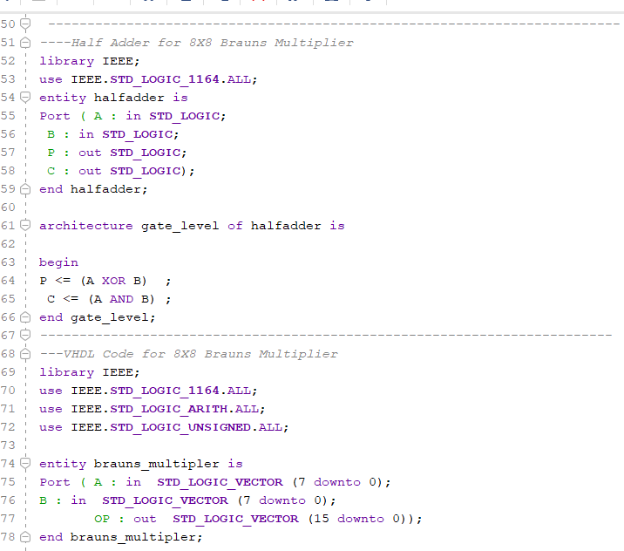
Figure 11: set-up of adders (1)

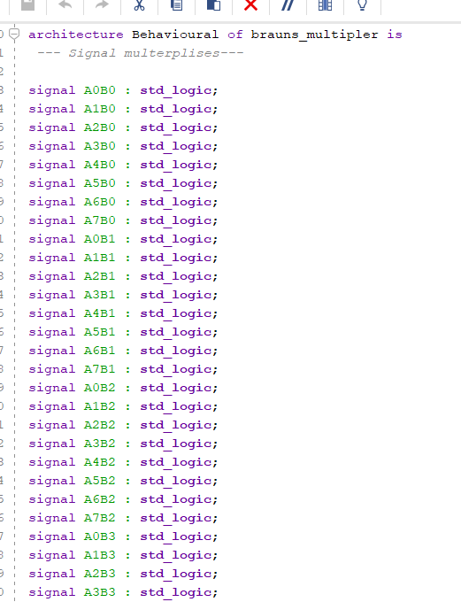
Figure 12: Declaring signals Brauns
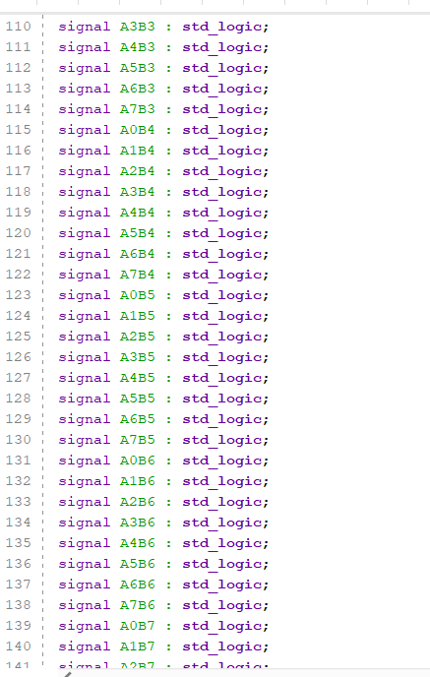
Figure 13: Declaring signals Brauns (1)
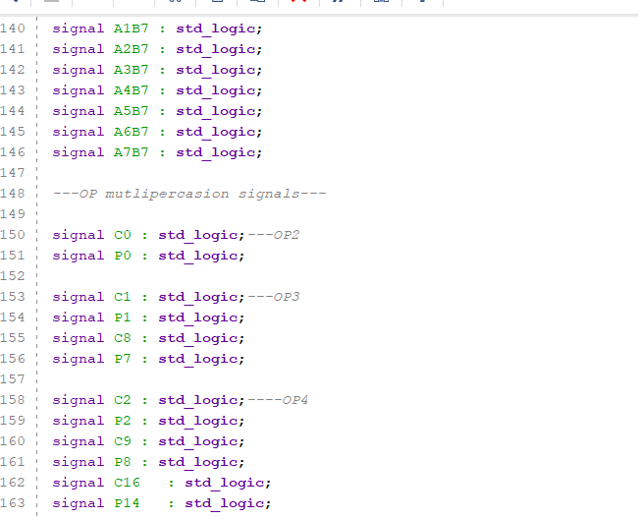
Figure 14: Declaring signals Brauns (2)
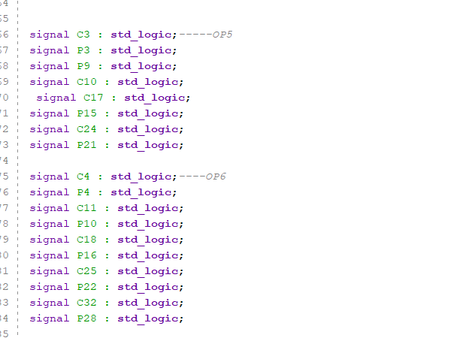
Figure 15: Declaring signals Braun’s (3)
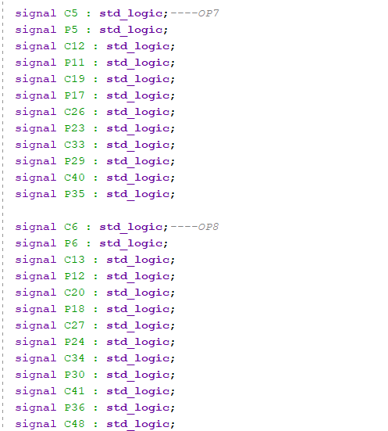
Figure 16: Declaring signals Braun’s (4)
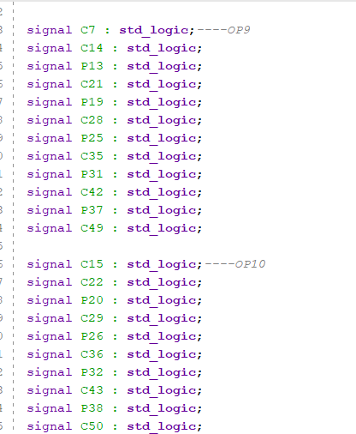
Figure 17: Declaring signals Braun’s (5)
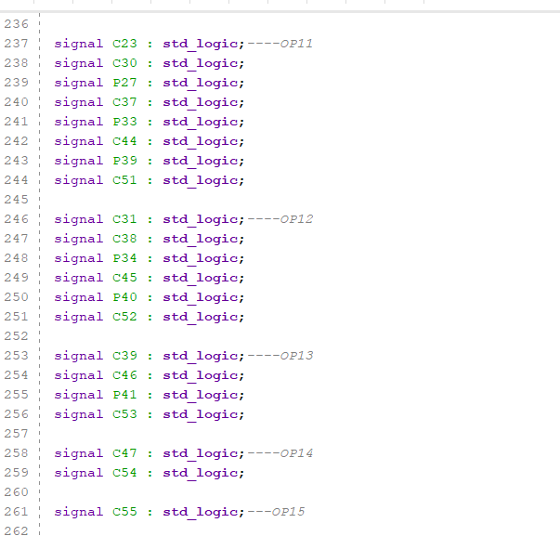
Figure 18: Declaring signals Braun’s (6)
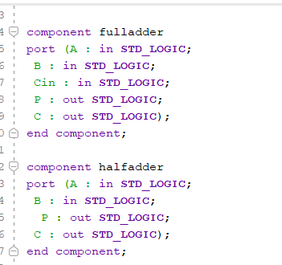
Figure 19: Component declaration
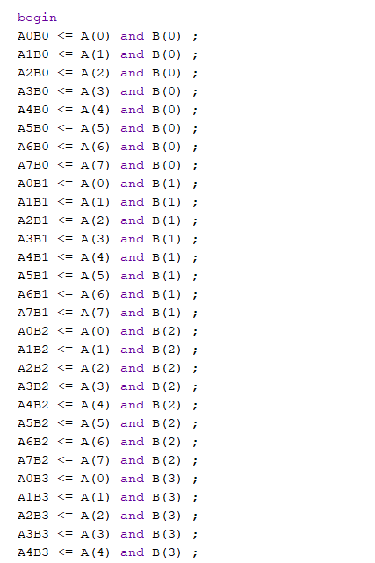
Figure 20: Assigning A and B
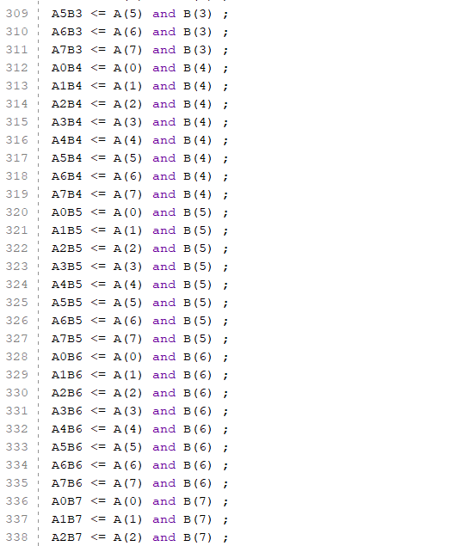
Figure 21Assigning A and B
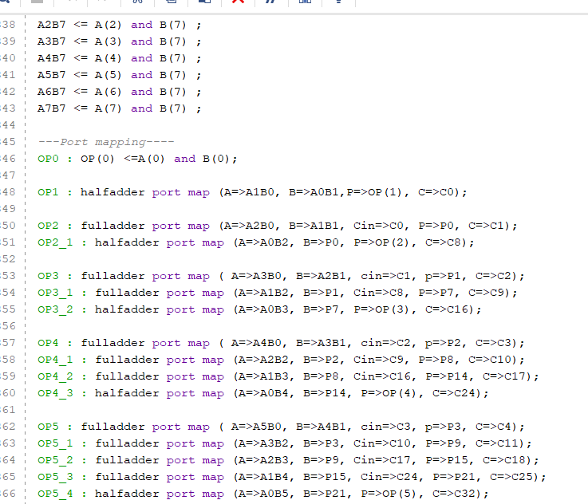
Figure 22: Port mapping of Braun’s
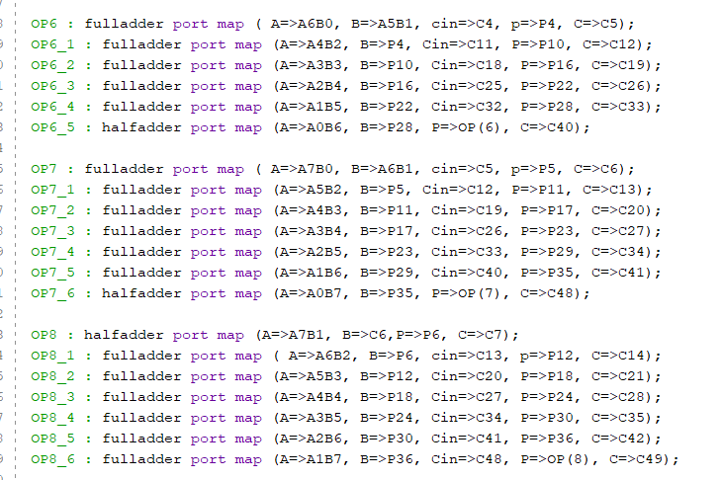
Figure 23: Port mapping of Braun’s (1)
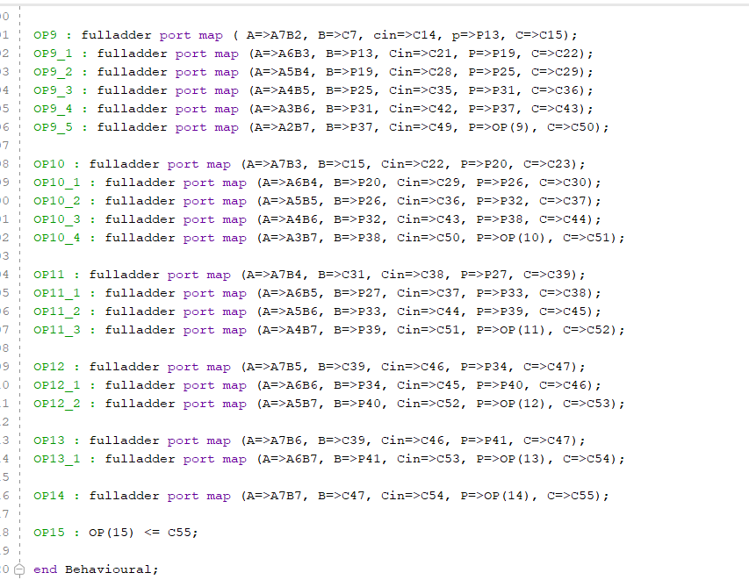
Figure 24: Port mapping of Braun’s (2)

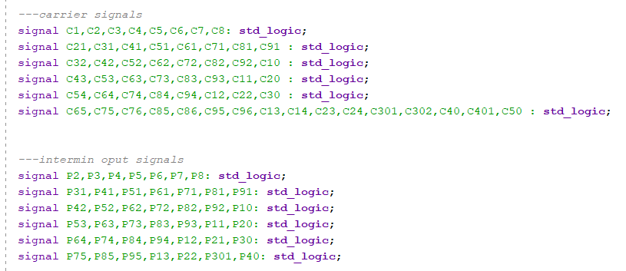
Figure 25: Wallace Tree signals
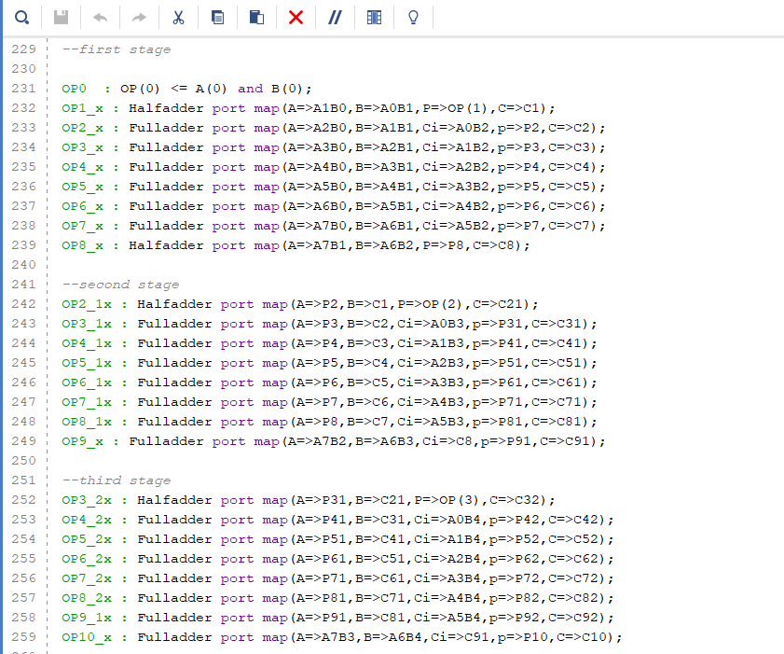
Figure 26: Wallace Tree port mapping

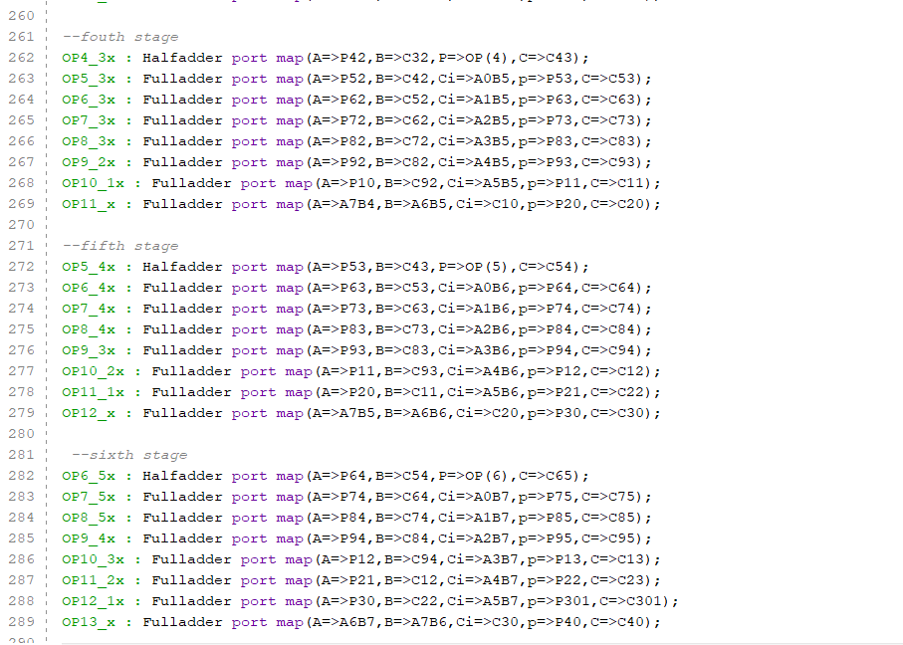
Figure 27: Wallace Tree port mapping (1)
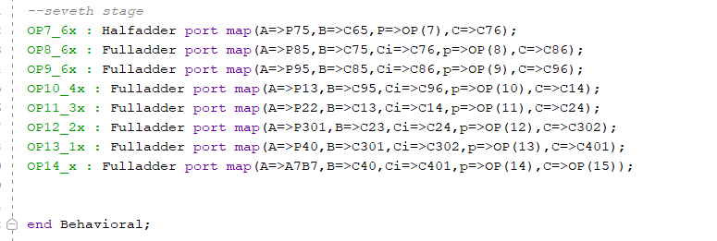
Figure 28: Wallace Tree port mapping (2)
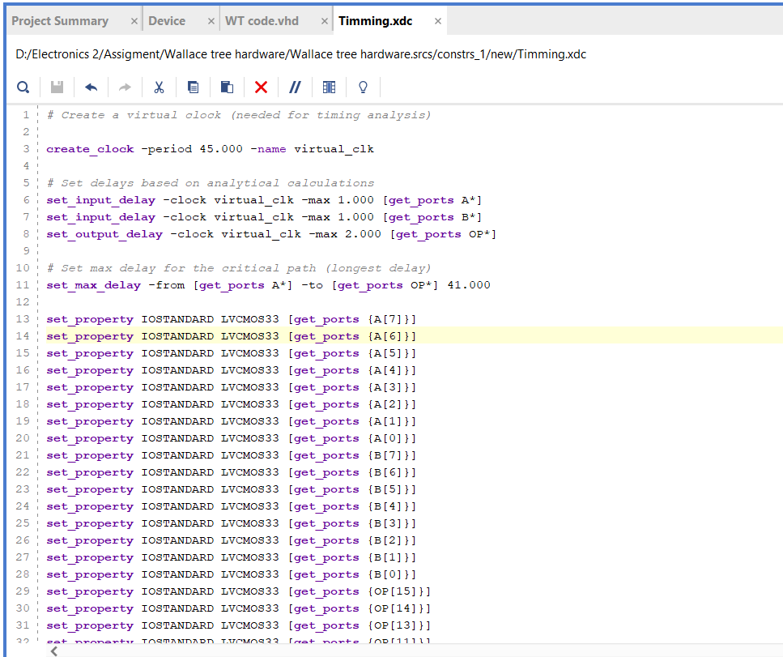
Figure 29: timing constant code for Braun’s
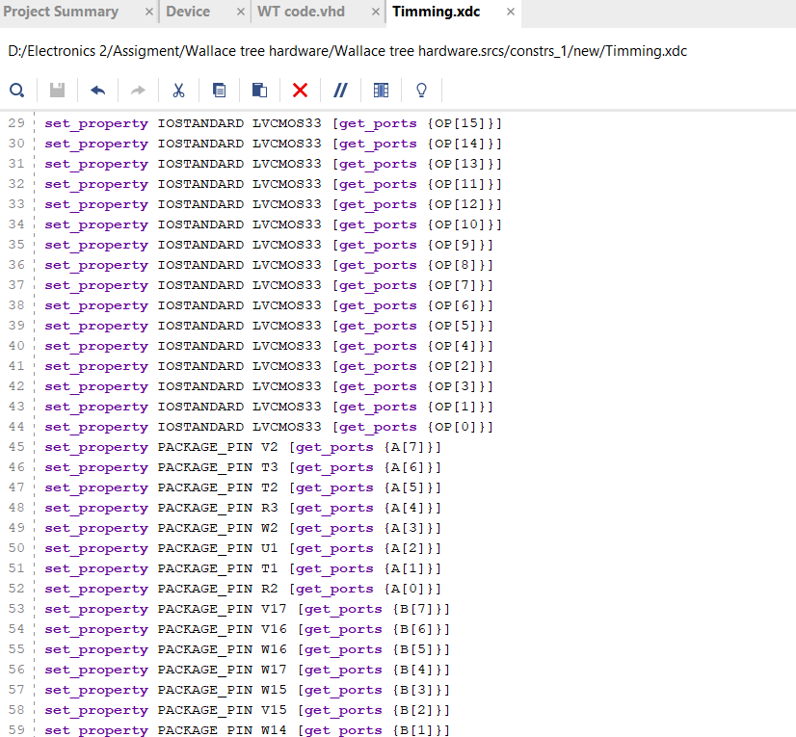
Figure 30: timing constant code
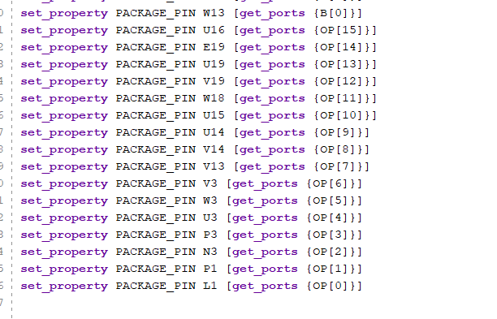
Figure 31: timing constant code (1)

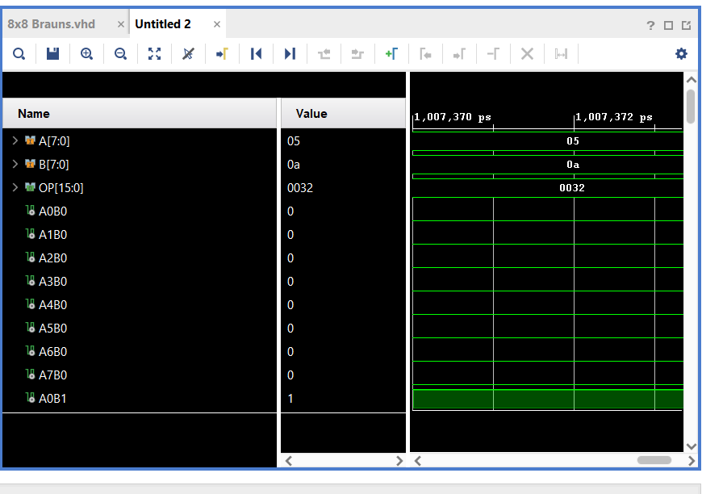
Figure 32: Braun’s 5*A simulations
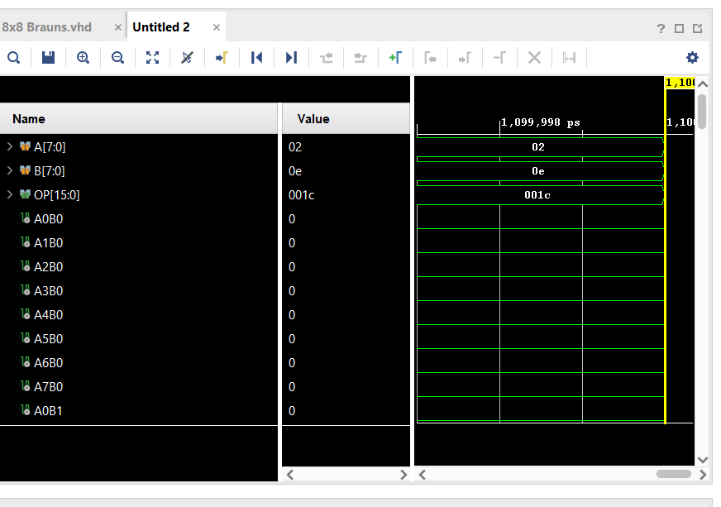
Figure 33: Braun’s 2*E simulations
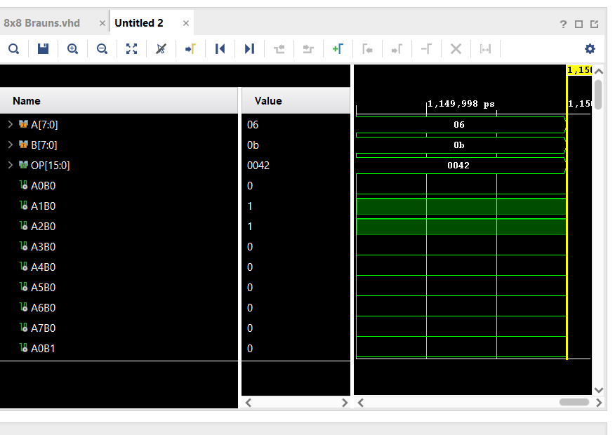
Figure 34: Braun’s 6*B simulations
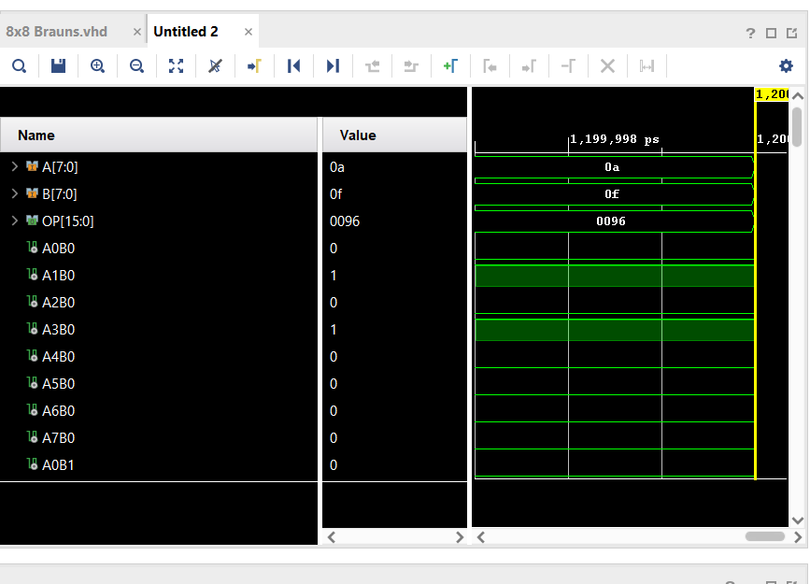
Figure 35: Braun’s A*F simulations
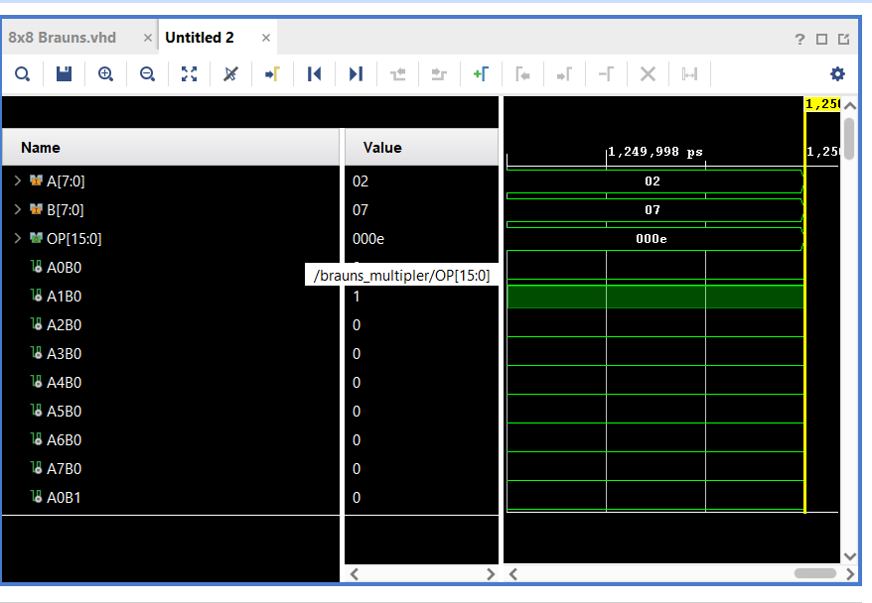
Figure 36: Braun’s 2*7 simulations
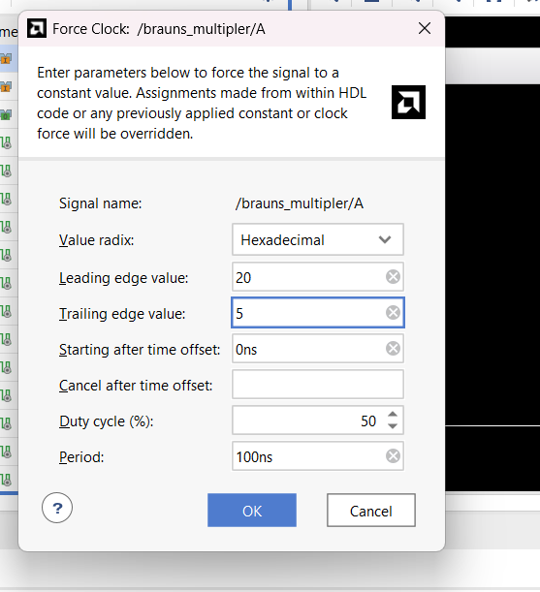
Figure 37: Clock leading and trailing edge
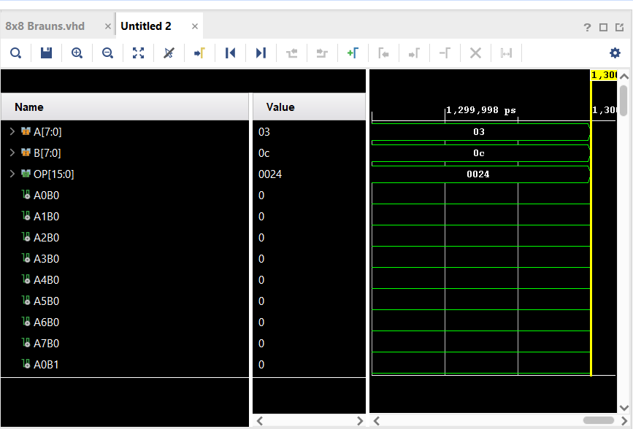
Figure 38: Braun’s 3*C simulations

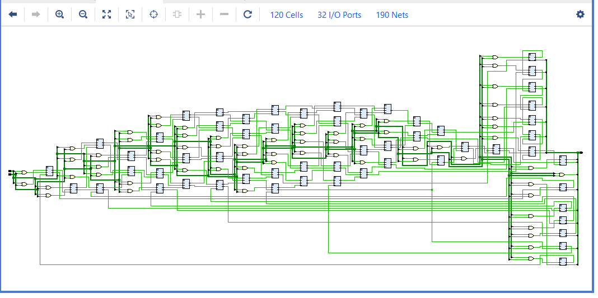
Figure 39: RTL schematic of Braun's multiplier
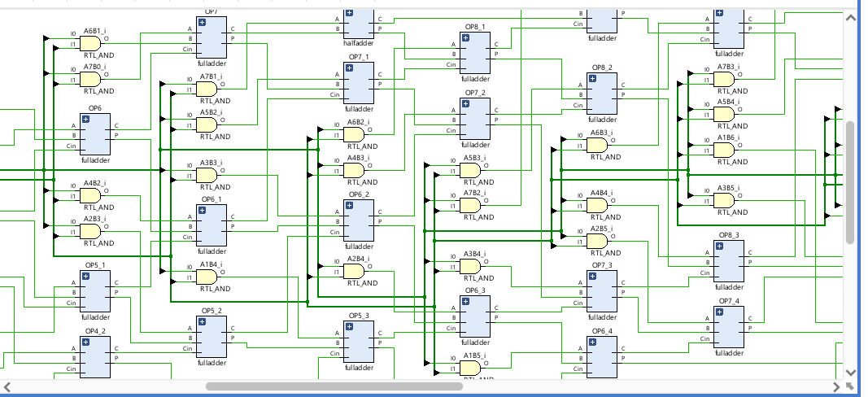
Figure 40: RTL schematic of Braun's multiplier (1)
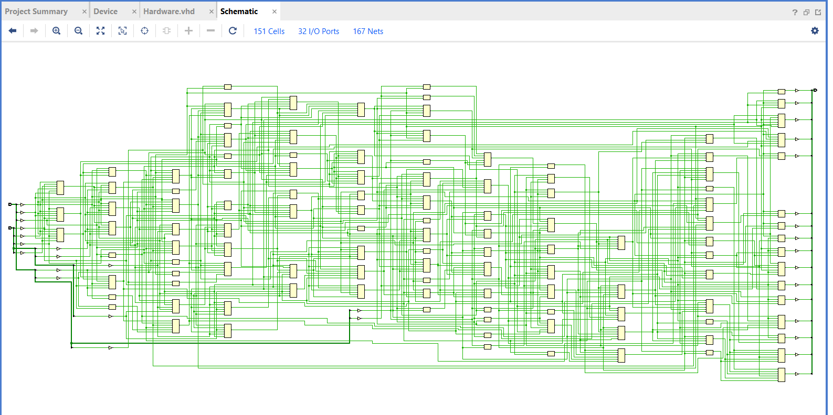
Figure 41: Implementation schematic of Braun's multiplier
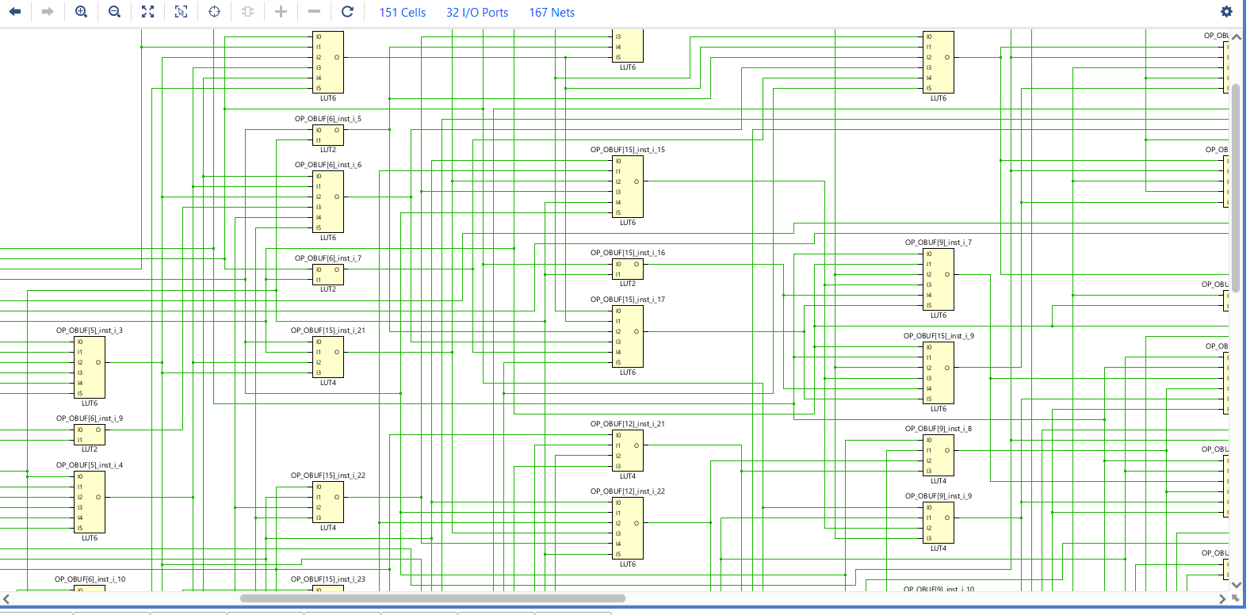
Figure 42: implementation schematic of Braun's multiplier (1)
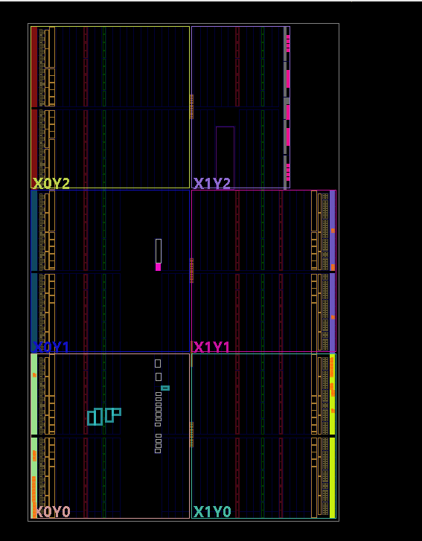
Figure 43: Braun's Devices layout
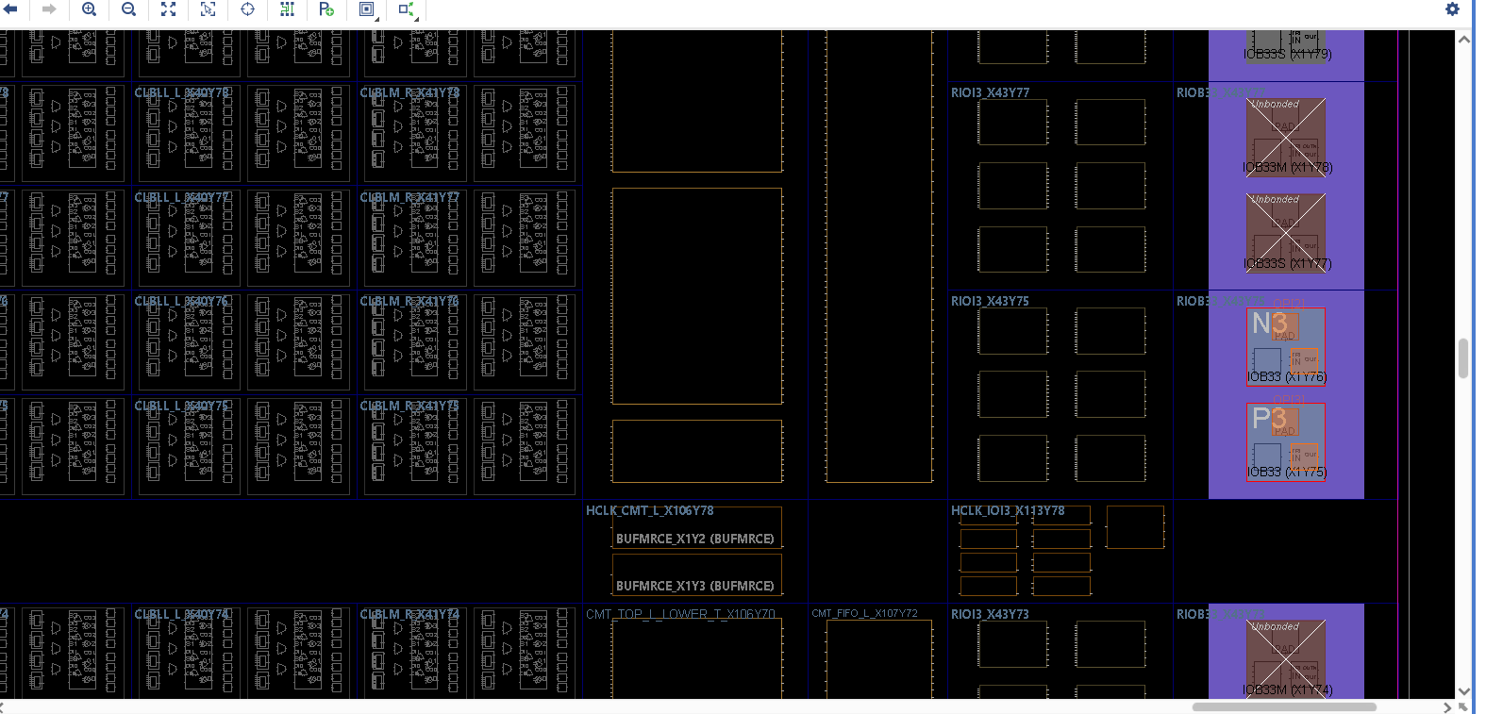
Figure 44: Braun's Devices layout (1)
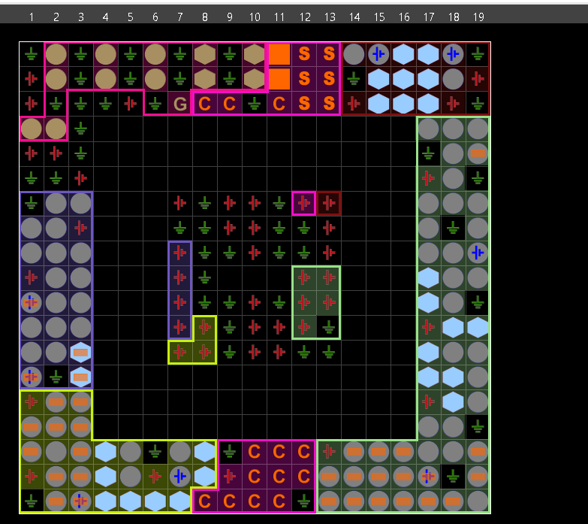
Figure 45:Braun's input/output pin locations
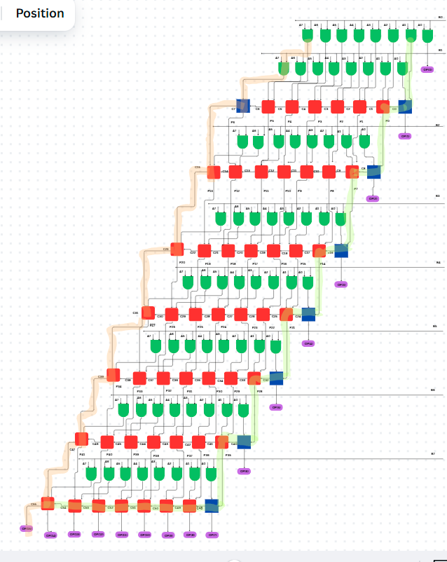
Figure 46: Braun’s longest and shortest delay
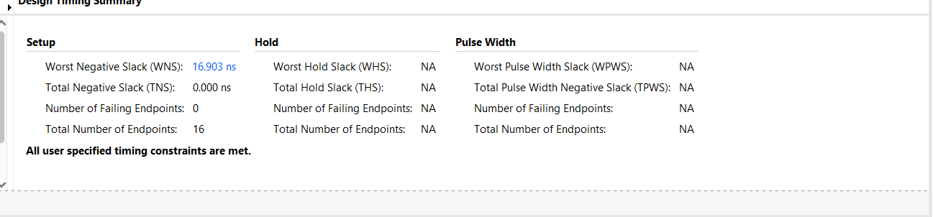
Figure 47: Simulations of Braun’s longest delay

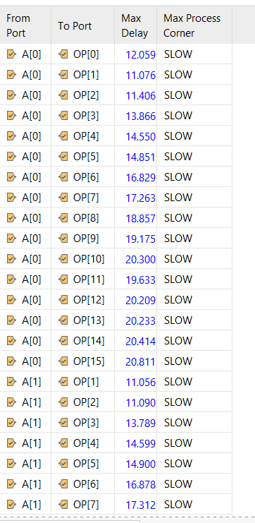
Figure 48: Braun’s individual delays
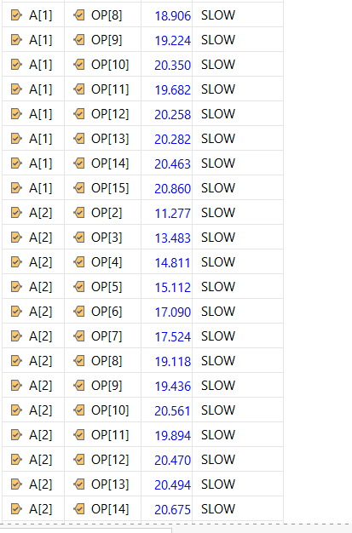
Figure 49: Braun’s individual delays (1)
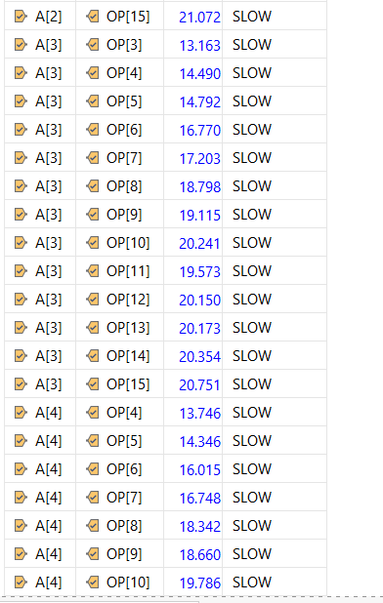
Figure 50: Braun’s individual delays (2)
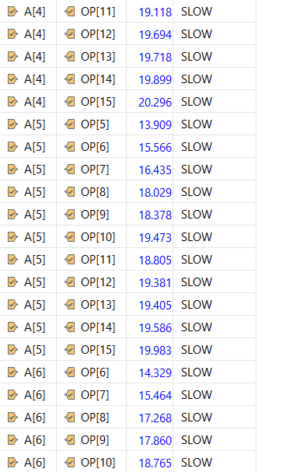
Figure 51: Braun’s individual delays (3)
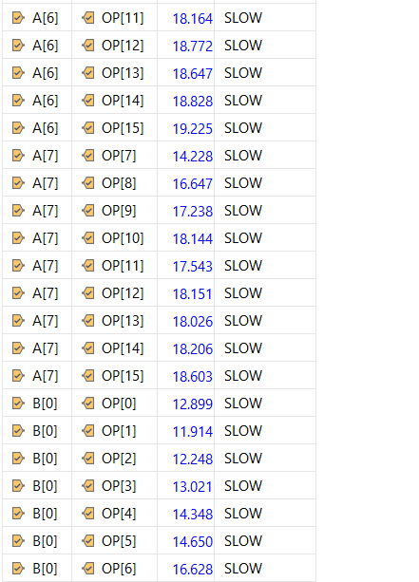
Figure 52: Braun’s individual delays (4)
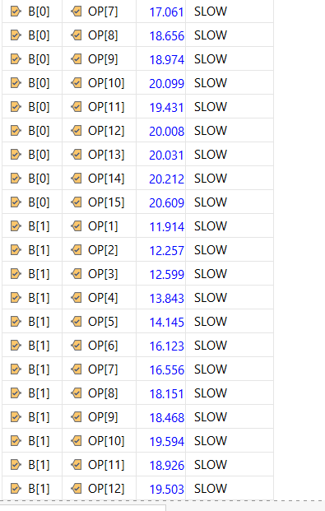
Figure 53: Braun’s individual delays (5)
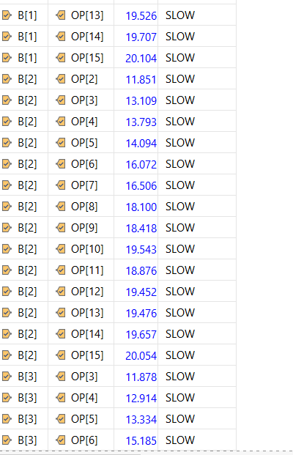
Figure 54: Braun’s individual delays (6)
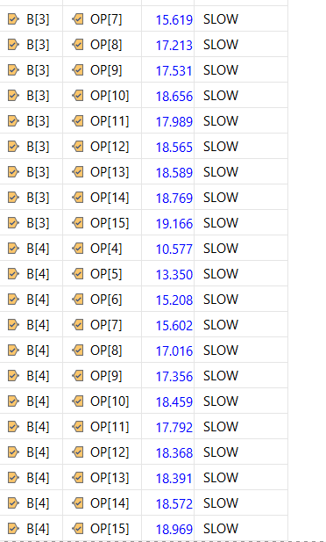
Figure 55: Braun’s individual delays (7)
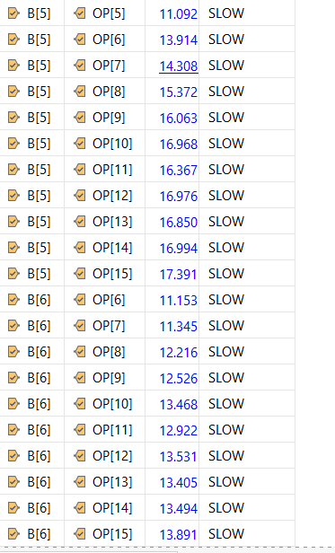
Figure 56: Braun’s individual delays (8)
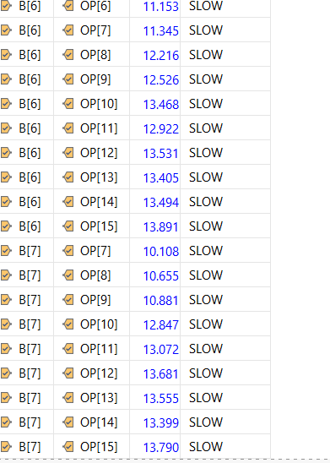
Figure 57: Braun’s individual delays (9)
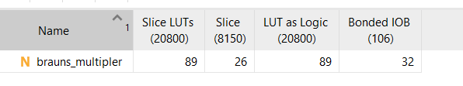
Figure 58: Braun's utilisation
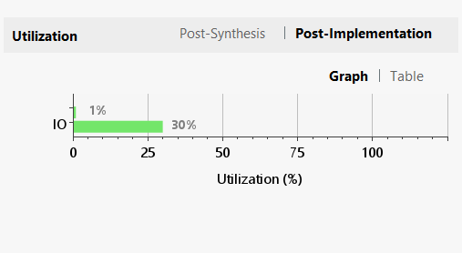
Figure 59: Braun's utilisation (1)
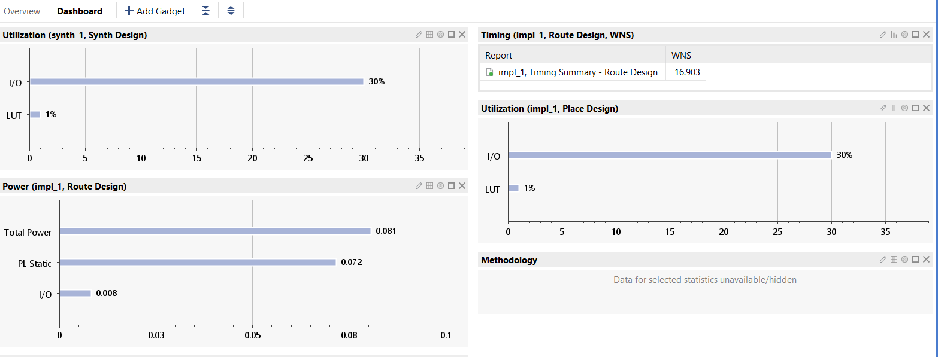
Figure 60: Braun's utilisation (2)
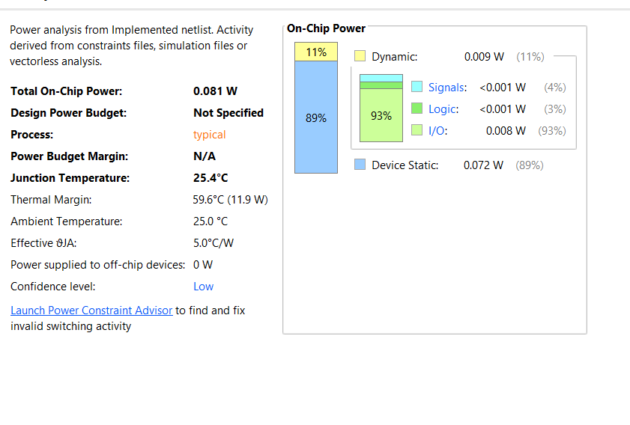
Figure 61: Braun’s power
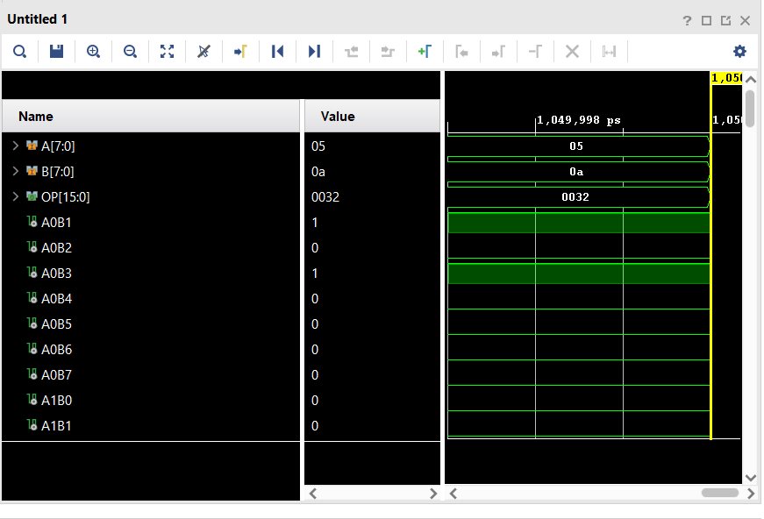
Figure 62: Wallace tree 5*A simulations
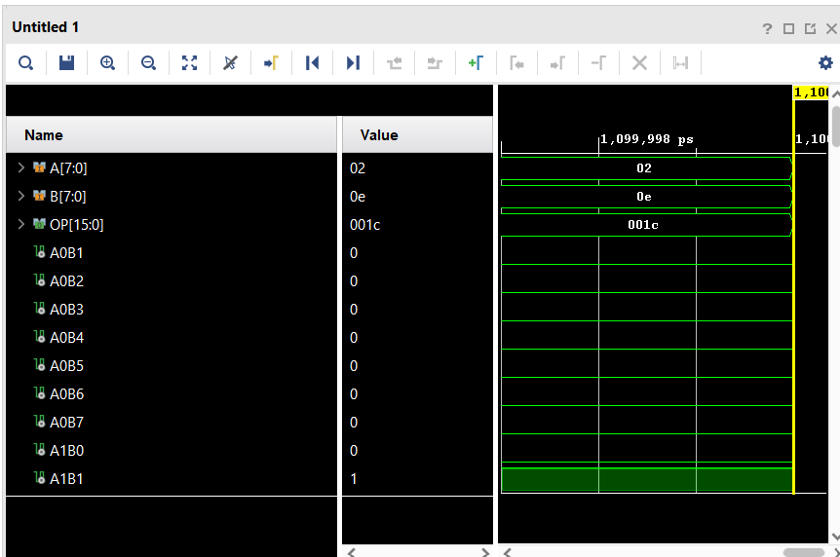
Figure 63: Wallace tree 2*E simulations

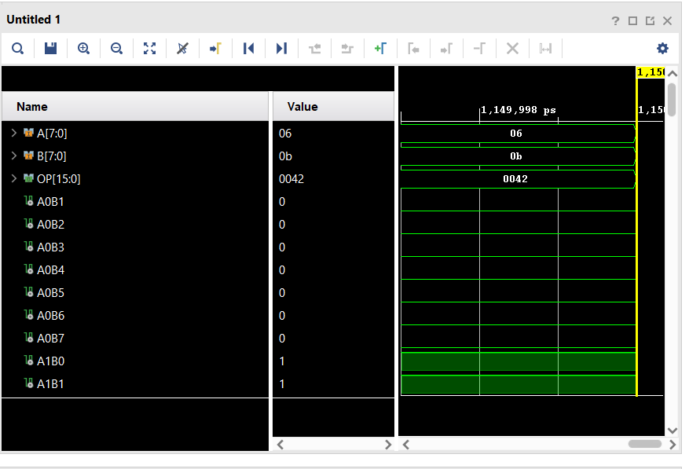
Figure 64: Wallace tree 6*B simulations
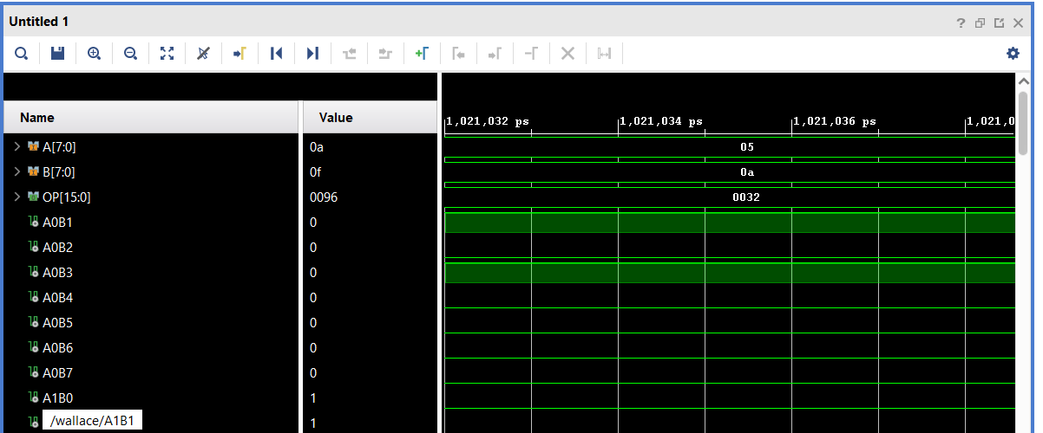
Figure 65: Wallace tree A*F simulations

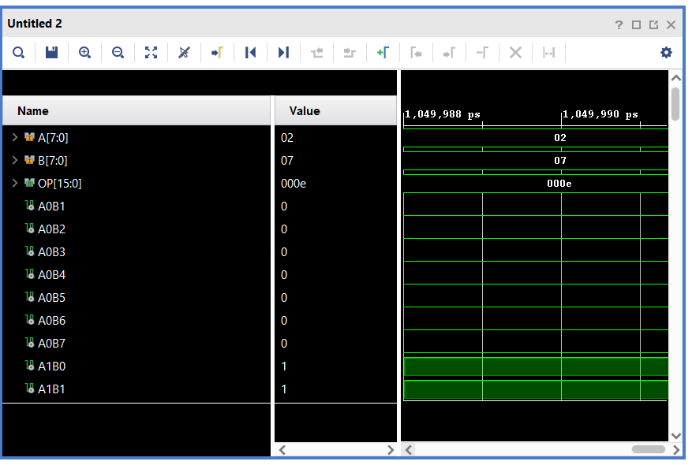
Figure 66: Wallace tree 2*7 simulations
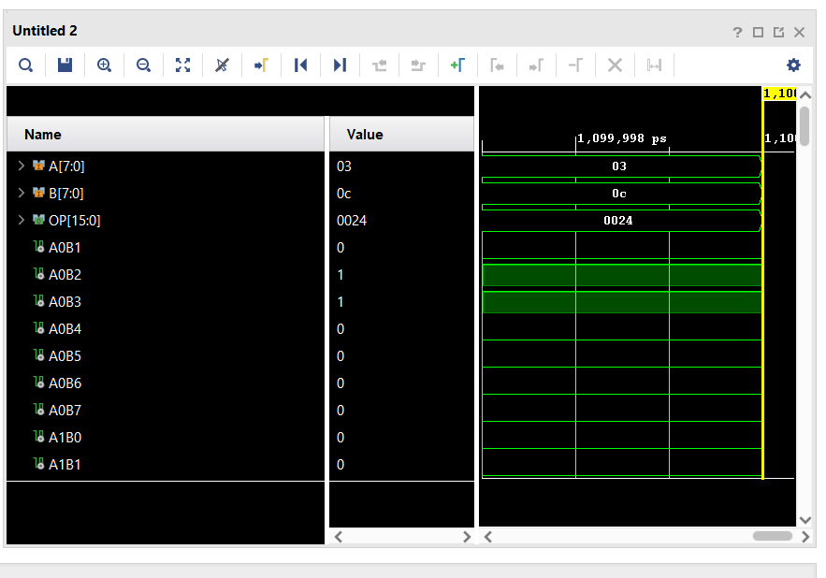
Figure 67: Wallace tree 3*C simulations
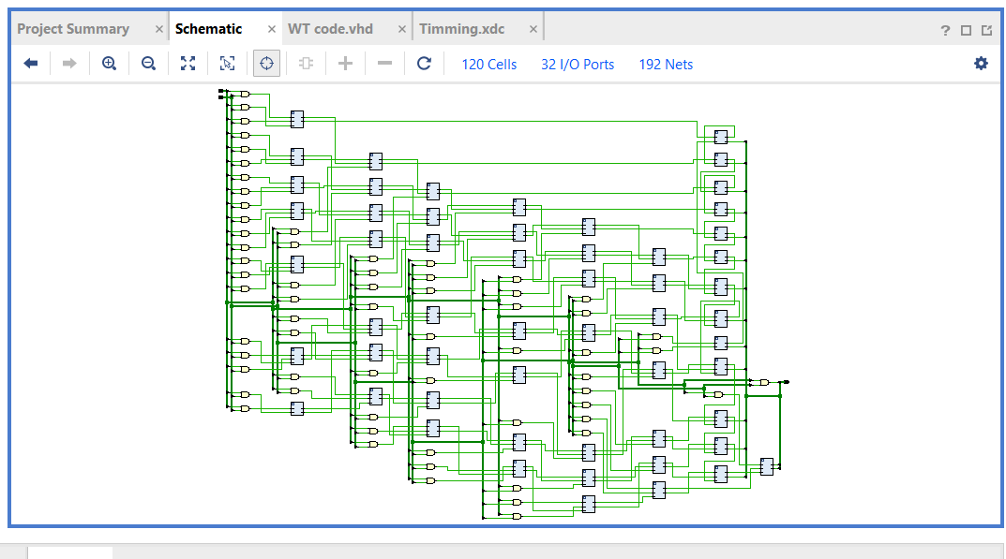
Figure 68: RTL schematics of Wallace tree
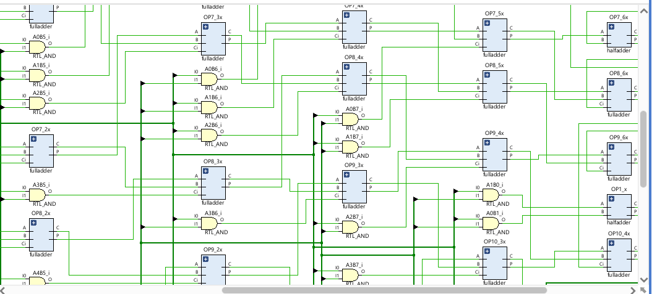
Figure 69: RTL schematics of Wallace tree (1)
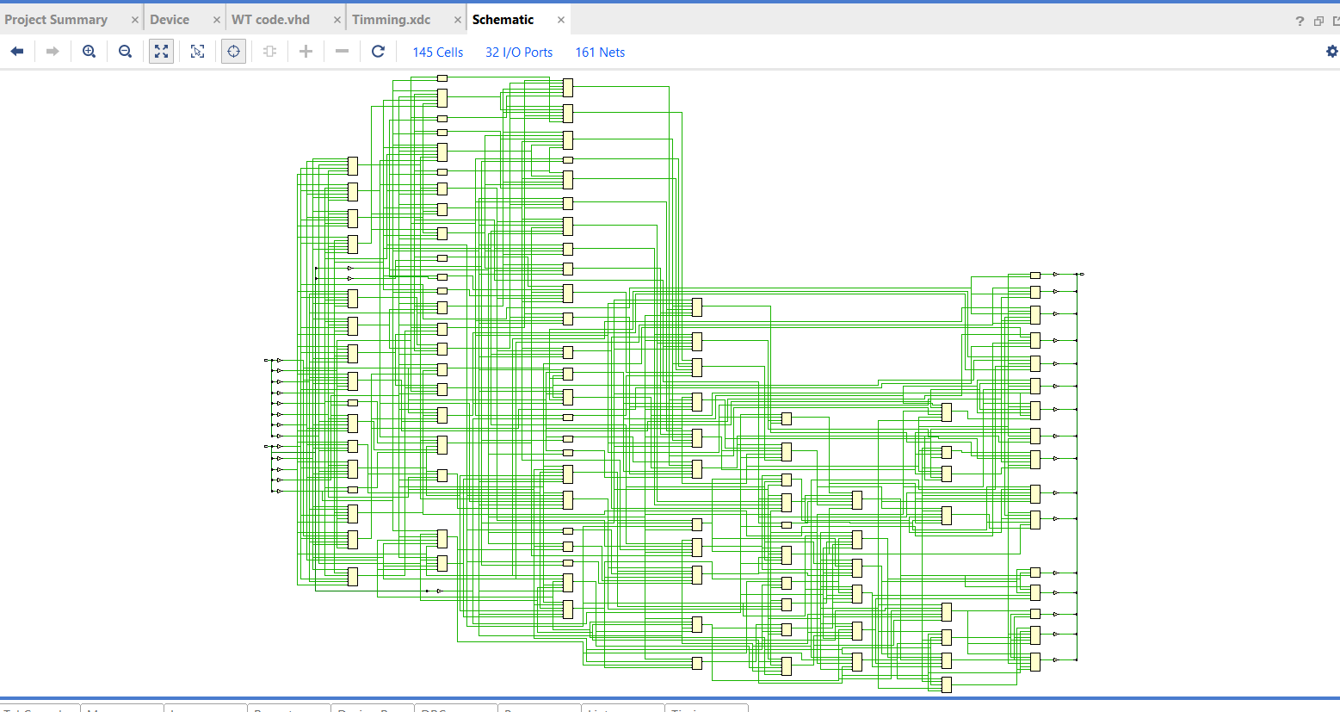
Figure 70: Implementation schematics of Wallace tree
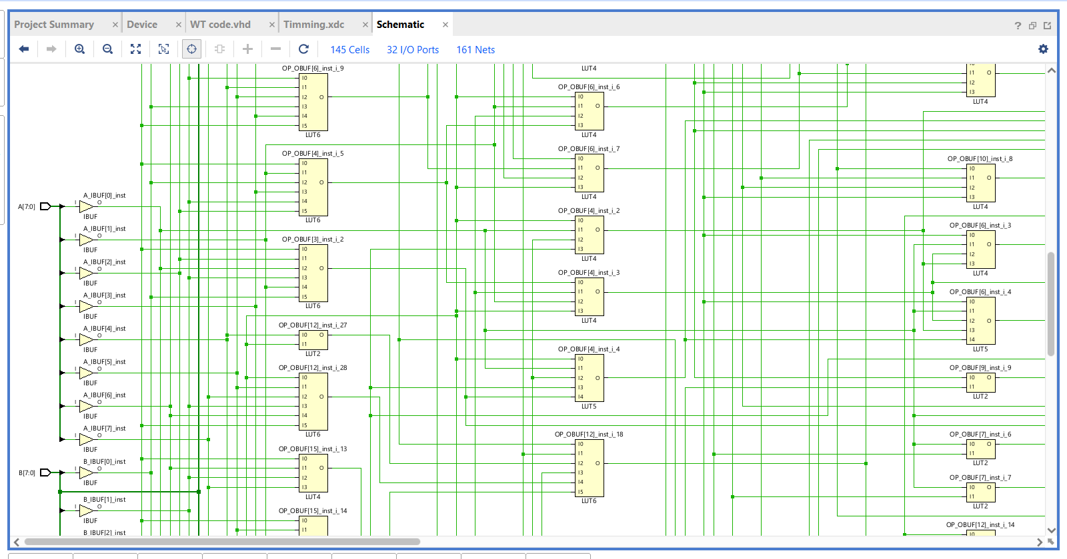
Figure 71: Implementation schematics of Wallace tree (1)

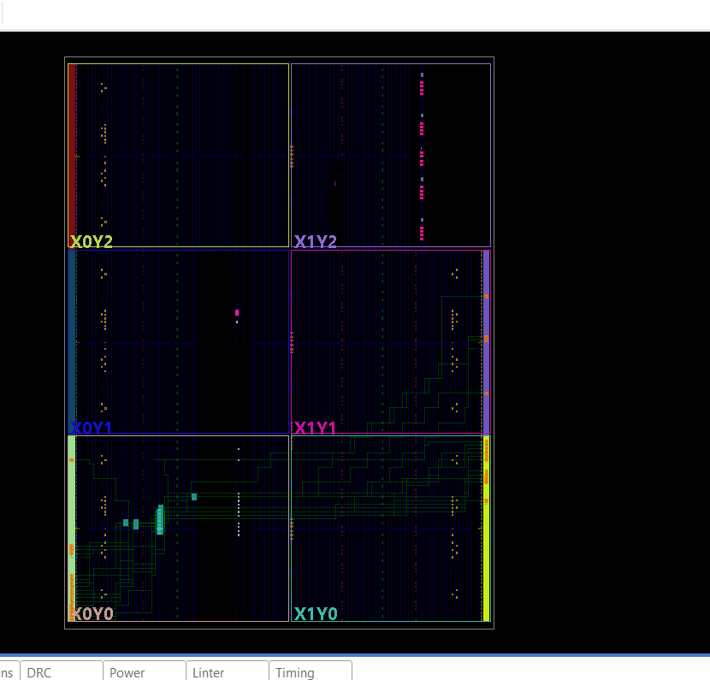
Figure 72: Device layout of Wallace tree
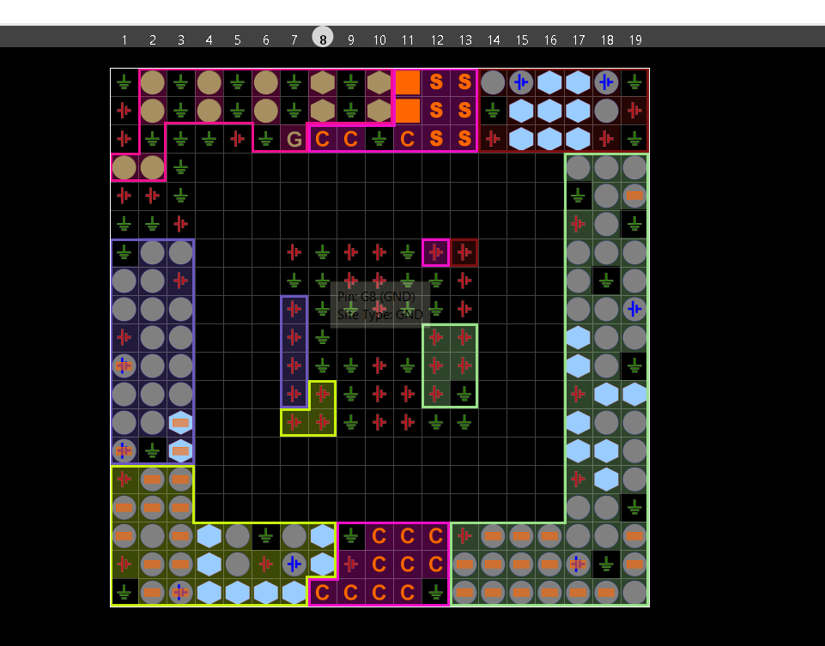
Figure 73: Wallace tree input/output pin locations

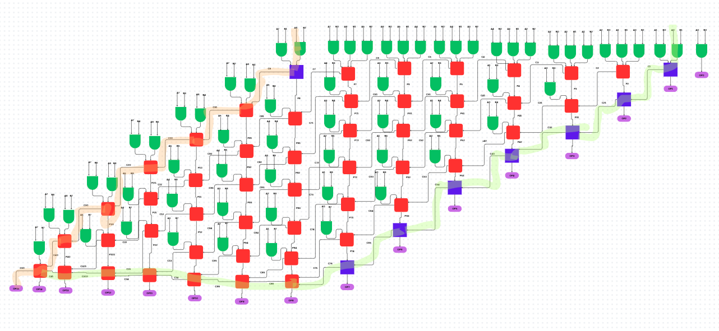
Figure 74: Longest and shortest delay of Wallace tree
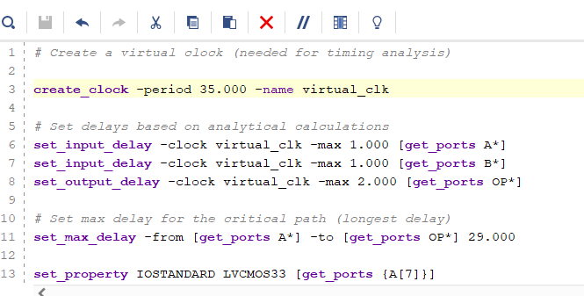
Figure 75:: timing constant code for Wallace tree

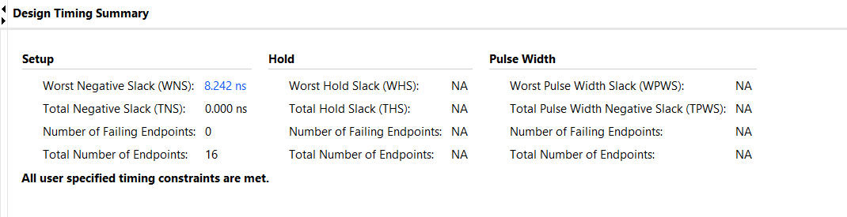
Figure 76: simulations of Wallace tree longest delay
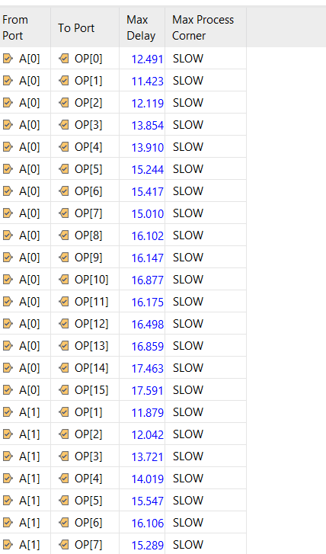
Figure 77: Wallace tree individual delays
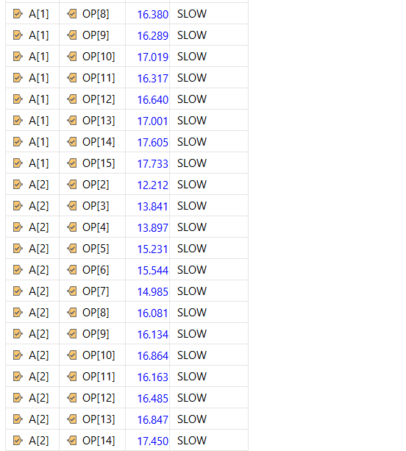
Figure 78: Wallace tree individual delays (1)
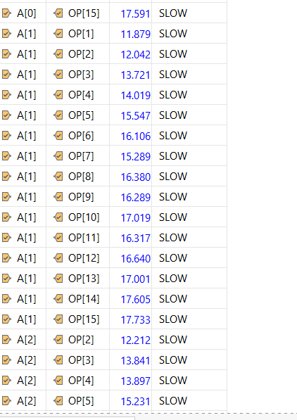
Figure 79: Wallace tree individual delays (2)
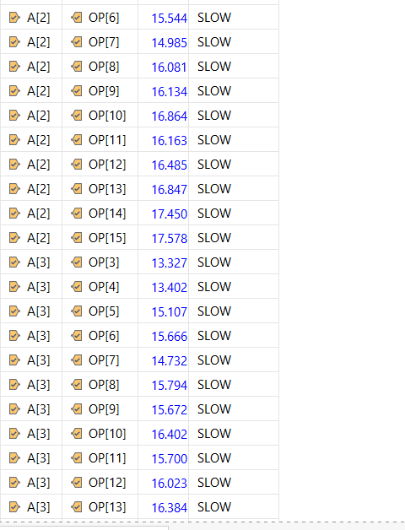
Figure 80: Wallace tree individual delays (3)
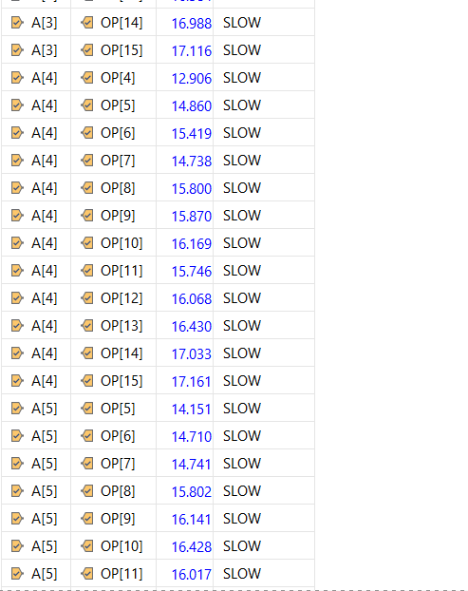
Figure 81: Wallace tree individual delays (4)
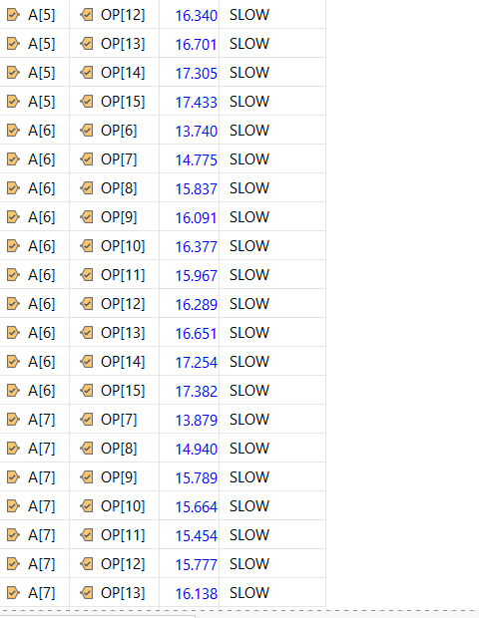
Figure 82: Wallace tree individual delays (5)
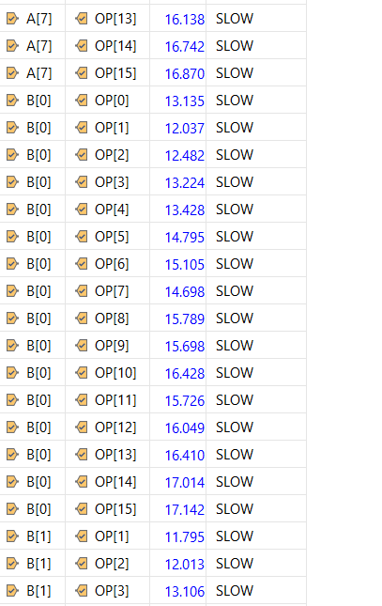
Figure 83: Wallace tree individual delays (6)
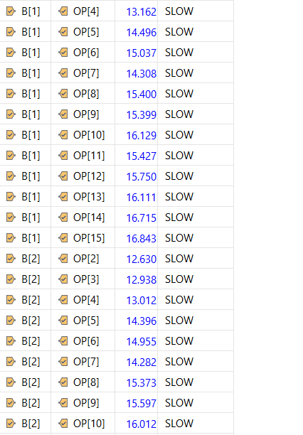
Figure 84: Wallace tree individual delays (7)
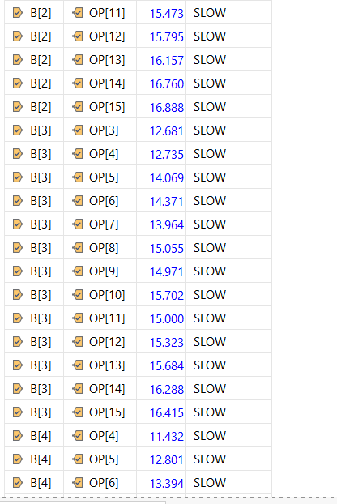
Figure 85: Wallace tree individual delays (8)
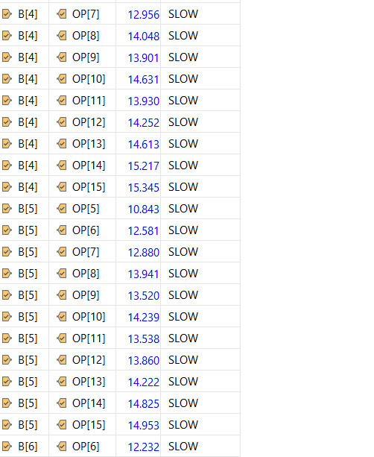
Figure 86: Wallace tree individual delays (9)
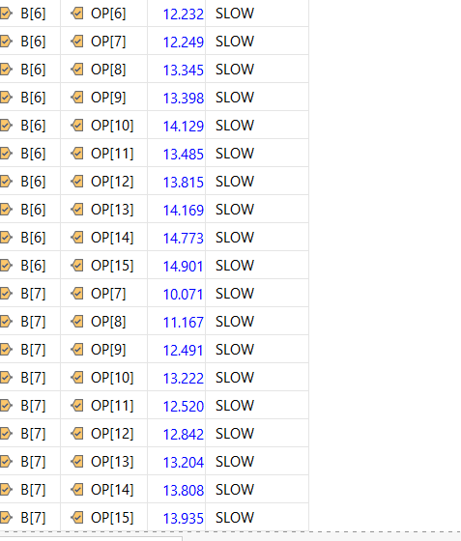
Figure 87: Wallace tree individual delays (10)
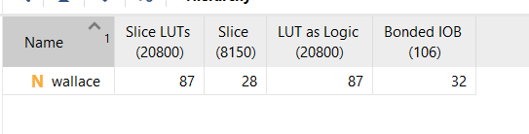
Figure 88: Wallace tree utilisation

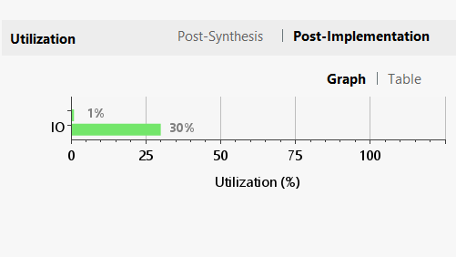
Figure 89: Wallace tree utilisation (1)

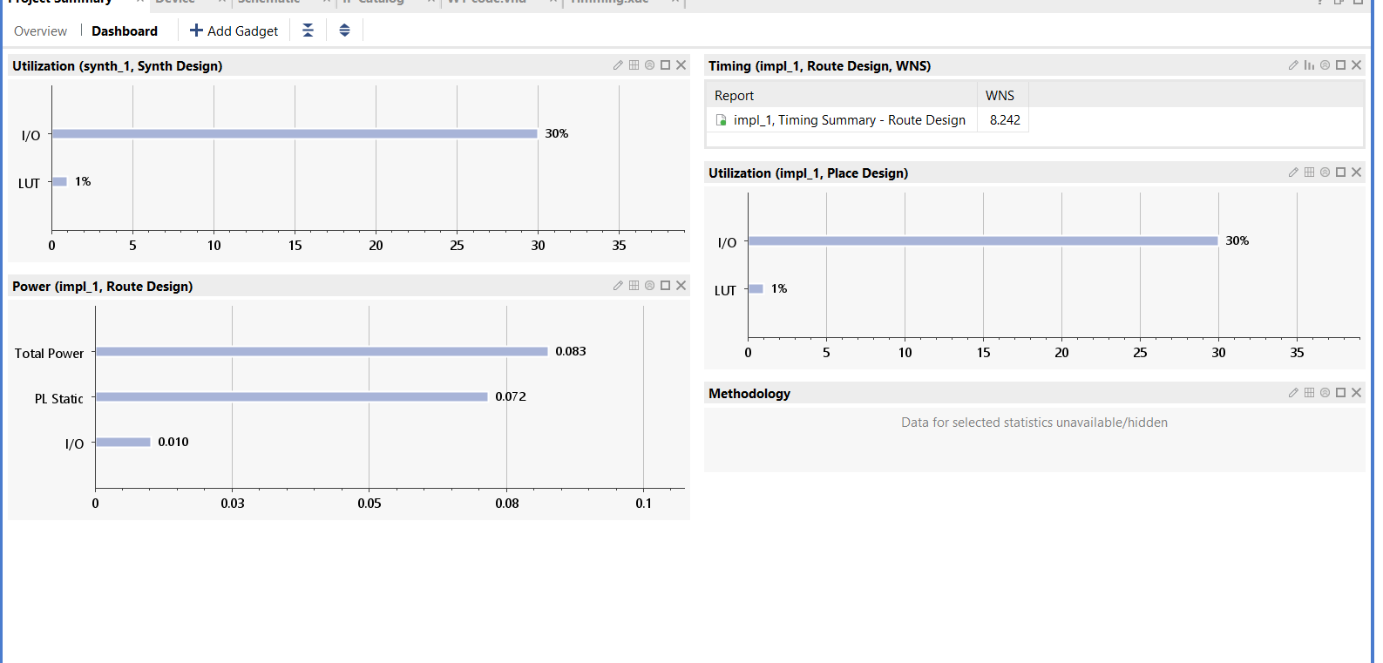
Figure 90: Wallace tree utilisation (2)

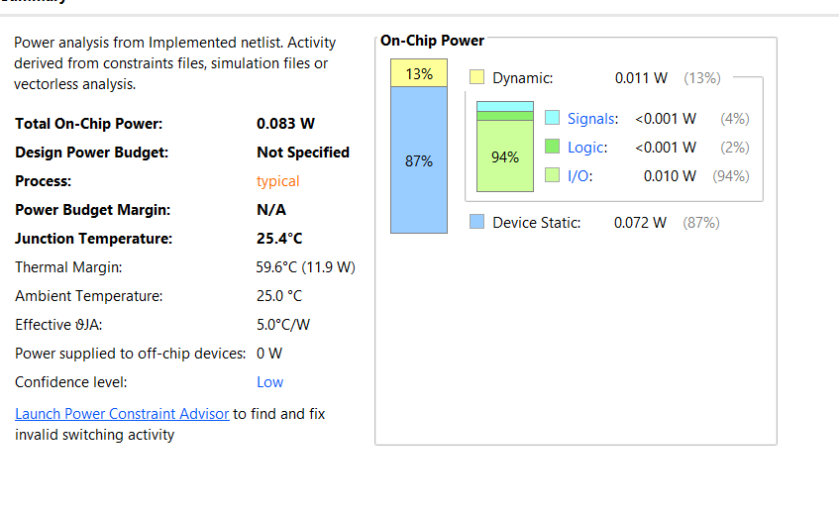
Figure 91: Wallace tree power
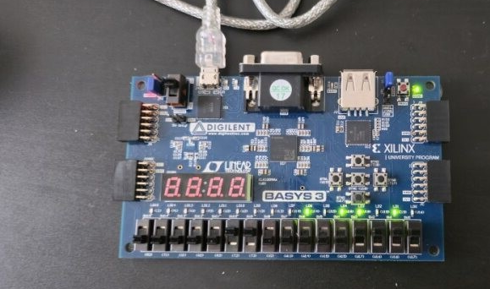
Figure 92: Practical simulations of both multipliers F*6=5A

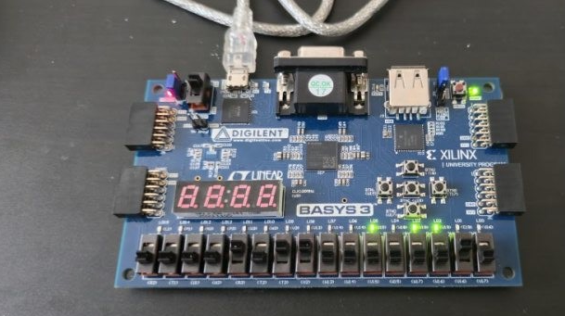
Figure 93: Practical simulations of both multipliers 2*B=16

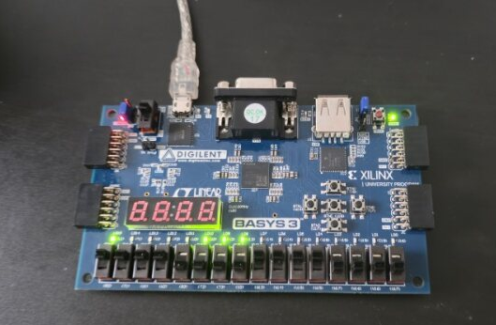
Figure 94: Practical simulations of both multipliers F*F=E1

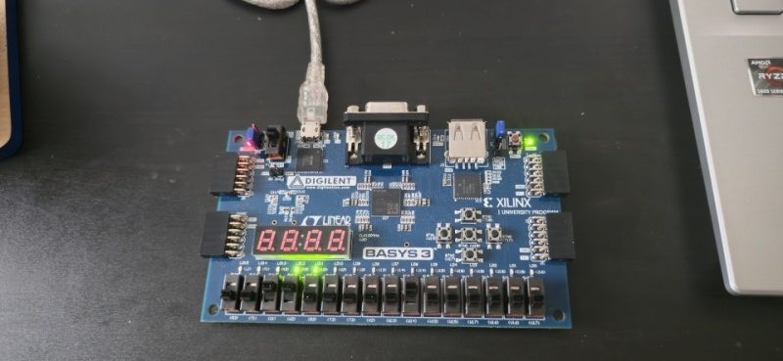
Figure 95: Practical simulations of both multipliers 2*C=18

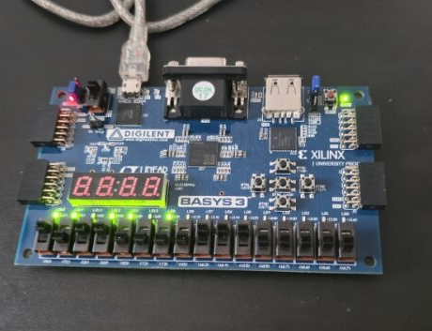
Figure 96: Practical simulations of both multipliers D*7=5B

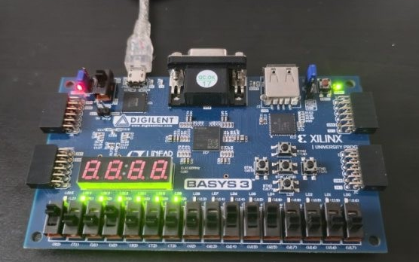
Figure 97: Practical simulations of both multipliers E*9=7E

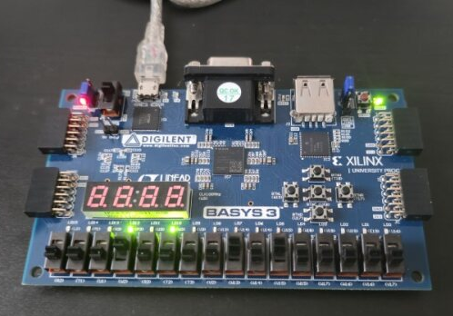
Figure 98: Practical simulations of both multipliers 5*8=28

