
Programme: Master of Business Administration
Module Code: LCMB7024
Module: Marketing Management
Lecturer: Dr Jayalakshmi Gopalkrishnan (London)
Assignment Title: Assessment component 2: Marketing Portfolio
Student Name: Rabbi Islam
Student ID: 2504996
Word Count: 2666

Table of Contents
Introduction 3
Element 1: STDP Analysis 3
1.1 Segmentation Strategy 3
1.2 Targeting Strategy 4
1.3 Differentiation Strategy 4
1.4 Positioning Strategy 5
Element 2: Critical Analysis of the Marketing Mix 7
2.1 Product Strategy 7
2.2 Price Strategy 8
2.3 Place (Distribution) Strategy 8
2.4 Promotion Strategy 9
2.5 Integrated Marketing Mix Evaluation 10
Element 3: Marketing Strategy Pitch 11
Element 4: Reflection 12
Reference List 14

Introduction
This report designs and critically analyses the SmartMeal Box of Sainsbury, a proposed healthy meal-kit brand, which aims to resolve the increasing stress between convenience and nutrition in the UK grocery market. The product, based on developed Sainsbury retail infrastructure and loyalty, will be designed to provide modern consumers with healthy meals that are economical, accessible, and time efficient (Retail economics, 2025). The report uses the STDP framework to find and support the strategic market focus of the brand, and then critically assesses differentiation and positioning in a growing competitive meal-solutions category. This analysis is based on current consumer trends in the UK and the marketing theory. In general, the report shows that SmartMeal Box can add value to Sainsbury when addressing structural changes in food consumption, lifestyles, and wellbeing priorities in the UK.

Element 1: STDP Analysis

1.1 Segmentation Strategy
The Sainsbury SmartMeal Box segmentation strategy is a multi-dimensional strategy, which encompasses demographic, psychographic, behavioural, and geographic variables, which aligns with other best practices in strategic marketing (Kotler et al., 2022). The main segments, in demographic terms, are working-age adults (22-45), especially urban professionals and young families, whose food preferences are becoming more and more influenced by the lack of time. McKevitt (2025) points out that UK working households tend to be more attracted to convenience-based food solutions and worry about the quality of nutrition.
Psychographically, the segment is health conscious, efficient and controls which conforms to Mintel (2024) observation that UK consumers are more and more equating home cooking with well-being but they are demanding less preparation effort. The segment exhibits behaviorally high frequency of supermarket use, digital use and receptivity to meal planning systems, especially where loyalty points are incorporated. The geographical locations with the highest demand are in cities and suburbs, where the increased working hours and commute make the consumption of convenience foods more vital (Mitchell-Fox, 2025). This combined segmentation guarantees that SmartMeal Box does not follow short-term consumption trends but is structured along with the trends in lifestyle.

1.2 Targeting Strategy
According to the segmentation analysis, SmartMeal Box will implement a focused-differentiated targeting approach, with the focus being on urban millennials between the age of 22-40 years, but with potential to be expanded to small families and health-conscious students, the two adjacent segments. The latter is a commercially appealing target population as it has the purchasing power, is digitally literate, and willing to accept hybrid retail approaches that combine online and physical access (Mintel, 2025).
Such a concentration is a strategic decision in the consideration of the high level of competition in the market of meal-kits, where excessively wide targeting leads to brand confusion. Compared to subscription-only competitors, Sainsbury is able to use physical retail presence and Nectar data to optimize targeting without relying on secondary segments (J Sainsbury PLC, 2023). Critically, this method allows achieving both the concentration of the market and its flexibility so that the operational effectiveness can be tailored and not divided (Kotler et al., 2022). Moreover, McKevitt (2025) points to millennials as the group that is disproportionately worried about the cost-health trade-off when buying food, which adds to the relevance of an affordable meal-kit offer. The targeting strategy suits the overall organisational capability and the demand trend of consumers.

1.3 Differentiation Strategy
SmartMeal Box is differentiated with value-accessibility hybrid strategy, it is positioned between the high-end subscription services and classic ready meals. SmartMeal Box offers more flexibility than HelloFresh and Gousto, with an in-store offering versus a subscription commitment and home delivery since it will reduce the perceived risk and will enhance access to trial (Mintel, 2024). This will overcome a reported obstacle to the meal-kit market in the UK, with subscription fatigue being a limiting factor to uptake (Rowberry, 2025).
Compared to high-end ready meals of Marks and Spencer, SmartMeal Box focuses on an active role in cooking, which corresponds with the health and skill-based consumption goals and is affordable. Differentiation is further reinforced by the integration with Nectar loyalty rewards, which integrates the product into an established behavioural ecosystem instead of forcing the consumers to switch to a new platform (Retail economics, 2025). Strategically, this distinction is justifiable, as this is based on structural advantages that are not easily emulated by competitors, especially the network of national stores and data-driven loyalty infrastructure of Sainsbury (Porter, 2008; Kotler et al., 2022).

1.4 Positioning Strategy
SmartMeal Box will position itself as the most easily accessible healthy meal kit in the UK that does not sacrifice convenience to a low cost or nutritional value. This positioning takes a unique spot on a perceptual map that is defined by accessibility to price (low-high) and effort needed (low-high). HelloFresh and Gousto are positioned in the higher-price, moderate-effort segment, and M&S ready meals are positioned in low-effort, premium-price. SmartMeal Box lies within the moderate effort and high accessibility, which represents an underserved gap.
This positioning is effective as it fits in the modern UK food behaviors where consumers desire control over their meals but do not want to spend much time preparing such meals (Thomas, 2025). More importantly, positioning is credible since it is supported with tangible factors, which comprise store presence, incorporation of loyalty, and clear pricing as opposed to abstract brand assertions. In the positioning theory presented by Ries and Trout, mental availability is facilitated by clarity and consistency, which is highly endorsed by this strategic positioning (Ries and Trout, 2001).

LOW PREPARATION EFFORT
Premium Takeaway / Restaurant Kits
M&S Ready Meals

Sainsbury’s SmartMeal Box
High accessibility /affordable
Low accessibility/ expensive

HelloFresh / Gousto

High Preparation Effort

Figure 1: Perpetual Position Map of Sainsbury’s SmartMeal Box
(Source: Self-developed)

Element 2: Critical Analysis of the Marketing Mix
The Sainsbury SmartMeal Box marketing mix is a well-planned strategy to support its STDP strategy by providing a consistent value proposition based on accessibility and health and convenience. Instead of considering the 4Ps as operation instruments only, this section critically considers the interaction between Product, Price, Place and Promotion in order to support competitive advantage in the UK meal-solutions market.

2.1 Product Strategy
The essence of differentiation of SmartMeal Box concerns the product component. SmartMeal Box is better than the traditional ready meals, providing consumers with the ability to control cooking, although the effort spent preparing the meals is controlled and reduced by a large factor, as compared to traditional ready meals by providing fresh ingredients in predetermined portions and offering guidance on the preparation process. This is consistent with the finding by Mintel (2024) that even in the UK consumers are increasingly associating real cooking with health and authenticity, but want to be simplified because of time constraints.
Strategically, SmartMeal Box is in an intermediate state between subscription meal kits and ready-to-eat meals. This minimizes perceived behavioural sacrifice, one of the primary barriers to adoption of health-oriented products (Kotler et al., 2022). Nutritional balance, serving portions, and labeling help the public health discourse to discuss obesity and diet-related diseases, which are the major concerns in the UK (Department of Health and Social Care, 2020).
Recipe guidance (through QR codes or the Sainsbury app) is supported through digital means to promote the product beyond its tangible aspects, adding value perceptions without significantly affecting the cost of production. Importantly, such product policy builds on the current supplier relationship and quality assurance system of Sainsbury and is therefore operationally viable and cannot be easily scaled to be adopted even by smaller competitors (J Sainsbury PLC, 2023).

2.2 Price Strategy
The key aspect of positioning SmartMeal Box as the most accessible healthy meal kit in the UK is its pricing. Compared to HelloFresh and Gousto, whose pricing models are based on subscription and high-end framing, SmartMeal Box implements a competitive, tiered pricing model with a foundation on mainstream grocery expectations. This correlates with the aspect of Kotler et al. (2022) claim that value-based pricing should be synchronized with the reference price of consumers to prevent cognitive dissonance.
According to McKevitt (2025), consumers in the UK are becoming more price-sensitive as they continue to experience cost-of-living pressures despite buying health-based food products. Incorporating SmartMeal Box into the current price structure of Sainsbury lowers the price-related perceptions of risk and increases the probability of trial. The effective price can also be further softened by nectar loyalty rewards which strengthens behavioural loyalty as opposed to depending on promotional discounting.
Most importantly, this strategy does not lead to the race to the bottom that accompanies price competition because it bases the value on convenience and health, and not on absolute cheapness. Although the margins might be less than that of premium subscription kits, the scale efficiencies and cross category basket expansion will support the strategy. This pricing strategy is thus a long-term brand sustainability and not a short-term penetration only.

2.3 Place (Distribution) Strategy
The strongest competitive advantage of SmartMeal Box is the place strategy. Delivery via Sainsbury Nationwide store network with the addition of online grocery delivery offers unprecedented accessibility when compared to the competitors operating strictly through subscriptions. UK consumers are willing to switch to hybrid shopping experiences that incorporate planned and unplanned buying in both physical and online stores (Mitchell-Fox, 2025).
Placing the product in-store close to fresh produce or chilled convenience areas will stimulate impulse trial and also strengthen health associations. This is in contrast to HelloFresh and Gousto, which have home-only models that restrict spontaneous adoption, and do not apply to consumers who are not willing to make a commitment to schedule delivery. Strategically, SmartMeal Box enjoys the so-called structural advantage that are referred to by Porter (2008) as a condition in which current resources reduce barriers to entry and increase defensibility.
The digital presence via the Sainsbury grocery platform provides parity with digitally native players and takes advantage of trusted infrastructure. Omnichannel also provides the opportunity to optimise ranging, regional demand forecast and personalised recommendations through Nectar insights. Importantly, this place strategy resonates perfectly with the targeting of urban millennials who demand access with no friction across channels and not channel exclusivity.

2.4 Promotion Strategy
The SmartMeal Box promotion focuses on behavioural activation and the establishment of trust over aspirational lifestyle image alone. Combined marketing through Nectar loyalty notifications, in-store advertising, online and social media will provide uniformity and allow micro-targeting. Keller (2013) underscores that good brands are created by consistent, consistent exposure in touch points, which this strategy entails.
Digital promotion aims at time-saving, health credibility, and cost transparency, focusing on the identified obstacles of adoption in the meal-kit category. Perceived risk is reduced by in-store sampling and introductory offers, whereas the engagement and confidence in use are increased by recipe-led content marketing. Notably, promoting messages do not exaggerate health benefits, and this has preserved the message even in a regulatory climate that has grown more skeptical of wellness marketing.
Most importantly, the combination of promotion and Nectar data will make it possible to conduct closed-loop marketing and help Sainsbury to gauge effectiveness and adjust messaging throughout time. This capability in promotions based on data is hard to copy by individual competitors, and this ability supports the long-term brand equity and strategic defensibility of SmartMeal Box.

2.5 Integrated Marketing Mix Evaluation
The success of SmartMeal Box marketing mix is not determined by separate elements but by the strategy of its coherence. Product design helps in supporting health and convenience positioning, price helps in supporting accessibility, place helps in maximising trial and scale, and promotion helps in building trust and behavioural loyalty. Competitive advantage is achieved when elements are mutually reinforcing and not optimized independent of each other as it is recommended under the original concept of the marketing mix by McCarthy.
In comparison to HelloFresh, Gousto, and M&S, SmartMeal Box compromises a little premium signalling to ensure mass accessibility-a partiality to which the UK consumer trend is strategically rational. In general, marketing mix helps to convert the STDP strategy into the operational reality so that SmartMeal Box can be not only conceptually appealing, but commercially feasible in the context of the UK grocery ecosystem.

Element 3: Marketing Strategy Pitch
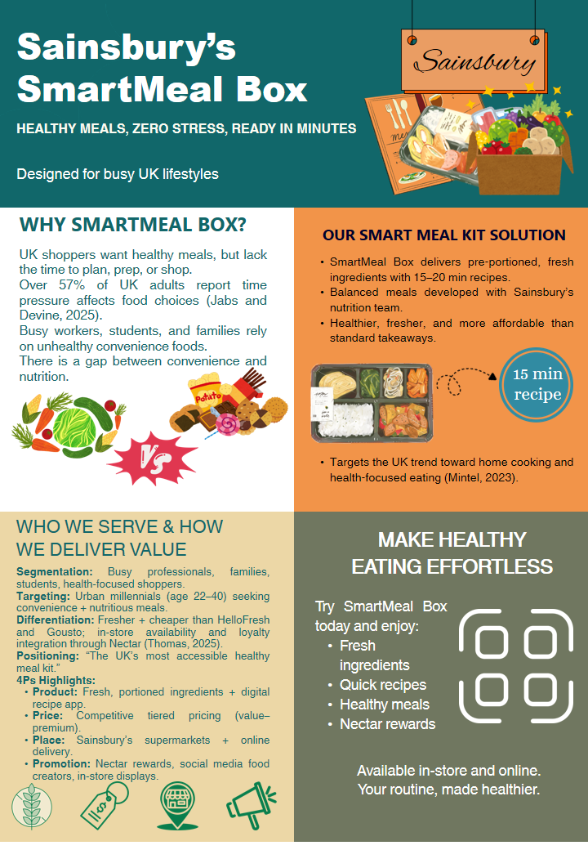
Hello everyone, today I have the pleasure of launching Sainsbury SmartMeal Box, a new meal box in the UK aimed at busy individuals who want to eat healthy without the hassle.
We understand that over fifty percent of the adults in the UK claim to lack time to plan or prepare food. Due to this, a large number of individuals end up consuming unhealthy fast food (Jabs and Devine, 2025). SmartMeal Box can address this issue by providing fresh pre-portioned ingredients that cook in 15-20 minutes. Every meal is created in collaboration with the nutrition experts at Sainsbury, hence customers receive healthy and delicious meals.
We focus on busy employees, students, young professionals, and families, in particular, millennial shoppers who prefer convenience but are also concerned with nutrition. SmartMeal Box contrasts HelloFresh and Gousto in the sense that it is fresher, cheaper and sold both in stores and online in Sainsbury. Customers are also able to earn Nectar points which makes the product even more desirable.
SmartMeal Box markets itself as the most accessible healthy meal kit in the UK.
Try SmartMeal Box- and make a healthy meal easy, quick and a part of your daily routine.

Element 4: Reflection
Forming the Sainsbury SmartMeal Box brand and the marketing strategy connected to it was a great chance to combine the theoretical ideas of marketing with the practical strategic decisions. Among the most valuable lessons learned in this process was the necessity of strategic coherence--the need to make sure that segmentation, targeting, differentiation, positioning and marketing mix support and enable each other. The systematic application of the STDP framework demonstrated how the poor quality of segmentation assumptions can lead to compromised downstream decisions, which support the claim by Kotler et al. (2022) that strategy formulation should come before tactical implementation.
Skills wise, the project enhanced my analytical ability especially in terms of integrating industry data with theory. The critical review of sources such as Mintel, Kantar, and IGD could not be finalized with citations, but rather with a critical assessment, as the acquired knowledge needed to be contextually relevant to the UK grocery market. This corresponds to the idea of constructive alignment introduced by Biggs (2003) where learning outcomes are attained through significant interaction with evidence instead of copying material. I also gained more confidence in competitive analysis, particularly in measuring structural strengths like the physical retail network and loyalty infrastructure of Sainsbury.
The process of preparing and delivering the marketing strategy pitch also improved my strategic communication skills. The need to translate the complicated analysis into a brief, coherent poster that is visually appealing prioritised and reflected real-world managerial constraints. This process helped to strengthen the importance of the audience-centred communication, which is stressed in modern day marketing practice (Keller, 2013). Critical self-reflection, however, will have shown that I had overemphasized the depth of analysis at the outset, at the cost of the storyline. Although the current versions of the pitch were academically strong, previous versions of the pitch did not have a clear strategic narrative, which may lower the involvement of stakeholders.
Considering the experiences of the experiential learning cycle proposed by Kolb (1984), one of the elements that need improvement is the process of refining and the need to incorporate feedback at the initial stages. In future projects, I would use formative feedback at an early stage to test the clarity, positioning logic and visual hierarchy before it can be finalised. I would also improve my performance by improving my quantitative scenario modelling, including indicative pricing or margin simulation, in order to improve the commercial plausibility of the strategic recommendations.
Generally, the overall project helped me improve my thinking and communicating skills as a marketing strategist and not as a tactical executor. With the new expertise in the area of synthesis, storytelling, and prioritisation of the evidence, I will be able to improve the strategic impact and professional relevance of the marketing work of the future even more.

Reference List
Biggs, J., (2003). Aligning teaching for constructing learning. Higher Education Academy, 1(4), pp.1-4.
Department of Health and Social Care (2020). Tackling obesity: Empowering Adults and Children to Live Healthier Lives Strategy. Policy Navigator.
J Sainsbury PLC (2023). Annual Report and Financial Statements 2023 Helping Everyone Eat Better.
Jabs, J. and Devine, C.M. (2025). Time Scarcity and Food choices: an Overview. Appetite, [online] 47(2), pp.196–204. doi:https://doi.org/10.1016/j.appet.2006.02.014.
Keller, K.L. (2013) Strategic Brand Management: Building, Measuring, and Managing Brand Equity. 4th edn. Harlow: Pearson Education.
Kolb, D.A. (1984) Experiential Learning: Experience as the Source of Learning and Development. Englewood Cliffs, NJ: Prentice Hall.
Kotler, P., Keller, K.L., Chernev, A. and Armstrong, G. (2022) Marketing Management. 16th edn. Harlow: Pearson Education.
McCarthy, E.J. (1964) Basic Marketing: A Managerial Approach. Homewood, IL: Richard D. Irwin.
McKevitt, F. (2025). Consumers Shopping Little and Often as Temperatures and Prices Rise. Kantar.com.
Mintel (2024). UK Sustainability in Foodservice Market Report 2023 | Mintel Store. Mintel Store.
Mintel (2025). UK Supermarkets Market Report 2024-2029 | Mintel. Mintel Store.
Mitchell-Fox, P. (2025). Global Convenience trends: the View through a UK Lens. Igd.com.
Porter, M.E. (2008) ‘The five competitive forces that shape strategy’, Harvard Business Review, 86(1), pp. 78–93.
Retail economics (2025). 5 Key Trends to 2025 for the Grocery Sector | Retail Economics | Retail Economics. www.retaileconomics.co.uk.
Ries, A. and Trout, J. (2001) Positioning: The Battle for Your Mind. New York: McGraw-Hill.
Rowberry, A. (2025). UK grocery retail channel forecast 2024-2029. Igd.com.
Thomas, R. (2025). UK trends 2024. [online] Igd.com. Available at: https://www.igd.com/reports/uk-trends-2024.

