PROGRAMME: MASTER OF BUSINESS ADMINISTRATION
MODULE: MARKETING MANAGEMENT
MODULE CODE: LCMB7024
ASSIGNMENT TITLE: MARKETING ENVIRONMENT ANALYSIS
LECTURER’S NAME: Laila Maazouz
Taonga Kaonga Sobere Snithers
STUDENT NAME: Karankumar Rameshbhai Chaudhary
STUDENT ID: 2538332

SUBMISSION DATE: Friday 24th July 2026 by 2 PM
Table of Contents
Task 1: Marketing Environment Analysis 3
1.1 Analysis of Two External Marketing Environment Actors 3
1.1.1 Environmental actors 3
1.1.2 Political and regulatory environment actors 6
Task 2: Strategic Growth and Competitive Positioning 9
2.1 Recommendation of a Strategic Growth Approach 9
2.1.1 Application of the Ansoff Matrix 9
2.1.2 Justification for Product Development Strategy 12
2.1.3 Growth Opportunities in the Green Steel Market 13
2.2 Achieving the Competitive Edge through the Lower-Carbon Business Model 13
2.2.1 Porter’s Generic Model for Competitive Advantage Perspective 13
2.2.2 Sustainability as a Source of Differentiation 14
2.2.3 Long-Term Competitive Positioning of Tata Steel 15
Task 3: Critical Reflection on AI Usage 17
3.1 Tool Disclosure 17
3.2 Critical Evaluation of AI Output 19
3.3 Contribution Analysis 19
3.4 Ethical & Professional Reflection 19
Reference list 21

Task 1: Marketing Environment Analysis

1.1 Analysis of Two External Marketing Environment Actors

1.1.1 Environmental actors
Climate change and decarbonisation pressures
External environmental forces, including pressure from decarbonisation policies and climate change, influenced the internal and external business operations of Tata Steel in India. The Indian steel sector accounts for 10-12% of the country's greenhouse gas emissions, making it a major carbon-intensive sector.
Additionally, the global average range of emissions around 2.0 tCO2/t has been crossed by the Indian steel sector as it contributes 2.55-2.65 tonnes of CO₂ per tonne of steel (Myllyvirta and Aggarwal, 2026). Following sustainability standards, the Indian government aims to increase production capacity to 400 million tonnes with an emission reduction by 25% by 2035.
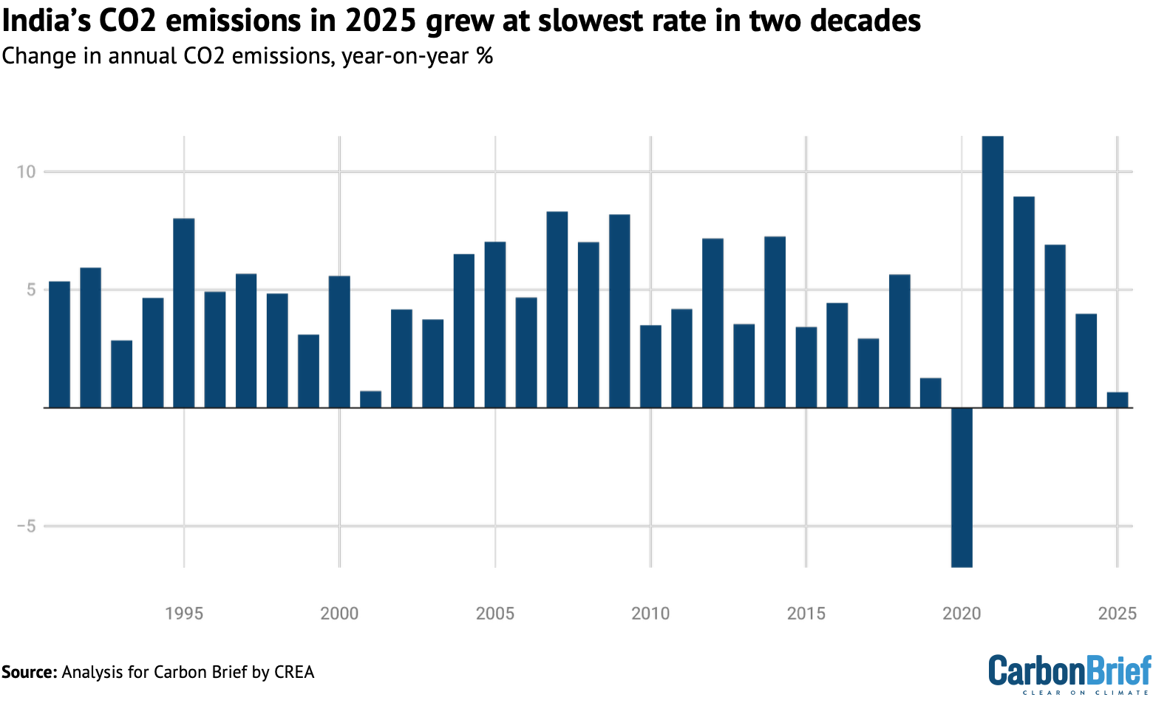
Figure 1: Carbon emission in India through the years
(Source: Myllyvirta and Aggarwal, 2026)
Henceforth, Tata Steel is also operating to accelerate its decarbonisation strategy and strive to comply with regulatory expectations as well as market demands. In 2025, Tata Steel reported 2.22 tCO₂ per tonne of crude steel emission and targeted to reduce it to <2.0 tCO₂/t by 2045 while achieving net-zero emissions (Tata Steel, 2026). Likewise, the investment priorities, production and technological adoption are also transforming in the Indian market.
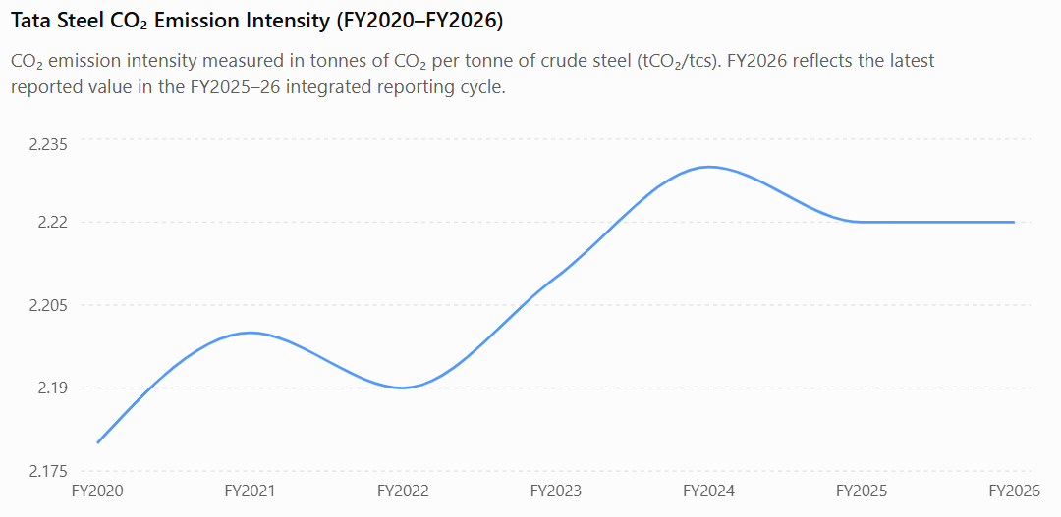
Figure 2: CO2 emission trend of Tata Steel
(Source: Tata Steel, 2026)
Environmental regulations and carbon policies
Environmental regulations and government policies regarding decarbonisation have influenced Tata Steel's operational transition to lower-carbon production in India. A budget of INR 19,744 crore (US$2.3 billion) has been considered by the National Green Hydrogen Mission to induce hydrogen-based steelmaking and accelerate low-carbon technologies (India Science and Technology, 2026; PIB Delhi, 2025).
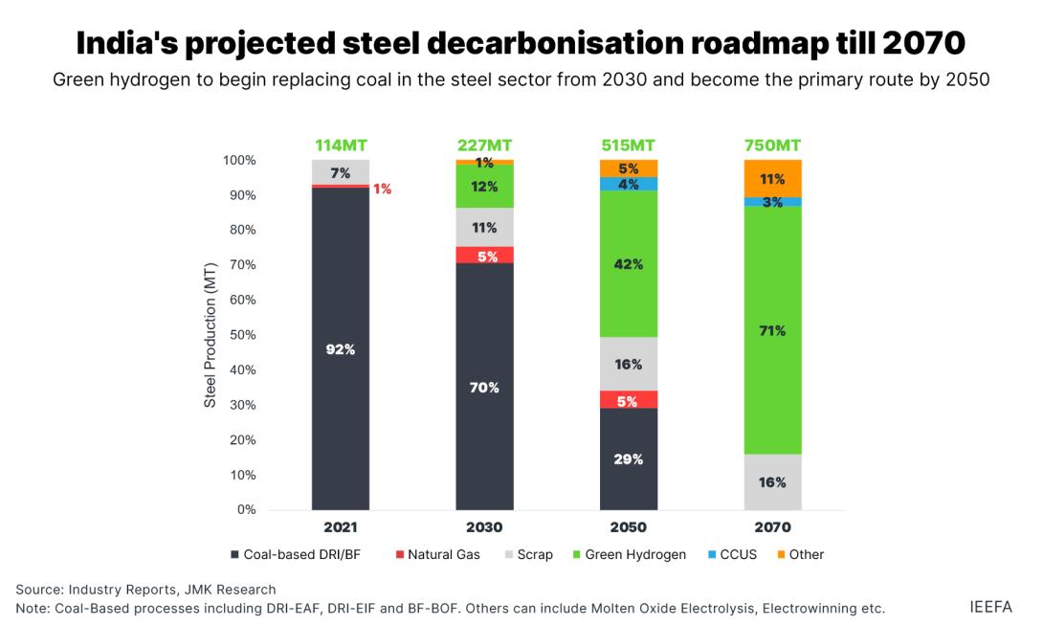
Figure 3: Steel decarbonisation in India
(Source: Garg et al., 2023)
Moreover, the Taxonomy of Green Steel in 2024 framework by the Ministry of Steel enabled strategy integration for categorising steel by emission level and within the threshold of < 2.2 tCO₂e per tonne of finished steel for green steel certification (PIB Delhi, 2024).
Operational transparency has been encouraged with the Business Responsibility and Sustainability Reporting (BRSR) framework, which guided Tata Steel to invest in efficient and sustainable technologies with higher credentials and an improved position in the emerging green steel markets.
Tata Steel's sustainability initiatives
The sustainability initiative undertaken by Tata Steel has focused on decarbonisation practices to strengthen its corporate branding as a responsible steel producer. Commissioning 15MW of green hydrogen capacity at Jamshedpur, Tata Steel has increased steel scrap utilisation by 18%, with 22% of electricity consumption highlighting renewable source usage in 2025 (Tata Steel, 2026). The planned investment in decarbonisation initiatives of > US$1 billion by 2030 also supported its net-zero target for 2045 (Force for Good, 2026).
Considering the corporate branding aspects, sustainability initiatives and prospective investments have increased its environmental credibility, ESG attractiveness and stakeholder confidence and presented it as a stable corporation in the emerging green steel market. On the other hand, Tata Steel competitors such as JSW Steel have aimed to obtain 1.95 tCO₂/tcs by 2030 and SAIL showed > 2.5 tCO₂/tcs record in carbon emissions (JSW, 2026; SAIL, 2026).
Henceforth, Tata Steel has an opportunistic position with sustainability investments and showed potential in improved environmental performance, gaining innovative brand positioning in the long-term market environment.
Opportunities and challenges arising from the environmental actors
Opportunities
- Extensive allocation by the National Green Hydrogen Mission has helped create opportunities for green steel production with low-carbon industrial technologies.
- Increased investment in ESG initiatives aligned with rising demand for sustainable materials has improved corporate brand perception of Tata Steel, with increased access in premium markets.
Challenges
- Planned investment of > US$1 billion in decarbonisation initiatives showed commitment to sustainable operations.
- Increased compliance costs with 100% implementation of the EU Carbon Border Adjustment Mechanism (CBAM) in 2026 can increase technological uncertainties with fluctuations in large-scale production of hydrogen-based steel.

1.1.2 Political and regulatory environment actors
Investor and ESG expectations are critical factors as political and regulatory actors that influence organisational transition into a low-carb production facility for Tata Steel in the Indian market. On the other hand, policy interventions, sustainability mandates and investor trust are affecting the sustainability initiatives of the company.
Government initiatives, including mandatory Business Responsibility and Sustainability Reporting (BRSR) and Carbon Credit Trading Scheme (CCTS), have increased the regulatory standards for environment-oriented performance (PIB Delhi, 2026). Moreover, ESG criteria are increasingly supported by institutional investors, while global interest has resulted in a hike of US$1.6 trillion in investment for the same. Hence, climate commitments and sustainability disclosures are encouraged (UNCTAD, 2026).
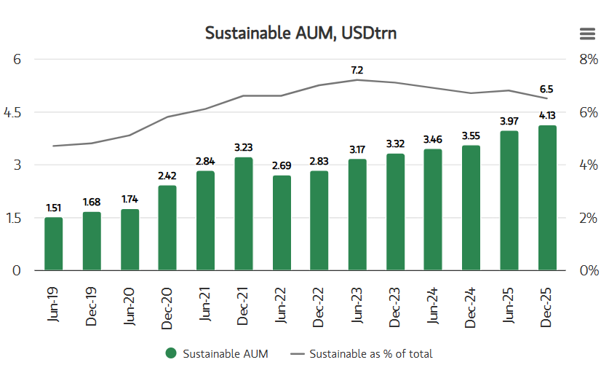
Figure 4: Investment and asset pattern for sustainability
(Source: Morgan Stanley, 2025)
Demand for low-carbon steel products is predicted to increase by 10-15% in the global market. Therefore, the sectoring operations have perceived a transformational need considering automotive, infrastructure and renewable energy sectors with decarbonisation targets. The automotive sector is projected to achieve 40% green steel production, addressing increasing consumption demand in Eurasia by 2035 (Transport Environment, 2025).
Therefore, the low-carbon steel portfolio is also integrated in Tata Steel’s agenda. The Tricomponent Attitude Model has highlighted this behavioural shift and demonstrated the role of stakeholders to develop cognitive awareness leading to organisational transformation as seen in the sustainability initiatives by Tata Steel. Nonetheless, the affective perceptions are reflective of the sustainable procurement decisions, while stimulated cognitive intentions result in beneficial supplier partnerships with ESG-oriented operations in the low-carbon steel market.
Influence on brand positioning and market competitiveness
Applying the Tricomponent Attitude Model to assess the influence of sustainability initiatives on market competitiveness and brand position of Tata (Lecture 4, p. 19).
Cognitive
Generally, the global steel sector is responsible for 7-9% of global GHG emissions (Idrissov, 2025). Utilising Tata Steel Carbon Bank, the company can produce verifiable proof of GHG emission reduction. With the credibility of sustainability initiatives, Tata Steel can convince its clients that its green solutions are capable of reducing GHG emissions, satisfying cognitive beliefs.
Affect
The leading position of Tata Steel in the global steel sector offers reputational security to the B2B clients, which helps to attain long-term B2B partnerships.
Conation
As Tata Steel is entering the renewable energy sector, Tata Steel needs to ensure that its sustainable solutions are able to satisfy the logical requirements of B2B clients at a rapid pace to ensure Tata Steel aims to achieve a leading position in the eco-labelled steel sector (Agarwal, 2026).

Task 2: Strategic Growth and Competitive Positioning

2.1 Recommendation of a Strategic Growth Approach

2.1.1 Application of the Ansoff Matrix
Evaluating the environmental and political factors, Tata Steel’s pivot toward sustainable practices while ensuring parallel growth should be rooted in product diversification (Lecture 2, p. 14). The execution of this transition may be initiated with eco-friendly technology, as the global green mining sector is growing at a CAGR of 3.55% from 2025 to 2034 (Fortune Business Insights, 2026).
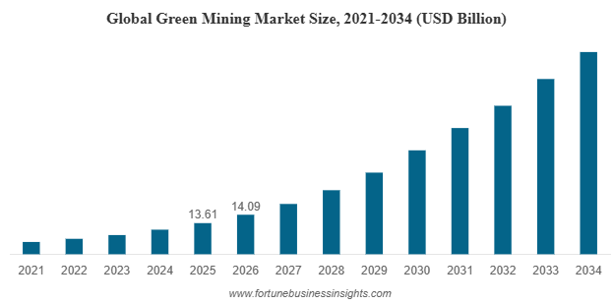
Figure 5: Growth of global green mining technologies
(Source: Fortune Business Insights, 2026)
Renewable electricity and green hydrogen as eco-friendly solutions
To diversify, Tata Steel is replacing traditional coal-based furnaces with renewable electricity and green hydrogen, applying Direct Reduced Iron, which is exhibited in a low-carbon steel-making process applied by the company in the UK’s largest low-carbon electric arc furnace project at Port Talbot, which is expected to reduce site-wide GHG emissions by 90% (Verma, 2026). Tata Steel has initiated to restructure its production process leveraging hydrogen, aiming to reduce GHG emissions by 35-40% by 2030 and produce 100% CO₂-neutral steel by 2045 (Tata Steel, 2026).
Recycling and circular economy
Prioritising a diversification strategy is evident from Tata Steel’s recycling initiative to reduce reliance on virgin iron ore and reduce waste. Tata Steel recycles 99.9% of its by-products and by 2030 aims to recycle 100% of its by-products (Tata Steel, 2026; Agarwal, 2026). Overall, Tata’s diversification strategy is rooted in circular economy philosophy, which encourages slag and industrial waste to be reprocessed into raw materials.
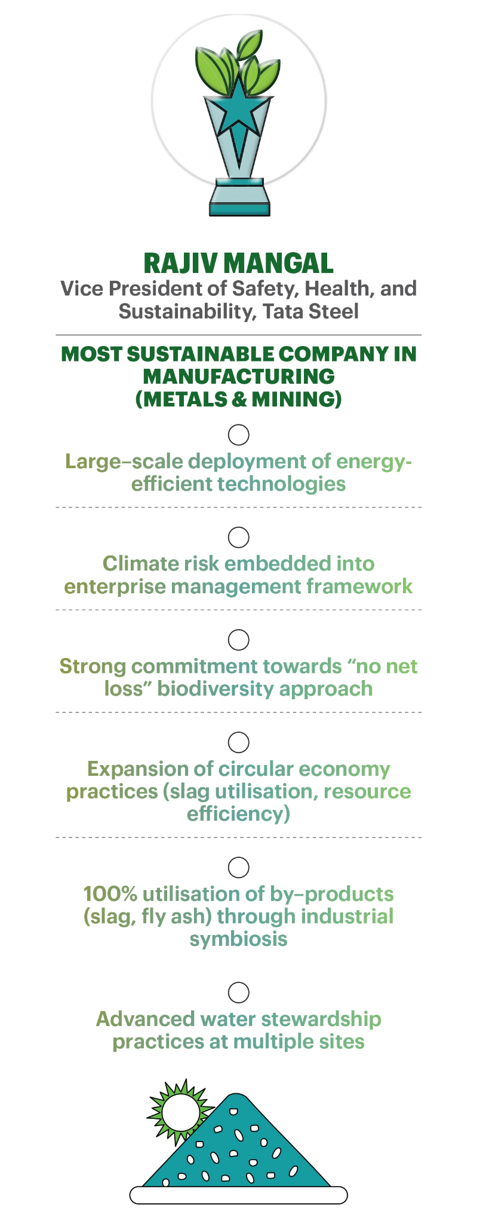
Figure 6: Tata Steel’s recycling strategy
(Source: Agarwal, 2026)

Eco-labelled steel
Tata is diversifying its operations in the renewable energy sector, such as hydrogen and nuclear power plants, by supplying eco-labelled steel, which is growing at a CAGR of 60.4% to meet decarbonisation goals (Tata Steel, 2026; Yahoo Finance, 2026).
Tata Steel’s diversification strategy involves backward vertical integration and related diversification as the company chooses to upgrade and refine its traditional manufacturing process (Lecture 2, p. 17), but involves risks of high capital investment and market uncertainty, which may narrow its profit margins.

2.1.2 Justification for Product Development Strategy
Using the Kano model of customer satisfaction, Tata’s product diversification strategy can be explained.
Category | Implications
Dissatisfiers or basic needs | According to Europe’s Carbon Border Adjustment Mechanism (CBAM), GHG emission standards have to be adhered to operate in the EU market.
Satisfiers or performance needs | Accelerating backward vertical integration to reduce GHG emissions to satisfy B2B clients
Delighters or excitement needs | Incorporation of eco-labelled steel, renewable energy sources, and green hydrogen solutions excited sustainability-focused clients, allowing Tata Steel to differentiate itself from competitors and achieve 6% YoY growth despite the global steel sector’s 2% decline in 2025.
Table 1: Green diversification strategy through the Kano model
(Source: Lecture 10, Deccan Chronicle, 2026; Carbon Market Watch, 2025)

2.1.3 Growth Opportunities in the Green Steel Market
Applying the Product Life Cycle (PLC) model, the growth opportunities for Tata’s diversification strategy have been analysed below.
PLC stage | Explanation
Growth transition | Rising demand from automotive clients to reduce their own respective GHG emissions
Growth accelerator | Government of India’s subsidiaries, such as PLI, declared incentives up to ₹17,000 crore to support green steel manufacturing.
Growth into early maturity | Alongside securing international projects, aggressive market expansion strategy is obligatory in renewable energy sector.
Table 2: Assessing growth opportunities
(Source: Lecture 6; PIB, 2025)

2.2 Achieving the Competitive Edge through the Lower-Carbon Business Model

2.2.1 Porter’s Generic Model for Competitive Advantage Perspective
Strategic metrics | Cost Leadership | Cost Focus | Differentiation | Differentiation focus
Uniquely diversified service portfolio | Backward vertical integration, incorporation of AI, and ML allow for reducing the costs of sustainable manufacturing practices | To satisfy price-sensitive clients | Developing premium yet unique steelmaking operations | Reaching net-zero goals and compliance with regulatory standards
Production costs | Capital investment in 2026FY increased by 38% to support technology adoption | Expanding technological infrastructure to meet the strategic goal | Hydrogen in green steel solutions creates vapour by reacting with iron ore instead of CO2 | Assuredly reducing scope 3 GHG emissions for clients
Table 3: Assessing competitive advantage for Tata Steel
(Source: Lecture 11; SMM, 2026)

2.2.2 Sustainability as a Source of Differentiation
By 2025, green steel is expected to reach a market value of 179.17 million tons, which satisfies the economic aspect of becoming sustainable for Tata Steel (EY, 2026). Alongside economic and regulatory drivers (CBAM), sustainability becomes a differentiating factor because it guarantees investors’ trust and consequently enhances industry reputation.
By ensuring that Tata Steel can live up to its sustainability goals and replace traditional blast furnaces, which produce high levels of GHG emissions, with green technologies, Tata can achieve the status of preferred supplier for B2B partners, especially in the construction and automotive sectors, who intend to reduce scope 3 carbon emissions from their supply chain.
The sustainability strategy strengthens investor trust through the transition toward green hydrogen and steel, offers access to EU markets, and secures its top position in the global steel industry with an annual crude steel capacity of 36 million tons per annum (Tata Steel, 2026).
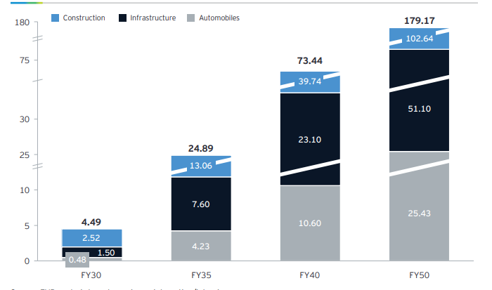
Figure 7: Projected growth scope of green steel
(Source: EY, 2026)

2.2.3 Long-Term Competitive Positioning of Tata Steel
Tata Steel’s global corporate branding is anchored on three pillars- sustainability, digital innovation, and diversity (Tata Steel, 2026). This brand positioning establishes Tata Steel as a responsible and forward-thinking company. The product diversification strategy attests to the product branding strategy for Tata Steel (Lecture 12, p.11). The low GHG-emission strategic leap makes the company stand out as a critical supply chain partner in the global mining sector.
The corporate branding of Tata resonates with the Tata Steel Carbon Bank, which constantly evaluates the reduction of GHG emissions in its services. The partnership with Google Cloud to introduce agentic AI helped Tata Steel emerge as a tech-driven company to automate sustainability operations (Tata Steel, 2026).

Task 3: Critical Reflection on AI Usage

3.1 Tool Disclosure
The use of AI in producing this report was limited and strictly adhered to the guidelines of the University of Wales, and in no way has AI been used to produce the submitted report. However, occasionally, ChatGPT Plus has been used to brainstorm ideas on a moderate level only, which is already a free version; hence, its assistance was limited to outlining ideas. Mostly, AI’s use has been limited to only enhancing understanding of different marketing theories and concepts, to understand the rationale for why a marketing framework which is discussed in the lecture notes is more applicable to a task, not to copy-paste the answers. The AI usage in this assignment has been justified with illustrative evidence pasted below.
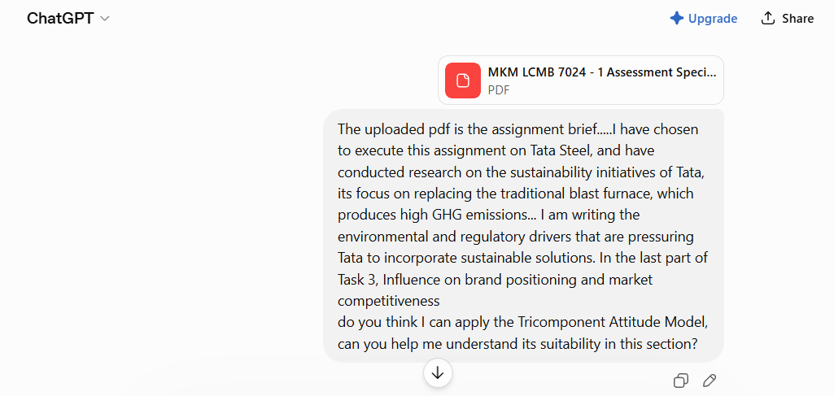
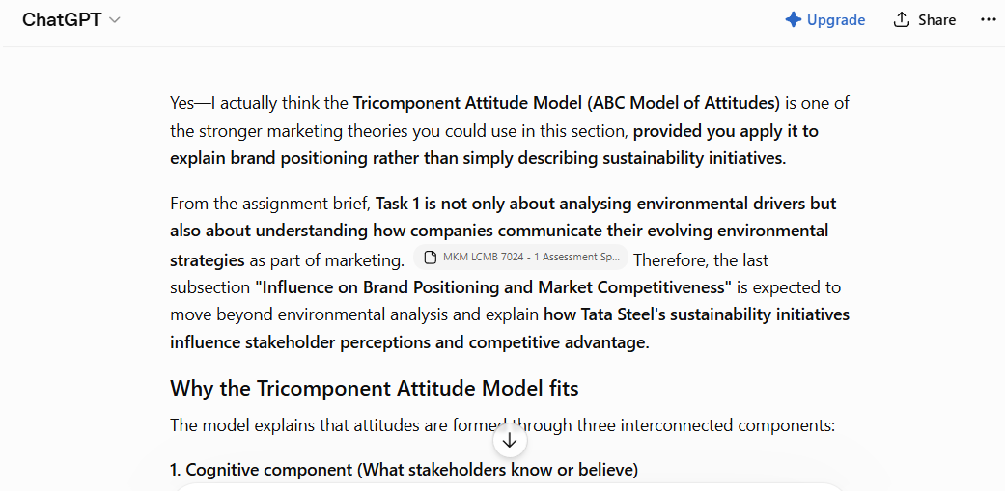
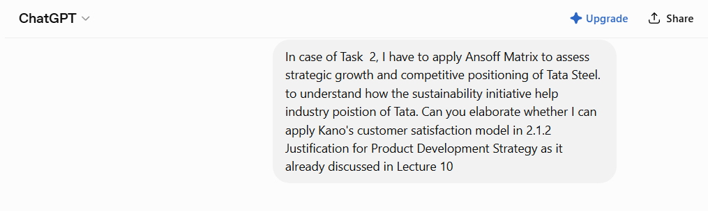
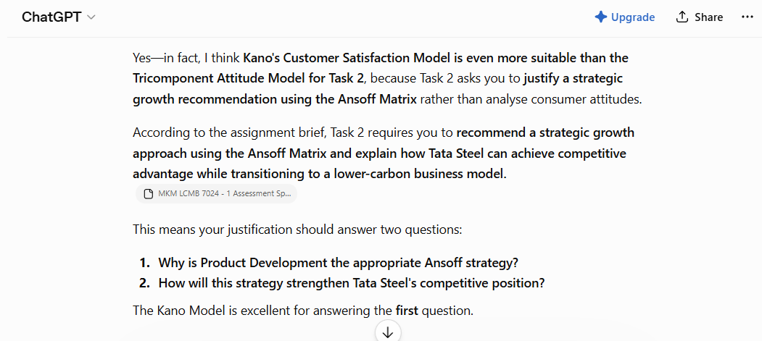
Figure 8: ChatGpt responses used to obtain justifications for theory incorporation
(Source: Self-developed)
It can be surmised that the use of ChatGPT Plus has been limited to broadening own understanding about which theoretical framework should be used in which sections of the assignment, adhering to university integrity policies.

3.2 Critical Evaluation of AI Output
It is widely acknowledged that AI often generates fabricated outputs, which are not based on factual real-life events. Hence, the AI-generated outputs have not been blindly followed; instead, they have been cross-checked with verifiable sources accessible on the internet, and the lecture notes have served as a trusted handbook for this assignment. Other trustworthy and verifiable sources for this assignment include the latest versions of the annual reports and sustainability reports of Tata Steel. During the outlining phase, ChatGpt produced a response that claimed that only focusing on the environmental factor would be sufficient for Task 1, but the assignment brief clearly states that I must discuss another relevant factor that encourages Tata Steel’s shift towards incorporating sustainable practices. As I read the assignment brief minutely, I was able to identify this logical error instantly. Throughout the rest of this assignment, whenever I asked AI to help me understand marketing concepts, I always verified the AI output against other verifiable sources to avoid using false information or wrongly applying any theoretical framework.

3.3 Contribution Analysis
I developed the structure for the assignment and chose Tata Steel as the selected company only after independently evaluating the company’s sustainability initiative first. I only used AI tools to receive an abstract idea about whether I can apply the theoretical framework in both Task 1 and Task 2. Apart from this, no AI tool can be given credit for producing this report. I produced the entire report after conducting thorough research and discovered statistical information from Tata Steel’s sustainability report, annual report, and other verifiable sources, such as Yahoo Finance.

3.4 Ethical & Professional Reflection
I understand that the incorporation of AI raises ethical integrity concerns, limiting the independent ability to critically analyse that is required for developing a marketing analysis report. This compelled me to conduct the entire research on my own, taking assistance from AI tools only where it was needed. Although I asked AI for the appropriateness of certain theoretical framework, I cross-checked the authenticity of the AI response to ensure human oversight.

Reference list
Carbon Market Watch, (2025). Carbon Border Adjustment Mechanism (CBAM) Available at: https://carbonmarketwatch.org/glossary/carbon-border-adjustment-mechanism-cbam/ (Accessed: 5 July 2026).
Chingis Idrissov (2025). Key Drivers and Technologies Shaping the Green Steel Market. Available at: https://www.idtechex.com/en/research-article/key-drivers-and-technologies-shaping-the-green-steel-market/32939 (Accessed: 4 July 2026).
Deccan Chronicle, (2026). Chandrasekaran Unveils Tata Steel's Green Growth Vision. Available at: https://www.deccanchronicle.com/business/tata-steel-posts-strong-fy26-growth-pat-surges-243-at-119th-agm-1967767 (Accessed: 4 July 2026).
EY, (2026). Unlocking green steel demand. Available at: https://www.ey.com/content/dam/ey-unified-site/ey-com/en-in/insights/mining-metals/doucments/ey-unlocking-green-steel-demand-digital.pdf (Accessed: 4 July 2026).
Force for Good (2026). One World - United Nations Driving Change. Available at: https://www.forcegood.org/tab-one-world (Accessed: 28 June 2026)
Fortune Business Insights (2026). Green Mining Market Size, Share, and Industry Analysis, By Type (Surface Mining and Underground Mining), By Technology (Power Reduction, Fuel & Maintenance Reduction, Emission Reduction, Water Reduction, and Others), and Regional Forecast, 2026-2034. Available at: https://www.fortunebusinessinsights.com/green-mining-market-109672?__cf_chl_f_tk=MXlCceuTCirvCL7K1gu.HNlUxknDI5OxVwevI4apGGk-1783409773-1.0.1.1-iU1OCQPqKCTdeNGZs.g3t.0hJXNsOzzoPoTqvIetiow (Accessed: 4 July 2026).
Garg, V., Gulia, J., Gupta, K., Shaik, N. and Srivastava, S. (2023). Steel decarbonisation in India. Available at: https://ieefa.org/resources/steel-decarbonisation-india (Accessed: 26 June 2026)
India Science and Technology (2026). National Green Hydrogen Mission. Available at: https://www.indiascienceandtechnology.gov.in/st-visions/national-mission/national-green-hydrogen-mission (Accessed: 30 June 2026)
JSW (2026). Climate Change. Available at: https://group.jsw.in/groups/sustainability-framework-measuring-success-climate-change (Accessed: 29 June 2026)
Morgan Stanley (2025). Sustainable Fund Returns Slightly Below Traditional Peers in Second Half of 2025. Available at: https://www.morganstanley.com/insights/articles/sustainable-fund-performance-second-half-2025 (Accessed: 27 June 2026)
Myllyvirta, L. and Aggarwal, A. (2026). Analysis: India’s CO2 emissions in 2025 grew at slowest rate in two decades. https://www.carbonbrief.org/analysis-indias-co2-emissions-in-2025-grew-at-slowest-rate-in-two-decades/ (Accessed: 28 June 2026)
Palak Agarwal, (2026). How Tata Steel is growing aggressively while minimising its carbon footprint. Available at: https://www.businesstoday.in/magazine/deep-dive/story/how-tata-steel-is-growing-aggressively-while-minimising-its-carbon-footprint-536099-2026-06-10 (Accessed: 6 July 2026).
PIB Delhi (2024). Union Minister of Steel and Heavy Industries, Shri H.D. Kumaraswamy, Releases India’s Green Steel Taxonomy. Available at: https://www.pib.gov.in/PressReleasePage.aspx?PRID=2083839&reg=48&lang=2 (Accessed: 29 June 2026)
PIB Delhi (2025). Unlocking India’s Green Hydrogen Production Potential. Available at: https://www.pib.gov.in/PressReleasePage.aspx?PRID=2189126&reg=48&lang=2 (Accessed: 30 June 2026)
PIB Delhi (2026). India Showcases Carbon Credit Trading Scheme and Renewable Energy Standards at WTO Trade and Environment Week 2026. Available at: https://www.pib.gov.in/PressReleasePage.aspx?PRID=2269438&reg=3&lang=1 (Accessed: 24 June 2026)
PIB, (2025). PLI 1.1 Scheme Boosts India’s Specialty Steel Sector. Available at: https://www.pib.gov.in/PressReleaseIframePage.aspx?PRID=2114558&reg=48&lang=2 (Accessed: 6 July 2026).
SAIL (2026). Environment Management Division. Available at: https://www.sail.co.in/en/plants/environment-management-division (Accessed: 26 June 2026)
SMM, (2026). [Tata Steel plans Rs 200bn capex for capacity expansion and new technology]. Available at: https://news.metal.com/newscontent/103992235-tata-steel-plans-rs-200bn-capex-for-capacity-expansion-and-new-technology (Accessed: 7 July 2026).
Swati Verma, (2026). Tata Steel may defer UK low-carbon steel project by up to 8 months; shares slip 2%. Available at: https://upstox.com/news/market-news/stocks/tata-steel-may-defer-uk-low-carbon-steel-project-by-up-to-8-months-amid-power-access-delays-shares-slip-2/article-194938/ (Accessed: 5 July 2026).
Tata Steel (2026). 119th year - Integrated Report and Annual Accounts 2025-26. Available at: https://www.tatasteel.com/media/25904/tatasteel-iar-2025-26.pdf (Accessed: 25 June 2026)
Tata Steel, (2026). Business Responsibility and Sustainability Report for FY 2025-26. Available at: https://www.tatasteel.com/media/25905/nsebsebrsr.pdf (Accessed: 3 July 2026).
Tata Steel, (2026). Green steel and sustainability. Available at: https://www.tatasteelnederland.com/en/sustainability (Accessed: 1 July 2026).
Tata Steel, (2026). How Tata Steel is growing aggressively while minimising its carbon footprint. Available at: https://www.tatasteel.com/sustainability/social/climate-action/ (Accessed: 7 July 2026).
Tata Steel, (2026). Integrated Report & Annual Accounts 2025-26. Available at: https://www.tatasteel.com/investors/integrated-reportannual-report/integrated-report-annual-accounts-2025-26-119th-year-and-related-documents/ (Accessed: 4 July 2026).
Tata Steel, (2026). Our commitment to the planet. Available at: https://products.tatasteelnederland.com/services/sustainable-solutions/zeremis/carbon-reduction-projects (Accessed: 7 July 2026).
Tata Steel, (2026). Tata Steel Partners with Google Cloud To Deploy a Unified Agentic AI Across its Global Value Chain. Available at: https://www.tatasteel.com/newsroom/press-releases/india/2026/tata-steel-partners-with-google-cloud-to-deploy-a-unified-agentic-ai-across-its-global-value-chain/ (Accessed: 2 July 2026).
Transport Environment (2025). Cleaning up steel in cars: why and how? Available at: https://uploads.transportenvironment.org/production/files/Green-steel-in-cars-briefing_July-2024.docx.pdf (Accessed: 26 June 2026)
UNCTAD (2026). Global investment rises 6% to $1.6 trillion, but development gains remain uneven. Available at: https://unctad.org/news/global-investment-rises-6-16-trillion-development-gains-remain-uneven (Accessed: 28 June 2026)
Yahoo Finance, (2025). Green Steel to Hit USD 189.82 Billion by 2032, at a CAGR of 60.4%, says Coherent Market Insights. Available at: https://finance.yahoo.com/news/green-steel-hit-usd-189-141900615.html?guccounter=1&guce_referrer=aHR0cHM6Ly93d3cuZ29vZ2xlLmNvbS8&guce_referrer_sig=AQAAANouHC6DvO45B0W-HDskI6kEykhycqUykf3nBX4o2FQ-cNcnN-a_K4YxRwG0x70ZzDXega-Mex5OXPWTUklCyyLYhBRoUVGcbhSTHUNJkcEswTNI3aVDebGnO_Ehw2J7IG_xYi3KdxpNvdqqkgqHiOqMAz3_7WPsKFlNoE6157J0 (Accessed: 3 July 2026).

