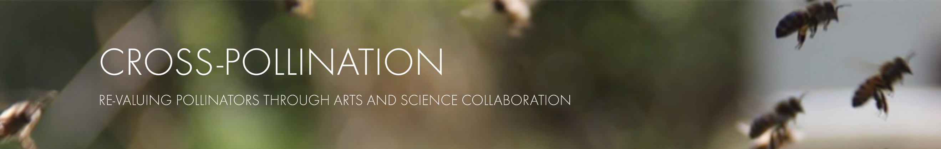
Are you interested in Art/Science collaborative projects?
Are you interested in bees or other pollinators?
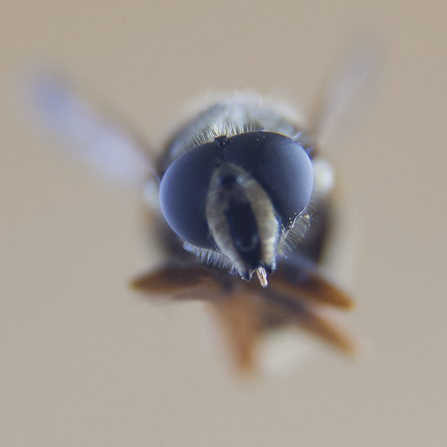

Two very interesting days of speakers from the USA and UK;
Day 1 at Alex Design Exchange in Swansea and
Day 2 at Dr Beynon’s Bug Farm, St Davids,
ending with the private view of the Cross-pollination exhibition.

For more information and to register go to- https://crosspollinationconference.eventbrite.co.uk
For more information about the project go to- https://crosspollinationartsciencecollaboration.wordpress.com/


