

Student name: Priscila Alice Vicente de Jesus Bonfim
Student ID:2510708

Module name: introduction to Health and social care
Module code:LCHS4003_LON

Lecturer name : Shepherd Ziko

Content page

Element 1 …………………………………………………………….. Poster

Element 2………………………………………………………………Reference list
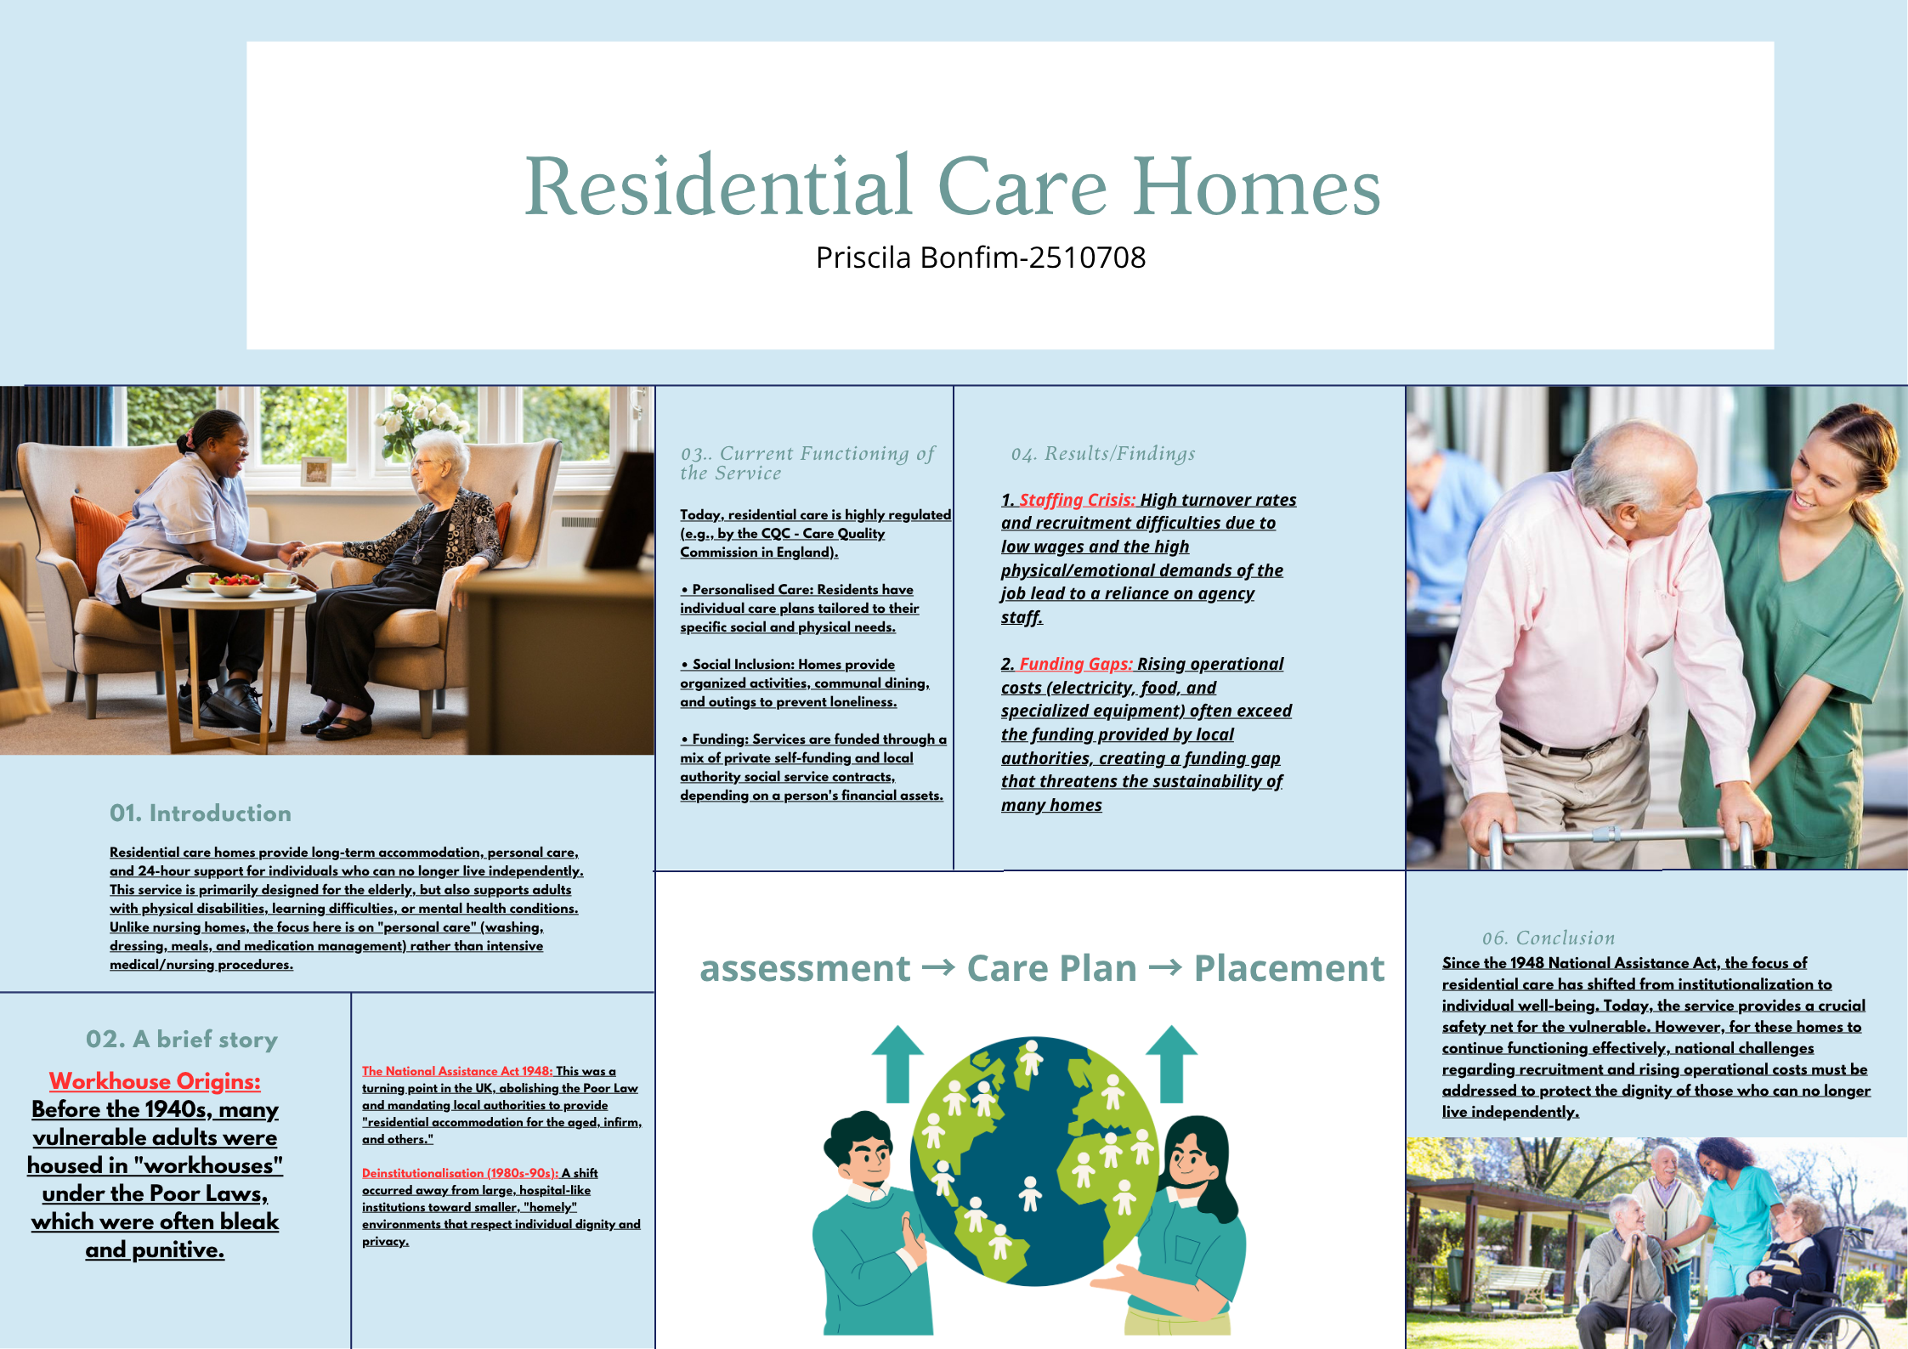

References

Care Quality Commission (2024) What we do. Available at: https://www.cqc.org.uk/about-us/what-we-do (Accessed: 26 March 2026).

Health Foundation (2019) £4.4bn funding gap projected for social care in England as spending per person falls further behind other UK countries. Available at: https://www.health.org.uk/press-office/press-releases/44bn-funding-gap-projected-for-social-care-in-england-as-spending-per (Accessed: 26 March 2026).

Legislation.gov.uk (1948) National Assistance Act 1948. Available at: https://www.legislation.gov.uk/ukpga/Geo6/11-12/29/enacted (Accessed: 26 March 2026).

Skills for Care (2024) The state of the adult social care sector and workforce in England, 2024. Leeds: Skills for Care. Available at: https://www.skillsforcare.org.uk/stateof (Accessed: 26 March 2026).

UK Parliament (2025) Welfare and insurance legislation, 1946-1948. Available at: https://www.parliament.uk/about/living-heritage/transformingsociety/tradeindustry/industrycommunity/case-study-so-davies-and-workplace-compensation/workplace-compensation-legislation/early-life-in-mining-communities1/ (Accessed: 26 March 2026).

