
Comparative International Marketing Strategy of Zara: A PESTEL, STP and 7Ps Analysis in the United Kingdom and India
Programme: Master of Business Administration
Module: International Marketing: Principles and Practices
Module code: LCMB7026
Tutor name: Tushara Balendran & Dian Mayasari
Student name: Md Abdur Roshid
Student ID: 2436449
Word count: 5219
Submission deadline: Friday 27/03/2026 by 2pm

Table of Contents
Section 1 1
1. Introduction 1
2. Comparative Macroenvironment Analysis (PESTEL) 2
2.1 Political Factors 2
2.2 Economic Factors 3
2.3 Social and Cultural Factors 4
2.4 Technological Factors 5
2.5 Legal Factors 5
2.6 Environmental Factors 6
3. Comparative STP Strategy (Segmentation, Targeting and Positioning) 7
3.1 Segmentation 7
3.2 Targeting 8
3.3 Positioning 8
4. Comparative 7Ps Strategy 9
4.1 Product 9
4.2 Price 10
4.3 Place (Distribution) 11
4.4 Promotion 11
4.5 People 12
4.6 Process 13
4.7 Physical Evidence 13
5. Directional Development Strategy (India Focus) 13
6. Ethical Issues in the Marketing Mix 15
7. Strategic Recommendations 17
Section 2 18
Reflective Account (Gibbs Reflective Cycle) 18
References 22

Section 1

1. Introduction
Zara is a Spanish fast-fashion retailer known for its rapid design-to-store cycle and extensive global footprint. Founded in 1975, it has grown into a major force in international apparel retailing, operating in more than 96 countries with over 6,600 stores worldwide and contributing over 70% of revenue to its parent company, Inditex, which reported €35.9 billion in sales in 2023 (Inditex, 2023). Zara’s ability to refresh fashion lines quickly and respond to trends has been a core competitive advantage, enabling new designs to reach stores in as little as 15 days compared with industry norms of several months. In the United Kingdom, Zara operates in a highly developed and competitive fast-fashion market. The UK fashion retail sector includes strong online and brick-and-mortar channels, with global rivals such as Shein reporting over £2 billion in UK sales in 2023, highlighting intense competitive pressures (Reid, 2024). In India, Zara operates through a joint venture with Trent Ltd, with revenue of approximately ₹2,782 crore (around US $330 million) in the 2025 financial year. Growth in this market has been modest, with top-line sales showing minimal increase, although net profit rose by 23%, reflecting changing market dynamics and competitive challenges (Malviya, 2025). Choosing the United Kingdom and India as study contexts allows a contrasting analysis of developed and emerging market environments, consumer behaviour, and strategic adaptation. This comparison will ground the international marketing assessment in real market performance and macroenvironmental conditions.
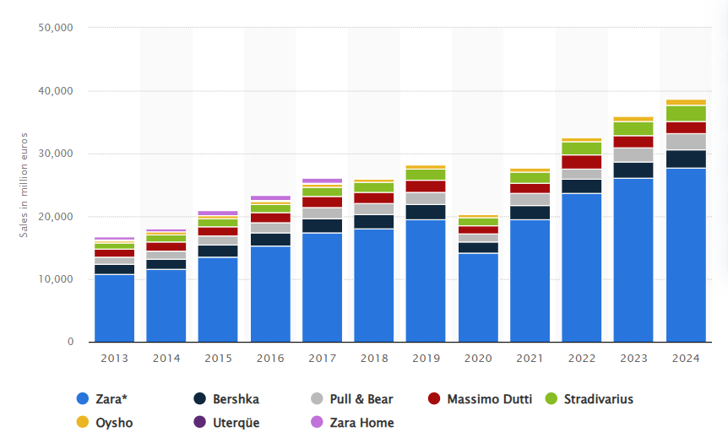
Figure: Zara sales over the years (Statista, 2024).

2. Comparative Macroenvironment Analysis (PESTEL)
The comparative PESTEL analysis will offer a systematic appraisal of the macro environmental forces that influence the operations of Zara in the United Kingdom and India. The two markets can be considered to be two opposite parts of the economic life cycle and the maturity of the regulations, which pose various strategic implications to international marketing.

2.1 Political Factors
The UK is established on a stable parliamentary democracy that has properly developed regulatory bodies. Nonetheless, Brexit has helped to redefine trade relationships, customs measures and the cost of imports that directly impacted the apparel retailers which depend on international supply chains. Other compliance checks and additional border checks have added to the administrative complexity for EU-related companies (Ward and Webb, 2024). Although in the UK, the political risk is not so high, the changes in policies concerning sustainability reporting, compliance with modern slavery, and corporate taxation have augmented the regulatory scrutiny on fashion enterprises.
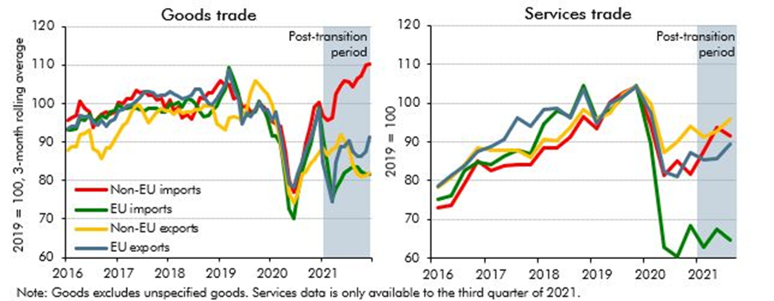
Figure: UK–EU Trade Volume (OBR, 2022).
However, India, on the contrary, is a federal democracy, which is typified by changing regulatory frameworks. The foreign direct investment in single-brand retail by the government is allowed 100% under specific conditions, whereas the regulation of compliance, such as the requirement of local sourcing, creates barriers to the operation. Different state-level regulations and bureaucracy could make market entry more complex. Even though the political situation has become more stable in recent years, a foreign company should pay close attention to the changes in policies associated with trade protectionism and trade duties. In the case of Zara, a joint venture lowers the risk of political and regulatory risk in the foreign operation and enables the company to be in compliance with local obligations.

2.2 Economic Factors
The UK is a developed and high-income economy that has a mature retail market. Nonetheless, changes in consumer discretionary spending have had impacts of recent inflationary pressures and the issue of cost of living. Brexit has also affected import pricing and margin management due to currency volatility. Nevertheless, these setbacks have not overtaken the UK, which is one of the biggest fashion markets in Europe with good consumers' purchasing power and having an advanced consumer who demands quality, sustainability and digitalisation (ONS, 2025) .
India is viewed as a rising economy and one of the BRIC states. It has witnessed a steady GDP growth over recent years, and it has one of the youngest populations in the world. The increasing urbanisation and the growth of middle-class earnings provide fashion retailers with opportunities for long-term growth. Income distribution is uneven, though, and price sensitivity is much higher than in the UK. Product pricing can also be raised by a change in the exchange rate and import duty. In this case, it implies that Zara would be positioned at a premium in India as compared to its average positioning in the UK.
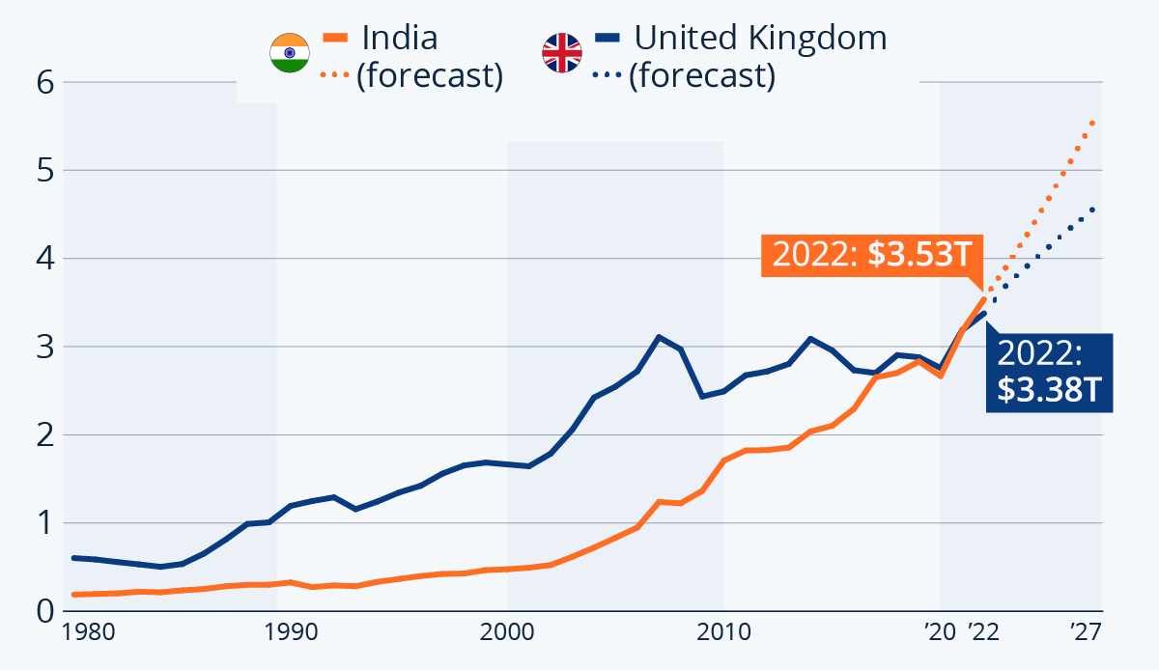
Figure: GDP Growth Comparison (Armstrong, 2022).

2.3 Social and Cultural Factors
There is a significant difference in the socio-cultural dynamics in the two countries. Sustainability awareness, ethical sourcing issues and environmental activism are some of the factors that affect fashion consumption in the UK. The environment of fast fashion is becoming more closely examined by consumers. The cultural practice promotes individualism, seasonal and social networking. Great digital literacy underlines the adoption of e-commerce and the use of omnichannel retailing.
The socio-cultural environment in India is different. It is a younger average population, and fashion consumption in urban centres is typically aspirational and status-oriented. The factors of cultural diversity in terms of different regions influence the choice of clothing, modesty, the adaptation to the climate and the dressing styles of festivals (McKinsey and Company, 2024). The Western fashion brands are regarded as having a global identity and elevation. Meanwhile, the traditional clothes are still very culturally relevant. Thus, Zara will have to strike a balance between global brand image and localised collections that involve cultural sensitivities and climate conditions.

2.4 Technological Factors
The UK also enjoys the benefit of an advanced digital infrastructure, broadband coverage, and fully developed and established e-commerce environments. Retail penetration with online retailing is high, and customers anticipate a close linkage between the physical and digital channels. This is in favour of the fast-response supply chain model and data-driven inventory management of Zara.
India has gone through a fast digital transformation, which is aided by cheap mobile information and the growing internet penetration. Digital payment and e-commerce platforms have increased (ONS, 2023). Nevertheless, there are still infrastructural differences between metropolitan and smaller cities. The efficiency of the logistics may be different, and it affects the distribution approaches. The growth of Zara in India should thus be consistent with metropolitan retail centres and online-only interactivity plans.

2.5 Legal Factors
The UK has stringent consumer protection, product safety, product labelling and product advertising policies. Legislation like the Modern Slavery Act demands transparency in the supply chains, making global fashion brands more accountable. Brand security is backed by strong intellectual property protection (GOV.UK, 2023).
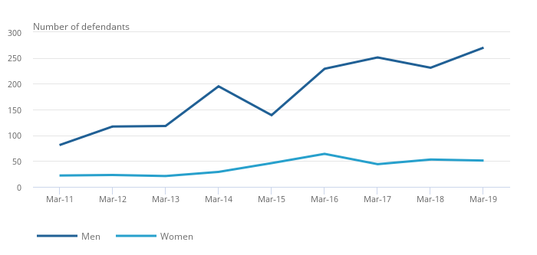
Figure: Number of Modern Slavery Reports Filed by UK Companies (ONS, 2020).
The legal environment in India is changing. Consumer protection laws do exist, but the enforcement mechanisms could vary in their effectiveness. Labelling, prices and packaging regulations mean that it has to adapt to the local compliance regulations. Protection of intellectual property is rising, but it may present a bigger problem in enforcement issues as compared to the UK.

2.6 Environmental Factors
In the UK, there is a very strong focus on environmental issues, and texts and clothing retailers are pressured by government policy and consumer activism to ensure they minimise carbon emissions and textile waste (DEFRA, 2023). Brand perception is directly related to sustainability reporting and ESG expectations.
Water scarcity and pollution are also some of the environmental issues in India. As consumers grow more price-oriented, sustainability awareness is on the rise, but consumers are still highly price-oriented in their buying choices. In the case of Zara, the environmental positioning is likely to be more reputational in the UK and a brand differentiator over the long term in India, instead of a buying-now factor.

3. Comparative STP Strategy (Segmentation, Targeting and Positioning)
The effectiveness of Zara in international marketing in the United Kingdom and India could be comprehended more effectively as a result of a comparative analysis of the Segmentation, Targeting and Positioning (STP) strategy used by Zara. Although the brand has a globally-identifiable image, its use of STP is indicative of market maturity, income distribution and culture variance.

3.1 Segmentation
In the UK, Zara is in a mature and competitive operating environment in fashion retailing. There are mainly demographic, psychographic and behavioural segmentation. The core segment has a demographic of urban customers of about 18 to 40 years of age, including students, young professionals and fashion-sensitive middle-income shoppers. Psychographically, the UK consumers are trendy, sustainability-conscious and digitally savvy (Basak, 2018). On the behavioural front, they are very high frequency of purchase, seasonal collections and online promotions are responsive. The geographical concentration of the UK market is also concentrated in the metropolitan regions of the country, including London, Manchester and Birmingham, where the footfall and online retail penetration are higher.
By comparison, the segmentation strategy that Zara has adopted in India is more heterogeneous. The target group, in terms of demographics, is also smaller as it targets mostly urban consumers with higher income levels of upper-middle-income and ages between 20 and 40 years. Corporate income disparities are wider, and this makes income segmentation stronger than it is the case in the UK (Baena, 2024). Indian consumers in this segment have a psychographic tendency to consider international brands as a status symbol and modern image. Behavioural segmentation pertains to infrequent and not regular purchases, with the consumption of fashion usually related to occasions, social functions and holidays. Geographically, Zara focuses on Tier 1 cities, such as Mumbai, Delhi and Bengaluru, with better purchasing power and mall infrastructure (Escalona Orcao and Ramos-Pérez, 2015).
Therefore, where UK segmentation does take the form of lifestyle and behavioural subtlety in an extensive middle-income market, UK segmentation is income-focused and urban-based because of structural economic variations.

3.2 Targeting
Zara uses a differentiated and selective targeting strategy in the two countries. In the UK, it targets the wide mid-market that wants fashion that is trendy and yet low-end. The brand competes against other fast-fashion retailers in terms of fast design turnover and value for money. The market size is big, reachable and quantifiable, making it a viable targeting population (Fraser and van der Ven, 2022). The prices and location of the stores in the Zara companies favour mass access in the high streets of the city and via the internet.
India Zara uses a more selective targeting in India. The brand targets rich urban consumers due to the surge in the cost of imports, the high pricing in comparison to local levels of income and the inadequate infrastructure. This is a focus-based targeting in a segment of the fashion-conscious middle- and upper-middle-income consumers (Gheorghe and Matefi, 2021). This segment is smaller in size than that in the UK but is expanding with urbanisation, increase in disposable incomes. Zara narrows its range of stores to high-end malls and major cities to support its semi-premium positioning.
Thus, Zara uses a rather general targeting strategy in the UK but a more focused and aspiration-oriented targeting strategy in India.

3.3 Positioning
Zara is slightly differentiated in its positioning in the two markets with global brand uniformity. The brand in the United Kingdom is positioned as an affordable fast-fashion retailer providing the current European style at reasonable prices. It also competes against the brands with a similar price-quality ratio, and speed to market is a fundamental point of difference (Ji, 2025). Positioning is embracing sustainability stories because of the pressure on companies to act ethically and responsibly.
The positioning of Zara in India has a higher level of aspirational undertones. Global Maestro brand sees itself as a high-end international brand in the Indian retail environment, yet it is recognised as fast fashion. Greater relative prices, scarcity of stores and belonging to the Western fashion trends lead to increased brand prestige. Positioning of Zara thus focuses on worldly elegance and cosiness as opposed to low costs in itself (Jonwal, 2025).
Altogether, the comparative analysis of STP shows that Zara standardises its global brand image but modifies the intensity of targeting, with an emphasis on breadth and positioning to the varying economic development, cultural background and purchasing power. The UK market can promote a wider, lifestyle-focused approach, and India must concentrate on a narrower, status-based strategy that is in sync with emerging market forces.

4. Comparative 7Ps Strategy
Comparative study of the international marketing mix of Zara in the United Kingdom and India shows how the brand meets the global standardisation and local adaptation. Despite having a single global image, commodity, buying power, buying infrastructure, consumer expectations, and regulatory conditions vary across regions, and this will affect how Zara will execute the 4Ps (Kotler and Keller, 2016).

4.1 Product
The product strategy of Zara is founded on rapidity, the ability to respond to trends and short inventory turnover. In 2023, Inditex also noted that it made revenue of €35.9 billion, with a majority of the amount being associated with Zara, which shows the effectiveness of Inditex's fast-fashion approach (Liu, Huang and Pan, 2024). The company is reputed to introduce new designs into the stores within two to three weeks, which is much higher than the old production cycles used in making the apparel.
The products at Zara in the United Kingdom have a wide variety of products according to the fashion trends in Europe. The nature of seasonal collections is based on the trends and shifts of the climate, as well as the close attention to sustainability among the customers (Malviya, 2025). The brand is further supporting its sustainable collection under the brand Join Life, as more consumers in the UK are becoming more environmentally aware.
In India, product adaptation is more obvious. The season defines the differences in climate, and product lines are shaped by seasons like Diwali. Design decisions are influenced by cultural norms regarding inappropriateness and the events. Nevertheless, Zara does not venture too much into localisation so that it does not lose its global brand identity and has a relatively standardised aesthetic.

4.2 Price
There are considerable macroeconomic differences in terms of pricing between the two countries. The fashion market in the UK is mature and extremely competitive in nature. Recent price sensitivity of consumers means a strong response to price increases in the UK, as inflationary pressures have taken a peak of over 10% in 2022 and are expected to moderate in the UK in 2023-2024 (Armstrong, 2023). Zara consequently keeps the middle-class prices to be able to compete with the prices of other fast-fashion retailers.
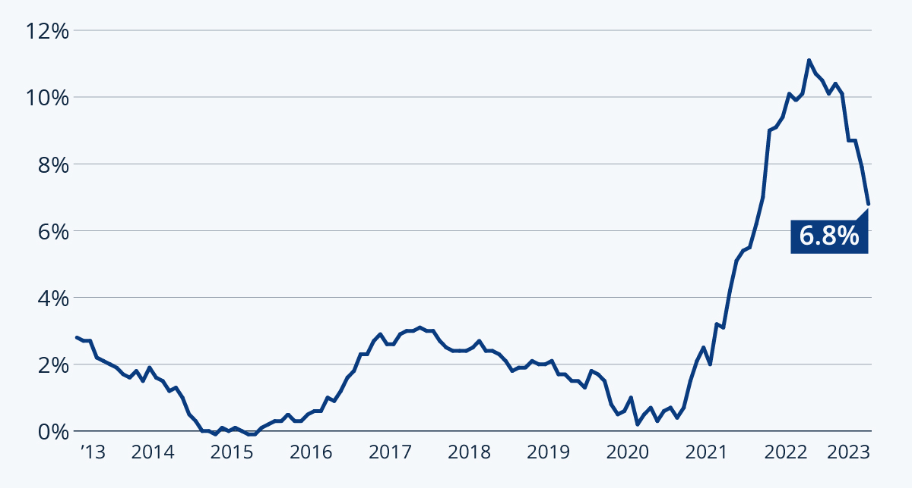
Figure: UK inflation rates (Armstrong, 2023).
The pricing strategy in India places Zara in the price range of the higher segment, as compared to the home-based income of the country. In the financial year 2025, Zara India has taken its revenue to about 2782 crore (approximately US$330 million), proving a stable performance against increased relative costs (Mathew and Spinelli, 2025). The cost is also inflated by cheap transportation and the utilisation of foreign currency, and is passed to the retail prices. Therefore, the pricing of Zara in India supports its aspirational positioning.

4.3 Place (Distribution)
The distribution strategy points out that there is a great difference between a developed and an emerging market. The UK enjoys well developed logistics infrastructure and e-commerce penetration. Online shopping represents a significant portion of the sales in the UK and the fashion industry, and Zara combines its physical outlets with online stores via the ability to collect certain orders through click and pick and delivery within an hour (Mostafa, 2023).
The retail infrastructure in India is equally improving, though it is uneven. Zara is mostly doing their business in high-end shopping malls found in popular metro cities like Mumbai, Delhi and Bengaluru. The small cities are more gradual to expand because of infrastructural differences and differences in purchasing power. Centralised supply chain management is a major factor that helps the company to ensure the consistency of products.

4.4 Promotion
Mass advertising is traditionally a less utilised instrument by Zara in comparison to its competitors, focusing on the location of its stores, window displays and online presence. In the UK, internet usage is essential in digital interaction, which is helped with 95% internet coverage. The buying decisions and awareness are fueled by social media and online platforms (Statista, 2022).
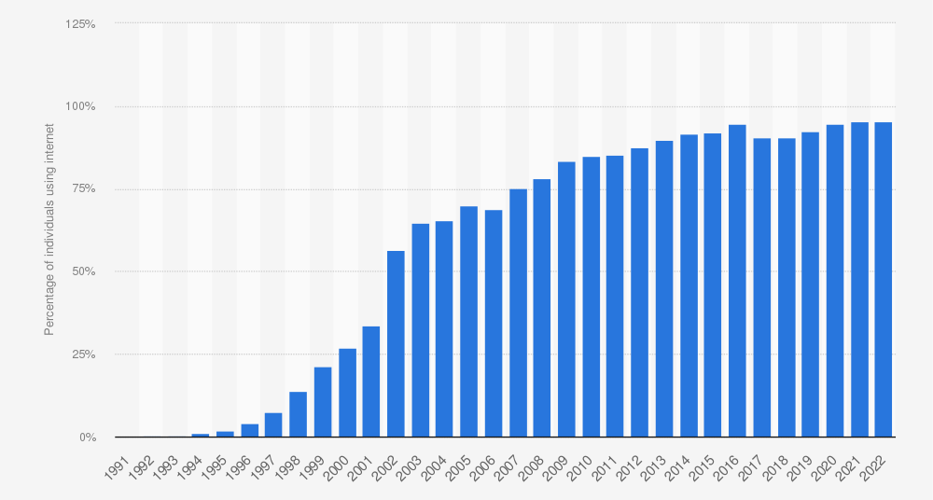
Figure: UK internet penetration (Statista, 2022).
Indian consumers are becoming more attracted to influencer marketing and using social media as part of their promotion strategy to attract younger consumers in urban areas. The internet penetration in India is more than 800 million, and this is a strong digital marketing prospect (Sitaro, 2020). Nevertheless, aspirational branding is in the spotlight, and Zara adopts a very slim global communication style instead of an overly localised campaign.

4.5 People
Individuals mention the employees' interaction with the customers, along with the representatives of the brand. The labour laws and consumer service demands dictate the workforce in the UK regarding Zara (Muthu, 2019). The employees are trained to provide efficient service that is informed by the trend in line with the retail/fast-paced model of the brand.
In India, the cultural differences affect the interaction styles with customers. There can be different expectations of services depending on the region, and language differences demand adaptive communication skills. When functioning in a joint venture, there is improved expertise in local management and understanding of culture. Management of the workforce will have to weigh between international brand requirements and local labour requirements.

4.6 Process
The process efficiency is the main competitive advantage of Zara. The company applies coupled supply chains, sophisticated data analytics and centralised distribution vertically in order to minimise production lead times (NIQ, 2023). Around the world, Inditex has one of the most responsive logistics systems, which manages to replenish stores several times a week.
In the UK, there are modern transport systems and warehouse systems that facilitate rapid restocking. In India, the distribution process across non-metropolitan areas may be delayed by logistical issues, including the lack of infrastructure in the region. However, the global supply chain model of Zara counterbalances some of these limitations using a hub and spoke coordination.

4.7 Physical Evidence
Store design, ambience and physical cues of the brand are physical evidence. Zara outlets in the UK are usually found in the busy urban centres with minimalistic interiors with a modern European look. This supports the brand positioning as contemporary and open (Talwar et al., 2025).
In India, perceived exclusivity is promoted by the location of the stores in the luxury malls. The aspirational image of the brand is provided by premium physical spaces. Store layout, lighting, and visual merchandising are international in nature as they ensure that the markets are the same.

5. Directional Development Strategy (India Focus)
The directional development strategy that Zara has adopted in India signifies a reserved yet growing market opportunity within an emerging economy. Instead of operating in India as an offshoot of its European business activities, Zara has adopted a systematic entry and expansion formula aimed at balancing the opportunities of growth with the complexity of the environment (Tőkés, 2022).
Zara entered India through a joint venture with Trent ltd. which is a Tata Group Company, which enabled the brand to export the local market understanding, regulatory management, as well as the retail infrastructure experience. This mode of entry minimised political and operational risk in a market which was defined by the changing foreign direct investment policies and requirements on sourcing. FDI in single- brand retail is permitted at 100% in India under some conditions, such as local sourcing requirements; thus partnership structure proves to be strategically beneficial (Yan, 2023). The joint venture model thus represents a polycentric orientation with local responsiveness being emphasised more than having rigid global control.
In terms of directional growth, the strategy of Zara in India is that of market development according to the Ansoff model. The company is not diversifying into products that are not related to it, but segments of a new region are being released with its existing products. Geographical concentration, however, has been in expansion. Tier 1 metropolitan areas like Mumbai, Delhi and Bengaluru are the main targets of the store locations (Yan, 2023). This is an urban concentration that signifies a meticulous expansion approach that concentrates on wealthy consumer groups instead of countrywide, swift expansion.
This considered strategy is supported by financial performance data. During the financial year 2025, Zara India recorded a revenue of about ₹2782 crore (approximately US$330M), whereas the net profit grew by 23% (Inditex, 2023). It implies that there is efficiency in operation and brand loyalty among its selected segment, although top-line growth has plateaued.
The future directional strategy of Zara in India could be based on the strategic expansion of India to Tier 2 cities and increasing disposable income through reinforcement of e-commerce platforms. The further adjustment to local demand patterns, festive consumption patterns and digital engagement trends will be important. All in all, the India strategy of Zara reflects the harmonisation between the universalisation of the brand and the situational market building.

6. Ethical Issues in the Marketing Mix
The issue of ethics plays a pivotal role in the analysis of international marketing that Zara practices in the United Kingdom and India. Being one of the fast-fashion retailers, Zara has been conducting business in an industry that is often criticised as harmful to the environment, employment conditions, and consumption-based business approaches (Gheorghe and Matefi, 2021). These are very relevant issues that are in conflict with components of the marketing mix.
A single significant ethical concern is associated with sustainability and environmental impact. The fast-fashion approach promotes the tendency to replace products regularly and consume them actively, which leads to the generation of textile waste and carbon emissions. With regards to the UK market, there is high consumer awareness in relation to sustainability and ethical sourcing in the UK market. The government control and consumer monitoring enforce transparency of supply chains under government laws, e.g. the Modern Slavery Act. Zara has also launched programs like its resource-sustainable collection, which is the Join Life, and promises to be able to develop a circular fashion (Iqbal, 2021). Critics, however saying that the speed of the production cycle of fast fashion might go against the longer-term goals in terms of sustainability. The moral dilemma is thus between business speed and environmental sustainability.

Figure: Zara “Join Life” initiative (Iqbal, 2021).
Sustainability consciousness is on the rise in India, although it takes a back seat to price sensitivity and aspirational consumption. Moral questioning in this market can target more labour provisions and equitable compensation among supply chains. Since Zara obtains goods worldwide, it is of paramount importance that the global labour laws are adhered to globally. The reputational risks of labour exploitation or hazardous working environments could influence the brand's credibility in all markets.
The other ethical aspect is the pricing strategy. The relatively high pricing of Zara in relation to the domestic income in India makes the question of accessibility and value perception an issue (Ji, 2025). Although premium positioning is a good option, ethical marketing needs to communicate openly on the quality of the product, and the origin to support price variations.
There is also an ethical implication in promotion. Advertisements should not perpetuate unrealistic body images or cultural insensitivity (Liu, Huang and Pan, 2024). Culturally sensitive communication will be necessary in multicultural surroundings, such as the UK, and multicultural societies such as India, in order to keep the brand legitimacy intact.
In general, Zara has ethical issues related to the profitability vs environmental responsibility, labour and marketing culture transparency, and labour and cultural background marketing. It is crucial to deal with them before, and it will contribute to the sustainability of the international brand in the long-term.

7. Strategic Recommendations
Under the comparative analysis of the macroenvironment, the STP strategy and marketing mix, there are strategic recommendations that can be offered to enhance the long-term competitiveness of the Zara company in the United Kingdom and the Indian market.
First, Zara in the UK should become tighter in terms of its sustainability leadership. Environmental consciousness and transparency in regulations are becoming a major force among UK consumers. Although Zara has also launched sustainable collections, the company ought to enlarge traceability programs and publish more understandable metrics of carbon-reduction and promote such programmes of recycling a garment as part of the circular fashion. Enhancing environmental communications would support brand trust in an established and somewhat questionable market (Malviya, 2025). Moreover, digital integration should be persisted in Zara, with the use of data analytics and omnichannel retail enhanced to create a customer experience, since the online penetration of fashion is still among the highest in the UK.
Second, Zara must use Zara to use a proxim and more gradual expansion approach in India. At the same time, ensuring continuity at Tier 1 cities, it will be possible to enter carefully at Tier 2 urban centres in increasing disposable incomes, so as to develop markets slowly but surely. This growth must be facilitated by the more advanced e-commerce facilities since India has a skyrocketing number of internet customers (Talwar et al., 2025). A digital-first approach can help eliminate the dependency on physical infrastructure and expand geographically.
Third, the selective product adaptation in India should be reinforced. Festive collections and climate-responsive designs in limited editions would boost cultural appeal without watering down global brand image. Concurrently, pricing structure can be changed by a differentiated product line to appeal to a larger group without losing aspirational positioning.
Lastly, Zara needs to strengthen ethical supply chain governance in the two markets. Reputational risk should also be countered by transparent reporting, fair labour compliance audits and sustainable sourcing commitments to meet the global standard ESG expectations.
In general, the future strategy of Zara must be an equilibrium between the global brand uniformity and additional local adjustment to better ensure sustainable leadership and growth through digitisation, as well as competitive advantage in both established and emerging market settings.

Section 2

Reflective Account (Gibbs Reflective Cycle)
1. Description
As I was preparing this report, I had a structure, which would have included reading lecture materials, reviewing secondary data and providing theoretical frameworks to the operations of Zara in the United Kingdom and India. I started with a review of the conceptual points that I studied in the course of the module, especially PESTEL, STP and the 7Ps model, because I did not want my analysis to be based on descriptions but on theory. I subsequently collected information on the company annual reports, government publications and other reliable sources in the industry to know about the macroeconomic and retail situation of the two countries. I put the report together in phases, where I have done the macroenvironment, then strategic analysis and lastly the recommendations. I tried to take a comparative approach, which was highlighted in the module during the process and not to consider countries individually.
2. Feelings
I was not certain that I would be able to apply marketing frameworks at the beginning since I was well-versed with the 4Ps gained through prior research. But soon I came to the realisation of the fact that international marketing demands a far higher degree of critical comparison. At the start, I was faced with the difficulty of balancing theory and real-world data without getting too descriptive. There was also a lack of clarity in my understanding of macroeconomic statistics, particularly in the comparisons between a developed market such as the UK and an emerging market such as India. This is because I gained more confidence in the ability to combine theory and evidence as I progressed. The comparative aspect also appealed to me on an intellectual level since it forced me to look past any differences on a superficial level.
3. Evaluation
The upsides of my learning process were that I always used concepts taught in lectures to organise each section. This assisted in trying to be on track with module expectations. The PESTEL model has allowed me to make a comparative analysis of the political, economic and socio-cultural differences systematically. In the same way, working with STP made me stop making general remarks on Zara and examine the variability of segmentation and positioning across markets.
But there are also some areas of weakness that I can identify. I had the temptation at times of attaching much weight to statistical data without necessarily elaborating on its strategic implications. It required me to mind myself to respond by saying so what after stating every piece of information. The other challenge was not to repeat things in different sections because the macro factors tend to intersect with the marketing mix decisions. To be able to be coherent and at the same time avoid duplication, it was essential to edit carefully and restructure.
4. Analysis
This process enhanced my trade in international marketing. The module has outlined that international marketing is different as compared to domestic marketing because there exist multidimensional environmental forces like culture, political structures and infrastructure, among others. This assignment made me see how such elements are interrelated. Also, economic conditions in India have a direct impact on this pricing strategy, whereas the cultural norms impact the product adaptation and promotion.
I also had an improved idea of thinking in a global mindset. In the first place, I perceived the strategy of Zara as rather universal on the global scale. Nevertheless, in the course of analysis, I realised that the brand identity is still global, but the way in which it is implemented may significantly differ based on the conditions in the host country. This is the contradiction between standardisation and adaptation that was examined in lectures.
Furthermore, ethical assessment also made me think over problems of multinational corporations' responsibilities critically. Instead of taking sustainability proclamations at face value, I needed to take into consideration the regulatoryexpectationss, consumer activism and reputational risk. It made me more capable of subjecting business practices to critical analysis and not merely describing them.
5. Conclusion
On the whole, the preparation of this report contributed to my development of skills to implement the international marketing frameworks into practice. I also came to know that to be an effective international strategy-maker, it is not only necessary to get familiar with the theory but also to interpret environmental data and make reasonable strategic decisions. Comparative approach enhanced my critical thinking approach and also assisted me in understanding the strategic trade-offs that firms encounter in the process of operating in a variety of markets. Another thing that I have to be more conscious of in post-graduate level is the significance of structured argumentation and evidence-based reasoning.
6. Action Plan
When handling similar assignments in the future, I will ensure to start data collection earlier in order to have more time to critically analyse the information obtained as opposed to merely data gathering. I am also planning to improve my skills in interpreting quantitative data and relating it to the strategic implications in a direct manner. Learning more about the new markets will enable me to analyse non-Western situations with more confidence.
Moreover, I want to master academic writing by making transitions in the relations between theory and practice smoother. Lastly, I will maintain cultivating a global marketing mentality through the study of international business cases and tracking the global retail trends. This will not only improve my academic performance but also my professional preparedness for the roles that need strategic decisions in the complex international environment.

References
Armstrong, M. (2022). Infographic: India Overtakes UK to Become Fifth Biggest Economy. [online] Statista Daily Data. Available at: https://www.statista.com/chart/28258/gdp-of-india-and-united-kingdom/?srsltid=AfmBOopZvkZg7DicCvkvp8UPh7PQN_fGpnjOqTydmSB9AX8UAPu913gE [Accessed 1 Mar. 2026].
Armstrong, M. (2023). Infographic: UK Inflation Rate At Lowest Point Since February 2022. [online] Statista Daily Data. Available at: https://www.statista.com/chart/26208/uk-cpih-cpi-inflation-timeline/?srsltid=AfmBOoqRShhnfIOZfVEYURtmvpH8B3k_ngrtu2ybgvWHD7IKCbj04tZP [Accessed 27 Feb. 2026].
Baena, V. (2024). The shift from fast fashion to socially and sustainable fast fashion: The pivotal role of ethical consideration of consumer intentions to purchase Zara. Corporate social-responsibility and environmental management, [online] 31(5). doi:https://doi.org/10.1002/csr.2803.
Basak, S. (2018). Zara: Study of a luxury fast fashion brand ; with respect to two different countries. [online] ResearchGate. doi:https://doi.org/10.13140/RG.2.2.29717.23528.
DEFRA (2023). Department for Environment, Food and Rural Affairs. [online] GOV.UK. Available at: https://www.gov.uk/government/organisations/department-for-environment-food-rural-affairs [Accessed 28 Feb. 2026].
Escalona Orcao, A.I. and Ramos-Pérez, D. (2015). Global production chains in the fast fashion sector, transports and logistics: the case of the Spanish retailer Inditex. Investigaciones Geográficas, 0(85), pp.113–127. doi:https://doi.org/10.14350/rig.40002.
Fraser, E. and van der Ven, H. (2022). Increasing Transparency in Global Supply Chains: the Case of the Fast Fashion Industry. Sustainability, 14(18), p.11520. doi:https://doi.org/10.3390/su141811520.
Gheorghe, C.A. and Matefi, R. (2021). Sustainability and Transparency—Necessary Conditions for the Transition from Fast to Slow Fashion: Zara Join Life Collection’s Analysis. Sustainability, 13(19), pp.1–16.
GOV.UK (2023). Competition and Markets Authority. [online] GOV.UK. Available at: https://www.gov.uk/government/organisations/competition-and-markets-authority [Accessed 28 Feb. 2026].
Inditex (2023). INDITEX | FY2023 Results. [online] Inditex.com. Available at: https://www.inditex.com/itxcomweb/es/en/press/news-detail/10da31b6-0c12-43e4-9e33-103766d27821/fy2023-results [Accessed 27 Feb. 2026].
Iqbal, S. (2021). How ethical is Zara’s ‘Join Life’ Collection? [online] Medium. Available at: https://medium.com/@sumraiqbal/how-ethical-is-zaras-join-life-collection-4173a92e069d [Accessed 28 Feb. 2026].
Ji, Y. (2025). Research on Zara’s Supply Chain System. Advances in Economics Management and Political Sciences, [online] 211(1), pp.36–43. doi:https://doi.org/10.54254/2754-1169/2025.cau26083.
Jonwal, S. (2025). Zara Case Study 2025: The Fast Fashion Giant’s Winning Strategy. [online] Young Urban Project. Available at: https://www.youngurbanproject.com/zara-case-study/ [Accessed 28 Feb. 2026].
Kotler, P. and Keller, K.L. (2016). Marketing Management. 15th ed. Boston: Pearson.
Liu, S., Huang, Y. and Pan, Q. (2024). Analyzing the strategic impact of zara’s branding strategies on consumer engagement and market position. SHS Web of Conferences, [online] 185(185), pp.1–6. Available at: https://www.shs-conferences.org/articles/shsconf/pdf/2024/05/shsconf_iclcc2024_03018.pdf.
Malviya, S. (2025). Zara India posts weakest sales growth in FY25 amid rising market competition; net profit up 23%. [online] The Economic Times. Available at: https://economictimes.indiatimes.com/industry/services/retail/zara-india-posts-weakest-sales-growth-in-fy25-amid-rising-market-competition-net-profit-up-23/articleshow/121785751.cms?from=mdr [Accessed 27 Feb. 2026].
Mathew, M. and Spinelli, R. (2025). Decoding sustainable drivers: A systematic literature review on sustainability-induced consumer behaviour in the fast fashion industry. Sustainable Production and Consumption, [online] 55, pp.132–145. doi:https://doi.org/10.1016/j.spc.2025.02.011.
McKinsey and Company (2024). The State of Fashion 2025: Challenges at every turn. [online] McKinsey. Available at: https://www.mckinsey.com/industries/retail/our-insights/state-of-fashion [Accessed 28 Feb. 2026].
Mostafa, S.S. (2023). Zara’s Sustainability. [online] doi:https://doi.org/10.13140/rg.2.2.30396.50569.
Muthu, S.S. (2019). Consumer Behaviour and Sustainable Fashion Consumption. Singapore Springer Singapore Springer.
NIQ (2023). Shein, Zara, H&M: Close-up on the Ultra-Fast Fashion Market. [online] NIQ. Available at: https://nielseniq.com/global/en/insights/analysis/2023/shein-zara-hm-close-up-on-the-ultra-fast-fashion-market/ [Accessed 28 Feb. 2026].
OBR (2022). The Latest Evidence on the Impact of Brexit on UK Trade. [online] Office for Budget Responsibility. Available at: https://obr.uk/box/the-latest-evidence-on-the-impact-of-brexit-on-uk-trade/ [Accessed 2 Mar. 2026].
ONS (2020). Modern Slavery in the UK - Office for National Statistics. [online] www.ons.gov.uk. Available at: https://www.ons.gov.uk/peoplepopulationandcommunity/crimeandjustice/articles/modernslaveryintheuk/march2020 [Accessed 2 Mar. 2026].
ONS (2023). Office for National Statistics. [online] Ons.gov.uk. Available at: https://www.ons.gov.uk/ [Accessed 28 Feb. 2026].
ONS (2025). Inflation and Price Indices - Office for National Statistics. [online] ons.gov.uk. Available at: https://www.ons.gov.uk/economy/inflationandpriceindices [Accessed 28 Feb. 2026].
Reid, H. (2024). Online retailer Shein’s 2023 sales hit $2 billion in UK. [online] Reuters. Available at: https://www.reuters.com/business/retail-consumer/online-retailer-sheins-2023-sales-hit-2-bln-uk-2024-10-08/ [Accessed 27 Feb. 2026].
Sitaro , T.D. (2020). Fast Fashion and Sustainability - The Case of Inditex-Zara . [online] Fordham University. Available at: https://research.library.fordham.edu/cgi/viewcontent.cgi?article=1044&context=international_senior [Accessed 28 Feb. 2026].
Statista (2024). Inditex: net sales worldwide by brand 2024| Statista. [online] Statista. Available at: https://www.statista.com/statistics/456505/sales-inditex-group-worldwide-by-format/?srsltid=AfmBOooutOkKevgQj9vGD0f795o7-4fJIlPEEGaWifbouiFV6QySkM3Q [Accessed 27 Feb. 2026].
Statista. (2022). UK: internet penetration 1991-2022| Statista. [online] Available at: https://www.statista.com/statistics/468663/uk-internet-penetration/?srsltid=AfmBOooGX_44t8dW8vnCMatlAPBmFi30efhLEcScW8S6P6SEstM-WqVP [Accessed 27 Feb. 2026].
Talwar, S., Alzeiby, E.A., Gupta, B. and Sharma, V.K. (2025). Psychological foundations of fast fashion: Managing tensions and paradoxes, and navigating ethical dualities. Acta Psychologica, [online] 261, p.105837. doi:https://doi.org/10.1016/j.actpsy.2025.105837.
Tőkés, G.E. (2022). The digital brand identity of fast-fashion brand zara. A case study. Acta Universitatis Sapientiae, Social Analysis, 12(1), pp.131–154.
Ward, M. and Webb, D. (2024). Statistics on UK-EU trade. commonslibrary.parliament.uk, [online] 7851(1). Available at: https://commonslibrary.parliament.uk/research-briefings/cbp-7851/ [Accessed 28 Feb. 2026].
Xie, Y. and Yang, Q. (2023). Comparative Analysis of Marketing Strategies of Fast Fashion Brands ZARA and H&M. BCP Business & Management, [online] 39(1), pp.318–324. doi:https://doi.org/10.54691/bcpbm.v39i.4162.
Yan, Y. (2023). Research on the Business Model and Brand Strategy of Fast Fashion BrandsTaking ZARA as an Example. Advances in Economics, Management and Political Sciences, [online] 26(1), pp.295–300. doi:https://doi.org/10.54254/2754-1169/26/20230587.

