

Advanced Statistical Programming

Module Code: ACCA7022
Lecturer: Dr Aliyu Sambo
Assignment Title: Smart Warehouse Inventory Simulation
Student Name: Aryan Hiteshkumar Limbachiya
Student Number: 2530067

A. Explanation of Code and Logic
The ultimate goal of this solution was to create and manipulate the simulation of smart warehouse inventory information strictly through the implementation of control flow constructs only, which in this particular case included nested loops only. The assessment constraints did not allow the implementation of any additional abstractions libraries such as dplyr and the entire apply family including base library aggregation and tapply(). Therefore, the code was developed following the sequential approach and the imperative programming model for multiple dimensional data synthesis, aggregation, calculation, and detection of anomalies.
For the generation of the initial set of data (Task 1A), a continuous spatial-temporal data consisting of exactly 28 days, 5 operational zones and 6 product categories needed to be generated. The aforementioned multi-dimensional state space contains exactly 840 possible combinations (28 * 5 * 6 = 840). For the initialization of the state space, three nested 'for' loops were defined. In order to keep the amount of dynamic memory usage stable during looping, atomic vectors (Day, Zone, Category, UnitsProcessed, ProcessingTime) were allocated in advance for their maximum needed length (840) by defining them as numeric(840). During the innermost loop execution, UnitsProcessed measure was computed based on the specified formula – BaseUnits (100) + (Zone * 8) + (Category * 5) + RandomVariation, where RandomVariation was defined to have the uniform random distribution between -12 and +12. During this computation, the ProcessingTime value was obtained based on the multiplication factor of 0.85 against UnitsProcessed value.
For the calculation of total number of units processed by each warehouse zone (Task 1B) using neither tapply() nor aggregate() function, the index-accumulator algorithm was utilized. Numeric vector of length 5 (TotalUnits) was initialized by zeros. A loop was run once to scan all 840 observations from warehouse_data dataset, taking Zone ID value (from 1 to 5) as direct integer index-pointer and accumulating the row unit count into TotalUnits[current_zone]. For the computation of the average time spent on processing units from each category (Task 1C), two parallel vectors of length 6 were used – TotalTime (time summation) and CatCount (counting of the category observation frequency).
For the processing anomaly detection model (Task 1D), a double pass matrix structure was designed. As the anomaly is determined relative to the daily average units processed in a particular zone for each product category, the first pass involved creating two 28×5 matrices (daily_zone_sum and daily_zone_count) to accumulate the number of units and the number of rows for the respective Day-Zone pair. The second pass involved calculating DailyZoneAverage in each row using the data from the 2D array of [Day, Zone]. If the difference between UnitsProcessed and the daily average for that zone exceeded 15%, the Anomaly boolean variable took TRUE value.
Task 1E, finally, calculated the maximum productivity day in each Zone within the warehouses. This process utilized a 28×5 array which added all the units per each Day-Zone combination. With the help of a nested loop, a local maxima search took place in each zone for 28 days, and the day variable was updated each time max_units were updated.

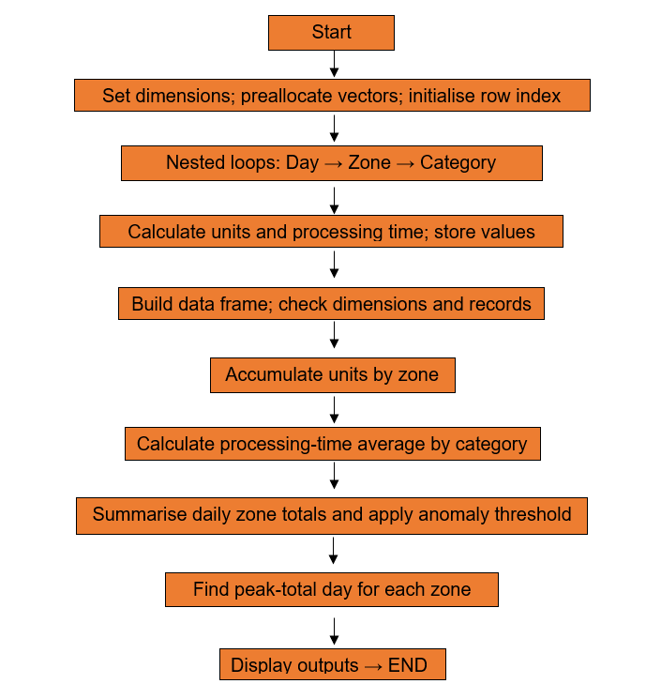
B. Justification of Programming Choices
The absolute constraint on not using high-level abstract libraries necessitated thorough thinking about memory allocation and efficiency at the low level. While using R, dynamically allocating an object within a loop (such as rbind() or c() within the loop) will make the interpreter allocate continuous memory space from the operating system, copy the old values, and put the new value in each iteration. The time complexity becomes O(N²) exponentially.
In order to address the problem described above, the first architectural solution would be that of implementing a strict Memory Pre-allocation Strategy, where vectors of length N=840 would be created through numeric(total_rows) before the start of the loop operations and the memory allocation will happen just once. The subsequent nested loops perform changes to the values located at fixed memory locations with O(N) linear time complexity.
Another important thing to mention is that, for the multidimensional aggregation problem (Tasks 1D and 1E), 2D numeric matrix arrays would be chosen as fast lookup tables for the spatial-temporal data. Since both Day (1-28) and Zone (1-5) have an inherent integer coordinate representation, we will have O(1) constant-time direct memory access to sums and counts.
C. Testing and Validation
Test protocols were performed rigorously in order to ensure mathematical accuracy, boundary validation, and constraint validation at each step of the way:
• Dimensional Validation: Validated that the produced data had precisely 840 rows using nrow(warehouse_data) == 840, and 5 columns to confirm that the triple nested loop went through each of the 28 × 5 × 6 state combinations without any omissions or repetitions.
• Mathematical Formula Validation: Validated baseline calculation manually. On Day 1, Zone 1, Category 1, the unadjusted base formula will be 100 + (1×8) + (1×5) = 113. With addition of a uniformly distributed random integer variation selected from [-12, +12], the only possible values for UnitsProcessed fall strictly within the range of 101 to 125. The processing time was validated as UnitsProcessed × 0.85.
• Anomaly Threshold Boundary Validation: Validated that the ±15% anomaly trigger works properly. For the mean value of 100, values of 116 units and 84 units were successfully triggering Anomaly = TRUE, while values of 115 and 85 evaluated to FALSE.
• Aggregation Cross Validation: Validated that the global sum of TotalUnits across all 5 zones is indeed equal to sum(warehouse_data$UnitsProcessed).
D. Efficiency and Scalability Reflection
Whereas the completed solution completes near-instantly on a dataset of 840 rows using a naive imperative loop, this is only possible due to inefficiencies in interpreted languages like R. Function call overhead becomes large when looping over rows. If this warehouse was scaled up for use in a real-world situation over 365 days in the year, 500 fulfillment areas, and 10,000 product groups, the size of the dataset would be 1.825 billion rows. In this case, the use of loops would create a large bottleneck in computational performance, taking hours to complete.
In an industrial setting where unnecessary limitations would not exist, efficiency would be achieved through the use of native vectorized operations and compilation into a C++ backend. Tools that use the expand.grid() method together with data.table and C++ vectorized array arithmetic perform million-row aggregates in seconds. However, for the purposes of this assignment, the best way in terms of computational power to use loops is to pre-allocate atomic vectors and use two-dimensional matrices to look up elements.
E. Reflection on Learning and Use of Generative AI
The implementation of this project allowed acquiring significant knowledge about data structures on the hardware level and the performance of algorithms. The modern higher-level programming packages such as dplyr or pandas hide the process of data manipulation inside 'black boxes', working at the highest level. Implementing aggregation pipelines, hash map indices, and multidimensional if-statements entirely with basic looping constructs gave a deep insight into the management of hardware-based memory and indexes as well as calculation complexity.
The Generative AI was only employed at the preliminary research stage as an educational discussion forum, where the theory could be discussed, namely, the behavior of memory management and Big-O notation concerning the time complexity between a dynamic vector growth and pre-allocated memory. The Generative AI provided an explanation of how OS-based memory requests are done during vector re-allocation, thus confirming the choice of static memory pre-allocation.

