

Postgraduate/Distance Learning
Assignment coversheet & feedback form

THIS SHEET MUST BE THE FIRST PAGE OF THE ASSIGNMENT YOU ARE SUBMITTING (DO NOT SEND AS A SEPARATE FILE)

For completion by the student:
Student Name: Alejo Matías López Silva

Student University Email: 1710936@student.uwtsd.ac.uk
Module code: HPCA7001  Module title: Foundations in Cultural Astronomy and Astrology | Student ID number:  1710936 |  |  | Educational support needs:  No
Assignment title: C. Consider the role of sky myths in two different cultures.

Assignment due date: 16th December 2019
This assignment is for the 1st 2nd 3rd 4th 5th 6th module of the degree
I confirm that this is my original work and that I have adhered to the University policy on plagiarism.
Signed ……………………………………………………………
Email submission:if you are submitting this form via email, please tick this box □
(as a substitute for your signature) to confirm that you agree to the above declaration.
Assignment Mark

1st Marker’s Provisional mark

2nd Marker’s/Moderator’s provisional mark

External Examiner’s mark (if relevant)

Final Mark

NB. All marks are provisional until confirmed by the Final Examination Board.

For completion by Marker 1 :
Comments:
Marker’s signature: |  |  | Date:
For completion by Marker 2/Moderator:

Comments:

Marker’s Signature: |  | Date:
External Examiner’s comments (if relevant)

External Examiner’s Signature: |  | Date:

Consider the role of sky myths in two different cultures
Word count: 3520

This essay considers the role of two sky myths in two different cultures. The first myth is the one of Jesus Christ in early christianity as depicted in the gospel of Luke. The second myth is the one of the Superman as pictured in the movie Man of Steel (2013) by Zack Snyder.

‘I am the light of the World’
According to the gospel of Luke, a Virgin called Mary was visited by an angel who asked her if she was willing to carry the son of God. She accepted her mission and was thus pregnant. She and her husband left their hometowns and gave birth to Jesus in Bethlehem.

Once the kid grew up, he visited his cousin John to be baptized. John had been preparing the people for the coming of the Messiah. During the ceremony, a dove descended from heaven and a voice recognized Jesus as the son of God. He then became famous, spreading a message of love and liberation. To accomplish his mission, he gathered twelve apostles. Jesus travelled with them and some women, performing miracles and telling stories that would emphasize the value of love, forgiveness, prayer and freedom. He would also prepare them for the day he would be gone.

After all his journeys and teachings, during one Easter, he had dinner with his disciples to say goodbye. He was then taken to justice. After a trial, he was not found guilty by Pontius Pilate, the judge, but the people demanded to have him crucified. Jesus died in the cross betrayed by those who he loved and wanted to protect. Three days later, he resurrected. He showed himself to his friends and imbued them with spiritual power.

‘Mankind is introduced to the Superman’
In Zack Snyder’s Man of Steell, Superman was originally born under the name of Kal-El (which means Kal, son of El) in Krypton, a collapsing planet. His father Jor-El saved him by sending him to Earth in a space pod when he was only a baby. Once he got here, he was found by Jonathan and Martha Kent, two farmers from Kansas, who had no children and raised him as his own under the name of Clark Kent. Because Earth’s Sun was younger and closer that the one in Krypton, Kal-El’s cells behaved differently giving him amazing powers: x-ray vision, laser vision, extra strength, light speed, steel skin and ability to fly. His foster father, Jonathan, advised him to hide his abilities and to try to act like any regular person. Clark struggled to follow his guidance but after his father’s death, felt lost and began a quest to find himself and his purpose. During this search, he ran into a hidden Kriptonian ship and found information about his origin. An image of his natural father told him that the people of Earth could be great people, even though they had flaws, and that it was because of their capacity for good that he had been sent to guide them. After this revelation Kal-El found meaning in his coming to Earth and decided to protect human kind. At that moment, an alien ship arrived to our planet carrying some surviving criminals from Krypton. They were hunting him and also hoped to kill humankind by re-shaping Earth into their former planet. But Kal-El introduced his empowered identity to mankind and Louise Lane, a reporter, named him Superman. After several battles, he defeated the criminals and saved the Earth and its inhabitants.

‘And the Word was made flesh’
Already in 1880, it was claimed that ‘the worship of the Sun was among the earliest of all creeds’. In 1886, Chambers had pointed out that this star was worshipped in Egypt and in Babylon. In the Persian tradition, it was revered under the name of Mithra. India natives also ‘meditate on the excellent glory of the divine vivifier’, hoping to be enlightened. The Greeks worshipped Helios or Apollo and the Romans, in due time, incorporated the veneration of the Sun. Nohaft refers to Herman Ussener in order to maintain that in the year 274 CE the emperor Aurelian elevated Sol Invictus to the state of supreme deity, establishing his cult on December 25th, near the Winter’s solstice. From then onwards, when christians celebrated the birth of the Sun, they could also celebrate the birth of their Christ. The connection was not hard to make as Jesus had claimed to be the light of this world. Campion assured that ‘Christianity is no less a sky religion than any other ancient Near Eastern faith’. Robin Heath also concluded that the association of Christ and Sol Invictus is well-recorded as Jesus’ birth was near the winter solstice and his death at hand with the spring equinox.

According to Anselm Grün, the first lines of the Gospel showed that Luke tried to portray himself as a historian. He was writing a ‘narrative theology’. Like many of the other solar deities, Jesus had a peculiar birth: born from a virgin. Grün specifically added that this scene was ‘known both in Jewish circles and in Hellenistic and Egyptian traditions.’ His godly nature was unmistakably recognized by the heavens when he was being baptized: the sky cleared and a ray of light fell onto him. ‘And a voice came from heaven, which said, Thou art my beloved Son; in thee I am well pleased’. During his teachings, Jesus would later make references to the tension between light and darkness.

Jesus was followed by disciples. From all of them, he picked twelve who were particularly special. ‘When morning came, he called his disciples to him and chose twelve of them, whom he also designated apostles’. The number of the disciples match that of the signs of the Zodiac. Barton claimed that whatever is present twelve times in the Bible is ‘influenced by the twelve signs of the zodiac’. Nicholas Campion supported this idea and added that the 72 disciples that were sent later also responded to the totality of space and time. In another paper, Campion cited Dupuis’ theory that ‘Jesus' life was an allegory of the Sun's course through the zodiac with crucifixion a symbolic representation of the cross of the year’.

Like the Sun, Jesus died and was reborn. When he was taken into trial, he claimed it was no longer his hour but that of the enemy, that in which ‘darkness reigns’. During his death (the death of the Sun) darkness came over the Earth. ‘It was now about noon, and darkness came over the whole land until three in the afternoon, for the Sun stopped shining’ [Italics are mine]. Scholars have questioned if this was an eclipse but it is impossible for a Solar Eclipse to have occurred as the scene happened during a Full Moon. Nicholas Campion suggested that, as the star of Bethlehem, the astronomical depiction may have been a metaphor. As the Sun is always reborn, so was Jesus. When the women went to visit his grave, he appeared to them and said ‘Why do you look for the living among the dead? He is not here; he has risen!’ [Italics are mine]. Three days had passed, thus connecting his resurrection with the winter’s solstice, ‘the point at which the Sun was to embark on its journey back to life from near-death of midwinter.’ Campion suggested astronomical correspondences with Christ, Christmas, the death of the Sun and the celebration of Sol Invictus.

Finally, when Jesus was resurrected and visited his disciples, he gave them instructions and literally ascended to his realm, the heavens, ‘While he was blessing them, he left them and was taken up into heaven.’ According to Campion, ‘heaven was the sky’ and thus in christian morality Jesus was returning to a place of good.

‘It’s not an S, on my world it means hope’
Superman was originally named Kal-El. ‘-el’ is a suffix in Hebrew that means ‘God’. Simcha Weinstein claimed that ‘Kal-El’ meant ‘all that is God’ and that his story was inspired in the one of Moses and in Jewish values. But director Tom Mankiewicz, who also made a movie about Superman, found better inspiration in the myth of Christ. As told by Zack Snyder, Kal-El had a peculiar birth, he was ‘Krypton’s first natural birth in centuries’. In this planet, population was artificially controlled. For earthlings, he was a creature that came from the sky and would be seen as a god: ‘you will be a god to them’. When his father decided to send him to this planet, it was because he could guide the people of Earth and give them hope.’ Later, he was referred as ‘a beacon to the world’, just like the Sun.

After his foster terrestrial father’s death, Clark Kent wandered, seeking his purpose. When he finally met the ghost of his natural father, he was introduced to his mission, which is a solar, guiding one to help the weak people of Earth:

Not if you guide them, Kal. Not if you give them hope. That is what this symbol means. The symbol of the house of El means hope. Embodied within that hope there is the fundamental belief: the potential of every person to be a force of good. That’s what you can bring them.

Kal-El was powerful and god-like because he had been incarnated onto Earth. On his home planet, he did not have superpowers. But he was now drilling vitality and energy from the Earth’s Sun: ‘Earth’s Sun is younger and brighter than Krypton’s was. Your cells are drunk in its radiation, straightening your muscles, your skin, your senses.’ The ‘S’ stood for hope on his home planet, but Louis Lane remarked that, here on Earth, it was simple the letter ’s’ with no symbolic meaning. ‘S for Superman’, she added later. As a solar myth, S may be for the Sun. Also some of his powers were related to light and vision: X-ray and laser eyesight. Besides, Kal-El’s fathers assured him that he could help humans accomplish wonders and that, in time, they would join him in the Sun:

‘You will give the people of Earth and ideal to strive towards. They will race behind, they will stumble, they will fall, but in time, they will join you in the Sun, Kal. In time, you will help them accomplish wonders.’


When Superman had to introduce himself to human kind, he went to meet with the military. He remained outside the facilities’ border, floating in the sky, and talked to the soldiers to be allowed in. When they looked up at him, their eyes narrowed as they sank under the Sun’s light coming right from behind of Superman. As shown in Figure 1, Kal-El was covered in sunlight and confused with it:
Figure 1. Man of Steel, visual supervisor John 'DJ' Desjardin (c) Warner Bros.
As a solar myth, Superman would have to die and be rebirth, thus accomplishing the same path that is performed by the Sun. At the end of Batman vs. Superman, Superman was killed in battle. The only way to succeed in the mission was for him to sacrifice himself. Yet, in the continuing sequel League of Justice he would be reborn.

‘For many will come in my name, claiming, ‘I am he,’ ’
As both are solar myths, there are many themes in common. This may not be surprising as Campion mentioned Taylor’s claim that all solar deities are one. Jesus and Kal-El shared a peculiar birth. Both their fathers were high above: in one case God himself and, in the other, Jor-El who spoke from a Space Shit which came from a planet far away.

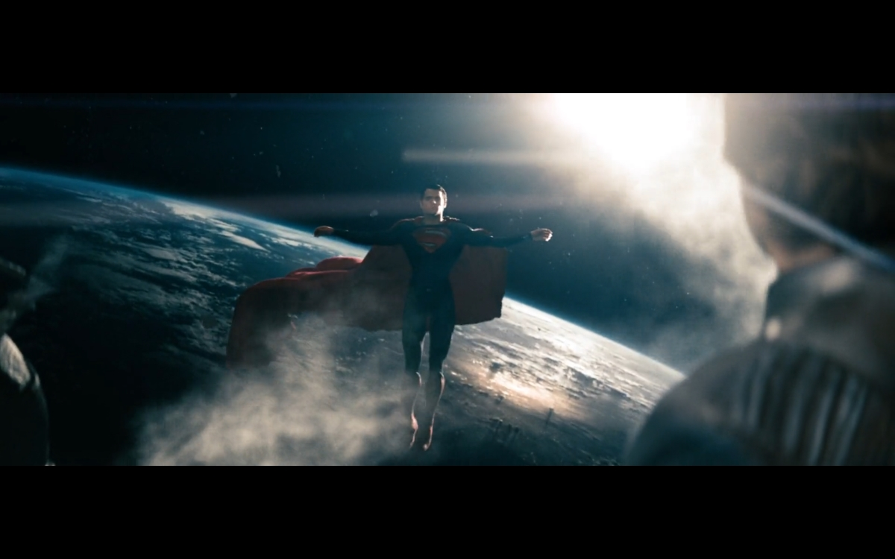
The passage of the Passion of Christ also brings parallel scenes. Jesus died on the cross sacrificing his human identity. When Kal-El found out about his past, he decided to sacrifice his Kryptonian past to save humanity. Figure 2 shows him jumping to outer space with the Earth below and the Sun shining on him while he opened his arms and formed a cross. As the music followed a dramatic pitch, he closed his eyes as if he was also visiting his Passion. In Figure 2, the Man on the right looking at him (from higher above) is his father.
Figure 2. Man of Steel, visual supervisor John 'DJ' Desjardin (c) Warner Bros.

Another point in common may be that both Jesus and Superman had to do sacrifices, they both surrendered to human kind. ‘I’m surrendering to mankind’ said Superman when being handcuffed. Jesus was arrested by the high priest and did not resist either: ‘Permit even this’.

‘And the light shines in the darkness, and the darkness did not comprehend it.’
The message of Jesus was a message of liberation. He had come to ‘heal the brokenhearted, to proclaim liberty to the captives and recovery of sight to the blind, to set at liberty those who are oppressed’. He was a savior. But he might have also been sending a political message: ‘Do you suppose that I came to give peace on earth? I tell you, not at all, but rather division.’ This myth could be a story that imbued the heart of revolutionaries. Koester believed that his message ‘implied a complete reversal of all political, social, and religious values’. And considered that Christ was the victim of an authoritative political system. The historical context may support this claim as the events related in the gospel happened while Palestine had to pay tributes to Rome. But Sanders suggested that the situation for the Jews and the tax system imposed to them were not as harsh as many scholars interpreted. Indeed, in the gospel of Luke, Jesus advised to comply with mundane law and to pay taxes properly. And when he was taken into trial, out of three accusations (rebellion, promoting tax evasion and pretending to be the Messiah), only one of them was studied. The first two were dismissed and not even discussed. Instead, Pilate only asked if he was king of jews. According to Tyson, it may be that Luke wanted to ‘purge Jesus with any connection to a political movement.’ Thus, the liberation he spoke of must have been of some other kind. Campion claimed that, back then, Gnosticism believed in an evil God and ‘only Christ, representing the pure spiritual light of the Sun, could save human beings’.

The many healings and conversations probed his power and depth of spirit. For instance, in Luke 4: 36, people were surprised that even evil spirits obeyed. But many of these demons could be understood as diseases. Grün suggested that Luke’s version of Jesus myth showed him as a physician, teaching us the path to healing. So that the light of the Sun was a healing light.

His acts could also be seen as promoting faith: ‘Thy faith hath saved thee; go in peace.’ Grün proposed that this text was written as propaganda of a way of life. But Jesus’ journey may have also worked as symbol, or a bridge to God. The story of Christ could be both the myth and the ritual that connected people to Him. According to Ingvild Gilhus, a myth could work ‘to invoke and sustain a process of change and transformation in the listeners, a process which occurs in the psychological level.’ And Grün added that after reading the gospel, one is transformed. Jesus set this model by speaking in parables. When he explained them to his disciples, he was also encouraging others to approach his own life as one big allegory. His story was a symbol itself which needed to be read and understood. He said to his disciples: ‘to you it has been given to know the mysteries of the kingdom of God, but to the rest it is given in parables.’

Segal claimed that ‘the ultimate payoff of myth is experiential: encountering divinity.’ When Jesus prayed in the Mount of Olives, he was reinforced by an angel. The Messiah may have been teaching his followers to pray and thus be reinvigorated during dark times, to keep faith. Anselm Grün and Meinrad Dufner also added that the Scriptures portrayed the all supportive and all forgiving nature of God. The weaker humans were, the stronger His grace. The life of Jesus probed ‘God’s condescending love for all men of whatever race or social status’. The story of Peter may have been an example. During the last supper, Jesus told him that he would deny him three times before the rooster would crow. When Peter found himself doing so and his Messiah set eyes on him ‘he went outside and wept bitterly’. Yet, Jesus kept no resentment and met him too after his resurrection. Grün and Dafner sustained that these examples set a path of humble acceptance. ‘A look at Jesus' way will encourage us not to evade the tribulations which meet us on our way, but to endure them.’
‘You wrote that the world doesn’t need a savior. But everyday I hear people crying for one'
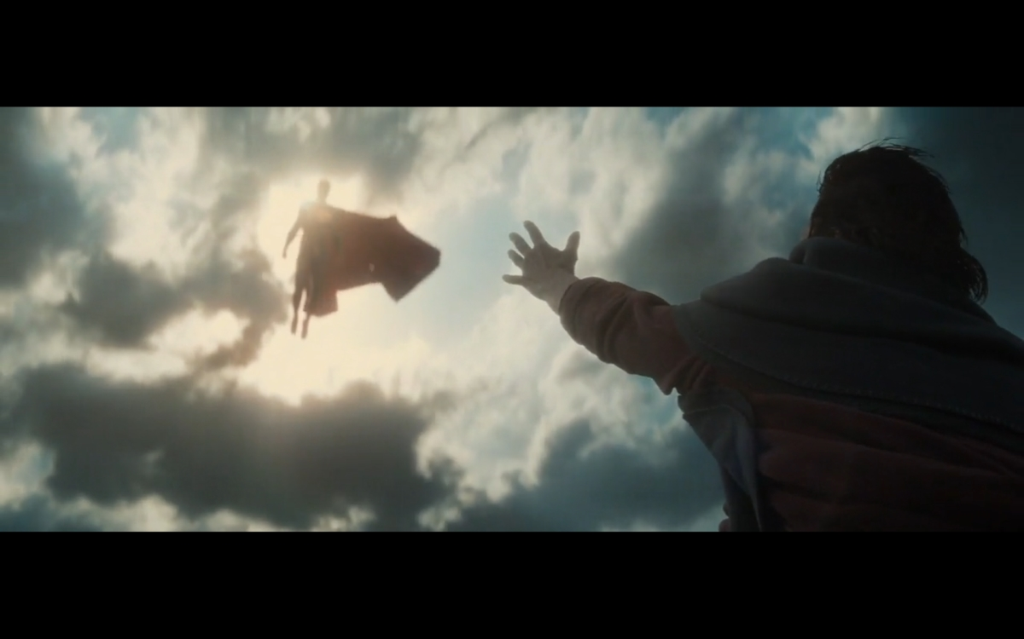

According to Segal, ‘the answer to the why of origin and function is usually a need, which myth arises to fulfill and lasts by continuing to fulfill.’ Superman’s myth was born in 1938 during the Great Depression. It was portraying values of courage and hope. He came to Earth from the sky displaying just a few superpowers: super strength, ability to jump skyscrapers and high speed. He could hardly be considered a solar hero back then. But the story grew more complex. During World War II, Superman started gaining more powers. He prided himself under the name 'Man of Steel' as he would face armory enemies. He was now a patriot fighting nazis. As the myth evolved, Superman became a solar deity. The survival of this story responded to contemporary needs and demands. According to www.statista.com, up to February 2015, he remained the best-selling comic book of all time. Figures 3.1 and 3.2 show how Zack Snyder depicted him as a savior:
Figures 4.1. Batman v Superman: Dawn of Justice, visual supervisor Larry Fong (c) Warner Bros.
Figure 3.1. Batman v Superman: Dawn of Justice, visual supervisor Larry Fong (c) Warner Bros.
According to Kal-El’s foster father the role of this myth was to answer the question ‘are we alone in the universe?’. The story of an alien may be one way of helping to cope with contradictory ideas that are being shared by scientists on whether or not there is life beyond Earth. But Mr. Kent did not see in his foster kid what his natural father, saw.

In today’s corrupted world, Superman strived to set an ideal, inspired by Jor-El’s words. Segal claimed that adults can hold on to myths ‘to deal with a much wider world.’ May Rollo added that ‘a hero is a myth in action’. So even though Superman’s myth has developed into a solar hero, the main role may be the same as when it was created: to imbue people with hope, courage and faith, as he himself stated in the movie.

In a complex world, it may be hard to decide what is good and what is bad, where there is light and where there is darkness. It may also be difficult to give value to sacrifices. This myth may inspire people as Superman himself, a god of light, had to face such conflicts. ‘No one stays good in this world’, Superman sighed. Grün and Dafner believed that there were two paths to spiritual realization. One that was set by a perfect unreachable model for people to strive towards to. And another which does not go up but steps downwards to a humble life, as the gospel of Luke has taught. It encourages to accept one’s inner darkness, shadows and imperfections. Superman myth as portrayed today in Zack Snyder’s movies seemed to expose that conflict. Kal-El, all mighty, coming from the sky, with so much greater power, had to accept his weakness, guilt and darker side in order to achieve his destiny. As the story of Jesus, today’s myth of the Superman may guide humans to surpass their tribulations.

Conclusion
This essay has considered the role of sky myths in two different cultures. These myths were the one of Jesus as told in the gospel of Luke and the one of Superman as portrayed in the movie Man of Steel. Both were solar heroes who had to pass their test, inspire humanity, die and be reborn. Their lives were deeply connected to the ideas of light and the Sun. In summary their role was to guide human kind to go through periods of crises and transformation, to work on self-acceptance and to help believe that courage and braveness can emerge from hope and faith. Anselm Grün claimed that the reason why the word ‘today’ was repeated seven times in Luke’s gospel was because this myth may be of significance even now. Humans, mere mortals as they are, might stumble behind Jesus and Superman, they might tremble, they might fall, but in time, they might join them in the Sun.

Bibliography

Main Primary Sources
The Holy Bible, Authorized King James Version (London: Oxford University Press, n.d.).
Snyder, Zack (dir.), Man Of Steel [Film], (Warner Bros., 2013).

Other Primary Sources
Siegler, Jerome and Joe Shuster, Action Comics 1 Superman, (DC Comic, 1938).
Snyder, Zack (dir.), Batman V Superman: Dawn Of Justice [Film], (Warner Bros., 2016).
Snyder, Zack (dir.), Justice League [Film], (Warner Bros., 2017).

Secondary Sources: JSTOR
Barton, George A., ‘The Astro-Mythological School Of Biblical Interpretation’, The Biblical World, 31.6 (1908), 433-444.
Bhattacharjee, Yudhijit, ‘A Distant Glimpse Of Alien Life?’, Science 333.6045 (2011), 930-32.
Chambers, Talbot W., ‘Sun Images And The Sun Of Righteousness’, The Old Testament Student, 5.5 (1886), 193-203.
Conybeare, F. C., ‘The Demonology Of The New Testament’, The Jewish Quarterly Review, 8.4 (1896), 576-608.
Gilhus, Ingvild Sælid, ’A Study In Liminal Symbolism’, Numen, 31.1 (1984), 106-128.
Kling, Bernt, Nancy King and D. S., ‘On SF Comics: Some Notes For A Future Encyclopedia’, Science Fiction Studies, 4. 3 (1977), 277-282.
Koester, Helmut, ‘Jesus The Victim’, Journal Of Biblical Literature, 111.1 (1992), 3-15.
Nothaft, C. P. E., ‘The Origins Of The Christmas Date: Some Recent Trends In Historical Research’, Church History, 81 4 (2012), 903-911.
Philips, Henry Jr., ‘Worship Of The Sun. The Story Told By A Coin Of Constantine The Great’, American Journal Of Numismatics, And Bulletin Of The American Numismatic And Archaeological Society, 14.3 (1880), 67-60.
Rowlingson, Donald T., ‘The Gospel-Perspective And The Quest Of The Historical Jesus’, Journal Of Bible And Religion, 33.4 (1965), 329-336.
Sanders, E. P., ‘Jesus In Historical Context’, Theology Today, 50.3 (1993), 429-448.
Tyson, Joseph B., ‘The Lukan Version Of The Trial Of Jesus’, Novum Testamentum, 3.4 (1959), 249-258.

Secondary Sources: Culture and Cosmos
Campion, Nicholas, 'The Sun Is God', Culture and Cosmos, 8.1 and 2 (2004), 45-56.
Heath, Robin, ’An Astronomical Basis For The Myth Of The Solar Hero', Culture And Cosmos, 1.1, 3-9.

Secondary Sources: Books
Campion, Nicholas, A History Of Western Astrology Volume 1 The Ancient World, (London: Bloomsbury Academy, 2013).
Campion, Nicholas, Astrology And Cosmology In The World’s Religions, (New York, NY: New York University Press, 2012).
Grün, Anselm, Jesus: The Image Of Humanity Luke’s Account, (New York, NY: Continuum, 2003).
Grün, Anselm and Meinrad Dufner, Una espiritualidad desde abajo: el diálogo con Dios desde el fondo de la persona, (Buenos Aires: Agape Libros, 2015).
Rollo, May, The Cry For Myths, (New York, NY: Norton & Company, 1991).
Segal, Robert A., Myth, A Very Short Introduction, (Oxford: Oxford University Press, 2004).

Other Secondary Sources
Dickholtz, Daniel, ‘Steel Dreams’, Starlog Yearbook (1998). <http://supermania78.com/2010/08/tom-mankiewicz-1942-2010/> [accessed 2 December 2019].
Statista Research Department, Best selling comic book of all time (2015), <https://www.statista.com/statistics/583041/best-selling-comic-books/>, [accessed 8 December 2019]. Weinstein, Simcha, Is Superman Jewish? Uncovering The Jewish Life Of Comic Book Heroes [video]. (2015) <https://youtu.be/k7Ks7tbXZl4> [accessed 9 December 2019].

The Holy Bible, Authorized King James Version (London: Oxford University Press, n.d.), Luke 1-24.
Zack Snyder (dir.), Man Of Steel [Film], (Warner Bros., 2013).
The Holy Bible, John 8. 12.
The Holy Bible, Luke 1. 26-35.
The Holy Bible, Luke 1. 38.
The Holy Bible, Luke 2. 1-7.
The Holy Bible, Luke 3. 21.
The Holy Bible, Luke 3. 4-6, 16-17.
The Holy Bible, Luke 3. 22.
The Holy Bible, Luke 4. 14, 18.
The Holy Bible, Luke 5. 13-16.
The Holy Bible, Luke 5-21.
The Holy Bible, Luke 22. 15.
The Holy Bible, Luke 23. 1.
The Holy Bible, Luke 23. 14-21.
The Holy Bible, Luke 23. 33-34. The Holy Bible, Luke 23. 46.
The Holy Bible, Luke 24. 1-7.
The Holy Bible, Luke 23. 45-49.
Zack Snyder (dir.), Batman V Superman: Dawn Of Justice [Film], (Warner Bros., 2016).
Zack Snyder (dir.), Man Of Steel [Film].
The Holy Bible,, John 1. 14.
Henry Philips, Jr., ‘Worship Of The Sun. The Story Told By A Coin Of Constantine The Great’, American Journal Of Numismatics, And Bulletin Of The American Numismatic And Archaeological Society, 14.3 (1880), 67-60 (p. 67).
Talbot W. Chambers, ‘Sun Images And The Sun Of Righteousness’, The Old Testament Student, 5.5 (1886), 193-203 (p.195).
Chambers, ‘Sun Images And The Sun Of Righteousness’, p.195.
Chambers, ‘Sun Images And The Sun Of Righteousness’, p.196.
Chambers, ‘Sun Images And The Sun Of Righteousness’, p.196.
C. P. E. Nothaft, ‘The Origins Of The Christmas Date: Some Recent Trends In Historical Research’, Church History, 81 4 (2012), 903-911 (p. 905).
C. P. E. Nohaft, ‘The Origins Of The Christmas Date: Some Recent Trends In Historical Research’, p.905.
The Holy Bible, John 8. 12.
Nicholas Campion, A History Of Western Astrology Volume 1 The Ancient World, (London: Bloomsbury Academy, 2013), p. 245.
Robin Heath, ‘An Astronomical Basis For The Myth Of The Solar Hero', Culture And Cosmos, 1.1, 3-9 (p. 4).
Anselm Grün, Jesus: The Image Of Humanity Luke’s Account, (New York, NY: Continuum, 2003), p. 6. The Holy Bible, Luke 1. 1-4.
Anselm Grün, Jesus: The Image Of Humanity Luke’s Account, p. 7.
The Holy Bible, Luke 1. 34.
Anselm Grün, Jesus: The Image Of Humanity Luke’s Account, p. 21.
The Holy Bible, Luke 3. 22.
The Holy Bible, Luke 11. 34-36.
The Holy Bible, Luke 6. 13.
George A. Barton, ‘The Astro-Mythological School Of Biblical Interpretation’, The Biblical World, 31.6 (1908), 433-444 (p. 437).
Nicholas Campion, A History Of Western Astrology Volume 1 The Ancient World, p. 247-248.
Nicholas Campion, 'The Sun Is God', Culture and Cosmos, 8.1 and 2 (2004), 45-56 (p.50).
The Holy Bible, Luke 22. 53.
The Holy Bible, Luke 23. 44.
Nicholas Campion, A History Of Western Astrology Volume 1 The Ancient World, p.253.
Nicholas Campion, A History Of Western Astrology Volume 1 The Ancient World, p.254.
The Holy Bible, Luke 24. 5-6.
The Holy Bible, Luke 24. 7. Nicholas Campion, Astrology And Cosmology In The World’s Religions, (New York, NY: New York University Press, 2012), p. 162.
Nicholas Campion, Astrology And Cosmology In The World’s Religions, p. 162.
The Holy Bible, Luke 24. 52.
Nicholas Campion, A History Of Western Astrology Volume 1 The Ancient World, p. 273.
Zack Snyder (dir.), Man Of Steel [Film].
Zack Snyder (dir.), Man Of Steel [Film].
Simcha Weinstein, Is Superman Jewish? Uncovering The Jewish Life Of Comic Book Heroes [video]. (2015) <https://youtu.be/k7Ks7tbXZl4> [accessed 9 December 2019].
Daniel Dickholtz, ‘Steel Dreams’, Starlog Yearbook (1998). <http://supermania78.com/2010/08/tom-mankiewicz-1942-2010/> [accessed 2 December 2019].
Zack Snyder (dir.), Man Of Steel [Film].
Zack Snyder (dir.), Man Of Steel [Film].
Zack Snyder (dir.), Man Of Steel [Film].
Zack Snyder (dir.), Man Of Steel [Film].
Zack Snyder (dir.), Justice League [Film], (Warner Bros., 2017).
Zack Snyder (dir.), Man Of Steel [Film].
Zack Snyder (dir.), Man Of Steel [Film].
Zack Snyder (dir.), Man Of Steel [Film].
Zack Snyder (dir.), Man Of Steel [Film].
Zack Snyder (dir.), Man Of Steel [Film].
Zack Snyder (dir.), Man Of Steel [Film].
Zack Snyder (dir.), Man Of Steel [Film].
Zack Snyder (dir.), Batman V Superman: Dawn Of Justice [Film].
Zack Snyder (dir.), Justice League [Film].
The Holy Bible, Luke 21. 8.
Nicholas Campion, ‘The Sun Is God’, p. 52.
Zack Snyder (dir.), Man Of Steel [Film]. The Holy Bible, Luke 1. 34.
Zack Snyder (dir.), Man Of Steel [Film]. The Holy Bible, Luke 3. 22.
The Holy Bible, Luke 22. 33-49.
Zack Snyder (dir.), Man Of Steel [Film].
The Holy Bible, Luke 22. 51.
The Holy Bible, John 1. 5.
The Holy Bible, Luke 4. 18.
Nicholas Campion, Astrology And Cosmology In The World’s Religion, p. 163.
The Holy Bible, Luke 4. 18.
Helmut Koester, ‘Jesus The Victim’, Journal Of Biblical Literature, 111.1 (1992), 3-15 (p.14).
Helmut Koester, ‘Jesus The Victim’, p.10.
E. P. Sanders, ‘Jesus In Historical Context’, Theology Today, 50.3 (1993), 429-448 (p. 433).
E. P. Sanders, ‘Jesus In Historical Context’, p. 446.
The Holy Bible, Luke 20. 25.
The Holy Bible, Luke 23. 2.
The Holy Bible, Luke 23. 3.
Joseph B. Tyson, ‘The Lukan Version Of The Trial Of Jesus’, Novum Testamentum, 3.4 (1959), 249-258 (p.255).
Nicholas Campion, Astrology And Cosmology In The World’s Religion, p. 168.
The Holy Bible, Luke 4. 36.
F. C. Conybeare, ‘The Demonology Of The New Testament’, The Jewish Quarterly Review, 8.4 (1896), 576-608 (p. 584).
Anselm Grün, Jesus: The Image Of Humanity Luke’s Account, p. 13.
The Holy Bible, Luke 7. 50.
Anselm Grün, Jesus: The Image Of Humanity Luke’s Account, p. 7.
Ingvild Sælid Gilhus, ‘A Study In Liminal Symbolism’, Numen, 31.1 (1984), 106-128 (p. 110).
Anselm Grün, Jesus: The Image Of Humanity Luke’s Account, p. 14.
The Holy Bible, Luke 11. 30.
The Holy Bible, Luke 8. 10.
Robert A. Segal, Myth, A Very Short Introduction, (Oxford: Oxford University Press, 2004), p. 56.
Holy Bible, Luke 22. 39-44.
Anselm Grün, Jesus: The Image Of Humanity Luke’s Account, p. 69.
Anselm Grün and Meinrad Dufner, Una espiritualidad desde abajo: el diálogo con Dios desde el fondo de la persona, (Buenos Aires: Agape Libros, 2015), p. 26.
Anselm Grün and Meinrad Dufner, Una espiritualidad desde abajo: el diálogo con Dios desde el fondo de la persona, p. 27.
Donald T. Rowlingson, ‘The Gospel-Perspective And The Quest Of The Historical Jesus’, Journal Of Bible And Religion, 33.4 (1965), 329-336 (p. 331).
Anselm Grün and Meinrad Dufner, Una espiritualidad desde abajo: el diálogo con Dios desde el fondo de la persona, p. 26.
The Holy Bible, Luke 22. 34.
The Holy Bible, Luke 22. 62.
The Holy Bible, Luke 24. 36.
Anselm Grün and Meinrad Dufner, Una espiritualidad desde abajo: el diálogo con Dios desde el fondo de la persona, p. 28.
Anselm Grün, Jesus: The Image Of Humanity Luke’s Account, p. 89.
Bryan Singer (dir.), Superman Returns [Film], (Warner Bros., 2006).
Robert A. Segal, Myth, A Very Short Introduction, p. 2.
Bernt Kling, Nancy King and D. S., ‘On SF Comics: Some Notes For A Future Encyclopedia’, Science Fiction Studies, 4. 3 (1977), 277-282 (p. 278).
Jerome Siegler and Joe Shuster, Action Comics 1 Superman, (DC Comics, 1938), p. 1.
Bernt Kling, Nancy King and D. S., ‘On SF Comics: Some Notes For A Future Encyclopedia’, p. 279.
Bernt Kling, Nancy King and D. S., ‘On SF Comics: Some Notes For A Future Encyclopedia’, p. 279.
Statista Research Department, Best selling comic book of all time (2015), <https://www.statista.com/statistics/583041/best-selling-comic-books/>, [accessed 8 December 2019].
Zack Snyder (dir.), Man Of Steel [Film], (Warner Bros., 2013).
Yudhijit Bhattacharjee, ‘A Distant Glimpse Of Alien Life?’, Science 333.6045 (2011), 930-32 (p.930).
Zack Snyder (dir.), Man Of Steel [Film], (Warner Bros., 2013).
Robert A. Segal, Myth, A Very Short Introduction, p. 139.
May Rollo, The Cry For Myths, (New York, NY: Norton & Company, 1991) p. 48.
Zack Snyder (dir.), Man Of Steel [Film], (Warner Bros., 2013).
Zack Snyder (dir.), Batman V Superman: Dawn Of Justice [Film], (Warner Bros., 2016).
Anselm Grün and Meinrad Dufner, Una espiritualidad desde abajo: el diálogo con Dios desde el fondo de la persona, p. 12.
Anselm Grün and Meinrad Dufner, Una espiritualidad desde abajo: el diálogo con Dios desde el fondo de la persona, p. 17.
Anselm Grün and Meinrad Dufner, Una espiritualidad desde abajo: el diálogo con Dios desde el fondo de la persona, p. 25.
Anselm Grün, Jesus: The Image Of Humanity Luke’s Account , p. 28.
Zack Snyder (dir.), Man Of Steel [Film], (Warner Bros., 2013).

